EE – 706 VIDEO PROCESSING HOMEWORK 2

Submitted by : Salim SIRTKAYA - 1124346

General Info :

I implemented Lucas-Kanade & Block Matching Optical Flow Estimation algorithms. The algorithms are tested on 4 consecutive frames of the well-known “flower garden” sequence.

The error is calculated as the mean square intensity difference of the original frame and the warped frame. Warping is from the second image to the first according to the optical flow vectors. Bilinear interpolation is used for subpixel calculations.

Lucas-Kanade Results:
- The following figures show the 1st and 2nd frames of the sequence, their original difference, calculated optical flow vectors. The window size is 5, 3 hierarchical levels are used and the maximum iteration number is 5.

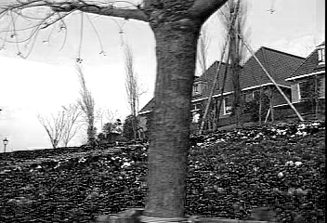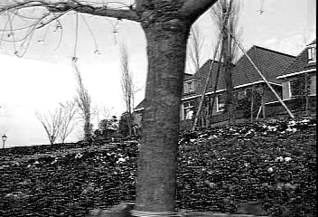

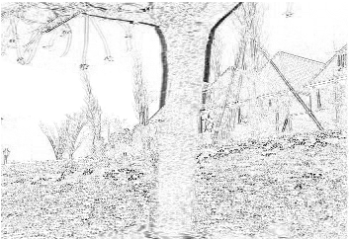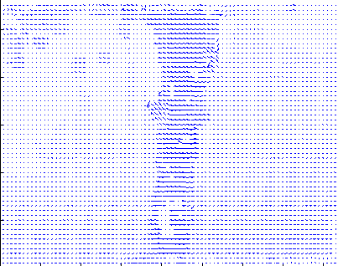

The MSE (Mean Square Error) for this problem is : 3049

The same algorithm is applied to the same sequence this time to first and fourth frames.
The MSE for this case is : 5785
This is an expected result since the Lucas-Kanade optical flow estimation method holds only for small motions.

This experiment is repeated for different window sizes and hierarchical levels. The iteration nember is kept as 5. The MSE results are as follows:

 | Window size = 5  Hierarcy level =3 | Window size = 5  Hierarcy level =2 | Window size = 9  Hierarcy level =2
Frame1 – Frame 2 | 3049 | 3055 | 3170
Frame1 – Frame 4 | 5785 | 5924 | 5828

We can conclude that decreasing the hierarchical levels degrades the estimate. However the computational complexity is also important. Also, increasing the window size does not make the estimate better although it smooths the flow field.

