EE706 DIGITAL VIDEO PROCESSING

PROJECT FINAL REPORT

Submitted By : Gökhan Göksügür & Salim Sırtkaya
Spring 2005

Digital Video Stabilization Based on Augmented Ego-motion Estimation with Inertial Measurements via Kalman Filtering

ABSTRACT

In this project, we analysed and implemented digital video stabilization and augmented ego-motion estimation of a “camera+imu” system mounted on a 6 degree of freedom moving platform. The Inertial Measurement Unit (IMU) gives rate and acceleration information in 3 axes. The aim is estimating the motion of the platform using the measurements coming from the camera and IMU and then removing the jittering motion (stabilization) while preserving the global motion.
Ego-motion estimation using camera measurements is based on a feature based optical flow estimation (KLT) followed by Essential Matrix (or Fundamental Matrix) estimation. The Essential Matrix estimation is based on 8-point algorithm (Least Median Squares method).
A non-linear estimation is conducted after linear estimation of the Essential Matrix that gives the rotation and translation parameters of the camera. The non-linear motion estimation algorithm is based on Levenberg-Marquardt minimization process. Inertial measurements of the camera platform in 6-degree of freedom will be used to augment image based motion estimation (IBME). A Kalman filter will be used to couple these measurements (inertial, image) optimally in a near-future work.
The stabilization system aims to eliminate global motion irregularities to have the processed sequence display desired global motions only. The stabilization system is divided into two parts. The global motion estimation system and the motion correction system. Global motion estimation part is implemented using one of the popular Optical Flow Estimation methods (exhaustive search method). Motion correction part of the stabilizer is implemented using adaptive Kalman filtering. Since the Kalman filter needs only system states at consecutive time instants and estimates system states in a recursive manner, it is the most suitable correction method for real time processing.
The motivation behind the unification of motion estimation and stabilization algorithms was their common use in autonomous navigation systems, especially in unmanned vehicle systems. Reliable and continuous motion estimation is a must in such systems. Video stabilization is also crucial in these systems especially for ground control, reliable target identification and plain video storage. In addition to these issues, the algorithms share a common background and dataset. Therefore we find it attractive to deal with these subjects in a collaborative manner.

In the following chapters you will find the details and results of motion estimation and video stabilization frameworks, seperately. The algorithms are not unified yet, therefore we can not give results of the unified algorithm. However, the same results are expected at the end, since there will not be any change in the algorithm philosophy after unification.

PART 1 - Ego-motion Estimation of a Moving Camera (Image Based Motion Estimation)

The proposed method for camera motion estimation is based on optimal fusion of two different estimation sources via Kalman Filtering. These sources are, Image Based Motion Estimation and inertial measurements ( 3 accelerometers + 3 gyroscopes ).
Due to the scope of this course we focused on Image Based Motion Estimation (IBME). IBME has found application areas in Optical Navigation in unmanned and space vehicles, automatic and safe descent/ascent of UAV’s, Platform Stabilization, Geo-referencing Systems, Alternative aiding for Inertial Navigation Systems etc.
Our IBME algorithms are based on automatic feature tracking between a pair of camera images followed by two frame motion estimation and scale recovery using range data. The output of the algorithm is an estimate of rigid motion (attitude and position) and motion covariance between frames. This motion estimate can be passed directly to the navigation and control system to enable rapid execution of safe and precise trajectories.
There are multiple steps in our algorithm. First, distinct features, which are pixels that can be tracked well across multiple images, are detected in the first image. Next, these features are located in the second image by feature tracking. Given these feature matches, the motion state and covariance of the spacecraft, up to a scale on translation, are computed using a two stage motion estimation algorithm. In these estimations it is assumed that the 2D image motion induced in the image plane is only due to camera motion. The block diagram for motion estimation is shown in the following figure.

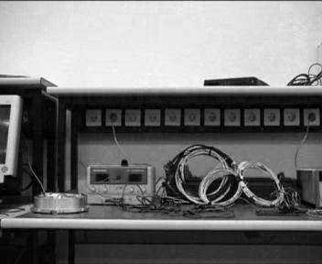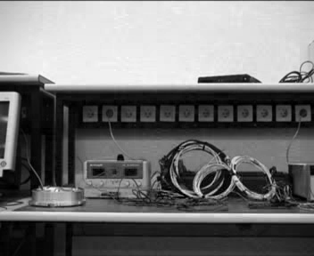
Extract Features
Image Based Motion Estimation – The algorithm
Track Features
Calculate Essential Matrix
Linear Motion Estimation
Non-linear Motion Estimation
Scale estimation of translational motion
Harris Corner Detector or Intensity Gradient Matrix analysis
Optical Flow Estimation based tracking (Kanade Lucas Tracker)
Modified 8-point Algorithm
Direct Minimization of Epipolar Constraint equation
Levenberg-Marquardt Algorithm
Using Range Finders (a-priori in test case)
Stabilization

Figure 1-1 The block-diagram of motion Image Based motion Estimation algorithm
The feature detection algorithm is based on intensity gradient estimations. The intensity gradient matrix of a random point is estimated. If its eigenvalues are greater than a prescribed threshold it is selected as a feature candidate. This random feature selection decreased the computation time. 100 random feature points were used in this implementation.
The features were tracked using Kanade-Lucas Feature Tracke. A hierarchical implementation of KLT was used. The hierarchy level was set to 3, the window size to 5, and the inner iteration number to 5.
The motion between two camera views can be described by a rigid transformation (R,T) where R encodes the rotation between views and T encodes the translation between views. Once features are tracked between images, the motion of the camera can be estimated by solving for the motion parameters that, when applied to the features in the first image, bring them close to the corresponding features in the second image. A two-stage algorithm, linear estimation followed by non-linear estimation, is proposed for this purpose.
In the first stage the Essential Matrix is estimated using the point correspondences, This is a linear algorithm. The result of this algorithm is then used as input to a more accurate nonlinear algorithm that solves for the motion parameters directly. Since a good initial estimate is needed to initialize any nonlinear feature-based motion estimation algorithm, this two stage approach is common. Output from the nonlinear algorithm is the estimate of the five motion parameters and their covariance. Our algorithm assumes that the camera taking the images has been intrinsically calibrated (i.e., focal length, radial distortion, optical center, skew and aspect are all known).
The non-linear algorithm is based on Levenberg-Marquardt Minimization Process. The details of these algorithms can be found in [1].
These brief explanations concluded the implementation issues. The algorithm is experimented on real data taken from a moving platform. The moving platform consists of following items: A camera, An Inertial Navigation System, A precise surfaced mechanical mount, Two computers, Test cables, Moving four wheel carriage. The inertial navigation system is used as ground-truth data. The experiment is conducted in a close environment. The experiment durations are short (at most 1 minute). The motion capability of the carriage was limited, therefore the motion is dominantly translational. In the following figures, the results of feature extraction, feature tracking and 5-dof motion estimation results are illustrated.

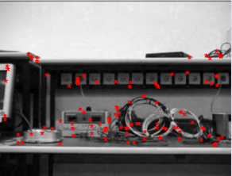
Figure 1-2 Output of random feature selection algorithm

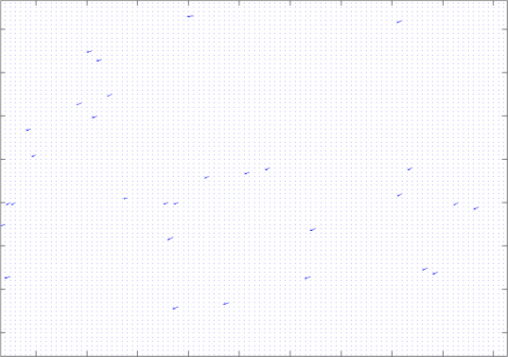
Figure 1-3 Output of the feature tracking algorithm. KLT is used for tracking

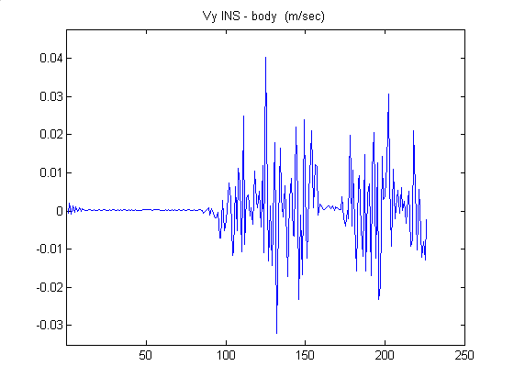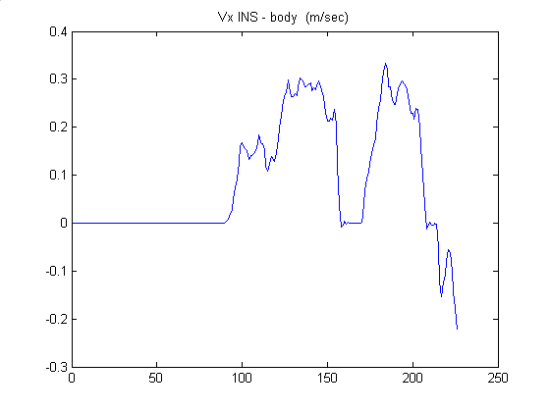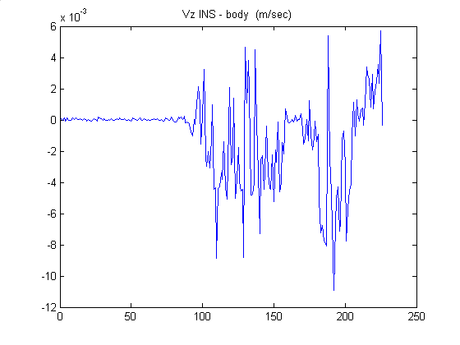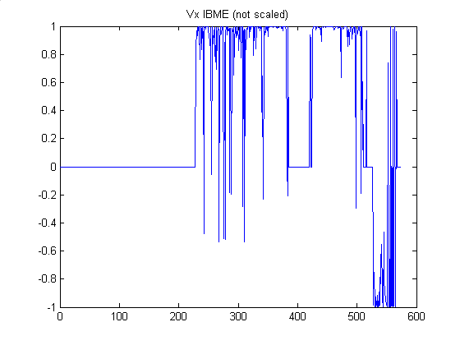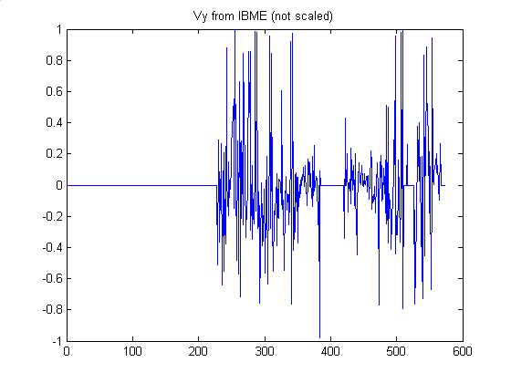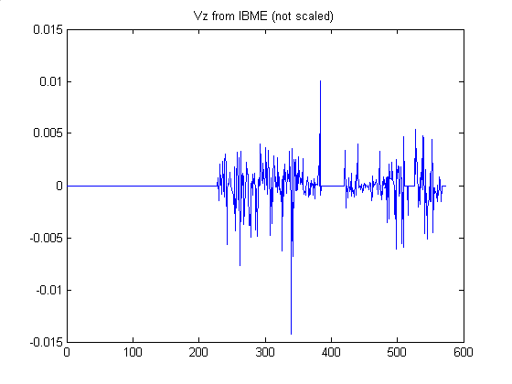
Inertial Navigation System Results of a 45 second experiment

Figure 1-4 Results of 5-dof motion estimation algorithm. The figures at the top are the results of inertial estimations (ground-truth), translation in x,y,z respectively. The figures at the lower part are the corresponding image based motion estimates without scaling. Note that the translation is dominanly on X axis. It is observed that the IBME results track the translations up to a scale. We expect more reliable results when scale estimation is introduced.
PART 2 – Digital Video Stabilization Based on Kalman Filtering

2-1. Introduction

The systems installed in either outdoor environments or vehicles have often suffered from image instability due to the vibrations on the platforms and which leads to disturbing visual experience. Removal of those undesired movements requires video stabilization techniques. There are typically three major stages constituting a video stabilization process, motion estimation, motion smoothing, and image compensation. In the motion estimation stage, the camera motion is estimated from the input images. Since the estimated motion may contain both expected and unexpected motions, they are smoothed in the motion smoothing stage. The image effect caused by unexpected camcorder motion is finally eliminated from the input image in the image compensation stage. The resulting image is a stabilized version of the input image.

2-2. Conceptual Design

In this project, I have built a video stabilization system that accept the high frequency components of the global motion vectors as undesired and remove them by smoothing. Since stabilization is based on global motion smoothing, success of global motion estimator affects the performance of the stabilizer. For global motion estimation, local motion vectors are found using block based full search algorithm. Assuming only translational motion is present in the system, most of the local motion vectors will assumed to be same. In such a condition, median filtering can give accurate estimate for global motion. Block diagram of the motion stabilizer is as given in Figure 2-1.

Median
Filter
Kalman
Filter
Exhaustive
Estimator
Motion
Corrector
Motion Estimator
Motion Smoother
Input
Video
Stabilized
Video

Fig.2-1 Motion Stabilizer Block Diagram

To get the global motion of the camera first we have to get local motion vectors. Local motion estimation is important since it directly affects the performance of the stabilization. Local motion estimation is used to obtain the local motion vectors for consecutive frames. In the project, block based exhaustive search algorithm is used to find motion vectors between consecutive frames. Given an image block in the anchor frame, the motion estimation problem is to find the matching block in the target frame within a predefined search region such that the error between these two blocks is minimized. For this purpose, in our project a frame is divided into N x N blocks and motion vectors are determined by searching matching blocks within Search Area Radius.

Assuming only translational motion most of the local motion vectors assumed to be the same. To get an average of these local motion vectors and to find the global motion vector for each frame median filter is applied to local motion vectors.

Since the high frequency components of motion are accepted as undesired, a low pass filter must be applied to global motion vectors. In our project I have implemented Kalman filter to remove these undesired motions.

2-3. Kalman Filter Basics

Kalman filter needs only the storage of system states only at time instants t and (t-1), that makes it suitable for real time stabilization of video. Kalman filter can be used to effectively obtain stabilized image sequences if a good linear dynamical system model can be constructed and if the noise covariances of the system can be approximated effectively. The smoothed motion vectors are used to correct the position of each frame.

The Kalman filter is essentially a set of mathematical equations that implement a predictor-corrector type estimator that is optimal in the sense that it minimizes the estimated error covariance, when some presumed conditions are met.

The Kalman filter addresses the general problem of trying to estimate the state of a discrete-time controlled process that is governed by the linear stochastic difference equation

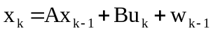
with a mesurement
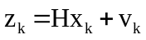

The random variables 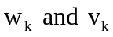 represents the process and measurement noise, respectively. They are assumed to be independent with normal probability distributions

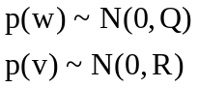
where, Q is the process noise covariance and R is the measurement noise covariance.

The Kalman filter estimates a process by using a form of feedback control: the filter estimates the process state at some time and then obtains feedback in the form of noisy measurements.
The equations for the Kalman filter fall into two groups: time update equations and measurement update equations. The time update equations are responsible for projecting forward the current state and error covariance estimates to obtain the a priori estimates for the next time step. The measurement update equations are responsible for the feedback—i.e. for incorporating a new measurement into the a priori estimate to obtain an improved a posteriori estimate[2].

2-4. Implementation

It is assumed that the motion dynamics of the camera can be described by constant velocity state equations[1]. The absolute position of the current frame with respect to the initial frame is taken as the instantaneous camera position. The interframe differential motion vector is assumed as the instantaneous camera velocity. The states of the camera motion model are formed by the camera position and camera velocity and can be described as

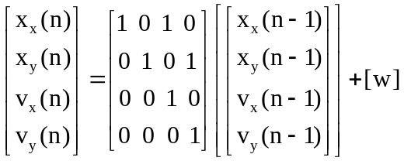

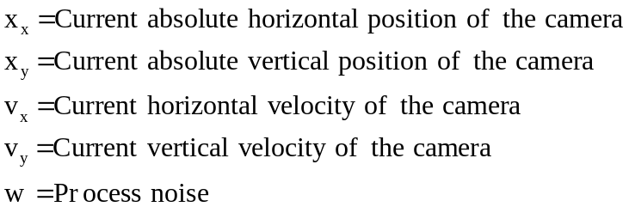

It is also assumed that the observer system measures the absolute position of each frame according to following state equations.

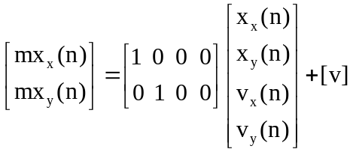

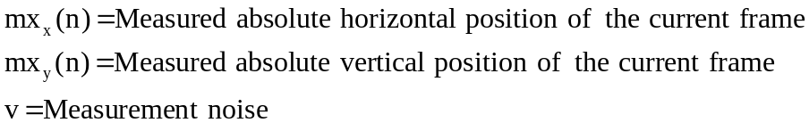

I have implemented the Kalman filter by assuming the process and measurement noise covariances Q and R are user defined. Normally, these covariances are not constant and must be estimated for each frame of the sequence. However, this requires the implementation of another estimator that increase computational load and decrease system response time.

As each stabilized frame is formed based on the previous frame and the smoothed motion vector, there is the problem of accumulation of error with time. In order to remove the effect of error accumulation I have synchronized the original and stabilized frame sequences in order to obtain a much more smooth stabilized video sequence.

2-5. Results

The result of the application of Kalman filter to the demo.avi sequence that is recorded by Salim Sırtkaya is shown below in Figure 2-2, where Q was taken as 0.1 and R was taken as 0.01. As can be seen the sequence has highly fluctuating components. Kalman filter was successful to keep the global motion of the camera and removed the unwanted jitter components.

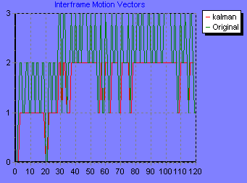

Figure 2-2. Result of Kalman Filter Stabilizer

REFERENCES
Motion Estimation part
[1] ‘Precise Image Based Motion Estimation for Autonomous Small Body Exploration’, Andrew E. Johnson, Larry H. Matthius
[2] Optimal motion estimation from visual and inertial measurements’, Dennis Strelow and Sanjiv Singh
[3] ‘Augmenting Inertial Navigation with Image-Based Motion Estimation’, Stergios I. Roumeliotis, Andrew E. Johnson, James F. Montogomery
[4] ‘Pyramidal Implementation of the Lucas Kanade Feature Tracker Description of the algorithm’, Jean-Yves Bouguet
[5] ‘Lecture Notes of EE-701 Robot Vision’, Aydın ALATAN, 2002, METU

Stabilization Part:
[6] Ertürk, Sarp. Real-Time Digital Image Stabilization Using Kalman Filters, Real Time Imaging 8, 317-328 (2002)
[7] Welch, Greg., Bishop, Gary. An Introduction to the Kalman Filter, Siggraph (2001)
[8] Ertürk,Sarp., Güllü, Kemal. Bulanık Denetleç Uyumlaması Kullanılan Kalman Filtresi ile Görüntü Stabilizasyonu.
[9] Engelsberg, A., Schmidt, G.. A comparative Review of Digital Image Stabilising Algorithms for Mobile Video Communications.
[10] Eylem Yaman, Sarp Ertürk .Görüntü Stabilizasyonu İçin Paralel İşlev Gören İki Kalman Filtresiyle İşlem Gürültü Varyansının Adaptifleştirilmesi

