EE706 MT1 Soln

Q2 b.
The reconstruction points are in -0.3, -0.1, 0.1 and 0.3. The distortion
is given by

d= 2( 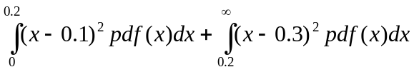) ~ 0.6554

Q3.

Assuming the line spacing for 4/3 aspect ratio is d_{y} than the basic lattice for 4/3 ratio is

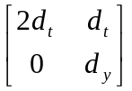

and the basic lattice for 16/9 ratio is

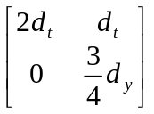

Q4.

Entropy = H = -0.8log 0.8 - 2 *0.1log 0.1 = 0.9219 bits

A huffman tree with the symbols a, b, c gives an average code
word length of 1.2 bits/symbol as shown below
0

1

0.1
0.2
0

1
0.1

0.8

a: 00
b: 1
c: 00

average codeword length = 2*0.1+2*0.1+0.8= 1.2 bits/symbol

This is not good enough so we need to group the symbols into blocks of two symbols. The probabilites of these pairs are P(aa) = 0.01, P(ab) = P(ba) = 0.08, P(ac) = P(ca) = 0.01, P(bb) = 0.64, P(bc) = P(cb) = 0.08, P(cc) = 0.01. A huffman tree with these 9 possible blocks gives an average code word length of 1.92 bits/block which is 0.96 bits/symbol.

aa 0.01 0.02
ac 0.01 0.04
ca 0.01 0.02
cc 0.01
bc 0.08 0.12
cb 0.08 0.16
ab 0.08 0.36
ba 0.08 0.2
bb 0.64

ca: 000010
cc: 000011
aa: 000000
ac: 000001
bc: 0001
cb : 010
ab: 011
ba: 001
bb:1

Arithmetic coding: The corresponding interval is [0.924912 0.929008). The codeword will be 111011010.

