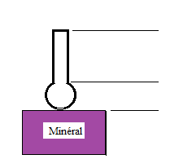

A separation of minerals by exploiting difference of surface properties (hydrophobicity) is called flotation. The reverse cationic flotation is commonly used to separate iron from silica. By adjusting the 'chemistry' of the pulp by adding various chemical reagents, iron minerals remain in the water and create sediment with a high concentration of iron (valuable minerals). At the same time, silica particles (gangue) attach to air bubbles and float to the surface.

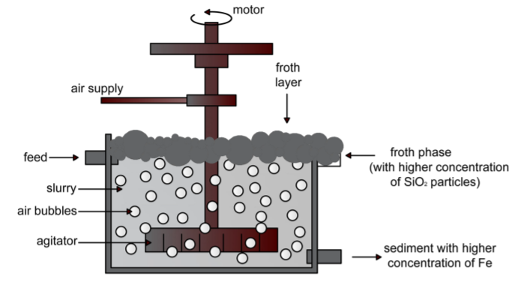

Flotation concentrate is periodically sampled to determine its purity (i.e., *%valuable*, *%gangue*). Higher *%gangue* in the concentrate is undesirable as it indicates that most valuable minerals had gone into the tailing. Purity measurement is usually done in a lab and can take some time before process engineers can make any adjustments based on the results. A timely investigation of concentrate purity is, therefore, a fundamental aspect for the control and optimization of the flotation process.

This notebook explores the application of deep learning to forecast gangue (*%silica*) in the flotation concentrate. The forecast will help process engineers assess purity of flotation concentrate and take corrective actions in advance. More specifically, the goal is to tackle the following tasks:

* How many steps (hours) ahead can *%silica in concentrate* be forecasted?
* Is it possible to forecast *%silica in concentrate* without using the data of *%iron in concentrate*?

The main goal is to use this data to predict how much impurity is in the ore concentrate. As this impurity is measured every hour, if we can predict how much silica (impurity) is in the ore concentrate, we can help the engineers, giving them early information to take actions (empowering!). Hence, they will be able to take corrective actions in advance (reduce impurity, if it is the case) and also help the environment (reducing the amount of ore that goes to tailings as we reduce silica in the ore concentrate).

* Date: Date collection date and time.
* % Iron Feed: Feed grade of iron-containing ore.
* % Silica Feed: Feed grade of silica-containing ore..
* Starch Flow: Depressant chemical for Iron(Fe) containing ore.
* Amina Flow: Collector chemical for Silica containing ore.
* Ore Pulp Flow: The amount of pulp flow fed to the Flotation Columns as the product of the previous process step.
* Ore Pulp pH: pH.
* Ore Pulp Density: The solid percent of ore fed to Flotation Columns.
* Flotation Column 01,02,03,04,05,06,07 Air Flow: The amount of air fed to the Flotations Columns to frothing.
* Flotation Column 01,02,03,04,05,06,07 Level: Showing float thickness of Flotation Columns.
* % Iron Concentrate: Concentrate grade of iron-containing ore.
* % Silica Concentrate: Concentrate grade of silica-containing ore