**CMPE 443 PRINCIPLES OF EMBEDDED SYSTEMS DESIGN**

**PRELAB #007 “TIMER”**

1. **Problem Definition**

You will use an RGB LED with 4 Timers. 3 of them will be used for Red, Green, Blue LEDs and the last one will be used for switching colors of the LED at every 1 second.

1. **RGB LED**

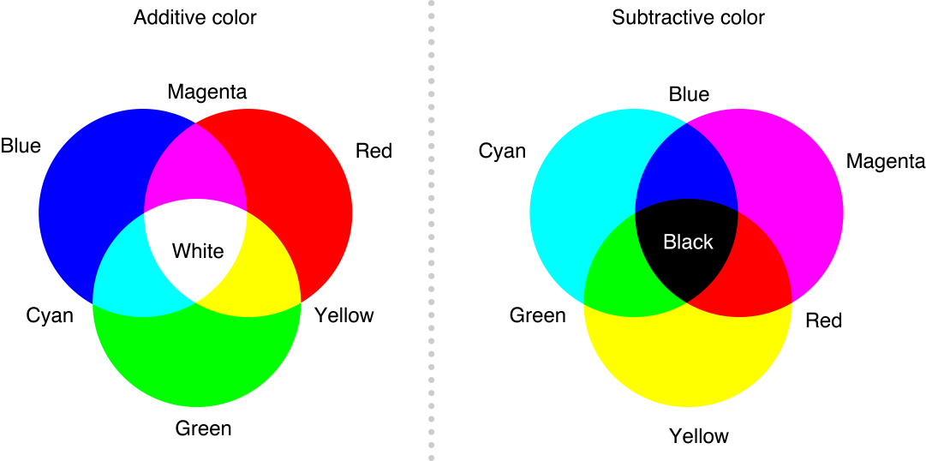

RGB-LED is working as an Additive Color. When all the RED,BLUE and GREEN is ON, it will give White color. When only RED and BLUE is ON, it will give Magenta Color.

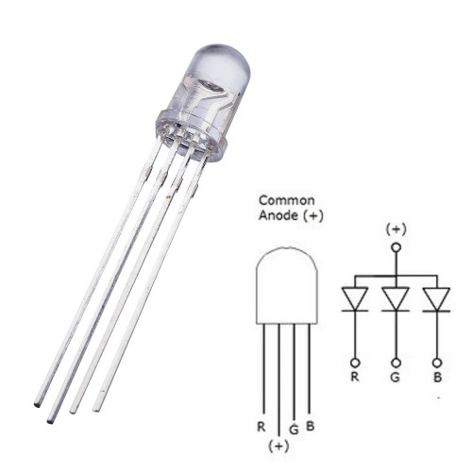

The longer leg of the LED (**ANODE**) should be connected to higher voltage and the short legs of the LED (**CATHODE**) should be connected to lower voltage. You need to connect the 1K resistor to the (+).

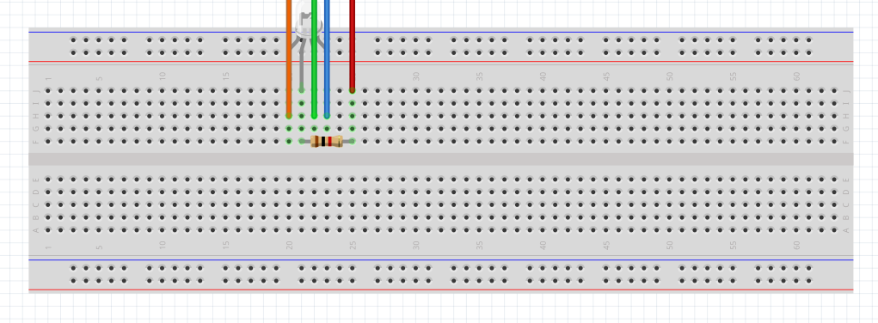

You need to connect the R,G,B LEDs pin to suitable pins of the board.

* Which pins are used? PD7 (blue), PD6 (green), PD5 (red)

1. **Timer**

You will use 4 Timers with interrupt.

* Which timers you selected?

TIM2, TIM3, TIM4, TIM5

* Enable update interrupt? (DIER)

TIM2->DIER |= (0x01);

TIM3->DIER |= (0x01);

TIM4->DIER |= (0x01);

TIM5->DIER |= (0x01);

* Generate update interrupt when CNT is reinitialized. (EGR)

TIM2->EGR |= (0x01);

TIM3->EGR |= (0x01);

TIM4->EGR |= (0x01);

TIM5->EGR |= (0x01);

* Configure for only counter overflow/underflow generates an update interrupt. (CR1)

TIM2->CR1 &= ~(1 << 1);

TIM3->CR1 &= ~(1 << 1);

TIM4->CR1 &= ~(1 << 1);

TIM5->CR1 &= ~(1 << 1);

* Configure prescaler to increase the CNT register for every 1 millisecond. (PSC)

TIM2->PSC = 4000 - 1;

TIM3->PSC = 4000 - 1;

TIM4->PSC = 4000 - 1;

TIM5->PSC = 4000 - 1;

ARR register values should be different at each timer. In order to show all the colors on an RGB LED, the on/off frequency of the LEDs should be different. Intensity of RED > GREEN > BLUE, so you need to configure Timers as:

* Timer connected to the RED LED should interrupt with 100Hz.
* Timer connected to the GREEN LED should interrupt with 200Hz.
* Timer connected to the BLUE LED should interrupt with 400Hz.
* Timer for the switching colors should interrupt with 1 Hz.
* What are the ARR register values for these timers?

TIM2->ARR = 9; // red 100Hz

TIM3->ARR = 4; // green 200Hz

TIM4->ARR = 2; // blue 400Hz

* Enable IRQ for Timers

__asm volatile( // enable all interrupts that are configured

“mov r0, #0 \n\t”

“msr primask, r0 \n\t”);

* Write IRQ Handles and Clear interrupts (SR) __________
* void TIM2_IRQHandler(void)
* {
* TIM2->SR = 0;
* if (state & 0x4)
* {
* if (GPIOD->ODR & 1 << 5)
* {
* GPIOD->ODR &= ~(1 << 5);
* }
* else
* {
* GPIOD->ODR |= (1 << 5);
* }
* }
* else
* {
* GPIOD->ODR |= (1 << 5);
* }
* }
* // green
* void TIM3_IRQHandler(void)
* {
* TIM3->SR = 0;
* if (state & 0x2)
* {
* if (GPIOD->ODR & 1 << 6)
* {
* GPIOD->ODR &= ~(1 << 6);
* }
* else
* {
* GPIOD->ODR |= (1 << 6);
* }
* }
* else
* {
* GPIOD->ODR |= (1 << 6);
* }
* }
* // blue
* void TIM4_IRQHandler(void)
* {
* TIM4->SR = 0;
* if (state & 0x1)
* {
* if (GPIOD->ODR & 1 << 7)
* {
* GPIOD->ODR &= ~(1 << 7);
* }
* else
* {
* GPIOD->ODR |= (1 << 7);
* }
* }
* else
* {
* GPIOD->ODR |= (1 << 7);
* }
* }
* // general
* void TIM5_IRQHandler(void)
* {
* TIM5->SR = 0;
* uint8_t rgb[8] = {0x7, 0x3, 0x5, 0x1, 0x6, 0x2, 0x4, 0x0};
* // White (all) - Cyan (blue-green) - Magenta (blue-red) - Blue - Yellow(red-green) - Green - Red - Black (none)
* state = rgb[i];
* if (i == 7)
* {
* i = 0;
* }else{
* i+=1;
* }
* }

1. **Code**

In this prelab, you need to write code for showing different colors every 1 second. The color pattern: White - Cyan - Magenta - Blue - Yellow - Green - Red - Black

In order to show these colors, you should configure the On/Off frequency of the LEDs correctly.

1. **Submission**

You will submit one zip file which contains this document and your project (all the files with the last configuration)

The naming of the zip file should be:

PRELAB<exp num>_<StudentID>.zip

1. **Related Videos and Links**

Timer Introduction:

<https://www.youtube.com/watch?v=BtAi6-7Lnlw>

How an RGB LED works:

<https://www.youtube.com/watch?v=wqzfbImsrPE>