1. **Write a program that allows the user to enter a number then print it.**

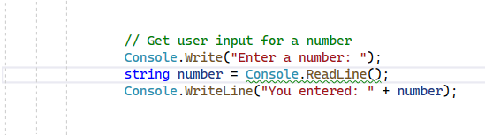

**Example**

Input: 5

Output: 5

1. **Write a program that takes a number from the user then print yes if that number can be divided by 3 and 4 otherwise print no.**

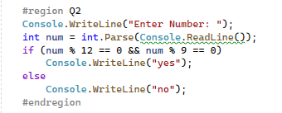

**Example (1)**

Input: 12

Output: Yes

**Example (2)**

Input: 9

Output: No

1. **Write a program that allows the user to insert 2 integers then print the max.**

**Example (1)**

Input: 3 5

Output: 5

**Example (2)**

Input: 10 7

Output: 10

1. **Write a program that allows the user to insert an integer then print negative if it is negative number otherwise print positive.**

**Example (1)**

Input: -5

Output: negative

**Example (2)**

Input: 10

Output: positive

1. **Write a program that takes 3 integers from the user then prints the max element and the min element.**

**Example (1)**

Input:7,8,5

Output:

max element = 8

min element = 5

**Example (2)**

Input: 3 6 9

Outputs:

Max element = 9

Min element = 3

**6- Write a program that allows the user to insert an integer number then check If a number is even or odd.**

1. **Write a program that takes character from the user then if it is a vowel chars (a,e,I,o,u) then print (vowel) otherwise print (consonant).**

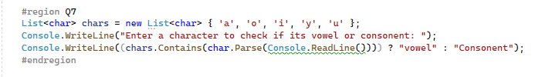

**Example (1)**

Input: O

Output: vowel

**Example (2)**

Input: b

Output: Consonant

1. **Write a program that allows the user to insert an integer then print all numbers between 1 to that number.**

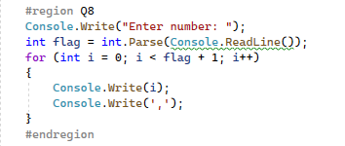

**Example**

Input: 5

Output: 1, 2, 3, 4, 5

1. **Write a program that allows the user to insert an integer then print a multiplication table up to 12.**

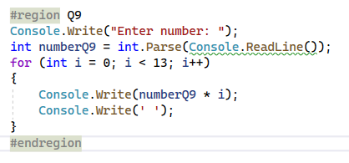

**Example**

Input: 5

Outputs: 5 10 15 20 25 30 35 40 45 50 55 60

1. **Write a program that allows to user to insert number then print all even numbers between 1 to this number**

**Example:**

Input: 15

Output: 2 4 6 8 10 12 14

1. **Write a program that takes two integers then prints the power.**

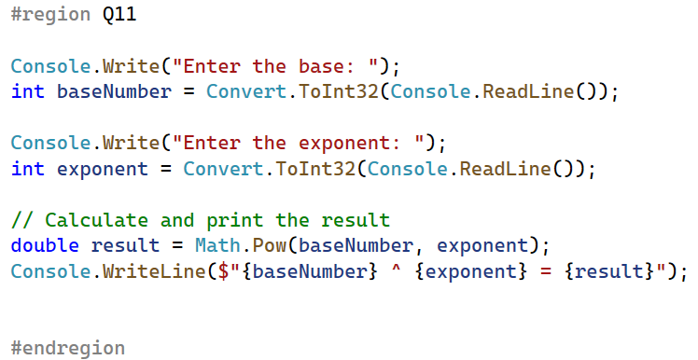

**Example:**

Input: 4 3

Output: 64

**Hint:** how to calculate 4^3 = 4 * 4 * 4 =64

**12- Write a program to enter marks of five subjects and calculate total, average and percentage.**

**Example**

Input: - Enter Marks of five subjects: 95 76 58 90 89

Output: Total marks = 408

Average Marks = 81

Percentage = 81

**13- Write a program to input the month number and print the number of days in that month.**

**Example**

Input: Month Number: 1

Output: Days in Month: 31

**14- Write a program to input marks of five subjects Physics, Chemistry, Biology, Mathematics and Computer, And Calculate percentage and grade.**

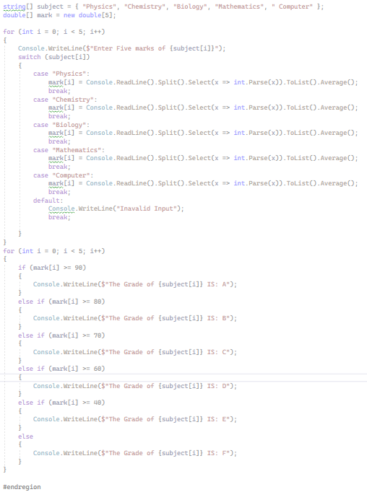

**Hint:**

Percentage >= 90%: Grad A

Percentage >= 80%: Grad B

Percentage >= 70%: Grad C

Percentage >= 60%: Grad D

Percentage >= 40%: Grad E

Percentage < 40%: Grad F

**15 - Write a program to check whether a number is positive or negative or zero.**

**16- Write a program to create a Simple Calculator.**

**17- Write a program to allow the user to enter a string and print the REVERSE of it.**

**18- Write a program to allow the user to enter int and print the REVERSED of it.**

**19. Write a program in C# Sharp to find the sum of all elements of the array.**

**20. Write a program in C# Sharp to count a total number of duplicate elements in an array.**

**21. Write a program in C# Sharp to merge two arrays of the same size sorted in ascending order.**

**22. Write a program in C# Sharp to count the frequency of each element of an array.**

**23. Write a program in C# Sharp to find maximum and minimum element in an array**

**24. Write a program in C# Sharp to find the second largest element in an array.**

**25. Consider an Array of Integer values with size N, having values as**

**in this Example**

|  |  |  |  |  |  |  |  |  |  |  |  |
| --- | --- | --- | --- | --- | --- | --- | --- | --- | --- | --- | --- |
| 7 | 0 0 | 0 | 0 | 5 | 6 | 7 | 5 | 0 | 7 | 5 | 3 |

write a program find the longest distance between Two equal cells. In this example. The distance is measured by the number Of cells- for example, the distance between the first and the fourth cell is 2 (cell 2 and cell 3).

In the example above, the longest distance is between the first 7 and the

10th 7, with a distance of 8 cells, i.e. the number of cells between the 1st

And the 10th 7s.

**Note:**

- Array values will be taken from the user

- If you have input like 1111111 then the distance is the number of

Cells between the first and the last cell.

**26. Given a list of space separated words, reverse the order of the words.**

Input: this is a test Output: test a is this

Input: all your base Output: base your all

Input: Word Output: Word

**Note :**

Check the **Split Function** (Member in String Class) Output will be a Single Console.WriteLine Statement