Name : N.M.Dhanushka Slainda Jayawardana

Email : [jayawardanasalinda@gmail.com](mailto:jayawardanasalinda@gmail.com)

Mobile : +94 71 388 2815

Wiley global technologies - Technical interview phase 1

COVID-19 tracking system

1. **High Level Architecture**

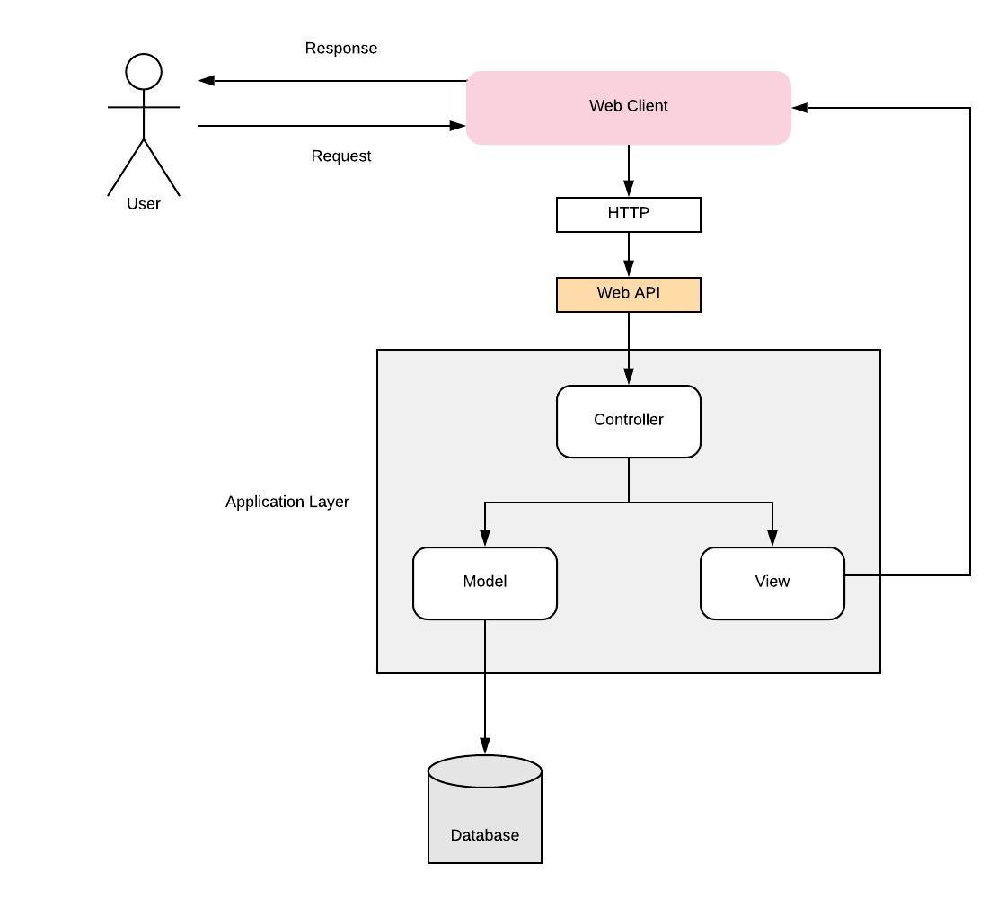

1. **Your technology selection and a brief explanation for your selection.**

For this system, I suppose to use the Laravel framework as the backend and Vue JS as the frontend.

The Laravel framework provides following advantages to application.

* **High security**

Laravel framework capable of providing high security to the application. It is not allowed to malware activities, security threats in web application.

* **Authentication system**

Laravel has a smooth, comfortable and powerful authentication system. It allowed authenticating API calls using libraries such as Passport.

* **Developer friendly coding**

Laravel has inbuilt libraries, packages, tools to make developments easier.

* **A well-known and open-source framework**

Laravel is an open-source, powerful and well-known framework in the world.

* **MVC Architecture**

Model-view-controller architecture provides built-in functionalities that the developer best uses of when developing an application. And it improves the performance of the application.

Based on the above factors, I chose the Laravel framework as backend.

Vue Js is small in size, Lightweight library, Faster than regular HTML. It compatible with the Laravel rather than react or angular. And it is a futuristic library. That’ why I suppose to use Vue Js.

1. **Sequence diagram**

