
YouTube link: YouTube. https://www.youtube.com/watch?v=JLiF7gZ2rjo
Individual Project (Flymandu)
Salin Khadka
BSc. (Hons) Computing, Softwarica College of IT and E-commerce, Coventry University
ST5007CEM Web Development
Hari Sharan Shrestha

Introduction
Flymandu is a state-of-the-art online platform designed to simplify the process of booking flights with various airlines. With a focus on intuitive user experience and seamless integration, Flymandu provides a comprehensive solution for both travelers and airlines. The platform, built using React for the frontend and a robust Spring Boot backend, ensures a smooth and secure booking experience for all users.
Flymandu offers a range of features to enhance the travel booking process. Users can easily search for flights, view detailed information, and make bookings with a few simple clicks. The platform supports a variety of airlines, providing users with numerous options to suit their travel needs. For administrators, Flymandu provides tools to manage and update flight information effortlessly.
One of the standout features of Flymandu is its streamlined booking management system, which allows users to track and manage their bookings with ease. The platform also includes an integrated notifications system, keeping users informed about their booking status and any important updates.
Flymandu is dedicated to delivering a user-centric experience. The platform promotes efficient flight management and offers a seamless interface for booking and tracking flights. Whether you are planning your next trip or managing flight details, Flymandu provides a reliable and enriching experience for all travelers.

Aim
To create a dynamic and user-friendly platform for booking flights, connecting travelers with a diverse range of airlines. By offering a streamlined booking experience, robust flight management tools, and interactive features, Flymandu aims to enhance the convenience and efficiency of air travel. Our goal is to foster a community of informed travelers who can easily search for, book, and manage their flights, while benefiting from an engaging and supportive travel ecosystem.

Objectives
- Seamless Flight Search and Booking: Provide a user-friendly interface for searching and booking flights across various airlines, ensuring a smooth and efficient booking experience.
- Comprehensive Flight Management: Enable users to view, manage, and track their flight bookings with ease, including options to modify or cancel reservations as needed.
- Admin Tools: Equip administrators with robust tools for managing flight information, approving bookings, and overseeing the overall operation of the platform.
- User Profile Management: Allow users to create and manage profiles, storing relevant personal and travel information for a more personalized experience.
- Enhanced Security: Ensure the security and privacy of user data and transactions through robust backend protection and secure data handling practices.
- Responsive Design: Develop a responsive design that provides a consistent and user-friendly experience across various devices and screen sizes.
- Community Engagement: Foster a community of travelers by providing features that encourage interaction, feedback, and sharing of travel experiences.

Learning Outcomes
By working on the Flymandu project, you will achieve several key learning outcomes. You'll gain valuable experience in enhancing user experience design through React, focusing on creating intuitive and engaging interfaces. You'll also develop advanced backend skills using Spring Boot, including managing API endpoints, user authentication, and data handling. Implementing interactive features, such as chatbots and real-time notifications, will deepen your understanding of enhancing user engagement and providing personalized support.
Additionally, you'll learn about the complexities of flight management systems, from booking processes to administrative tools. You'll acquire knowledge in implementing security best practices to protect user data and ensure secure transactions. Mastering responsive design principles will enable you to create a seamless experience across various devices.
Experience in database management will be gained by designing and managing systems for efficient storage of flight, booking, and user data. You'll enhance your problem-solving and debugging skills by addressing development challenges and integrating APIs. The project will also develop your project management abilities, including version control and collaboration. Lastly, incorporating user feedback into the development process will help you continually improve the platform and adapt to user needs, preparing you for future projects and professional opportunities.

Features Included in the system

User Login for Admin and User:
Description: The Flymandu platform features a dual login system that caters to two primary user roles: Admins and Users. This separation ensures that each role has access to specific functionalities and features tailored to their needs.
- User Login:
Purpose: Allows regular users to log in and access features such as flight search, booking management, and personal account settings.Access Rights: Users can search for flights, make bookings, view and manage their reservations, and receive real-time notifications about their bookings.
- Admin Login:
Purpose: Provides administrators with access to the backend of the platform, where they can manage flight information, oversee booking approvals, and perform administrative tasks.Access Rights: Admins can add, update, and delete flight listings, approve or reject bookings, and view comprehensive reports on user activity and system performance.

This dual login system ensures that each user type has access to the appropriate tools and features, enhancing both security and functionality by restricting access based on user role.
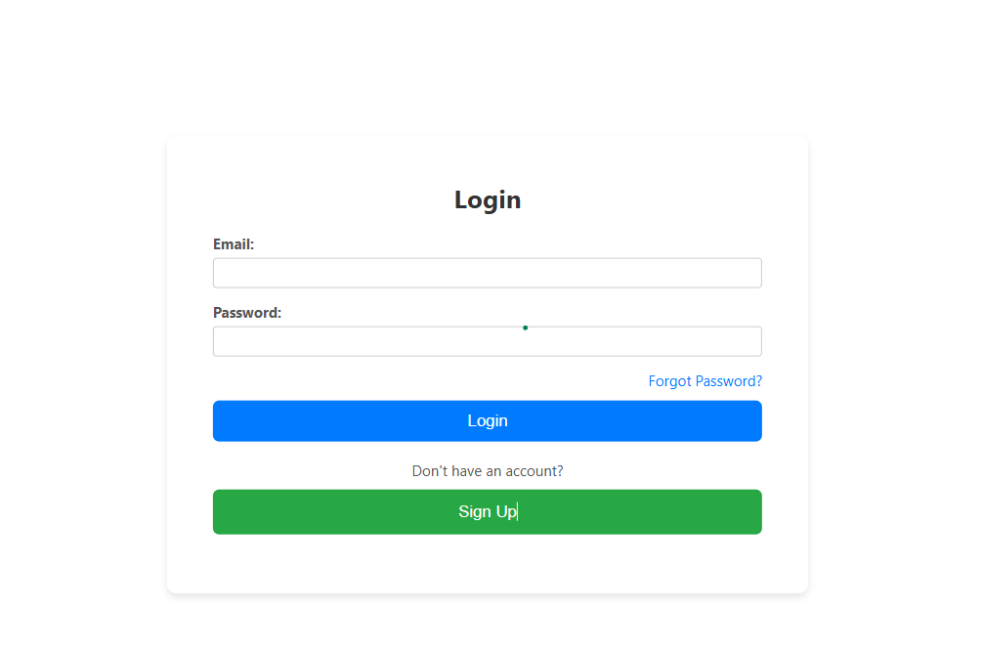
Figure 1LoginPage

User Registration:
The Flymandu platform includes a comprehensive user registration system that allows new users to create accounts and access personalized features based on their roles. The registration process is designed to be simple and secure, ensuring a smooth onboarding experience for both general users and administrators.
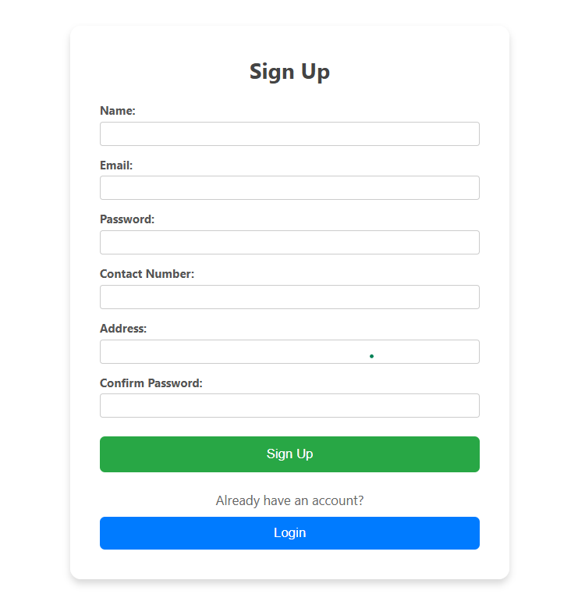
Figure 2SIgnupPage

Homepage:
The Flymandu homepage is designed to provide users with an engaging and intuitive introduction to the platform. At the top of the page, the navbar is prominently displayed, offering a fixed and accessible menu that includes links to key sections such as Home, Flights, My Bookings, Profile, and Help. For admins, a dedicated link to the Admin Dashboard is also available. The navbar features the Flymandu logo, which serves as a clickable link back to the homepage, and includes a login/logout button that adapts based on user authentication status.
The introduction section on the homepage provides a warm welcome to Flymandu, highlighting the platform’s primary features and benefits. It includes an interactive search bar that enables users to begin their flight search immediately. This section briefly explains how users can search for flights, manage their bookings, and utilize the integrated chatbot for personalized assistance. Additionally, it offers insights into community engagement opportunities, such as providing feedback and exploring user interactions.
At the bottom of the page, the footer ensures users have easy access to important information and resources. It contains contact details, links to the privacy policy, terms of service, and an about us section, along with social media icons for connecting with Flymandu on various platforms. A newsletter signup option is also available for users to receive updates and news about the platform. The footer is fixed at the bottom of the page, maintaining its visibility and accessibility across different sections of the website.
Overall, the homepage is designed with a responsive layout to provide a consistent experience across devices, featuring a visually appealing design that includes high-quality images, clean typography, and a cohesive color scheme. Accessibility features ensure that all users can navigate the site effectively, making the Flymandu homepage both functional and inviting.
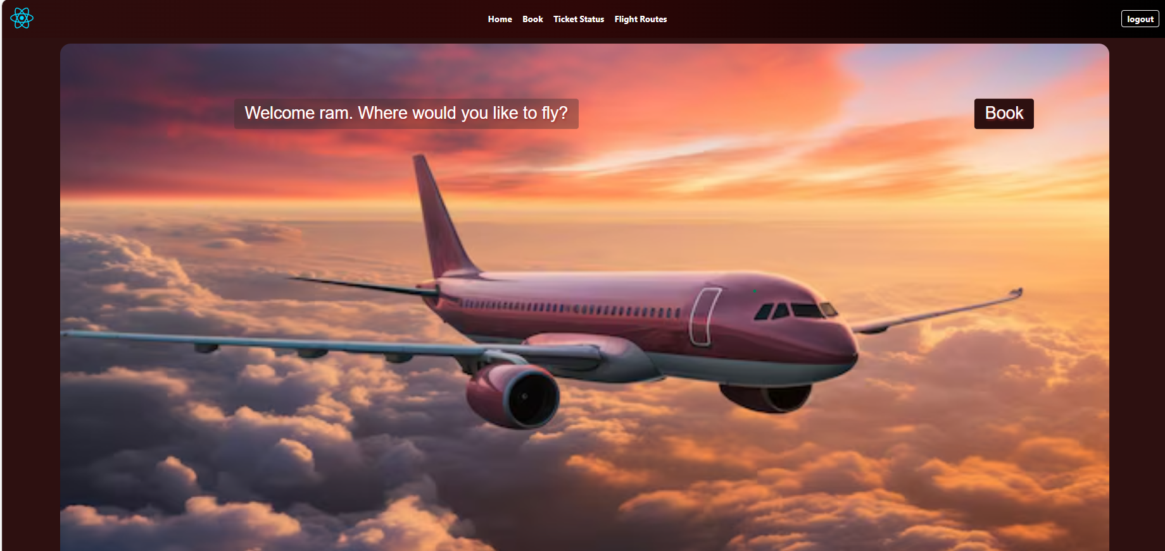
Figure 3Homepage1
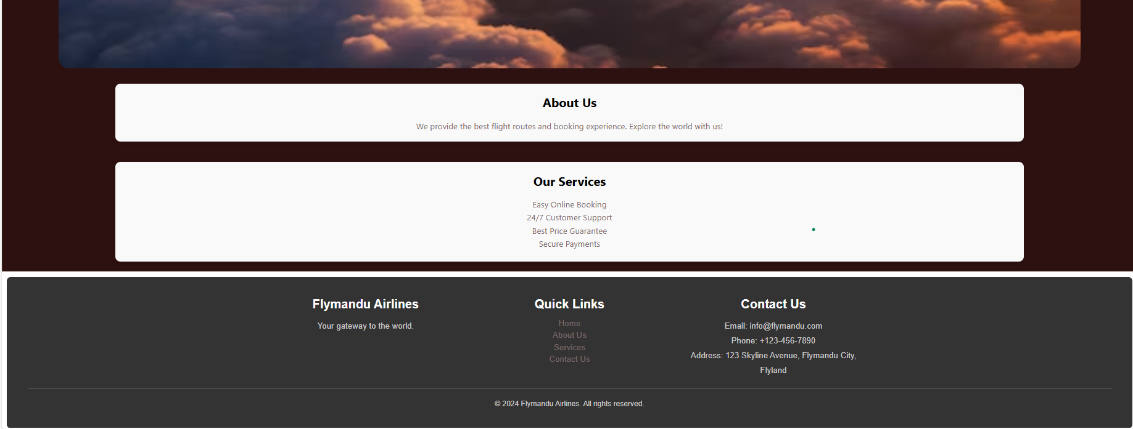
Figure 4Homepage2

