PHONEBOOK MANAGEMENT SYSTEM

Group Number: 8
Name of the Group Members:
SALIQ GOWHAR (211AI043)
ASHUTOSH GUPTA (211AI008)
BHAVYA (211AI011)
ADITI SINGH (211AI004)
K RITVIK (211AI022)

What is the Problem?
(150-200 words approx.)

We as humans have this natural tendency to communicate with new people every day and we always try to grow our social networks and our friend circles, hence developing a very basic need to have an effective management and storage of all our contacts containing some necessary information including phone numbers, emails, and addresses in a single place. It becomes a necessity to effectively develop such a phonebook which is capable of performing all the basic operations like searching, updating, deletion, and addition of contacts in the least possible time and auxiliary space and capable of providing other advanced features like making a call, maintaining a log and sending messages. To achieve this, it is mandatory to make use of the best possible data structure given the fact that the aim can be achieved through various data structures each having their own merits as well as demerits. We need to choose or create a data structure in a way that it provides the least possible time as well as space complexity for all the operations and features or at least for most of them.

What is the Possible Solution?
(Minimum 150 words or more, include figures and tables if needed)

Everyone in present times uses the contacts application already installed on our gadgets be it mobile phones, laptops, or tablets which we use for fulfilling our day-to-day communication needs and also for the storage of all our contacts and necessary details in a single place. These pre-installed contacts application is implemented in such a way that they are capable of performing all the specified tasks in the most effective way possible. Our aim in this project was to create the very backend of this contacts application and implementing a system which is capable of replicating all the features present in the contact application, and also implementing it in a way that all the data structures used for various features are chosen in a way that we are able to achieve the best-case time and space complexities possible. We were able to create a system similar to the contacts application which is already the best possible solution available for the problem and we were also able to add a new feature i.e. merging the Call Log with our phonebook, adding to the efficiency of the system as well as helping the user in time management and reducing the dependency of the user on another Call application to check their call logs.
Which Data Structure to Use for the Solution (Details of the Data Structure)
(Minimum 150 words or more, include figure and tables if needed)

Even though the solution is achievable using multiple data structures like generic trees, doubly linked lists, and arrays, but in order to achieve the best solution we have used the following:

- Red Black Tree:
For the creation of the phonebook, we have used ordered maps which are a key value pair and both the key as well as the value can be of any type and these can store the data in a sorted manner based on their keys. Maps are available in the standard template library of C++ whose implementation is based on Red-Black trees. A Red-Black tree is a kind of self-balancing binary search tree (absolute value of the difference between the height of left subtree and right subtree is less than or equal to 1) where each node has an extra bit, and that bit is often interpreted as the color (red or black). These colors are used to ensure that the tree remains balanced during insertions and deletions. Every node is coloured either red or black. Root and leaves are black. Since most of the operations in a self-balancing binary search tree such as Red Black Tree is O(h) where h is logn, it is preferably the best data structure for the problem. It stores all our contacts in a sorted manner and along with the rich functions provided by STL, it becomes extremely easy to perform various operations on them.

- Vectors:
For the implementation of the Call Log and to store the numbers of various contacts, we have used Vectors. Vectors are the same as dynamic arrays with the ability to resize itself automatically when an element is inserted or deleted, with their storage being handled automatically by the container. Vector elements are placed in contiguous storage so that they can be accessed and traversed using iterators. In vectors, data is inserted at the end. Inserting at the end takes differential time, as sometimes the array may need to be extended. Removing the last element takes only constant time because no resizing happens. Inserting and erasing at the beginning or in the middle is linear in time.

- Others:
Some other data structures that we have used are strings which is a class in C++ used for storing a sequence of characters, which we have used for general email and name storages and nodes which are objects of a user defined data storage classes which we have used for general purpose contact storages in our phonebook.

Justify Why This is the Best Data Structure for this Application?
(Minimum 150 words or more, better to list the justifications point-wise, include figure and tables if needed)

The solution could have been achieved using other data structures as well including Doubly Linked Lists, Generic Trees, and Binary search trees in general, but we have specifically used ordered maps (RBT implementation) due to the following reasons:

- Time complexity: The time complexities for searching, updating, and deleting in a RBT is O(logn), and no other data structure is capable of providing the time complexities for all three operations other than AVL Trees. The reason behind not considering an AVL tree or any other self-balancing tree over a RBT were:
- Complex implementation where as RBT being available as a map in STL.
- For RBT, re-balancing operation is O (1) while the same is O(logn) for an AVL tree, hence making RBT more efficient as compared to AVL trees.

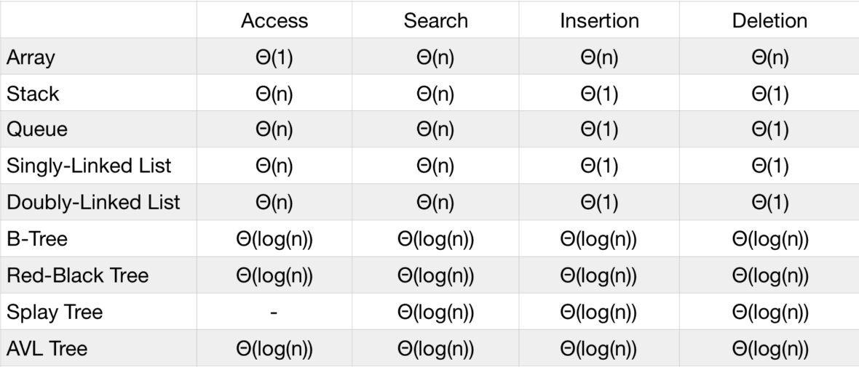

- Sorted Storage of contacts: Even though the use of Hash Tables could have given us O (1) complexities but the primary reason for not using a Hash Table for the storage of our data was that we needed to store and display the contacts in a sorted manner on the basis of their contact names, which just in case had we stored in a Hash Table, we would be required to sort the contacts, hence increasing our time complexity to O(nlogn) with internal comparisons having time complexity of O(L) with L being the length of the shorter string. Considering the sorting aspect we could have even used a priority queue but that would come at the cost of our primary three operations being O(N).

Implementation Details (Experimental Setup)
(150-200 words approx.)

- Implementation of Phonebook:
We have started by creating a node to store the details of our contacts which contain the numbers and the email of the contact, followed by creating a class named phonebook for our phonebook system which contains a map with key equal to the name of the contact and value equal to the node corresponding to the contact. This class has a constructor which initializes our phonebook with the contacts of all the project members. The user is asked to choose a number based on the desired operation. The complete list of operations available are as under:

- Search a contact:
The user is given the flexibility to search by name, email or number and is asked to enter a number corresponding to their choice. The existence of the contact is checked, if it is absent a message is displayed else the key i.e. the name is generated using different functions as the easiest identifying factor is the name of the contact, and then the value corresponding to the key is displayed on the output window. E.g. If the user decides to search the contact using the number, a function getKeyByNumber() is called with the number entered being the parameter and which in turns return the name of the corresponding contact. The same process is repeated for searching with email.
- Display all contacts:
Function call is made to the displayALL() function which creates an iterator pointing to the beginning of the map and which prints all the contacts iteratively with O(n) time complexity.
- Add a new contact:
The user is asked to enter the name of the contact and a function checkExistence() is called to check if the contact already exits or not. If it exists then the user is asked whether they want to update the contact or not, else they are asked for the number and email corresponding to the new contact and the contact is added to the phonebook.
- Delete a contact:
The user is given the flexibility to search by name, email or number and is asked to enter a number corresponding to their choice. The existence of the contact is checked, if it is absent a message is displayed else the key i.e. the name is generated, and sent to a function deleteByKey() which deletes the contact and updates the phone book.
- Update a contact:
The user is asked to enter the name and the update function is called where the user is given four options and the desired action is performed:

- To change name.
- To change email.
- To change number.
- To add a new number.

- Implementation of Call Log:
We have created a log node which will store the name, number and time/date of the call made to a contact. The user is given multiple option to make a call and they can make a call via name, number, email or even call a random number. For any option chosen the among the first three, the key is generated and the callByKey() function is called, which virtually make a call and creates a node consisting of the name, number, time, and date of the call and which is pushed into the vector array. For making a call to a random number, a node is created with the same details and pushed into the vector array. This vector array acts as our call log and has two operations:
- Display call log.
- Clear call log.
Multiple other features can be added but we have implemented the most primary features for now.
Complexity/Performance Analysis
(100 words approx.)

- For the phonebook, searching, deleting, updating, and inserting contacts is O(logn) considering the user is doing it via the name of the contact, as name of the contact is the most frequently used parameter for these operations in a phonebook, but if the user is performing these operations via number or email, it is O(n) as we must traverse all the nodes to find the desired number or the email. Since most operations we do in our contacts, is based on the name, we can conclude that the best case and the average case time complexity is O(logn).

- For the call log, since the primary storage is a vector, displaying and clearing the log is O(n) as we need to traverse through each node and making a call is O(logn) similar to the phonebook operations.

Observations and Conclusions
(100 words approx.)

We were able to explore various data structures and learn about their implementations, thus were successfully able to create a working model of a real time phonebook application with many additional features and optimisations in the least complexities possible. We were able to merge the call log inside the phonebook thus removing the need for another application to maintain our logs.
Link to the code: https://github.com/saliq7/Phonebook-Management-System.git

