Android Development

1. Download Java JDK from Oracle site

<https://www.oracle.com/technetwork/java/javase/downloads/jdk11-downloads-5066655.html>

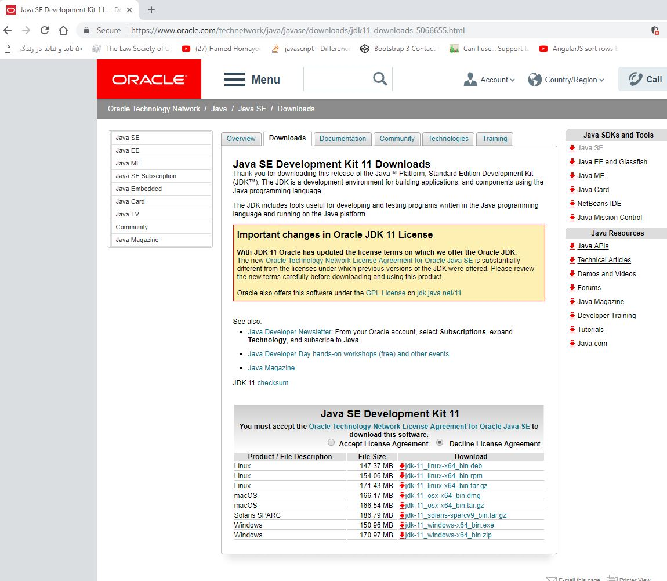

JDK – Java Development Kit

JRE – Java Runtime Environment

How to add an environment variable:

After running the installer, we go to Java folder -> jdk8 and copy the path

Then

System -> Advanced System Settings -> Environment variables -> click “New” button

Variable name is going to be “ JAVA_HOME “

Variable path is going to be “ C:\Program Files\Java\jdk8 “

Now **JAVA JDK** is **installed** and configured

1. Download Android Studio

https://developer.android.com/studio/

when you run your first application, you get an **Error** “ emulator ERROR: k86 emulation currently requires hardware acceleration! “

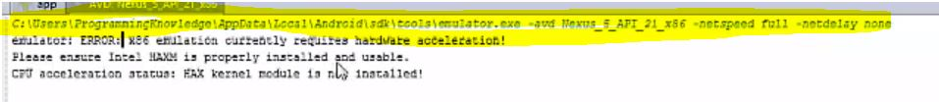

Go to the address on the first line until /sdk then go to the “ extras -> intel -> Hardware_Accelerated_Execution_Manager “ folder and then install “ intelhaxrn-android “

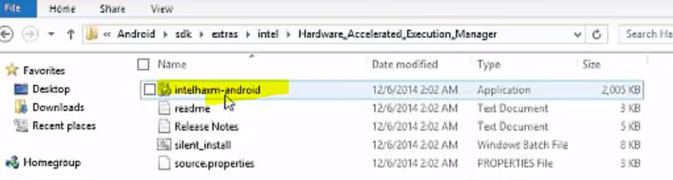

Give it 2G or more memory and then install and finish.

Now install the emulator “ Nexus 5X with API 17 “

“ genymotion “ from “ <https://www.genymotion.com/> “

# Installing the plugin Genymotion

You can install Genymotion plugin for Android Studio:

[[Open](javascript:void(0);)**JetBrains repository method**](javascript:void(0);)

1. Start Android Studio.
2. Go to:
   * **Windows and Linux:** File/Settings.
   * **macOS:** Android Studio/Preferences.
3. Select **Plugins** and click **Browse repositories**.
4. Right-click (double-click for Mac OS X) on **Genymotion**.
5. Click **Download and install** and proceed with the next steps.
6. Restart Android Studio by clicking **Restart**.

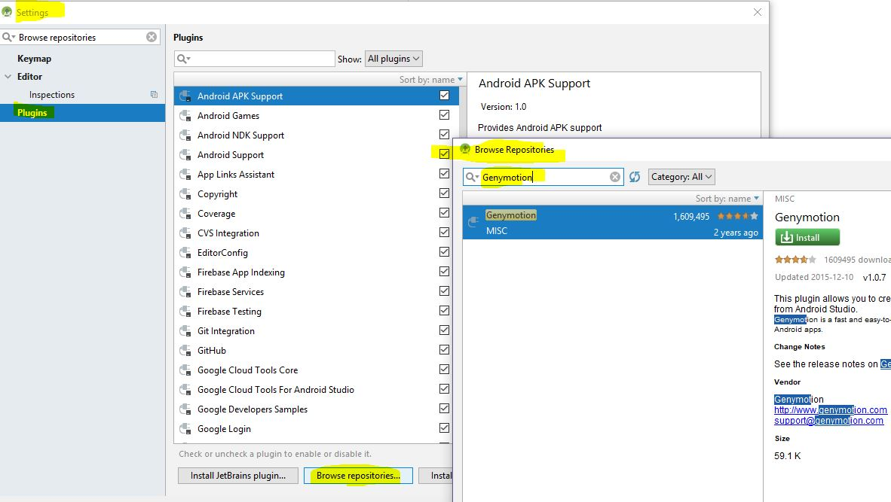

Install Genymotion as plugin

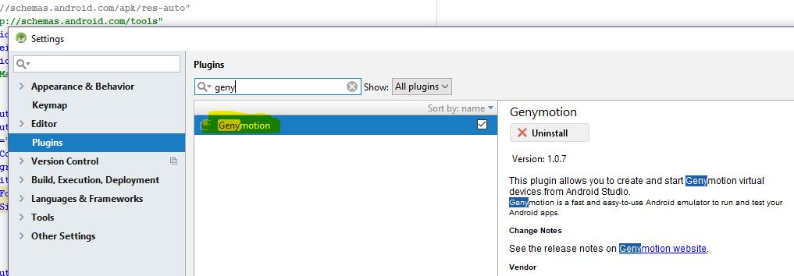

Activity Life Cycle :

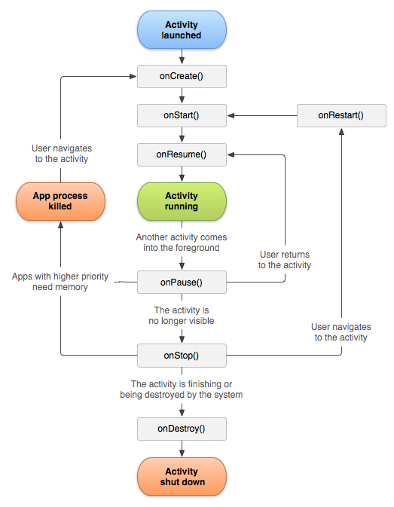

How to activate the lifecycle activities show up

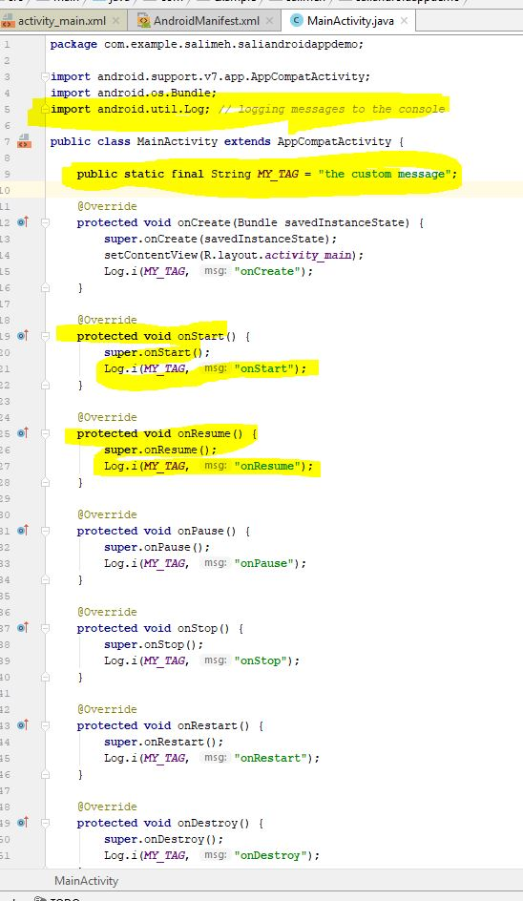

**import** android.util.Log; *// logging messages to the console***public class** MainActivity **extends** AppCompatActivity {  
  
 **public static final** String ***MY_TAG*** = **"the custom message"**;  
  
 @Override  
 **protected void** onCreate(Bundle savedInstanceState) {  
 **super**.onCreate(savedInstanceState);  
 setContentView(R.layout.***activity_main***);  
 Log.*i*(***MY_TAG***, **"onCreate"**);  
 }  
  
 @Override  
 **protected void** onStart() {  
 **super**.onStart();  
 Log.*i*(***MY_TAG***, **"onStart"**);  
 }  
  
 @Override  
 **protected void** onResume() {  
 **super**.onResume();  
 Log.*i*(***MY_TAG***, **"onResume"**);  
 }  
  
 @Override  
 **protected void** onPause() {  
 **super**.onPause();  
 Log.*i*(***MY_TAG***, **"onPause"**);  
 }  
  
 @Override  
 **protected void** onStop() {  
 **super**.onStop();  
 Log.*i*(***MY_TAG***, **"onStop"**);  
 }

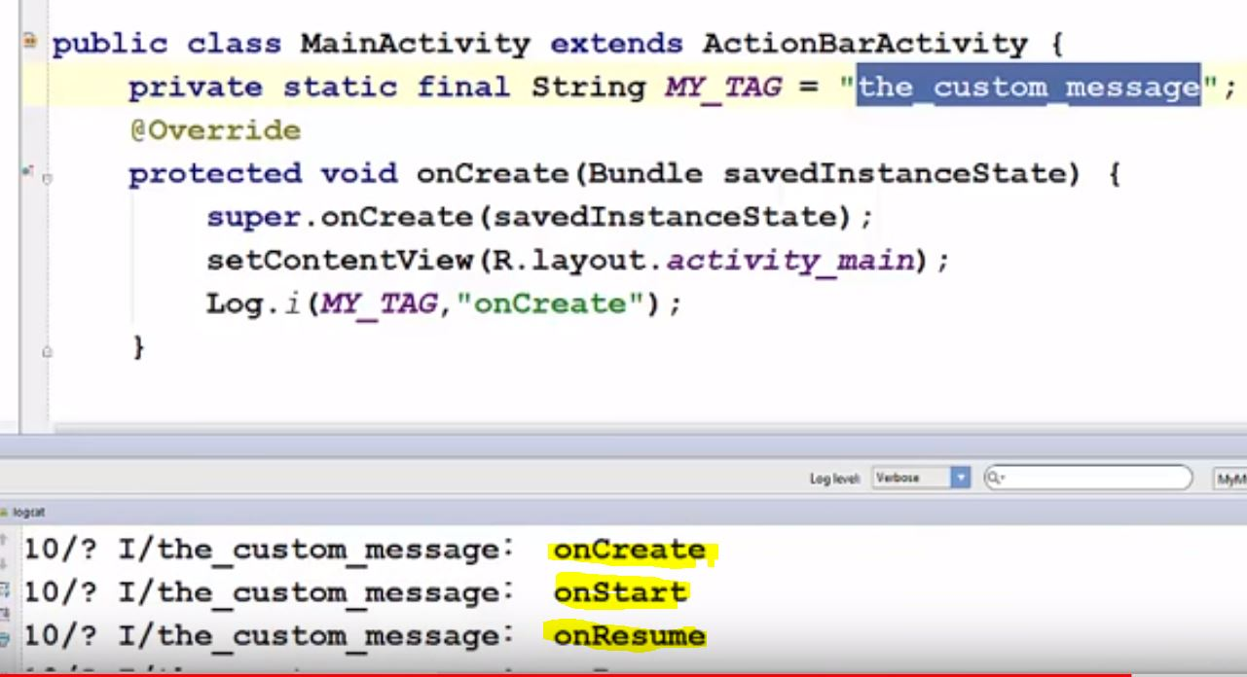

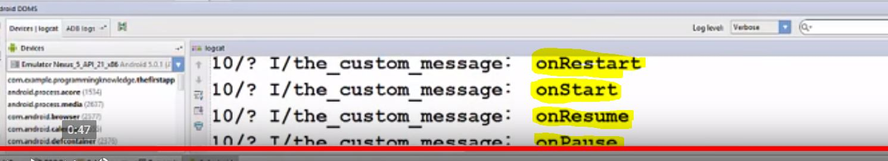

Create a simple calculator:

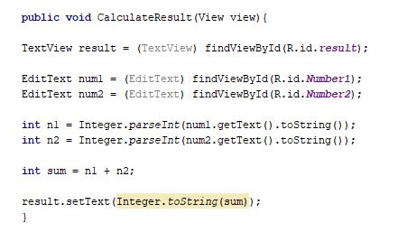

**public void** CalculateResult(View view){  
  
TextView result = (TextView) findViewById(R.id.***result***);  
  
EditText num1 = (EditText) findViewById(R.id.***Number1***);  
EditText num2 = (EditText) findViewById(R.id.***Number2***);  
  
**int** n1 = Integer.*parseInt*(num1.getText().toString());  
**int** n2 = Integer.*parseInt*(num2.getText().toString());  
  
**int** sum = n1 + n2;  
  
result.setText(Integer.*toString*(sum));  
}

How to create a ListView with List Adopter: