**Browser Versions**:

Internet Explorer version: **IE 11**

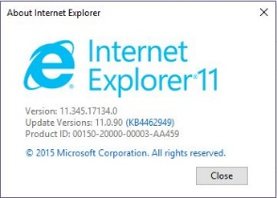

Firefox version: **63.0.1**

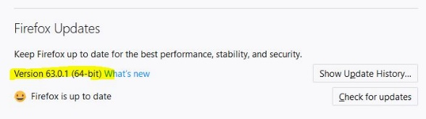

Google Chrome version: **70.0.3538**

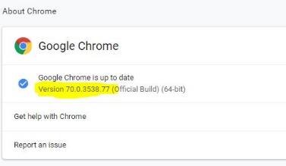

<http://myvmlab.senecacollege.ca:6311/contactus>

1. There is a big blank space in the middle of page in small screen size

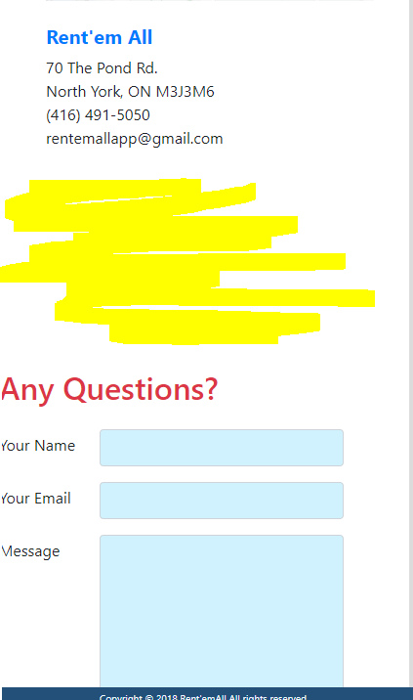

1. Contact form needs to receive some margin on the left side in the small screen sizes

