**Browser Versions**:

Internet Explorer version: **IE 11**

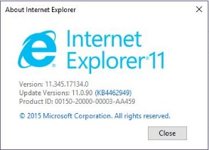

Firefox version: **63.0.1**

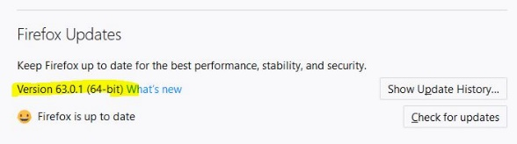

Google Chrome version: **70.0.3538**

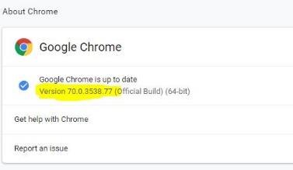

<http://myvmlab.senecacollege.ca:6311/faq>

1. Accordions text does not wrap properly in the small screen sizes. In fact, they break the page

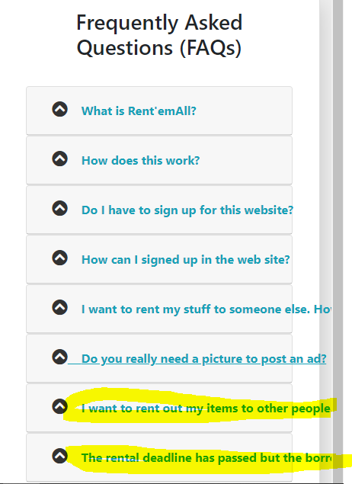

1. FAQ images inside accordions do not properly adhere to sizing break points.

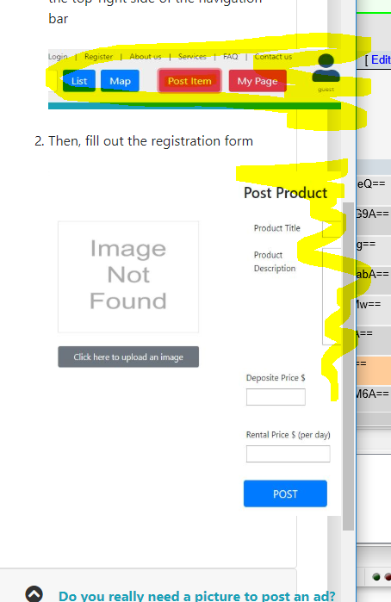

1. The last accordion does not work as expected.

