**Browser Versions**:

Internet Explorer version: **IE 11**



Firefox version: **63.0.1**

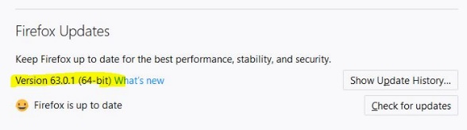

Google Chrome version: **70.0.3538**

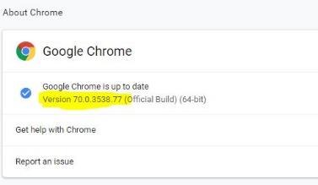

<http://myvmlab.senecacollege.ca:6311>

1. Our website is responsive based on the screen sizes but for some issues which is probably caused by the main header the web pages slightly break and cause scroll bar at the bottom of the page

The scrollbar is happening in all the pages, regardless of page content since is caused by common components call to the pages.



1. Website’s logo needs to be coded as a responsive image. At the moment, it covers other page contents in the small screen sizes and it is interfering with other components functionalities.



1. Hamburger button on the small screens displays some margin issues for its content link items.

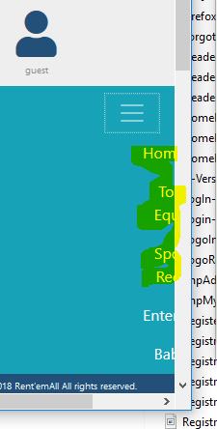

1. On the hand hold devices screen sizes, the main navigation bar has some alignment issues.

