<http://myvmlab.senecacollege.ca:6311/register>

**Browser Versions**:

Internet Explorer version: **IE 11**

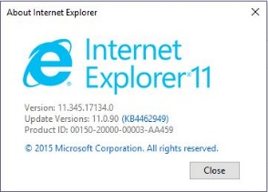

Firefox version: **63.0.1**

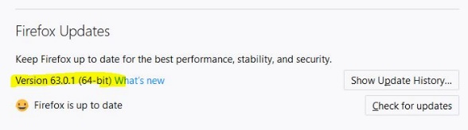

Google Chrome version: **70.0.3538**

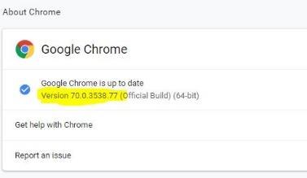

phpMyAdmin at start of testing:

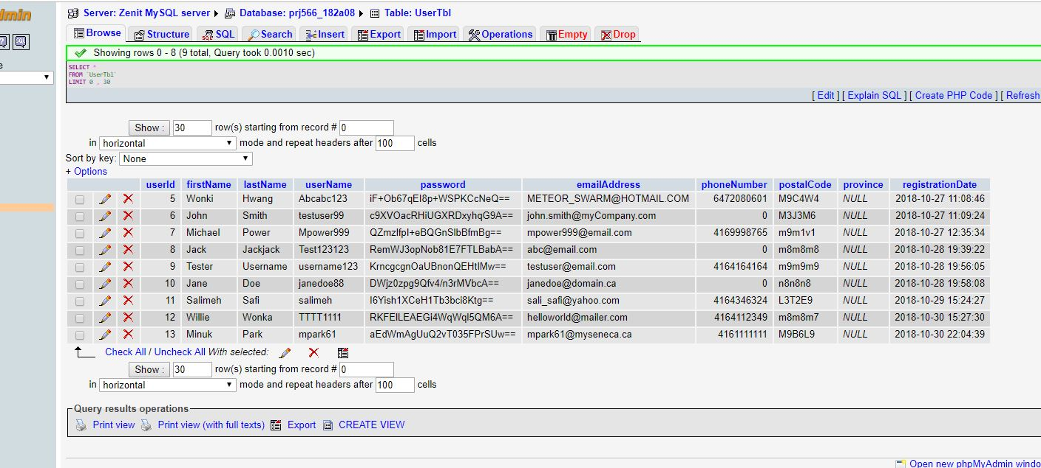

In Chrome browser:

* Registration form does not register a new user – page tries to connect to myvmlab…

but it gives error after a few minutes

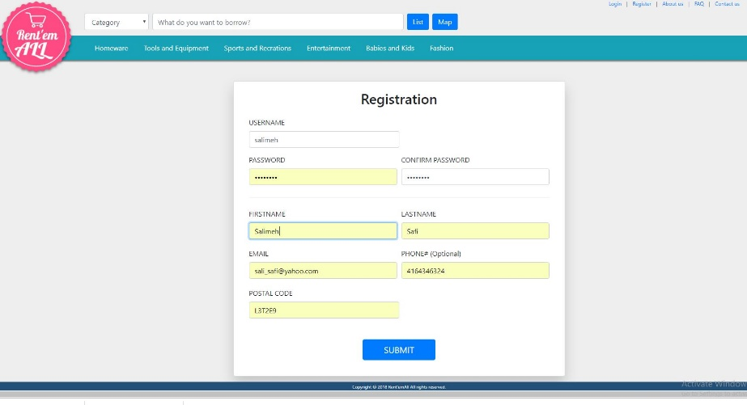

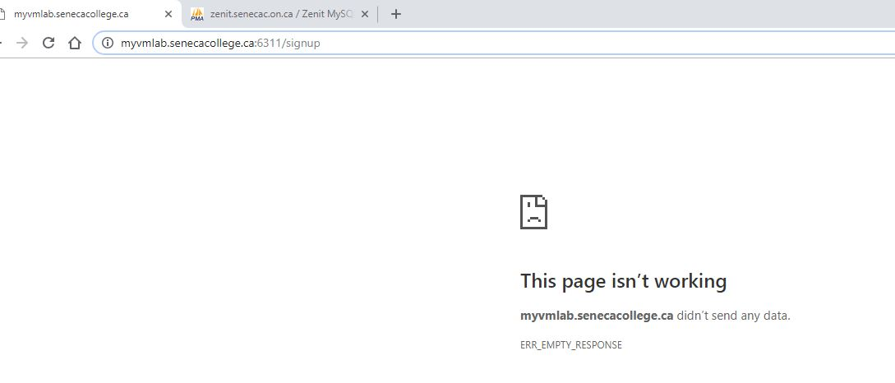

In Internet Explorer and Firefox:

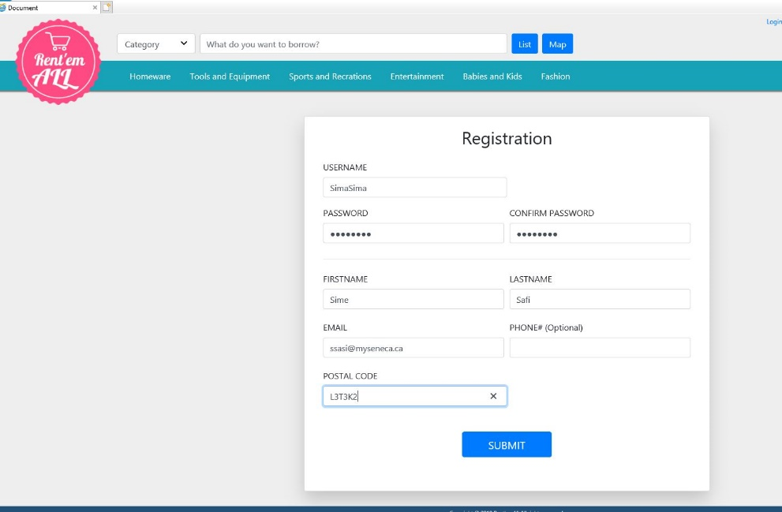

Page quickly redirects to the Login page but the new user is not getting registered in the database

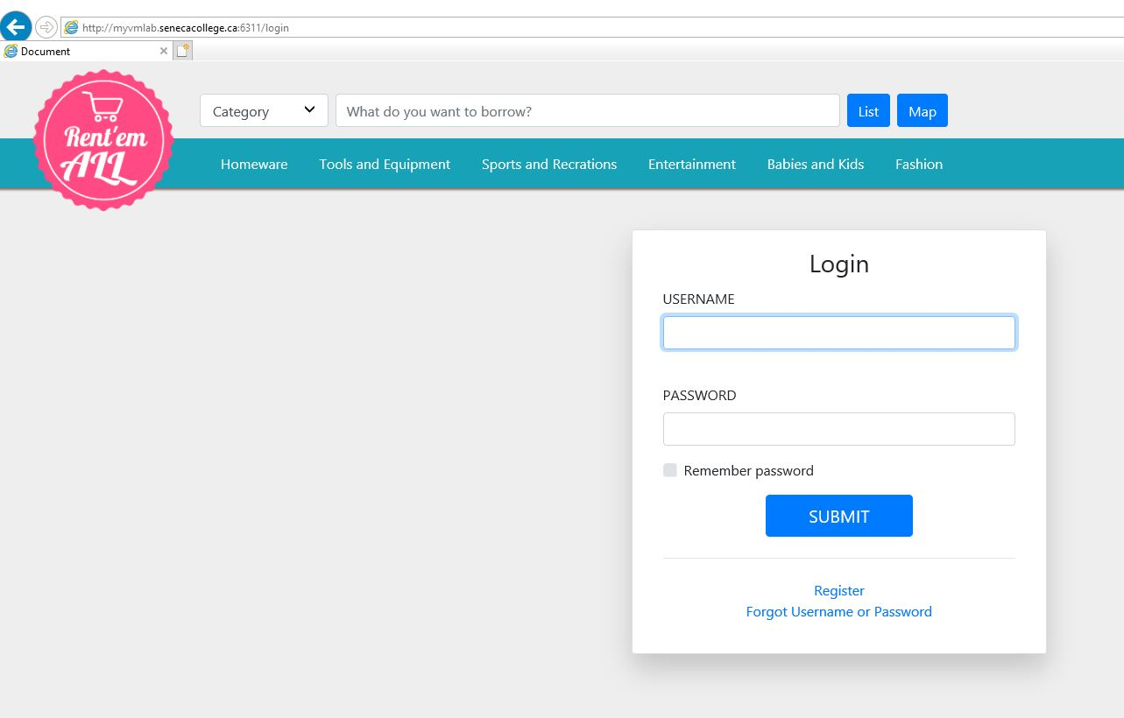

phpMyAdmin at the end of testing:

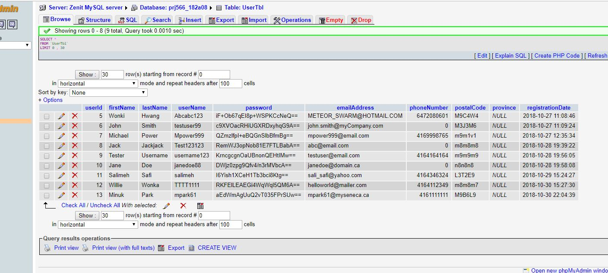

Problem:

No new user got registered