<http://myvmlab.senecacollege.ca:6311/register>

**Browser Versions**:

Internet Explorer version: **IE 11**

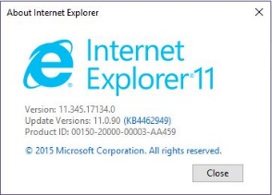

Firefox version: **63.0.1**

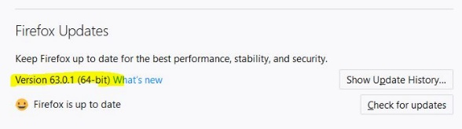

Google Chrome version: **70.0.3538**

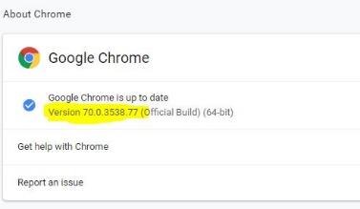

Inside the Registration form, we need to track user’s Province as well as Postal Code. Therefore, the Province << dropdown menu >> must be added to the registration form.

* Dropdown component assure us that the user is from inside Canada and not foreign.

At this moment Province is not << NOT NULL >> which is better to change and be considered as

<< NOT NULL >>

phpMyAdmin:

