**DBS501 ASSIGNMENT ONE GROUP 8**

**Q1:**

SET SERVEROUTPUT ON;

SET VERIFY OFF;

ACCEPT city PROMPT 'Please provide the valid city without department: '

DECLARE

v_department departments%ROWTYPE;

v_one_department BOOLEAN;

v_many_department BOOLEAN;

v_no_city BOOLEAN;

v_location departments.location_id%TYPE;

v_dept_count NUMBER(3);

BEGIN

SELECT location_id INTO v_location

FROM locations

WHERE city = '&city';

SELECT COUNT(*) INTO v_dept_count

FROM departments

WHERE location_id = v_location;

IF v_dept_count = 1 THEN

DBMS_OUTPUT.PUT_LINE('This city already contains department: ' || '&city');

ELSIF v_dept_count > 1 THEN

DBMS_OUTPUT.PUT_LINE('This city has MORE THAN ONE department: ' || '&city');

ELSE

SELECT MAX(department_id) + 50 INTO v_department.department_id

FROM departments;

SELECT manager_id INTO v_department.manager_id

FROM employees

GROUP BY manager_id

HAVING count(manager_id) = ( SELECT MAX(COUNT(manager_id))

FROM employees

GROUP BY manager_id);

v_department.department_name := 'Testing';

v_department.location_id := v_location;

INSERT INTO departments VALUES v_department;

END IF;

EXCEPTION

WHEN no_data_found THEN

DBMS_OUTPUT.PUT_LINE('This city is NOT listed: ' || '&city');

END;

/

SELECT * FROM departments WHERE department_name = 'Testing';

ROLLBACK;

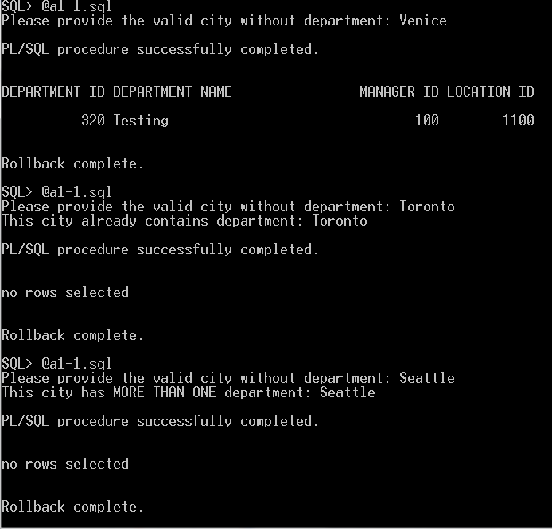

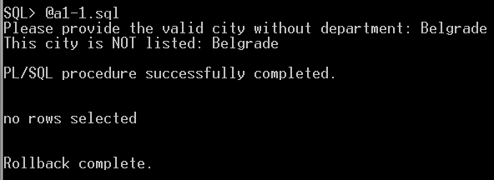

**Q2:**

ACCEPT course_desc PROMPT 'Enter the beginning of the Course Description in UPPER case: '

DECLARE

v_description varchar(50):='&course_desc';

cursor course_c1 is

select course_no from course

where upper(description) like v_description||'%';

cursor section_c1 is

select section_id from section

where course_no in (select course_no from course

where prerequisite in (select course_no from course

where upper(description) like v_description||'%'))

order by section_id;

v_count number;

v_section section_c1%rowtype;

v_course course_c1%rowtype;

v_flag char(1):='y';

e_manyStudent EXCEPTION;

begin

open course_c1;

fetch course_c1 into v_course;

if course_c1%NOTFOUND then

DBMS_OUTPUT.PUT_LINE('There is NO VALID course that starts on: '||v_description ||'. Try again.');

v_flag :='n';

close course_c1;

end if;

if v_flag='y' then

open section_c1;

fetch section_c1 into v_section;

if section_c1%NOTFOUND then

DBMS_OUTPUT.PUT_LINE('There is NO PREREQUISITE course that starts on:'|| v_description||'. Try again.');

close section_c1;

else

close section_c1;

for section_ind in section_c1 loop

begin

select count(*) into v_count

from enrollment

where section_id=section_ind.section_id;

if v_count>=7 then

raise e_manyStudent;

else

DBMS_OUTPUT.PUT_LINE('There are '||v_count ||' students for section ID '||section_ind.section_id);

end if;

EXCEPTION

when e_manyStudent then

DBMS_OUTPUT.PUT_LINE('There are too many students for section '||section_ind.section_id);

DBMS_OUTPUT.PUT_LINE('^^^^^^^^^^^^^^^^^^^^^^^^^^^^^^^^^^');

end;

end loop;

end if;

end if;

end ;

/

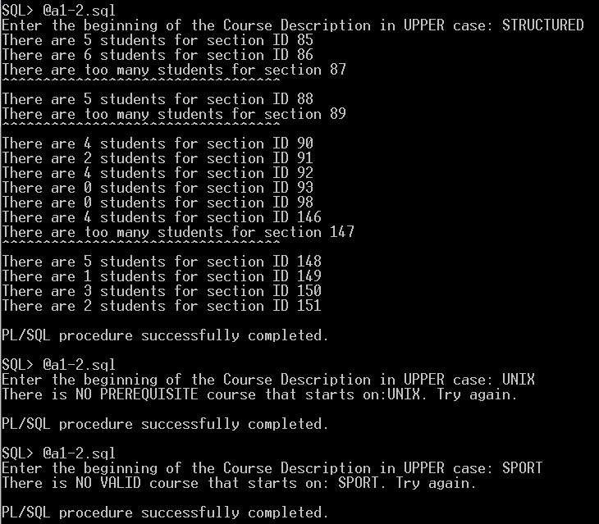

**Q3:**

SET SERVEROUTPUT ON;

SET VERIFY OFF;

accept desc prompt 'Enter the beginning of the Course description in UPPER case: '

declare

desc_input varchar(50) :='&desc';

cursor c1 is

select course_no, description, cost, prerequisite

from course

where upper(description) like upper(desc_input)||'%';

type pre_rec_type is record(

pre_course_no course.course_no%type,

pre_description course.description%type,

pre_cost course.cost%type);

type course_rec_type is record(

course_no course.course_no%type,

description course.description%type,

cost course.cost%type,

pre_rec pre_rec_type);

pre_rec pre_rec_type;

course_rec course_rec_type;

Begin

open c1;

fetch c1 into course_rec.course_no, course_rec.description, course_rec.cost, course_rec.pre_rec.pre_course_no;

if c1%NOTFOUND then

dbms_output.put_line('There is NO VALID course that starts on: '||desc_input||'. Try again.');

close c1;

else

close c1;

for ind in c1 loop

course_rec.course_no:=ind.course_no;

course_rec.description:=ind.description;

course_rec.cost:=ind.cost;

course_rec.pre_rec.pre_course_no:=ind.prerequisite;

begin

select description, cost into course_rec.pre_rec.pre_description, course_rec.pre_rec.pre_cost

from course

where course_no =course_rec.pre_rec.pre_course_no;

dbms_output.put_line('Course: '||course_rec.course_no||' - '||course_rec.description);

dbms_output.put_line('Cost: '||course_rec.cost);

dbms_output.put_line('Prerequisite: '||course_rec.pre_rec.pre_course_no||' - '||course_rec.pre_rec.pre_description);

dbms_output.put_line('Prerequisite Cost: '||course_rec.pre_rec.pre_cost);

dbms_output.put_line('=========================================================');

exception

when NO_DATA_FOUND then

dbms_output.put_line('There is NO prerequisite course for any course that starts on '||upper(desc_input)||'. Try again. ');

end;

end loop;

end if;

end;

/

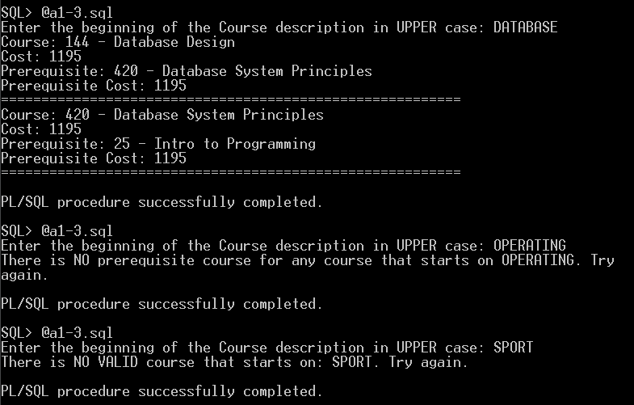

**Q4:**

SET SERVEROUTPUT ON;

SET VERIFY OFF;

ACCEPT firstEnSearch PROMPT 'Enter your first program key word '

ACCEPT secondEnSearch PROMPT 'Enter your second program key word '

DECLARE

CURSOR course_cl IS SELECT course_no, description from course

WHERE UPPER(description) LIKE UPPER('%' || '&firstEnSearch' ||'%') AND UPPER (description) LIKE UPPER('%' || '&secondEnSearch' || '%');

CURSOR section_cl(p_course NUMBER) IS

SELECT section_id ,section_no FROM section WHERE course_no = p_course;

CURSOR studEnr(p_section NUMBER) IS

SELECT COUNT(*) cont FROM enrollment WHERE section_id = p_section;

v_course course_cl%ROWTYPE;

checker course_cl%ROWTYPE;

v_section section_cl%ROWTYPE;

studentsEnrolled NUMBER(5);

BEGIN

OPEN course_cl;

FETCH course_cl into checker;

IF course_cl%NOTFOUND THEN

DBMS_OUTPUT.PUT_LINE('There is NO course containing these 2 words. Try again.');

CLOSE course_cl;

ELSE

CLOSE course_cl;

for course_ind in course_cl LOOP

v_course.course_no :=course_ind.course_no;

v_course.description := course_ind.description;

DBMS_OUTPUT.PUT_LINE (v_course.course_no || ' ' || v_course.description || CHR(10)||

'**************************************');

for section_ind in section_cl(v_course.course_no) LOOP

for student_ind in studEnr(section_ind.section_id) LOOP

studentsEnrolled:=student_ind.cont;

if studentsEnrolled>0 then

DBMS_OUTPUT.PUT_LINE ('Section: ' || section_ind.section_no || ' has an enrollment of: ' || studentsEnrolled);

end if;

end loop;

end loop;

end loop;

END IF;

END;

/

