DBS501, FALL 2018, ASSIGNMENT ONE, due on Friday, Oct 19th by 3pm
Submit your PRINTOUT of 4 CODE solutions and e-mail the same with the ATTACHMENT

1) Write the PL/SQL block that will add a new row to the Departments table like shown:
Department_id → Highest value of all Id’s increased by 50
Department_name → Testing
Manager_id → One with most people under supervision (do NOT assume it is a President, prove it with the code)
Location_id → You will be asked to input the City name where you want to place your new department. And that value will be converted to its related Location_id.
You will then display that new row and later undo the insert.
Your input value should be a VALID city name without any department. You need also to code for following cases: There is already ONE department in that city, there is MORE THAN ONE department there and the city is NOT listed in the Locations table.
You do NOT need to use cursor for this question, Here are the outputs:

Top of Form
Please provide the valid city without department: |  | 

DEPARTMENT_ID | DEPARTMENT_NAME | MANAGER_ID | LOCATION_ID
320 | Testing | 100 | 1100
Rollback complete.
Top of Form
Please provide the valid city without department: |  | 

This city already contains department: Toronto
PL/SQL procedure successfully completed.

no rows selected
Rollback complete.

Top of Form
Please provide the valid city without department: |  | 

This city has MORE THAN ONE department: Seattle
PL/SQL procedure successfully completed.
no rows selected
Rollback complete.

Top of Form
Please provide the valid city without department: |  | 

This city is NOT listed: Belgrade
PL/SQL procedure successfully completed.
no rows selected
Rollback complete.

SET SERVEROUTPUT ON;
SET VERIFY OFF;

ACCEPT city PROMPT 'Please provide the valid city without department: '

DECLARE
v_department departments%ROWTYPE;
v_one_department BOOLEAN;
v_many_department BOOLEAN;
v_no_city BOOLEAN;
v_location departments.location_id%TYPE;
v_dept_count NUMBER(3);

BEGIN
SELECT location_id INTO v_location
FROM locations
WHERE city = '&city';

SELECT COUNT(*) INTO v_dept_count
FROM departments
WHERE location_id = v_location;

IF v_dept_count = 1 THEN
DBMS_OUTPUT.PUT_LINE('This city already contains department: ' || '&city');
ELSIF v_dept_count > 1 THEN
DBMS_OUTPUT.PUT_LINE('This city has MORE THAN ONE department: ' || '&city');
ELSE
SELECT MAX(department_id) + 50 INTO v_department.department_id
FROM departments;

SELECT manager_id INTO v_department.manager_id
FROM employees
GROUP BY manager_id
HAVING count(manager_id) = ( SELECT MAX(COUNT(manager_id))
FROM employees
GROUP BY manager_id);

v_department.department_name := 'Testing';

v_department.location_id := v_location;

INSERT INTO departments VALUES v_department;
END IF;

EXCEPTION
WHEN no_data_found THEN
DBMS_OUTPUT.PUT_LINE('This city is NOT listed: ' || '&city');
END;
/

SELECT * FROM departments
WHERE department_name = 'Testing';

ROLLBACK;

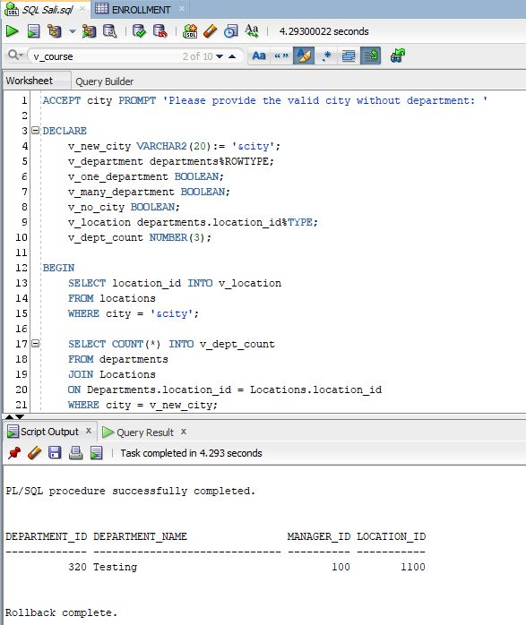

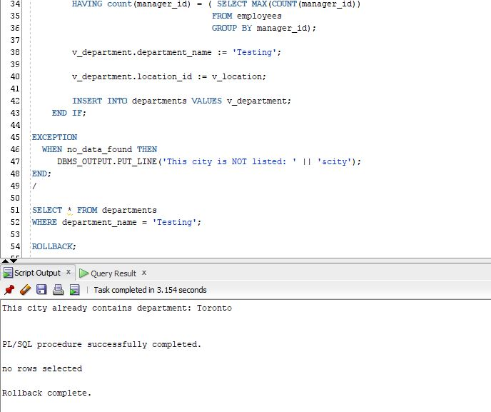

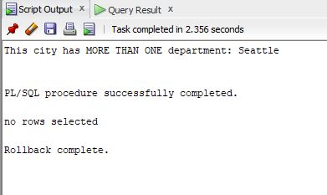

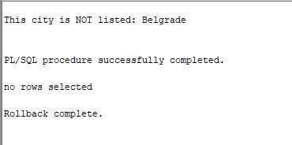

Enter SQL: @assignment1.sql
Please provide the valid city without department: Venice

PL/SQL procedure successfully completed.

DEPARTMENT_ID DEPARTMENT_NAME MANAGER_ID LOCATION_ID
------------- ------------------------------ ---------- -----------
320 Testing 100 1100

Rollback complete.

Enter SQL: @assignment1.sql
Please provide the valid city without department: Toronto
This city already contains department: Toronto

PL/SQL procedure successfully completed.

no rows selected

Rollback complete.

Enter SQL: @assignment1.sql
Please provide the valid city without department: Seattle
This city has MORE THAN ONE department: Seattle

PL/SQL procedure successfully completed.

no rows selected

Rollback complete.

Enter SQL: @assignment1.sql
Please provide the valid city without department: Belgrade
This city is NOT listed: Belgrade

PL/SQL procedure successfully completed.

no rows selected

Rollback complete.

Enter SQL: spool off

2) Write the PL/SQL block that will as input accept the start of the Course Description (one or more words) that is definitely used as a PREREQUISITE course. Then for each section of all courses that have this course (or courses) as a Prerequisite, determine the number of students registered. If this number is equal to or greater than 7, raise the user-defined exception and display message like “There are too many students for that section”. Otherwise, display how many students are in that section. Use For Cursor Loop and Exception Handler as well. Make sure that your program is able to process all sections. Also, you need to deal with the situations where input points to a valid course that is NO prerequisite at all and also if input points to a non-existing course. Here are the possible outputs:

Top of Form
Enter the beginning of the Course Description in UPPER case: |  | 
Bottom of Form

There are 5 students for section ID 85
There are 6 students for section ID 86
There are too many students for section 87
^^^^^^^^^^^^^^^^^^^^^^^^^^
There are 5 students for section ID 88
There are too many students for section 89
^^^^^^^^^^^^^^^^^^^^^^^^^^
There are 4 students for section ID 90
There are 2 students for section ID 91
There are 4 students for section ID 92
There are 0 students for section ID 93
There are 0 students for section ID 98
There are 4 students for section ID 146
There are too many students for section 147
^^^^^^^^^^^^^^^^^^^^^^^^^^
There are 5 students for section ID 148
There are 1 students for section ID 149
There are 3 students for section ID 150
There are 2 students for section ID 151
PL/SQL procedure successfully completed.

Top of Form
Enter the beginning of the Course Description in UPPER case: |  | 
Bottom of Form

There is NO PREREQUISITE course that starts on: UNIX. Try again.
PL/SQL procedure successfully completed.

Top of Form
Enter the beginning of the Course Description in UPPER case: |  | 
Bottom of Form

There is NO VALID course that starts on: SPORT. Try again.
PL/SQL procedure successfully completed.

SET SERVEROUTPUT ON;
SET VERIFY OFF;

ACCEPT course_desc PROMPT 'Enter the beginning of the Course Description in UPPER case: '

DECLARE
v_course_desc VARCHAR2(20) := '&course_desc';

CURSOR course_cl IS
SELECT c1.course_no,
c1.description,
c2.course_no AS Prereq
FROM Course c1, Course c2
WHERE c1.prerequisite = c2.course_no
AND UPPER(c1.description) LIKE UPPER('&course_desc' ||'%');

CURSOR section_cl IS
SELECT section_id
FROM section
WHERE course_no IN (SELECT course_no FROM course
WHERE prerequisite IN (SELECT course_no FROM course
WHERE UPPER(description) LIKE v_course_desc||'%'))
ORDER BY section_id;
v_count NUMBER(5);
v_course course_cl%ROWTYPE;
v_section section_cl%ROWTYPE;
v_flag CHAR(1):='y';
e_manyStudent EXCEPTION;

BEGIN

OPEN course_cl;
FETCH course_cl INTO v_course;
IF course_cl%NOTFOUND THEN
DBMS_OUTPUT.PUT_LINE('There is NO PREREQUISITE course that starts on: '|| v_course_desc || '. Try again.');
v_flag :='n';
CLOSE course_cl;
ELSIF v_flag='y' THEN
OPEN section_cl;
FETCH section_cl INTO v_section;
IF section_c1%NOTFOUND THEN
DBMS_OUTPUT.PUT_LINE('There is NO PREREQUISITE course that starts on:'|| v_course_desc||'. Try again.');
CLOSE section_c1;
ELSE
CLOSE section_c1;
FOR section_ind IN section_c1 LOOP
BEGIN
SELECT COUNT(*) INTO v_count
FROM Enrollment
WHERE section_id = section_ind.section_id;

IF v_count >= 7 THEN
RAISE e_manyStudent;

ELSIF v_count > 0 THEN
DBMS_OUTPUT.PUT_LINE ('There are ' || studentsEnrolled || ' students for section ID ' || v_section.section_id);
END IF;

EXCEPTION
WHEN e_manyStudent THEN
DBMS_OUTPUT.PUT_LINE('There are too many students for section '||section_ind.section_id);
DBMS_OUTPUT.PUT_LINE('^^^^^^^^^^^^^^^^^^^^^^^^^^');
END;
END LOOP; -- END OF FOR LOOP
END IF;
END IF;
END;
/

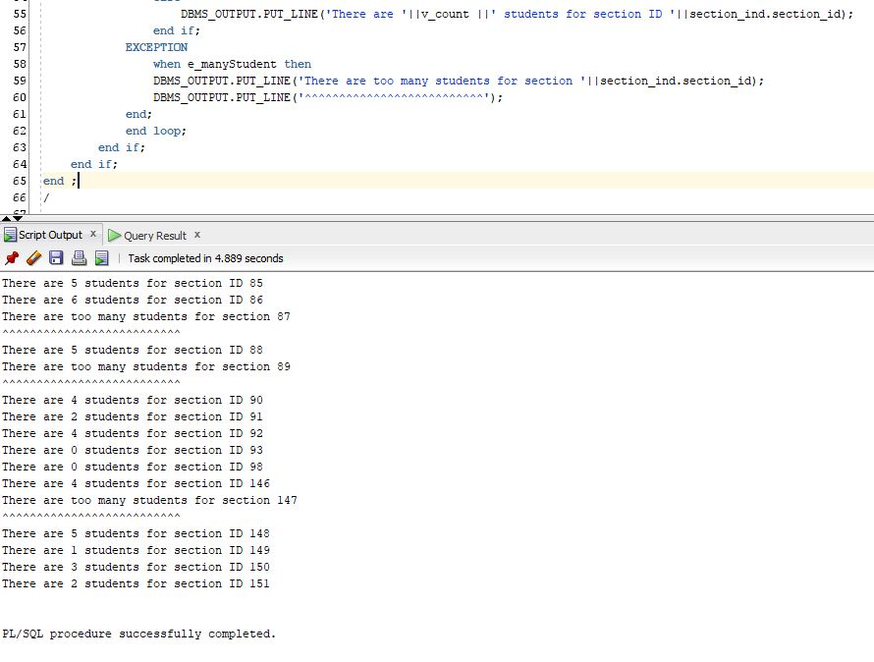

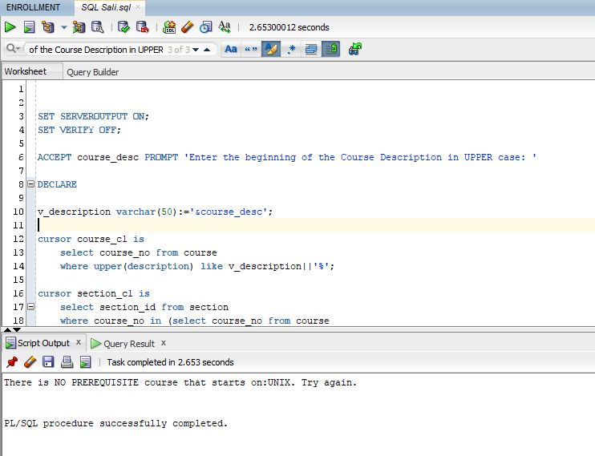

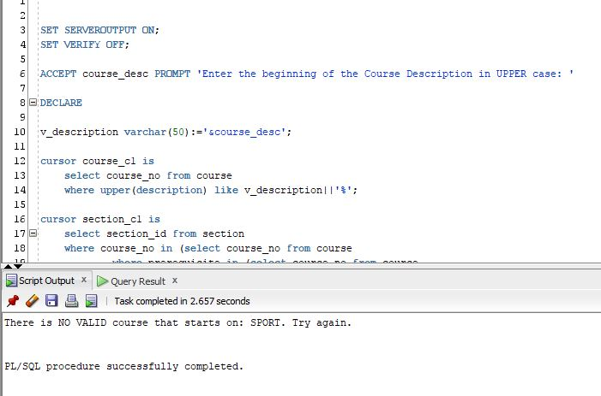
3) Write the PL/SQL block that will as input accept the start of the Course Description (one or more words) that possibly has a PREREQUISITE course. Then, it will display for each course that starts like the provided input the following components: Course Number, Description and Cost followed by the prerequisite Course Number, Description and Cost.. Use For Cursor Loop. You should create a User-Defined Nested Record of four components, where the fourth component is Record again. Also, you need to deal with the situations where your input points to a valid course that has NO prerequisites at all and also if your input points to a non-existing course. Here are the possible outputs:

Top of Form
Enter the beginning of the Course description in UPPER case: |  | 
Course: 144 - Database Design
Cost: 1195
Prerequisite: 420 - Database System Principles
Prerequisite Cost: 1195
========================================
Course: 420 - Database System Principles
Cost: 1195
Prerequisite: 25 - Intro to Programming
Prerequisite Cost: 1195
========================================
PL/SQL procedure successfully completed.
Top of Form
Enter the beginning of the Course description in UPPER case: |  | 
There is NO prerequisite course for any course that starts on OPERATING. Try again.
PL/SQL procedure successfully completed.
Top of Form
Enter the beginning of the Course description in UPPER case:

SET SERVEROUTPUT ON;
SET VERIFY OFF;

accept desc prompt 'Enter the beginning of the Course description in UPPER case: '
declare
desc_input varchar(50) :='&desc';

cursor c1 is
select course_no, description, cost, prerequisite
from course
where upper(description) like upper(desc_input)||'%';

type pre_rec_type is record(
pre_course_no course.course_no%type,
pre_description course.description%type,
pre_cost course.cost%type);

type course_rec_type is record(
course_no course.course_no%type,
description course.description%type,
cost course.cost%type,
pre_rec pre_rec_type);

pre_rec pre_rec_type;
course_rec course_rec_type;

Begin
open c1;
fetch c1 into course_rec.course_no,course_rec.description,course_rec.cost,course_rec.pre_rec.pre_course_no;
if c1%NOTFOUND then
dbms_output.put_line('There is NO VALID course that starts on: '||desc_input||'. Try again.');
close c1;
else
close c1;
for ind in c1 loop
course_rec.course_no:=ind.course_no;
course_rec.description:=ind.description;
course_rec.cost:=ind.cost;
course_rec.pre_rec.pre_course_no:=ind.prerequisite;
begin
select description, cost into course_rec.pre_rec.pre_description, course_rec.pre_rec.pre_cost
from course
where course_no =course_rec.pre_rec.pre_course_no;
dbms_output.put_line('Course: '||course_rec.course_no||' - '||course_rec.description);
dbms_output.put_line('Cost: '||course_rec.cost);
dbms_output.put_line('Prerequisite: '||course_rec.pre_rec.pre_course_no||' - '||course_rec.pre_rec.pre_description);
dbms_output.put_line('Prerequisite Cost: '||course_rec.pre_rec.pre_cost);
dbms_output.put_line('=========================================================');
exception
when NO_DATA_FOUND then
dbms_output.put_line('There is NO prerequisite course for any course that starts on '||upper(desc_input)||'. Try again. ');
end;
end loop;
end if;
end;
/
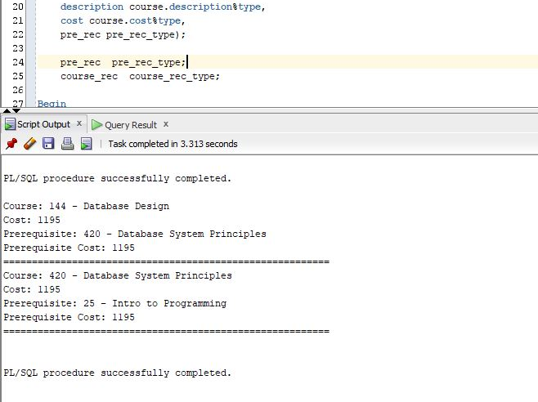
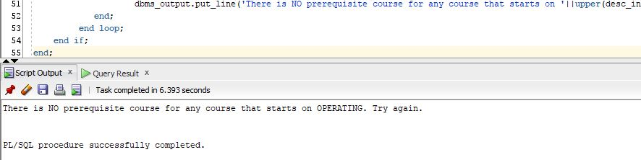
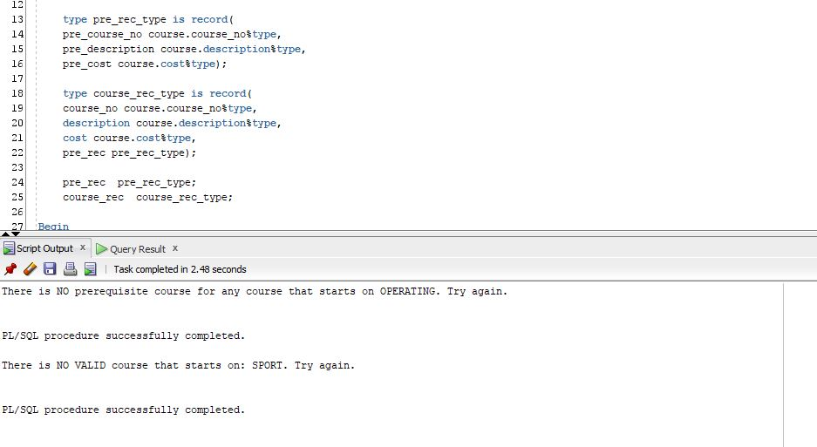
4) Write a PL/SQL block to display the course number and name and then for each section it will show the enrollment number. Use Nested For Cursor Loops where the parent cursor will give information about each course and the child cursor will count the enrollment for each section. The child cursor will contain ONE input argument.
You will be prompted to enter TWO key words within the course description and here are your possible outputs:
I) If you entered words JAVA and PROGRAM, the output looks like:

20 Intro to Java Programming
**************************************
Section: 1 has an enrollment of: 4
Section: 2 has an enrollment of: 8
Section: 5 has an enrollment of: 3
Section: 4 has an enrollment of: 1
Section: 3 has an enrollment of: 5
Section: 7 has an enrollment of: 2
122 Intermediate Java Programming
**************************************
Section: 1 has an enrollment of: 4
Section: 2 has an enrollment of: 3
Section: 4 has an enrollment of: 5
Section: 5 has an enrollment of: 8
Section: 3 has an enrollment of: 4
124 Advanced Java Programming
**************************************
Section: 1 has an enrollment of: 5
Section: 2 has an enrollment of: 1
Section: 3 has an enrollment of: 2
146 Java for C/C++ Programmers
**************************************
Section: 1 has an enrollment of: 1
Section: 2 has an enrollment of: 2
450 DB Programming in Java
**************************************
Section: 1 has an enrollment of: 1
PL/SQL procedure successfully completed.

II) If you entered words INTRO and C, the output looks like:

20 Intro to Computers
************************************
Section: 2 has an enrollment of: 3
Section: 4 has an enrollment of: 2
Section: 8 has an enrollment of: 2
Section: 7 has an enrollment of: 2
240 Intro to the Basic Language
*************************************
Section: 1 has an enrollment of: 12
Section: 2 has an enrollment of: 1
PL/SQL procedure successfully completed.

III) If you entered words INTRO and SOCCER, the output looks like:

There is NO course containing these 2 words. Try again.
PL/SQL procedure successfully completed.

SET SERVEROUTPUT ON;
SET VERIFY OFF;

ACCEPT firstEnSearch PROMPT 'Enter your first program key word'
ACCEPT secondEnSearch PROMPT 'Enter your second program key word'
DECLARE
CURSOR course_cl IS SELECT course_no, description from course
WHERE UPPER(description) LIKE UPPER('%' || '&firstEnSearch' ||'%') AND UPPER(description) LIKE UPPER('%' || '&secondEnSearch' || '%');
CURSOR section_cl(p_course NUMBER) IS
SELECT section_id FROM section WHERE course_no = p_course;
CURSOR studEnr(p_section NUMBER) IS
SELECT COUNT(*) FROM enrollment WHERE section_id = p_section;
v_course course_cl%ROWTYPE;
checker course_cl%ROWTYPE;
v_section section_cl%ROWTYPE;
studentsEnrolled NUMBER(5);
BEGIN
OPEN course_cl;
FETCH course_cl into checker;
IF course_cl%NOTFOUND THEN
DBMS_OUTPUT.PUT_LINE('There is NO course containing these 2 words. Try again.');
CLOSE course_cl;
ELSE
CLOSE course_cl;
OPEN course_cl; LOOP
FETCH course_cl INTO v_course;
EXIT WHEN course_cl%NOTFOUND;
DBMS_OUTPUT.PUT_LINE (v_course.course_no || ' ' || v_course.description || CHR(10)||
'**************************************');
OPEN section_cl(v_course.course_no); LOOP
FETCH section_cl INTO v_section;
EXIT WHEN section_cl%NOTFOUND;
OPEN studEnr(v_section.section_id); LOOP
FETCH studEnr INTO studentsEnrolled;
EXIT WHEN studEnr%NOTFOUND;
DBMS_OUTPUT.PUT_LINE ('Section: ' || section_cl%ROWCOUNT || ' has an enrollment of: ' || studentsEnrolled);
END LOOP;
CLOSE studEnr;
END LOOP;
CLOSE section_cl;
END LOOP;
CLOSE course_cl;
END IF;
END;
/

