Chapter 6 Practice

Firstly create a new table called RETIRED_EMPS like in the Chapter 6.
Here is the code:

CREATE TABLE retired_emps (
empno NUMBER(4),
ename VARCHAR2(20),
job VARCHAR2(20),
mgr NUMBER(4),
hiredate DATE,
leavedate DATE,
sal NUMBER(7,2),
comm NUMBER(7,2),
deptno NUMBER(4) )

1) Write PL/SQL block that will be used to ADD row to the new table and then will inspect the content of the table. You will add 3 rows by providing valid employee numbers (who are about to retire). As retirement date always use “Yesterday’s Date”.
After running this block 3 times with Id’s of (174,201,141) here is the table output:

EMPNO | ENAME | JOB | MGR | HIREDATE | LEAVEDATE | SAL | COMM | DEPTNO
174 | Abel | SA_REP | 149 | 11-MAY-96 | 28-SEP-09 | 11000 | .3 | 80
201 | Hartstein | MK_MAN | 100 | 17-FEB-96 | 28-SEP-09 | 13000 |  | 20
141 | Rajs | ST_CLERK | 124 | 17-OCT-95 | 28-SEP-09 | 3500 |  | 50

INSERT INTO retired_emps
VALUES ( 141, 'Rais', 'ST_CLERK', 124, to_date('17-Oct-95','DD-Mon-YY'), to_date('28-Sep-09','DD-Mon-YY'), 3500, 0, 50 );

SET SERVEROUTPUT ON
SET VERIFY OFF
ACCEPT empnum PROMPT 'Please provide the employee number: '
DECLARE
emp_rec employees%ROWTYPE;
BEGIN
SELECT * INTO emp_rec
FROM employees
WHERE employee_id = &empnum;

INSERT INTO retired_emps VALUES (emp_rec.employee_id, emp_rec.last_name,
emp_rec.job_id, emp_rec.manager_id, emp_rec.hire_date,
SYSDATE -1,emp_rec.salary, emp_rec.commission_pct, emp_rec.department_id);
END;
/
SELECT * FROM retired_emps;

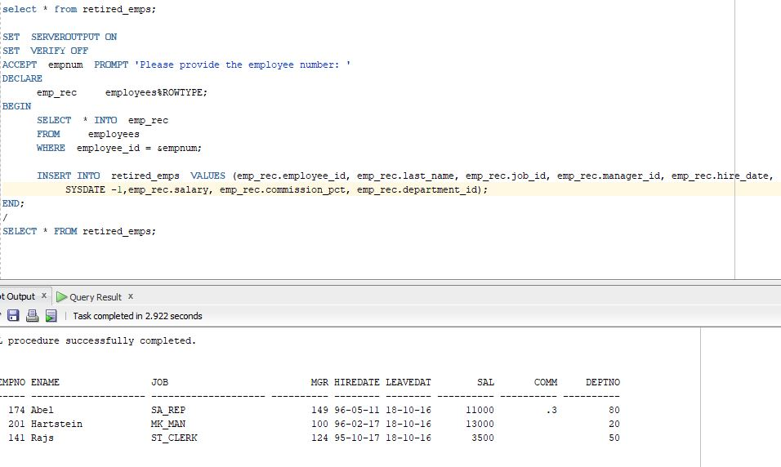

2) Write a PL/SQL block that will be used to MODIFY the WHOLE row in the new table and then will inspect the content of the table. You will modify just one row by providing valid employee number. As retirement date use “Tomorrow’s Date”, the person to retire will get $5,000 on the top of his/her salary. If he/she is eligible for the commission, that value should be increased by 50%.

After providing value 174 here is the output.
Top of Form
Please provide the employee number: |  | 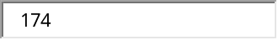

EMPNO | ENAME | JOB | MGR | HIREDATE | LEAVEDATE | SAL | COMM | DEPTNO
174 | Abel | SA_REP | 149 | 11-MAY-96 | 30-SEP-09 | 16000 | .45 | 80
201 | Hartstein | MK_MAN | 100 | 17-FEB-96 | 28-SEP-09 | 13000 |  | 20
141 | Rajs | ST_CLERK | 124 | 17-OCT-95 | 28-SEP-09 | 3500 |  | 50

3) Write a PL/SQL block that will use RECORD type in order to display message like shown:
Today is : 29-SEP-09
It is : TUESDAY
Time is: 15:07:13
PL/SQL procedure successfully completed.

SET SERVEROUTPUT ON
DECLARE
TYPE day_rec_type IS RECORD (
curr_date DATE,
curr_day VARCHAR(12),
curr_time VARCHAR2(8) := '00:00:00') ;
day_rec DAY_REC_TYPE;
BEGIN
SELECT TRUNC(sysdate), TO_CHAR(sysdate,'DAY'), TO_CHAR(sysdate,'HH24:MI:SS')
INTO day_rec
FROM dual;
DBMS_OUTPUT.PUT_LINE('Today is : ' || day_rec.curr_date);
DBMS_OUTPUT.PUT_LINE('It is : ' || day_rec.curr_day);
DBMS_OUTPUT.PUT_LINE('Time is: ' || day_rec.curr_time);
END;

4) Write a PL/SQL block that will use NESTED RECORD type of 2 components (Name and Address) in order to display message about Students’s full name and complete address like shown below:

Enter a valid Student Number: |  | 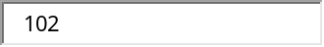

Full Name is : Fred Crocitto
Full Address is : 101-09 120th St. Richmond Hill NY 11419
PL/SQL procedure successfully completed.

SET SERVEROUTPUT ON
ACCEPT studentnum PROMPT 'Enter a valid Student Number: '
SET VERIFY OFF
DECLARE
TYPE name_type IS RECORD (
fname VARCHAR2(20),
lname VARCHAR2(20) );
TYPE address_type IS RECORD (
street VARCHAR2(50),
city VARCHAR2(20),
state CHAR(2),
zip VARCHAR2(6));
TYPE person_type IS RECORD (
name NAME_TYPE,
address ADDRESS_TYPE);
person_rec PERSON_TYPE;
BEGIN
SELECT first_name, last_name, street_address, city, state, z.zip
INTO person_rec.name.fname, person_rec.name.lname, person_rec.address.street,
person_rec.address.city, person_rec.address.state, person_rec.address.zip
FROM Student s , Zipcode z
WHERE s.zip= z.zip
AND student_id = &studentnum;
DBMS_OUTPUT.PUT_LINE('Full Name is : ' || person_rec.name.fname || ' ' || person_rec.name.lname);
DBMS_OUTPUT.PUT_LINE('Full Address is : ' || person_rec.address.street || ' ' || person_rec.address.city || ' ' || person_rec.address.state || ' ' || person_rec.address.zip);
END;

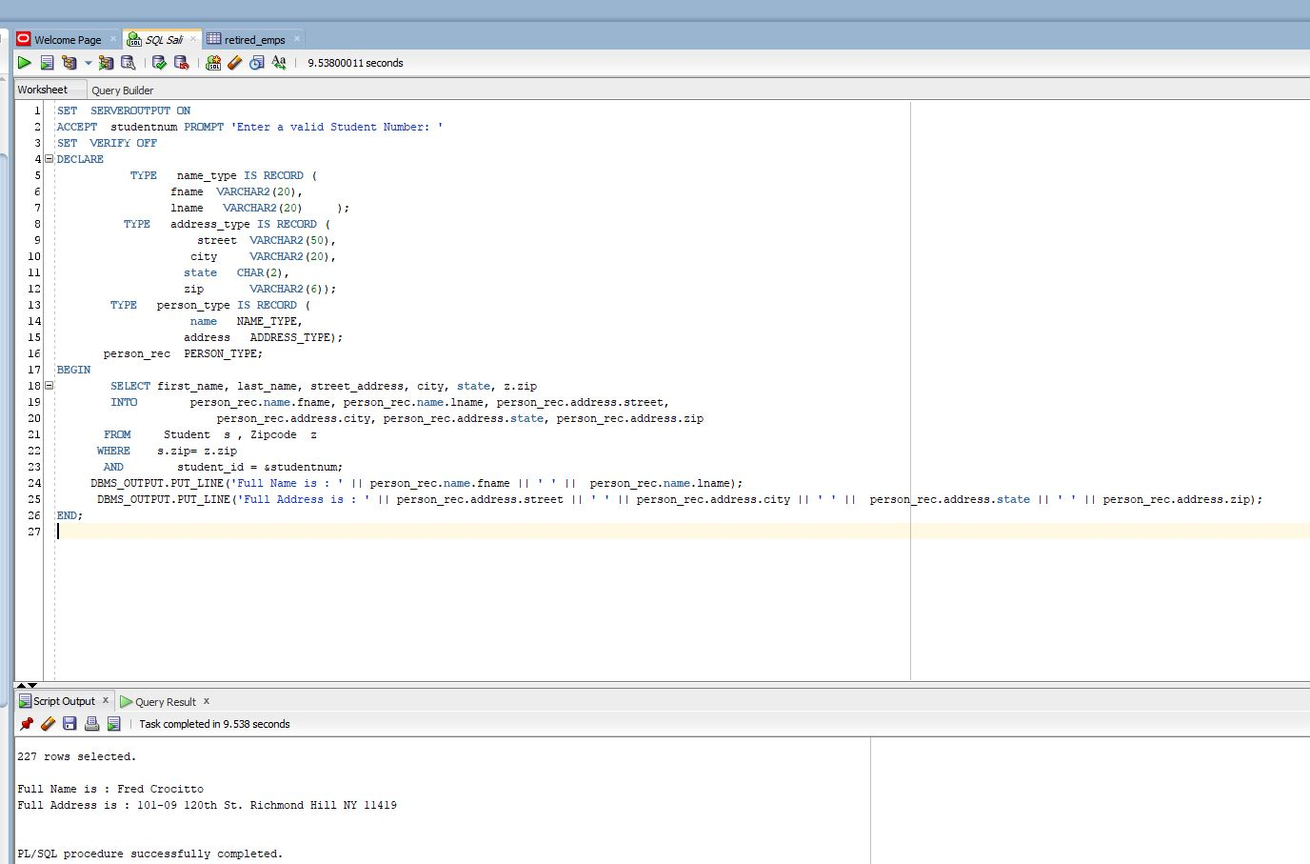

5) ) Write a PL/SQL block that will use PL/SQL (INDEX BY) table to display department names and their location numbers, when user provides just the First Letter of the department. Do NOT use an explicit cursor to solve this problem. Here is the output:

Top of Form
Please provide the First Letter of Department Name |  | 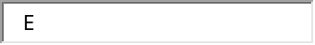

Executive in location 1700
PL/SQL procedure successfully completed.

Top of Form
Please provide the First Letter of Department Name |  | 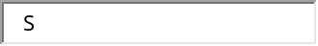

ERROR at line 1:
ORA-01422: exact fetch returns more than requested number of rows
ORA-06512: at line 13
If we have MORE THAN ONE department starting on that letter, then the error happens and the ONLY WAY to solve that kind of problem is to use EXPLICIT CURSORS → See Chapter 7 Practice

SET SERVEROUTPUT ON
SET VERIFY OFF
ACCEPT empnum PROMPT 'Please provide the employee number: '
DECLARE
oldemp_rec retired_emps%ROWTYPE;
BEGIN
SELECT * INTO oldemp_rec
FROM retired_emps
WHERE empno = &empnum;

oldemp_rec.leavedate := SYSDATE +1;
oldemp_rec.sal := oldemp_rec.sal + 5000;

IF oldemp_rec.comm IS NOT NULL THEN
oldemp_rec.comm := oldemp_rec.comm*1.5;
END IF;

UPDATE retired_emps SET ROW = oldemp_rec
WHERE empno = &empnum;

END;
/
SELECT * FROM retired_emps;

4)
Note: If you follow the style of Example 3 and provide in the INTO clause just the RECORD NAME like shown, you will end up with the error – for Nested Records you must specify EACH COMPONENT separately
SELECT first_name, last_name, street_address, city, state, z.zip
INTO person_rec
INTO person_rec
*
ERROR at line 20:
ORA-06550: line 20, column 21:
PLS-00597: expression 'PERSON_REC' in the INTO list is of wrong type
5)
SET SERVEROUTPUT ON
SET VERIFY OFF
ACCEPT dept PROMPT 'Please provide the First Letter of Department Name: '
DECLARE
TYPE dept_tab_type IS TABLE OF departments%ROWTYPE
INDEX BY BINARY_INTEGER;
dept_tab dept_tab_type;
v_bound NUMBER(3);
a NUMBER(3) := 0;
BEGIN
SELECT COUNT(*) INTO v_bound
FROM departments
WHERE department_name LIKE '&dept%' ;
FOR i IN 1..v_bound LOOP
a := a + 1;
SELECT * INTO dept_tab(a)
FROM departments
WHERE department_name LIKE '&dept%' ;
DBMS_OUTPUT.PUT_LINE(dept_tab(a).department_name || ' in location ' || dept_tab(a).location_id);
END LOOP;
END;

