Chapter 7 Practice

1) A) Write a PL/SQL block that will use an Explicit Cursor to display full names of all students whose Id is not higher than the provided one by the input. Manually deal with all 4 phases of your Cursor. Do NOT deal with the case when your active set is initially empty (NO rows selected). Here is the output.
Top of Form
Enter highest Student Id that you want to see: |  | 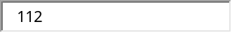
Bottom of Form

Bottom of Form
Student's full name is : Fred Crocitto
Student's full name is : Laetia Enison
Student's full name is : J. Landry
Student's full name is : Maria Martin
Student's full name is : Catherine Mierzwa
Student's full name is : Angel Moskowitz
Student's full name is : Peggy Noviello
Student's full name is : Judith Olvsade
Student's full name is : Judy Sethi
Student's full name is : Thomas Thomas
Student's full name is : Larry Walter
PL/SQL procedure successfully completed.

SET SERVEROUTPUT ON
SET VERIFY OFF
ACCEPT studnum PROMPT 'Enter highest Student Id that you want to see: '
DECLARE
CURSOR c1 IS SELECT first_name, last_name
FROM Student
WHERE student_id <= &studnum
ORDER BY last_name, first_name;
stud_name c1%ROWTYPE;
BEGIN
OPEN c1;
LOOP
FETCH c1 INTO stud_name;
EXIT WHEN c1%NOTFOUND;
DBMS_OUTPUT.PUT_LINE(q'{Student's full name is : }' || stud_name.first_name || ' ' || stud_name.last_name);
END LOOP;
CLOSE c1;
END;

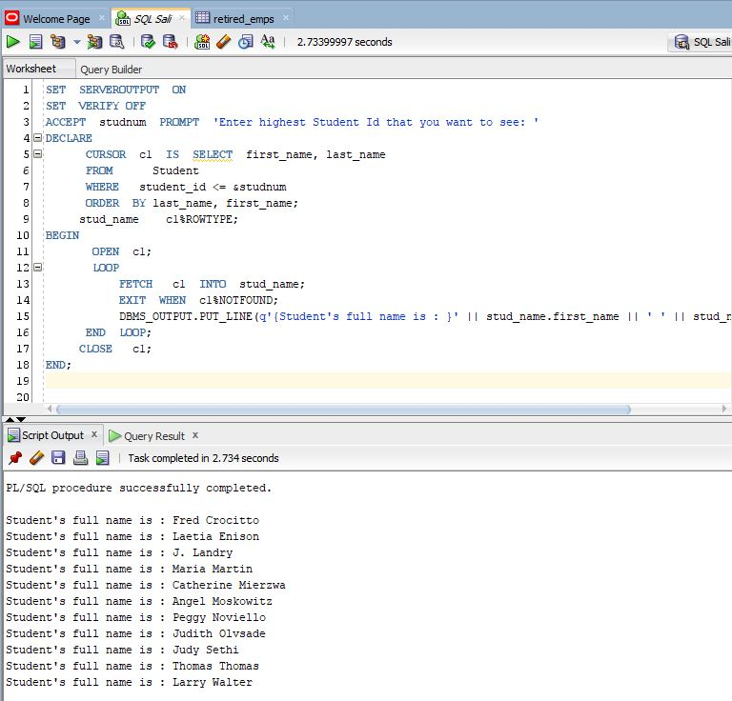

B) Rewrite problem A) by using an automatic Cursor solution (Cursor For Loop).

SET SERVEROUTPUT ON
SET VERIFY OFF
ACCEPT studnum PROMPT 'Enter highest Student Id that you want to see: '
DECLARE
CURSOR c1 IS SELECT first_name, last_name
FROM Student
WHERE student_id <= &studnum
ORDER BY last_name, first_name; -- DO NOT holding variables (or record)

BEGIN
FOR i IN c1 LOOP -- DO NOT declare cursor loop index
DBMS_OUTPUT.PUT_LINE(q'{Student's full name is : }' || i.first_name || ' ' || i.last_name);
END LOOP;
END;

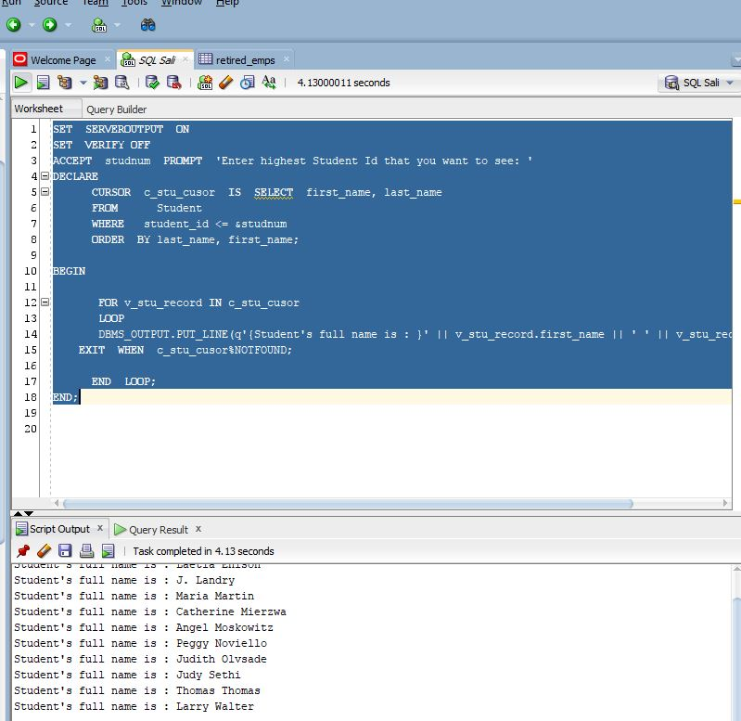

2) A) Add code to your 1) A) solution that will take care if your active set is initially empty (meaning NO rows are identified) with the appropriate message like shown below.

Top of Form
Enter highest Student Id that you want to see: |  | 
Bottom of Form

Your Id did NOT yield any students. Try higher Id.
PL/SQL procedure successfully completed.

SET SERVEROUTPUT ON
SET VERIFY OFF
ACCEPT studnum PROMPT 'Enter highest Student Id that you want to see: '
DECLARE
CURSOR c1 IS SELECT first_name, last_name
FROM Student
WHERE student_id <= &studnum
ORDER BY last_name, first_name;
stud_name c1%ROWTYPE;
BEGIN
OPEN c1;
FETCH c1 INTO stud_name;
IF c1%ROWCOUNT = 0 THEN
DBMS_OUTPUT.PUT_LINE('Your Id did NOT yield any students. Try higher Id.');
ELSE
CLOSE c1;
OPEN c1;
LOOP
FETCH c1 INTO stud_name;
EXIT WHEN c1%NOTFOUND;
DBMS_OUTPUT.PUT_LINE(q'{Student's full name is : }' || stud_name.first_name || ' ' || stud_name.last_name);
END LOOP;
END IF;
CLOSE c1;
END;

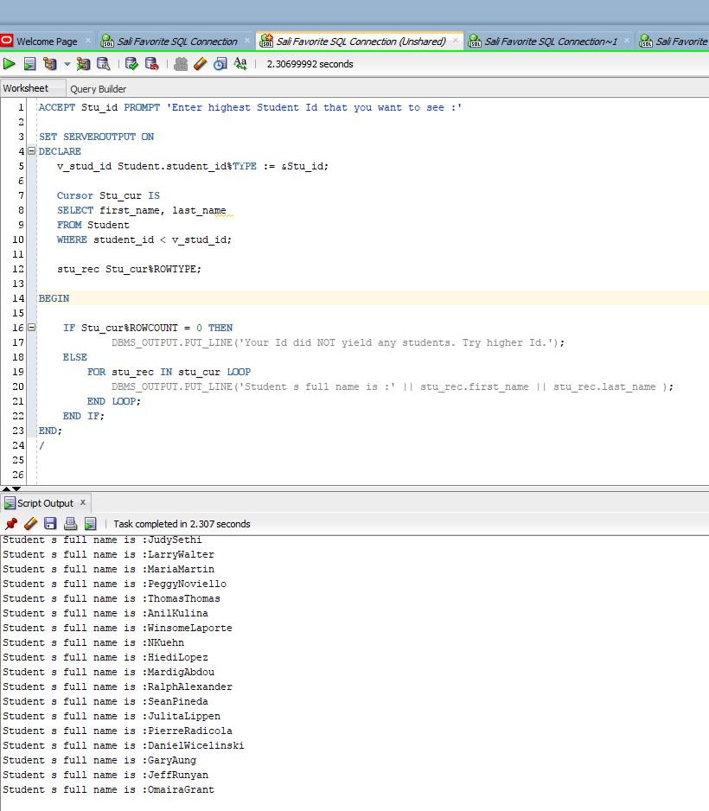

- Rewrite problem A) by using an automatic Cursor solution (Cursor For Loop) PLUS display before each student record the index number and also at the bottom show the Total Number of records (students) displayed.
Here is the output.

Top of Form
Enter highest Student Id that you want to see:
Bottom of Form

Your Id did NOT yield any students. Try higher Id.
PL/SQL procedure successfully completed.

Top of Form
Enter highest Student Id that you want to see:

Current Record# is: 1
Student's full name is : Fred Crocitto
Current Record# is: 2
Student's full name is : Laetia Enison
Current Record# is: 3
Student's full name is : J. Landry
Current Record# is: 4
Student's full name is : Maria Martin
Current Record# is: 5
Student's full name is : Catherine Mierzwa
Current Record# is: 6
Student's full name is : Angel Moskowitz
Current Record# is: 7
Student's full name is : Peggy Noviello
Current Record# is: 8
Student's full name is : Judith Olvsade
Current Record# is: 9
Student's full name is : Judy Sethi
Current Record# is: 10
Student's full name is : Thomas Thomas
Current Record# is: 11
Student's full name is : Larry Walter
======================================
Total # of Student records is: 11
PL/SQL procedure successfully completed.

SET SERVEROUTPUT ON
SET VERIFY OFF
ACCEPT studnum PROMPT 'Enter highest Student Id that you want to see: '
DECLARE
CURSOR c1 IS SELECT first_name, last_name
FROM Student
WHERE student_id <= &studnum
ORDER BY last_name, first_name;
stud_rec c1%ROWTYPE;
tot# NUMBER(5) := 0;

BEGIN
OPEN c1;
FETCH c1 INTO stud_rec;
If c1%NOTFOUND THEN
DBMS_OUTPUT.PUT_LINE('No student records found. Try to increase your Id search. ');
CLOSE c1;
ELSE
CLOSE c1;
FOR i IN c1 LOOP
DBMS_OUTPUT.PUT_LINE('Current Record# is: ' || c1%ROWCOUNT);
DBMS_OUTPUT.PUT_LINE(q'{Student's full name is : }' || i.first_name || ' ' || i.last_name);
tot# := c1%ROWCOUNT;
END LOOP;
DBMS_OUTPUT.PUT_LINE('=================================');
DBMS_OUTPUT.PUT_LINE('Total # of Student records is: ' || tot#);
END IF;
END;

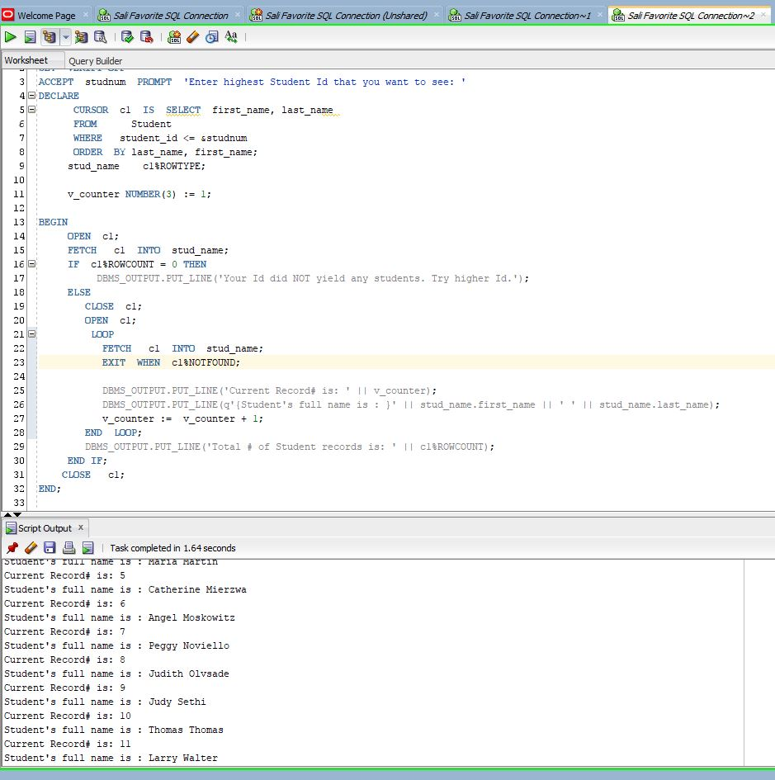

B)

SET SERVEROUTPUT ON
SET VERIFY OFF
ACCEPT studnum PROMPT 'Enter highest Student Id that you want to see: '
DECLARE
CURSOR c1 IS SELECT first_name, last_name
FROM Student
WHERE student_id <= &studnum
ORDER BY last_name, first_name; -- DO NOT holding variables (or record)

BEGIN
FOR i IN c1 LOOP -- DO NOT declare cursor loop index
DBMS_OUTPUT.PUT_LINE(q'{Student's full name is : }' || i.first_name || ' ' || i.last_name);
END LOOP;
END;
B)

3) Write a PL/SQL block that will use PL/SQL (INDEX BY) table to display department names and their location numbers, when user provides just the First Letter of the department. Use an explicit cursor to solve this problem. Also, take care when NO department starts with the provided letter input. Here is the output:
Top of Form
Please provide the First Letter of Department Name |  | 

Sales in location 2500
Shareholder Services in location 1700
Shipping in location 1500
PL/SQL procedure successfully completed.

Top of Form
Please provide the First Letter of Department Name |  | 

No department starts with the letter Z
PL/SQL procedure successfully completed.

3) In Chapter 6 we had the same question, but we could take care only if there was ONLY ONE department name that starts with the input letter. The code in the BOLD font deals with the situation of the initially empty active set (NO rows).

SET SERVEROUTPUT ON
SET VERIFY OFF
ACCEPT dept PROMPT 'Please provide the First Letter of Department Name'

DECLARE
TYPE dept_tab_type IS TABLE OF departments%ROWTYPE
INDEX BY BINARY_INTEGER;

dept_tab dept_tab_type;
a NUMBER(3) := 0;

CURSOR c1 IS
SELECT * FROM departments
WHERE department_name LIKE '&dept%' ;
dept_rec c1%ROWTYPE;

BEGIN
OPEN c1;
FETCH c1 INTO dept_rec;
If c1%NOTFOUND THEN
DBMS_OUTPUT.PUT_LINE('No department starts with the letter ' || '&dept');
END IF;
CLOSE c1;

FOR i IN c1 LOOP
a := a + 1;
SELECT i.department_name, i.location_id INTO dept_tab(a).department_name,
dept_tab(a).location_id
FROM departments
WHERE department_id = i.department_id;

DBMS_OUTPUT.PUT_LINE(dept_tab(a).department_name || ' in location ' ||
dept_tab(a).location_id);
END LOOP;
END;

4) Write a PL/SQL block that will use PL/SQL (INDEX BY) table to store last names of employees who earn more than $12,000 in descending order. Use also an explicit cursor to solve this problem. Here is the output:
Last Name is : 1: King
Last Name is : 2: Kochhar
Last Name is : 3: De Haan
Last Name is : 4: Russell
Last Name is : 5: Partners
Last Name is : 6: Hartstein
PL/SQL procedure successfully completed.

4)
SET SERVEROUTPUT ON
DECLARE
CURSOR c1 IS
SELECT last_name
FROM employees
WHERE salary > 12000
ORDER BY salary DESC;
TYPE lname_tab_type IS TABLE OF employees.last_name%TYPE
INDEX BY BINARY_INTEGER;
lname_tab LNAME_TAB_TYPE;
counter INTEGER := 0;
BEGIN
FOR ind IN c1 LOOP
counter := counter + 1;
lname_tab(counter) := ind.last_name;
DBMS_OUTPUT.PUT_LINE('Last Name is : ' || counter || ': ' || lname_tab(counter));
END LOOP;
END;

5) Rewrite the problem 4) by using NESTED TABLE and EXTENT METHOD.

5)
SET SERVEROUTPUT ON
DECLARE
CURSOR c1 IS
SELECT last_name
FROM employees
WHERE salary > 12000
ORDER BY salary DESC;
TYPE lname_type IS TABLE OF employees.last_name%TYPE;
-- INDEX BY BINARY_INTEGER;
lname_tab LNAME_TYPE := LNAME_TYPE();
counter INTEGER := 0;
BEGIN
FOR ind IN c1 LOOP
counter := counter + 1;
lname_tab.EXTEND;
lname_tab(counter) := ind.last_name;
DBMS_OUTPUT.PUT_LINE('Last Name is : ' || counter || ': ' || lname_tab(counter));
END LOOP;
END;
Note: As you see the ONLY three differences between solutions 4) and 5) are that
- When declaring Nested Table you DO NOT specify INDEX BY clause
- You must initialize it with TYPE_NAME := TYPE_NAME()
If you do NOT perform Step 2 then the error will happen like
ERROR at line 1:
ORA-06531: Reference to uninitialized collection
- Before assigning values (populating) your Nested Table via Cursor, you must use EXTEND method with IDENTIFIER.EXTEND
If you do NOT perform Step 3 then the error will happen like
ERROR at line 1:
ORA-06533: Subscript beyond count

6) Write a PL/SQL block that will perform an Exclusive Update (the set of rows will be locked before the update happens). You will be prompted for the Lower and Higher bound for Manager Id value (Chair of department) and for the Lowest value of Location Id for the department. Then you will check is department located in one of the locations with greater Id value (than the input) and whether its Manager Id (Chair Id) belongs to the provided range.
If that is the case you will modify that department’s manager value to be BLANK. You will NOT wait to get your row locks.
Also, you will display How Many departments were processed and How Many managers were fired from their chairing positions and When.
Use an Explicit Cursor For Loop with the passing parameter. After performing 2 tests like shown below you will UNDO your update. Here is the output:

Top of Form
Enter the lower bound for manager Id: |  | 

Top of Form
Enter the upper bound for manager Id: |  | 

Top of Form
Enter the minimum value for Location Id: |  | 

Department# 70, Public Relations has NO manager starting 07-OCT-09
Department# 40, Human Resources has NO manager starting 07-OCT-09
Number of processed departments is: 3
Number of departments that lost manager is: 2
PL/SQL procedure successfully completed.

Top of Form
Enter the lower bound for manager Id:

Top of Form
Enter the upper bound for manager Id: |  | 

Top of Form
Enter the minimum value for Location Id:

Depratment# 80, Sales has NO manager starting 07-OCT-09
Number of processed departments is: 3
Number of departments that lost manager is: 1
PL/SQL procedure successfully completed.

ROLLBACK
Rollback complete.

6)
SET SERVEROUTPUT ON
SET VERIFY OFF
ACCEPT v_lower PROMPT 'Enter the lower bound for manager Id: '
ACCEPT v_upper PROMPT 'Enter the upper bound for manager Id: '
ACCEPT num PROMPT 'Enter the minimum value for Location Id: '

DECLARE
CURSOR c1(loc# NUMBER) IS SELECT * FROM departments
WHERE location_id > loc#
FOR UPDATE OF manager_id NOWAIT;

counter INTEGER := 0;
v_total INTEGER;

BEGIN
FOR ind IN c1(&num) LOOP
IF ind.manager_id BETWEEN &v_lower AND &v_upper THEN
UPDATE departments
SET manager_id = NULL
WHERE CURRENT OF c1;
counter := counter + 1;
DBMS_OUTPUT.PUT_LINE('Depratment# ' || ind.department_id || ', ' || ind.department_name || ' has NO manager starting ' || TO_CHAR(sysdate,'DD-MON-RR'));
END IF;
v_total := c1%ROWCOUNT;
END LOOP;

DBMS_OUTPUT.PUT_LINE('Number of processed departments is: ' || v_total);
DBMS_OUTPUT.PUT_LINE('Number of departments that lost manager is: ' || counter);
END;

