The Basic of Linux Command Line
Introduction
Today, many of us are familiar with computers (desktops and laptops), smartphones, and
tablets which have graphical user interfaces (also referred to as GUIs), allowing us to
navigate apps, the web, and our files (like documents and photos) through a visual
experience. The Windows, macOS, and Linux operating systems each present varieties of a
desktop environment (with images of folders and files, for example), and dropdown menus,
all of which provide access to computer programs, applications, and our own media.
Although GUIs can be an intuitive way to use a computer for many users, they often do not
provide us with the greatest power over our machines, and they may prevent us from having
full administrative access on our computers, including installing, modifying, or deleting
software or files. Additionally, as GUIs are largely visual, they are often not as accessible as
they could be for all users.
One way of navigating both your own personal computer and remote cloud servers without
a GUI is through a text-based terminal or command-line interface CLI . You can launch one
in the browser by clicking on the blue Launch an Interactive Terminal! button, below:
Launch an Interactive Terminal!
Terminal interfaces exist on almost every computer operating system, and terminal
emulators are also available as apps for tablets and smartphones. Terminals provide users
with greater overall access to their machines through increased administrator access,
greater ability to customize environments, and opportunities to automate processes. They
also provide users with the ability to access remote computers, such as cloud servers.
This tutorial will provide users who are new to terminal environments with the basics of
using a command-line interface through an embedded web terminal in your browser, which
you can launch below. If you already have some familiarity with terminals, you may prefer to
go through our Introduction to the Linux Terminal tutorial instead. Once you complete this
tutorial, you should have an understanding of how to use a terminal on a Linux (or macOS
computer or server.
Understanding the Terminal Window
When you first get access to a new computer or smartphone, you likely want to turn it on
and get a feel for how to use it by checking which apps are available, and to learn where
things are so that you can customize the device to suit your needs. You can become familiar
with a computer through a terminal in a similar way.
The interactive terminal you launched in this browser window, by clicking the
Launch an Interactive Terminal! button above, displays a black rectangle on the
bottom of your browser window:
If you have not launched the terminal, please do so now:
Launch an Interactive Terminal!
In your interactive browser terminal, there should be a dollar sign, $ and a blinking cursor.
This is where you will begin to type commands to tell the terminal what to do.
Whatever flavor of Linux distribution you are using, you should have a terminal on your operating system that works similarly to the terminal we’ll be using in this course.
When you launch a terminal, the symbols at the end of the prompt may be a $ symbol or a # symbol, which have the following meaning:
$ or dollar sign — you are logged in as a regular user
# or hashtag/pound symbol — you are logged in as a user with elevated privileges
The user that is noted in the # environment is also known as a root user, which is
considered to be a super user, or administrator, by default.
We assume you are logged in as a regular user for most of the commands we will be using, but
you also have administrator privileges.
Please note that it is best to exercise more care when working on a your computer’s terminal
as there may be changes you can make as an administrator on the terminal that can make
permanent changes on the computer you are using.
We’ll begin working with the terminal by typing a command. A command is an instruction
that is given by a user, communicating what it is that the user wants the computer to do.
You will be typing your commands into the terminal and then pressing ENTER or RETURN
when you are ready for the computer to execute a given command.
Let’s type the following command followed by ENTER. You can also copy the command and paste it in your terminals:
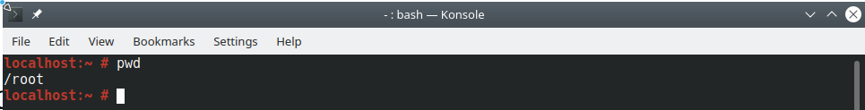
Once you run this command, you’ll receive an output that displays your current working directory.
The pwd command stands for “present working directory,” and it lets you know where you
are within the current file system.
In this example, it is assumed that you are in the directory (or folder) called /root , which stands for the user called root, a user with elevated privileges. On a personal computer, this directory may be
called the name of the user who owns the computer. Sammy Shark’s computer may have
/sammy or /sammy-shark as their primary user directory.
Right now, this directory is empty. Let’s create a directory to store the files we’ll be creating
as we go through this lesson, which we can call files, for example.
To do this, we’ll use the mkdir command, which stands for “make directory.” After we type
the command, we’ll need to write the name of the folder, which will pass the value to the
command so that the command can execute on creating this directory. This value (the name
of the folder) is known as an argument, which is an input being given to the command. If
you are familiar with natural language grammar, you can think of the argument as an object
that is being acted upon by the verb of the command.
In order to create a new directory called files we’ll write the following, with mkdir being the command and files being the argument:
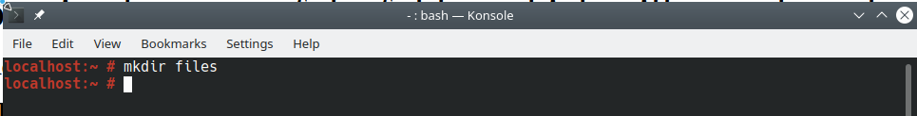
After you run this command, you won’t receive any output other than a new line with a blinking cursor. With this fresh line on your terminal, you are ready for your next command.

Listing Contents and Understanding Permissions
As we have not received any concrete feedback about our new directory yet, we’ll use a
command to learn more about what is in our present working directory. You can confirm that
the new directory is indeed there by listing out the files in the directory, with the ls
command (signifying “list”):
$ ls
You’ll receive output that confirms the files directory is created:
Output
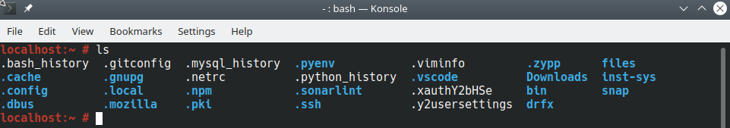
This gives us general information about what is in our present working directory. If we want
to have more details, we can run the ls command with what is called a flag. In Linux
commands, a flag is written with a hyphen - and letters, passing additional options (and
more arguments) to the command. In our example, we’ll add the -l flag, which — when
paired with ls — denotes that we would like to use the option to use a long listing format
with our command.
Let’s type this command and flag, like so:
$ ls -l
Upon pressing ENTER, we’ll receive the following output in our terminal:
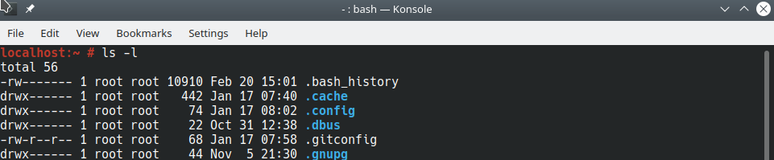
To get a somewhat more human readable output, we can also pass the -h or
--human-readable flag, which will print memory sizes in a human readable format, as
below. Generally, one hyphen - refers to single-letter options, and two hyphens -- refer to
options that are written out in words. Note that some options can use both formats. We can
build multiple options into a command by chaining flags together, as in -lh .
For example, the two commands below deliver the same results even though they are
written differently:
$ ls -lh
$ ls -l --human-readable
Both of these commands will return the following output, similar to the output above but
with greater context of the memory blocks:
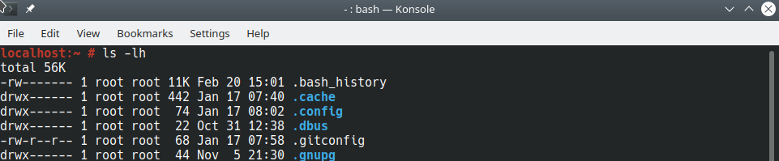
total 56K
The first line of output lets us know that 56K of computer memory is dedicated to the folder.
The second line of output has many more details, which we’ll go over in more detail. A
general high-level reference of all the information that we’ll cover is indicated in the table
below.
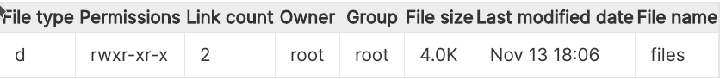

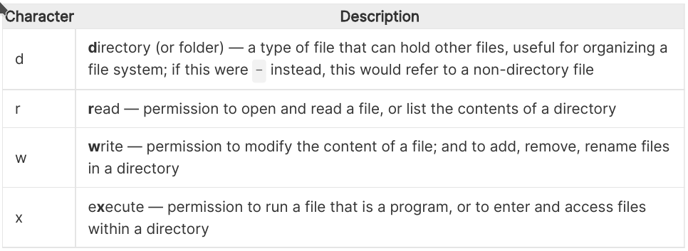
You’ll note that the name of our directory, files, is at the end of the second line of output.
This name indicates which specific item in the /root user directory is being described by
the line of output. If we had another file in the directory, we would have another line of
output with details on that file.
At the front of the line, there is a list of characters and dashes. Let’s break down the
meaning of each of the characters:
Character
d
r
w
x
Description
directory (or folder) — a type of file that can hold other files, useful for organizing a
file system; if this were - instead, this would refer to a non-directory file
read — permission to open and read a file, or list the contents of a directory
write — permission to modify the content of a file; and to add, remove, rename files
in a directory
execute — permission to run a file that is a program, or to enter and access files
within a directory
In the first drwx characters of the string, the first letter d means that the item files is a
directory. If this were a file other than a directory, this string of characters would begin with
a hyphen instead, as in -rwx , where the first hyphen signifies a non-directory file. The
following three letters, rwx , represent the permissions for the owner of the directory
files , and mean that the directory files can be read, written, and executed by the
owner of the file. If any of these characters were replaced with hyphens, that would mean
that the owner does not have the type of permission represented by that character. We’ll
discuss how to identify the owner of a file in just a moment.
The next three characters in the output are r-x , which represent the group permissions for
the files directory. In this instance, the group has read and execute permissions, but not
write permissions, as the w is replaced with a - . We’ll discuss how to identify the group in
just a moment.
The final three characters of the first string, r-x represents the permissions for any other
groups that have access to the machine. In this case, these user groups can also read and
execute, but not write.
S C R O L L TO TO P
https://www.digitalocean.com/community/tutorials/a-linux-command-line-primer
7/27
3/29/2021
A Linux Command Line Primer | DigitalOcean
The number 2 in the output refers to the number of links to this file. In Linux, links provide a
method to create shortcuts to help users navigate the filesystem. When you created this file,
Linux did some background work to create an absolute link to the file, and a self-referential
link to the file to allow for users to navigate along a relative path. We’ll discuss absolute and
relative paths in the next section.
After the number 2 , the word root is displayed twice. This part of the output gives
information about the owner and group associated with the files directory. The first
instance of root in this line refers to the owner of the directory, whose permissions we saw
earlier are rwx . The root user is the owner as we created the files directory as the root
user and are the current owner of the file. Though the root user is the only user in our
current environment, Unix-like operating systems often have more than one user and so it is
useful to know which user has ownership of a file.
The second instance of root refers to the group that has access to the files directory,
whose permissions we saw earlier are r-x . In this case, the group name is the same as the
owner username root . In real-world environments, there may be other groups on the
operating system that have access to the directory, such as staff or a username like
sammy .
The rest of the details on this output line are the 4.0K for the memory allocation of the
directory on the machine, and the date that the directory was last modified (so far, we have
just created it).
With this greater understanding of file systems and permissions, we can move onto
navigating the file system on our Linux terminal.
Navigating the Filesystem
So far, we have learned how to determine where we are in a filesystem, how to make a new
directory, how to list out files, and how to determine permissions.
Let’s next learn how to move around the file system. We have made a new directory, but we
are still in the main /root user directory. In order to move into the /files directory that we
have created, we’ll use the cd command and pass the name of the directory we want to
S C R O L L TO TO P
https://www.digitalocean.com/community/tutorials/a-linux-command-line-primer
8/27
3/29/2021
A Linux Command Line Primer | DigitalOcean
move into as the argument. The command cd stands for “change directory,” and we’ll
construct it like so:
$ cd files
Again, you won’t receive output other than a new line with a blinking cursor, but we can
check that we are in the /files directory with the pwd command we used earlier:
$ pwd
You’ll get the following output, confirming where you are:
Output
/root/files
This validates that you are in the /files directory of the /root user directory. Does this
syntax look familiar to you? It may remind you of a website’s URL with its forward slashes,
and, indeed, websites are structured on servers within directories, too.
Let’s move to the primary directory of the server. Regardless of where we are in a
filesystem, we can always use the command cd / to move to the primary directory:
$ cd /
To confirm that we have moved and learn what is in this directory, let’s run our list command:
$ ls
We’ll receive the following output:
Output
bin boot dev etc home lib lib32 lib64 libx32 media mnt opt proc rootS C R O L L TO TO P
https://www.digitalocean.com/community/tutorials/a-linux-command-line-primer
run
9/27
3/29/2021
A Linux Command Line Primer | DigitalOcean
There are a lot of files in there! The / directory is the main directory of a Linux server,
referred to as the “root” directory. Note that the root directory is different from the default
“root” user. You can think of the / directory as the major artery of a Linux machine, as it
contains all the folders necessary to run the computer. For example, the sys directory holds
the Linux kernel and system information virtual filesystem. If you would like to learn more
about each of these directories, you can visit the Linux Foundation documentation.
You’ll also notice that there is a directory we have been in already, the /root user folder.
From the / directory, we can change directories back into /root then back into /files , or
we can move directly back into that folder by typing the absolute path there with cd :
$ cd /root/files
Now, if you run pwd you’ll receive /root/files as your output.
A file path is the representation of where a file or directory is located on your computer or
server. You can call a path to a file or directory in either a relative or absolute way. A relative
path would be when we move to a location relative to our current working directory, like we
did when we were already in root/ and then moved into files/ . An absolute path is when
we call the direct line to a location, as we did above with /root/files , showing that we
started in the / directory, called the root/ user directory and then the nested files/
directory.
Additionally, Linux leveragesdot notation to help users navigate via relative paths. A single
. stands for the directory you are currently in, and a double .. stands for the parent
directory. So, from where we currently are ( /root/files ), we can use two dots to return to
the parent root/ user directory, like so:
$ cd ..
If you run pwd , you’ll receive /root as your output, and if you run ls , you’ll receive files
as your output.
Another important symbol to be familiar with is ~ which stands for the home directory of
your machine. Here, our home directory is called root/ for the root user, but on a local
S C R O L L TO TO P
machine it may be your own name as in sammy-shark/ .
https://www.digitalocean.com/community/tutorials/a-linux-command-line-primer
10/27
3/29/2021
A Linux Command Line Primer | DigitalOcean
You can type the following from anywhere on your machine and return to this home
directory:
$ cd ~
At this point, feel free to navigate around your file system with the commands you have
learned so far. In the next section, we’ll begin working with text files.
Creating and Modifying Text Files
Now that we have a foundation in the Linux file system and how to get around it, let’s start
creating new files and learn about how to manipulate text on the command line.
Let’s first be sure that we’re in the files/ directory of the root/ user folder, which we can
do by either verifying with pwd , or by changing directories on the absolute path:
$ cd /root/files
Now, we’ll create a new text file. We’ll be making a .txt file, which is a standard file that
can be read across operating systems. Unlike .doc files, a .txt file is composed of
unformatted text. Unformatted text, including the text in .txt files, can readily be used on
the command line, and therefore can be used when working with textual data
programmatically (as in, to automate text analysis, to pull information from text, and more).
We’ll begin by using the touch command, which can create a new file or modify an existing
file. To use it, you can use the command touch and pass the name of the text file you want
to create as the argument, as demonstrated below.
$ touch ocean.txt
Once you press ENTER , you’ll receive a new line of the command prompt, and you can list
the current contents of files/ to ensure it was created.
$ ls
S C R O L L TO TO P
https://www.digitalocean.com/community/tutorials/a-linux-command-line-primer
11/27
3/29/2021
A Linux Command Line Primer | DigitalOcean
Output
ocean.txt
So far we have created an ocean.txt file which contains no text at the time of creation.
If we want to create a text file that is initialized with text, we can use the echo command,
which is used to display strings of text in Linux.
We can use echo directly on the command line to have the interface repeat after us. The
traditional first program, "Hello, World!" , can be written with echo like so:
$ echo Hello, World!
Output
Hello,World!
Named for Echo of Ovid’s Metamorphosis, the echo command returns back what we
request. In this case, it echoed, “Hello, World!” On its own, however, the echo command
does not allow us to store the value of our text into a text file. In order to do that, we will
need to type the following:
$ echo "Sammy the Shark" > sammy.txt
The above command uses echo , then the text we would like to add to our file in quotes,
then the redirection operator > , and finally the name of our new text file, sammy.txt .
We can check that our new file exists, again with ls .
$ ls
Output
ocean.txt sammy.txt
https://www.digitalocean.com/community/tutorials/a-linux-command-line-primer
S C R O L L TO TO P
12/27
3/29/2021
A Linux Command Line Primer | DigitalOcean
We now have two text files in our root/ user folder. Next, we can confirm that the file
sammy.txt does have the text we asked the terminal to echo into it. We can do that with
the cat command. Short for concatenate, the cat command is very useful for working with
files. Among its functions is showing the contents of a file.
$ cat sammy.txt
Once we run the command, we’ll receive the following output:
Output
Sammy the Shark
If we were to run cat on the empty file ocean.txt , we would receive nothing in return as
there is no text in that file. We can add text to this existing file with echo as well. Let’s add a
quote from Zora Neale Hurston to the file.
$ echo "Some people could look at a mud puddle and see an ocean with ships." > ocean
Now, if we run cat on the file, we’ll receive output of the text we just entered.
$ cat ocean.txt
Output
Some people could look at a mud puddle and see an ocean with ships.
So far, we have created text files and have added text to these files, but we have not yet
modified these files. If we would like to do that, we can use a command-line text editor.
Several popular choices exist, including Vim and Emacs. For our purposes, we’ll use nano,
which is a less complex CLI text editor program that we can use to begin our exploration.
The nano text editor can be summoned with the nano command. If we want to edit our
existing sammy.txt file, we can do so by passing the file name as an argument.
S C R O L L TO TO P
$ nano sammy.txt
https://www.digitalocean.com/community/tutorials/a-linux-command-line-primer
13/27
3/29/2021
A Linux Command Line Primer | DigitalOcean
The file will open up on your terminal:
sammy.txt
Sammy the Shark
With your keyboard’s arrow keys, move your cursor to the end of the line and begin typing a
few lines from the perspective of Sammy.
Note On the command line, you can’t use your mouse or other pointer to navigate, both
through the file system and within files. You’ll need to use your keyboard, and your arrow keys
in particular, to move around textual files.
When you’re done with your file, it may read something like this:
sammy.txt
Sammy the Shark
Hello, I am Sammy.
I am studying computer science.
Nice to meet you!
With your file now containing the text you would like, we can now save and close the file.
You may notice that there is some guidance at the bottom of your terminal window:
^G Get Help
^O WriteOut
^R Read File ^Y Prev Page ^K Cut Text ^C Cur Pos
^X Exit
^J Justify
^W Where Is ^V Next Page ^U UnCut Text ^T To Spell
Because we are currently done with working on this file, we would like to Exit the file.
Here, the ^ symbol refers to the Control or CTRL key on your keyboard, and the output
above tells us that we need to combine that key with X (use this lower case, without
pressing the SHIFT key) in order to leave the file. Let’s press those two keys together:
CTRL x
S C R O L L TO TO P
https://www.digitalocean.com/community/tutorials/a-linux-command-line-primer
14/27
3/29/2021
A Linux Command Line Primer | DigitalOcean
The above is often written inline as CTRL + X or Ctrl+x in technical documentation.
At this point, you’ll receive the following prompt:
Output
Save modified buffer?
Y Yes
N No
^C Cancel
In order to save it, we’ll press the letter y for yes:
y
You’ll receive feedback like the following.
Output
File Name to Write: sammy.txt
There are additional options, including cancelling with CTRL + C , but if you are comfortable
with closing the file, you can press ENTER at this point to save the file and exit it.
Let’s say that we want to make a few files of students at DigitalOcean University. Let’s
create a new directory in files/ called students :
$ mkdir students
Next, let’s move sammy.txt into the new students/ directory. The mv command, which
stands for move, will allow us to change the location of a file. The command is constructed
by taking the file we want to move as the first argument, and the new location as the second
argument. Both of the following executions will produce the same result.
$ mv sammy.txt students
$ mv sammy.txt students/sammy.txt
https://www.digitalocean.com/community/tutorials/a-linux-command-line-primer
S C R O L L TO TO P
15/27
3/29/2021
A Linux Command Line Primer | DigitalOcean
This latter option would be useful if we would like to change the name of the file, as in
mv sammy.txt students/sammy-the-shark.txt .
Now, if we run the ls command, we’ll see that only ocean.txt and the students/
directory are in our current directory ( files/ ). Let’s move into the students/ folder.
$ cd students
In order to have a template for the other students, we can copy the sammy.txt file to create
more files. To do this, we can use the cp command, which stands for copy. This command
works similarly to the mv command, taking the original file as the first argument, and the
new file as the second argument. We’ll make a file for Alex the Leafy Seadragon:
$ cp sammy.txt alex.txt
Now, we can open alex.txt and inspect it.
$ nano alex.txt
So far, alex.txt looks identical to sammy.txt . By replacing some of the words, we can
modify this file to read like the following. Note that you can use CTRL + K to remove an
entire line.
alex.txt
Alex the Leafy Seadragon
Hello, I am Alex.
I am studying oceanography.
Nice to meet you!
You can save and close the file by pressing CTRL + X then y then ENTER .
If you would like to get more practice with text files, consider creating files for Jamie the
Mantis Shrimp, Jesse the Octopus, Drew the Squid, or Taylor the Yellowfin Tuna.
S C R O L L TO TO P
https://www.digitalocean.com/community/tutorials/a-linux-command-line-primer
16/27
3/29/2021
A Linux Command Line Primer | DigitalOcean
Once you feel comfortable with creating, editing, copying, and moving text files, we can
move onto the next section.
Autocompletion and History
Many versions of the command line, including the interactive terminal embedded in this
tutorial, allow you to autocomplete and to reuse commands as you go. This supports you
moving more quickly as it saves you typing time.
Try typing cat along with the first few letters of one of the text files you have been working
on — for example, cat sa . Before you finish typing the whole file name of sammy.txt ,
press the TAB key instead. This should autocomplete the full file name, so that your terminal
prompt displays the following:
$ cat sammy.txt
Now, if you press ENTER , the terminal should return the contents of the file to the command
line.
Another shortcut is to press the UP arrow key, which will let you cycle through the most
recent commands you have run. On a new line with a blinking cursor, press the UP arrow key
a few times to have quick access to your previous commands.
If you need to replicate all the commands you have done in your terminal, you can also
summon the entire history of this session with the aptly named history command:
$ history
Depending on how much you have practiced, you should receive 30 or more lines of
commands, starting with the following output:
Output
1 pwd
2 mkdir files
3 ls
https://www.digitalocean.com/community/tutorials/a-linux-command-line-primer
S C R O L L TO TO P
17/27
3/29/2021
4 ls -l
...
A Linux Command Line Primer | DigitalOcean
Familiarizing yourself with these shortcuts will support you as you become more proficient
with the command line interface.
Working with Files from the Web
One of the most exciting aspects of working on a command line interface connected to the
internet is that you have access to all of the resources on the web, and can act on them in
an automated way. With the terminal, you can also directly access cloud servers that you
have credentials for, manage and orchestrate cloud infrastructure, build your own web apps,
and more. For now, as we have already learned how to work with text files on the terminal,
we’ll go over how to pull down a text file from the web so that the machine we are using has
that text file available to us.
Let’s move back into the files/ directory:
$ cd /root/files
From here, we’ll use the curl command to transfer data from the web to our personal
interactive terminal on the browser. The command curl stands for client URL (web
address).
We have uploaded a short passage from Jules Verne’s Twenty Thousand Leagues Under the
Seas on a cloud server. We’ll pass the URL of that file to the curl command, as
demonstrated below.
$ curl https://assets.digitalocean.com/articles/command-line-intro/verne_twenty-th
Once we press ENTER , we’ll receive the text of the passage as output to our terminal
(excerpted below)
Output
"You like the sea, Captain?"
https://www.digitalocean.com/community/tutorials/a-linux-command-line-primer
S C R O L L TO TO P
18/27
3/29/2021
ou l e t e sea, Capta ?
A Linux Command Line Primer | DigitalOcean
"Yes; I love it! The sea is everything. It covers seven tenths of the terrestrial glob
...
"Captain Nemo," said I to my host, who had just thrown himself on one of the divans, "
is a library which would do honor to more than one of the continental palaces, and I a
absolutely astounded when I consider that it can follow you to the bottom of the seas.
While it’s interesting to have the text display on our terminal window, we do not have the file
available to us, we have only transferred the data but have not stored it. You can verify that
the file is not there by running ls ).
In order to save the text to a file, we’ll need to run curl with the -O flag, which enables us
to output the text to a file, taking the same name of the remote file for our local copy.
$ curl -O https://assets.digitalocean.com/articles/command-line-intro/verne_twenty
You’ll receive feedback from the terminal that your file has downloaded.
Output
% Total
% Received % Xferd Average Speed Time
Time
Time Current
Dload Upload Total Spent
Left Speed
100 2671 100 2671
0
0 68487
0 --:--:-- --:--:-- --:--:-- 68487
If you would like to use a specific and alternate name of the file, you could do so with the -o
flag and pass the name of the new file as an argument (in this case, jules.txt ).
$ curl -o jules.txt https://assets.digitalocean.com/articles/command-line-intro/ve
We can now work on this file exactly as we would any other text file. Try using cat , or
editing it with nano .
In the next section, we’ll clean up some of the files and exit our terminal.
S C R O L L TO TO P
https://www.digitalocean.com/community/tutorials/a-linux-command-line-primer
19/27
3/29/2021
A Linux Command Line Primer | DigitalOcean
Removing Files and Terminating Commands
As with any other computer, we sometimes need to remove files and folders that are no
longer relevant, and exit the program we are using.
Let’s say that the students we know from DigitalOcean University have graduated and we
need to clean up their files and the relevant folder. Ensure you are in the students/
directory:
$ cd /root/files/students
If you run ls , your folder may have a few files, like so:
Output
alex.txt drew.txt jamie.txt jesse.txt sammy.txt taylor.txt
We can remove individual files with the rm command, which stands for remove. We’ll need
to pass the file we want to remove as the argument.
Warning Note that once you remove a file, it cannot be undone. Be sure that you want to
remove the file before pressing ENTER .
$ rm sammy.txt
Now, if we run ls , we’ll notice that sammy.txt is no longer in the folder:
Output
alex.txt drew.txt jamie.txt jesse.txt taylor.txt
While we now know we can remove individual files with rm , it is not very time efficient if we
want to remove the entire students/ directory and all of its contents.
The command that is used to remove directories is called rmdir , which stands for remove
directory. Let’s move to the parent folder of files so that we can work with S the
C R O L students/
L TO TO P
directory from there (we would not be able to delete a folder we are presently in).
https://www.digitalocean.com/community/tutorials/a-linux-command-line-primer
20/27
3/29/2021
A Linux Command Line Primer | DigitalOcean
$ cd ..
From the root/ user directory, we can run rmdir on students .
$ rmdir students
However, this does not work, as we receive the following feedback:
Output
rmdir: failed to remove 'students': Directory not empty
The command did not work as rmdir only works on empty directories and the students
directory still has files in it. Here, you can create a new, empty folder, and try rmdir on it.
Empty folders can be removed with rmdir .)
To remove the directory with files still inside, we’ll need to try a different option. In computer
science, recursion is commonly used to iteratively self-reference; so we can call both a
primary item and all its dependencies. Using the rm command, we can recursively remove
the primary students directory and all of its content dependencies. We’ll use the -r flag,
which stands for recursive, and pass the folder students as the argument.
$ rm -r students
At this point, if we run ls , we’ll notice that students/ is no longer in our present directory,
and none of the files it held are available either, as they have all been deleted.
When you are done with a terminal session, and especially when you are working on a
remote server, you can exit the terminal with the exit command. Once you feel
comfortable with what you have achieved in this session (as you won’t be able to restore it),
you can type the following, followed by ENTER to leave the terminal.
$ exit
Copy Run
https://www.digitalocean.com/community/tutorials/a-linux-command-line-primer
S C R O L L TO TO P
21/27
3/29/2021
A Linux Command Line Primer | DigitalOcean
On our interactive terminal, we’ll receive the following output, confirming that our session
has ended.
Output
The environment has expired.
Please refresh to get a new environment.
With this session complete, you can refresh this page and then launch a new terminal to try
out alternate commands, or create a new file system to explore.
Conclusion
Congratulations! You now know your way around the terminal interface, and are well on your
way to doing more with computers and servers.
To continue your learning, you can take a guided pathway on setting up and managing
remote servers with our Introduction to Cloud Computing curriculum.
Was this helpful?
Yes
No
   
2
Report an issue
About the authors
Lisa Tagliaferri
Community and Developer Education
https://www.digitalocean.com/community/tutorials/a-linux-command-line-primer
S C R O L L TO TO P
22/27
3/29/2021
A Linux Command Line Primer | DigitalOcean
Still looking for an answer?

Ask a question

Search for more help
REL ATED
What is a Virtual Machine?
Tutorial
How To Improve Website Performance Using gzip and Nginx on Ubuntu 20.04
Tutorial
Comments
2 Comments
Leave a comment...
Sign In to Comment
cerniagigante
December 17, 2020
0
Great tutorial... I’ll link to it as I often have students coming to my office
“Hi prof, I want to do a project with you.”
https://www.digitalocean.com/community/tutorials/a-linux-command-line-primer
S C R O L L TO TO P
23/27
3/29/2021
A Linux Command Line Primer | DigitalOcean
“That’s great! Do you know some unix?”
blank stare
desperate look
Reply
Report
ltagliaferri 
December 17, 2020
So glad to hear this will be useful for your students! I appreciate knowing that this will serve
0
educators like yourself :)
Reply
Report
This work is licensed under a Creative
Commons Attribution-NonCommercial-
ShareAlike 4.0 International License.
GET OUR BIWEEKLY NEWSLETTER
Sign up for Infrastructure as a
Newsletter.
https://www.digitalocean.com/community/tutorials/a-linux-command-line-primer
S C R O L L TO TO P
24/27
3/29/2021
A Linux Command Line Primer | DigitalOcean
HOLLIE'S HUB FOR GOOD
Working on improving health and
education, reducing inequality,
and spurring economic growth?
We'd like to help.
BECOME A CONTRIBUTOR
You get paid; we donate to tech
nonprofits.
Featured on Community Kubernetes Course Learn Python 3 Machine Learning in Python
Getting started with Go Intro to Kubernetes
DigitalOcean Products Virtual Machines
Managed Databases Managed Kubernetes
Block Storage
Object Storage
Marketplace VPC Load Balancers
Welcome to the developer cloud
DigitalOcean makes it simple to launch in the
cloud and scale up as you grow – whether you’re
running one virtual machine or ten thousand.
S C R O L L TO TO P
https://www.digitalocean.com/community/tutorials/a-linux-command-line-primer
25/27
3/29/2021
Learn More
A Linux Command Line Primer | DigitalOcean
© 2021 DigitalOcean, LLC. All rights reserved.
Company
About
Leadership
Blog
Careers
Partners
Referral Program
Press
Legal
Security & Trust Center
Products
Pricing
Products Overview
Droplets
Kubernetes
Managed Databases
Spaces
Marketplace
Load Balancers
Block Storage
API Documentation
Documentation
Release Notes
Community
Tutorials
Q&A
Tools and Integrations
Tags
Product Ideas
Write for DigitalOcean
Presentation Grants
Hatch Startup Program
Shop Swag
Research Program
Open Source
Code of Conduct
https://www.digitalocean.com/community/tutorials/a-linux-command-line-primer
Contact
Get Support
Trouble Signing In?
Sales
Report Abuse
System Status
S C R O L L TO TO P
26/27
3/29/2021
A Linux Command Line Primer | DigitalOcean
https://www.digitalocean.com/community/tutorials/a-linux-command-line-primer
S C R O L L TO TO P
27/27

