Senior Project Proposal – Dynamically Linked State Database for use in Machine Learning
Sal Skare

A machine learning algorithm is a method by which a program continually improves at a task given more input. In this project, I propose a new approach to machine learning based around the concept of a Dynamically Linked State Database.
The aforementioned database works on a similar principal to the way the human brain processes and stores memories. The database stored long-term memories to disk, while the current state of the program exists in RAM. Each entry into the database will be a full snapshot of current working memory, chunked by reaching a dissimilarity threshold. The snapshot will be subdivided by input method, each section will then be compared to other entries in the database, and linked to strongly correlated entries. Upon recall of memories, working memory becomes a composite of linked similarities, combined based on weighted factors such as age and relevance.

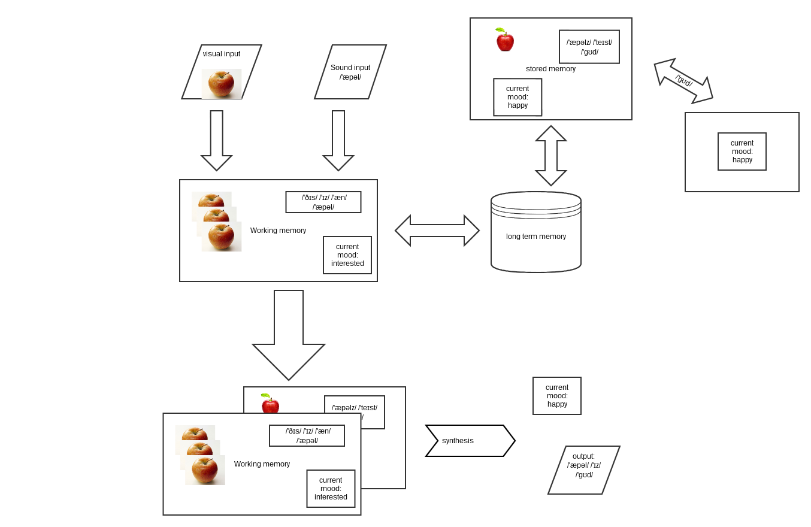Illustration 1: A rough flowchart of the Dynamically Linked State Database
I believe that this is a novel way of processing and storing data in relation to a machine learning algorithm, and merits research into feasibility and effectiveness in real world applications. The scope of the project is as follows:
- Establish the core functions of the database.
- Construct a functioning prototype utilizing OpenCV and pocketsphinx for inputs.
- Test the prototype to establish the success of the algorithm in cataloging and recalling data in a meaningful way.
At the end of the project I hope to come away with a better understanding of the effectiveness of the database algorithm.
In this project I plan to utilize the following resources:
- OpenCV and pocketsphinx documentation
- C language man pages
- Various books/documents on Neural Nets
- StackOverflow
- A live resource who is knowledgeable in programming using high level functional languages



