CSE306 - Computer Architecture Sessional

Assignment 3

8-bit MIPS Design and Simulation

**Submitted by:**

1805038 – Iftekhar E Mahbub Zeeon

1805049 - Somonidro Roy

1805050 - Salman Khondoker

1805053 - HAZ. Sameen Shahgir

1805055 - Shamit Fatin

17 August, 2022

1. **Introduction**

Microprocessor without Interlocked Pipe-lined Stages (MIPS) is a Reduced Instruction Set Computer (RISC) Instruction Set Architecture (ISA). In this assignment, we implement a Processor both in software and hardware that operates on a simplified ISA based on MIPS with the 16-bit instructions of the following formats.

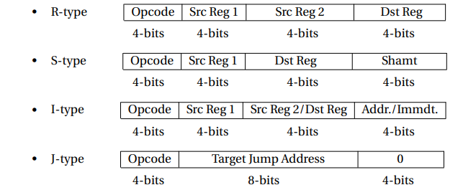

Some of the key specifications of this project are:

* 8-bit Data bus
* 16-bit Address bus
* 4-bit ALU
* Support for 16 operations in hardware
* Can simulate stack operations through lw and sw.

1. **Instruction Set:**

Section A2 Group 3 Instruction Set Assignment: BDEFPIOLHCNJKAGM

**Control Word**

|  |  |  |  |  |  |  |  |  |  |  |  |
| --- | --- | --- | --- | --- | --- | --- | --- | --- | --- | --- | --- |
| 11 | 10 | 9 | 8 | 6 | 7 | 5 | 4 | 3 | 2 | 1 | 0 |
| Reg  Dst | Jump | BEQ | BNEQ | MemRead | MemWrite | Mem-toReg | ALU Op(2) | ALU Op(1) | ALU Op(0) | ALU-Src | Reg-Write |

|  |  |  |  |  |  |
| --- | --- | --- | --- | --- | --- |
| **ID** | **Name** | **Type** | **Opcode** | **Control Word (Bin)** | **Control Word (Hex)** |
| B | addi | I | 0000 | 0000 0000 0011 | 003 |
| D | subi | I | 0001 | 0000 0000 0111 | 007 |
| E | and | R | 0010 | 1000 0000 1001 | 809 |
| F | andi | I | 0011 | 0000 0000 1011 | 00b |
| P | j | J | 0100 | 0100 0000 0000 | 400 |
| I | sll | R | 0101 | 0000 0001 0111 | 017 |
| O | bneq | I | 0110 | 0001 0000 0100 | 104 |
| L | lw | S | 0111 | 0000 1100 0011 | 0c3 |
| H | ori | I | 1000 | 0000 0000 1111 | 00f |
| C | sub | R | 1001 | 1000 0000 0101 | 805 |
| N | beq | I | 1010 | 0010 0000 0100 | 204 |
| J | srl | R | 1011 | 0000 0001 1011 | 01b |
| K | nor | R | 1100 | 1000 0001 0001 | 811 |
| A | add | R | 1101 | 1000 0000 0001 | 801 |
| G | or | R | 1110 | 1000 0000 1101 | 80d |
| M | sw | S | 1111 | 0000 0010 0010 | 022 |

1. **Circuit Diagram**

**AL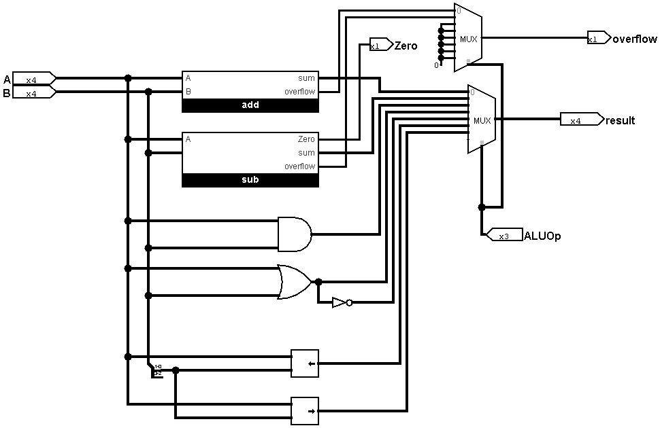U:**

**Register File:**

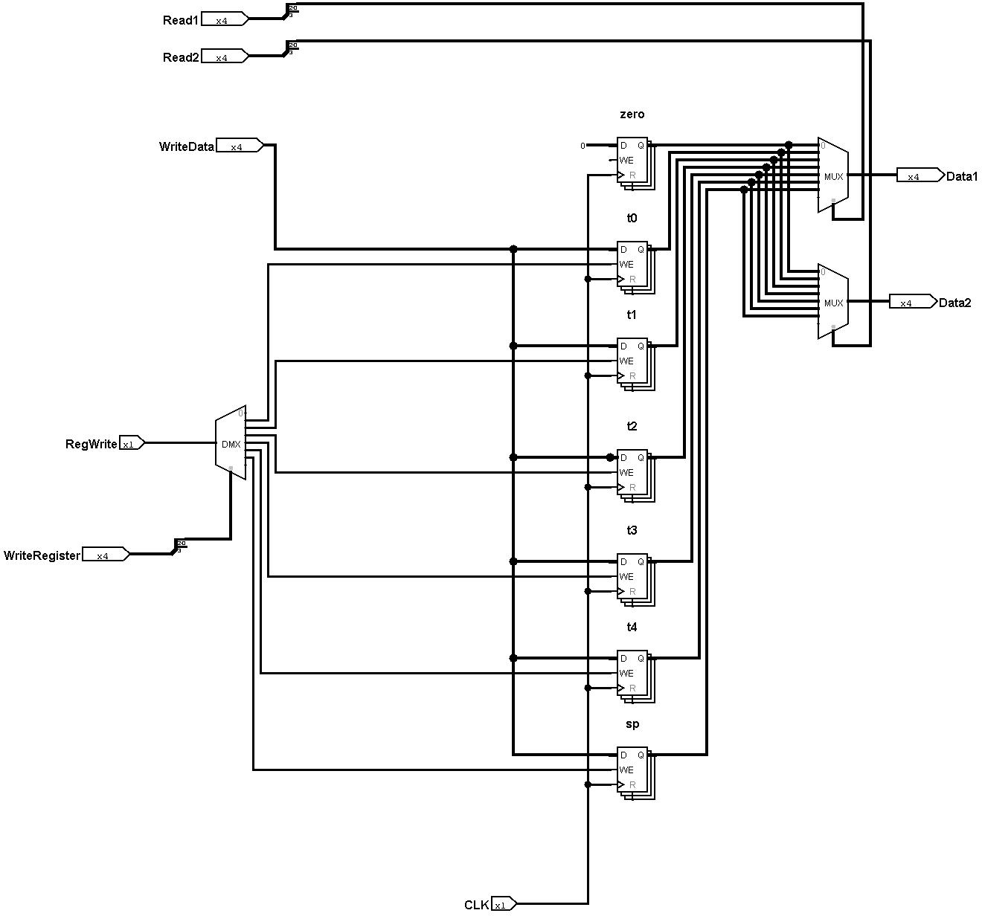

**Control Unit:**

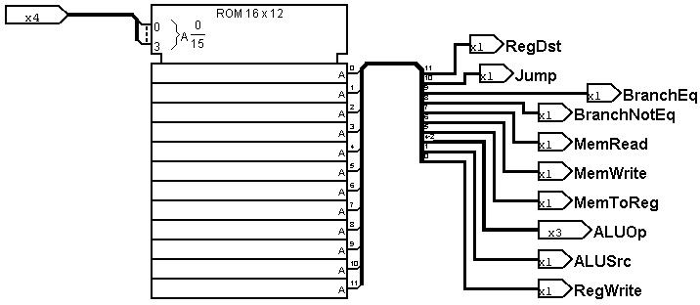

**Memory File:**

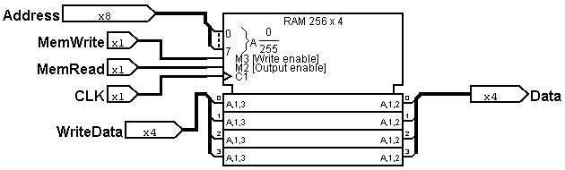

1. **Program Creation and Execution**

* Write the assembly code in a [file_name].txt file
* Compile mips2hex.cpp**: g++ mips2hex.cpp**
* Run the command: **./a.exe [file_name]**
* A hex.txt file should automatically be created in the current directory.
* Flash the hex code in the instructions.txt into the Instruction EEPROM
* The processor is now ready to execute.
* Step through the instructions one at a time using the Clock Pulse button.
* Instruction, Control, ALU, Register and Memory contents are displayed with LEDS

1. **Special Features**

The microprocessor supports stack operations using a dedicated stack pointer $sp. Since the 4-bit ALU can address 16 memory addresses, we reserved the first 12 for heap and the last 4 for stack. A maximum of 4 elements can be stored in the stack at any one time. Each stack operation is replaced by two instructions by the assembler. For example:

sw $t1, 0($sp) = sw $t1, 0($sp) subi $sp, $sp, 1

lw $t1, 4($sp) = lw $t1, 1($sp) addi $sp, $sp, 1

1. **IC User with Count**

|  |  |  |
| --- | --- | --- |
| IC | Type | Count |
| ATMEGA32 | ROM/RAM/ALU emulation | 4 |
| 74157 | Quad 2x1 MUX | 7 |
| 7483 | 4 Bit Adder | 4 |
| 7432 | Quad OR Gate | 1 |
| 7404 | Quad NOT Gate | 1 |
| 7408 | Quad AND Gate | 1 |
| Shamit’s parts |  |  |

1. **Discussion:**

* We noticed that to achieve 1 CPI for all instructions, the memory needs to be read at the rising edge of the clock pulse and the registers need to be written to at the falling edge.
* As per problem specification, the address bus is 8 bits long. A total of 256 instructions can be loaded at once and the Memory File has 256×4 = 1024 bits total capacity. However, since the ALU output is 4 bits, which is zero extended to 8 bits, only the first 16 addresses can be accessed.
* For *serial left shift* [sll] and *serial right shift* [srl] operations, if the shift amount exceeds 3, we have taken to be *modulo 4*. For example, **sll $t0, $t1, 7** is executed as **sll $t0, $t1, 3** since 7%4=3. This was done because in shifter IC chips, the shift amount cannot exceed the operand bit size.
* For branching operations [beq] and [bneq], the offset is sign extended. This allows branching 8 instructions backwards and 7 instructions forward.
* Due to the market scarcity of 4-bit ALU **IC 74181** chip, it had to be simulated using an **ATMEGA32**. The **ATMEGA32** also performs the shift operations which are not natively supported in **IC 74181**.
* Due to the market scarcity of parallel **EEPROM**, the Control Unit, Instruction File and Memory File had to be simulated using **ATMEGA32**. The clock cycle of the microcontroller is 1MHz and hence fast enough that operations appear instantaneous as in the combinatorial circuits it replaces.
* The two additional Adders used for PC increment and branching were implemented using only **IC 7483.**
* The overall design philosophy was to create the processor in such a way that the **ATMEGA32** could be easily replaced with their corresponding IC chips, hence staying true to the intention of this assignment: *building a processor from the ground up.*