
Department of Computer Science and Engineering
BACKEND ENGINEERING AND SYSTEM CHALLENGE (APEX 2026)
PROJECT DOCUMENTATION
Date: 10-10-2026 | Venue: 2nd Floor, A Block
Field | Details
Project Title | SECURE PASSWORD MANAGER UI
Team Name / Team No. | 6
Year / Semester / Section | II Year B.Tech / _1__ Sem / ___
Technology Stack | MongoDB, Express.js, React, Node.JS
Project Category | Full-stack Web Application / Cybersecurity
Faculty Mentor | YEDUKONDALU
Team Members
S.No | Name of the Student | Roll No. | Role
1 | Salloju Vishnu Vardhan Chary | 25MVCSMR0077 | Team Lead
2 | Koppolla Venkata Phaneendra Kumar | 25MVCSMR0049 | Member
3 | Kathi Sai Rithivik | 25MVCSMR0045 | Member
4 | Mohammed Thulif Rehan | 25MVCSMR0062 | Member

1. Problem Statement

Secure Password Manager UI 1. Problem Statement Build a MERN-based secure password manager ui that Build a password-management application with authentication. 2. Detailed Description The system should manage user, website, username, password using MongoDB. React should provide the user interface, while Node.js and Express.js should handle the backend APIs. The system should support the main operations required for the project, including adding, viewing, updating, and managing relevant records. 3. Objectives • Demonstrate MERN Stack development. • Implement CRUD operations using MongoDB. • Build REST APIs using Node.js and Express.js. • Develop the frontend using React.js. • Implement authentication and role-based access where required. • Display project information and results clearly

2. Objectives

- Build a full-stack password manager using the MERN architecture.
- Provide registration and login with Gmail OTP verification.
- Store account passwords as secure hashes rather than plain text.
- Protect saved website credentials with encryption at rest.
- Support create, read, update, search, copy, favorite, categorize, and delete operations.
- Provide password generation and a Security Center for basic credential hygiene checks.
- Deliver a responsive interface with light/dark themes and multiple credential viewing modes.
- Restrict users to their own credentials through authenticated backend APIs.

3. Proposed System and Architecture

SecureVault follows a three-layer architecture. The React application provides the user interface. The Express API validates requests, handles authentication and OTP verification, applies authorization checks, and performs encryption-related operations. MongoDB stores user profiles and credential records.
Layer | Technology | Responsibility
Presentation | React + Vite | Login, registration, OTP entry, dashboard, credential forms, search, settings and responsive UI.
Application / API | Node.js + Express.js | Authentication routes, OTP workflows, validation, authorization, credential CRUD and error handling.
Data | MongoDB / Mongoose | User accounts, verification state, and user-scoped credential records.
Email | Nodemailer + Gmail SMTP | Deliver registration and login OTP messages.
Security | bcrypt, JWT/cookie strategy, AES-256-GCM (intended design) | Password hashing, authenticated sessions/tokens, and encryption of saved credentials.

4. High-Level Data Flow

User → React UI → Express API → Authentication / OTP checks → MongoDB
↘ Nodemailer → Gmail OTP email
Authenticated user → Credential API → Encryption/decryption service → MongoDB
The frontend should never decide whether a user is authenticated by itself. The backend must validate the session/token and authorize each request. Every credential query must be scoped to the authenticated user's ID.

5. User Authentication and Gmail OTP Flow

5.1 New User Registration
- The user enters name, email, password and confirmation on the registration page.
- The backend validates the input and checks for an existing account.
- The account password is hashed using bcrypt or the project's existing secure password-hashing library.
- The backend generates a cryptographically random six-digit OTP and sends it using Nodemailer and Gmail SMTP.
- The user enters the OTP on the verification page.
- The backend checks the OTP hash, purpose, expiry and attempt count; the OTP is single-use.
- After successful verification, the account is marked verified and the user can proceed to login.

5.2 Existing User Login
- The user enters the registered email and account password.
- The backend validates the credentials; invalid credentials do not trigger a successful login.
- For valid credentials, the backend creates a fresh login OTP challenge and sends the OTP to the registered email.
- The user enters the OTP; the backend verifies it and rejects invalid, expired, reused or excessive-attempt challenges.
- Only after successful OTP verification does the backend create the authenticated session or issue the configured JWT.
- The user is redirected to the SecureVault dashboard.

5.3 OTP Safety Controls
- OTP expiry target: five minutes.
- Resend cooldown target: 60 seconds, with server-side rate limiting.
- Limit verification attempts (for example, five attempts per challenge).
- Store a hash of the OTP rather than plaintext; invalidate previous and used OTPs.
- Use distinct challenge purposes for registration and login.
- Do not return OTPs, passwords, JWTs, encryption keys or SMTP credentials in API responses or logs.
- If email delivery fails, do not claim the OTP was sent or grant authenticated access.
Gmail SMTP requires a valid supported authentication method. For App Password authentication, the sender account must have 2-Step Verification enabled and an App Password configured on the backend. OAuth2 is another supported approach. Credentials belong in backend environment variables and must not be committed to source control.

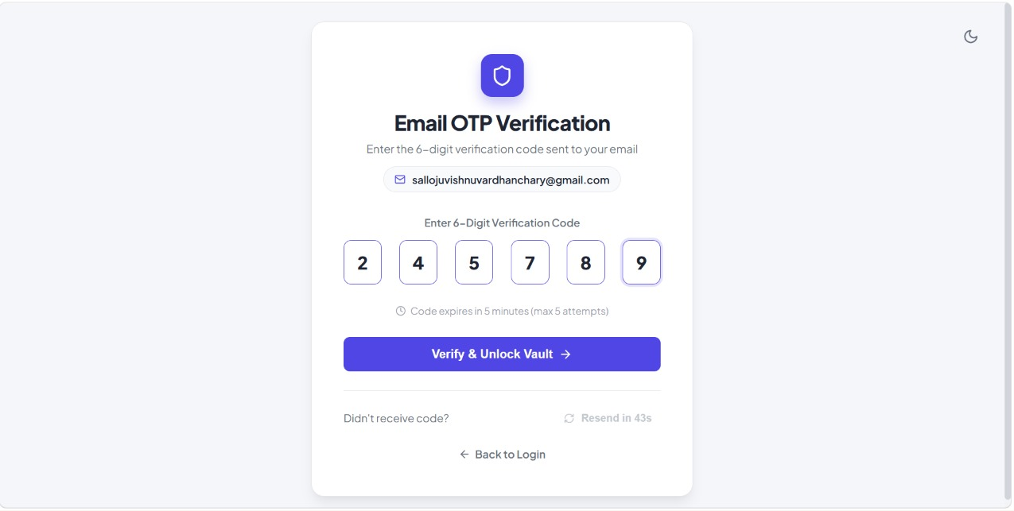

6. Core Features and Modules

Module | Description
Registration and Login | Account creation and credential validation.
Email OTP Verification | Email verification during registration and second-step verification during login.
Dashboard | Overview and navigation to password-management areas.
All Passwords | Display saved credential records using supported card, list or table views.
Credential CRUD | Add, view/reveal, edit and delete website, URL, username/email, password and category fields.
Search and Filtering | Find credentials by website or account details and filter by category.
Favorites | Mark frequently used records for quick access.
Password Generator | Generate stronger random passwords using browser cryptographic APIs where implemented.
Security Center | Provide basic checks or reminders such as identifying password reuse where implemented.
Settings and Theme | Responsive layout, light/dark mode, and user interface preferences.
Logout and Route Protection | Clear the authenticated session and prevent unauthenticated access to private pages and APIs.

7. Database Design
Field | Purpose
_id | Unique MongoDB user identifier.
name | User's display name.
email | Normalized unique email address.
passwordHash | Hash of the account password; never store the plaintext password.
emailVerified | Indicates whether registration email verification succeeded.
createdAt / updatedAt | Account timestamps.

7.2 Credential Record
Field | Purpose
_id | Unique credential identifier.
userId | Owner reference used for authorization and query scoping.
website / url | Website or service name and URL.
username / email | Login identifier for the stored website account.
encryptedPassword | Encrypted saved website password; never plaintext at rest.
iv / authTag | Encryption parameters required by an authenticated encryption scheme, where applicable.
category / favorite | Organization and favorite status.
createdAt / updatedAt | Credential timestamps.

8. Security Design
- Account password hashing: use bcrypt (or an established password-hashing library) with appropriate parameters.
- Saved credential encryption: the project documentation describes AES-256-GCM; use a unique nonce/IV for each encryption operation and authenticate ciphertext.
- Key management: keep encryption keys on the server or use a deliberately designed client-side zero-knowledge architecture. Do not store encryption keys alongside encrypted records in the database.
- Authentication: issue a JWT or create a session only after successful login OTP verification. If JWT cookies are used, configure HttpOnly, Secure in production, SameSite, expiry, and CSRF protection appropriately.
- Authorization: check the authenticated user's ID on every credential read, update, reveal and delete operation.
- Configuration: keep MongoDB URI, JWT secrets, encryption keys, and Gmail credentials in backend environment variables; exclude `.env` from Git.
- Transport: use HTTPS in production, restrict CORS to the trusted frontend origin, validate inputs, rate-limit sensitive endpoints, and avoid leaking stack traces.
- Logging: never log account passwords, OTPs, authentication tokens, encryption keys, or plaintext saved credentials.
Important limitation: encryption on the server does not by itself provide zero-knowledge security. If the backend can access the encryption key and plaintext, a compromised backend may expose credentials. A zero-knowledge design requires key derivation and encryption/decryption to be performed client-side, with careful recovery and usability design.

9. API Design

Method | Example Endpoint | Purpose
POST | /api/auth/register | Register a user and initiate registration OTP verification.
POST | /api/auth/verify-registration-otp | Verify registration OTP and activate the account.
POST | /api/auth/login | Validate credentials and initiate login OTP.
POST | /api/auth/verify-login-otp | Verify login OTP and create the authenticated session.
POST | /api/auth/resend-otp | Request a new OTP subject to cooldown and rate limits.
GET | /api/auth/me | Return safe details for the authenticated user.
POST | /api/auth/logout | Clear/revoke the authenticated session.
GET | /api/credentials | List the current user's credentials.
POST | /api/credentials | Create a credential for the current user.
GET | /api/credentials/:id | Read an owned credential.
PATCH | /api/credentials/:id | Update an owned credential.
DELETE | /api/credentials/:id | Delete an owned credential.

10. Testing and Test Cases

Test | Input / Action | Expected Result
Registration | Valid details and valid registration OTP | Account is verified and registration completes.
Duplicate email | Register with an existing email | Request is rejected safely.
Invalid OTP | Enter an incorrect OTP | Verification fails; attempt count increases.
Expired OTP | Enter OTP after expiry | Verification is rejected.
OTP resend | Resend before cooldown ends | Request is rate-limited.
Login | Correct password and valid login OTP | Authenticated dashboard access is granted.
Invalid login | Wrong email/password | Authentication is rejected.
Email failure | Invalid SMTP configuration or Gmail rejects login | Safe error shown; no authenticated access granted.
Protected route | Request credentials without session/token | Backend returns unauthorized response.
Ownership | User A requests User B's credential ID | Access is denied.
CRUD | Create, view, edit and delete owned credential | Changes are persisted and correctly scoped.
Logout | Logout then request a protected API | Session is cleared and request is rejected.

These are required test cases and expected outcomes. They should not be interpreted as evidence that every test has already passed. Run them against the actual development and deployed environments and record the results.

11. Deployment and Configuration
- Frontend: install dependencies in the frontend directory and run the Vite development server; production builds should be deployed as a frontend service/static site.
- Backend: install dependencies in the backend directory and start the Express server using the package.json start script.
- MongoDB: use MongoDB Atlas or a reachable MongoDB server. A local URI such as `127.0.0.1` on a developer laptop is not reachable from a separate Render service.
- Environment variables: configure MONGODB_URI, JWT_SECRET (or the actual token-secret variable), JWT_EXPIRES_IN, ENCRYPTION_KEY, CLIENT_URL, NODE_ENV, PORT, GMAIL_USER and GMAIL_APP_PASSWORD as required by the code.
- CORS: set CLIENT_URL to the actual deployed frontend origin in production.
- Secrets: configure deployment environment variables through the hosting dashboard; never commit `.env` or paste real secrets into public issue trackers.
Deployment readiness depends on the actual environment values, a reachable database, matching frontend/backend URLs, and successful SMTP authentication. Confirm these by reviewing runtime logs and testing a complete OTP flow after deployment.

12. Results and Expected Output
The intended result is a responsive password-management interface in which an unauthenticated user must register or log in, complete the required Gmail OTP step, and then manage only their own saved credentials. The dashboard supports credential organization and retrieval, while backend authorization and encryption-related controls reduce exposure of sensitive information.
Expected visible behavior includes registration/login forms, OTP entry and resend feedback, a protected dashboard, credential cards or tables, search and category filters, password reveal/copy actions, favorites, a password generator, and logout. Actual output and performance should be documented after running the completed build and test cases.

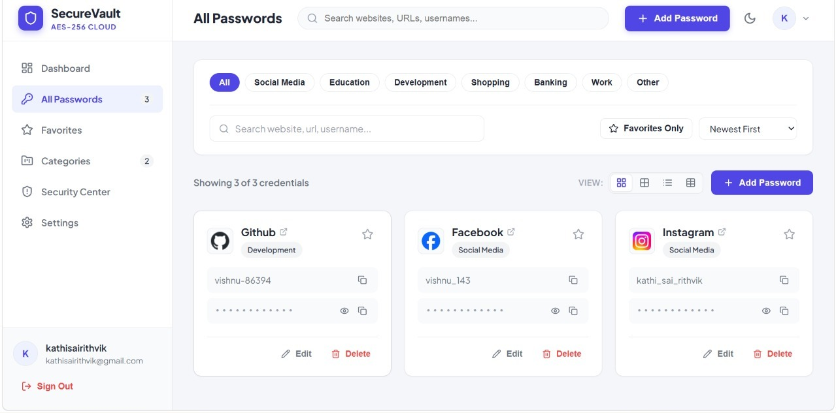

13. Future Scope
- Implement a client-side zero-knowledge vault with a carefully designed recovery strategy.
- Add optional authenticator-app MFA and backup codes.
- Add breach-password checks using privacy-preserving services where appropriate.
- Introduce session/device management and revocation.
- Add automated security tests, dependency scanning, and independent penetration testing.
- Improve accessibility, audit logging that excludes secrets, and deployment monitoring.
- Add secure import/export with explicit warnings and protected export files.

14. References
- MongoDB Documentation — https://www.mongodb.com/docs/
- Express.js Documentation — https://expressjs.com/
- React Documentation — https://react.dev/
- Node.js Documentation — https://nodejs.org/docs/
- Nodemailer Documentation — https://nodemailer.com/
- OWASP Cheat Sheet Series — https://cheatsheetseries.owasp.org/
- JSON Web Token (JWT) — https://jwt.io/introduction
- Node.js Crypto Documentation — https://nodejs.org/api/crypto.html

15.Appendix A. Environment Variable Names
Use the variable names expected by the existing source code. Example names are shown below; never place actual secrets in this document.
PORT=5000
NODE_ENV=development
CLIENT_URL=http://localhost:5173
MONGODB_URI=<your-mongodb-connection-string>
JWT_SECRET=<generate-a-long-random-secret>
JWT_EXPIRES_IN=15m
ENCRYPTION_KEY=<secure-key-in-the-format-required-by-the-code>
GMAIL_USER=<otp-sender-gmail-address>
GMAIL_APP_PASSWORD=<gmail-app-password>
For production, use the deployed frontend URL and a secure remote MongoDB URI. Keep the real `.env` file out of Git and ZIP files shared publicly.

16 . Conclusion
SecureVault is designed as a full-stack password manager that combines React-based user interaction, Express API services, MongoDB persistence, Gmail OTP verification, and protection for stored website credentials. Its key objective is to make credential management more organized while enforcing authentication and per-user access control. Before production use, the project should be tested end to end, secrets must be managed safely, the database and SMTP service must be configured correctly, and the encryption and session design should receive a focused security review.

