**Name: Sally Sherweif Mohamed**

**Exam 2.A**

* Main.dart:

import 'package:flutter/material.dart';  
import 'package:newtest/src/app_root.dart';  
  
void main(){  
 runApp(AppRoot());  
}

* App_root.dart:

import 'package:flutter/material.dart';  
import 'package:newtest/screens/welcome_screen.dart';  
  
  
class AppRoot extends StatelessWidget{  
 @override  
 Widget build(BuildContext context) {  
 // *TODO: implement build* return MaterialApp(  
 debugShowCheckedModeBanner: false,  
 home: WelcomeScreen(),  
 );  
 }  
}

* Welcome_screen.dart:

import 'package:flutter/material.dart';  
import 'package:newtest/screens/places.dart';  
  
class WelcomeScreen extends StatefulWidget{  
 @override  
 State<WelcomeScreen> createState() => _WelcomeScreenState();  
}  
  
class _WelcomeScreenState extends State<WelcomeScreen> {  
 @override  
 Widget build(BuildContext context) {  
  
 return Scaffold(  
 body: Container(  
 decoration: BoxDecoration(  
 image: DecorationImage(  
 image: AssetImage('images/welcome.png'),  
 fit: BoxFit.cover  
 )  
 ),  
  
 child: PageView(  
 scrollDirection: Axis.horizontal,  
 children:[  
  
 const Column(  
 mainAxisAlignment: MainAxisAlignment.start,  
 children: [  
 Row(  
 children: [  
 Padding(  
 padding: EdgeInsets.only(  
 top: 15,  
 left: 10  
 ),  
 child: Column(  
 children: [  
 Text('Explore Beauty \nOf Journey', style: TextStyle(  
 color: Colors.*black*,  
 fontSize: 50,  
 fontWeight: FontWeight.*bold* ),),  
  
 ],  
 ),  
 ),  
 ],  
 ),  
  
 Row(  
 children: [  
 Padding(  
 padding: EdgeInsets.only(  
 top: 5,  
 left: 10  
 ),  
 child: Text('Everything you can imagine, is here', style: TextStyle(  
 color: Colors.*black*,  
 fontSize: 15  
 ),),  
 ),  
 ],  
 ),  
 Spacer(  
 flex: 1,  
 ),  
 Row(mainAxisAlignment: MainAxisAlignment.center,  
 children: [  
 Row(  
 children: [  
 Icon(Icons.*arrow_forward_ios_sharp*, color: Colors.*white*),  
 Icon(Icons.*arrow_forward_ios_sharp*, color: Colors.*white*),  
 Icon(Icons.*arrow_forward_ios_sharp*, color: Colors.*white*)  
 ],  
 ),  
 SizedBox(width: 10,),  
 Column(  
 children: [  
 Text('Swipe to Explore Now', style: TextStyle(color: Colors.*white*,  
 fontSize: 20),),  
 ],  
 )  
 ],  
 )  
 ],  
 ),  
 Places(),  
 ],  
 ),  
 ),  
 );  
 }  
}

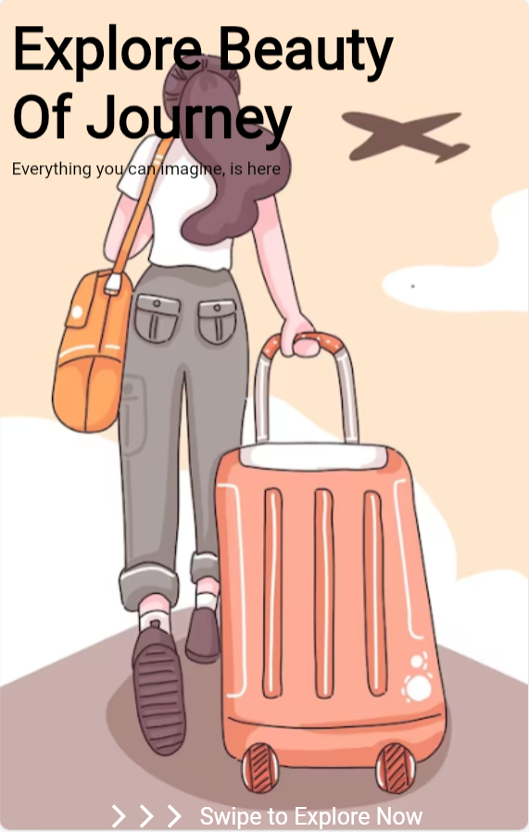

* Places.dart:

import 'package:flutter/material.dart';  
  
class Places extends StatefulWidget{  
 @override  
 State<Places> createState() => _PlacesState();  
}  
  
class _PlacesState extends State<Places> {  
 @override  
 Widget build(BuildContext context) {  
  
 return Scaffold(  
 body: Column(  
 children: [  
 Row(mainAxisAlignment: MainAxisAlignment.center,  
 children: [  
 Column(  
 children: [  
 Container(  
 child: CircleAvatar(  
 radius: 30,  
 backgroundImage: AssetImage('images/man.png'),  
 ),  
 ),  
 ],  
 ),  
 Padding(  
 padding: const EdgeInsets.all(8.0),  
 child: Column(  
 children: [  
 Row(children: [Text('Welcome Back'), Icon(Icons.*handshake*)],),  
 Row(children: [Text('Ronald Richards', style: TextStyle(fontSize: 20, fontWeight: FontWeight.*bold*),)],)  
 ],  
 ),  
 ),  
 Column(  
 children: [  
 Container(  
 child: CircleAvatar(  
 radius: 20,  
 child: Icon(Icons.*timer_outlined*, color: Colors.*white*),  
 backgroundColor: Colors.*red*[100],  
 ),  
 )  
 ],  
 )  
 ],  
 ),  
 Row(),  
 Row(),  
 Row(  
 children: [  
 ],  
 )  
 ],  
 ),  
 bottomNavigationBar: BottomNavigationBar(  
 items: <BottomNavigationBarItem>[  
 BottomNavigationBarItem(  
 icon: Icon(Icons.*home*, color: Colors.*grey*,),  
 label: '',  
 backgroundColor: Colors.*red*[100]),  
 BottomNavigationBarItem(  
 icon: Icon(Icons.*location_on*, color: Colors.*grey*,),  
 label: 'Destination'),  
 BottomNavigationBarItem(  
 icon: Icon(Icons.*map_outlined*, color: Colors.*grey*),  
 label: 'Location'),  
 BottomNavigationBarItem(  
 icon: Icon(Icons.*favorite*, color: Colors.*grey*),  
 label: 'Favourites'),  
 BottomNavigationBarItem(  
 icon: Icon(Icons.*person_outline*, color: Colors.*grey*),  
 label: 'Profile')  
 ],  
 ),  
 );  
 }  
}

