

Lebanese University

Faculty of Engineering III

Electrical and Electronic Department

Object Oriented Programming

Ticket Booking System

Sally Zaiter 6957

Dalia Ismail 6645

2025- 2026

TABLE OF CONTENTS
TABLE OF CONTENTS ii
LIST OF FIGURES iIi
CHAPTER 1 INTRODUCTION 1
CHAPTER 2 System Design and Implementation 2
2.1 Introduction 2
2.2 System Design 3
2.4 Implementation Steps 7
CHAPTER 3 Conclusion and Future Work 32
3.1 Conclusion 32
3.2 Future Work 33

III- LIST OF FIGURES

Figure ‎3-1: UML Diagram for user 3
Figure ‎3-2: UML Diagram for event 3
Figure ‎3-3: UML Diagram for booking 3

referring to : website online ………….
fig 1:

: INTRODUCTION

Objective

The main objective of our project is to create an application for Event Ticket Booking System using C# and Windows Forms. The system has to provide an interface for admins and one for users, where admins can create, update, and remove events. While users can search for events, book available seats, and cancel their booking. The project also covers OOP concepts and data handling using JSON files.

Problem Statement
In many cases, event management is handled often manually or with simple tools such as paper lists or spreadsheets, this approach can lead to several problems, including data inconsistency, difficulty in tracking available seats, and lack of a centralized system for managing events. This creates the need for a simple, reliable, and organized system to manage events and bookings efficiently.

Proposed Solution

Although the project was initially intended as a desktop application, it was designed also to be adaptable for both desktop and online use.

The application provides two main roles: an admin interface to manage events and a user interface to search and book events. we choose that all data provided by each of these two, to be stored in JSON files. By implementing this solution, the project delivers a practical tool that improves organization, efficiency, and user experience in event management.

: System Design and Implementation

Introduction
In this chapter, we are going to explain how we designed and implemented our event booking system. We first analyzed the given key features in order to conclude the needed classes.

So first, we need to create a “User class” handling its properties: user info and booked events by user. Users can book, cancel and search for events.
Next a Booking class for tracking bookings and seat numbers (bookingID, user, event, seatNumber, status). Also include seat logic for booking and cancelling events.

And of course we need event class to include events info.

We decided to keep admin as a role like adding/removing events, updating seat capacity, and viewing reports, so no need for an admin class.

Based on this analyze, we could decide the structure and relationships between the classes.

The following sections will show the system design with diagrams, list of the required components, and we provide a step-by-step implementation of our project.

System Design
Ticket Booking use case

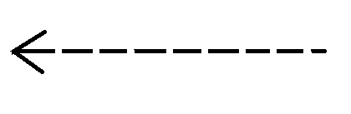
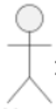
use Case Diagram
Actor
Update Booking
Update seat count
Cancel all Booking
Check seat availability
“include”
“Generalization”
“Generalization”
Search Event
By date
By price
By category
View
Select Event
Booking Event
“Generalization”
“include”
“include”
Controller/Admin
“include”
Select Event
View
“include”
Summary
Update seats of event
Remove Event
Add Event
System boundary
Association
Use case
Userr
The Use Case Diagram of the Event Ticket Booking System was designed by first identifying the main actors interacting with the system, which are the User and the Admin (Controller).

The User actor is responsible for browsing and booking events. The user can Search Event, which is modeled as a generalized use case with specialized forms:
- Search by Date,
- Search by Price,
- and Search by Category.
This generalization represents an is-a relationship, where each specialized search is a specific type of the general search functionality.
After searching, the user can View the available events, Select Event, and then Book Event. The Book Event use case includes Check Seat Availability and Update Seat Count to ensure that bookings are only completed when seats are available and that the system correctly updates the remaining seats. The user can also Cancel all Booking and Update booking(add or remove a places in a booked event) which results in updating the seat count accordingly.
The Admin (Controller) actor manages the events in the system. The admin can Add Event, Remove Event, and Update Seats of Event. the admin can view system reports through the Summary use case, which provides an overview of ticket sales. The admin may also View and Select Event before performing management operations such as removing an event or updating its seat capacity.
The include relationships are used to represent necessary sub-functions that are always executed as part of a main use case, such as checking seat availability during booking. The system boundary defines the scope of the system and clearly separates the actors from the system’s internal functionalities

Class Diagram
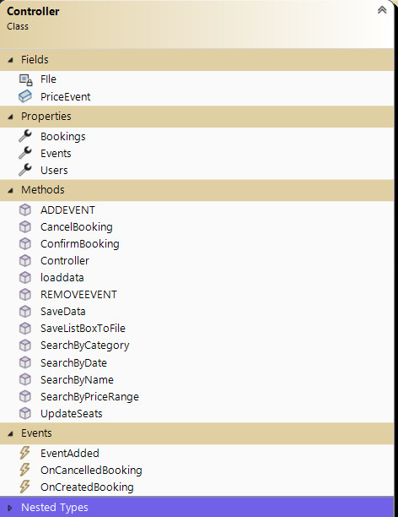
++ UML amd relationships


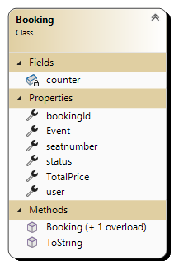
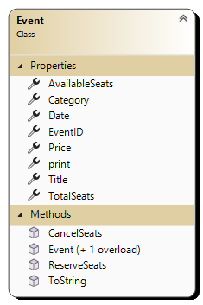

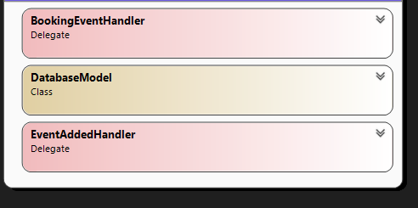

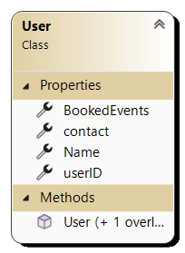

1
1

- User – Booking (Association, One-to-Many):
The relationship between User and Booking is an association because a user can create multiple
bookings, while each booking is associated with exactly one user.
It’s an association type multiplicity (e.g. One user can have many bookings)

- Event – Booking (Association, One-to-Many):
The relationship between Event and Booking is also an association since a single event can have
many bookings, but each booking refers to only one event.
One event can have many bookings

- Controller contains 3 lists:Bookings,users,events ,and a methods contains those as parameters so this class hold the 3 classes but the 3 classes can exist independently outside the controller.
And we know that the aggregation is a type of “has a“ relationship
Controller “has a” :
*Events
*Users
*Bookings.
public List<Event> Events { get; set; } = new List<Event>();
public List<Booking> Bookings { get; set; } = new List<Booking>();
public List<User> Users { get; set; }=new List<User>();

- And we can talk about dependency relation between booking class and user/event class
“Dependencyis represented when a reference to one class is used in another class.”

public Booking(User user, Event Event, int seatnumber, string status)

{
bookingId = counter++;
this.user = user;
this.Event = Event;
this.seatnumber = seatnumber;
this.TotalPrice = Event.Price * seatnumber;
this.status = status;

}
Booking class use event class and user class as paramateres so the relation of dependency
exist.

Required Components
our project is implemented using:
- Programming Language: C#
- Framework: .NET (Windows Forms)
- Development Environment: Microsoft Visual Studio
- Interfaces UI: Windows Forms
- Data Storage: JSON files.
- Additional Tools: Built-in .NET libraries for file handling and optionally the class diagram feature.

Implementation steps

• PROJECT SETUP: as a first step, open vs studio C# window forms.

• MVC folders: create 3 folders: model, view, controller

  - model (classes) → contain data and logic
  - view (forms) → display events, bookings, seat availability
  - controller → (Handles interactions between View and Model

PREVIEW:
    - Models
    - Forms (UI)
    - Data storage (JSON)
    - Controller (logic & flow)

• In Solution Explorer;
right click on project file add new item folder name it model.
same processes for view and controller folder.

• MODEL: creating the classes: User, Booking, Event
right click on model folder add new item Class User

same processes for other classes. in each created class code.
we added for each one the needed properties and methods.

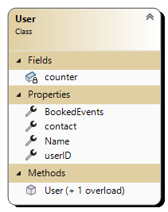
Name | Type | modifier | Description
 | properties
userID | int | public | Unique id for each user
Name | string | public | User full name
contact | string | public | User email info
BookedEvents | List<Booking> | public | A list of each userBookings
 | methods
User(string name, string Contact) |  | public | Constructor that initialize a new user and auto-assigns ID
public User() |  |  | Default constructor for some code or frameworks (like JSON, UI bindings
 | fields
counter | int | private static | Stores last ID to auto-generated user IDs.
table 1: User class
NOTE: the counter field is a static variable used to automatically generate unique IDs for each user. It is shared by all objects of this class and increases each time a new user is created.

namespace OOP_lastversion.model // define a namespace for model class
{
properties to store user infos
; userID, Name, contact
public class User //define user class
{
public int userID { get; set; }
public string Name { get; set; }
public string contact { get; set;}//via email

[JsonIgnore]
List of user bookings,ignored during JSON serialization to avoid repetition

public List<Booking>
BookedEvents { get; set; }= new List<Booking>();

//the id will be inserted in the form,generated automatically by the application(we will see it in the login user form)
Default constructor for some code or frameworks (like JSON, UI bindings) that need to create a User without parameters.
public User() { }

public User(string name, string Contact)
{
Name = name;
contact = Contact;
BookedEvents = new List<Booking>();
}
Define parameterized constructor ,assign values to properties .
And initialize bookings list
}

}

Name | Type | modifier | Description
 | properties
bookingId | int | public | Unique id for booking
User | User | public | user name who made the booking
Event | Event | public | the Event being booked
Seatnumber | int | public | nb of seats booked by a user
Status | string | public | Booking status (confirmed/cancelled)
TotalPrice | int | public | Total price of this booking  (price of event * seatnumber )
 | methods
Booking(User user, Event Event, int seatnumber, string status) |  | public | Constructor to create a booking and assigns ID (view the body)
public Booking () { } |  | public | Default constructor for some code or frameworks (like JSON, UI bindings)
ToString() | string | public override | Returns a customized format booking details.
 | Fields
Counter | int | private static | Auto-degenerates unique booking IDs
table 2: Booking class

NOTE:- we want for each user to have his own list of booking IDs. for example, we can have booking
nb 1, 2,… for userA and booking nb 1,2,.. for userB, and not bookingID in general.
    - the counter field is a static variable used to automatically generates a unique ID for each new booking created.
    - Keyword override tells c# to use this method instead of the inherited one from object
Static counter to auto-generate booking IDs
namespace OOP_lastversion.model
{
public class Booking
{
private static int counter = 1;
properties to store Booking infos ;

public int bookingId { get; set; }
public User user { get; set; }
public Event Event { get; set; }
public int seatnumber { get; set; }
public string status { get; set; }//confirmed,canceled
Default constructor for some code or frameworks (like JSON, UI bindings) that need to create a Booking without parameters.
public int TotalPrice { get; set; }

public Booking ()
{ }

public Booking(User user, Event Event, int seatnumber, string status)
{
bookingId = counter++;
Define parameterized constructor, assign values to properties.
(+ calculate price = event price * nb of seats booked )
this.user = user;
this.Event = Event;
this.seatnumber = seatnumber;
this.TotalPrice = Event.Price * seatnumber;
this.status = status;
}

public override string ToString()
{ return string.Format("{0,-10}{1,-15}{2,-20}{3,-25}{4,-10}{5,-15} {6,-20}",$"User
nb:{user.userID}", $" Booking:{bookingId}", user.Name, Event.Title,
$"Seats:{seatnumber}",$"Total:{TotalPrice} ",$"Status:{status}");
} }
Customize a Format booking info as a string to display. This will be used when to show items in the listbox later on, in a certain format!
Name | Type | modifier | Description
 | properties
EventID | int | public | Unique ID for the event
Name / title | string | public | Event name
Date | DateTime | public | Date of the Event
Category | string | public | Event category
Price | int | public | Price of the event
TotalSeats | int | public | Total number of seats in the event
AvailableSeats | int | public | Remaining available seats (after bookings )
 | methods
Event(int EventID, string Title, string Category, DateTime Date, int Price, int seats) |  | public | Constructor that initializes a new user and assigns ID
public Event() { } |  |  | Default constructor without parameters.
ReserveSeats(int seatnumber) | bool | public | Reserves seats if available
CancelSeats(int seatnb) | void | public | Cancels seats and restores the availability of canceled seats
ToString() | string | public override | Returns a short event description
Print | string | public | Returns a formatted event details
table 3: Booking class

NOTE: we won’t add an auto-generated counter for eventID, because when admin remove an event with id = 2, the list will be shifted, which we don’t want this, we want to leave the IDs unique for each event, whether it is cancelled or created.

namespace OOP_lastversion.model
{
public class Event
properties to store Event infos ;
{
public int EventID { get; set; }
public string Title { get; set; }
public DateTime Date { get; set; }
public string Category { get; set; }
public int Price { get; set; }
public int TotalSeats { get; set; }
Default constructor without parameters.
public int AvailableSeats { get; set; }

public Event() { }

public Event(int EventID, string Title, string Category, DateTime Date, int Price, int seats)
{
this.EventID = EventID;
Define parameterized constructor, assign values to properties.
+ initialize available seats
this. Title = Title;
this.Category = Category;
this.Date = Date;
this.Price = Price;
TotalSeats = seats;
AvailableSeats = seats;
}

public bool ReserveSeats(int seatnumber)
{
if (AvailableSeats < seatnumber)
{ return false; }
AvailableSeats = AvailableSeats - seatnumber;
return true;
}

Method to try to reserve seats,
It checks availability, reduce seats, and return a true/false

Cancel seats for event,
increase available seats, make sure it doesn’t exceed total seats.
public void CancelSeats(int seatnb)
{
AvailableSeats= AvailableSeats+ seatnb;
if (AvailableSeats > TotalSeats)
{ AvailableSeats = TotalSeats; }
}

public override string ToString()
{
return $"Event{EventID}: \t {Title} \t Category: {Category} \t Date:
{Date.ToShortDateString()} \t Seats available: {AvailableSeats} \t Price:{Price}";

// return detailed event infos for listboxes. “\t” is added for design purpose
}
}

- public → can be accessed from anywhere (other classes or forms).
- private → can be accessed only inside the class itself where it’s defined.

Our classes represent the core data of the system. They define how users, events, and bookings are stored and manipulated. We move now to designing interfaces to allow interaction with the system, using Windows Forms

• VIEW (forms): we setup a plan for our forms to allows users and admin to interact with the application.

With every form created in the view folder, the vs will auto generate three files as shown in the figA: designer file, resource file, ‘form.cs’.
The “form.designer.cs” is auto-updated with every modification we did in the design window of the form.
the ‘form.cs’ file is where we write the form’s code and logic.
How to access it? right click on form view code or F7

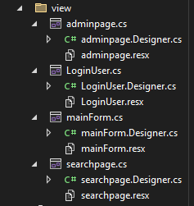figA
Form Purpose

Form1 homepage of the application, allowing the user to choose between
admin access (with password) or user area.

adminpage Allows admins to manage events by adding, removing, updating seats,
and viewing a summary of bookings including revenues.(total and for each event)

searchpage for users to search an event with his free time or favourite category or based
on a specific price (we do that before get username and email to avoid fill the
information without found his convenient event,the user can update seats e.g.
add more seats booking or remove some seats booked ,and full cancellation for
all seats in a selected event.

LoginUser Collects user information and confirms seat booking for the selected event,
validating input and creating the booking.

For each of the 4 form:
provide a screenshot (figure)
table of tools we added with description

- form1 ( mainForm )
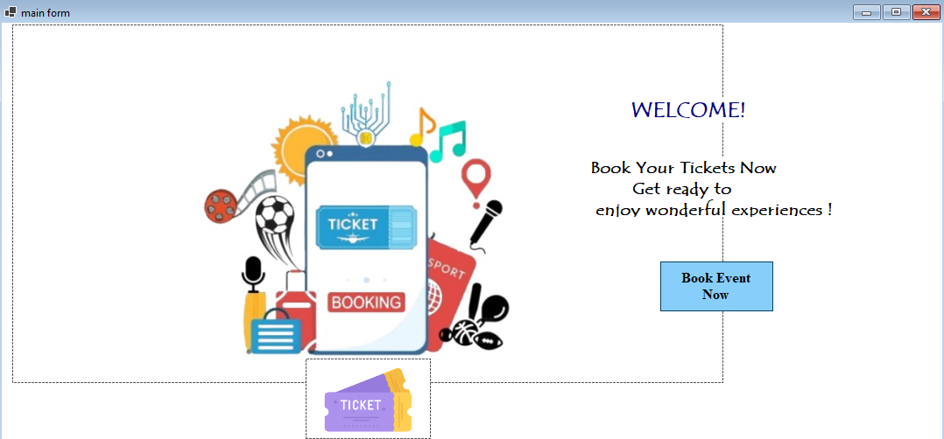
Tool added | (Name) | Added properties | Description/ purpose
Label | label1 | Text: WELCOME!
Label | label2 | Text: Book Your Tickets Now get ready to enjoy wonderful experiences !
picturebox | picBoxAdmin | Image: and add image | This will show the admin form with password
Button | button2 | Text: Book Event Now | This button will show user forms
picturebox | pictureBox2 | Image: and add image
table 4: properties of tools form
- set the back color of the form: White
- for the admin button, we will assign a password for admin only; to prevent other than admin to add/remove/edit events… using ‘Microsoft.VisualBasic.Interaction.InputBox()’
partial means the class is split between code-behind and designer files
namespace lastversionoop
{
public partial class Form1 : Form
{
Sets up and configures all form controls automatically, when the form is created!

declare a variable, to store the Controller object

private Controller controller;

private string adminSecret = "1";
define admin password and assign value

public Form1()
Form constructor
Initialize form components
Create an instance of Controller and assign it to a controller object
{
InitializeComponent();
this.controller = new Controller();
}
Sets up and configures all form controls automatically, when the form is created!

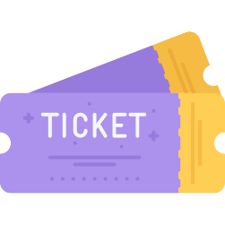
We decided to add a password to the admin button to restrict access
and ensure that only authorized people can open the admin page!

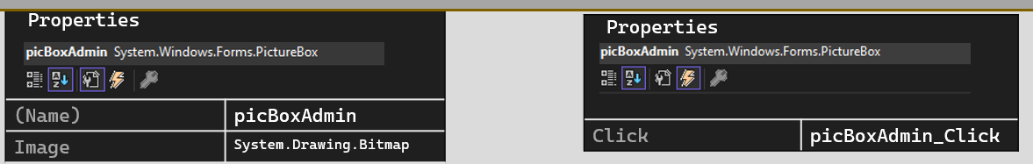

admin image click method

private void button1_Click(object sender, EventArgs e)
{
string input = Microsoft.VisualBasic.Interaction.InputBox(
"Enter secret admin password:", "Admin Login",""); // default empty

We used a built-in Microsoft VisualBasic InputBox method to get password input

if (input == adminSecret)
Check if password adminSecret is correct,

Define adminpage object
Show the desired panel
Hide current form
{
adminpage adminForm = new adminpage(controller);
adminForm.Show();
this.Hide();
}
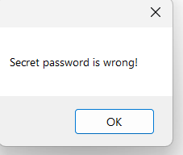
else
{ MessageBox.Show("Secret password is wrong!"); }
}
User button click method

private void button2_Click(object sender, EventArgs e) //and add event
{
searchpage UF = new searchpage(controller, this); //define object UF
UF.Show();
define a user page object
this.Hide();
}
}

[syntax] :
variable_created.Show(); Show user page
This/form_name.Hide(); Hide current form

Show() and Hide () are built-in methods ,
they are inherited from the form class in winForms
we use it to have an organized form

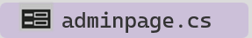

- Admin Form – add and remove events, update seats capacity, view report.
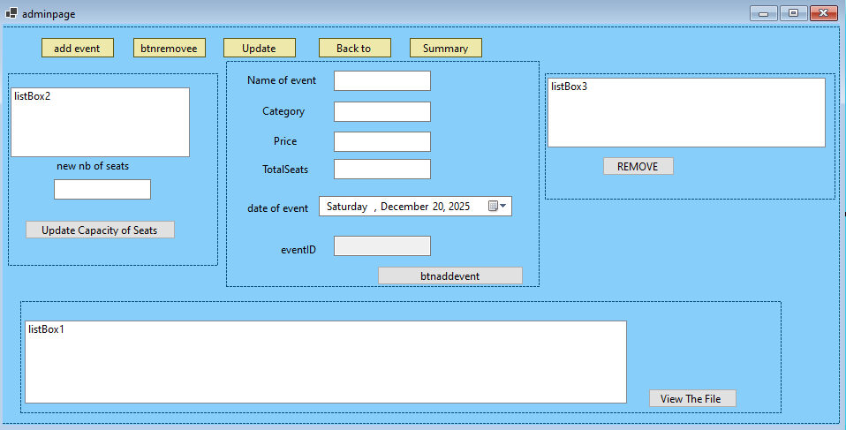
Tool added | (Name) | Added properties | Description/ purpose
Panel | panel1
Buttons | buttonA | Text: add event  Event: buttonA_Click | When this button is clicked , show panelA
 | buttonR | remove event  buttonR_Click | Show panelR
 | updateeventseats | Update Seats  updateeventseats_Click | Show
 | button5 | Back to main form  button5_Click | Show
 | buttonS | Summary  buttonS_Click | Show the form1
Panel | panelA
Label | label1,2,3,4,5,6 | Add Text
TextBox | Txttitle, txtcategory, txtprice, txtseats, txtid
DateTimePicker | dteventdate
Button | btnaddevent | ADD THE EVENT  btnaddevent_Click | To create the event, with the entered details in the textboxes.
 | panelU
 | label7
 | nbseatstxt
 | listBox2 |  | To display the lists of events
 | button4 | Update Capacity of Seats  button4_Click
 | panelR
ListBox | listBox3
Button | removent | REMOVE THE EVENT  removent_Click
 | panelS
 | listBox1
 | button6 | View and download The File  button6_Click
 | errorProvider1 | In adminpage
table 4:

- set back color of the form: light sky blue

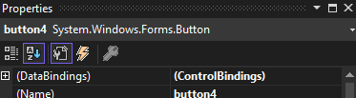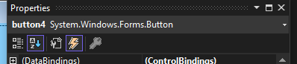
properties properties properties events

code
using lastversionoop.controller; ….
namespace lastversionoop
{
public partial class adminpage : Form
{
private Controller controller;
public adminpage(Controller c) //constructor adminpage with controller c parameter that is used to connect the form with all other forms the same controller is used in each other to conserve the information updated.
{
InitializeComponent();
this.controller = c; // assign passed controller to local controller
hidepanels();// hide all panels to more organize the form when the admin click a button his proper panel appear
}
//for design purpose
For design purpose;
We defined a method hidepanels()
to hide all panels we add.
And set their visibility to false
[syntax] : panelname.Visible = false/true ;
private void hidepanels()
{
panelA.Visible = false;
panelR.Visible = false;
panelU.Visible = false;
panelS.Visible = false;
}

private void adminpage_Load(object sender, EventArgs e)
{
listBox3.DataSource = controller.Events;
listBox2.DataSource = controller.Events;
Load events into list boxes we added when the form adminpage loads
listBox2.DisplayMember = null;
listBox3.DisplayMember = null;

}

private void ShowPanel(Panel panel, int Width, int Height)//we define a method to set size and center the panel also for organization and design
{
panel.Size = new Size(Width, Height);//set the size
panel.Left = (this.ClientSize.Width - panel.Width) / 2;//center the panel horizontally
panel.Top = (this.ClientSize.Height - panel.Height) / 2;//center it vertically
}
For design purpose;
Hide all panels, make the panelU visible
And center then resize it,
giving width = 600 pxl and height = 400 pxl
And also provide a certain size for the listbiox
Same for buttonS_Click and button updateseats-click and buttonR

//add eventss
private void buttonA_Click(object sender, EventArgs e)
{
hidepanels();
panelA.Visible = true;
ShowPanel(panelA, 600, 400);
//note :the sizes it can be changed in the code to have a last organzation
}
//so when we click the button the panel of add event appear

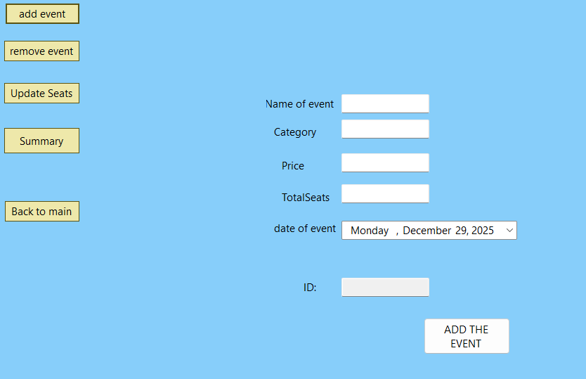

private void btnaddevent_Click(object sender, EventArgs e)
{
int id = controller.Events.Count + 1;//generate a new event id

string name = txttitle.Text;
Get event details
from the input textboxes we added in the form
[syntax] : type vaiable = textboxname.Text;
string category = txtcategory.Text;
DateTime date = dteventdate.Value;
int price = int.Parse(txtprice.Text);
int seats = int.Parse(txtseats.Text);

Event ev = new Event(id, name, category, date, price, seats);//here we create a new event with all details input

txtid.Text = ev.EventID.ToString();//the textbox is put readonly on the properties

public void ADDEVENT (Event e)
{
Events.Add(e);
SaveData();
}
controller.ADDEVENT(ev);

//that add the event to the list of events
of controller and saved to the file

listBox3.DataSource = null;
Refresh the event lists on the form
Reset and rebind the listBox data source to refresh and display the updated events list
listBox3.DataSource = controller.Events;
listBox3.DisplayMember = null;
listBox2.DataSource = null;
listBox2.DataSource = controller.Events;
listBox2.DisplayMember = null;

//when we write the display member = null that’s mean the display refer to the method
String to string in the class Event

MessageBox.Show("event added successfully and saved to file");
foreach (Control c in panelA.Controls)
{
clear all boxes in the panel
if (c is TextBox) ((TextBox)c).Clear();

}
panelA.Visible = false;
}
//remove eventss
private void buttonR_Click(object sender, EventArgs e)
{
hidepanels();
panelR.Visible = true;
ShowPanel(panelR, 700, 300);
listBox3.Size = new(470, 300);
This 2 lines are writed to easily move in the list box vertically and horizontally

listBox3.HorizontalScrollbar = true;
listBox3.ScrollAlwaysVisible = true;
}// when we click this button the panel to remove an event appear

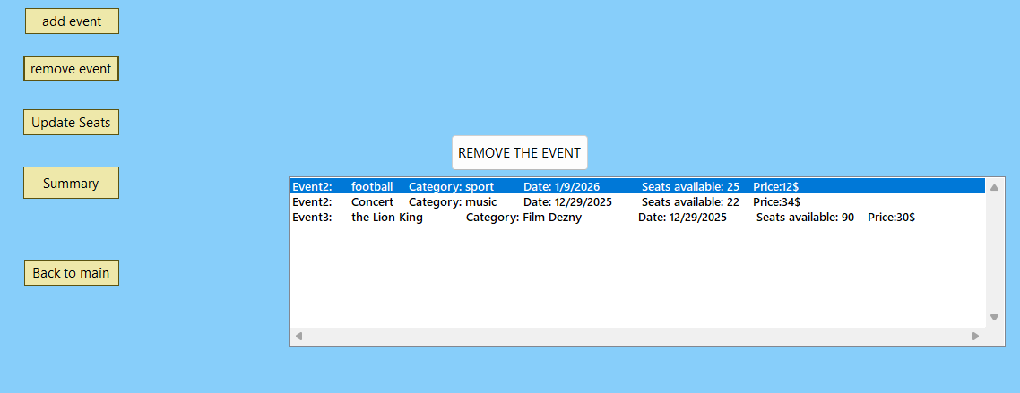

private void removent_Click(object sender, EventArgs e)
{
if (listBox3.Items.Count == null) { MessageBox.Show("No event to remove"); //check if
there are no events to remove
panelR.Visible = false; return; }
if (listBox3.SelectedItem == null) {MessageBox.Show("Please select an event"); return; }
//if the admin doesn’t select an event from the list that’s error so return
Event selectedevent = (Event)listBox3.SelectedItem;
Get selected event

controller.REMOVEEVENT(selectedevent);
public bool REMOVEEVENT(Event e)
{
if(e==null) return false;
Events.Remove(e );
SaveData() ;
return true;
}

the event is removed from list and updates
saved to the file json

One major issue was handling event deletion while maintaining booking history. Initially, deleting an event caused the related bookings to be lost, which affected reporting and revenue calculation.
To solve this problem, a status-based approach was implemented. Instead of deleting bookings, their status is updated to "Removed" when an event is deleted.
This ensures data consistency, preserves booking history, and prevents removed or cancelled bookings from affecting seat availability and total revenue calculations. This ensures data integrity and allows the system to keep a complete booking history.the method of remove event is changed to
public bool REMOVEEVENT(Event e)
{
if(e==null) return false;
foreach(Booking b in Bookings )
{
If(b.Event==e)b.status=”Removed” }
Events.Remove(e );
SaveData() ;
return true;
}

MessageBox.Show("event removed and saved to file");

listBox3.DataSource = null;
listBox3.DataSource = controller.Events;
listBox3.DisplayMember = null;

listBox2.DataSource = null;
Refresh event lists
listBox2.DataSource = controller.Events;
listBox2.DisplayMember = null;

panelR.Visible = false;
}
//editsss eventss
private void updateeventseats_Click(object sender, EventArgs e)
{
hidepanels();
panelU.Visible = true;
ShowPanel(panelU, 700, 400);
listBox2.Size = new(470, 400);
listBox2.HorizontalScrollbar = true;
listBox2.ScrollAlwaysVisible = true;
}// when we click the panel of update seats appear the admin put the number of seats to change it and click the button
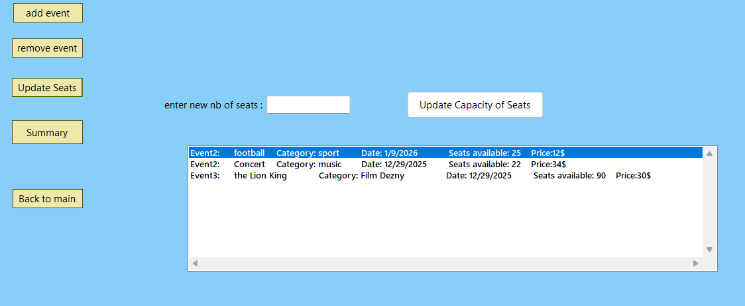

private void button4_Click(object sender, EventArgs e)
{
Read and convert seats input
int nbseats;
try
{ nbseats = int.Parse(nbseatstxt.Text); }//Parse method convert string to integer value
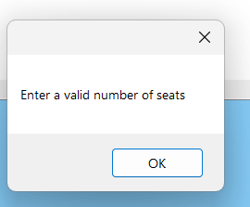
catch
{ MessageBox.Show("Enter a valid number of seats"); return; }

// the admin try to input the number of seats if its not integer the
program catch an error and set a message box like:

if (nbseats < 0) { MessageBox.Show("Enter a valid number of seats"); return; }
// check that the seatnumber>0 to get it and update .other its false
Check if an event exits

if (listBox2.Items.Count == null) { MessageBox.Show("No event to change seat");
panelU.Visible = false; return; }
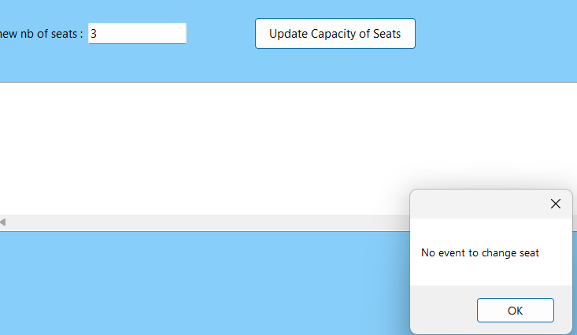
q
if (listBox2.SelectedItem == null) {MessageBox.Show("Please select an event"); return; }

Check if an event is selected

Event selectedevent = (Event)listBox2.SelectedItem;//get selected event

controller.UpdateSeats(selectedevent, nbseats);
// the seats of event are changed and saved
public void UpdateSeats(Event ev , int seats)
{
if (ev != null)
{
ev.TotalSeats = seats;
ev.AvailableSeats = seats;
SaveData();
}
}
to the data json using controller

MessageBox.Show("seats updated.");
Refresh event lists
[syntax]: listBoxName. … = value;
Reset and rebind the listBox data source to refresh and display the updated events list

listBox3.DataSource = null;
listBox3.DataSource = controller.Events;
listBox3.DisplayMember = null;

listBox2.DataSource = null;
listBox2.DataSource = controller.Events;
listBox2.DisplayMember = null;

foreach (Control c in panelU.Controls)
{
Loop through all controls in the panel and clear the text of each TextBox.
Control is the UI component inside the panel
if (c is TextBox) ((TextBox)c).Clear();
}
panelU.Visible = false;
}
//summary
private void buttonS_Click(object sender, EventArgs e)
{
On button2 click, hide all created panels and only show the summary panel, while center it and resize it giving panel name, width = 990 pxl and height = 450 pxl as parameters for our method ShowPanel()
hidepanels();
panelS.Visible = true;
ShowPanel(panelS, 990, 450);
listBox1.Size = new(990, 450);

listBox1.Items.Clear();
//refresh the list box to set the new data
Display all bookings in the list for each element in booking list, referring to the controller.

foreach (var booking in controller.Bookings)
{ listBox1.Items.Add(booking.ToString()); }

int totalrevenue = controller.Bookings.Where(b => b.status != "Cancelled" && b.status!="Removed").Sum(b => b.TotalPrice);
Calculate total revenue
Without the events there are cancelled or removed
Display it in the listBox1
//here the total revenue of all bookings in all events
Calculate total revenue for current event from its booking.excluded the removed and cancelled booking of the event
listBox1.Items.Add("-----------------------------------");
listBox1.Items.Add($"TotalRevenue:{totalrevenue}$");
listBox1.Items.Add("-----------------------------------");

foreach (var ev in controller.Events)
{
int re = controller.Bookings.Where(b => b.Event.EventID == ev.EventID && b.status != "Cancelled"
&& b.status!="Removed").Sum(b => b.TotalPrice);
//here we calculate the total price of all bookings in each event
listBox1.Items.Add($"{ev.Title.PadRight(20)}:\t {ev.AvailableSeats}/{ev.TotalSeats}\t || {re} $");
}}//format to display in the list box

private void button6_Click(object sender, EventArgs e)
{
controller.SaveListBoxToFile(listBox1);
MessageBox.Show("Summary saved to summary.txt");
listBox1.Visible = false;
button6.Visible = false;
} // Initially, the system did not store sales summaries permanently.
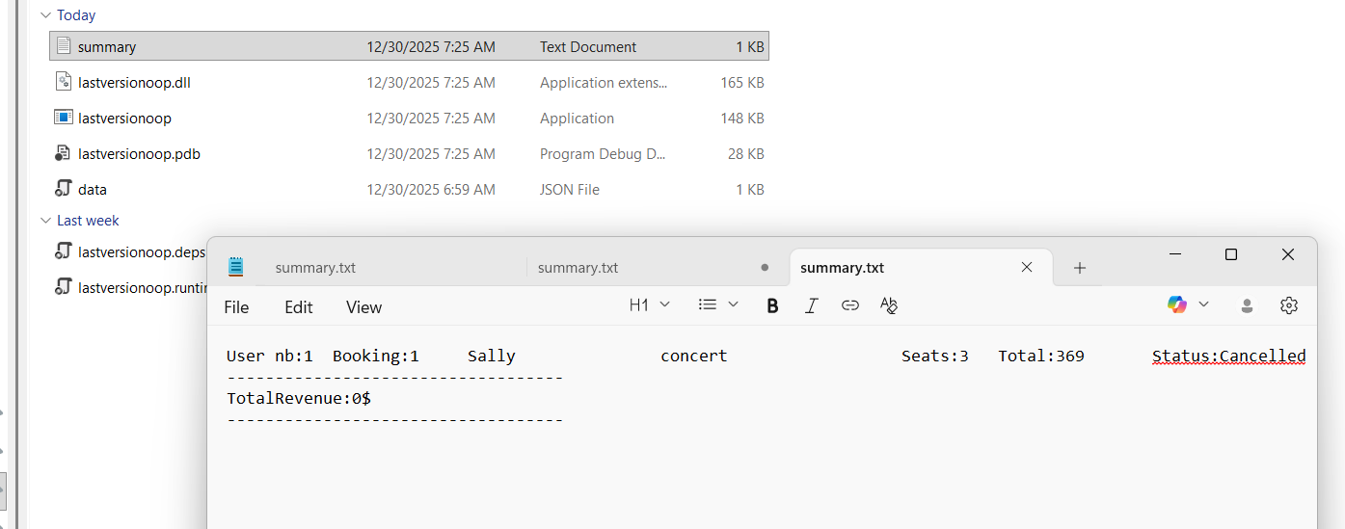
We later added file storage to save summaries, allowing admins to access reports even after restarting the application.

//folder of the code->bin->debug->netis8->summary file (string path = Path.Combine(
AppDomain.CurrentDomain.BaseDirectory, "summary.txt" ))
private void button5_Click(object sender, EventArgs e)
{
Back buttons in the forms allow users to navigate to the previous screen without losing any entered data, improving user experience and maintaining the state of the application
Form1 main = new Form1();
this.Close();
main.Show();
}

}
}

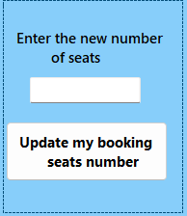
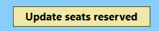

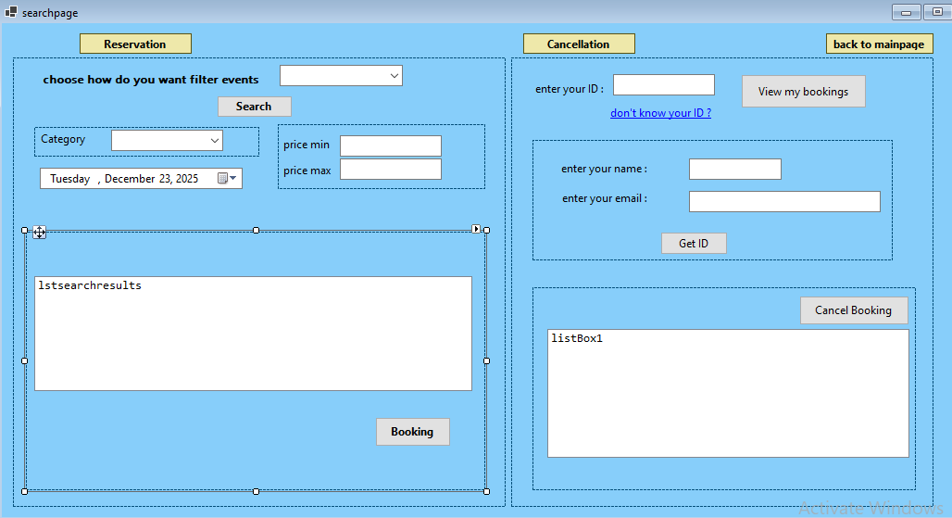
- User Form – search events
searchpage.cs

Tool added | (Name) | Added properties | Description/ purpose
 | reservebtn | Reservation  reservebtn_Click
 | panel1 | Contain the component of reserve
 | label1 | Text
 | comboBox1 | Items: Date, Category, Price  comboBox1_SelectedIndexChanged
 | btnsearch | Search  btnsearch_Click
 | panel2 | Contain
 | label2
 | cbCategory(combox) | Added using a code method
 | dateTimePicker1
 | panel3
 | label4, label5
 | Txtmin, txtmax
 | panelresult | Contain the listof search and the buuton of moving to the login form
 | lstsearchresults | Show the events of search
 | bookbtn | Booking  bookbtn_Click
 | cancelbtn | Cancellation of all seats of an event  cancelbtn_Click
 | panelC | Show the component of cancel
 | label3 | enter your ID :
 | txtidtocancel
 | linkLabel1 | Text: don't know your ID ?  linkLabel1_LinkClicked
 | panelID
 | label6, label7 | Add text
 | tbName, tbEmail
 | GetID | Get ID  GetID_Click
 | view | View my bookings  view_Click
 | panel4
 | listBox1
 | cnclbtn | Cancel Booking  cnclbtn_Click
 | btnseatreserved | To change the number of seats bookings
 | Panel 5 | Contain the component to chang or updates seats
 | Label 8 | Enter the new number of seats
 | txtupdateseats | Enter the new number
 | Button 2 | To confirm updating and save data
 | button1 | back to mainpage  button1_Click
table: properties of tools added in the searchpage form

booking
search
resevation

Updateseats
Confirm updating
view

Full cancellation
view
Confirm cancellation of all seats

//Notes:
In this form first we make the reservation and cancellation buttons but we mark that the user cannot cancel some seats and if the user want to add more seats it should be login for new so with an update method he can with him id add or remove and we put the cancel to full cancellation of an select event
And we do a panel to reset id if the user forget it
Initializes searchpage with a reference to the form and the controller c (to access events, users, bookings )

namespace lastversionoop
{
public partial class searchpage : Form
{
private Controller controller;
private Form mainform;
public searchpage(Controller c, Form f)
{
InitializeComponent();// to set up all IU elements

this.controller = c;

this.mainform = f;

hidepanels();// hide all panels at the start

LoadCategories();// call this methods which fills combobox with event categories

controller.OnCancelledBooking += controllerOnCancelledBooking;
controller.OnUpdatebooking += controlleronupdatebooking;

}
The application uses events to manage booking operations such as cancellation and update.
The controller exposes two events: OnCancelledBooking and OnUpdateBooking, which the user interface subscribes to.

private void controllerOnCancelledBooking (Booking b)
{
controller.SaveData();
MessageBox.Show($"Booking for {b.Event.Title} cancelled successfully!");
}
When a booking is cancelled or updated, the corresponding event handler is triggered.
Each handler saves the updated data by calling SaveData() and displays a confirmation message to inform the user about the performed action
private void controlleronupdatebooking(Booking b)
{
controller.SaveData();
MessageBox.Show($"Booking for {b.Event.Title} updated successfully!");
}
.

To fill the category combobox with all events categories

private void LoadCategories()
{
cbCategory.Items.Clear();//clear the previous items in it

var categories = controller.Events.Select(e => e.Category).Distinct().ToList();
Get distinct entered categories of events
Add each category to the combobox

foreach (var c in categories) cbCategory.Items.Add(c);

if (cbCategory.Items.Count > 0) cbCategory.SelectedIndex = 0;
}
private void searchpage_Load(object sender, EventArgs e)
{
When the form is displayed,
It sets the combobox at no search type selection initially,
Make sure that the UI related panels are hiden initially.
comboBox1.SelectedIndex = -1;
comboBox1_SelectedIndexChanged(null, null);
}
private void hidepanels()
{
panel1.Visible = false;
panel2.Visible = false;
panel3.Visible = false;
panelresult.Visible = false;
dateTimePicker1.Visible = false;

panelC.Visible = false;
Hide all panels
Show panel in a certain size
panelID.Visible = false;
panel4.Visible = false;
}
private void ShowPanel(Panel panel, int Width, int Height)
{
panel.Size = new Size(Width, Height);
panel.Left = (this.ClientSize.Width - panel.Width) / 2;
panel.Top = (this.ClientSize.Height - panel.Height) / 2;
}

//reservation
private void reservebtn_Click(object sender, EventArgs e)
{
hidepanels();
panel1.Visible = true;
ShowPanel(panel1, 900, 400);
}
private void comboBox1_SelectedIndexChanged(object sender, EventArgs e)
{//this method is used to show the panel with the select of user
If date the datetimepicker appear
If category the combox of category of available events appear if price that allowed to user to input a range search
panel2.Visible = panel3.Visible = dateTimePicker1.Visible = false;
if (comboBox1.SelectedItem == null) return;
//we use switch case that more easily
First we put a textbox but we find the combox more organized and easy to use
switch (comboBox1.SelectedItem.ToString())
{
case "Date":
dateTimePicker1.Visible = true;
break;
case "Category":
panel2.Visible = true;
break;
case "Price":
Connects UI filters to controller search methods to show matching events to user
panel3.Visible = true;
break;
}
}
private void btnsearch_Click(object sender, EventArgs e)
{
if (comboBox1.SelectedItem == null)//check that the user should select an item
{ MessageBox.Show("Please select search type first"); return; }

List<Event> events = new List<Event>();
In case of date choice,
Show the convenient panel in a certain size and position.
Call controller.SearchByDate
switch (comboBox1.SelectedItem.ToString())
{
case "Date":
{
panelresult.Visible = true;
panelresult.Size = new Size(900, 300);
lstsearchresults.Size = new Size(850, 300);
panelresult.Location = new Point(50, 150);
lstsearchresults.HorizontalScrollbar = true;
lstsearchresults.ScrollAlwaysVisible = true;
//point(x,y)
events = controller.SearchByDate(dateTimePicker1.Value);
break;
}
case "Category":
{
if (cbCategory.SelectedItem == null)
{ MessageBox.Show("Please select a category first"); return; }

panelresult.Visible = true;
panelresult.Size = new Size(900, 300);
lstsearchresults.Size = new Size(850, 300);
panelresult.Location = new Point(50, 150);

string category = cbCategory.SelectedItem.ToString();
events = controller.SearchByCategory(category);
In case of category choice,
Show the panel in a certain size and position.
Get the selected category from the cbCategory.
Call controller.SearchByCategory
break;
}
case "Price":
{
if (int.TryParse(txtmin.Text, out int min) && int.TryParse(txtmax.Text, out int max))
//check that the input are integers
{
panelresult.Visible = true;
In case of price choice,
For valid price range,
Show the convenient panel in a certain size and position.
Call controller.SearchByPrice
panelresult.Size = new Size(900, 300);
lstsearchresults.Size = new Size(850, 300);
panelresult.Location = new Point(50, 150);
events = controller.SearchByPriceRange(min, max);
}
else
{ MessageBox.Show("Invalid price range!"); return; }
In no events found, show error message in the listbox
break;
}
}

if (events.Count == 0)
{
lstsearchresults.Items.Add("No events found."); return;
In events found, bind the result list to the listbox, using DataSource and DisplayMember
}
Check if there are search results available

lstsearchresults.DataSource = null;
lstsearchresults.DataSource = events;
lstsearchresults.DisplayMember = "print";
}
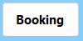

private void bookbtn_Click(object sender, EventArgs e)
executed when user clicks the book button
{
if (lstsearchresults.DataSource == null)
{ MessageBox.Show("No events to booking"); return; }

Make sure user selects an event form listbox
if (lstsearchresults.SelectedItem == null)
{ MessageBox.Show("Please select an event first."); return; }

Event selectedEvent = (Event)lstsearchresults.SelectedItem;

if (selectedEvent.AvailableSeats <= 0)
{ MessageBox.Show("No seats left for this event!"); this.Close (); return; }
If everything valid, open loginUser form and pass the selected event,
to continue the booking process
LoginUser us = new LoginUser(controller, selectedEvent);

//we connect this form to the form login with the same controller
to book the event selected
us.Show();
}
Here we have a problem that view panel is common between the 2 cancel and update so we use a variable that have 2 value update or cancel and that control which panel show with view panel

private lastaction;

private void cancelbtn_Click(object sender, EventArgs e)
{
hidepanels();
for the methods;
reservebtn_Click
cancelbtn_Click
updateseatbtn
button1_Click
Same logic of the button process
listBox1.Visible = cnclbtn.Visible = false;

panelC.Visible = true;
ShowPanel(panelC, 900, 400);
}

If the user forget his id we made a link to reset it .he put the information name and
contact and the program give him the id
We find the solution so that the user does not have to enter his informations all the
time and we remember that the user maybe forget it so we make a reset method
private void linkLabel1_LinkClicked(object sender, LinkLabelLinkClickedEventArgs e)
{
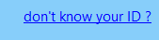
panelID.Visible = true;
When click on the label link, the panelID shows in a certain size.
ShowPanel(panelC, 900, 400);

panel4.Visible = false;
}
Find the user’s ID based on the entered name and email
private void GetID_Click(object sender, EventArgs e)
{
string name = tbName.Text.Trim();
string contact = tbEmail.Text.Trim();

Make sure that name and email text are filled

if (string.IsNullOrEmpty(name) || string.IsNullOrEmpty(contact))
{ MessageBox.Show("Please enter both name and email."); return; }
Search controller.Users for a matching user

var user = controller.Users.FirstOrDefault
(u => u.Name.Trim().Equals(name, StringComparison.OrdinalIgnoreCase)
&& u.contact.Trim().Equals(contact, StringComparison.OrdinalIgnoreCase));

if (user == null)
{ MessageBox.Show("User not found. Please check your info."); return; }

else
{ txtidtocancel.Text = user.userID.ToString();
MessageBox.Show("Your ID has been found!");
panelID.Visible = false;
}
}
Show all bookings of a user when this button is clicked in the cancellation or update area

private void view_Click(object sender, EventArgs e)
{
if (!int.TryParse(txtidtocancel.Text, out int userid))
{ MessageBox.Show("Invalid User ID"); return; }
listBox1.Visible = true;
userID validation with int.tryParse : check if entered ID can be converted into a valid integer ID, if not show error message. If yes just continue.
listBox1.Location = panelID.Location;
listBox1.HorizontalScrollbar = true;
listBox1.ScrollAlwaysVisible = true;
panelID.Visible = false;

userid = int.Parse(txtidtocancel.Text);
var user = controller.Users.FirstOrDefault(u => u.userID == userid);

if (user == null)
Search for user in controller.Users based on userID given by the user
{
MessageBox.Show("User not found");
panelC.Visible = false;
return;
}
If no user found, show error message

If user found,
Bind user bookedeevents, to the listbox, to show them.
If user found, show the cancel panel and listbox
listBox1.DataSource = null;
listBox1.DataSource = user.BookedEvents;
listBox1.DisplayMember = null;

if (listBox1.Items.Count == 0)
Show message, if user has no booking
{
MessageBox.Show("no events booking by you,sorry");
panelC.Visible = false;
return;
}
If the lastaction is cancel the panel contains a cancel button appear if its update the panel contain text box of new number and button to confirm seats updated appear
listBox1.Visible = true;
if (lastaction == "Cancel")
panel4.Visible = true;
if (lastaction == "Update")
panel5.Visible = true;

listBox1.Size = new(860, 200);//for design }
Execute when user clicks cancel button
private void cnclbtn_Click(object sender, EventArgs e)
{
if (!int.TryParse(txtidtocancel.Text, out int userid))
{ MessageBox.Show("Invalid User ID"); return; }

Check the entered userID validity

var user = controller.Users.FirstOrDefault(u => u.userID == userid);

Create user to find the corresponding user in the controller, based on given userid

if (user == null)
{ MessageBox.Show("User not found"); return; }
Show error message if user is not found

if (listBox1.SelectedItem == null)
{ MessageBox.Show("Please select a booking first."); return; }

Booking selectedBooking = (Booking)listBox1.SelectedItem;
Check if a booking is selected in listbox

If the status
of booking
is:

cancelled or removed we don’t want to cancel so we excluded this 2 cases

if (selectedBooking.status == "Cancelled" || selectedBooking.status=="Removed")
{ MessageBox.Show("Please select an event not cancelled or removed "); }

controller.CancelBooking(user, selectedBooking);
public void CancelBooking(User user, Booking b)
{
if (b.status != "Cancelled")
{

b.Event.CancelSeats(b.seatnumber);

b.status = "Cancelled";
OnCancelledBooking?.Invoke(b);

}
}

private void controllerOnCancelledBooking (Booking b)
{
controller.SaveData();
MessageBox.Show($"Booking for {b.Event.Title} cancelled successfully!");}

We call this method from controller

We call the event subscribed
Raised the event

//the action is triggered automatically when booking
Refresh listbox to show updated status
is cancelled because we use event
listBox1.DataSource = null;
listBox1.DataSource = user.BookedEvents;
listBox1.DisplayMember = null;

}
private void button1_Click(object sender, EventArgs e) //back to main button
{
Form1 main = new Form1();
this.Close();
main.Show();
}
}
}
private void btnseatreserved_Click(object sender, EventArgs e)
{
hidepanels();
lastaction = "Update";

panelC.Visible = true; listBox1.Visible = false;
ShowPanel(panelC, 900, 400);
Update seats input by user

}

private void button2_Click(object sender, EventArgs e)
{
int userid = int.Parse(txtidtocancel.Text);//convert the text box to integer
var user = controller.Users.FirstOrDefault(u => u.userID == userid);
if (user == null)
{
MessageBox.Show("User not found");
return;
}its from view to get the user here

// Check if a booking is selected in the listbox
if (listBox1.SelectedItem == null)
{
MessageBox.Show("Please select a booking first.");
Check the seat number if its an integer and greater than 0 to be accepted
return;
}//check selecting an event to continue if not return
int seatnumber = 0;
try
{
seatnumber = int.Parse(txtupdateseats.Text.Trim());
}
catch
{
MessageBox.Show("the seat number should be an integer");
Get the selected to change its seats
txtupdateseats.Clear();
return;
}
if (seatnumber < 0) { MessageBox.Show("Enter a valid number of seats"); return; }
If the status
of booking
is:

cancelled or removed we don’t want to update seats so we excluded this 2 cases
// Get the selected booking
Booking selectedBooking = (Booking)listBox1.SelectedItem;

// update seat number
if (selectedBooking.status == "Cancelled" || selectedBooking.status=="Removed")
{ MessageBox.Show("Please select an event not cancelled or removed"); }

controller.updatebooking(selectedBooking, int.Parse(txtupdateseats.Text));
//same for cancel we triggered the event to run the subscribe method
onupdateseatrs
listBox1.DataSource = null;
listBox1.DataSource = user.BookedEvents;
listBox1.DisplayMember = null;
Refresh listbox to show updated status
}}}
4-loginuser
loginUser.cs
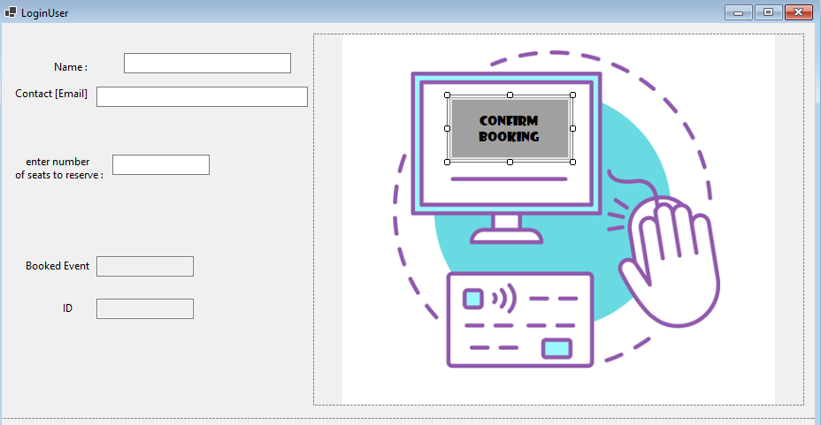
Tool added | (Name) | Added properties | Description/ purpose
 | panel1
 | label1,3,5,4,2
 | Txtname, txtcontact, txtseatnb,
 | Txtbookedevent, txtid
 | pictureBox1
 | btnbooking | Confirm Booking  button1_Click
We prefer to put the form login at end because if the user don’t found an event this is not obligate to fill his information so we prefer this design

When the user enter his information we cannot put the condition of email and assign his id based to the information until click the button
The solution it :to use the leave event of button that when the user leave in the input is invalid its false
Let’s see all in the code

code:
Create an object to store reference to controller
using lastversionoop.controller; …..
namespace lastversionoop
{
public partial class LoginUser : Form
{
Create an object to store reference to the selected event
private Controller controller;
private Event selectedevent;

private model.User currentuser;
//here we first have a problem how connect the user in the methods of leav e to the button so we use a variable user into the class
public LoginUser(Controller c, Event e)
Create a constructor with controller and event parameters
{
InitializeComponent();
this.controller = c;
A build-in method that sets up the form controls and layout when the form is created
selectedevent = e;

Assign values to the parameters

txtbookedevent.Text = selectedevent.Title;
Display event title,
Automatically based to the selected event in the form of search


controller.OnCreatedBooking += Controller_createdbooking;
Subscribe Controller_createdbooking method the controller’s OnCreatedBooking event, so it runs whenever a booking is created.
}

private void Controller_createdbooking(Booking booking)
{
{
MessageBox.Show($"Booking confirmed for {booking.seatnumber} in{booking.Event.Ttle} ");
controller.SaveData();
Event handler called when a booking is created.
In the body : show a confirmation message, and save data.
}
}

private void txtcontact_Leave(object sender, EventArgs e)
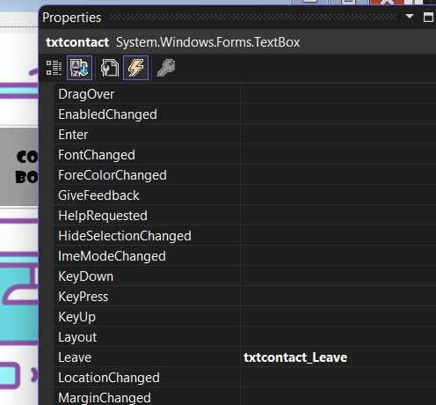
{
Read user name and email
From properties I add
to leave this method

string username = txtname.Text.Trim();
string email = txtcontact.Text.Trim();

if (string.IsNullOrEmpty(username) || string.IsNullOrEmpty(email))
{
Check if fields are not empty
If not show error MessageBox
MessageBox.Show("Please enter both username and email.");
return;
}

if (!email.EndsWith("@gmail.com") || email.IndexOf('@') <= 0)
{
MessageBox.Show("Email should be like :something@gmail.com");
txtcontact.Clear();
Check the validation of entered email format
return;
}
model.User a = null;

//here we have first a problem if a user login two time the id is different so we mark that we can search the same information and assign the same id
foreach (model.User u in controller.Users)
{
if (u.Name == txtname.Text || u.contact == txtcontact.Text)
{
Search using foreach loop, for existing user in list.
a = u;

break;
If name and email already exists.
Use the existing user if found
}
}
if (a == null)
{
In case user we are searching for, is not found;
Create a new User object
Assign a new user ID
Add this user to users list
a = new model.User(txtname.Text, txtcontact.Text);
a.userID = controller.Users.Count + 1;
controller.Users.Add(a);

}
txtid.Text = a.userID.ToString();
//display the user also read only
currentuser = a;
//assign a to currentuser to use it in the click button booking
}

private void txtseatnb_Leave(object sender, EventArgs e)
{
Read and convert seats input from textbox created.
int seatnumber = 0;
try
{
seatnumber = int.Parse(txtseatnb.Text.Trim());
Show error, if input is not a number positif and stop execution
}
catch
{
MessageBox.Show("the seat number should be an integer");
txtseatnb.Clear();
return;
}
if(seatnumber<0) MessageBox.Show("the seat number should be an positive integer");
}

private void button1_Click(object sender, EventArgs e)
{

string username = txtname.Text.Trim();
string email = txtcontact.Text.Trim();

int seatnumber=int.Parse(txtseatnb.Text.Trim());

if (currentuser== null)
{
MessageBox.Show("Please enter valid user information first.");
return;
}
Try to create booking using controller.

Booking booking = controller.ConfirmBooking(currentuser, selectedevent, seatnumber);

if (booking != null)
{
controller.PriceEvent += booking.TotalPrice;
MessageBox.Show($"Booking confirmed for:\n {booking.seatnumber} in {booking.Event.Title} \n Total Price={booking.TotalPrice}\n date:{booking.Event.Date}");
this.Close();
}
else
{
MessageBox.Show("Failed to book. No available seats.");
}
}
}
If booking is successful,
Add booking price to the total revenue
And show a confirmation MESSAGE in a MessageBox
Close current form
If not, show a MessageBox of failure,
in case no seats are available

}

• Saving Data, using JSON Files: (File Handling)

This is needed to make sure our data is not lost when the application is closed. Instead of using a database like SQL, we choose to use a JSON file to store all system data; including users, events, and bookings.

So JSON was chosen because it is lightweight, easy to read, and simple to integrate with C#. It also fits well with small-scale desktop applications where a full database is not required, which is our case.

All data is saved in a single file named (data.json). When the application starts, the system checks if the file exists:

- If it exists, the data is loaded into memory.
- If it does not exist, an empty data structure is created and saved.

Any modification to the data (adding events, booking seats, or cancellations) triggers an update to the JSON file, ensuring data consistency.
Data is converted to JSON using serialization
The file is created and written using File.WriteAllText
When the app starts, JSON file is read and converted back to objects using deserialization
This allows data to be saved and restored between runs of the program

• controller code:
The controller class represents the core logic of our application. It connects interfaces (forms) to the model classes. In our case, its main role is to manage events, users, bookings, and data persistence using a JSON file which we will add later on. By separating logic from presentation, the application remains well-structured, maintainable, and easy to extend later.

In the controller folder: Right-click → Add → New → code file → Name it Controller
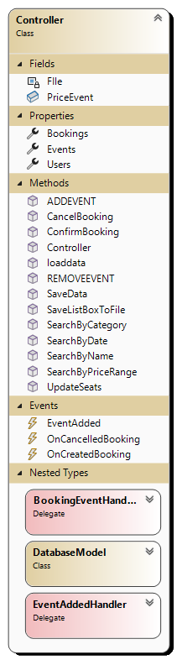
namespace lastversionoop.controller
To define JSON file used for data storage. (saving and loading data)
a private constant string that stores the name of the JSON file
private → Accessible only inside the Controller class
Const → A constant value (cannot be changed after compilation)
string → Data type : text
FIle → Variable name
"data.json" → The fixed value assigned to the constant, named data
{
public class Controller
{
private const string FIle = "data.json";

Creating lists to store events, bookings, and users

public List<Event> Events { get; set; } = new List<Event>();
public List<Booking> Bookings { get; set; } = new List<Booking>();
public List<User> Users { get; set; }=new List<User>();
Define methods for custom delegate;
used to define events so the controller can notify forms when a booking is created or Cancelled or Updated
public int PriceEvent = 0;//to store total revenue
public delegate void BookingEventHandler(Booking booking);

public event BookingEventHandler OnCreatedBooking;
public event BookingEventHandler OnCancelledBooking;
public event BookingEventHandler OnUpdatebooking;
declare events based on the delegate types
Trigger actions when bookings (created or cancelled or updated)
allow the Controller to notify the UI (forms) automatically when data changes, without tight coupling.

public Controller()
{ loaddata(); }
Load saved data when controller starts.

//save data
public void SaveData()
{
DatabaseModel data = new DatabaseModel{ Events = Events, Users = Users, Bookings = Bookings };
string json=JsonSerializer.Serialize(data,new JsonSerializerOptions { WriteIndented = true });
File.WriteAllText(FIle, json);
}

Methods to collects Events, Users, and Bookings into one object : data.
Serializes that object into a formatted JSON string.
Writes the JSON to the file data.json.
Purpose:Saves all application data so it can be reloaded later

Purpose:Loads saved data from data.json and restores the application state
public void loaddata()
{
if (!File.Exists(FIle))
{ SaveData(); return; }

string json = File.ReadAllText(FIle);
var data = JsonSerializer.Deserialize<DatabaseModel>(json);

Events = data.Events ?? new List<Event>();
Users = data.Users ?? new List<User>();
Bookings = data.Bookings ?? new List<Booking>();
If the file doesn’t exist, create it with SaveData() and stop.
Read the JSON content from the file
Convert the JSON back into a DatabaseModel object
Assign loaded data, or (??) empty lists if null;
for events, users, bookings.
Re-link bookings to their corresponding users so each user knows their booked events
foreach (var b in Bookings)
{
if (b.user == null) continue;
var user = Users.FirstOrDefault(u => u.userID == b.user.userID);
var ev = Events.FirstOrDefault(e => e.EventID == b.Event.EventID);
if (user != null)
{
b.user= user;
user.BookedEvents.Add(b);
}
if(ev!=null)
b.Event= ev;
} }
public class DatabaseModel
{
public List<Event> Events { get; set; }
public List<User> Users{ get; set; }
public List<Booking> Bookings { get; set; }
}
//add event
A helper class used to serialize and deserialize all application data
(events, users, bookings) to and from JSON.
Events → stores all event object
Users → stores all user objects
Bookings → stores all booking objects
groups all data in one structure so the controller can easily save/load it from data.json

public void ADDEVENT (Event e)
{
Adds a new event to Events list.
Triggers event to notify UI.
Saves data to JSON.
Events.Add(e);
SaveData();
}
// remove event
public bool REMOVEEVENT(Event e)
{
Removes the event from Events list, if not null.
And when remove the event put all bookings status removed to excepted its from the total revenue and the seats booking
Saves changes to JSON.

if(e==null) return false;

foreach(Booking b in Bookings)
{
if(b.Event==e)
{
b.status = "Removed";
}
}
Events.Remove(e );
SaveData() ;
return true;
}
//update seats
public void UpdateSeats(Event ev , int seats)
{
Updates total and available seats of the event.
Saves changes to JSON
if (ev != null)
{
ev.TotalSeats = seats;
ev.AvailableSeats = seats;
SaveData();
}
}

//booking
public Booking ConfirmBooking(User user,Event e,int seatnumber)
{
if (!e.ReserveSeats(seatnumber)) return null;

Booking b= new Booking(user,e,seatnumber,"Confirmed");
Checks if requested seats are available.
Creates a new Booking if possible.
Add booking to user and Bookings list.
Triggers OnCreatedBooking event.
Returns the booking object,
or null if not enough seats
user.BookedEvents.Add(b);
Bookings.Add(b);
OnCreatedBooking?.Invoke(b);
return b;
}
//cancel
public void CancelBooking(User user, Booking b)
{
if (b.status != "Cancelled")
{
Marks the booking as “Cancelled”.
Removes it from user’s booked events and main bookings list.
Frees up the reserved seats in the event.
Triggers OnCancelledBooking event.
While keeping the cancelled booking in history.

b.Event.CancelSeats(b.seatnumber);

b.status = "Cancelled";
OnCancelledBooking?.Invoke(b);

} }

Here first I have the problem :
b.status = "Cancelled";
b.Event.CancelSeats(b.seatnumber);
I write the code like that and I find that is false because the number of seats isn’t substracted right
I find that the false it put the status cancelled before decrease the seats

public void updatebooking(Booking b,int seatnumber)
{
Enter the new seat find the difference between them and add or substract the available seats and change the price with change of seats
Triggers Onupdateseats event
if (b.status != "Confirmed") return;
if (seatnumber < 0) return;
int d = seatnumber- b.seatnumber;

if (d > 0)
{
if (d > b.Event.AvailableSeats) return;
b.Event.AvailableSeats -= d;
}
if(d<0)
b.Event.AvailableSeats +=(- d);
b.seatnumber = seatnumber; ;
b.TotalPrice = b.Event.Price * b.seatnumber;
b.status = (b.seatnumber == 0) ? "Cancelled" : "Confirmed";
OnUpdatebooking?.Invoke(b);
}

Returns events scheduled on the specified date (ignores time)

// returns events on that date (date only comparison)
public List<Event> SearchByDate(DateTime date)
{
return Events.Where(e => e.Date.Date == date.Date).ToList();
}

// returns events whose category matches (case-insensitive)
public List<Event> SearchByCategory(string category)
{
if (string.IsNullOrWhiteSpace(category)) return new List<Event>();

return Events.Where(e => e.Category != null && e.Category.Equals(category,
StringComparison.OrdinalIgnoreCase)).ToList();
}
Returns empty list if input is blank.
Returns events whose category matches the input (case-insensitive).

// returns events with price between min and max (inclusive)
public List<Event> SearchByPriceRange(int minPrice, int maxPrice)
{
if (minPrice > maxPrice) return new List<Event>();

return Events.Where(e => e.Price >= minPrice && e.Price <= maxPrice).ToList();
}
Returns empty list if min > max.
Returns events with price between min and max.

Saves all items from a ListBox to a text file (summary.txt) on the desktop.
And opens the file automatically after saving.

public void SaveListBoxToFile(ListBox listBox)
{
string path = Path.Combine(
AppDomain.CurrentDomain.BaseDirectory, "summary.txt" );

using (StreamWriter sw = new StreamWriter(path))
{
starts an external process.
foreach (var item in listBox.Items)
{ sw.WriteLine(item.ToString());}

System.Diagnostics.Process.Start( new System.Diagnostics.ProcessStartInfo
{ FileName = path, UseShellExecute = true } );
}

lets Windows choose the default program (Notepad).
the file to open (summary.txt)

built-in .NET class used to define how a file or application should be opened or executed.
}
}
methods allow user to search events by different criteria and export booking summaries to a file

data Management and Persistence
controller stores all system data in three main created lists: events, users, bookings. data is saved and loaded in JSON file (data.json), system keep data without using database.

Event Management Logic
controller allows admin to manage events like : Add new events to the system, Remove existing events, Update the total seats number of an event.
When a new event is added, an event notification is triggered to update the user interface automatically.

Booking and Cancellation Logic : in the controller,

The booking process:
- The system first checks if enough seats are available.
- If seats are available, the booking is confirmed and seats are reserved.
- The booking is added to both the booking list and the user’s booking history
- if seats = 0, user can’t have a booking foe this event.
For cancellation:
- The booking status is updated to Cancelled.
- Seats cancelled are restored to the event’s total nb seats of the event.

Search Functionalities
controller provides several search methods to help users find events easily:
- Search by date.
- Search by category.
- Search by price range (min and max).
Each search method filters the event list based on user input and returns matching results, in a listbox or a datagridview.

Event Handling
To improve communication between controller and user interface, controller uses events:
- When a booking is created.
- When a booking is cancelled.
- When a new event is added.
These events allow the forms to update automatically.

Summary and File Export
controller also includes functionality to export booking summaries to a text file. This file is saved on the desktop and we set it to open automatically, allowing admins to view ticket sales reports easily.

• program.cs: 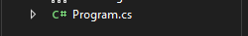
Check the Program.cs file, make sure form1 is defined as the startup form in our application: static void Main() { Application.Run(new Form1()); …… }
this ensures that our application begins execution by launching the main form; ( or MainForm is the first interface displayed when the program starts)

using statements
The using statements are used to include required namespaces for our project layers so that classes and methods (such as model, controller, view, JSON, .NET libraries and Windows Forms components) can be accessed in the code.
Some are auto-generated by Visual Studio, while others were added manually to fix errors and use specific features.
Without them, the compiler cannot recognize these classes and errors occur.

Manually added
using lastversionoop; 👉 Access main project namespace. — Auto / sometimes added by IDE
using lastversionoop.model; 👉 Access model classes (User, Event, Booking).
using lastversionoop.controller; 👉 Access Controller class and logic.
using lastversionoop.view; 👉 Access other form classes (views).
using System.Text.Json; 👉 JSON serialization/deserialization data and saving
using System.Text.Json.Serialization; 👉 JSON attributes like [JsonIgnore].
Auto-generated
using System; 👉 Basic .NET types (String, DateTime, etc.).
using System.Collections.Generic; 👉 Generic collections like List<>.
using System.Linq; 👉 LINQ queries (Where, Sum, etc.).
using System.Text; 👉 Text encoding and strings
using System.Threading.Tasks; 👉 Async programming support.
using System.IO; 👉 File input/output operations.
using System.ComponentModel; 👉 component and designer support.
using System.Data; 👉 Data-related classes.
using System.Drawing; 👉 Colors, sizes, graphics.
using System.Windows.Forms; 👉 Windows Forms UI classes
using Microsoft.VisualBasic.ApplicationServices; 👉 VisualBasic helper services

design patterns :

Singleton Pattern — For the Controller
- we didn’t create multiple controllers.
- it Keeps the state consistent (events, users, bookings).

Observer Pattern — Perfect fit for Delegates & Events
- example: “BookingCreated” event IS the Observer pattern.
- The controller is the subject, the forms are observers.
- ✔ so Observer pattern is implemented by using events

Factory Pattern — For Creating Bookings or Events: Instead of manually creating bookings everywhere:
Before: “ new Booking(id, user, ev, seat, status);

Factory approach:
public static class BookingFactory
{
public static Booking Create(User user, Event ev, int seat)
{
return new Booking(BookingController.Instance.GenerateBookingID(),user, ev, seat, "Booked");
}
}
• Centralizes creation logic
• You can add validation inside
• Cleaner BookingPage

- Design Patterns → solve common problems (Singleton for manager, Observer for events, Factory for object creation)
- SOLID principles → make code maintainable and extendable

• Testing and Validation

To ensure that the application functions correctly, several test cases were performed during the development. (build solutions and run the program). Each main functionality was tested to verify that the system behaves as expected.

* Booking an event when seats are available successfully creates a booking and updates the remaining seats.

* Attempting to book seats when availability is insufficient correctly rejects the booking.

* Cancelling a booking restores the reserved seats and updates the booking status.

* Searching for events by date, category, and price range returns correct results.

* Adding and removing events as admins updates the system immediately.

* Closing and reopening the application confirms that data is correctly saved and loaded from the JSON file.

* testing the Showpanel() and hidepanel()

: Conclusion and Future Work

Conclusion
In this project, we designed an Event Booking System using OOP principles,in C# Windows Forms.
Our system can be used as a desktop and an online application. The main goal was to create a simple and organized application allowing admins to manage events details and users to search, book, and cancel events.
The system was designed to handle seat reservations safely, prevent overbooking, and automatically update the UI when bookings change.
Object-oriented programming concepts were applied by dividing the system into clear components such as models, controllers, and forms (MVC). The User, Event, and Booking classes were designed based on the key features of the system, ensuring proper data representation and interaction. The controller handles the business logic, managing bookings, seat availability, and communication between the interfaces and stored data.
To ensure data storage, our choice was a JSON file to store events, users, and bookings, which allow the application to retain data between executions without the complexity of a database, making it suitable for our case.
Then the graphical interfaces were built using Windows Forms, providing clear and functional interfaces for both admins and users. Each form was designed with a specific purpose, and event-driven programming was used to handle user actions effectively.
This project helped reinforce practical programming skills, especially in object-oriented design, event handling, data persistence, and application structuring.
While the system meets its main objectives, it can be further improved by adding many features Nevertheless, the project successfully demonstrates a complete and functional event booking system for real-life deployment.

Future Work
In this paragraph we are suggesting ideas to be expanded so our project will be more developed and to be used in real live.

- add location and time: ex Zee’s Concert — 20/12/2025 — 21:00
- Search by event name. (add it to the combobox).
- Improve the search functionality with multiple filters at once.
- replace the JSON file with a database (SQL Server or SQLite).
- add online payment ways.
- Editt events: seats capacity, date , name,….
- Add user login to his account, so he doesn’t fill his infos when booking
- add QR code; for future check-in for event.
- design the ticket and to be sended to users by email for ex.
- Add seat selection by seatID instead of general availability.
- add Interactive Seat Map and VIP Booking

Use the system for events like: concerts, theaters, talks, sports events, conference, cinema, train, airplane, hotel.

Generate detailed sales reports in PDF or Excel format.

Make the application web-based.
- design the message boxes.



