CSCI251: Advanced Programming
Assignment 2

Student Name: SALLY
Student ID: 4603229
I have read the policy for plagiarism at Wollongong University.
I declare that this assignment solution is entirely my work.
Requirements
We are required to develop a program that reads in user-input data of shapes with their coordinates. Using the data to calculate the area of each shape and print the shapes info summary, with the option to sort the shapes according to ascending/descending order of space type and area size.

a2_main.cpp
Line 4 – 10: Main method
The main method calls the processChoice() and pass in the return of mainMenu() to determine subsequent function to be called.

a2.h
Line 1-2: Declaration of #ifndef headguard
#ifndef to prevent redeclaration of any identifiers and prevent recursive inclusions.
Line 4 – 7: Declaration of #include
< iostream> is used for user input
< vector> is used to store coordinates and shapes
<string> is used for calling of ‘string_of’ function to print double and int
<algorithm> is used to call the sort and transform functions.

Line 9: Declaration of namespace std
Line 12 – 16: Declaration of struct, to input x-axis and y-axis of each coordinate.
Line 19 – 52: Declaration of ShapeTwoD super class.

Line 54 – 164: Declaration of sub classes of ShapeTwoD super class.

Line 54 – 84: Circle class
Line 86 – 112: Square class
Line 114 – 137: Rectangle class
Line 139 – 164: Cross class

Line 166-178: Declaration of function prototypes

a2.cpp
Line 4: Global Vector declarations
Line 6 – 10: Reset Screen Function
This is to clear previous screen as we move on to the next user selection.

Line 12 – 42: Main Menu
This part has the same method with our Assignment 1. User input is validated using while loop. The mainMenu() return an integer value which will be passed as parameter for processChoice().

Line 44 – 60: Return to Main Menu Function
This function helps to return to main menu after user has input data or has computed area or has reviewed the shapes summary. It is similar to the method used in Assignment 1.

Line 62 – 273: Input and Store Shape Data Function
This function is called when user selects option 1. While-loop is used to validate user input of shape type and space type. User input is not case sensitive as the input are converted to lowercase.

Multiple if-statements are used to implement further functions for each shape type and space type.
For Square, Rectangle and Cross shape, for-loop is used to get the coordinates of the vertices. Square and Rectangle have 4 vertices, so it loops 4 times while Cross have 12 vertices, so it loops 12 times to get x and y axis of struct xyPoint from user. These coordinates of struct xyPoint are then added into respective vector of xyPoint using the setXYPoints() function of each sub class. For Circle, the coordinate is set as center point using the setXYPoints() of circle class.

At the end of every shape and its coordinates input, the program will display a confirmation message and call the returnMainMenu() to return to main menu.

Line 275-287: sortXY()
This function is to arrange the element of vector of struct xyPoint of Cross in ascending order of x-axis and y-axis.

Line 289-300: Compute Shape Area
This function loops thru the element of shapes_vector and call the computeArea() function of each subclass to calculate the shape area.

Line 302-313: Display Summary of the Shapes
This function loops thru the element of shapes_vector and call the toString() function of each subclass to display the info of the area and vertices.

Line 315 – 319: Boolean Operator to sort the shapes in descending order of area size. The Boolean value is used as parameter in the sort() function.

Line 321 – 337: Boolean Operator to sort the shapes with Warp Spaces is being displayed first and then Normal Spaces, then it is further sorted in descending order of area size. The Boolean value is used as parameter in the sort() function.

Line 339 – 394: Sorting the Shapes Area and Space Type
Switch statement is used to call different functions depending on user input of ‘q’, ‘a’, ‘b’ or ‘c’.
For-loop is used to loop thru shapes_vector and call the toString() of each subclass to display the shapes information.

Line 357 – 383: Process Choice
The integer value return from mainMenu() will be passed as parameter for this function. For case 5, a Quit function (beyond assignment instructions) is implemented. Upon quitting the program, shapes saved in the vector of shapes will be deleted.

shapeTwoD.cpp
Line 3 – 6: Get Name of Shape

Line 8 – 17: Get Space Type
The Boolean value is used in the Boolean comparator to sort based on Warp Space or Normal Space type.

Line 14 – 17: Set Name
To be used in the Constructor of ShapeTwoD super class.

Line 19 – 22: Set Warp Space
To be used in the Constructor of ShapeTwoD super class.

Line 24 – 35: toString()
This function is used by sub classes to print the information of the shape.

Circle.cpp
Line 3 – 7: Set Radius
User input radius value and set it using this function.

Line 9 – 13: Set Centre Point
Set the centre point of circle with user input values.

Line 15 – 22: Set Min X-axis, Max X-axis, Min Y-axis, Max Y-axis
Set the range of x and y axis.

Line 24 – 37: Boolean Check (Inside Shape)
Check if any point is inside the shape. Online research: https://www.geeksforgeeks.org/find-if-a-point-lies-inside-or-on-circle/

Line 39 – 51: Boolean Check (On Perimeter)
Checks if any points is on the perimeter of the shape. Online research: https://www.geeksforgeeks.org/find-if-a-point-lies-inside-or-on-circle/

Line 70 – 74: Compute the area of the shape.

Line 103 – 106: Get Area of Shape
This is used later on for sorting.

Line 25 – 67: toString()
To display information of the shapes.

Square.cpp & Rectangle.cpp
The functions and formulas for Square and Rectangle class are the same. The only difference is the naming convention of the vectors in each class.
Line 3 – 7: Add Point into Vector
Each coordinate by user input will be pushed back into the vector of xyPoint.

Line 9 – 39: Set Min X-axis, Max X-axis, Min Y-axis, Max Y-axis
Set the range of x and y axis using the for-loop.
Initialize the values of min max of x and y axis to the value of first point and then loop thru all 4 points and set the min max of x and y axis.

Line 41 – 54: Boolean Check (Inside Shape)
Check if any point is in the shape.

Line 56 – 74: Boolean Check (On Perimeter)
Check if any points is on the perimeter of the shape using if-else statement. Check the vertical and horizontal sides of the rectangle and square.

Line 76 – 81: Compute the area of the shape.

Line 83 – 87: Get Area of Shape
This is used later on for sorting.

Line 89 – 146: toString()
To display information of the shapes.

Cross.cpp
Line 3 – 7: Add Point into Vector
Each coordinate by user input will be pushed back into the vector of xyPoint.

Line 9 – 12: Sort the vector of xyPoint in Ascending Order of X-axis and Y-axis
The sorting ensures the index of the vector of vertices are fixed which helps for computing area and checking whether the point is in shape or on perimeter of the shape. However, for checking of where the point lies, it can only apply on symmetrical cross shape due to the fixed indexes.

Line 14 – 44: Set Min X-axis, Max X-axis, Min Y-axis, Max Y-axis
Set the range of x and y axis using the for-loop.
Initialize the values of min max of x and y axis to the value of first point and then loop thru all 12 points and set the min max of x and y axis.

Line 46 – 81: Boolean Check (Inside Shape)
Check if any point is in the Shape using if-else statement for each small square of the cross.

Line 83 – 115: Boolean Check (On Perimeter)
Checks if any points is on the perimeter of the shape using if-else statement for each line that connects two vertices.

Line 117 – 126: Computes the Area
Area of the cross is calculated by taking the area of outer red square and minus the area of a, b, c and d.
Line 128 – 132: Get Area of Shape
This is used later on for sorting.

Line 134 – 191: toString()
Called by base class ShapeTwoD in Option 3 and Option 4

Program Demo

Compiling, Executing & Main Menu
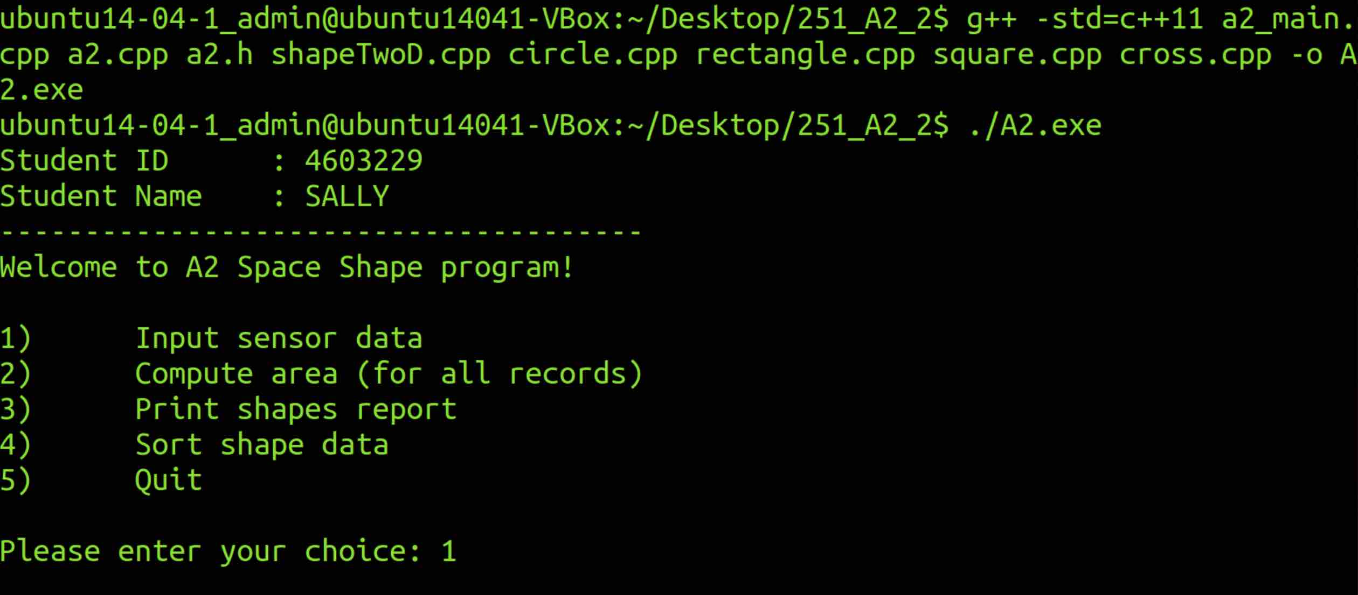

Input Data - Circle
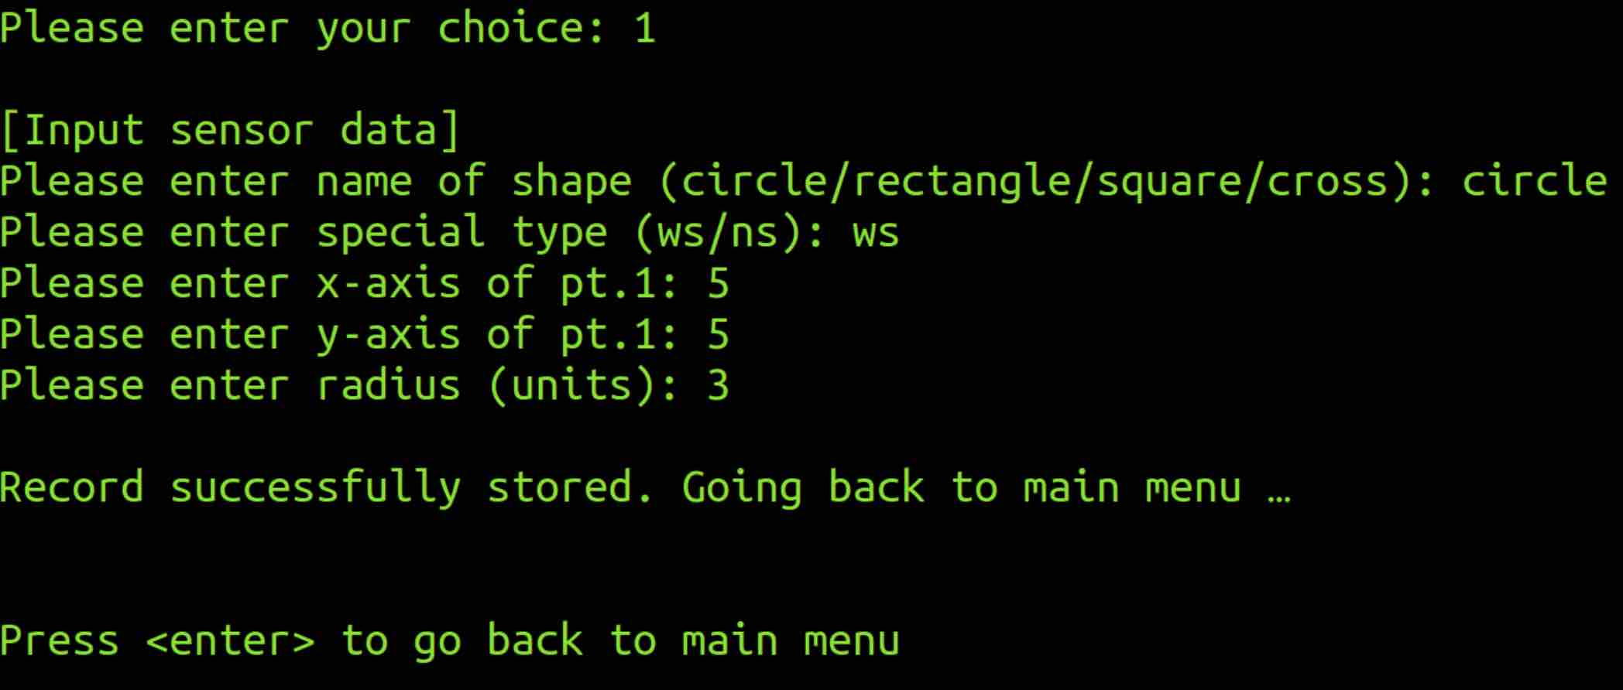

Input Data – Rectangle
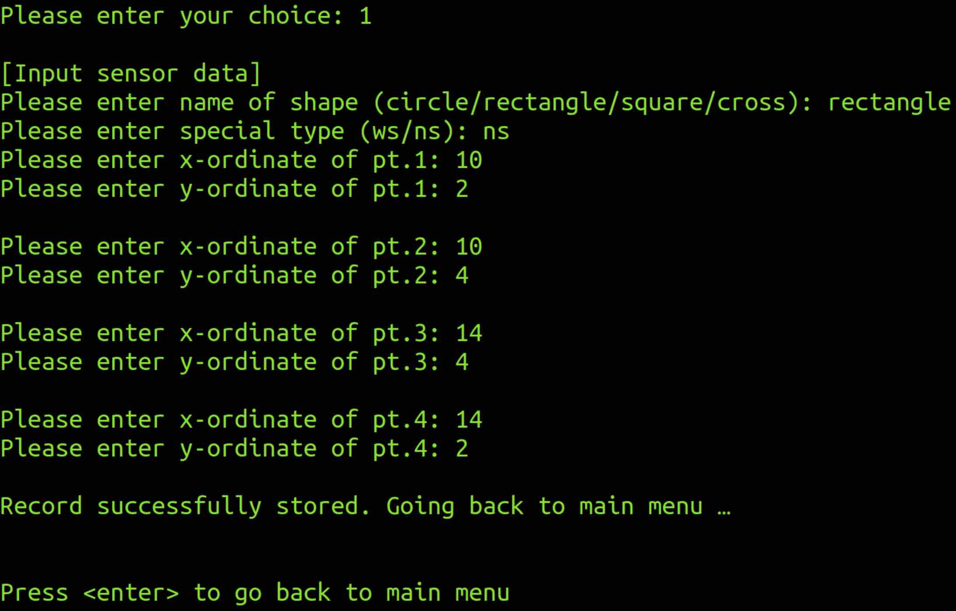

Input – Square
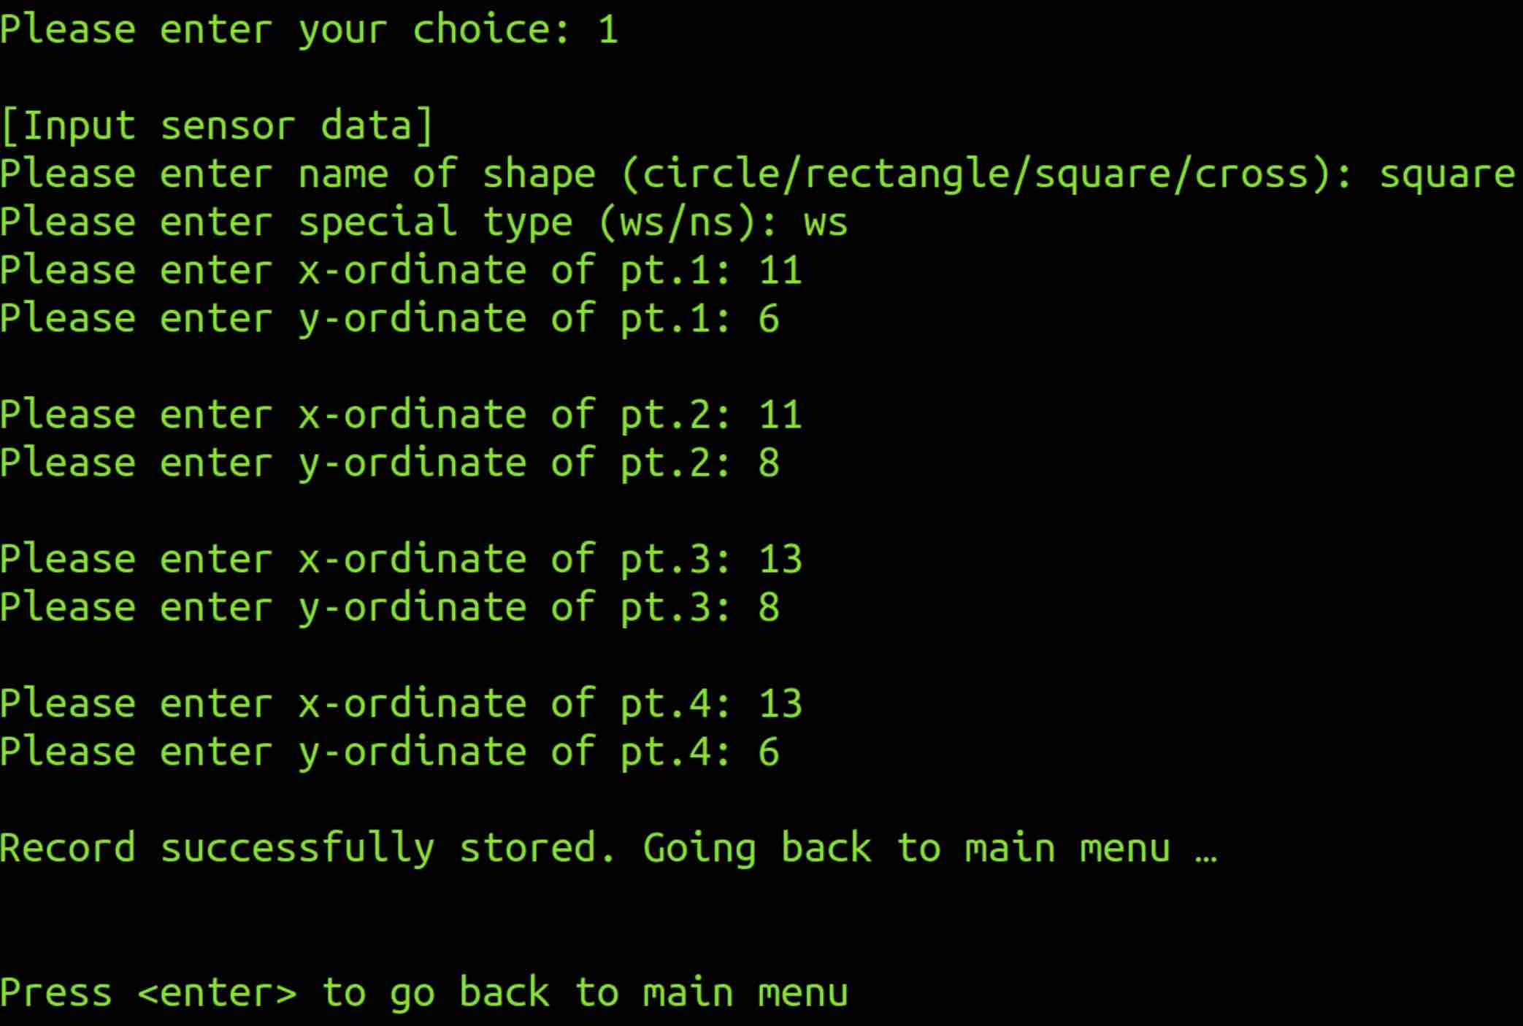

Input – Cross
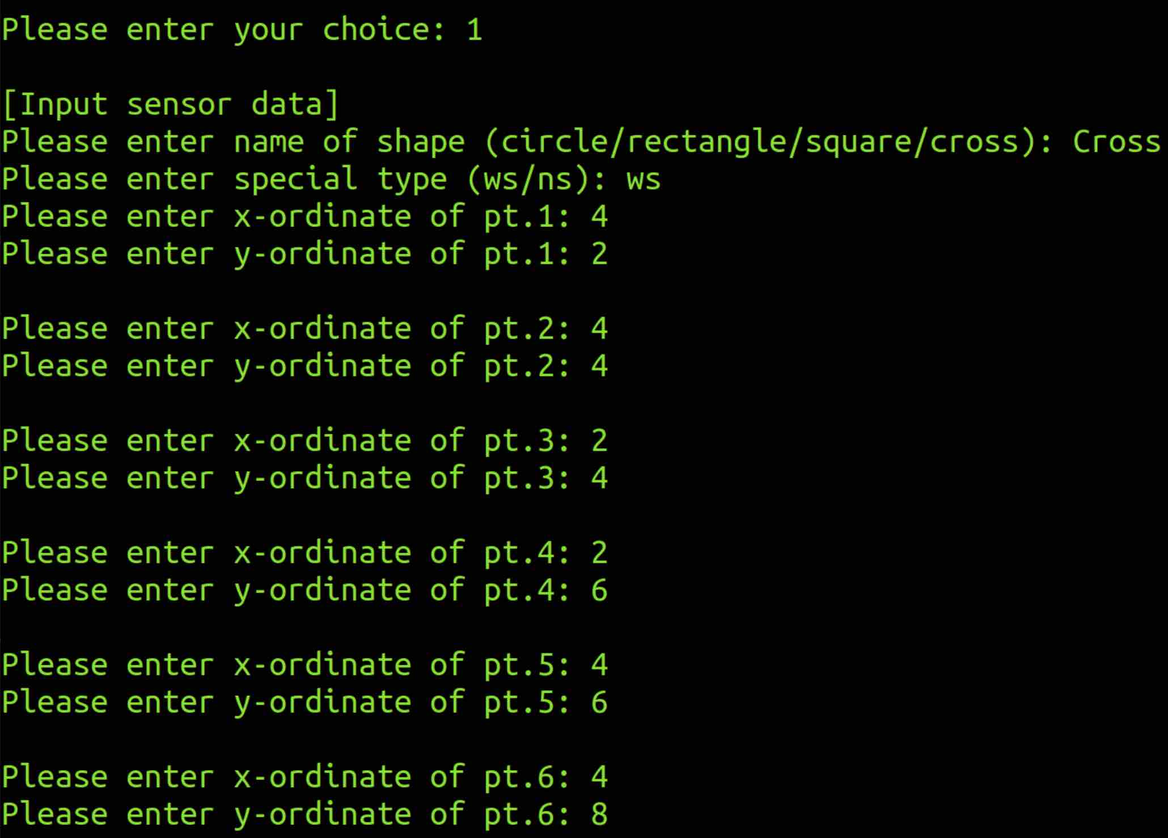
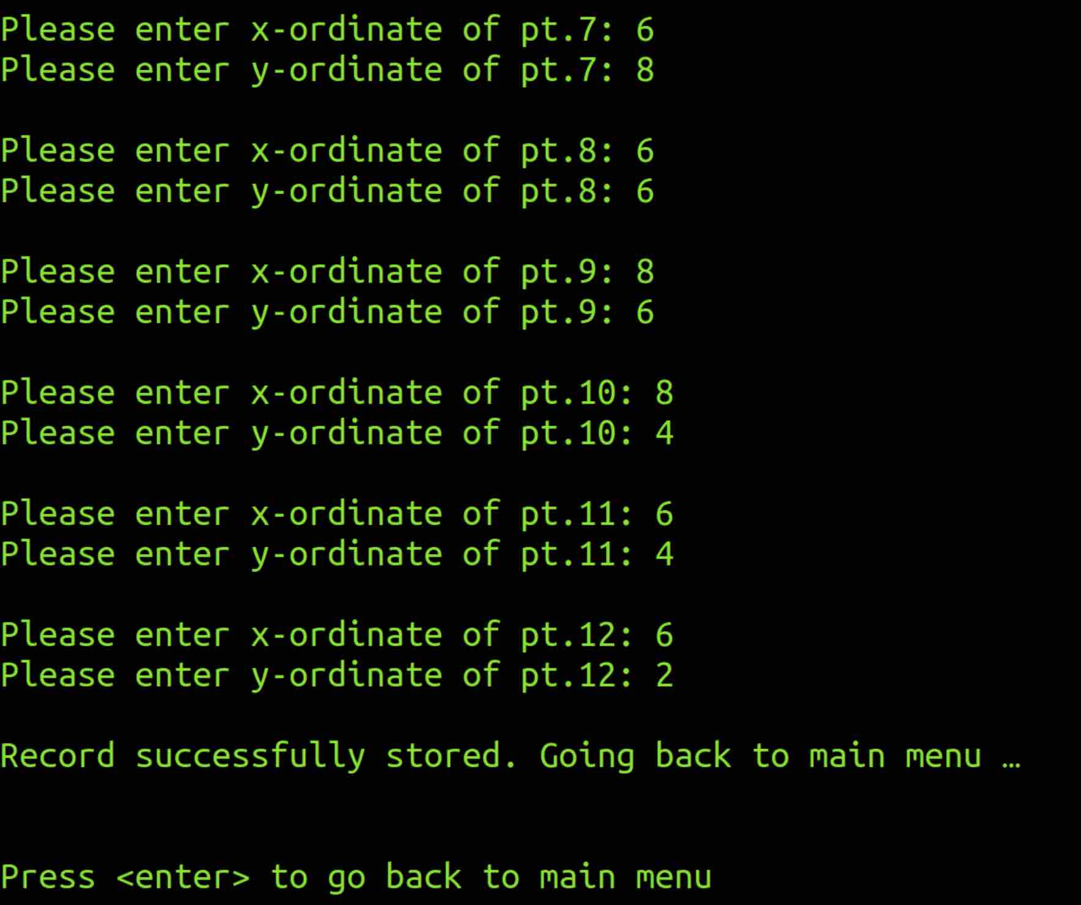

Option 2: Compute Area
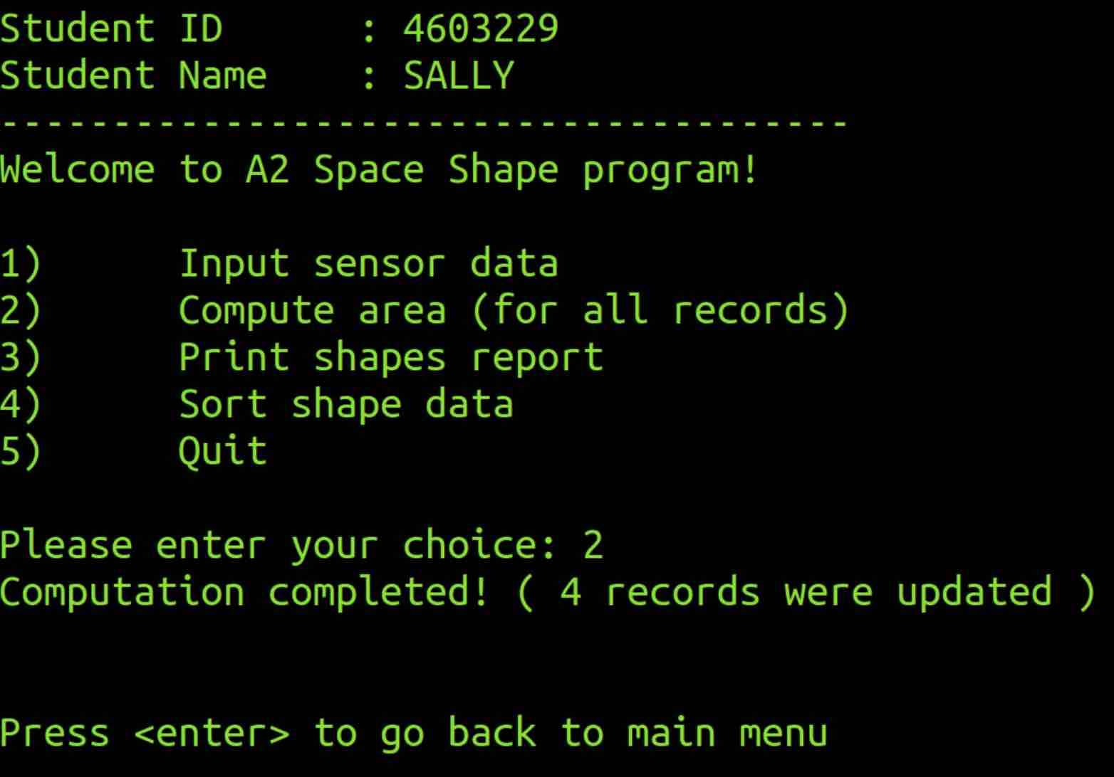

Option 3: Print Shape
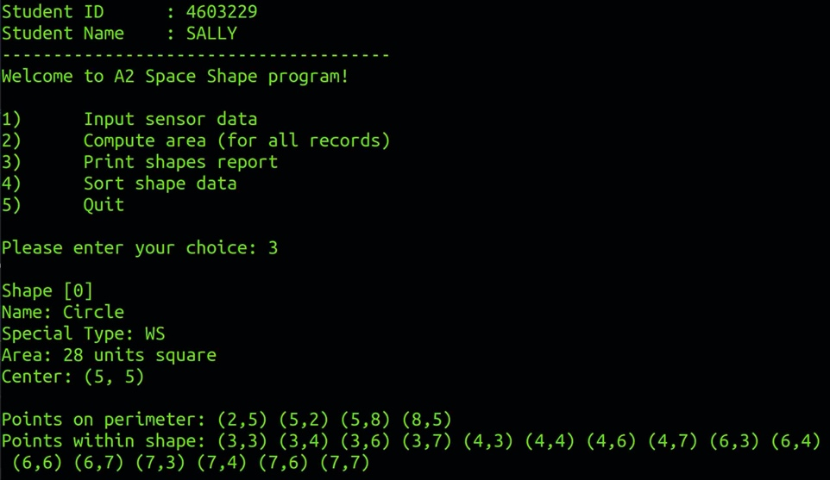
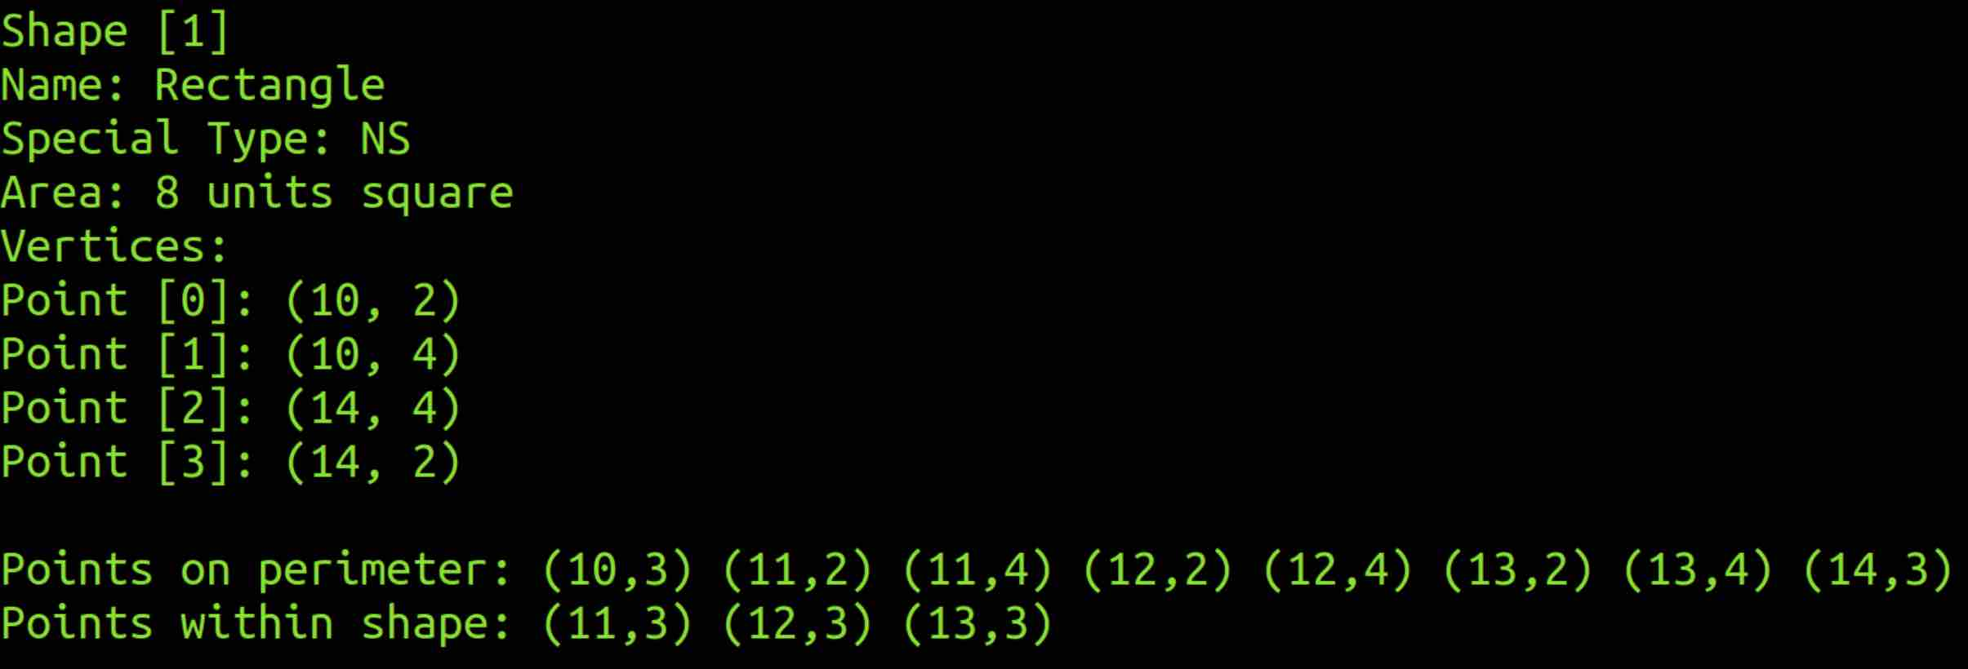
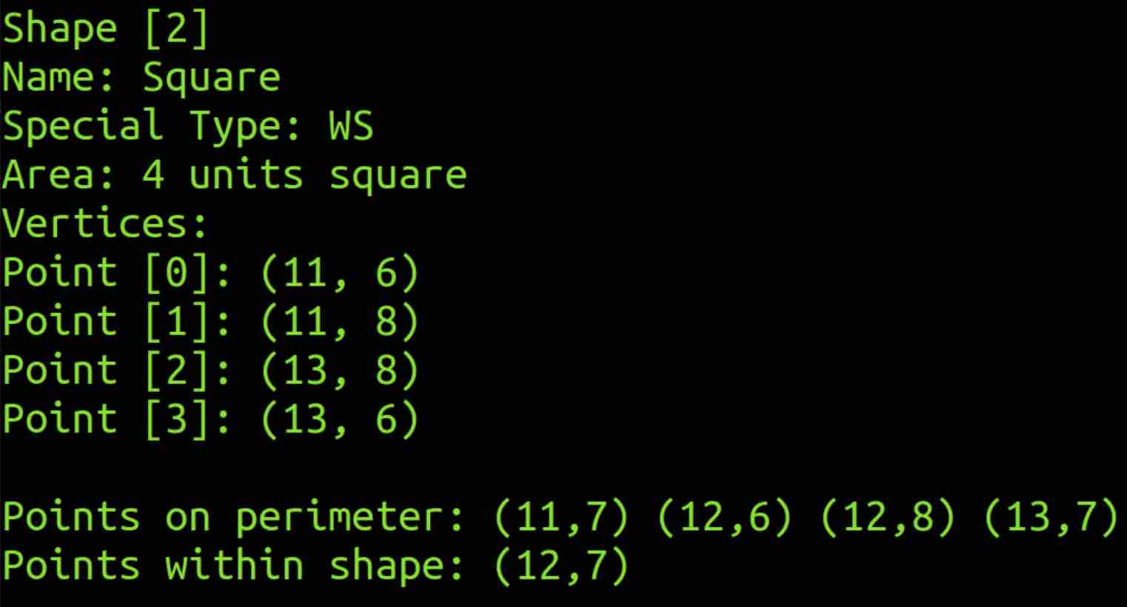
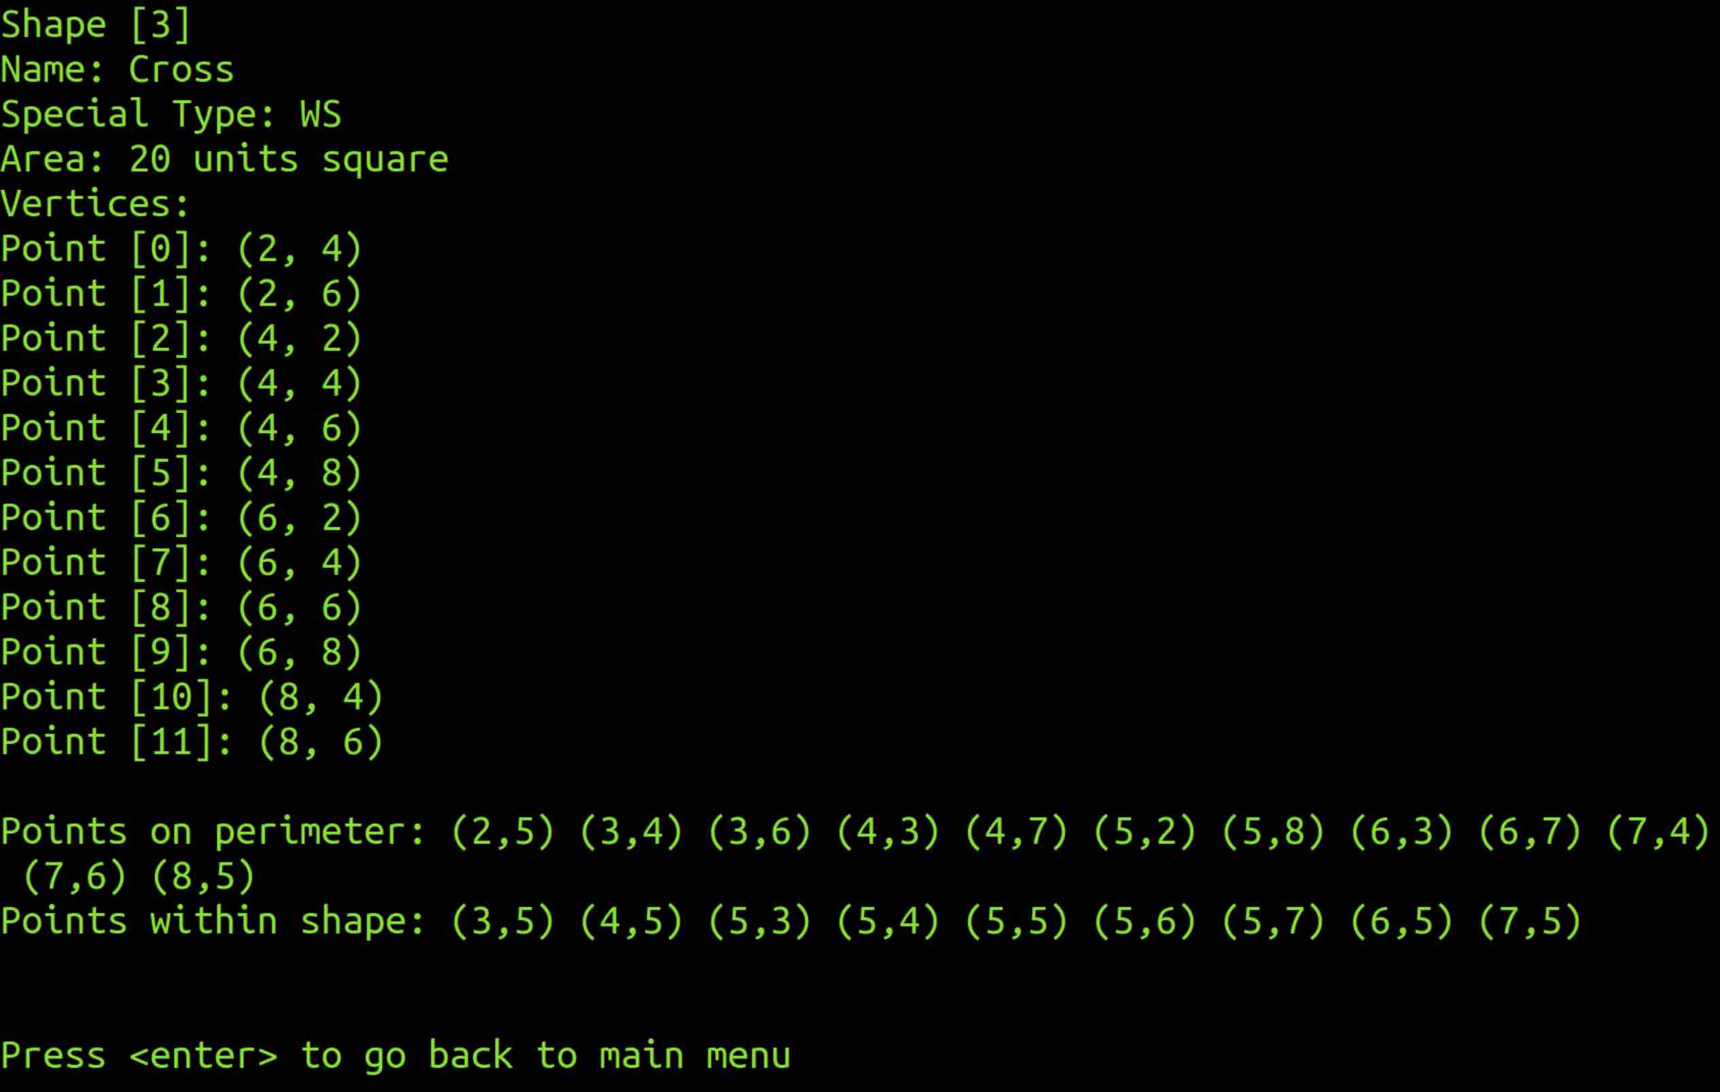

Option 4: Sort Menu
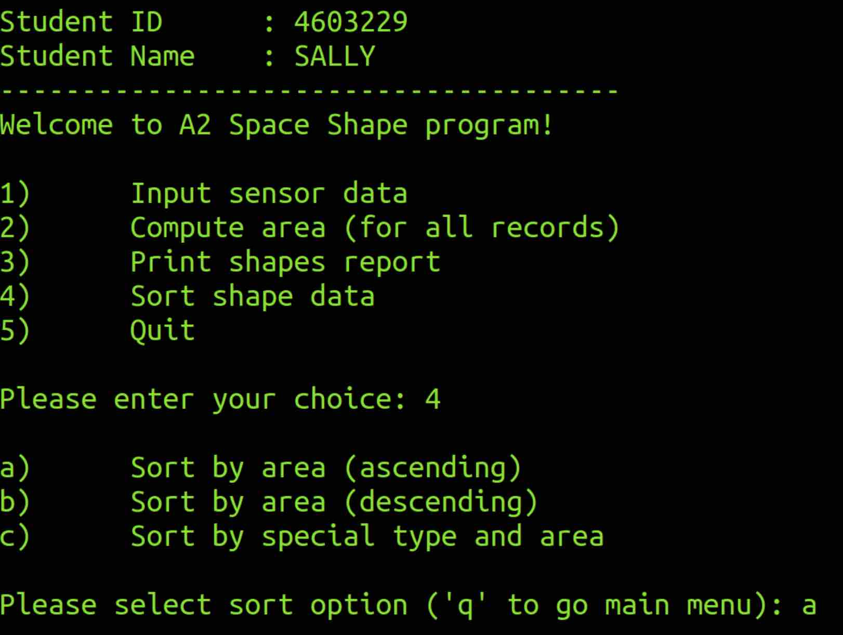

Option 4a: Ascending Area

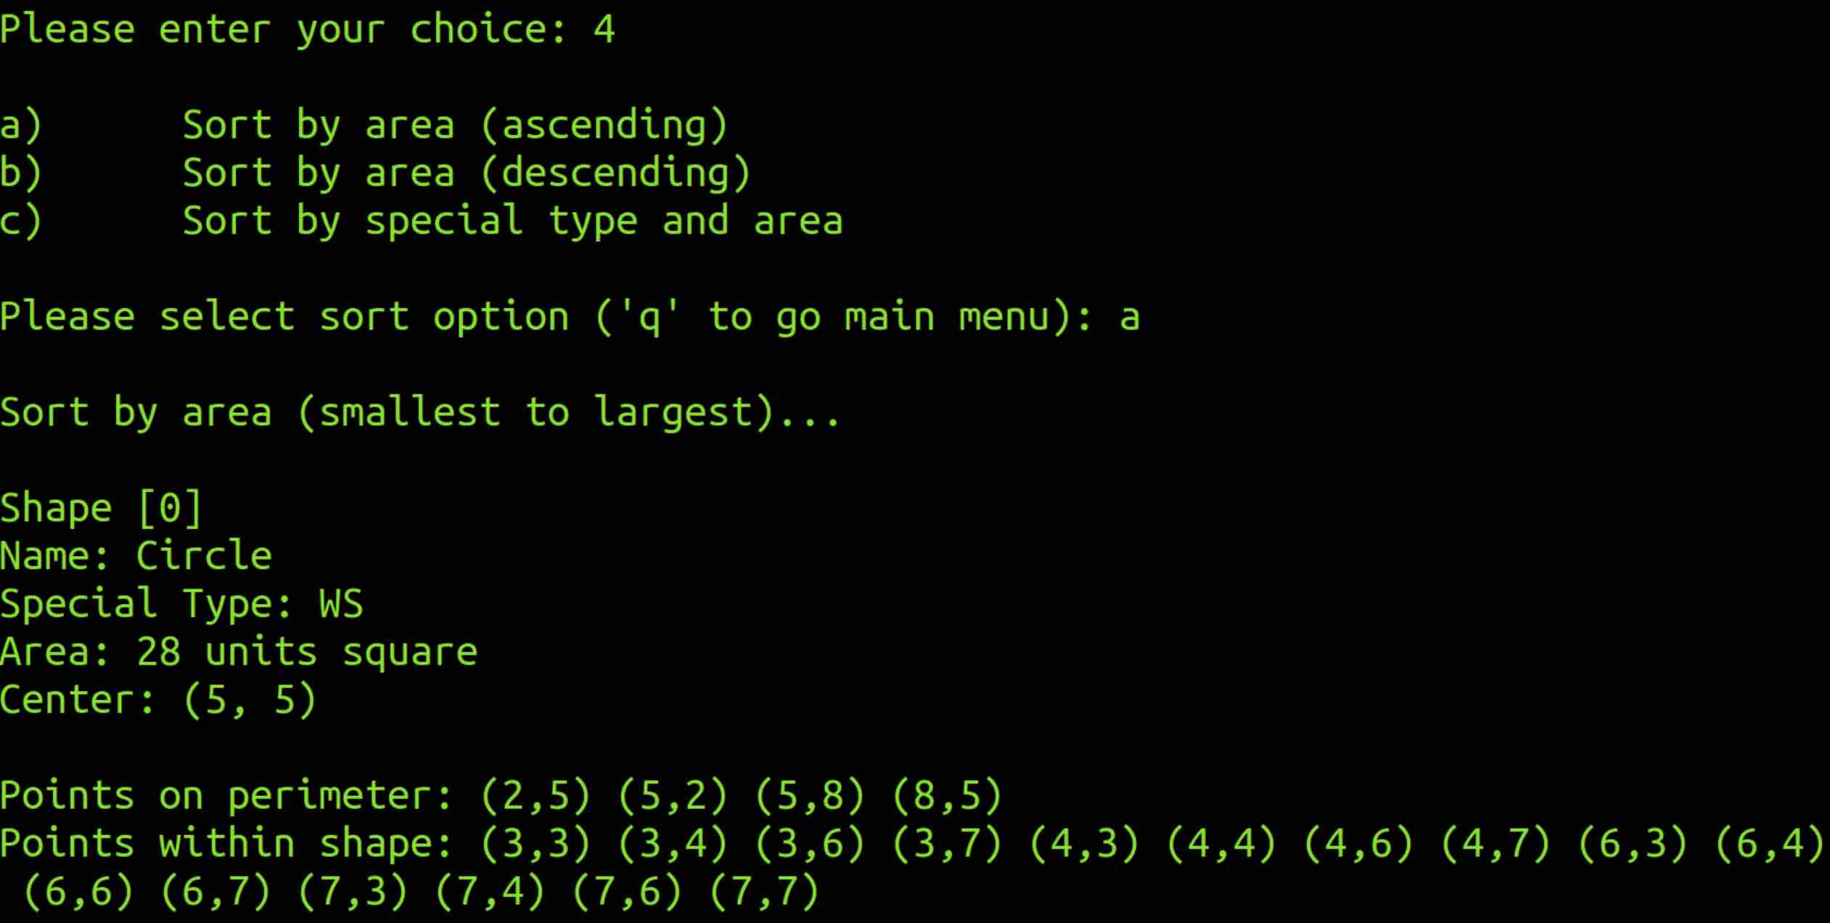
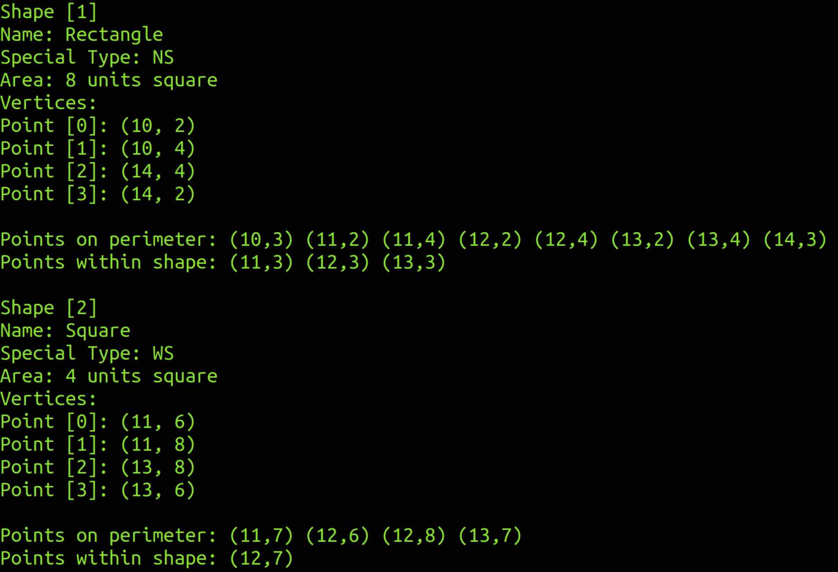
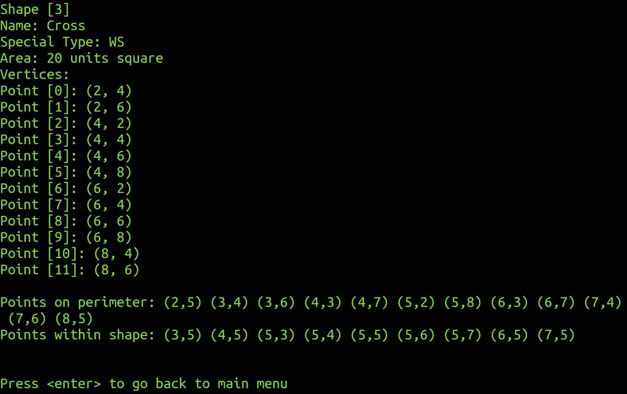

Option 4b: Descending Area
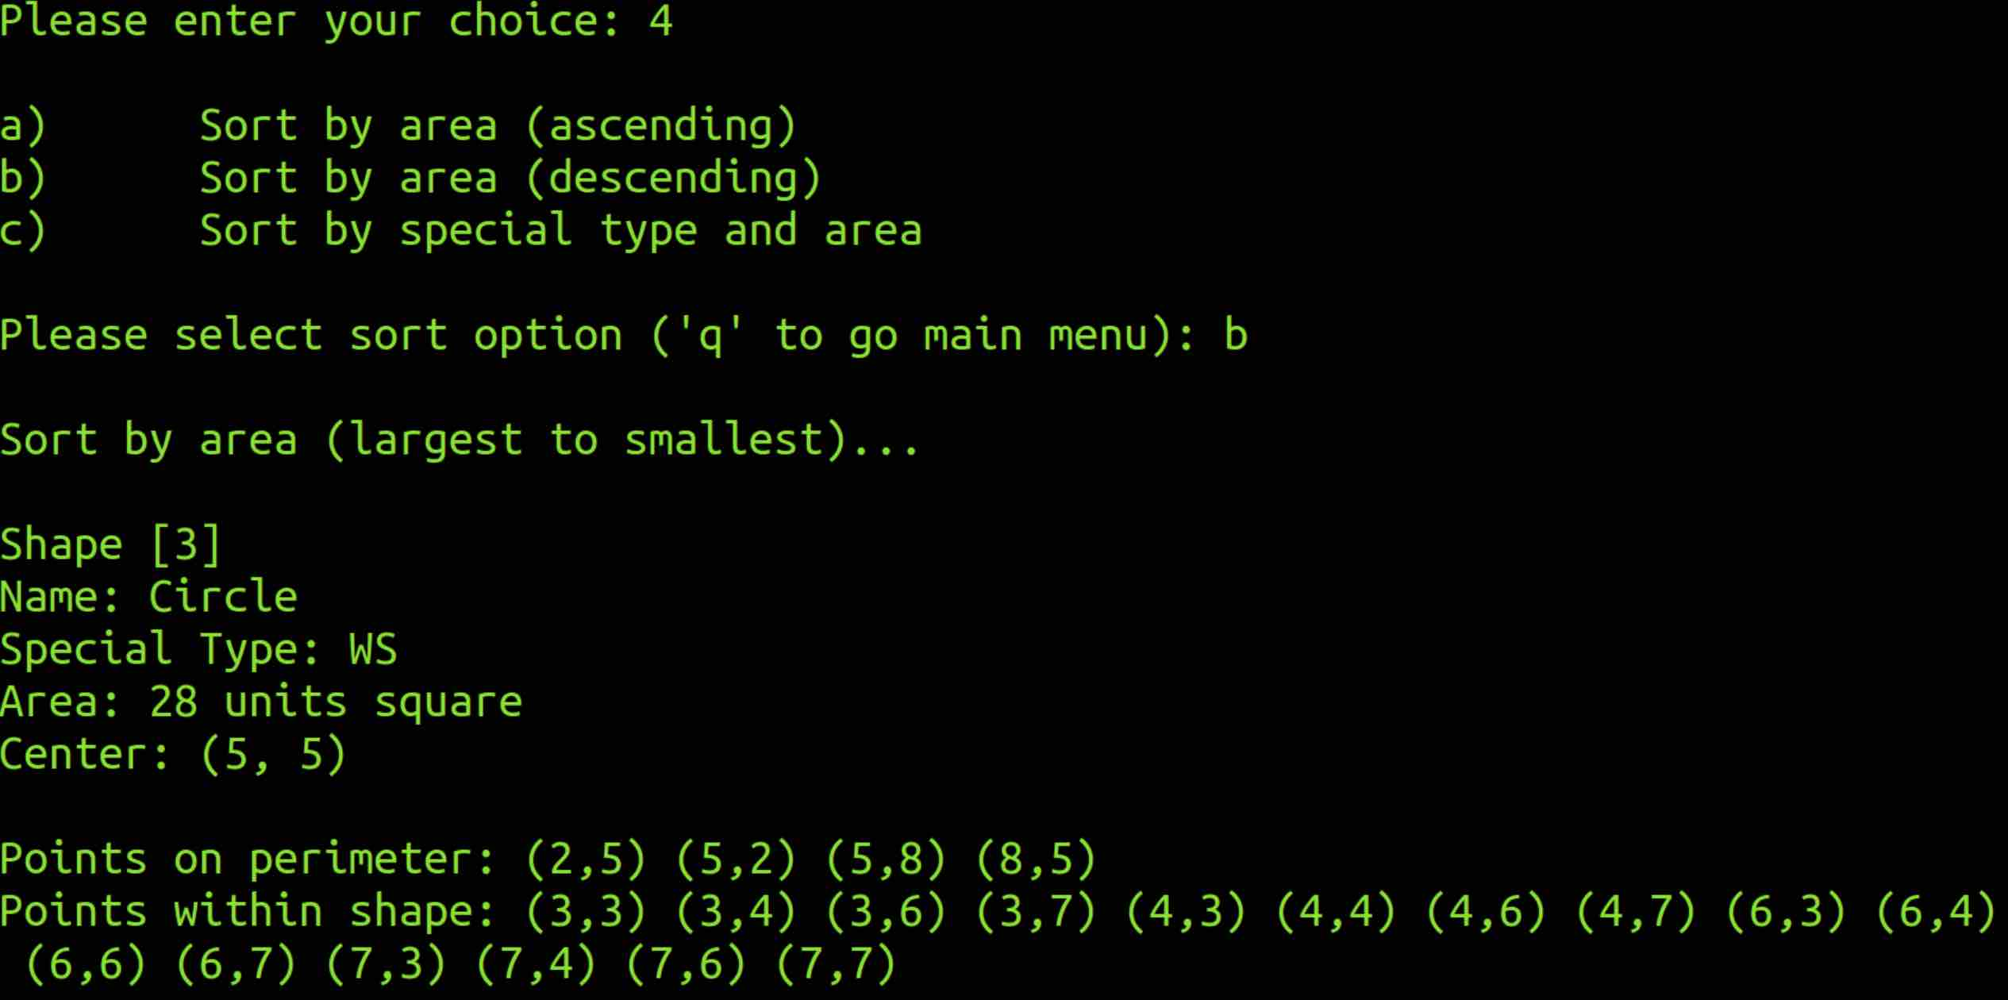
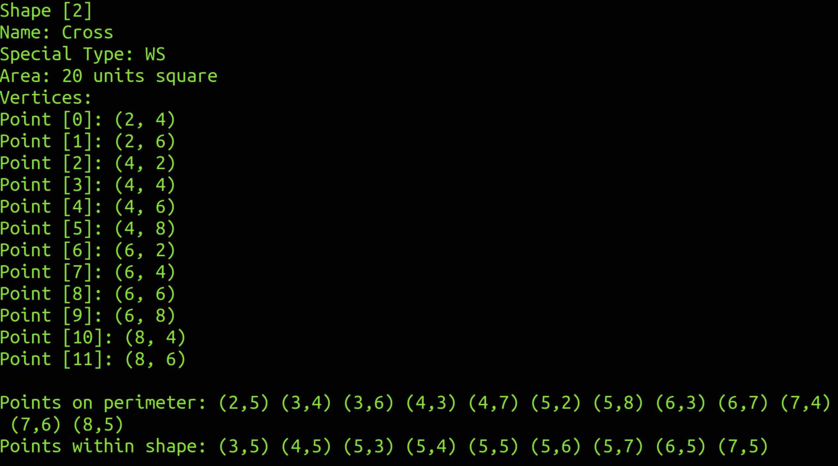
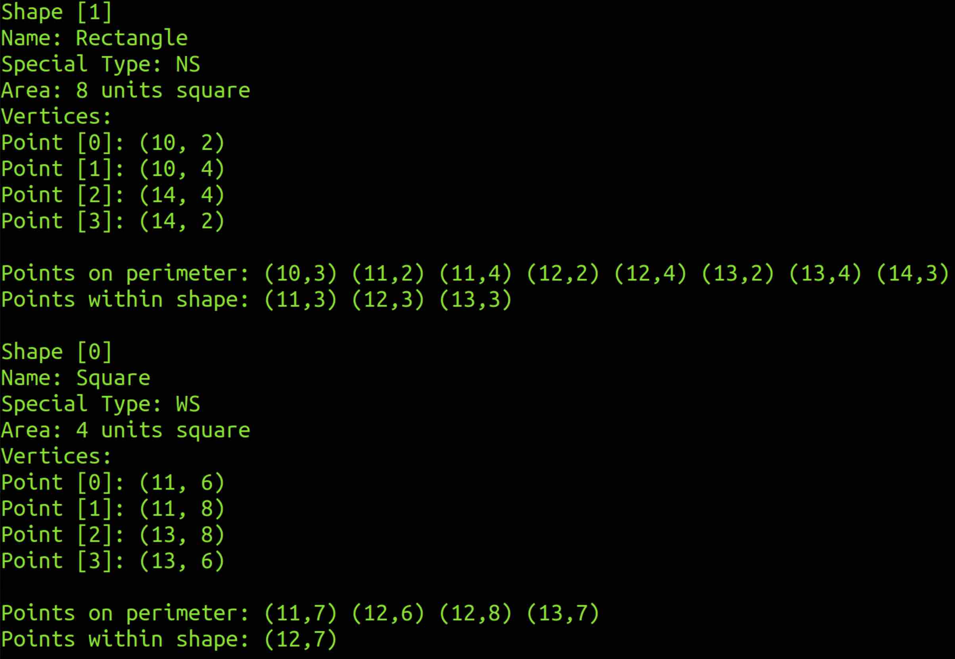
Option 4c: WS type first then NS type & Descending Area
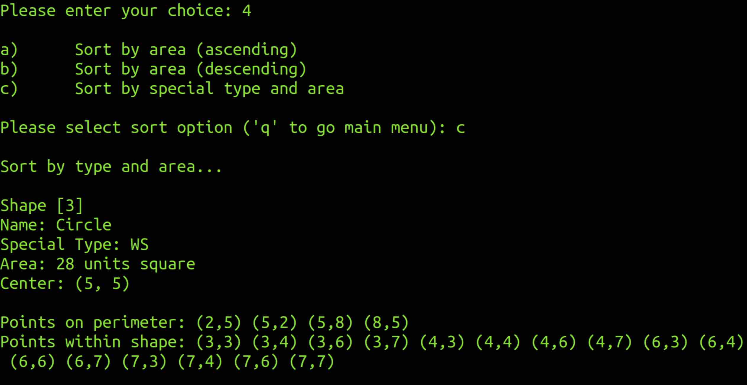
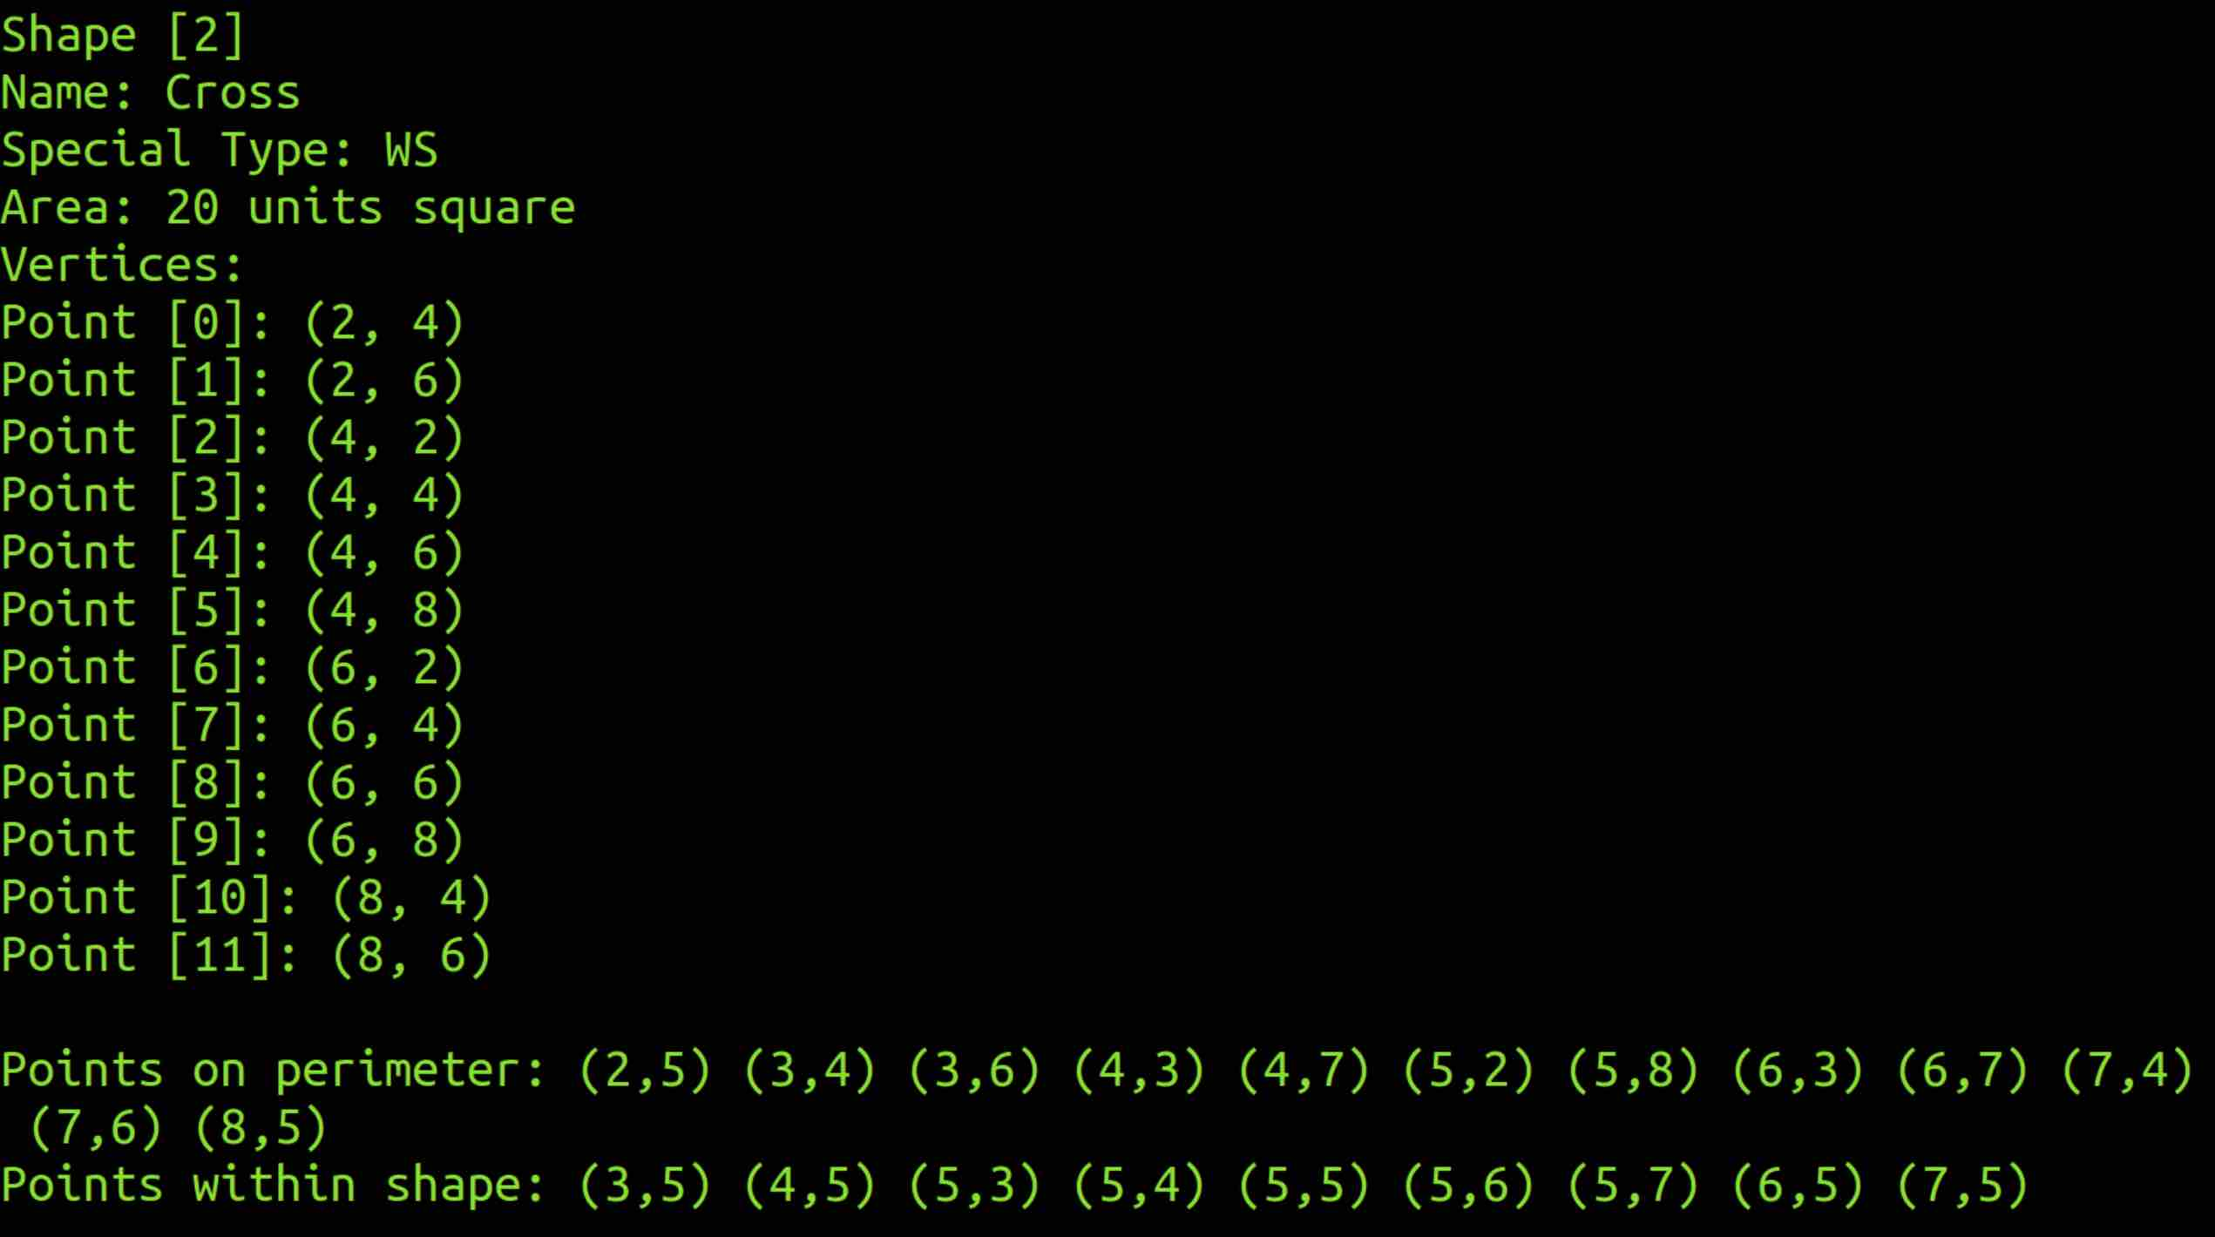
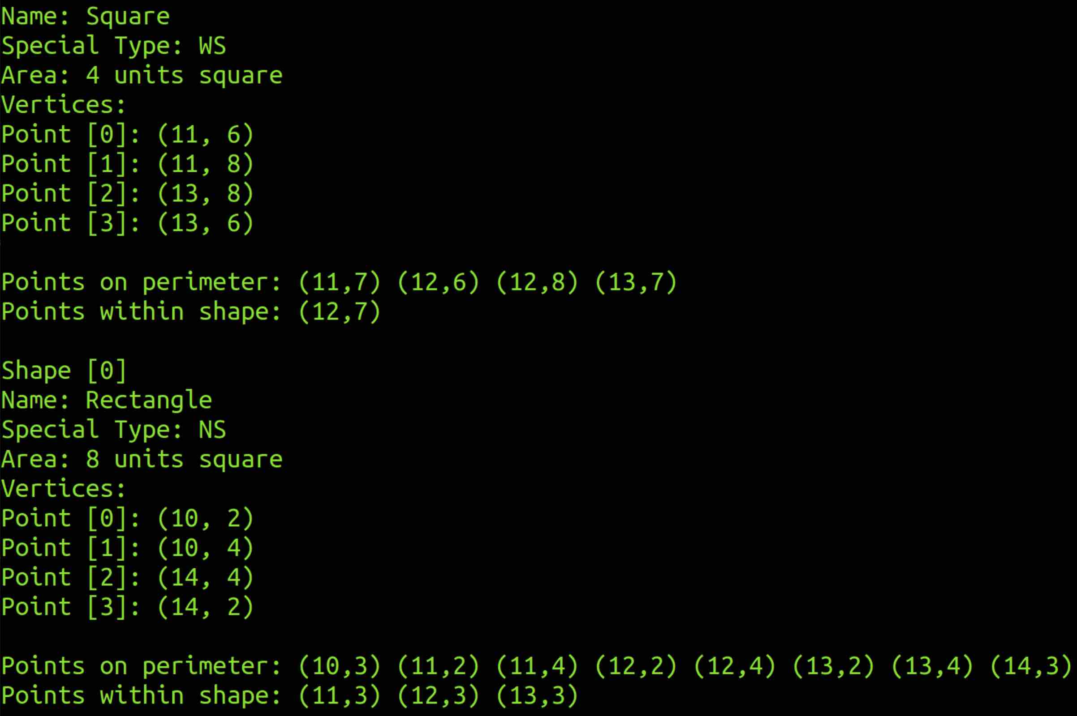

Option 4q & 5
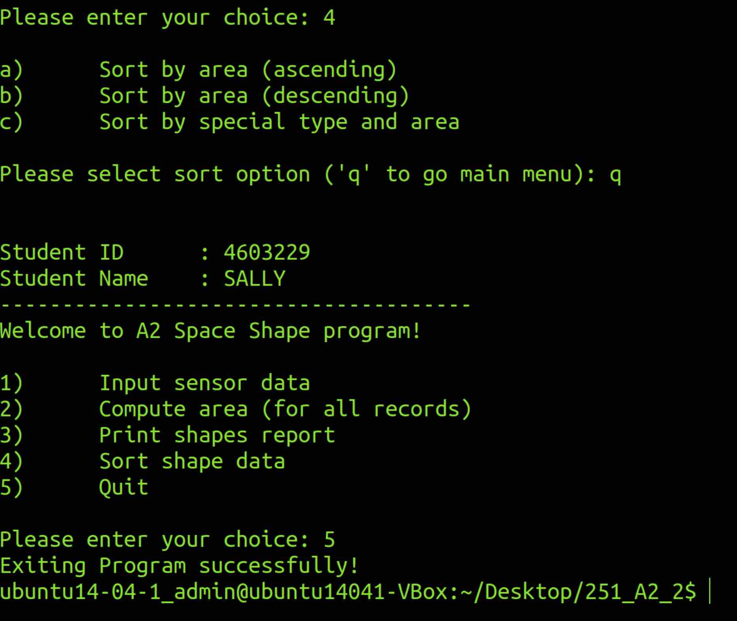

Reflections

The hardest part of this assignment was to figure out the conditions for getting the point on shape, point in shape and calculating the cross shape area. I have re used some of my assignment 1 code as it has similar function such as clear screen, back to main menu and some user input validation. After understanding how to use vector in previous assignment, this assignment gets a little bit easier in terms of the vector usage. Another difficult part was to take long time to understand the long-winded question paper which let us have a taste of maybe just 1% of the real workplace requirement information which might be a thick document.

