CSCI251: Advanced Programming
Assignment 3

Student Name: SALLY
Student ID: 4603229
I have read the policy for plagiarism at Wollongong University.
I declare that this assignment solution is entirely my work.
Requirements
We need to develop a program that reads in and process records from a file that contains data for different classes. These data are messy (unsorted), and the program needs to remove duplicate data, filter and display the data according to user-specified sorting criteria. User is then able to output the sorted data displayed in external file.

csci251_a3.cpp
Line 3 – 10: Main method
The main method calls the processChoice() and pass in the return of mainMenu() to determine subsequent function to be called.

assn3.h
Line 1-2: Declaration of #ifndef headguard
#ifndef to prevent redeclaration of any identifiers and prevent recursive inclusions.
Line 4-16: Declaration of #include
Line 18-154: Declaration of class Point2D, Point3D, Line2D and Line3D
Line 156-171: Declaration of function prototypes
Line 173: #endif

MyTemplates.h
This file consists of Function Templates & Sorting Comparators

assn3.cpp
This file contains all the implementation code.
Line 3 – 9: Global Variables
I have declared 3 global variables to be used during sorting and one integer variable to be used as confirmation flag before storing sorted data.

Line 11 - 15: Global Vectors
These vectors will be storing all the points and lines extracted from the input file.

Line 17 - 21: resetScreen()
This function helps to clear the screen before proceeding to next option.

Line 23 - 55: Main Menu
This function displays the menu and prompt user to input further instruction such as read in data, filter, sort, view or store data. It returns user input as an integer which will be passed into processChoice() to further activate switch case to call the next relevant function.

Line 57 – 88: processChoice()
This function will further activate switch case to call the next relevant function based on user input in the main menu.

Line 90 – 202: Option 1 - Reading data
This function uses Regex to extract line by line from the input file. This similar method was used in my Assignment 1 as well. Each matching data will then be stored to their respective vector for Point2D, Point3D, Line2D and Line3D.

Line 204 – 263: Option 2 – Filter
This function display interface for user to choose filter criteria.

Line 265 – 356: Option 3 – Sorting
This function display interface for user to choose sorting criteria.

Line 425 – 465: Option 4 – Sorting Order (Ascending/Descending)
This function display interface for user to choose sorting order criteria.

Line 467 – 746: View Data
This function consists of multiple nested if-else to filter and sort the data. It involves the usage of sorting comparator which is declared in the MyTemplates.h, the three global variables declared earlier. The global variable “counter” is updated here as well to be used later on when storing data.

Line 748 – 834: Store Data
The global variable counter is used in here to make sure user has viewed the sorted data before they decide to output it to external file. It copies part of viewData() the for-loop to print the data into external file. After closing the file, outputSuccessMsg() will be called to inform user on how many records has been written to the external file.

Line 865 – 883: Return Main Menu
This function is used as well previously in Assignment 1 and 2. It allows user to get back to Main Menu.

Point2D.cpp, Point3D.cpp, Line2D.cpp, Line3D.cpp
These 4 files are to declare all the necessary classes for the program. Point2D is super class of Point3D while Line2D is super class of Line3D.
Program Demo
Main menu and Option 1 – Reading file
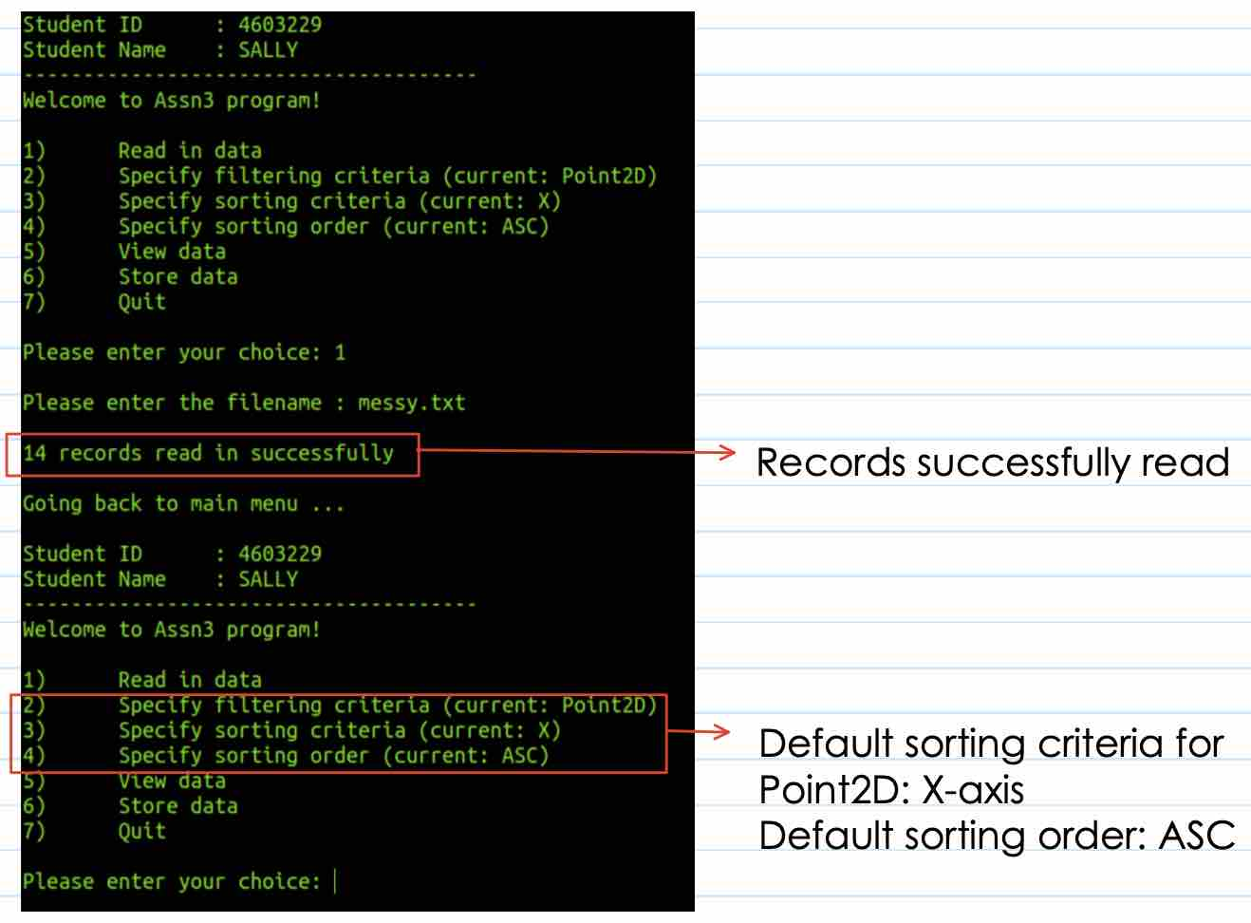

Set filter to Point3D – showing default sort criteria and default sort order
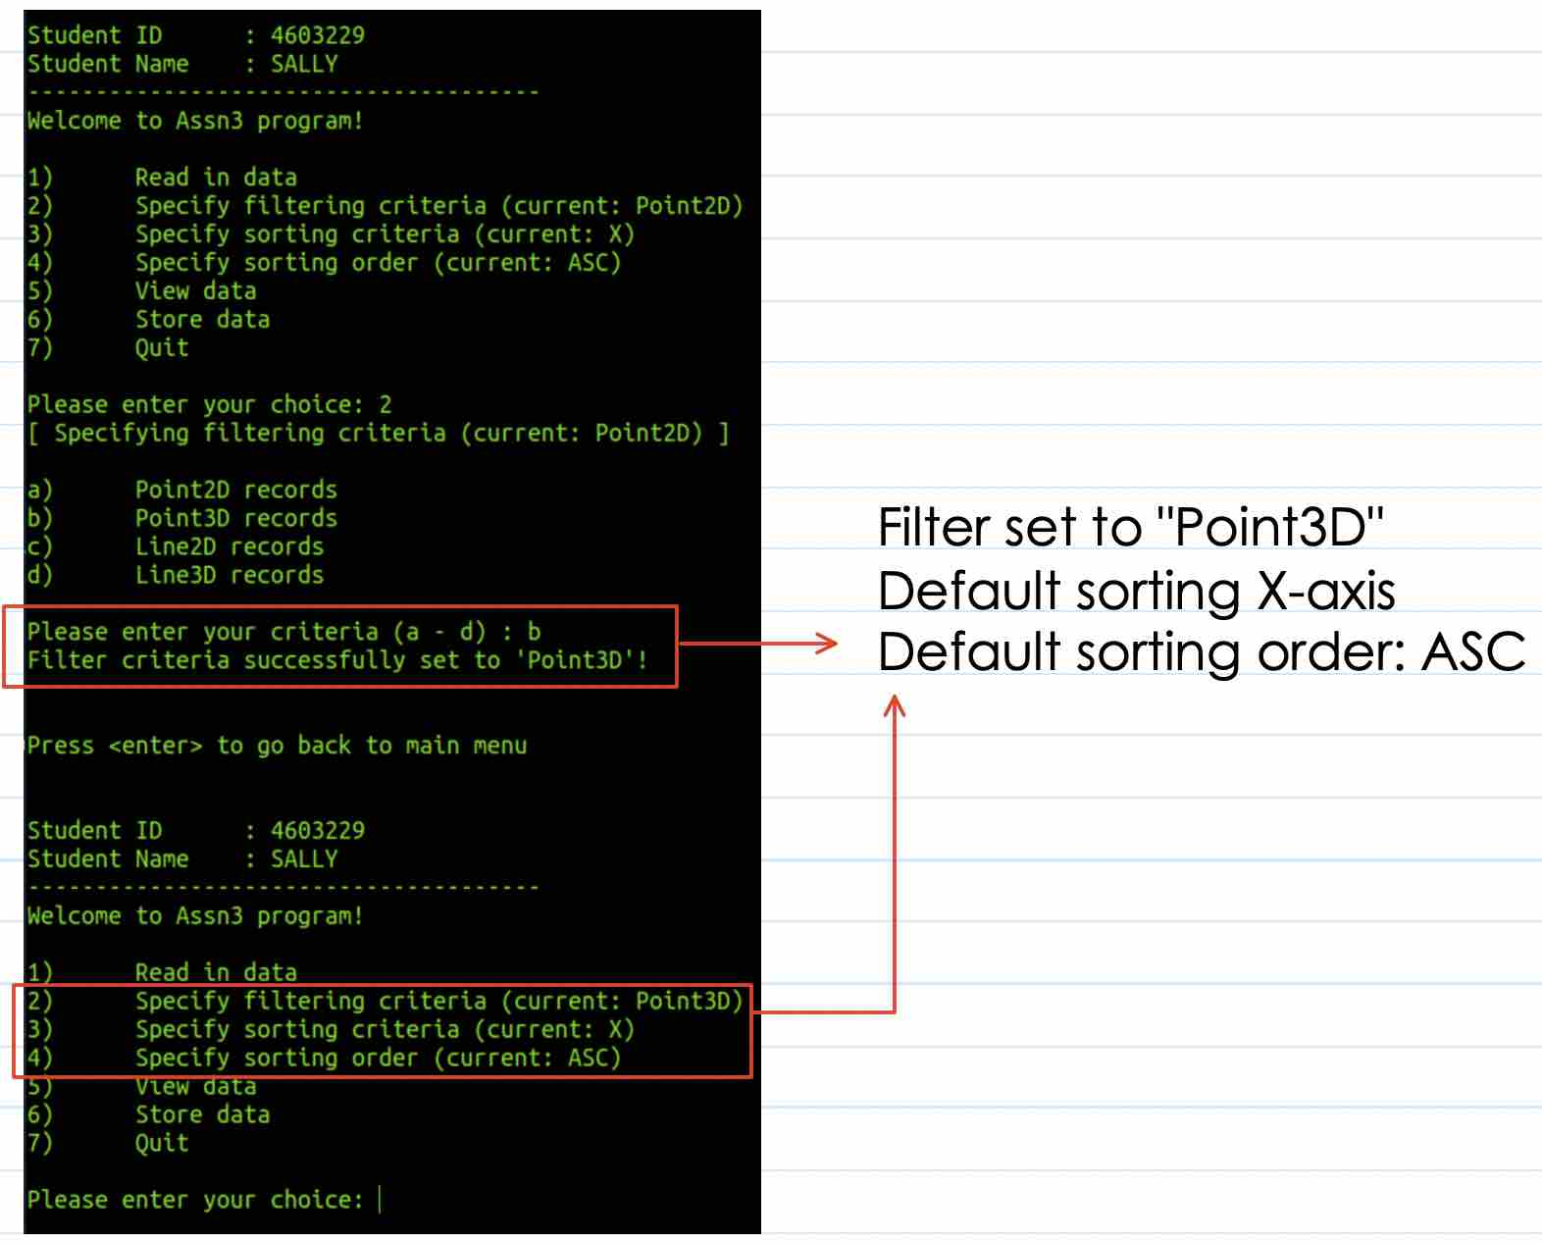

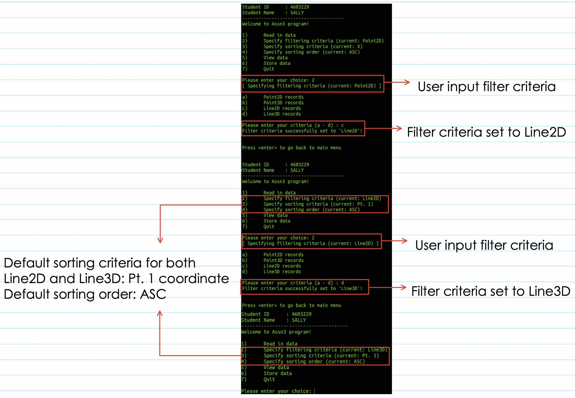
Set filter to Line2D and Line3D – showing default sort criteria and default sort order

Set sorting criteria for Point2D
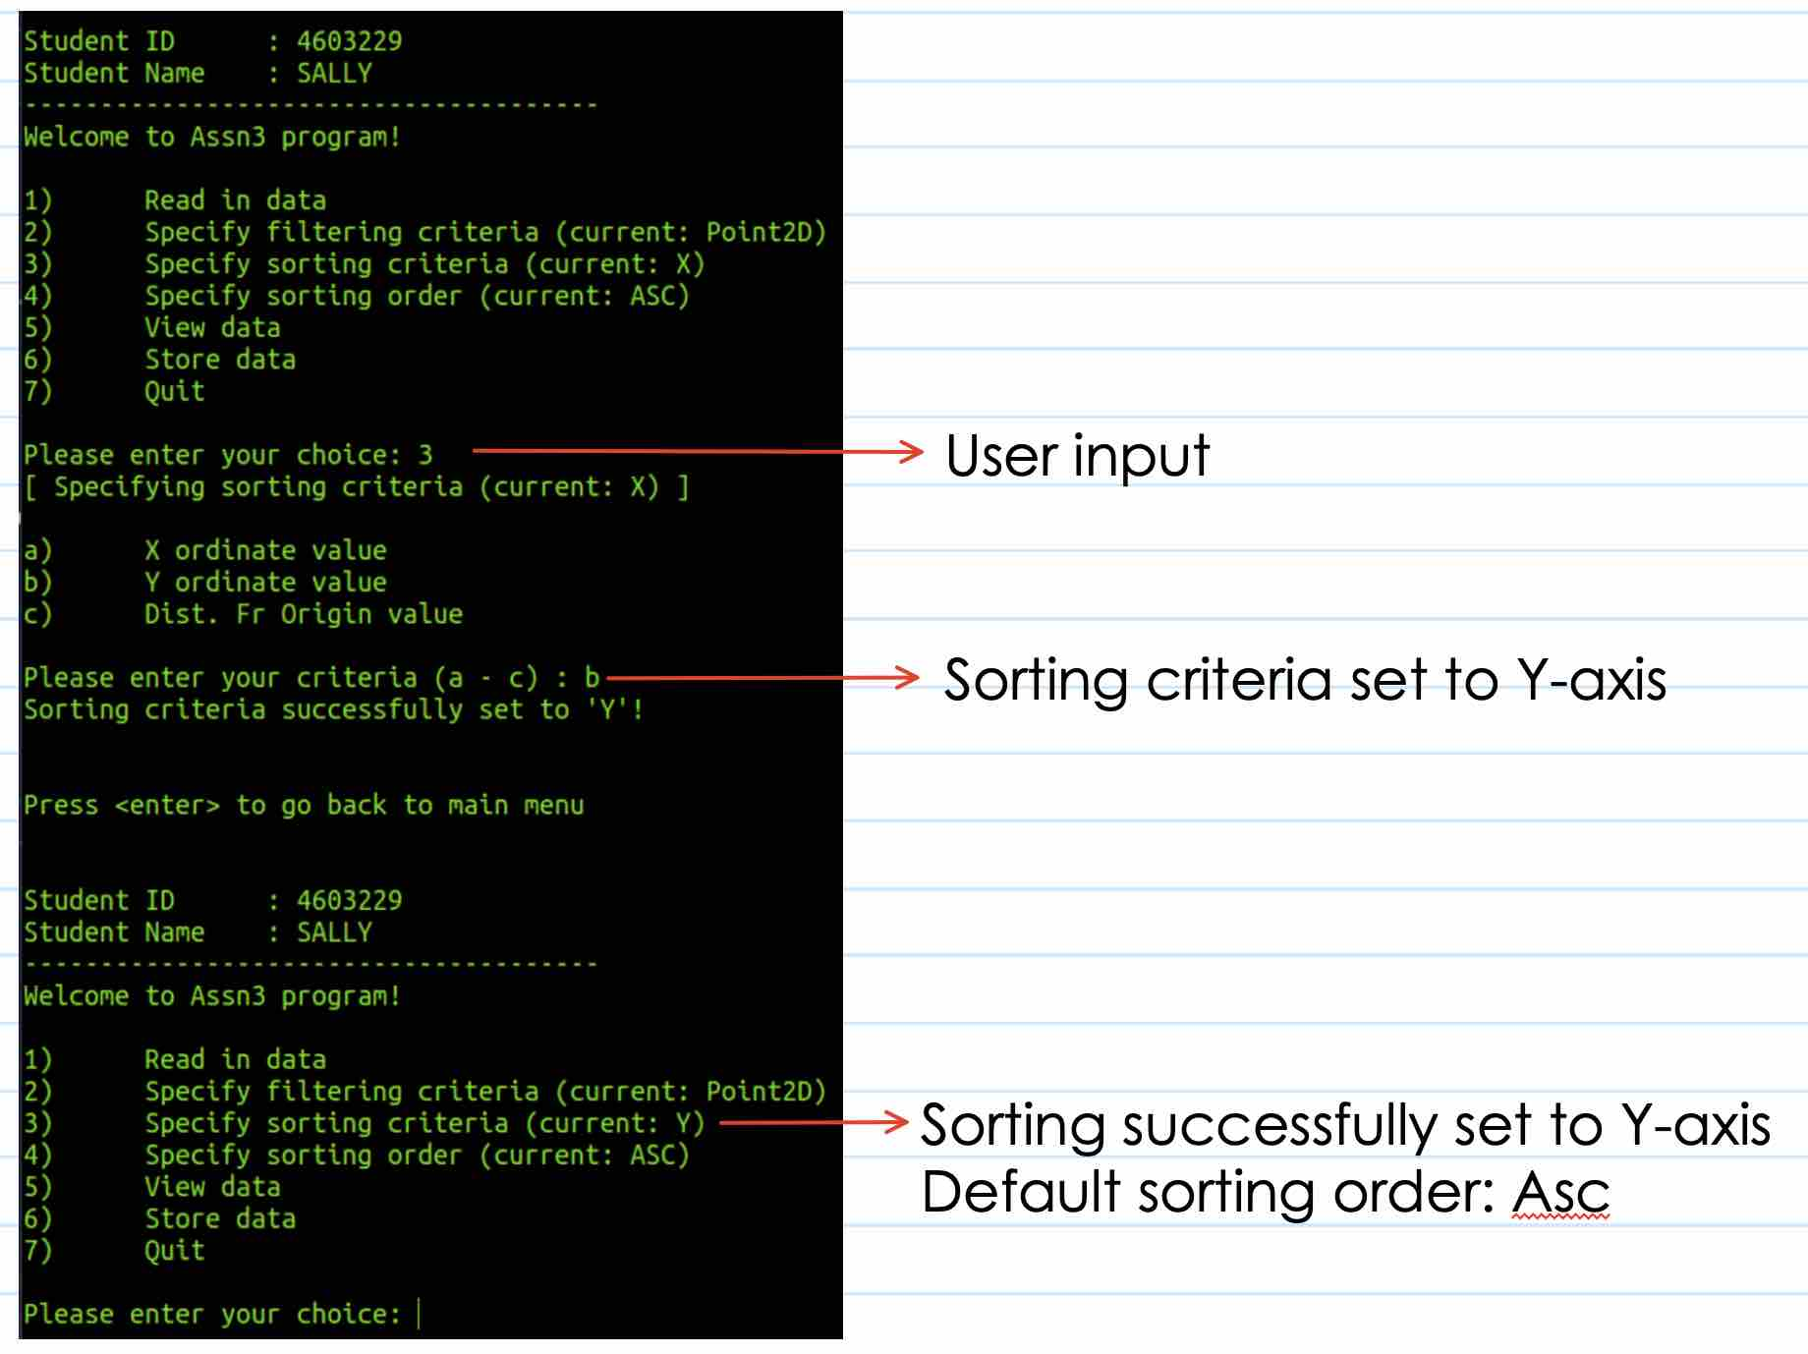
Set sorting order for Point2D
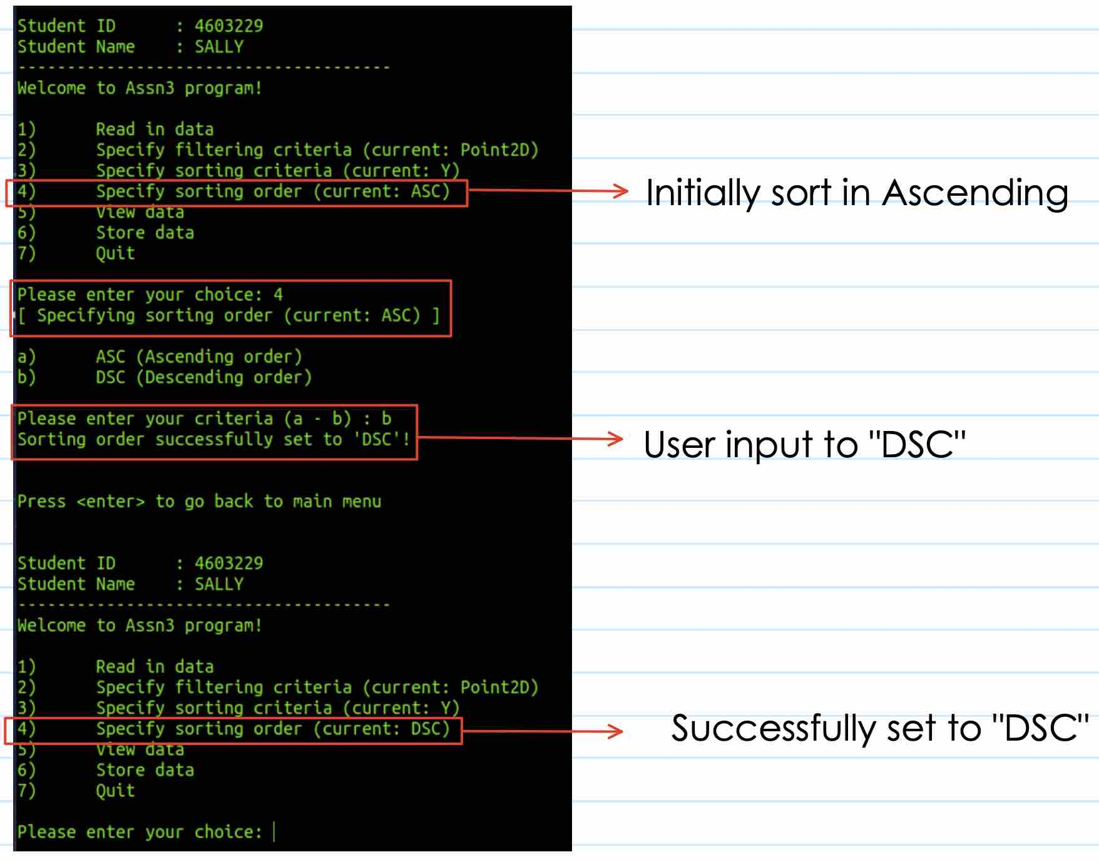

Sorting order back to ASC after sorting criteria changed
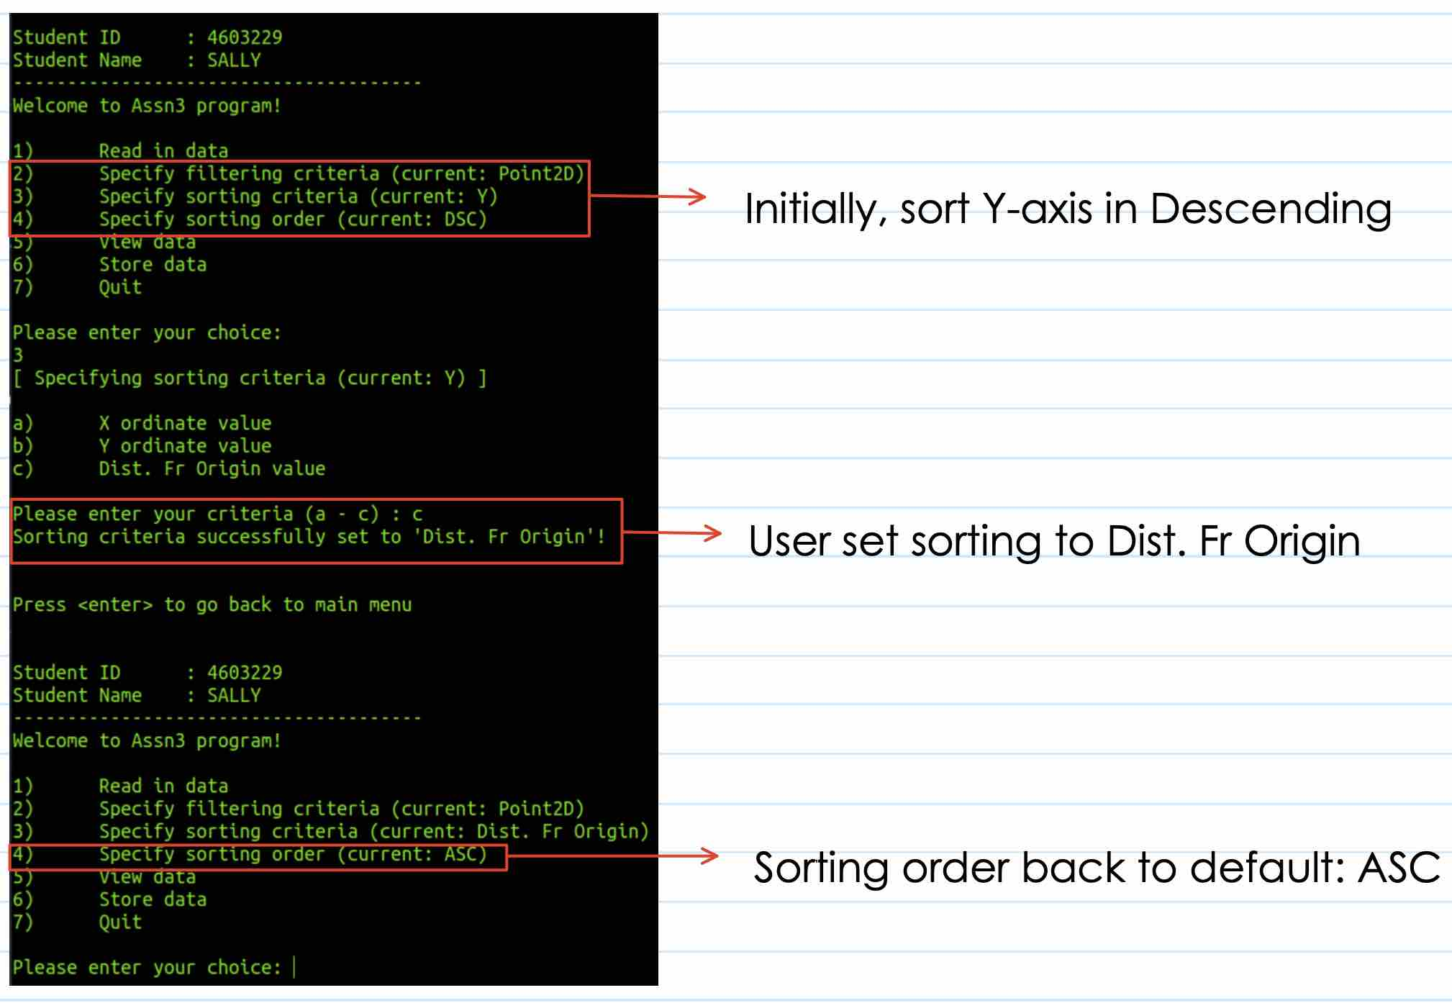

Set sorting criteria for Point3D
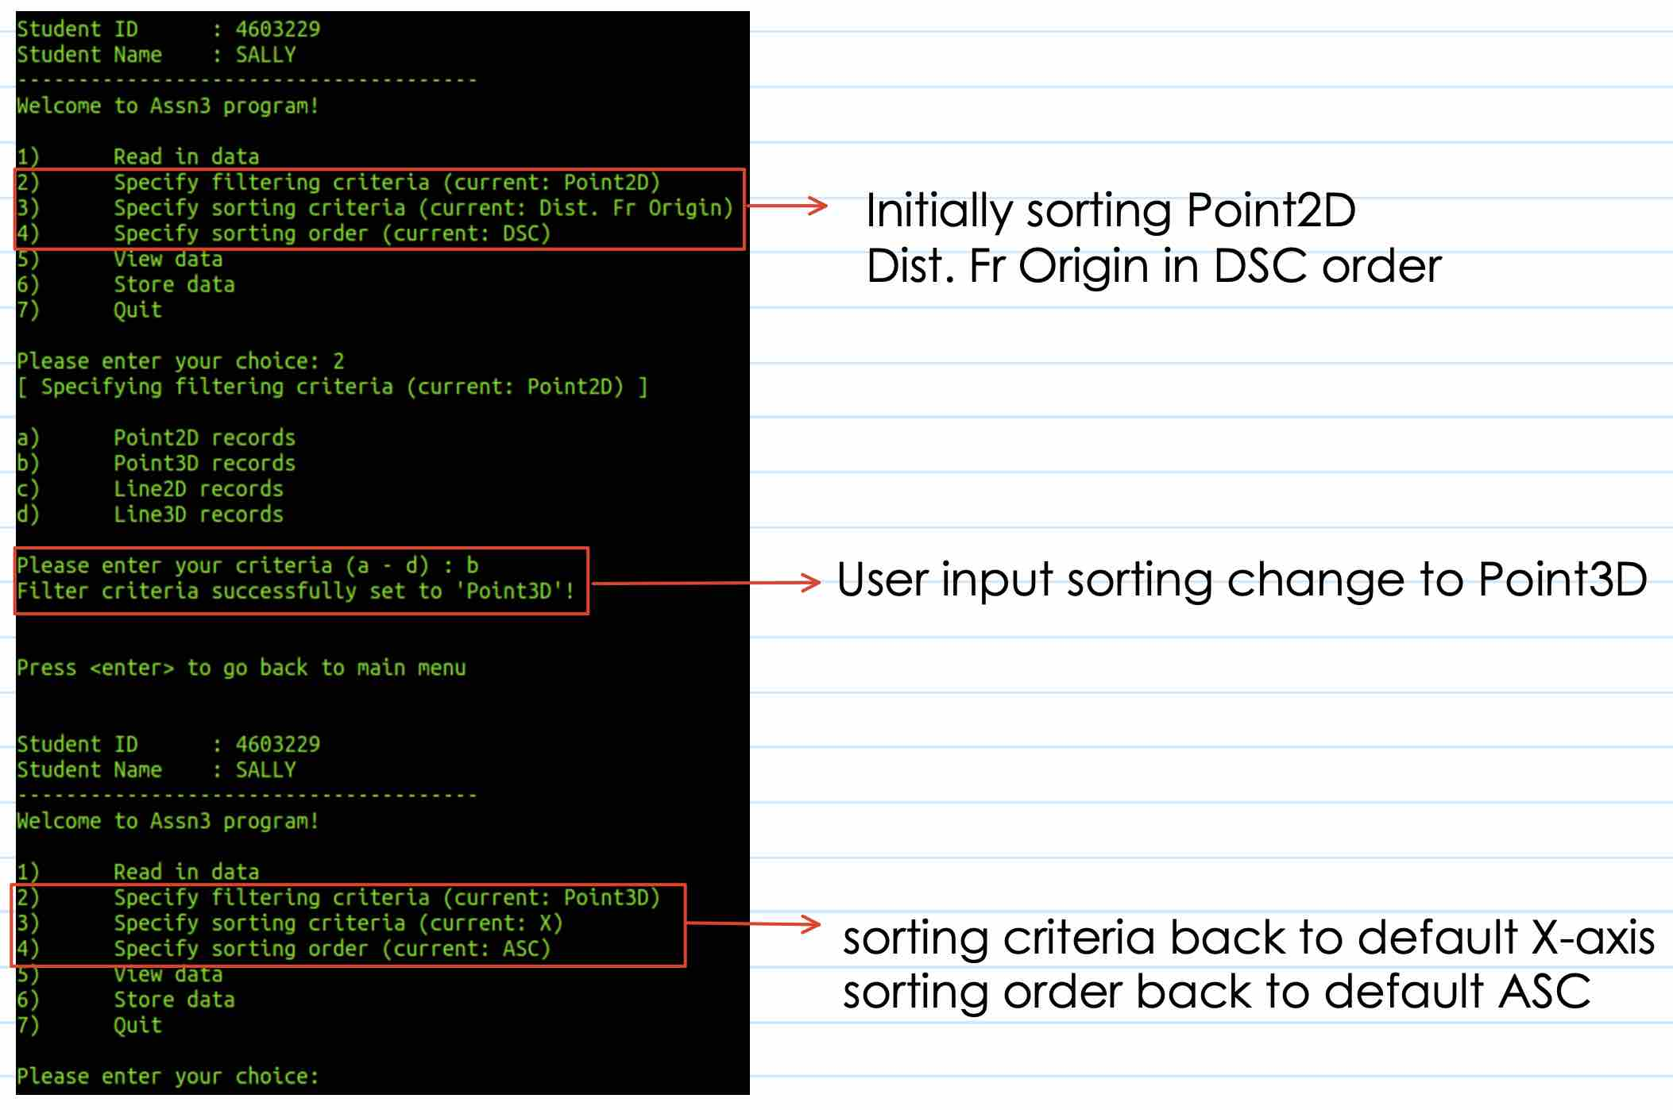
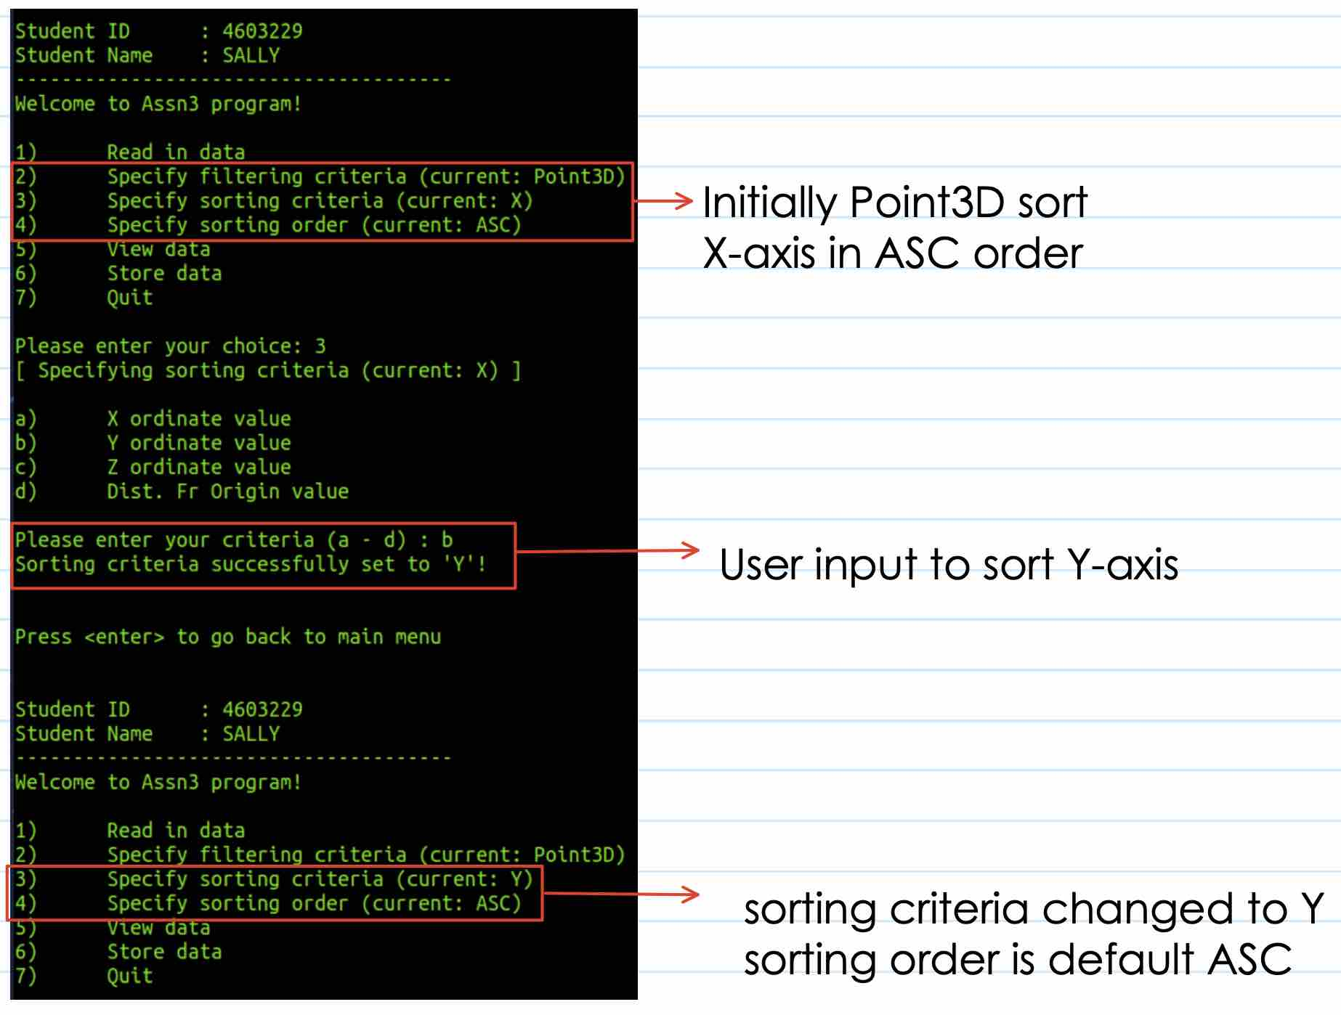
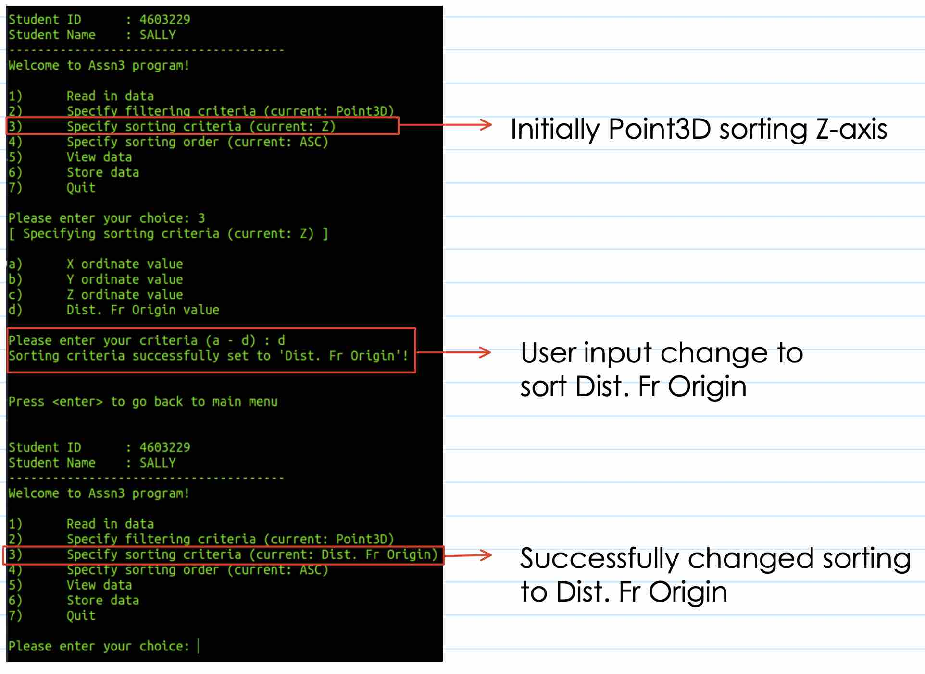

Set sorting order for Point3D
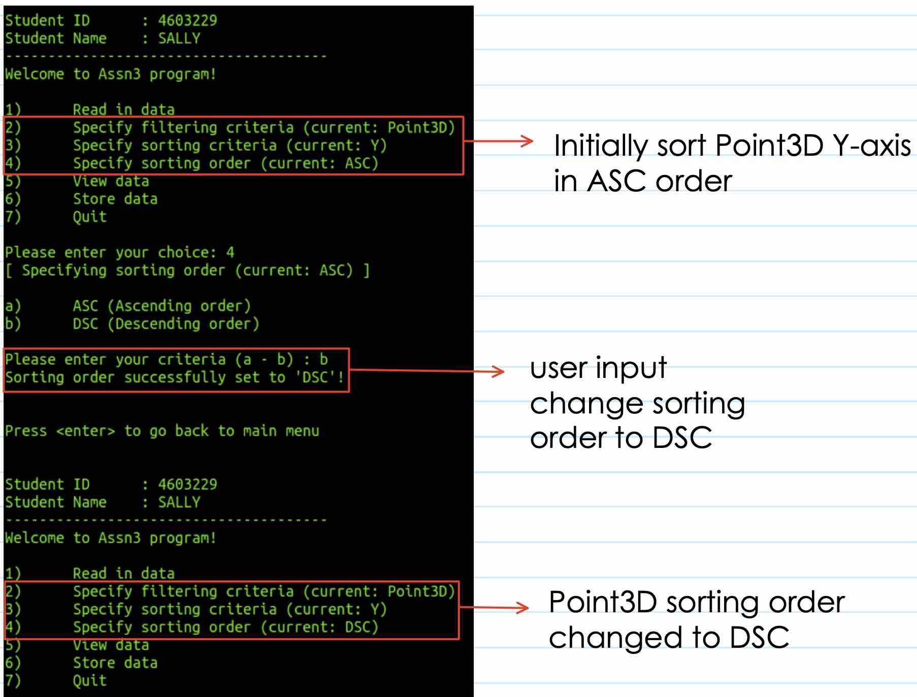

Sorting order back to ASC after sorting criteria changed
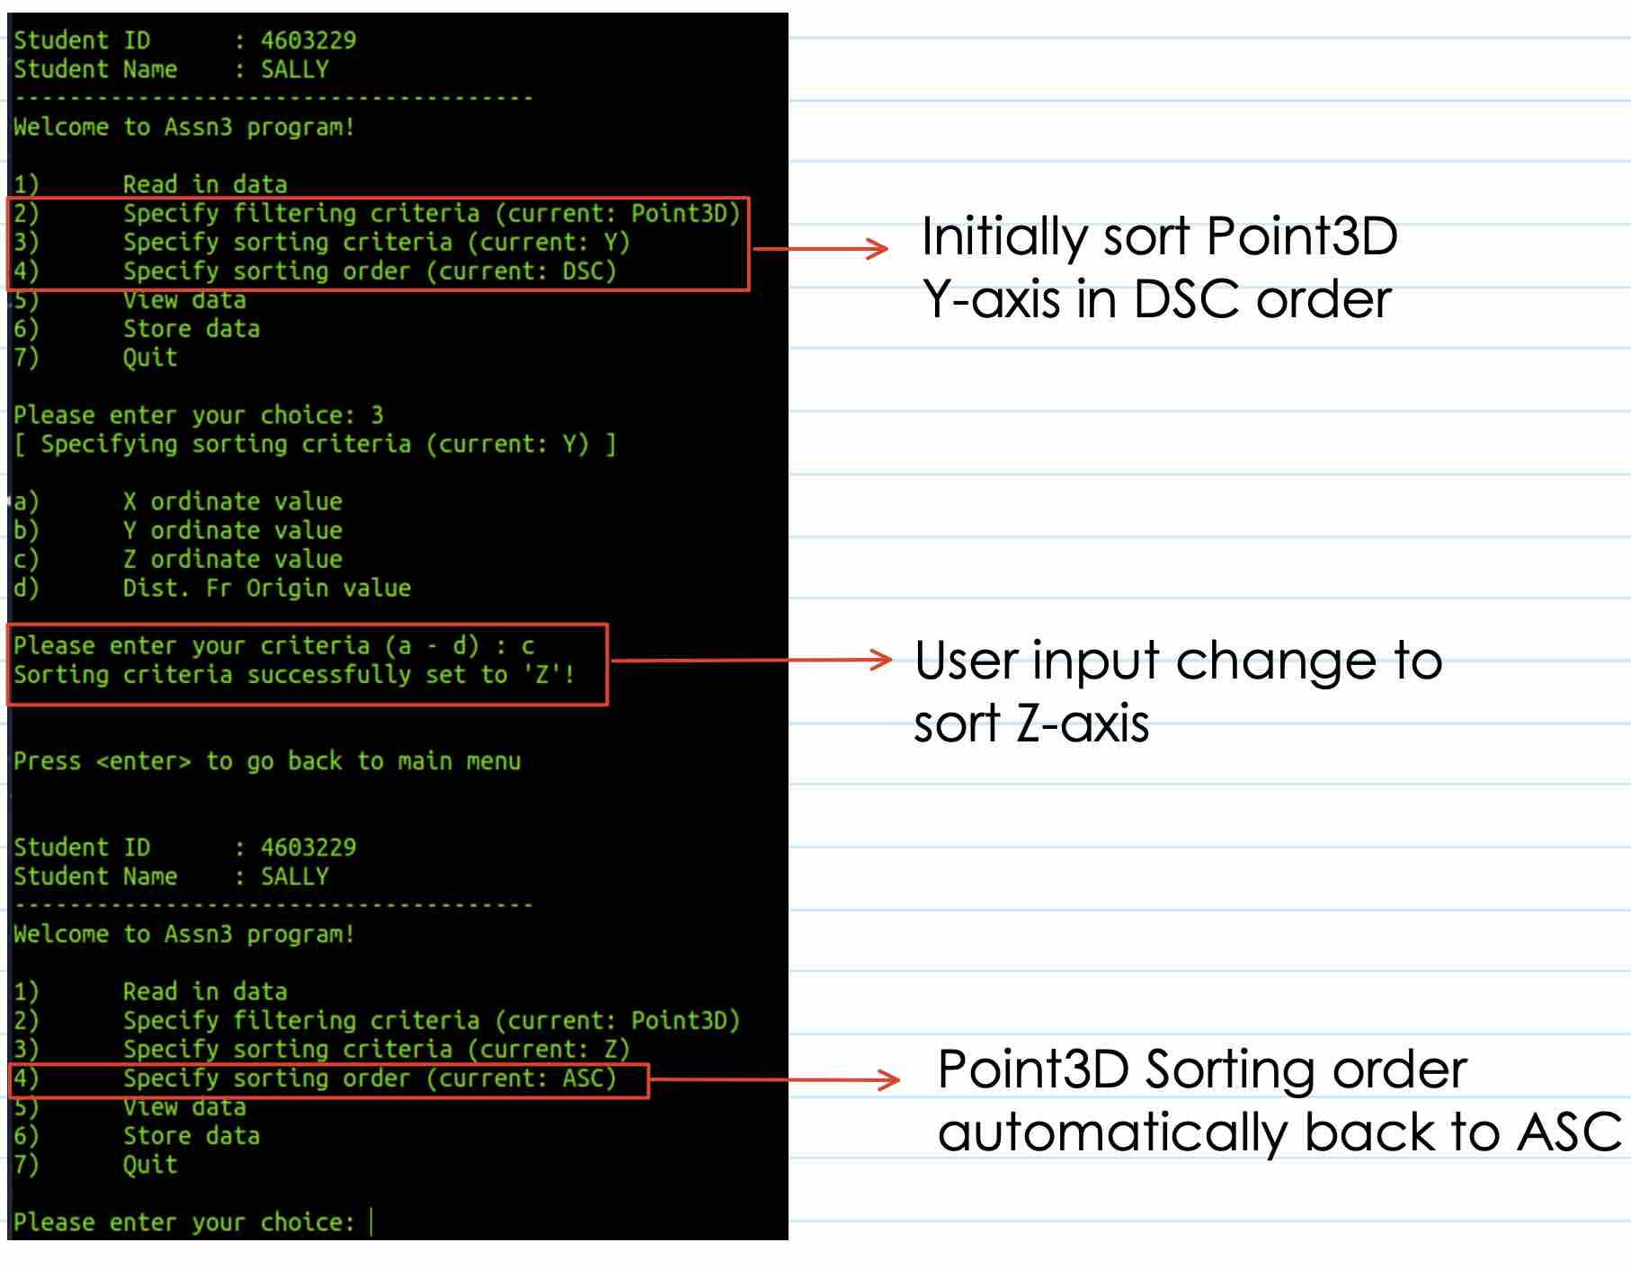

Set sorting criteria and sorting order for Line2D – all sorting criteria can sort in ASC/DSC
Set to sort Line2D Pt. 1 to DSC
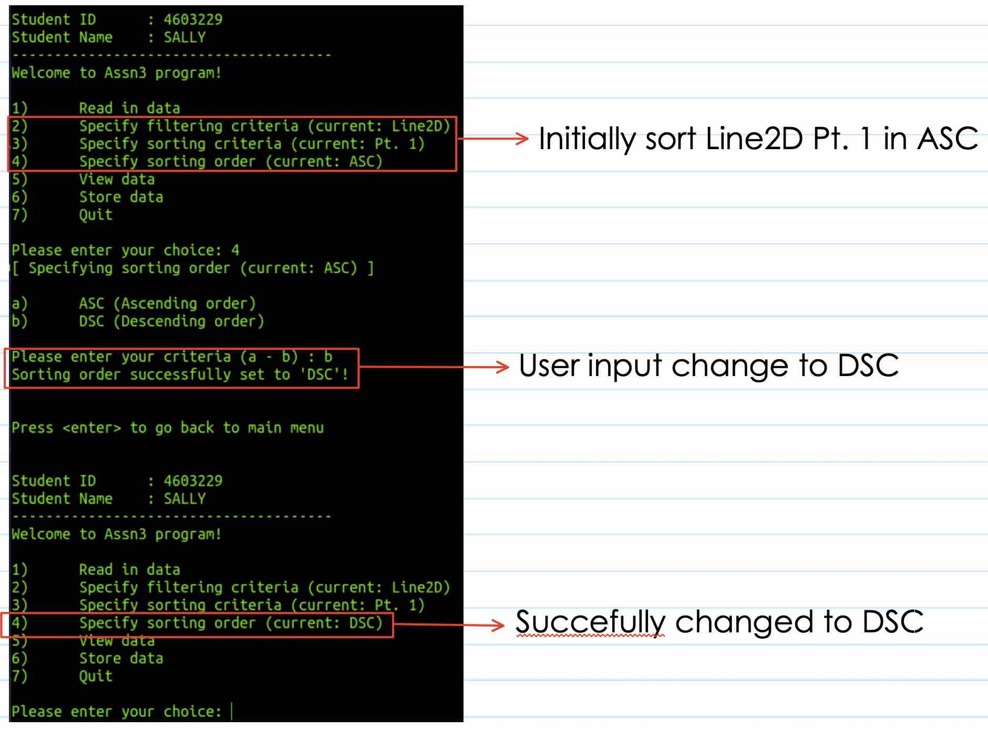

Set to sort Line2D Pt. 2, sorting order back to default ASC order
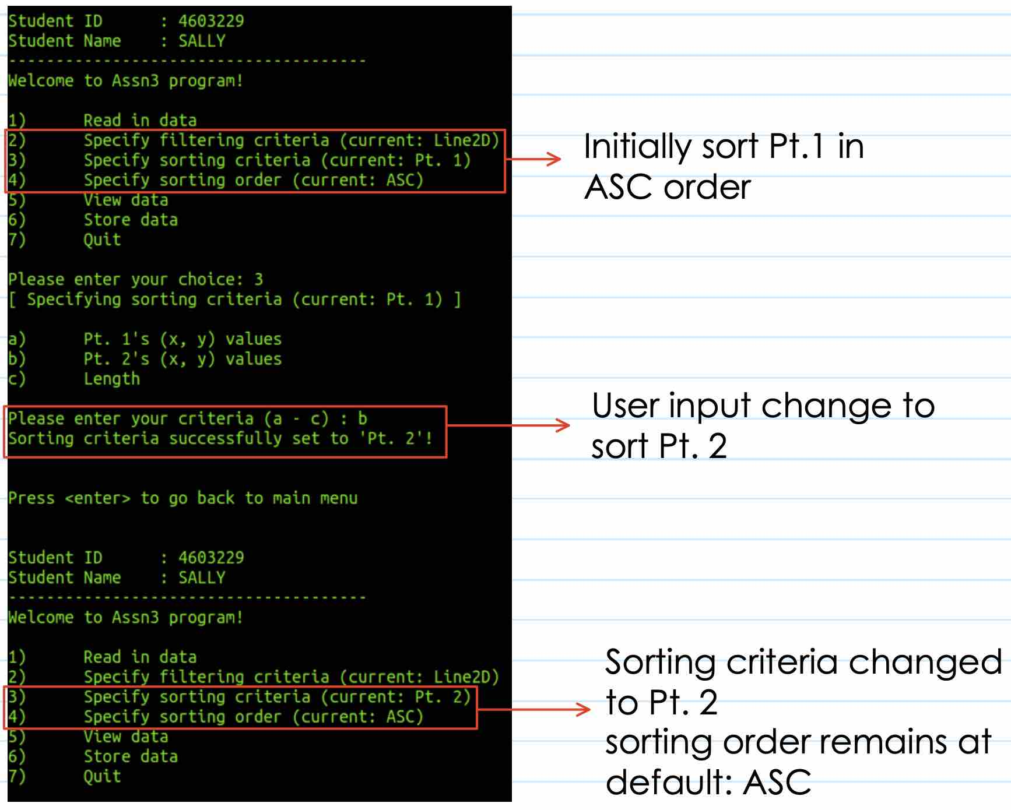

Set to sort Line2D Pt.2 in DSC
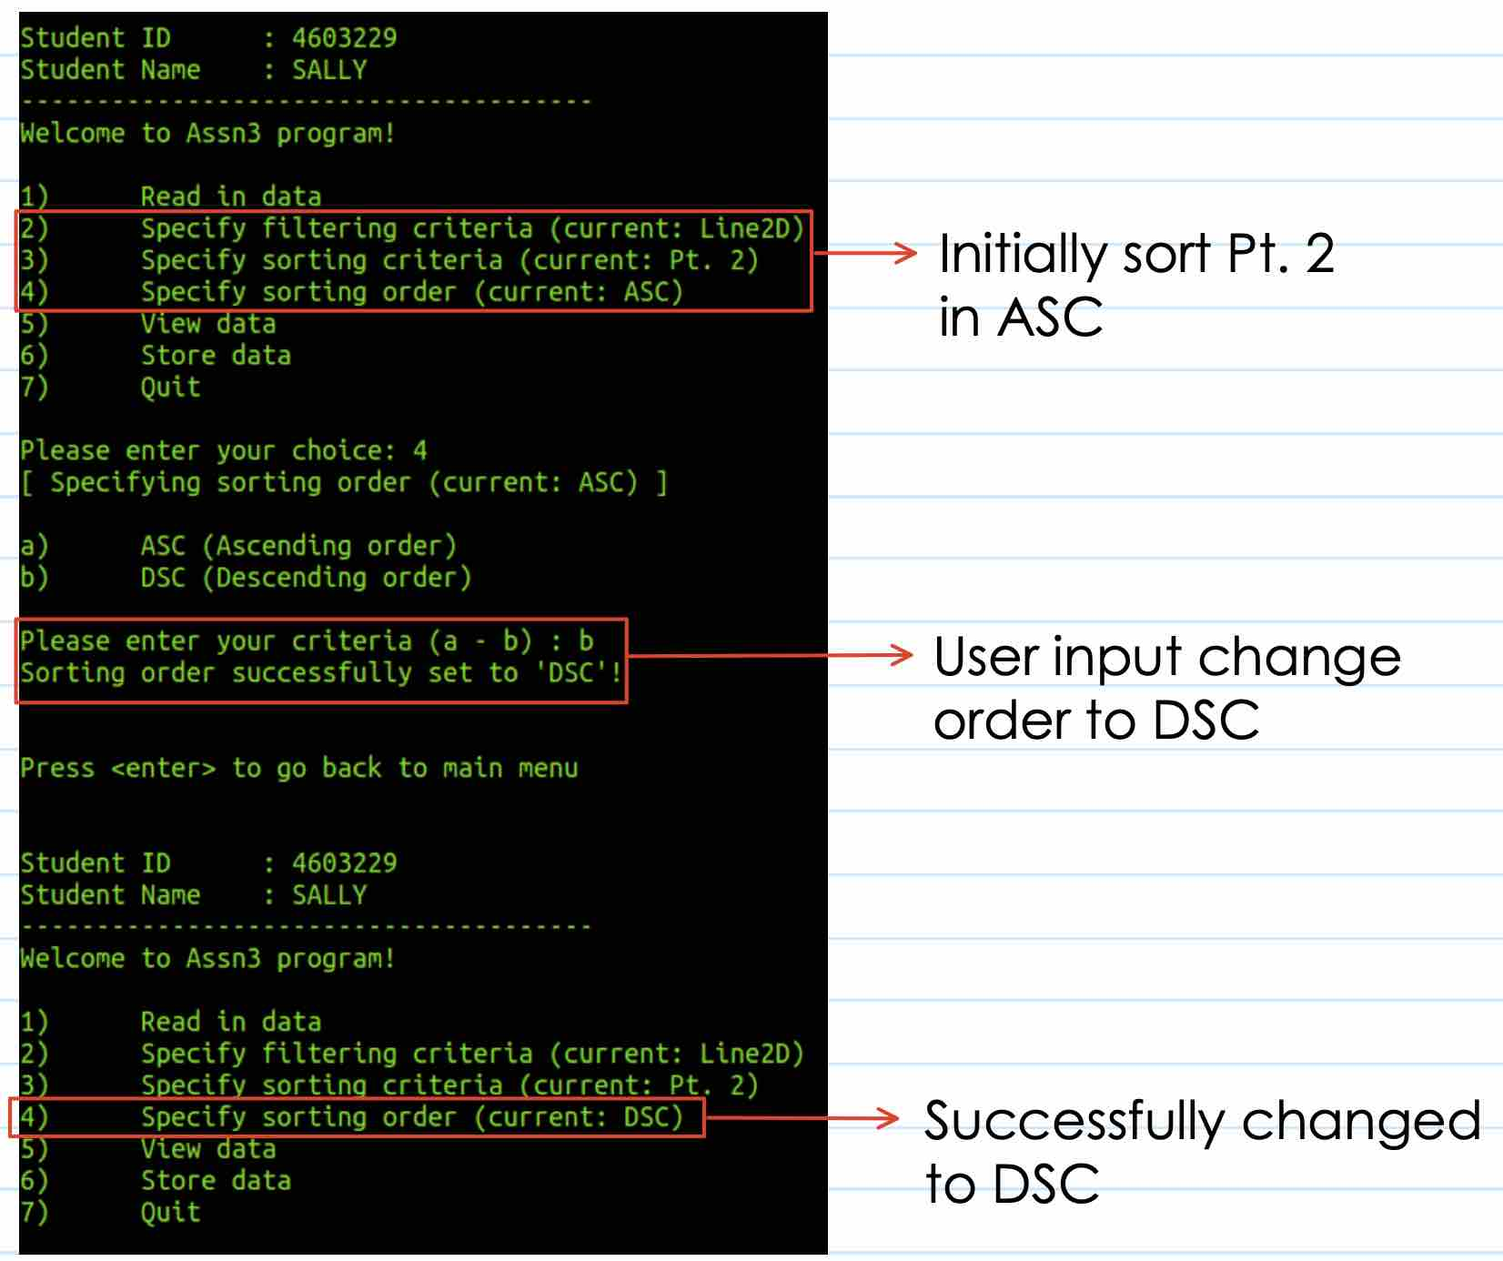

Set to sort Line2D Length, sorting order back to default ASC
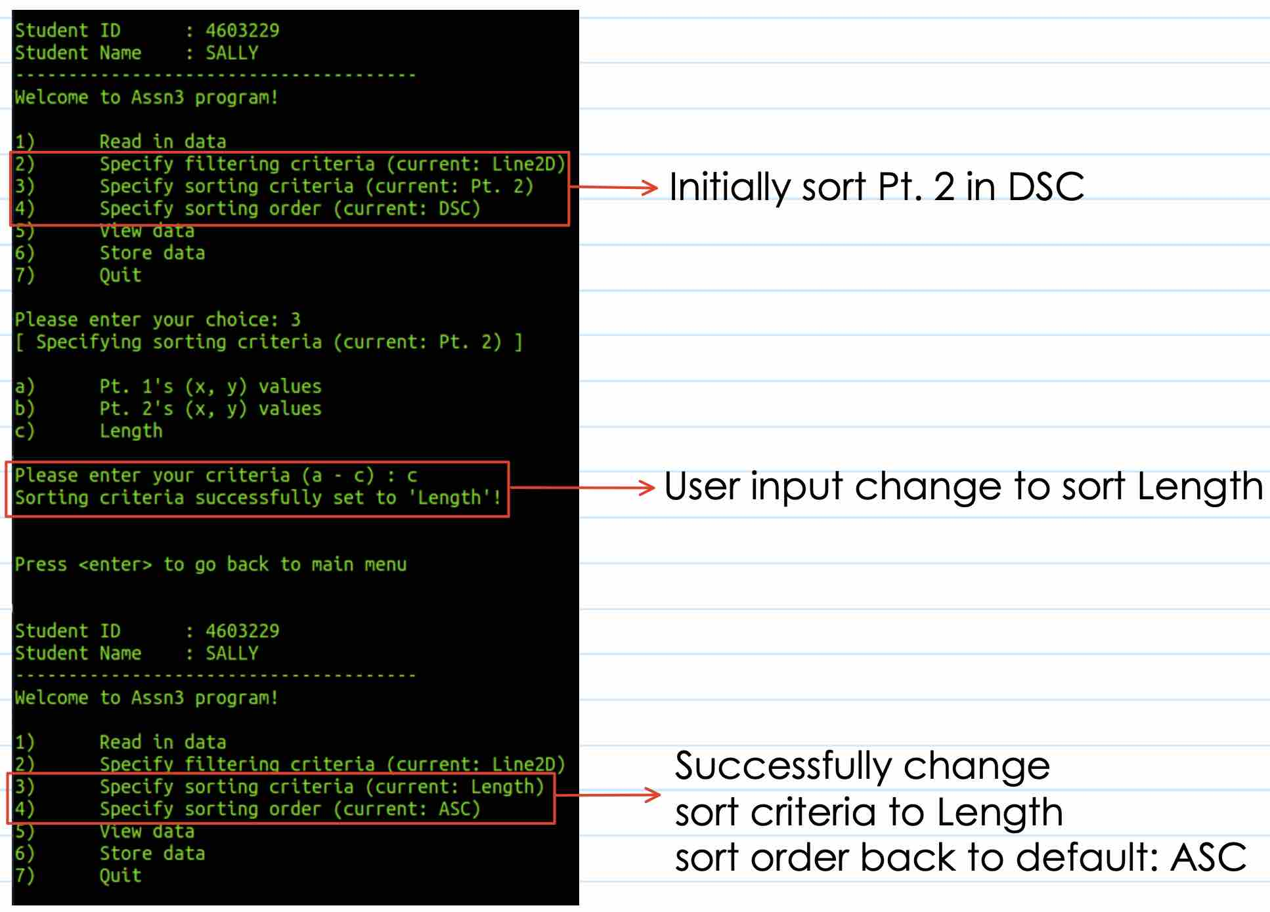

Set to sort Line2D Length in DSC
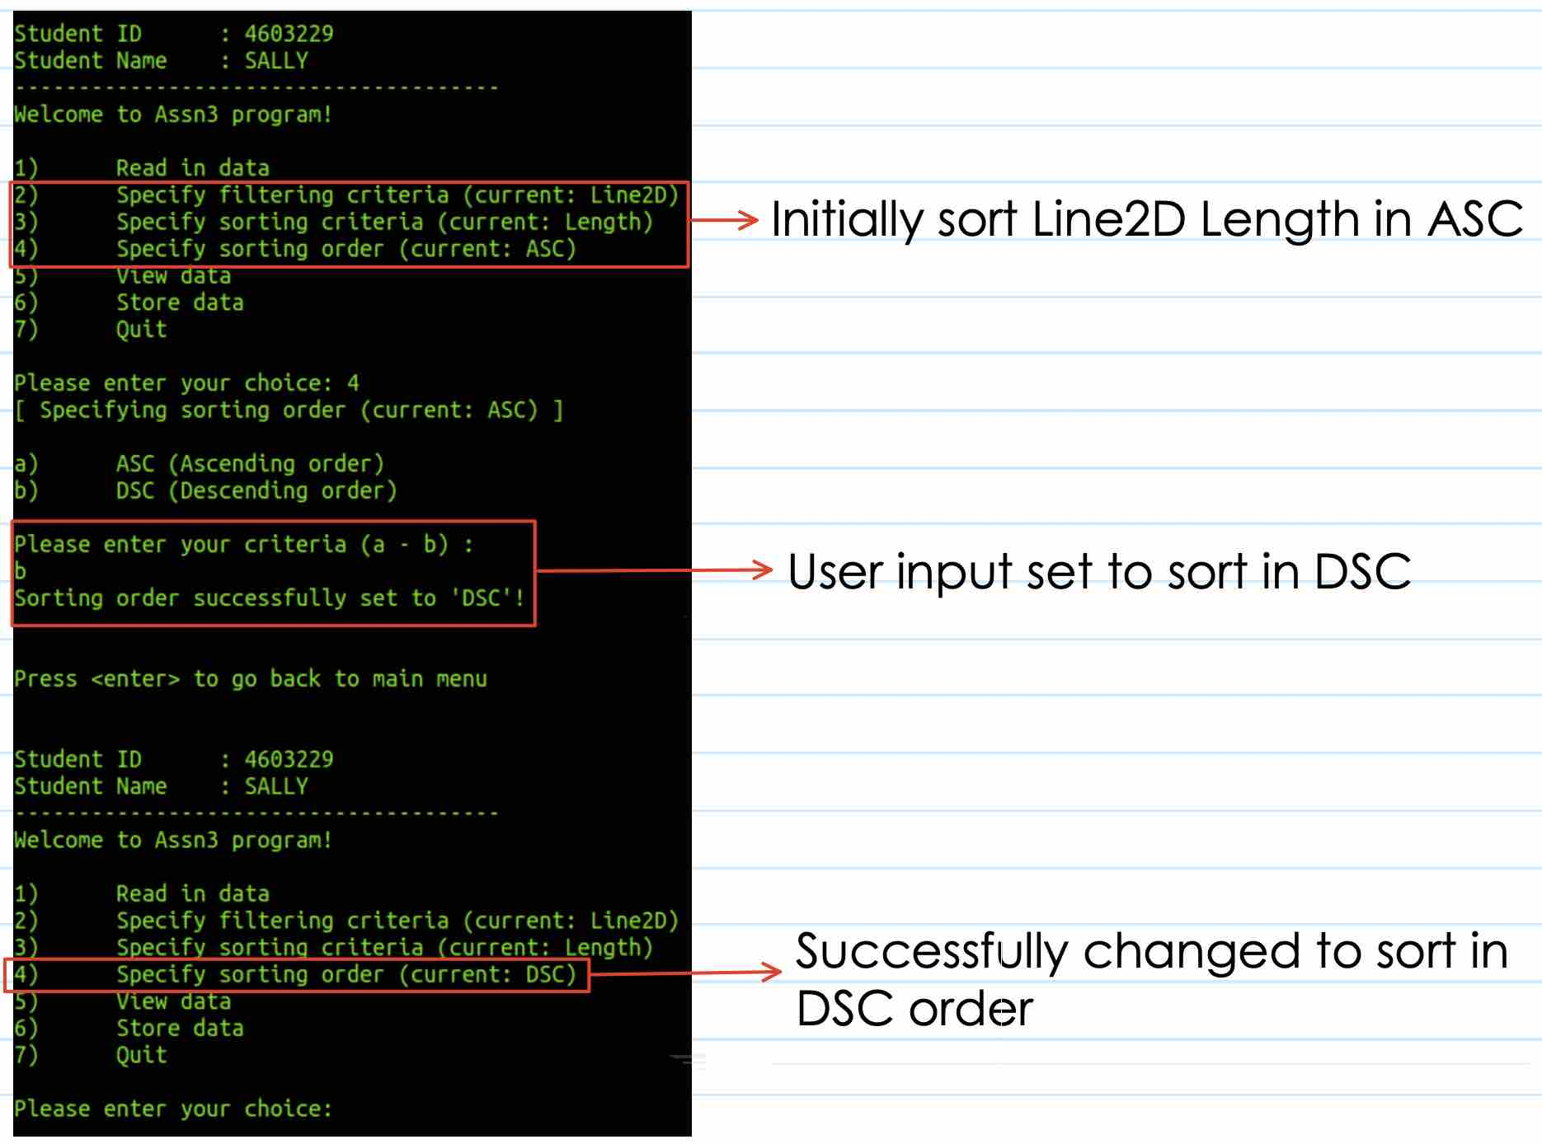

Set sorting criteria and sorting order for Line3D – all sorting criteria can sort in ASC/DSC
Set to sort Line3D Pt. 1 to DSC
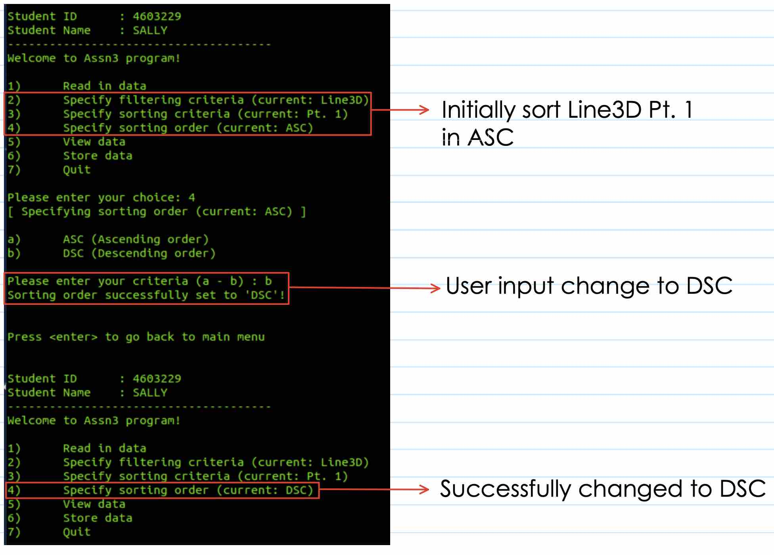

Set to sort Line3D Pt. 2, sort order back to default ASC
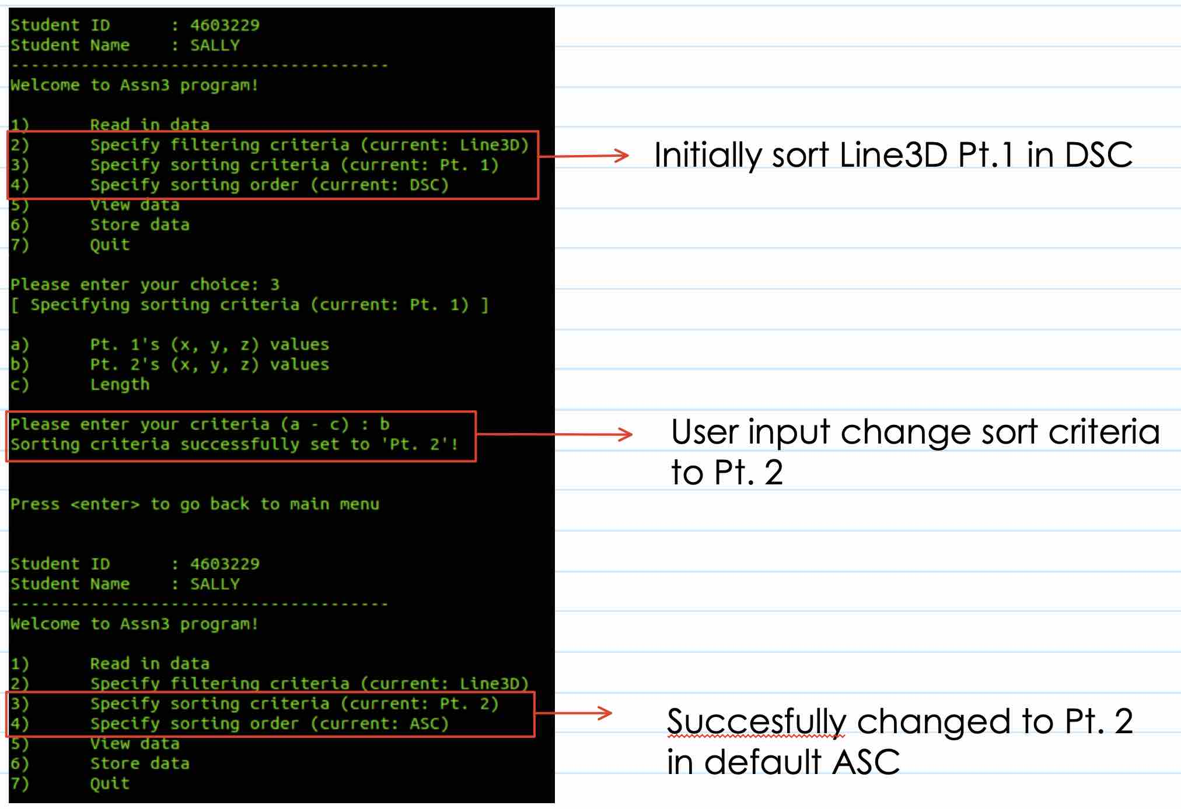

Set to sort Line3D Pt. 2 in DSC order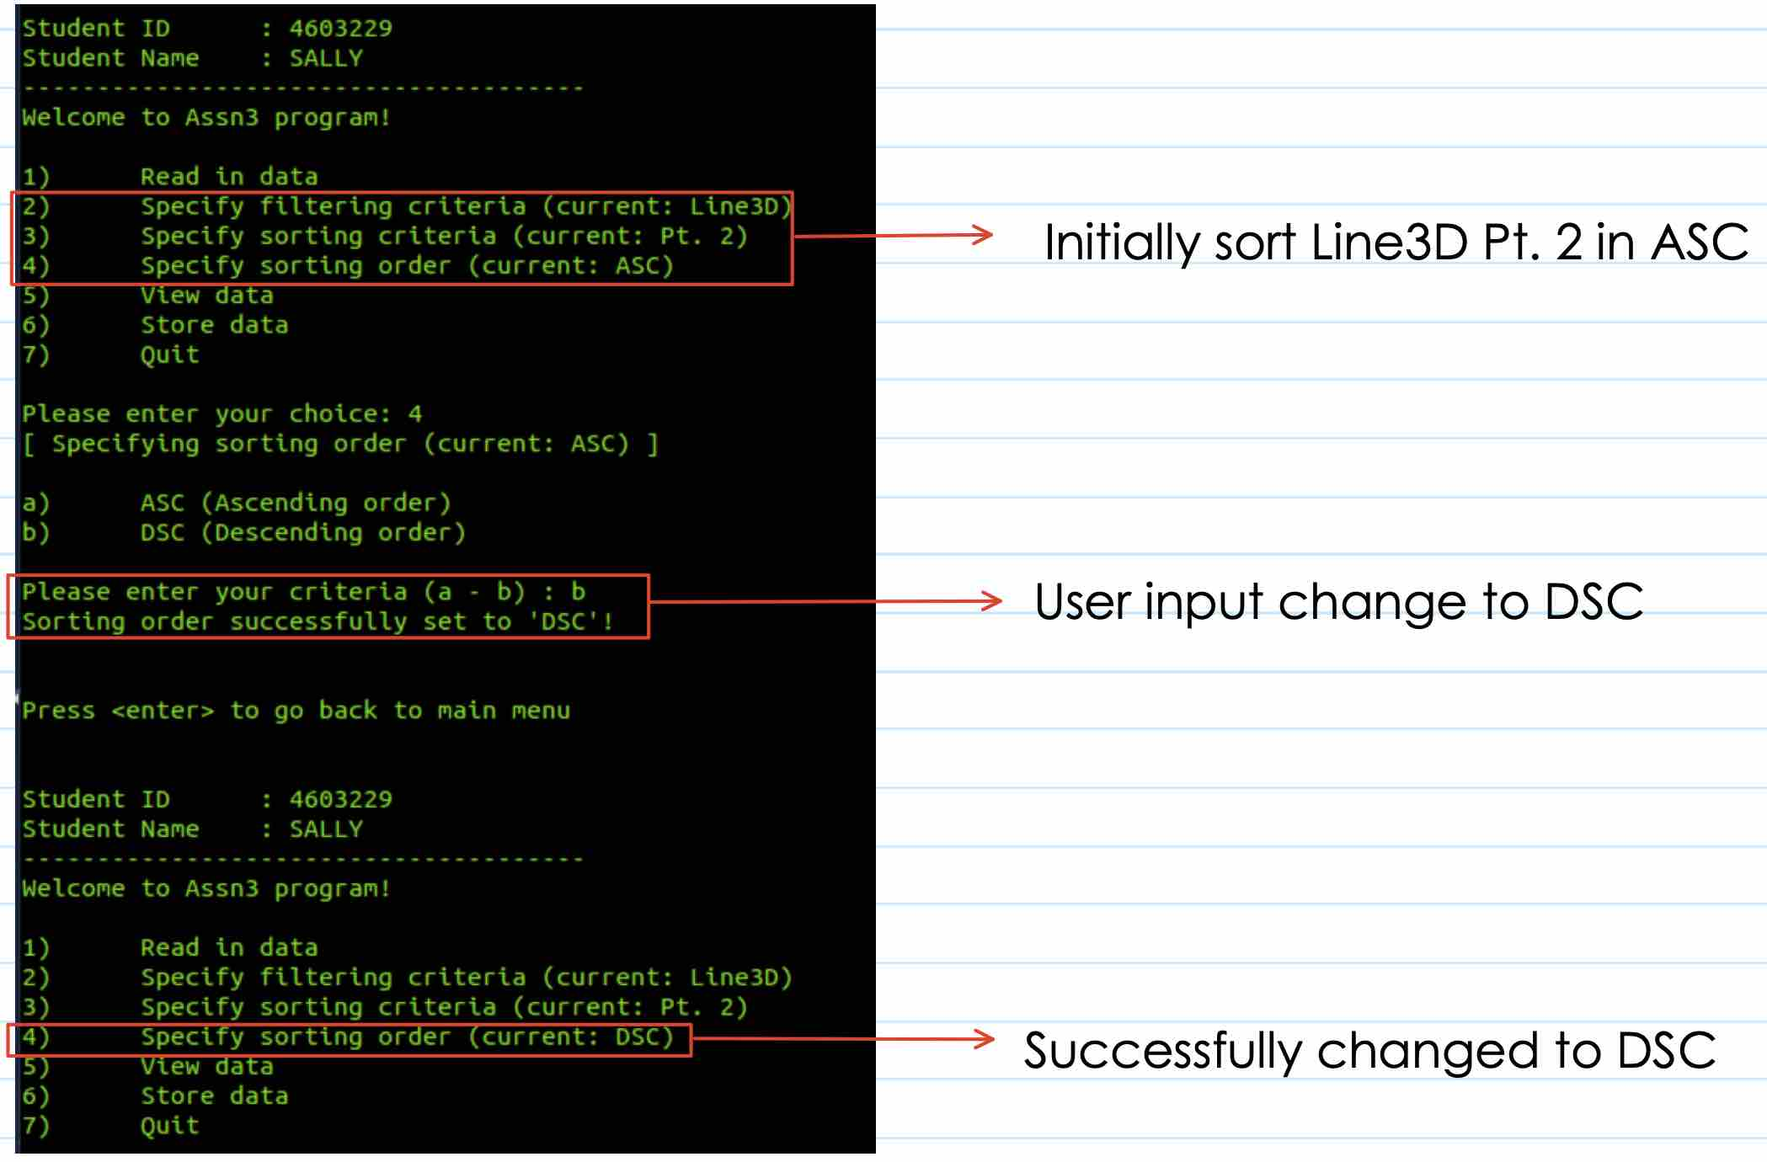

Set to sort Line3D Length, sorting order back to default ASC
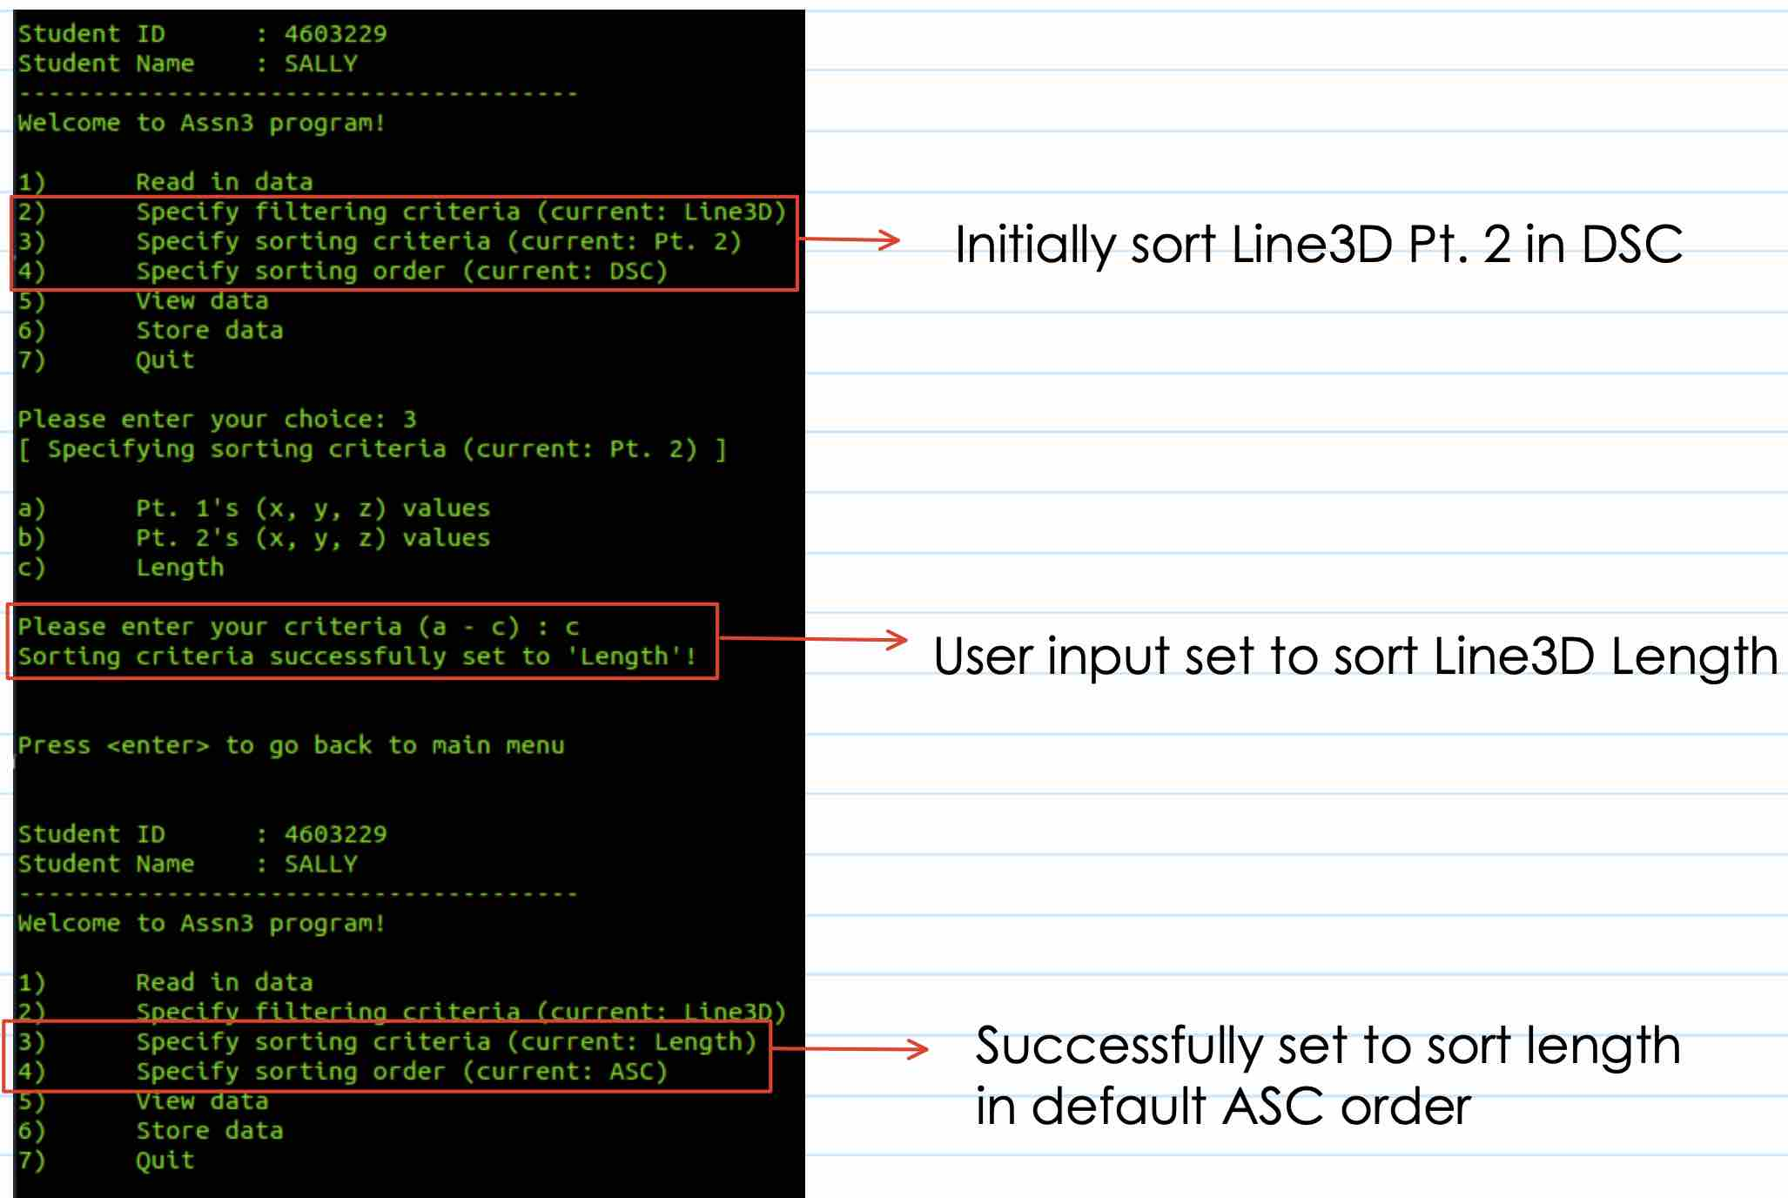

Set to sort Line3D Length in DSC order
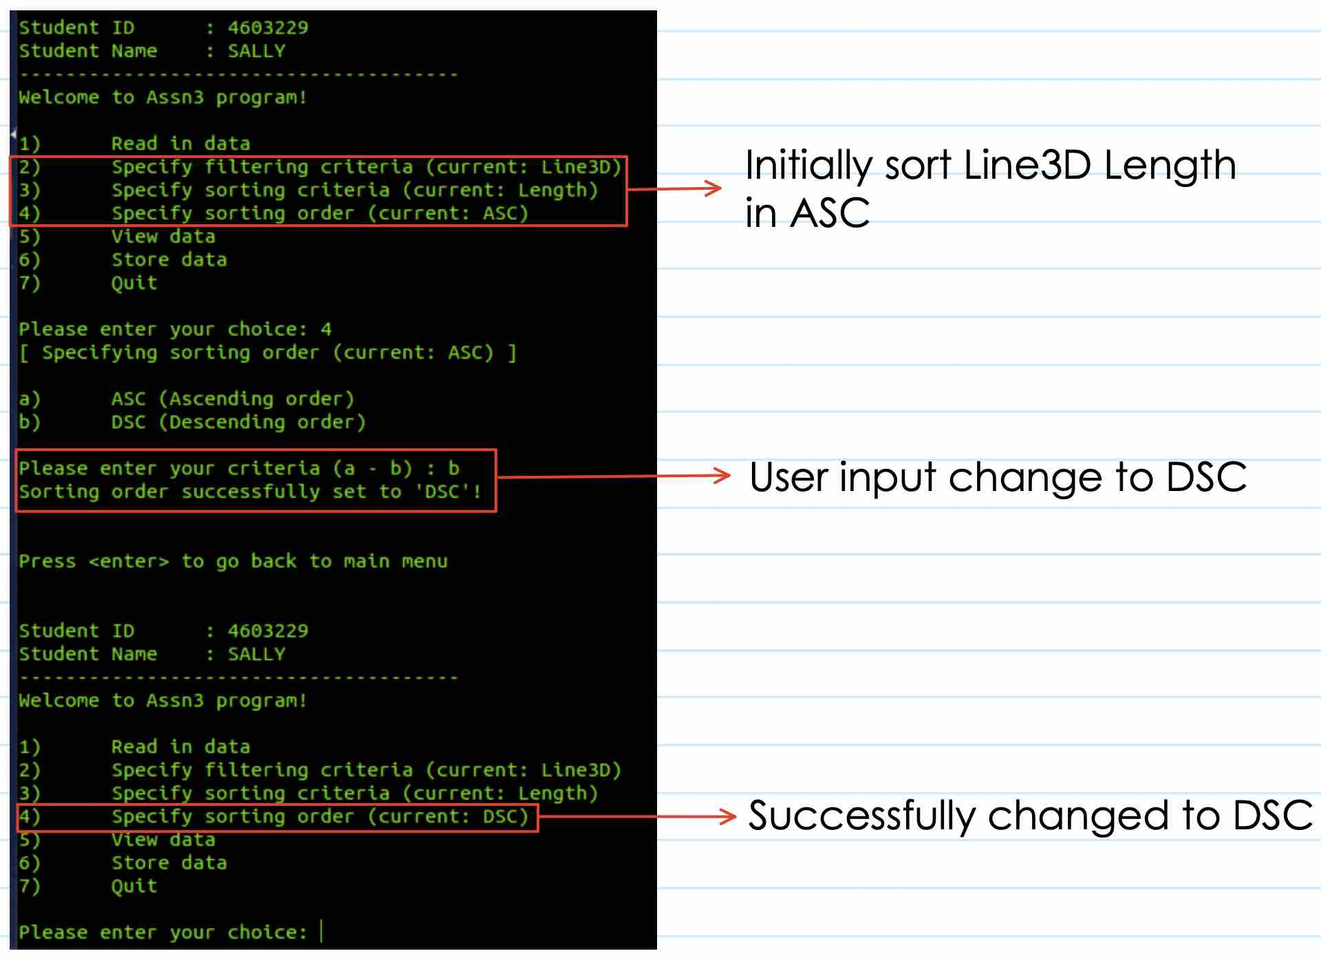

View Data & Store Data – Point2D sort X-axis in ASC order
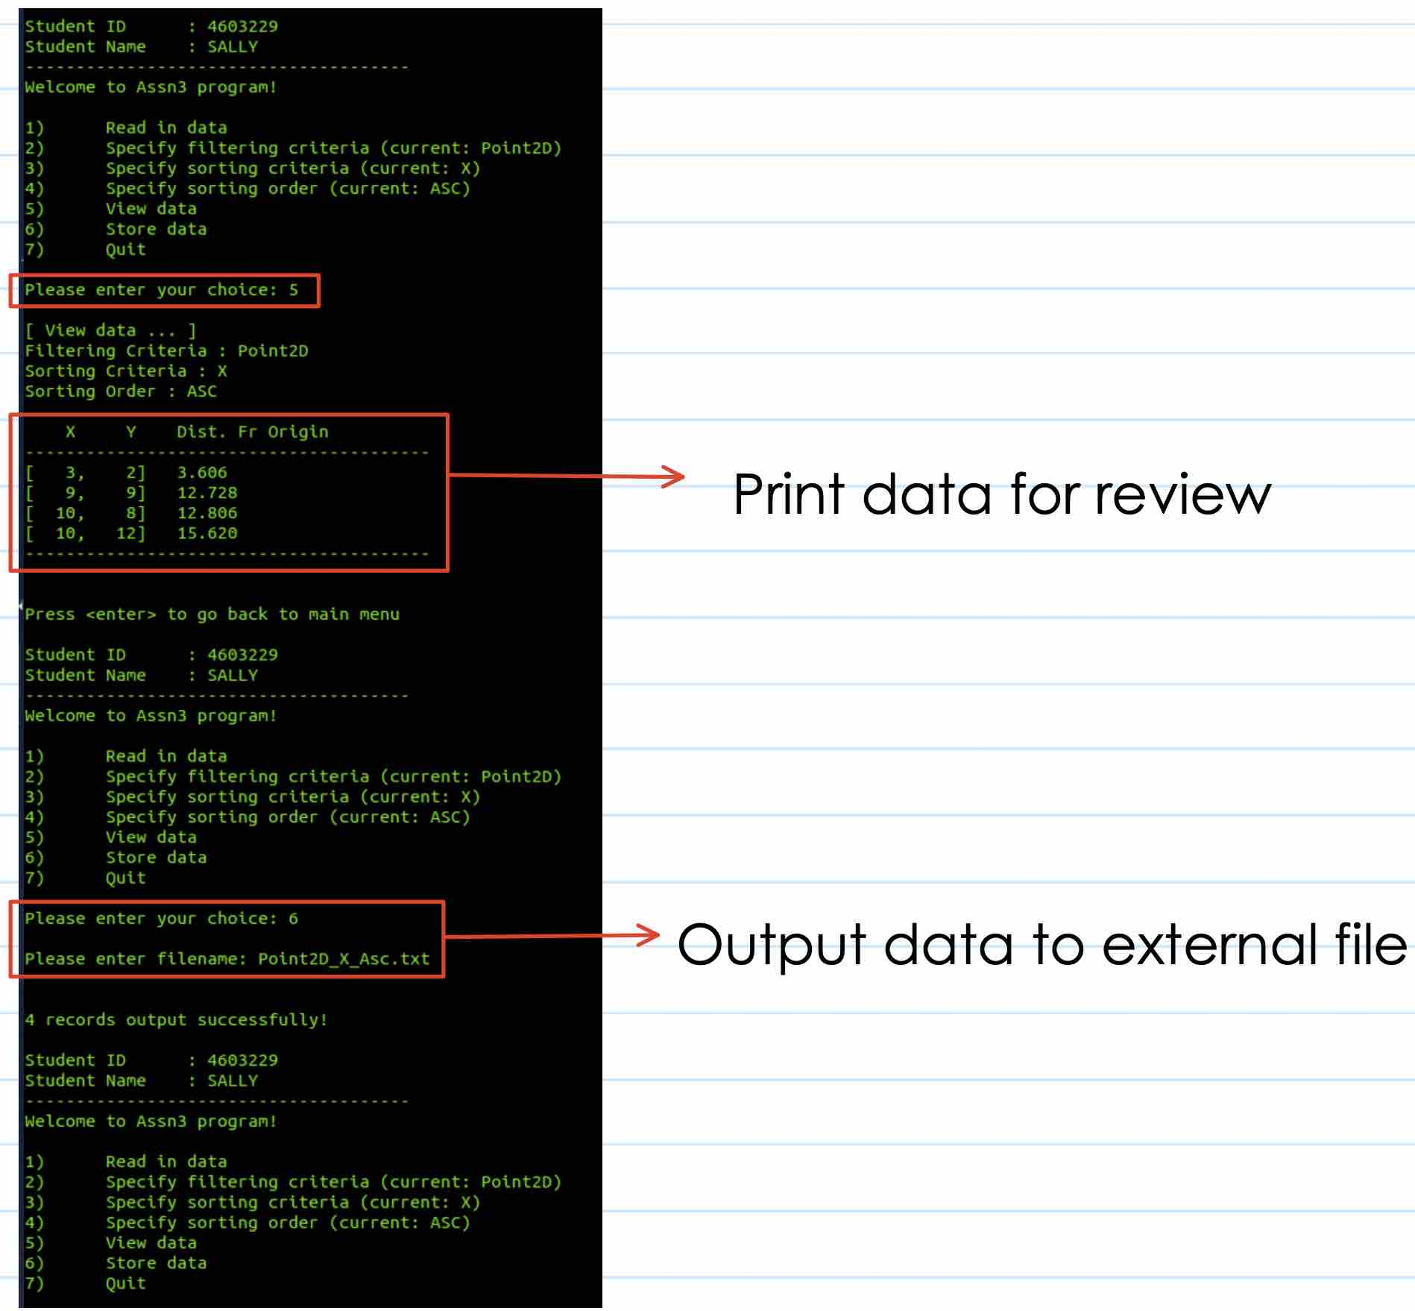

Data stored
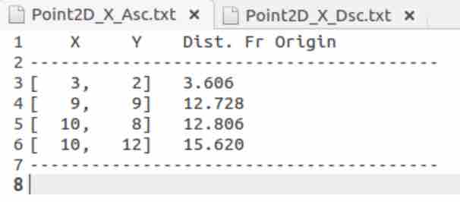

View Data – Point2D sort X-axis in DSC order
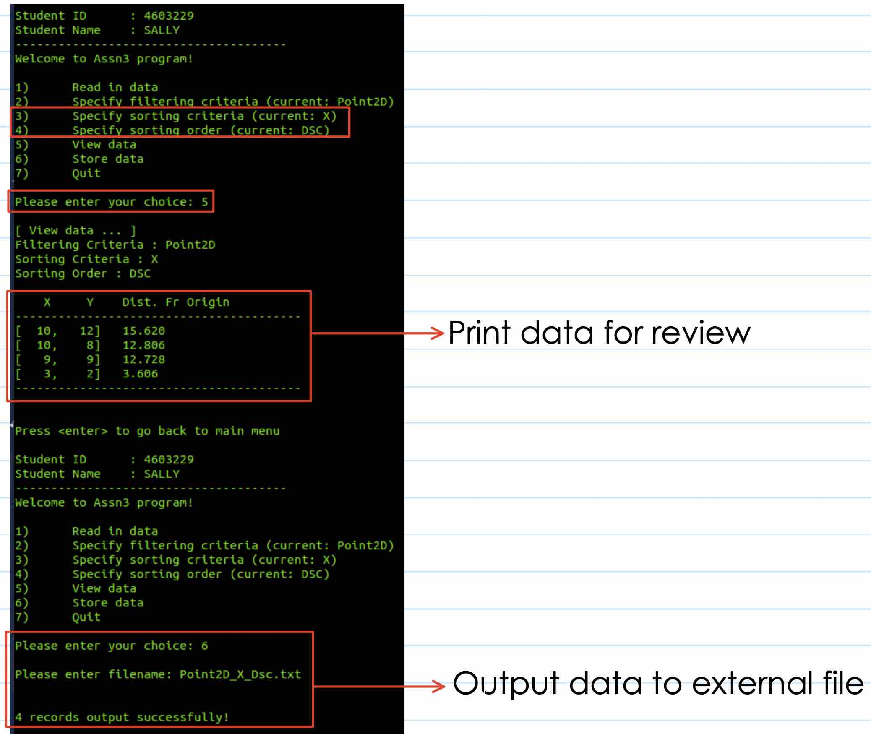

Data Stored
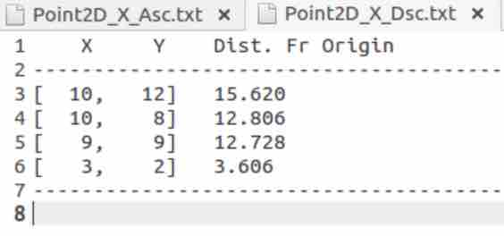

View Data – Point2D sort Y-axis
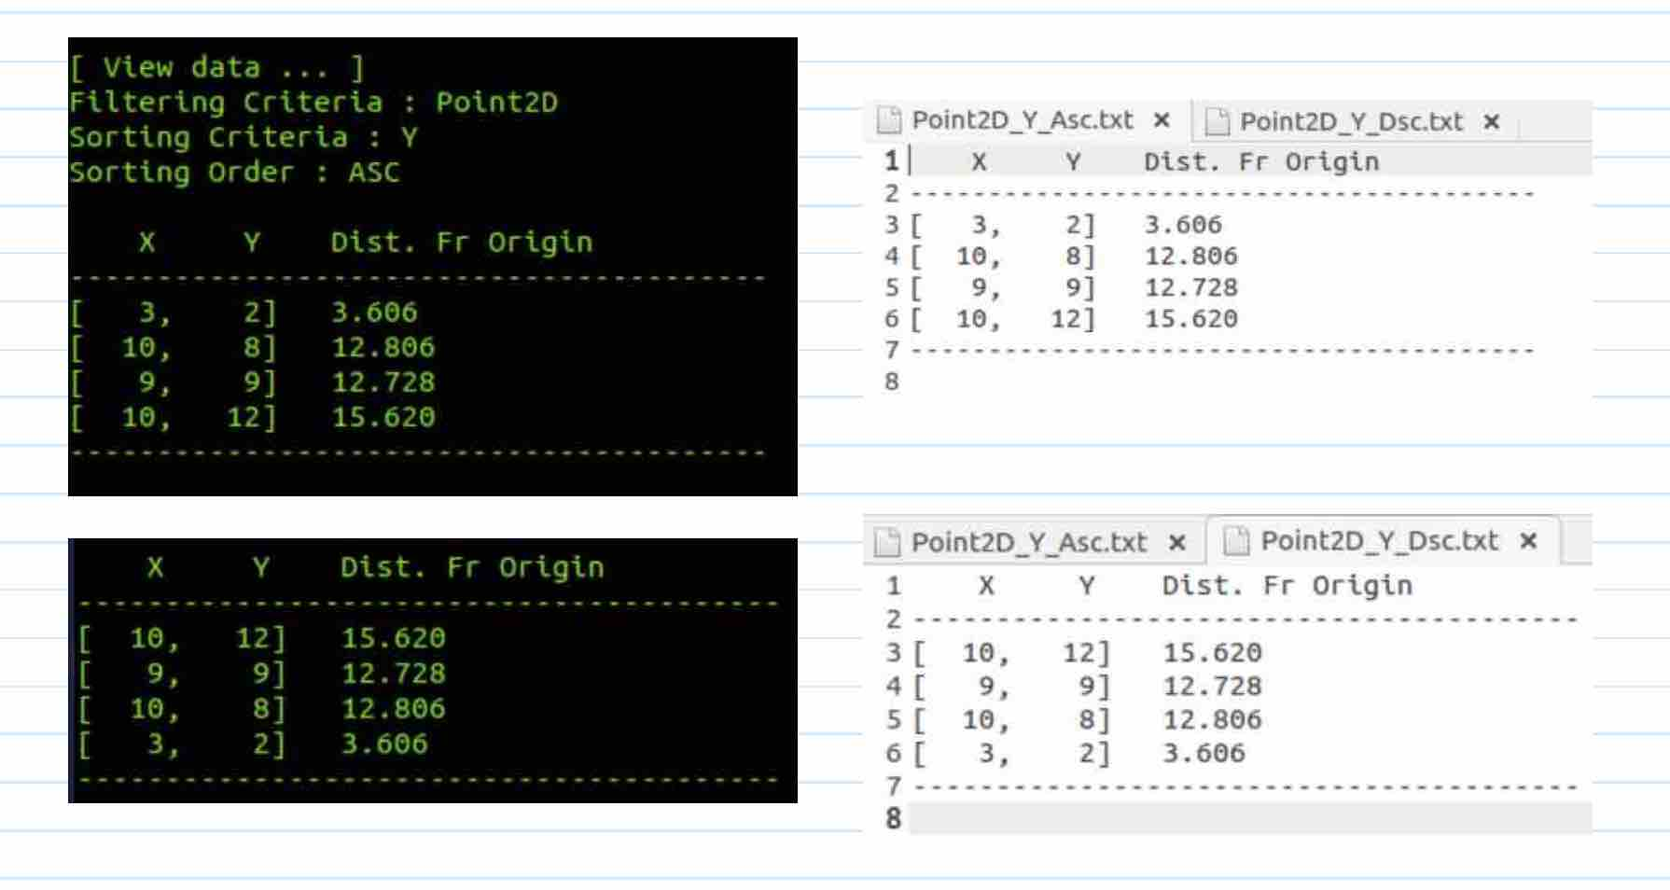

View Data – Point2D sort Distance in ASC
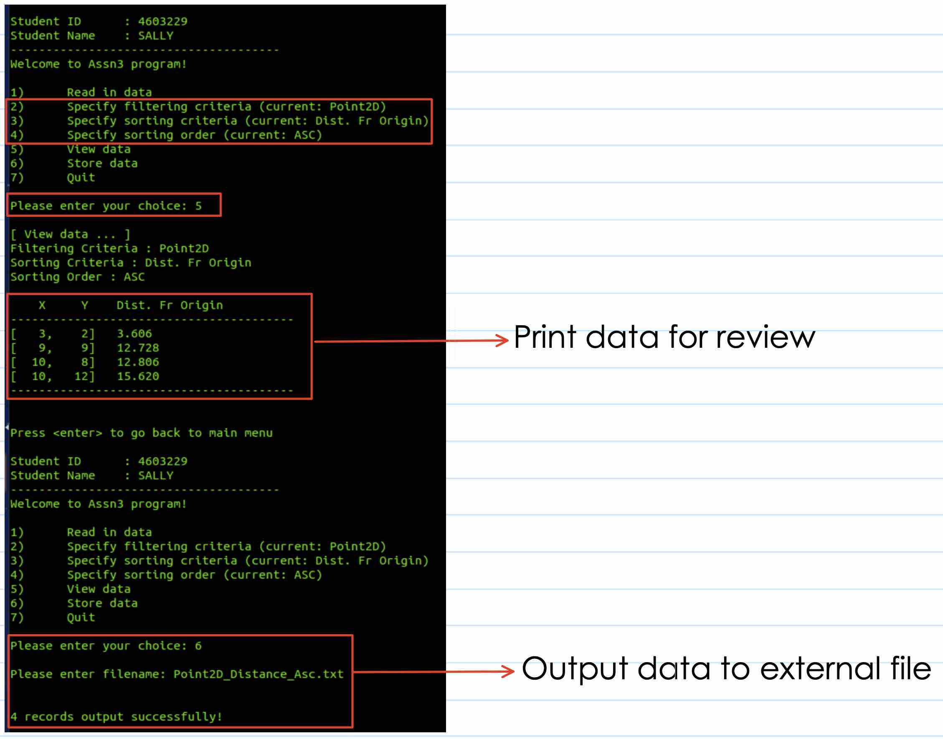

Stored data
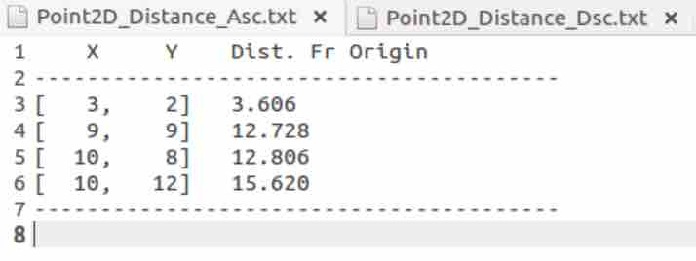

View Data – Point2D sort Distance in DSC
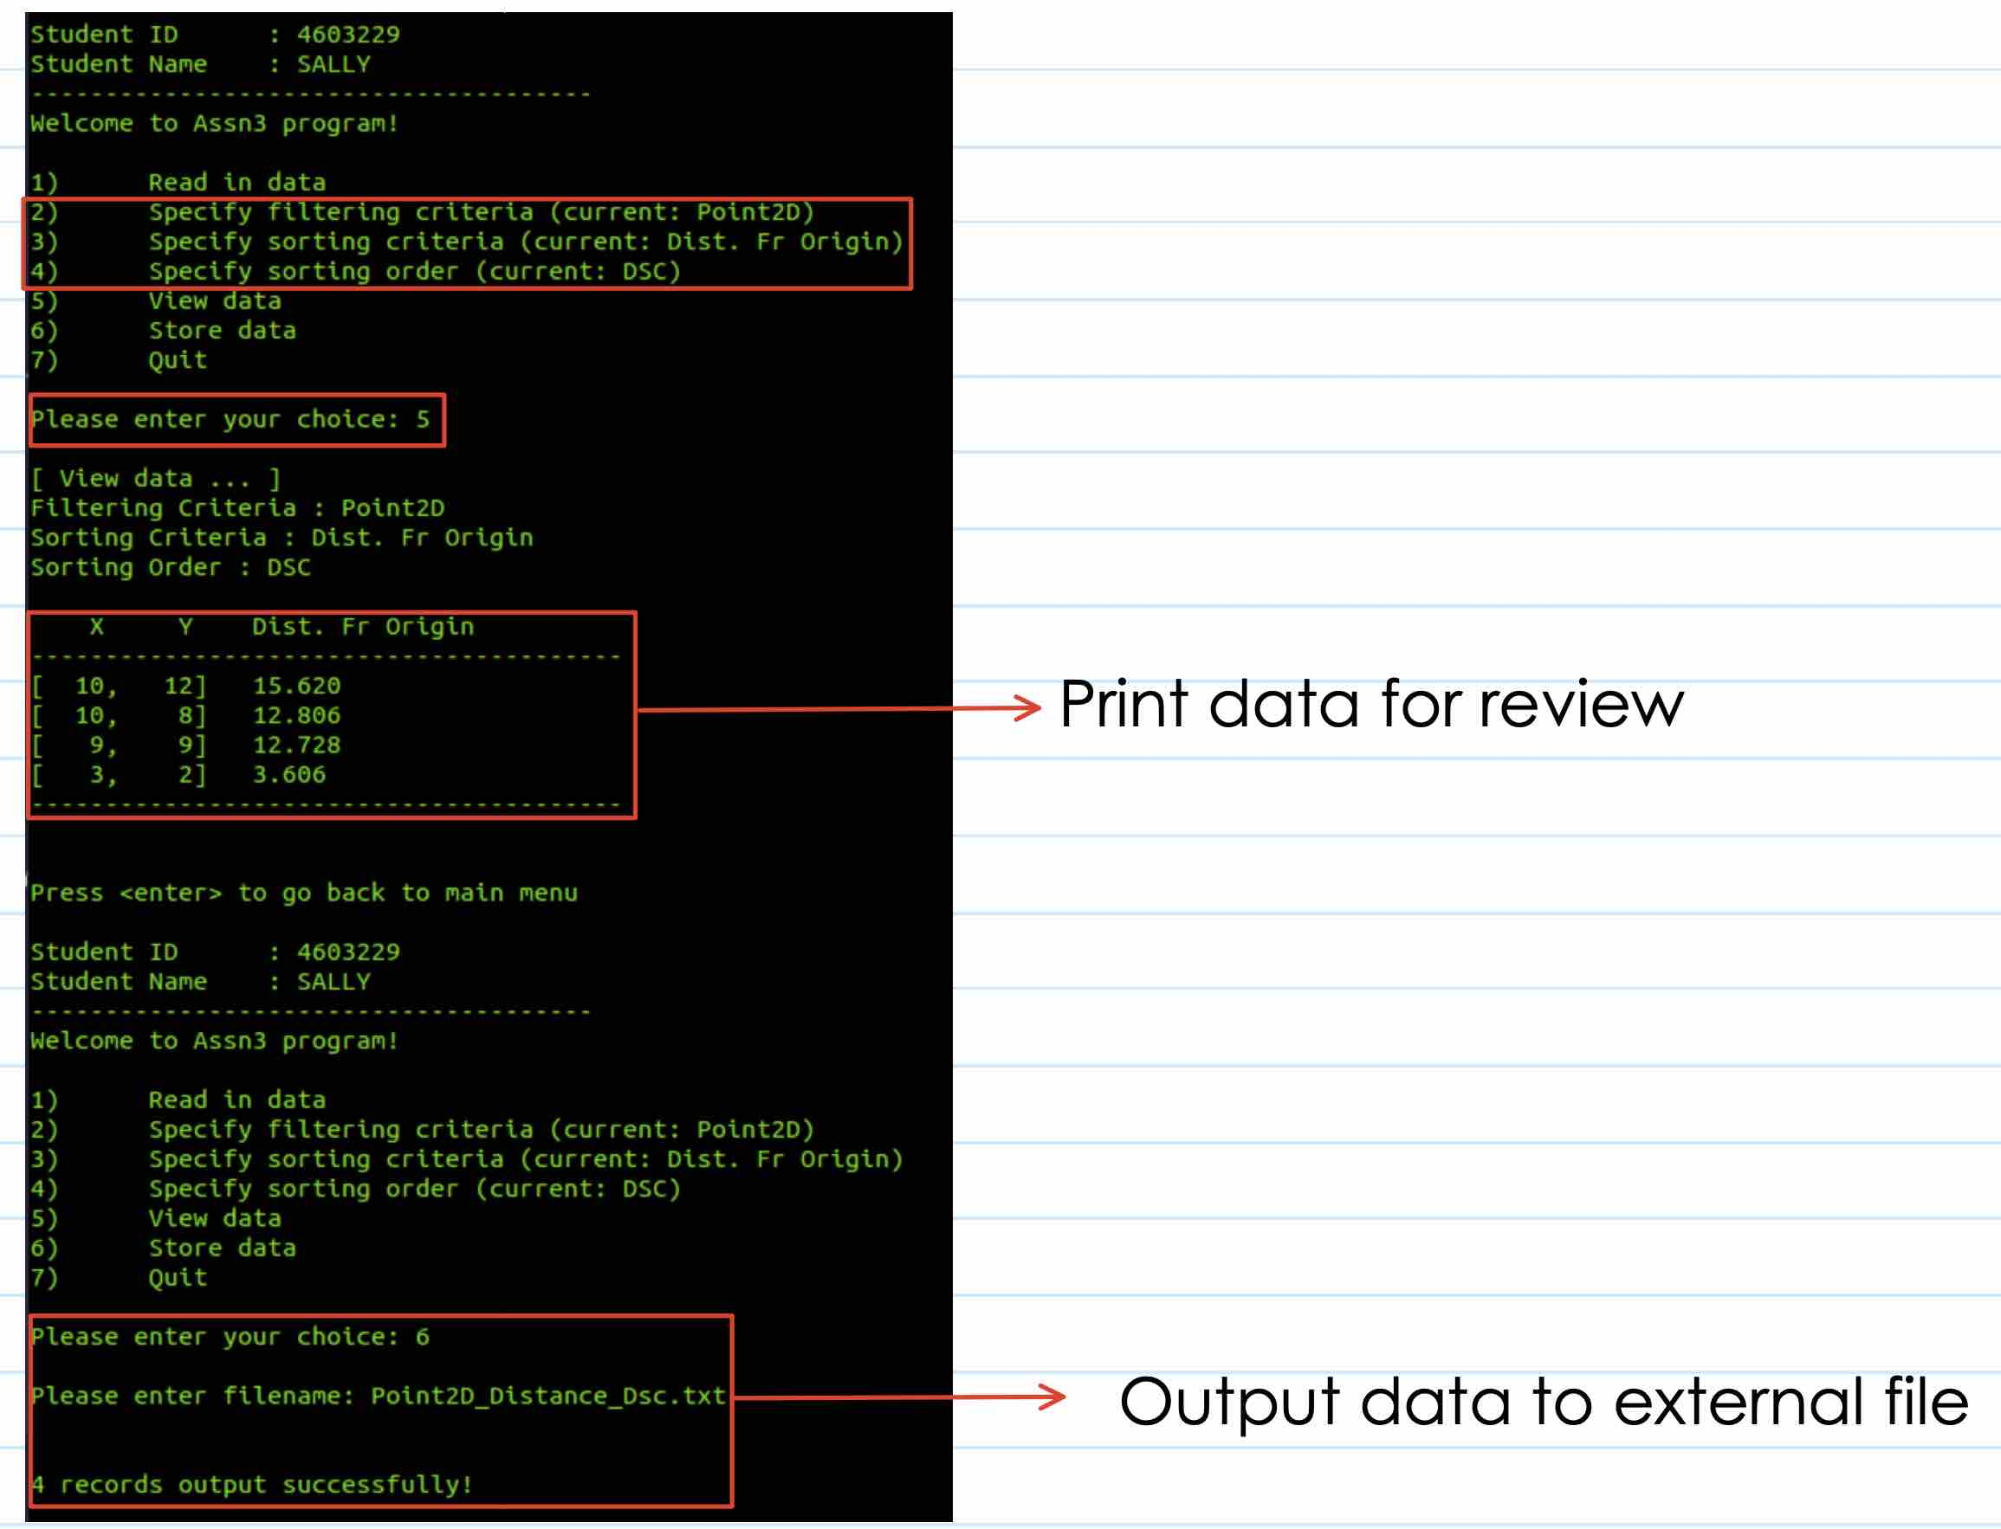

Stored data
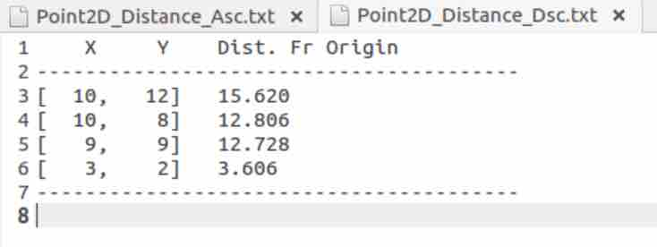

View Data – Point3D
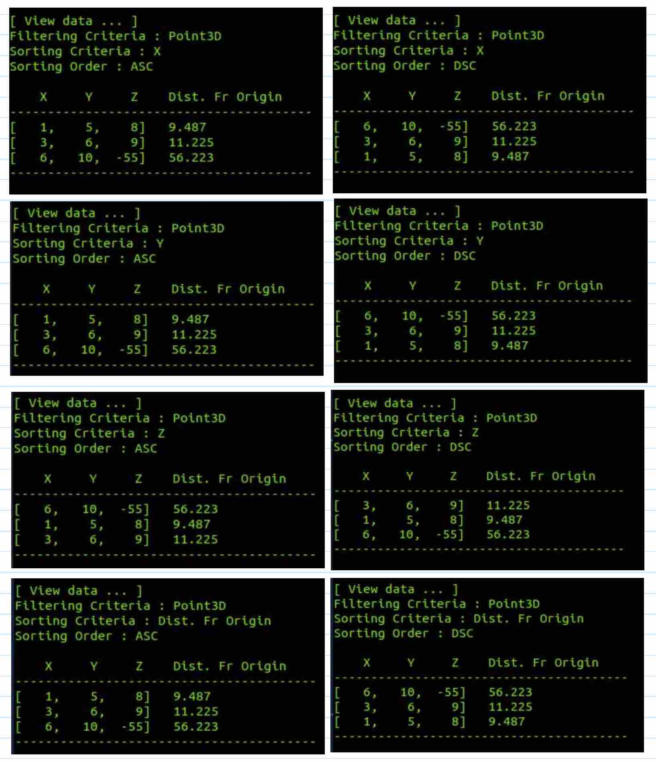

View Data – Line2D
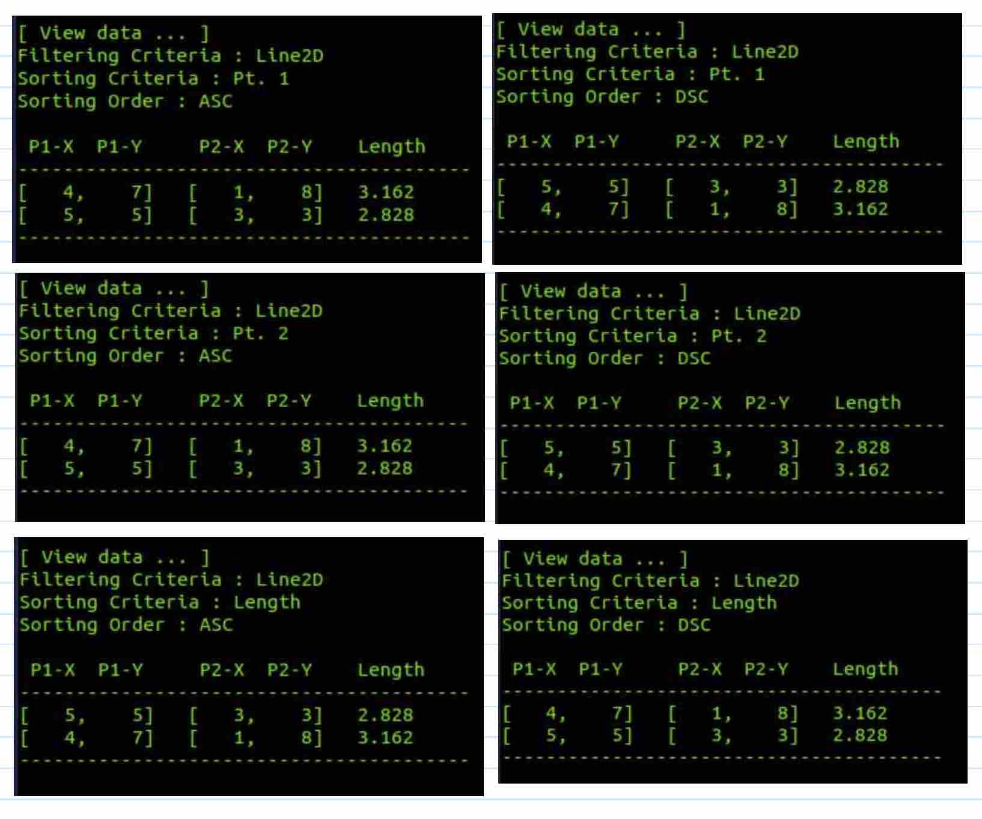

View Data – Line3D
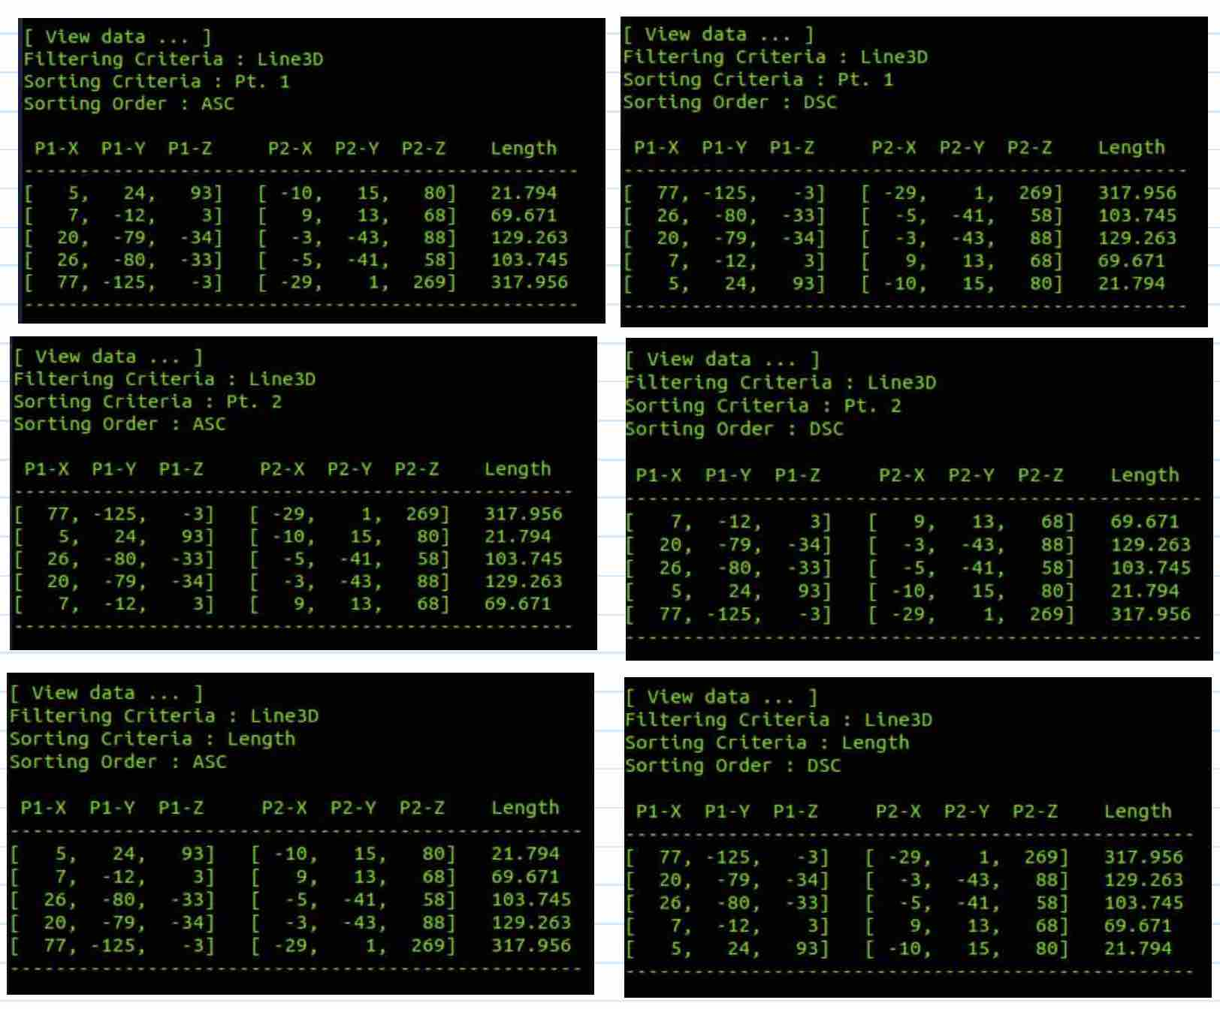

Stored Data – Point3D
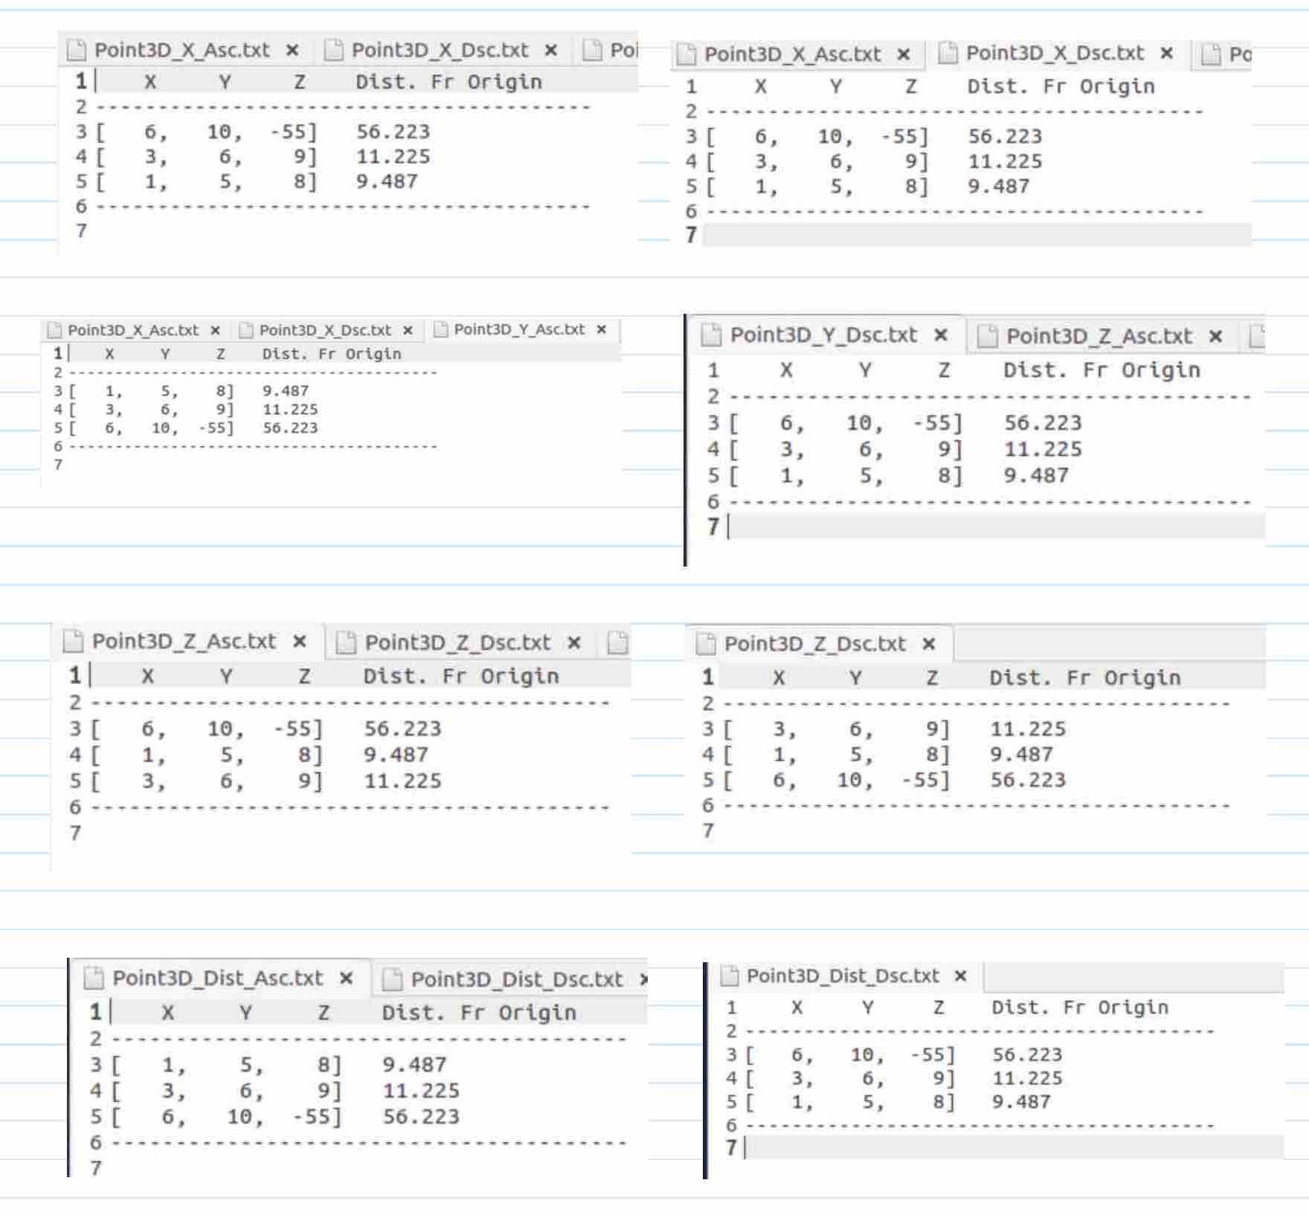

Store Data – Line2D
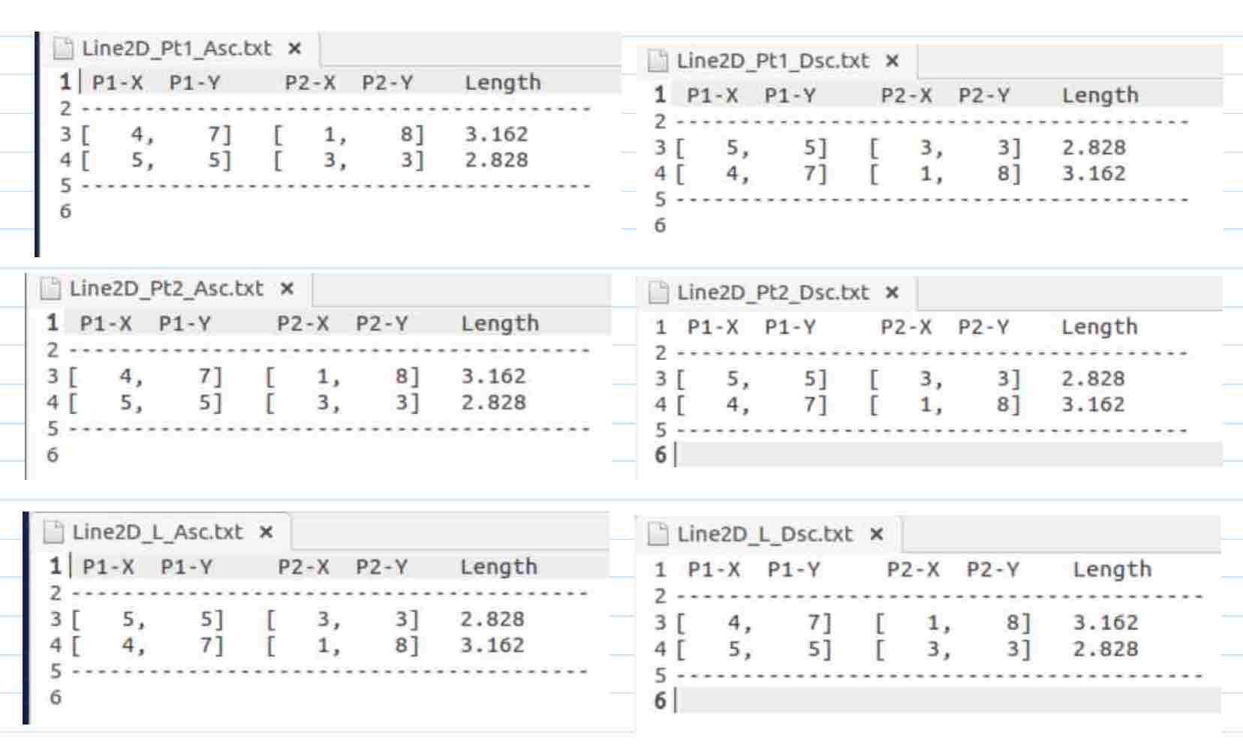

Store Data – Line3D
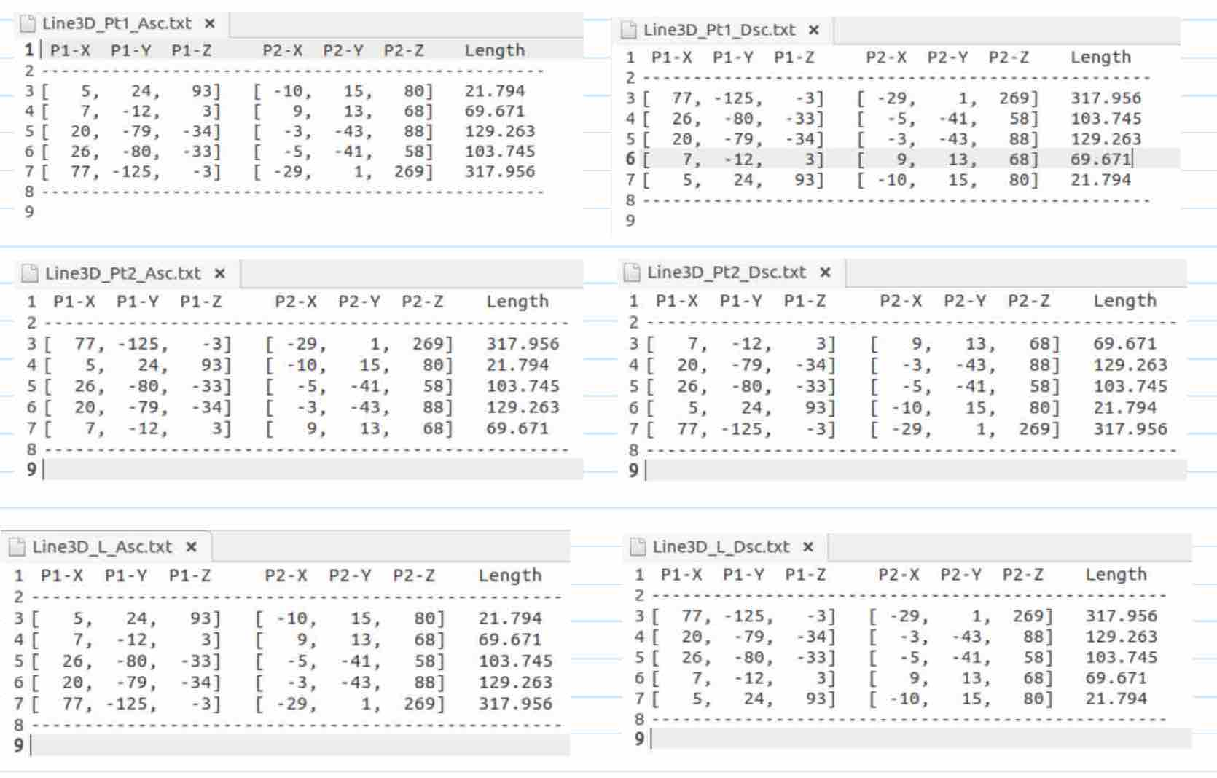

Reflections
This assignment allow us to recap all the concepts used in A1 and A2 but it adds in new concept such as operator overloading, and function class templates. The hardest part of this assignment is to understand the usage of function and class templates for the sorting.

