This summary applies to monetary gifts only (not contracts) for public universities, because the director of development asked for sources of philanthropic support. The justification for these filters (arguments reasons supported by data) for this filtering is presented in supplementary document.
1. Executive Summary: What are your main findings and recommendations, in a single paragraph?
Overall, UVA has strong track record of attracting monetary gifts from foreign giftors in comparison to other public universities. However, UVA lags behind other direct competitors, such as public ivies², in the total amount of monetary donations from other countries. UVA’s lackluster performance in comparison to comparable universities, in part, can be attributed to UVA’s failure to attract donations from regions outside of Europe. UVA’s region gap in donations is especially apparent in East Asia, which donates more to public US universities than any other region, including Europe. Additionally, almost all of the money UVA receives from donations outside of Europe originates from one type of organization (charities), while other comparable public universities have been successful in soliciting donations from industry and individual donors in addition to charities. Consequently, UVA should focus its efforts on soliciting donations from East Asian countries with track records of larger donations, such as Hong Kong and Japan. Outside of Europe, UVA should also concentrate some effort in attracting donations from individual donors and industrial organizations rather than focusing solely on charities.

2. Summarize the results of your initial analyses of overall giving and giving to UVA (1-3 paragraphs).
With respect to overall giving, East Asia (38% sum total donations (std)) and Europe (27% std) are the regions that give the largest total sum of donations of monetary gifts to US universities¹ (counts are similar). The other 4 regions combined, excluding the middle east², make up only 19% of total donation sums, see Figure 1. With respect to country, England gives the most money followed by Japan, Hong Kong, Qatar, China, and Canada. Those same countries also give the highest number of gifts save for Qatar¹. In terms of donations, European donations tend to be driven by primarily England; whereas, in East Asia, giftors seem to be spread across multiple countries in the region.

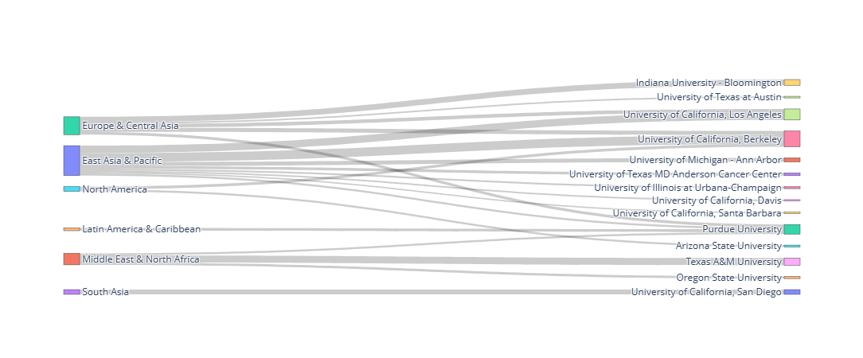
Figure 1. Alluvial chart of donations from international regions to US universities.

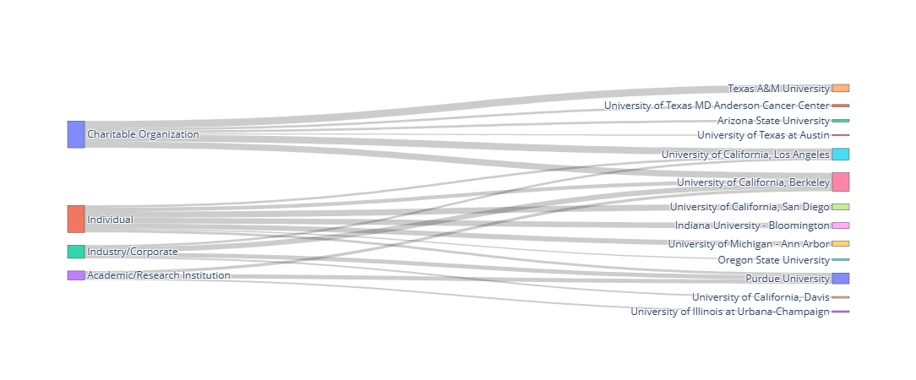
Figure 2. Alluvial chart showing donating organization by category to US universities.

Across all regions, Charitable organizations (28% std), followed by individuals (33% std) and industry/corporations (21% std) are the primary contributors to these donations (counts similar), see Figure 2. These three sectors donate in comparable amounts; however, donations from individuals have a slight edge over the other two. As a side note, looking at the top donors is not useful. They tend to be a result of foundations/institutes that have years long, deep-seated investments in a single university (branch campuses/research institutes, e.g., Qatar foundation and Tata), see Figure 3. These individual universities are the only places where these organizations are giving their money. Hence, we should focus on the regions- and countries- that donate in larger counts to a greater number of universities.
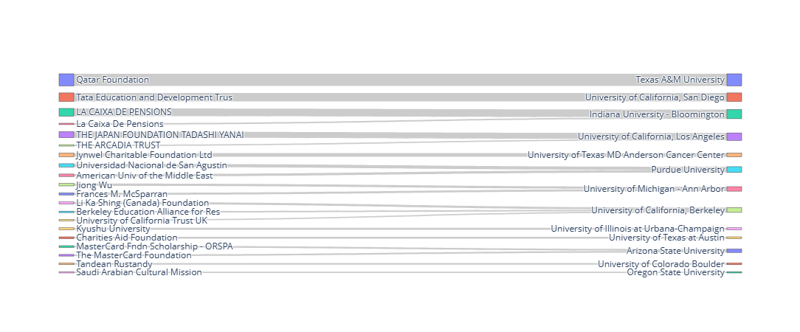
Figure 3. Alluvial chart of organizations donations to US Universities.

Overall, UVA does well in monetary gifts in comparison to other public universities (rank 22 out of 77/ 73rd percentile ). In comparison to public ivy league universities, it places in the middle of the pack (rank 9 out of 14/ 43rd percentile). Much of its funding comes from Europe (68%, sum). Within Europe, UVA receives the greatest number of donations from England equaling approximately the same amount as two larger gifts coming from Switzerland and Guernsey. In Europe, UVA receives a roughly even amount of money from individuals, charities and industry. In North America, UVA received one large gift from North America (12%) from a charity in Bermuda. UVA received 2 medium gifts from East Asia (11%), both from the same charity in Singapore. From South Asia, UVA received 4 small gifts (8%), all from a research institute in Bangladesh. Finally, a small amount of money was given to UVA from the middle east, specifically Israel. The overwhelming majority of the money UVA receives outside of Europe is from charities. Outside of Europe, UVA’s donations appear scattered and seemingly random rather than strategically targeted to a specific sector/country.

3. Describe a strategy for finding new potential sources of money for UVA. What countries or institutions should UVA target, and why? (1-3 paragraphs)
UVA has real room to grow into new regions and sectors where it should direct its strategy for acquiring philanthropic donations. Probably UVA’s biggest opportunity for growth comes from East Asia, the largest donating region across the top 3 sectors (individuals, charity, industry). UVA only receives 11% of its donations from East Asia, and both come from one charity. Of the 11 of UVA’s competitors in the core public ivy league² that receive donations from East Asia, UVA comes in dead last in both sum and count.
In terms of sector, most of money UVA receives outside of Europe comes from charities (73%. sums); whereas, within Europe, UVAs donations come from all 3 of the top sectors in approximately even amounts (individual, 41.8%, industry, 29.8% and charity, 26.6%). In comparison, outside of Europe, the other public ivies receive gifts fairly evenly distributed across all 3 top sectors (individual, 38.3%, charity, 27.2%, and industry, $23.7. Hence, other comparable schools are receiving gifts from the other sectors outside of charity and in large amounts in regions outside of Europe.
East Asia is composed of countries that house successful, industrial leaders, charities and wealthy individual philanthropists. Other public universities, including public ivies, have benefited fiscally from their generosity. UVA should make a concentrated effort in East Asia in all 3 sectors, making its presence known as a world leading university with an exceptional educational and research reputation. Also, UVA could emphasize that they are open to international collaborations and support by broadcasting the cutting-edge research UVA is conducting with messages carefully customized to the relevant sectors of interest as well as potential funders. Hong Kong, China, and Japan appear to be the three major countries in that region that UVA should narrow in on as they have the largest donation presence. Finally, UVA should strategically target industrial and individual donations in other areas outside of Europe where they have only been successful with charities, such as South Asia. Finally, UVA should strength existing connections by reinforcing their relationships with donors in England by communicating the outcomes of donations for key stakeholders/donators.

4. Conclude with a summary of UVA's prospects for increasing foreign giving. (1 paragraph).
UVA has shown that it can be successful in attracting monetary donations from all three top sectors from its track record of donations in Europe, especially England. However, UVA has a striking lack of presence outside of Europe in other sectors outside of charity. In particular, East Asia has an established precedent for supporting US public universities through monetary gifts from charities as well as industry and individual donations. By targeting individuals and companies with a history of donating to US universities in East Asia and other regions, UVA could see a meaningful increase in its monetary gifts as well as establish meaningful long-term relationships that give way to sustained future donations.

¹The middle east, e.g., Qatar., gives several large gifts almost exclusively to individual universities in which they have close ties (e.g., branch campuses (Qatar= Texas A & M) or government funding). Therefore, they are not really donating gifts, or at least gifts that are relevant to UVA. Research organizations largely donate to research collaborations and/or grants which are not in the purview of this summary.
² The public ivy league, of which UVA is a member, is composed of large public flagship universities of comparable academic reputation (Moll, 1985).

