|  |  |  |
| --- | --- | --- |
| **Numeric Converter Instructions** | **April 5**  **2018** | |
| **This instruction manual will assist users who encounter any issues.** | | **Instruction Manual** |

**Login Page:**

**To Login:**

1. 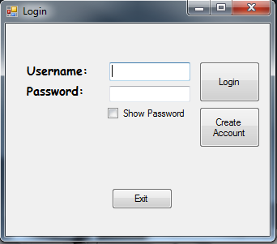Enter your Username and Password. Click Login.

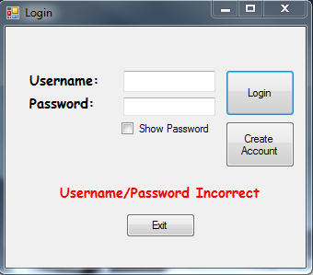

If you receive this error, “Username/Password Incorrect”, Click on “Create Account” Button.

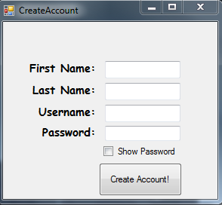

Fill out the fields and click “Create Account”

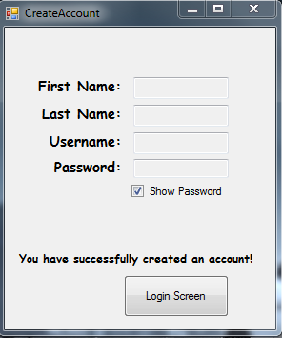

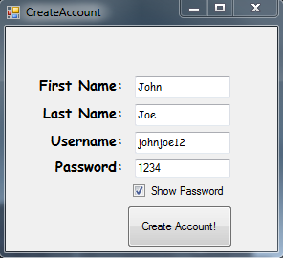

Click on “Login Screen” To return to login

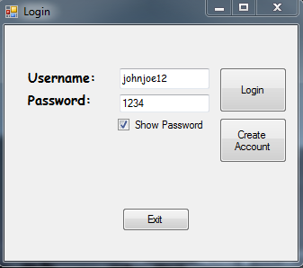

Enter ***your*** information as shown in the picture above. Click “Login” After entering in ***your***information.

* After logging in, you will see this page.
* You can click the button “Roman Numeral Converter” for the Roman Numeral Converter.
* You can click the button “Arabic Numeral Converter” for the Arabic Numeral Converter.
* You can click “Logout” to log out and return to the Login Screen
* You can click “Exit” to exit the application
* You can click “File” and select either “Logout” or “Exit”
* You can click “Help” > “Get Help” to receive help.

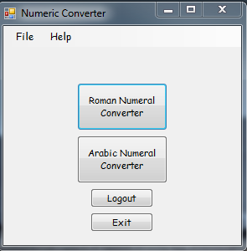

1. 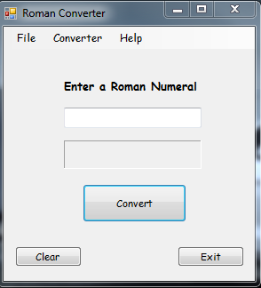Enter a Roman Numeral into the text box
2. Click the button “Convert”
3. You should see the Roman Numeral converted to a Arabic Number

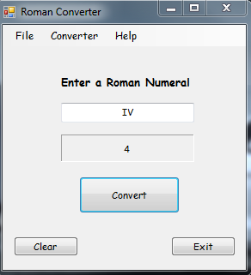

* You should see something like this.
* Click “Clear” to clear the text in the text box and the label
* Click “exit” to Exit application.
* You can click “Converter” > “Arabic” to switch to the Arabic Converter.
* You can click “File” > “Home” to return to the Home page
* You can click “File” > “Logout” to log out
* You can click “File” > “Exit” to exit the application