Requirements

Hunter Duerr

1. Purpose and Overview
   1. Allow users to input either a Roman Numerals or Arabic integer and instantly converts it to the opposite number system.
2. Program Scope
   1. The Number Converter is intended to be run from the user’s PC, as a desktop application.
   2. Displays the output instantaneously on screen after pressing the convert button.
3. References
   1. Appendix A – Roman Numeral Chart
4. Reliability
   1. The program must reliably convert the two number systems accurately from 1 to 3900.
   2. The program will display an error message if invalid input is entered i.e. decimals.
5. Distribution and Availability
   1. This program will be available free to download on Github.
6. User Profile
   1. The program in intended for anyone who interested in converting Arabic to Roman Numerals i.e. students, educators, and historians, etc.
   2. Users can enter incorrect input values as reference
7. Operating Environment
   1. Hardware - The program must be able to operate on a PC meeting the requirements for the Windows 7 operating system, equipped with standard mouse and keyboard inputs and a 1024 x 768 color display.
   2. Software and Dependencies - The program should run under Windows 7 or later. It requires the installation of virtual studio.
   3. Network Connectivity - The program may not be capable of linking to or referencing Internet data
   4. Memory and Storage - The program must operate within 512 MB of memory and 260KB of free hard disk space.
8. Security Requirements
   1. The program is open source and will contain non-sensitive data and will not require any special security features.
9. General Definitions
   1. Roman Numeral - The numeric system represented by Roman numerals originated in ancient Rome and remained the usual way of writing numbers throughout Europe well into the Late Middle Ages.
   2. The Hindu–Arabic numeral system (also called the Arabic numeral system or Hindu numeral system)is a positional decimal numeral system that is the most common system for the symbolic representation of numbers in the world.
10. Data Requirements
    1. Program will not convert a number over 3999.
    2. Program will not accept decimal for conversions.
11. General Requirements
    1. This program must provide a user interface that will allow the user to convert either a numeric or Arabic number to the opposite format. This will be done with a text box in which the user will enter either the roman or Arabic number. There will be a button that the user can click in order to convert the number in the text box to the opposite format that will be displayed in a label.

Appendix A – Data Specification

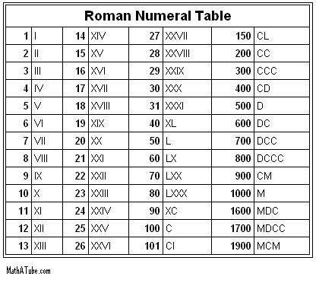

**TESTING NOTES:**

UI is slightly confusing; the Roman Numeral Converter and the Arabic Numeral Converter could be placed on the same form for ease of access. The login function is kind of unnecessary for such a simple program, and the ‘Remember me’ function is a security risk.

SPECIFIC ERRORS:

~~4a- Converter only goes up to 3999. Not 4000.~~

~~6b- The program code itself would have to be somehow packaged along with the finished desktop application at release in order to accomplish this.~~

~~7a- this runs correctly, but if put on an older operating system it raises an error. Looking into this would be beneficial, as .NET can run on XP computers as well as Vista.~~