DETAILS OF GUIDED EXAMPLES FROM TUTORS
Applied 2
FIT5137 Advanced Database Technology
Lab 2 Star Schemas

PART I: The International College Case Study

Description
The admission office handles enrolment, payment, and marketing campaigns to international students, often through educational agents located overseas. This admission office has an operational system that maintains all the details of international students enrolled in the College. Payment details are also handled by this office. Basically, the operational system has the following features:
- Every student's details are kept in the database. This includes the courses that the students enrol.
- As the College is a multi-campus university, some courses are offered in a different campus. The admission office handles international students of all campuses.
- Some international students coming to the College are handled by an educational agent. This is particularly common for the first course that a student enrols in. Subsequent courses are not normally handled by an agent, because the students themselves deal directly with the College.
- International students pay tuition fees several times (normally once every semester) for each course they are doing.

An E/R diagram to show the current operational system is shown below:
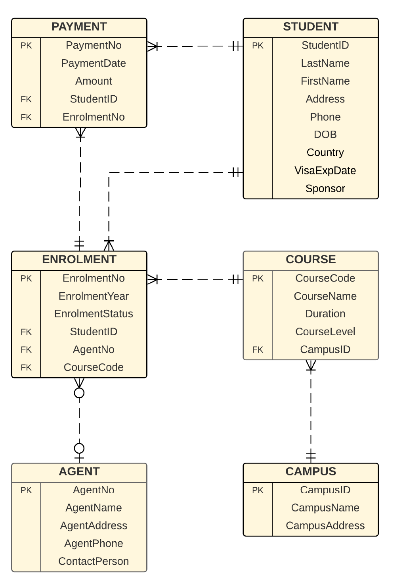
The operational database that maintains the above system has the following tables. Note that the Primary Keys (PK) are underline, whereas Foreign Keys (FK) are printed in italic. All the relationships in this E/R diagram are all Non-Associative Relationships as the entities do not share any common PK.
- Student (StudentID, LastName, FirstName, Address, Phone, DOB, Country, VisaExpDate, Sponsor)
- Campus (CampusID, CampusName, CampusAddress)
- Course (CourseCode, CourseName, Duration, CourseLevel, CampusID)
- Agent (AgentNo, AgentName, AgentAddress, AgentPhone, ContactPerson)
- Enrolment (EnrolmentNo, EnrolmentYear, EnrolmentStatus, StudentID, AgentNo, CourseCode)
- Payment (PaymentNo, PaymentDate, Amount, StudentID, EnrolmentNo)

You can access the Operational Database by executing the following query:
select * from opdb.<table_name>;

The College now requires a data warehouse for analysis purposes. The analysis is needed for identifying at least the following questions:
- What is the total income coming from certain countries?
- What is the total income for certain postgraduate courses in a certain year?
- What is the total income as a result of each agent?
- How many payments are generated each year?

Note:

We would like to bring your attention to a crucial aspect of this unit regarding the Lab exercises and Assignments. The star schema design, including the fact measures and dimensions, is entirely based on the specific questions we provide for each exercise and assignment.

It is essential to closely follow the question requirements and design the star schema accordingly. The fact measures and dimensions should align precisely with the data and analysis needed to address the given problem.

Please ensure that you thoroughly understand the question prompts and the expected outcomes before proceeding with the star schema design. Any deviation from the provided question may lead to inaccurate results and impact your assessment.

Here is the star schema created based on the requirements above:
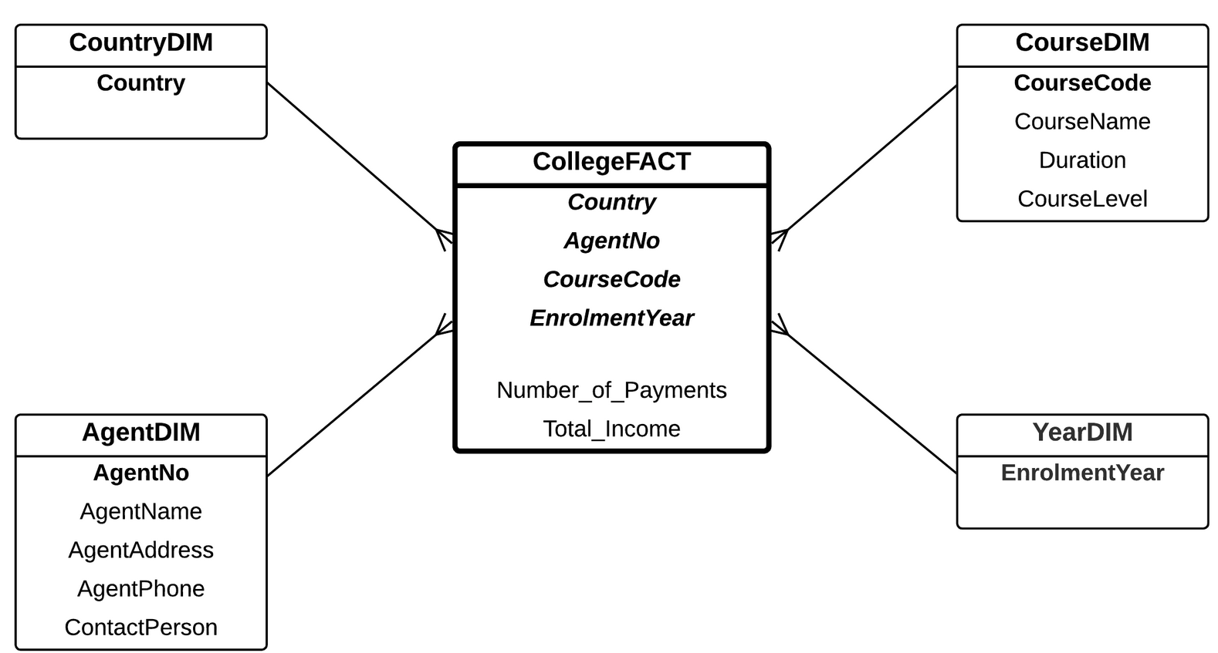
The star schema is then implemented in SQL using the following codes:

/*
drop table AgentDim;
drop table CountryDim;
drop table CourseDim;
drop table YearDim;
drop table CollegeFact;
*/

-- Agent Dimension
create table AgentDim as
select * from opdb.Agent;

select * from AgentDim;

--Country Dimension
create table CountryDim as
select distinct Country
from opdb.Student;

select * from CountryDim;

--Course Dimension
create table CourseDim as
select CourseCode, CourseName, Duration, CourseLevel
from opdb.Course;

select * from CourseDim;

--Year Dimension
create table YearDim as
select distinct EnrolmentYear
from opdb.Enrolment;

select * from YearDim;

--Fact Table
create table CollegeFact as
select
S.Country,
E.AgentNo,
E.CourseCode,
E.EnrolmentYear,
count(p.PaymentNo) as Number_of_payments,
sum(P.Amount) as Total_Income
from opdb.Student S, opdb.Enrolment E, opdb.Payment P
where E.EnrolmentNo = P.EnrolmentNo
and E.StudentID = S.StudentID
group by
S.Country,
E.AgentNo,
E.CourseCode,
E.EnrolmentYear;

select * from CollegeFact;

Tasks:
Using the star schema created, write the SQL statements to produce the following reports:
  - What is the total income coming from Australia?
  - What is the total income for each course?
  - What is the total income for the Master of Data Science course(C6003) in 2019?
  - What is the total income from New Star Agent?

1. What is the total income coming from Australia?
SELECT SUM(Total_Income) AS Total_Income_Australia
FROM CollegeFact
WHERE Country = 'Australia';

2. What is the total income for each course?
SELECT d.CourseName, SUM(f.Total_Income) AS Course_Total_Income
FROM CollegeFact f
JOIN CourseDim d ON f.CourseCode = d.CourseCode
GROUP BY d.CourseName, d.CourseCode;

3. What is the total income for the Master of Data Science course(C6003) in 2019?
SELECT SUM(Total_Income) AS Total_Income_MDS_2019
FROM CollegeFact
WHERE CourseCode = 'C6003' AND EnrolmentYear = 2019;

4. What is the total income from New Star Agent?
SELECT SUM(f.Total_Income) AS Total_Income_New_Star
FROM CollegeFact f
JOIN AgentDim a ON f.AgentNo = a.AgentNo
WHERE a.AgentName = 'New Star Agent';

PART II: The Sales Case Study (Quarter)

Description
The E/R diagram is shown below. It is a very simplistic Sales operational system. It has four entities: Product, Sales, Branch, and Category. The Product-Sales relationship is a 1-many relationship, and the Sales-Branch relationship is a many-1 relationship. Literally, Product-Branch can be seen as a many-many relationship. However, because Sales has its own PK (e.g. SalesNo), the relationships with Branch and Product become Non-Associative Relationships. The Product-Category relationship is a many-1 relationship.
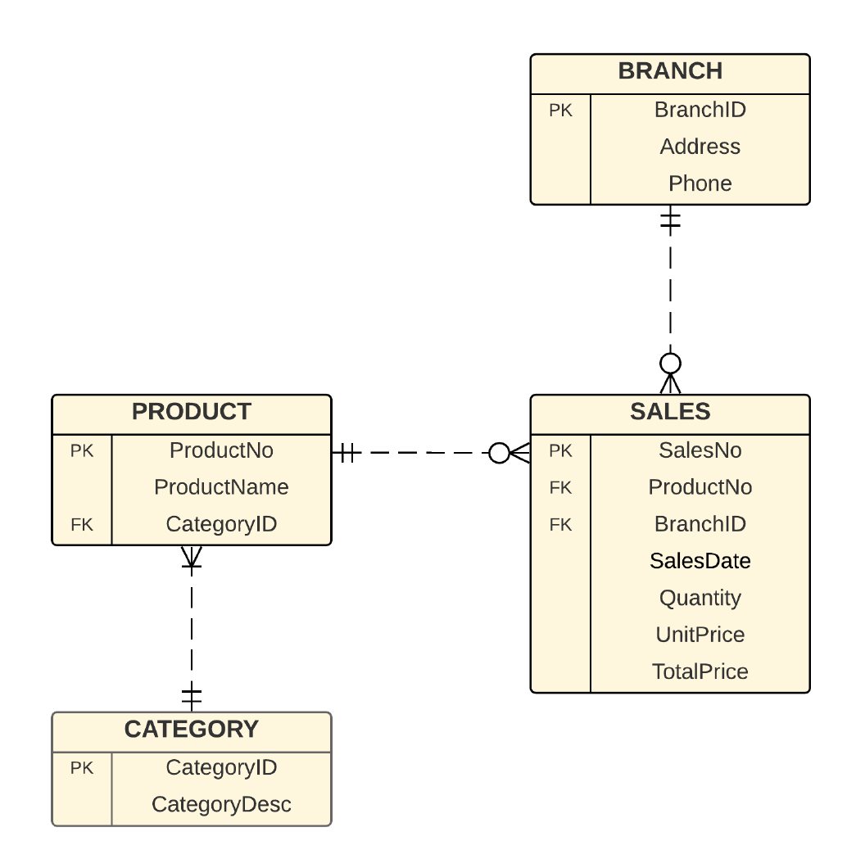
You can access the Operational Database by executing the following query:
select * from opdb.<table_name>;

The manager would like to analyse Total Sales from various point of views, including time (Quarter), branch and category . so a star schema was created based on the requirements as follows:
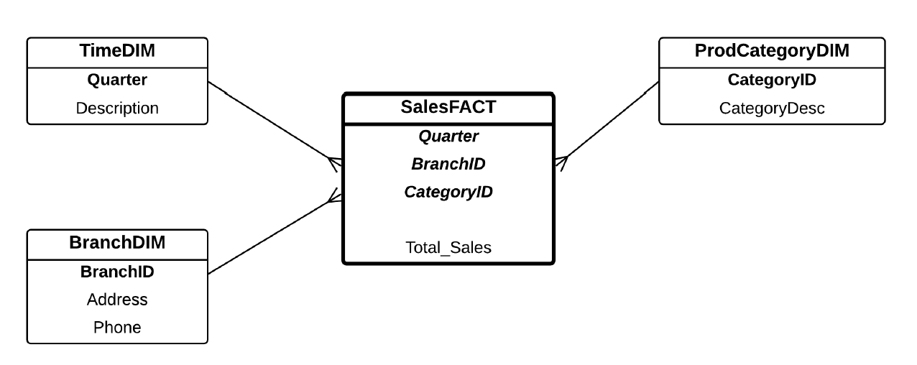

The star schema is then implemented in SQL using the following codes:

/*
drop table ProdCategoryDim;
drop table BranchDim;
drop table TimeDim;
drop table TempFact;
drop table SalesFact;
*/

-- Prodcategory Dimension
create table ProdCategoryDim as
select * from opdb.Category;

select * from ProdCategoryDim;

-- Branch Dimension
create table BranchDim as
select * from opdb.Branch;

select * from BranchDim;

--Time Dimension => Do dimension này là user-defined nên phải tự CREATE - INSERT DATA
create table TimeDim
(
Quarter number(1),
Description varchar2(20)
);

insert into TimeDim values (1, 'Jan-Mar');
insert into TimeDim values (2, 'Apr-Jun');
insert into TimeDim values (3, 'Jul-Sep');
insert into TimeDim values (4, 'Oct-Dec');

select * from TimeDim;

-- TempFact Table
=> Do trong các dimension của warehouse đã xuất hiện USER-DEFINED DIMENSION chưa từng xuất hiện trong operational db nên không thể trực tiếp input data từ dimension đó sang official FACT TABLE => Phải tạo Temp Fact table = vùng đệm trung gian để tổng hợp, làm sạch và chuẩn bị dữ liệu trước khi nạp chính thức vào bảng sự kiện chính

create table TempFact as
select S.SalesDate, B.BranchID, C.CategoryID, S.TotalPrice
from opdb.Branch B, opdb.Sales S, opdb.Product P, opdb.Category C
where B.BranchID = S.BranchID
and S.ProductNo = P.ProductNo
and P.CategoryID = C.CategoryID;

- Sau khi đã extract tất cả những attribute REQUIRED + CÓ SẴN TRONG OPERATIONAL DB => ALTER TEMPFACT VÀ ADD USER-DEFINED ATTRIBUTE bằng cách manipulate format của attribute được chọn sao cho phù hợp với requirements

- Ví dụ ở đây ta Alter TempFact => Add user-defined Quarter => Manipulate format của Quarter dựa trên attribute sẵn có trong TempFact là SalesDate => Create Official Fact table với những attribute đạt chuẩn format của query cuối cùng trong TempFact

alter table TempFact
add (Quarter number(1));

update TempFact
set Quarter = 1
where to_char(SalesDate, 'MM') >= '01'
and to_char(SalesDate, 'MM') <= '03';

update TempFact
set Quarter = 2
where to_char(SalesDate, 'MM') >= '04'
and to_char(SalesDate, 'MM') <= '06';

update TempFact
set Quarter = 3
where to_char(SalesDate, 'MM') >= '07'
and to_char(SalesDate, 'MM') <= '09';

update TempFact
set Quarter = 4
where Quarter is null;

select * from TempFact;

-- SalesFact Table
create table SalesFact as
select Quarter, BranchID, CategoryID,
sum(TotalPrice) as Total_Sales
from TempFact
group by Quarter, BranchID, CategoryID;

select * from SalesFact;

Tasks:
Using the star schema created, write the SQL statements to produce the following reports:
  - Show the total sales in different quarters.
  - Show the total sales for different branches and product categories.
  - Show the total sales of Kitchen supplies in Quarter 1

1. Show the total sales in different quarters.
SELECT t.Description AS Quarter, SUM(f.Total_Sales) AS Total_Sales
FROM SalesFact f
JOIN TimeDim t ON f.Quarter = t.Quarter
GROUP BY t.Description, f.Quarter
ORDER BY f.Quarter;

2. Show the total sales for different branches and product categories.
SELECT b.Address AS Branch, p.CategoryDesc AS Category, SUM(f.Total_Sales) AS Total_Sales
FROM SalesFact f
JOIN BranchDim b ON f.BranchID = b.BranchID
JOIN ProdCategoryDim p ON f.CategoryID = p.CategoryID
GROUP BY b.Address, p.CategoryDesc;

3. Show the total sales of Kitchen supplies in Quarter 1
SELECT SUM(f.Total_Sales) AS Total_Kitchen_Sales_Q1
FROM SalesFact f
JOIN ProdCategoryDim p ON f.CategoryID = p.CategoryID
WHERE f.Quarter = 1 AND p.CategoryDesc = 'Kitchen supplies';
PART III: The Sales Case Study (Month)

Description
The E/R diagram is shown below. It is a very simplistic Sales operational system. It has four entities: Product, Sales, Branch, and Category. The Product-Sales relationship is a 1-many relationship, and the Sales-Branch relationship is a many-1 relationship. Literally, Product-Branch can be seen as a many-many relationship. However, because Sales has its own PK (e.g. SalesNo), the relationships with Branch and Product become Non-Associative Relationships. The Product-Category relationship is a many-1 relationship.
The manager would like to analyse Total Sales from various point of views, including Time (month), Branch, and Product Category

Tasks
Given the requirements above, complete the following:
- Create a star schema for the Sales data.
- Define the dimensions and attributes for the Sales star schema.
- Write the SQL statements for the implementation of the star schema.
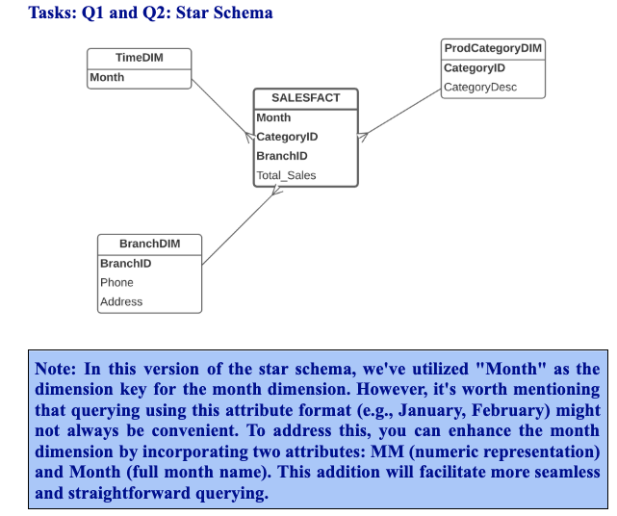
CREATE TABLE BranchDim AS SELECT * FROM opdb.BRANCH;

CREATE TABLE ProdCategoryDim AS SELECT * FROM opdb.CATEGORY;

CREATE TABLE TimeDim2 AS => Transform available attribute “SalesDate” luôn để facilitate more seamless and straightforward querying
SELECT DISTINCT
TO_CHAR(salesdate, 'MM') AS MM,
TO_CHAR(salesdate, 'MONTH') AS Month_desc
FROM opdb.Sales;

INSERT INTO TimeDim values (1,’January’);
….
INSERT INTO TimeDim values (12, ‘December’);

Do đó có thể tạo trực tiếp bảng SaleFacts luôn do tất cả data đều bắt nguồn từ opdb:
-- SalesFact2 Table
create table SalesFact2 as
select to_char(S.salesdate, 'MONTH') as Month, S. BranchID, P. CategoryID,
sum(S.TotalPrice) as Total_Sales
from opdb.Sales S, opdb.Product P - vẫn extract từ bảng gốc (explained as belows)
where S.productno = P.productno
group by to_char(S.salesdate, 'MONTH'), BranchID, CategoryID;

select * from SalesFact2;

Explanation:

Trong Task Q3 của bài Lab, bảng SalesFact2 bắt buộc phải được tạo ra bằng cách truy vấn trực tiếp từ các bảng của hệ thống gốc (opdb.Sales và opdb.Product) thay vì từ các bảng Dimension mới tạo (như ProdCategoryDim, BranchDim, TimeDim2) vì những lý do chính sau đây:
- Bảng Dimension không chứa dữ liệu sự kiện đo lường (Measures/Facts): Các bảng Dimension được sinh ra chỉ để lưu trữ dữ liệu mô tả (descriptive attributes) dùng làm tiêu chí phân tích (ví dụ: tên danh mục, tên chi nhánh). Chúng không lưu trữ các con số giao dịch thực tế. Để tính được tổng doanh thu bán hàng (sum(S.TotalPrice)), hệ thống bắt buộc phải đọc từ bảng chứa các giao dịch phát sinh hàng ngày, chính là bảng opdb.Sales ở database nguồn.
- Thiếu thông tin để liên kết khóa (Key Mapping): Bảng Fact cần các khóa ngoại (Month, BranchID, CategoryID) để liên kết ngược lại với các Dimension.
  - Bảng opdb.Sales có sẵn BranchID và salesdate (có thể dùng hàm to_char để biến đổi thành Month).
  - Tuy nhiên, opdb.Sales không chứa CategoryID (mã danh mục) mà chỉ chứa productno (mã sản phẩm).
  - Bảng dimension ProdCategoryDim thì lại được tạo từ opdb.Category, do đó nó không chứa productno để map với giao dịch.
  - Vì vậy, ta phải JOIN bảng opdb.Sales với opdb.Product (từ operational database) thông qua productno thì mới lấy ra được CategoryID của món hàng đã bán để đưa vào Fact table.
- Bản chất của Fact Table: Fact table luôn ghi nhận lại các "sự kiện" (event). Trong trường hợp này, sự kiện là các giao dịch mua bán. Nơi duy nhất chứa chi tiết các sự kiện này (ngày nào, bán ở đâu, sản phẩm gì, giá bao nhiêu) chính là operational database. Do đó, Fact table luôn phải được trích xuất (extract) và tổng hợp (group by) từ hệ thống nguồn gốc này.
Tóm lại, Dimension table đóng vai trò như các "từ điển" cung cấp ngữ cảnh để lọc và nhóm dữ liệu, còn Fact table phải được tổng hợp từ dữ liệu gốc (operational database) vì đó là nơi duy nhất chứa đầy đủ các chi tiết giao dịch để thực hiện các phép tính toán (SUM).
- Write the SQL statements to produce the following reports:
  - Show the total sales by different months.
  - Show the total sales by different branches and product categories.

- Show the total sales by different months.
select Month, sum(Total_Sales) as Total_Sales
from SalesFact2
group by Month;

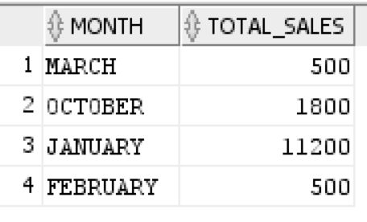

- Show the total sales by different branches and product categories.

select B.BranchID, B.Address, P.CategoryDesc, sum(S.Total_Sales) as Total_Sales
from SalesFact2 S, BranchDim B, ProdCategoryDim P
where B.BranchID = S.BranchID and
P.CategoryID = S.CategoryID
group by B.BranchID, B.Address, P.CategoryDesc;

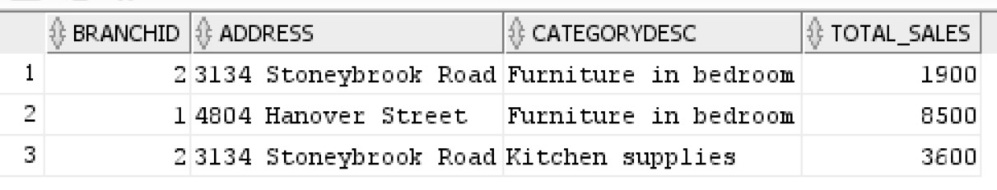

Pre-Data Warehousing: Exploring Dirty Data

Data cleaning is to clean data that is dirty. The crucial step in data cleaning is to identify data incorrectness, inconsistency, etc. before loading the data into the data warehouse. Here, we have listed five examples of data cleaning methods. However, you may encounter other types of data errors in real-world scenarios.

For example:
- Duplication problems
- Relationship problems
- Inconsistent values
- Incorrect values
- The null value problems

1. Duplication problems: This error occurs when an attempt is made to insert a record with a primary key value that already exists in the table. It is important to ensure that primary keys are unique to avoid duplicate key value errors.

To check duplicate records
SELECT <<PK attribute>>, COUNT(*)
FROM <<operational database table>>
GROUP BY <<PK attribute>>
HAVING COUNT(*) > 1;

To clear duplicate records
CREATE TABLE <<new table>> AS
SELECT DISTINCT *
FROM <<old table>>;

2. Relationship problems or Constraint Violations: Constraints such as primary key, foreign key, unique, or check constraints can be violated if the data being inserted or updated does not adhere to the specified rules. It is necessary to validate data against the defined constraints to avoid such errors.

To check invalid FK values
SELECT *
FROM <<table 1>>
WHERE <<FK>> NOT IN
(SELECT <<PK>>
FROM <<table 2>>);

To resolve this issue (simplest approach):
DELETE
FROM <<table 1>>
WHERE <<FK>> NOT IN
(SELECT <<PK>>
FROM <<table 2>>);

3. Inconsistent values. For example: inconsistent values can be different in units, codes or precision, such as two different attributes conflicting with each other.

To check if there is any inconsistent values:
SELECT *
FROM contract
WHERE starttime > endtime

If there is any inconsistent values, to resolve the issue (simplest approach):
DELETE
FROM contract
WHERE starttime > endtime;

4. Incorrect values: Incorrect values can be incorrect spelling, attributes falling outside the correct data range, illogical values of the attribute or incorrect data types

To check if there are any incorrect values:
SELECT *
FROM charter
WHERE char_distance < 0;

If there are any inconsistent values, to resolve the issue (simplest approach):
DELETE
FROM charter
WHERE char_distance <0;

5. Null Value Problems
For example: Uselog case study

To check if there is any null value in the Major table:
SELECT *
FROM major
WHERE major_name IS NULL;

If there is any null value, to resolve the issue (simplest approach):
DELETE
FROM major
WHERE major_name IS NULL;

Lab - 3a USELOG Case Study
Data Cleaning & Simple Star Schema

Description
University Computer Lab's director keeps track of the lab usage, measured by the number of students using the lab. This particular function is very important for budgeting purposes. The computer lab director assigns you the task of developing a small Data Warehouse in which to keep track of the lab usage statistics. The main requirements for this database are to:
- Show the usage numbers by different time periods (e.g. morning, afternoon, night)
- Show the usage numbers by time period, by major, and by student's class
- Compare the usage numbers for different majors and semesters (e.g semester 1 and semester 2).
Use the provided database that includes the following tables: USELOG, STUDENT, MAJOR, and CLASS
USELOG contains the student access data
USELOG (Log_Date, Log_Time, Student_ID, Act)

STUDENT is a table containing student data
STUDENT (Student_ID, Sex, Full/Part, Type, Class_ID, Major_Code)

MAJOR is a table containing major data
MAJOR (Major_Name, Major_Code)

CLASS is a table containing class data
CLASS (Class_Description, Class_ID)

The above case study has been discussed in the lecture this week. Your task today is to implement the data warehouse in Oracle.
The following operational databases have been provided for you:
dw.Class: table that stores information about classification ids and descriptions
dw.Major: table that stores information about major codes and descriptions
dw.Student: table that stores information about students as described above
dw.Uselog: table that stores information about lab usage as described above
You do not need to copy these four tables (dw.Class, dw.Major, dw.Student, and dw.Uselog) into your account. You can just simply use these tables.

Part A: Implement Star Schema
In this section, we will design and create the star schema based on the primary requirements, using the provided code.

To fulfil the main requirement, we can visualise the star schema as follows:
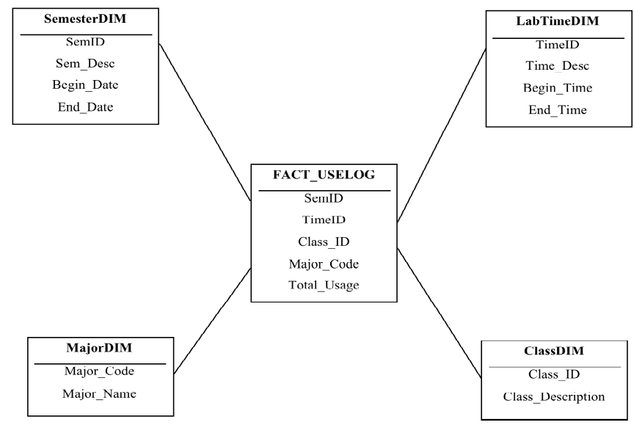

--first create the dimensions
--create semester dimension

drop table semesterDIM;
create table semesterDIM
(SemID varchar2(10),
Sem_Desc varchar2(20),
begin_date date,
end_date date);

-- create time dimension (note do not use time as a
-- table name, it is a reserved keyword)

drop table labtimeDIM;
create table labtimeDIM
(TimeID number,
Time_Desc varchar2(15),
begin_time date,
end_time date);

-- create major and class dimensions

drop table majorDIM;
create table majorDIM as
select * from dw.major;

drop table classDIM;
create table classDIM as
select * from dw.class;

-- populate semester dimension
-- (the begin and end date can be changed)

insert into semesterDIM values ('S1', 'Semester1', to_date('01-JAN', 'DD-MON'), to_date('15-JUL', 'DD-MON'));

insert into semesterDIM values ('S2', 'Semester2', to_date('16-JUL', 'DD-MON'), to_date('31-DEC', 'DD-MON'));

--populate labtime dimension
insert into labtimeDIM values(1, 'morning', to_date('06:01', 'HH24:MI'), to_date('12:00', 'HH24:MI'));

insert into labtimeDIM values(2, 'afternoon', to_date('12:01', 'HH24:MI'), to_date('18:00', 'HH24:MI'));

insert into labtimeDIM values(3, 'night', to_date('18:01', 'HH24:MI'), to_date('06:00', 'HH24:MI'));

-- secondly, create a temp table to extract from uselog table

drop table tempfact_uselog;
create table tempfact_uselog as
select U.log_date , U.log_time,
U.student_ID, S.class_id, S.major_code
from dw.uselog U, dw.student S
where U.student_id = S.student_id;

-- add a column in the tempfact table to store timeid
-- (cannot directly do this in the tempfact table because
-- log_time was of DATE type and timeid is of NUMBER type).
alter table tempfact_uselog
add (timeid number);

update tempfact_uselog
set timeid = 1
where to_char(log_time, 'HH24:MI') >= '06:01'
and to_char(log_time, 'HH24:MI') <='12:00';

update tempfact_uselog
set timeid = 2
where to_char(log_time, 'HH24:MI') >= '12:01'
and to_char(log_time, 'HH24:MI') <='18:00';

-- note that we use OR in the last update statement to
-- include the time between 18:01 and 06:00.

update tempfact_uselog
set timeid = 3
where to_char(log_time, 'HH24:MI') >= '18:01'
or to_char(log_time, 'HH24:MI') <='06:00';

-- alternatively, you may want to update timeid=3
-- for all other records where the time_id is still empty
-- update tempfact_uselog
-- set timeid = 3
-- where timeid is NULL;

-- add a column in the tempfact_uselog table to store semid
-- (cannot directly do this in the test table because
-- log_date was of DATE type and semid is of VARCHAR type.)

alter table tempfact_uselog
add (semid varchar2(10));

-- populate the new attribute semid by summarizing
-- the date(log_date)

update tempfact_uselog
set semid = 'S1'
where to_char(log_date, 'MMDD') >= '0101'
and to_char(log_date, 'MMDD') <= '0715';

update tempfact_uselog
set semid = 'S2'
where to_char(log_date, 'MMDD') >= '0716'
and to_char(log_date, 'MMDD') <= '1231';

-- Now, create the fact table,
-- make sure to include the TOTAL aggregate.
-- This is an aggregate table of the earlier tempfact table.

create table fact_uselog as
select t.semid, t.timeid, t.class_id,
t.major_code, count(t.student_id) as total_usage
from tempfact_uselog t
group by t.semid, t.timeid, t.class_id, t.major_code;

While creating a star schema is a crucial step in data warehousing, it's important to first understand the state of the data in the operational database. If dirty data is not addressed before schema creation, it can lead to inaccuracies and issues down the line.

Part B: Data Exploration
The purpose of this exercise is to practice data exploration, which will help you understand the content and structure of each table. This understanding is essential for the subsequent data cleaning process. You will need to answer the questions to gain insight into the data exploration process.

Operational Database Exploration

- How many rows in ‘dw.student’?

SELECT COUNT(*) AS student_rows
FROM dw.student;

- What does ‘dw.student’ look like? Write a SQL query to retrieve and review all columns and rows.

SELECT *
FROM dw.student;

- How many rows in ‘dw.uselog’?

SELECT COUNT(*) AS uselog_rows
FROM dw.uselog;

- What does ‘dw.uselog’ look like?
SELECT log_date,
TO_CHAR(log_time, 'HH24:MI') AS log_time,
student_id,
act
FROM dw.uselog
ORDER BY student_id, log_date, log_time;

- How many rows in ‘dw.major’?
SELECT COUNT(*) AS major_rows
FROM dw.major;

- What does ‘dw.major’ look like?
SELECT *
FROM dw.major;

- How many rows in ‘dw.class’?
SELECT COUNT(*) AS class_rows
FROM dw.class;

- What does ‘dw.class’ look like?
SELECT *
FROM dw.class;

We've explored all the tables in the data warehouse earlier. Does anything seem wrong?

- Compare the number of records between ‘tempfact_uselog’ and ‘fact_uselog’. Why is the number of rows different between these 2 tables?
SELECT COUNT(*) AS tempfact_rows FROM tempfact_uselog;
SELECT COUNT(*) AS fact_rows FROM fact_uselog;

When we create tempfact_uselog we join between dw.uselog with dw.student using the following SQL statement:

create table tempfact_uselog as
select U.log_date , U.log_time,
U.student_ID, S.class_id, S.major_code
from dw.uselog U, dw.student S
where U.student_id = S.student_id;

The relationship between ‘dw.student’ and ‘dw.uselog’ is one-to-many, meaning that each entry in ‘dw.student’ can have multiple corresponding entries in ‘dw.uselog’. Does something not seem right for the number of rows in ‘tempfact_uselog’?

Why they differ + and why this difference is expected and correct:
tempfact_uselog is at event grain: one row per (cleaned) access event, carrying semid, timeid, class_id, major_code. fact_uselog is built with GROUP BY t.semid, t.timeid, t.class_id, t.major_code and COUNT(student_id) AS total_usage. Aggregation collapses many event rows that share the same four-dimension combination into a single summarised row whose measure is the count.
So fact_uselog has far fewer rows than tempfact_uselog - one per unique dimensional combination rather than one per event. This is the normal, desirable behaviour of an aggregate fact table: it trades row-level detail for query speed on the reporting questions (usage by semester/time/class/major). The drop in row count is aggregation, not data loss.

- Compare the number of records between ‘tempfact_uselog’ and ‘dw.uselog’. Why is the number of rows different between these 2 tables?
The student → uselog relationship is one-to-many (one student, many accesses). A correct one-to-many join should return exactly one matching student row per access event, so tempfact_uselog ought to have the same row count as dw.uselog (assuming every access belongs to a known student).
If tempfact_uselog comes out larger than dw.uselog, the join has fanned out - some student_id matched more than one row in dw.student. That can only happen if dw.student contains duplicate students (the same Student_ID appearing on multiple rows). Each duplicated student multiplies its access events. => Đáng nhẽ ở đây số rows của tempfact table phải giống với table bên MANY vì nó tempfact join STUDENT + USELOG ( kết quả của JOIN này ra tất cả số rows của uselog) => Trong trường hợp nó nhiều hơn thì đã xuất hiện DUPLICATES
(If instead it came out smaller, that would indicate uselog events whose student_id has no match in dw.student - orphan events dropped by the inner join. Both directions are worth checking; the lab's framing steers us toward the duplicate case.)

- From question 10, what could be causing the difference in the number of rows between ‘tempfact_uselog’ and ‘dw.uselog’? Could there be issues with the data in one of the tables, such as duplicate, missing or incorrect records?

The most likely cause, given the direction of the discrepancy (tempfact > uselog), is duplicate rows in dw.student - the same Student_ID stored more than once. Because the join key is student_id, every duplicate student row produces an extra copy of every access that student made, inflating tempfact_uselog.
Secondary possibilities worth keeping in mind:
- Missing/orphan records => accessed in dw.uselog for a student_id that isn't in dw.student (referential integrity failure). These would shrink tempfact, not grow it.
- Duplicate rows in dw.uselog itself = the exact same access logged twice.
- Incorrect key values - malformed student_id that accidentally matches the wrong student.

Q12-Q15 systematically confirm which of these is actually present.

- Investigate ‘dw.uselog’ and ‘tempfact_uselog’ using the following SQL statement:

-- content dw.uselog from operational database
Select log_date,
to_char(log_time, 'HH24:MI') as log_time,
student_ID, act
From dw.uselog;

-- content from data warehousing
Select log_date,
to_char(log_time, 'HH24:MI') as log_time,
student_ID
From tempfact_uselog;

Write down what you found from this investigation?

What you find: Setting the two side by side, individual access events that are unique in dw.uselog appear more than once in tempfact_uselog - same log_date, same log_time, same student_id, but repeated. Since dw.uselog itself shows each such event only once, the duplication was introduced by the join, which confirms the multiplication is coming from the student side, not the uselog side. In other words, dw.uselog's events are fine; the join partner is duplicating them.

- From the information of investigation in question 11 and 12, which table contains dirty data? And what type of dirty data?

dw.student contains the dirty data, and the type is DUPLICATE data - the same Student_ID (a value that should be a unique primary key) appears on multiple rows. Because student_id is the join key, those duplicates fan the one-to-many join out, which is exactly the inflation observed in Q10-Q12.

- Write the SQL statements needed to check for dirty data identified in question 11. Use the information from your previous investigation to guide your queries.(Hint: you can check the code in the Additional Material - Data Cleaning)

- From the previous question, we identified duplicate data in the operational database, indicating the presence of dirty data. What other types of dirty data might be present? Write SQL queries to investigate these additional types of dirty data, such as relationships problems. (Hint: you can check the code in the Additional Material - Data Cleaning)

Why these: NOT EXISTS (or an anti-join / LEFT JOIN ... WHERE key IS NULL) is the canonical way to find rows on the "many" side that have no valid parent on the "one" side. Guarding with IS NOT NULL in (a)/(b) separates invalid codes from missing codes so the two problems are reported distinctly. Together these catch the three remaining dirty-data types - orphan foreign keys, orphan events, and missing values - that a duplicate check alone would miss.

Part C: Data Cleaning & Implement Star Schema
After thoroughly exploring and investigating the data, we've identified several issues in both the operational database and the data warehouse. The next critical step is the data cleaning process, where we'll address these problems to ensure the data is accurate, consistent, and reliable for further analysis and use.

First, we will re-create the tempfact_uselog table using the name tempfact_uselog2. There are several approaches to data cleaning, and in this case, you have a couple of options:
- Copying and Cleaning: You could copy the operational database tables (e.g., dw.student) to your local database and manually clean the duplicate records.
- Using DISTINCT: Alternatively, you could add the DISTINCT clause when reconstructing the tempfact table. This would automatically eliminate any duplicate records that resulted from the join operation.

create table tempfact_uselog2 as
select distinct U.log_date , U.log_time,
U.student_ID, S.class_id, S.major_code
from dw.uselog U, dw.student S
where U.student_id = S.student_id;

- How many records in ‘tempfact_uselog2’?

Why DISTINCT fixes it: the duplicate student rows produced identical joined rows (same date, time, student, class, major). DISTINCT collapses those identical output rows back to one, undoing the fan-out. After this, tempfact_uselog2 should equal the number of genuine, resolvable access events.

- Why the rows in ‘tempfact_uselog2’ differently with ‘dw.uselog’?
Two effects combine, so the counts may still not be identical:
- DISTINCT removed the duplicate multiplication introduced by the duplicated students - this brings the count down toward the true event count. Good.
- The inner join still drops orphan events - any dw.uselog row whose student_id has no match in dw.student is excluded (there's no student to supply class_id/major_code). This can leave tempfact_uselog2 smaller than dw.uselog.
- A subtle caveat: DISTINCT also collapses two genuinely separate accesses by the same student that happen to share the identical log_date and log_time down to a stored DATE resolution. If such true-but-identical events exist, DISTINCT would under-count them. In this teaching dataset that's assumed negligible, but it's the honest limitation of the DISTINCT approach versus properly de-duplicating dw.student first.
Net: tempfact_uselog2 reflects cleaned, de-duplicated, resolvable events, which is what the fact table should be built from - so a difference from the raw dw.uselog count is expected and correct.
Now we repeat all the step to create the tempfact_uselog2 again

alter table tempfact_uselog2
add (timeid number);

update tempfact_uselog2
set timeid = 1
where to_char(log_time, 'HH24:MI') >= '06:01'
and to_char(log_time, 'HH24:MI') <='12:00';

- How many records update for timeid = 1? Write a SQL query to count the total number of records where timeid is equal to 1.

update tempfact_uselog2
set timeid = 2
where to_char(log_time, 'HH24:MI') >= '12:01'
and to_char(log_time, 'HH24:MI') <='18:00';

- How many records update for timeid = 2? Write a SQL query to count the total number of records where timeid is equal to 2.

update tempfact_uselog2
set timeid = 3
where to_char(log_time, 'HH24:MI') >= '18:01'
or to_char(log_time, 'HH24:MI') <='06:00';

- How many records update for timeid = 3? Write a SQL query to count the total number of records where timeid is equal to 3.

alter table tempfact_uselog2
add (semid varchar2(10));

update tempfact_uselog2
set semid = 'S1'
where to_char(log_date, 'MMDD') >= '0101'
and to_char(log_date, 'MMDD') <= '0715';

- How many records are updated for semid = ‘S1’? Write a SQL query to count the total number of records where semid is equal to S1.

update tempfact_uselog2
set semid = 'S2'
where to_char(log_date, 'MMDD') >= '0716'
and to_char(log_date, 'MMDD') <= '1231';

- How many records are updated for semid = ‘S2’? Write a SQL query to count the total number of records where semid is equal to S2.

After creating the fact_uselog2 table using the SQL statement provided:

create table fact_uselog2 as
select t.semid, t.timeid, t.class_id,
t.major_code, count(t.student_id) as total_usage
from tempfact_uselog2 t
group by t.semid, t.timeid, t.class_id, t.major_code;

The next step is to compare the contents of the fact_uselog and fact_uselog2 tables. Examine the differences in record counts and any discrepancies in the total_usage values to understand the impact of the data cleaning process.

--fact table before data cleaning process
select *
from fact_uselog
order by semid, timeid, class_id, major_code;

--fact table after data cleaning process
select *
from fact_uselog2
order by semid, timeid, class_id, major_code;

- What is the difference between the ‘fact_uselog’ and ‘fact_uselog2’ tables? If you do not perform data cleaning, how might dirty data affect your analysis?

The difference: fact_uselog was built from the dirty staging table, so its total_usage counts are inflated - the duplicated students caused their accesses to be counted multiple times. fact_uselog2, built from the de-duplicated tempfact_uselog2, reports the true usage. The overcount column above is literally the number of phantom visits dirty data injected into each cell.

How dirty data would harm analysis if left uncleaned: the whole point of this warehouse is budgeting based on lab demand. Inflated usage numbers would make the lab look busier than it is, potentially driving decisions to over-allocate budget, staff, or machines - and the distortion isn't uniform: it's concentrated on whichever majors/classes happened to contain the duplicated students, so comparisons between majors and between semesters (requirements 2 and 3) become invalid. Dirty data doesn't just add noise; it biases exactly the comparisons the system exists to support. Cleaning first is therefore not optional polish - it's a correctness prerequisite.

Tips for completing Assignment2
Before building a data warehouse, it is crucial to ensure that the data cleaning process is thoroughly conducted to accurately reflect the information. While the process of data exploration and cleaning might be time-consuming, you're on the right track. For the case study that provide information like USELOG case study, which does not provide an ERD diagram, you should follow these steps:

Task 1:
Ensure that the input data to the data warehouse has undergone a thorough data cleaning process to guarantee accuracy.
Tip: To better understand the dataset, consider drawing an ERD based on the dataset and the provided scenario.

Task 2 & 3:
Draw a suitable star schema and use SQL commands to create the data warehouse based on this schema.

Task 4:
Answer the provided queries using SQL commands. Additionally, formulate one more question, provide the SQL query to answer it, and explain why management would find this information useful. Ensure that all three SQL queries involve the fact table and at least one dimension table.

Note:
Assignment 2, the Data Warehouse Major Assignment, will include tasks similar to those outlined in [Tasks 1-4].

THE END

Lab - 3b ROBCOR Case Study
Data Cleaning & Simple Star Schema

ROBCOR, Inc. provides “on demand” aviation charters, using a mix of different airplane and airplane types. Because ROBCOR, Inc., has grown rapidly, it has hired you to be its first database manager. Your first and critical assignment is to develop a decision support system to analyze the charter data. The charter operations manager wants to be able to analyze charter data such as total hours flown, total fuel used, and total revenue (charter distance x model charge per mile). She would also like to be able to drill-down by pilot, airplane model, and time periods. The main requirements for this database are to:
- Show the total revenue each month/year
- Show the total hours flown by each pilot
- Show the total fuel used by each airplane model.
The database currently has the following tables:
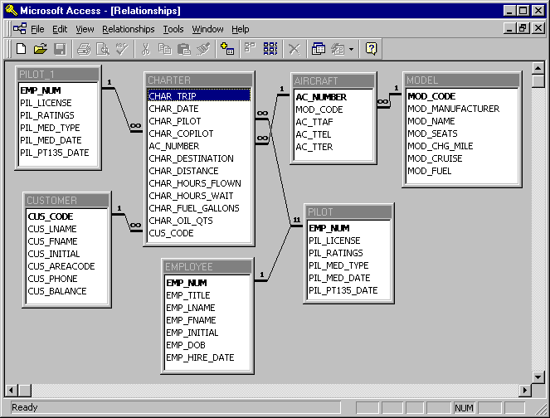

The tables can be copied from the dw account, using:
Select * from dw.<table_name>;
Or
Create Table <your_table_name> As
Select …
From dw.<table_name>
Where …

Before implementing the star schema, it's important to explore the data and ensure it is in the correct format and free of dirty data. Therefore, this lab will provide you with practical experience in the data cleaning process.

Part A: Data Exploration
Before creating the star schema or using any data from the operational databases, it is essential to thoroughly explore the data. This step will help you understand the content of each table and verify whether the ERD is accurate. A thorough understanding of the data is crucial before proceeding to ensure that the schema and subsequent analyses are based on correct and complete information.

- Explore the content of all tables in the operational database.

- Did you identify any issues related to the tables in the operational database during your exploration?
Typical issues to report from the exploration (and how each surfaces):
- A missing table. The requirements and the join in Part B reference dw.charter, dw.aircraft, dw.model, and dw.pilot. If the ERD implies an EMPLOYEE table (pilots are employees, and Char_Pilot/Char_Copilot are employee numbers) but only a PILOT table is present, then the table that would validate crew identity is absent. This is the key "missing table" the later questions probe.
- Referential concerns on Char_Pilot, Char_Copilot, and AC_Number - do they all resolve to pilot/aircraft?
- Possible NULLs in crew columns (flights with no recorded pilot).
- Possible duplicates in any table (checked explicitly in Q6).

- Considering your previous exploration, if a table that should be present is missing from the operational database, which related tables might also be affected? Think about tables that have relationships with the missing table.
If EMPLOYEE (the parent of pilots/crew) is missing, every table that references an employee is affected:
- dw.charter - its Char_Pilot and Char_Copilot columns are employee numbers that can no longer be validated against a master employee list.
- dw.pilot - if PILOT is a specialisation of EMPLOYEE (pilot rows are meant to be a subset of employees, keyed by EMP_Num), then without EMPLOYEE we cannot confirm that every pilot is a real employee, nor resolve employee attributes (name, hire date) for reporting "hours flown by each pilot".
So the missing parent compromises charter (facts referencing crew) and pilot (the dimension that should inherit from it).

- Thoroughly check the tables that have a relationship with the missing table.

- Upon further exploration of the data, is it possible that the co-pilot is the same person as the pilot on the same flight? Additionally, are there any flights recorded in the data that do not have a designated pilot?

- Since we cannot be certain that each table is free of duplicate data, it is essential to check for duplicates in every table to ensure data accuracy and integrity.

- After exploring all the tables in the operational database, what additional checks might be performed to identify and address dirty data?

Part B: Data Cleaning and Star Schema Implementation
After exploring all the tables in the operational database, we are now ready to perform data cleaning and implement the star schema. Although the dirty data identified may not directly impact the star schema so in this example we might not perform any data cleaning. However, it is crucial to address and clean all data issues in the assignment before proceeding with the schema creation.

From the requirement, we can draw a star schema as this.
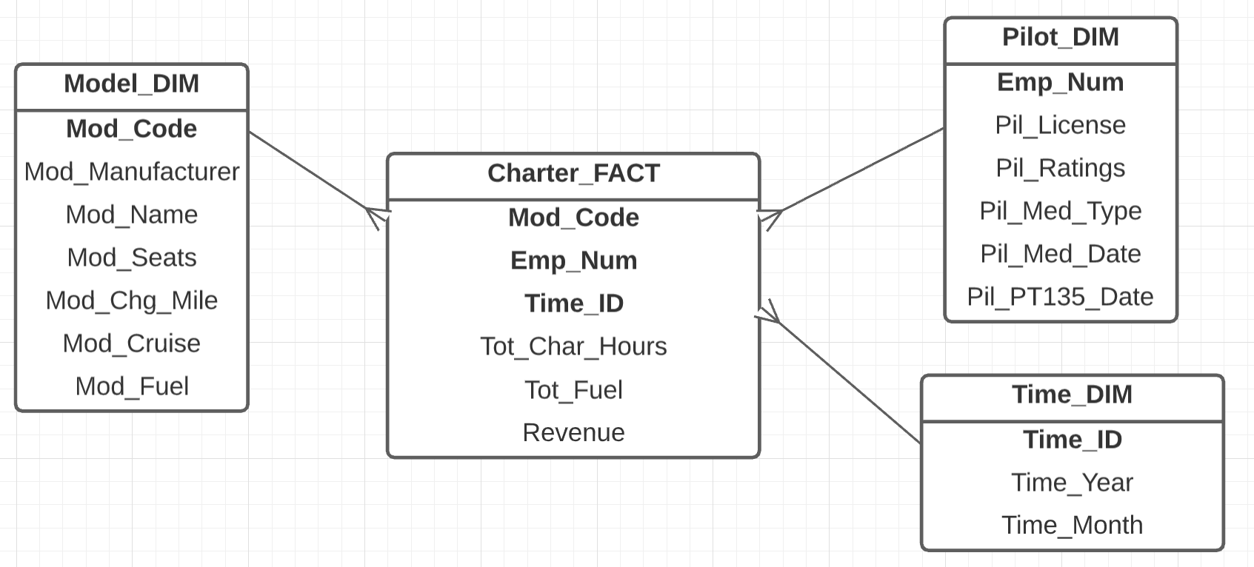

--First create the dimensions
create table time_dim As
select Distinct to_char(char_date, 'YYYYMM') as Time_ID,
to_char(char_date, 'Month') as Time_Month,
to_char(char_date, 'YYYY') as Time_Year
from dw.Charter;

create table model_dim as
select * from dw.model;

create table pilot_dim as
select * from dw.pilot;

--Second, create the Charter_fact (the fact table) table
create table charter_fact as
select C.Char_Pilot as EMP_Num,
M.Mod_Code,
to_char(C.Char_Date, 'YYYYMM') as Time_ID,
sum(C.Char_Hours_Flown) as Tot_Char_Hours,
sum(C.Char_Fuel_Gallons) as Tot_Fuel,
sum(C.Char_Distance * M.Mod_chg_mile) as Revenue
from dw.Charter C, dw.Model M, dw.Aircraft A
where C.AC_Number=A.AC_Number and A.Mod_Code=M.Mod_Code
group by C.Char_Pilot, M.Mod_Code, to_char(C.Char_Date, 'YYYYMM');

- After creating the charter_fact, does the Tot_char_hours accurately reflect the total hours flown by each pilot?

No - it does not, for two distinct reasons:
1. Only the pilot is counted; the co-pilot's hours are ignored. The fact table attributes each flight's hours solely to Char_Pilot. But Char_Copilot also flew those hours. Requirement 2 asks for "total hours flown by each pilot" - a person accrues flight hours whether they sat in the pilot or co-pilot seat. Because Char_Copilot never appears as an EMP_Num, every co-pilot's contribution is missing, so Tot_Char_Hours understates the true hours flown by anyone who ever served as co-pilot.
2. The grain double-splits hours across Mod_Code, so no single row is a pilot's total. Tot_Char_Hours is grouped by (Char_Pilot, Mod_Code, Time_ID). A pilot who flew several aircraft models in a month appears on several rows, with their hours split across models. So an individual row is not "hours flown by that pilot" - it's "hours by that pilot, on that model, in that month". To get a pilot's actual monthly (or overall) total you must re-aggregate away Mod_Code:

THE END

FIT5137 Advanced Database Technology
Lab 4 Bridge Table
TRUCK DELIVERY CASE STUDY

1. A Truck Delivery Case Study - Description

A trucking company is responsible for picking up shipments from warehouses of a retail chain called MYER, and delivering the shipments to individual retail stores of MYER. A truck may carry several shipments during a single trip, which is identified by TripID, and delivers those shipments to multiple stores. Trucks have different capacities for both the volumes they can hold and the weights they can carry. At the moment, a truck makes several trips each week. An operational database is being used to keep track the deliveries, including the scheduling of trucks, which provide timely deliveries to stores. The following is an E/R diagram of the truck delivery system.

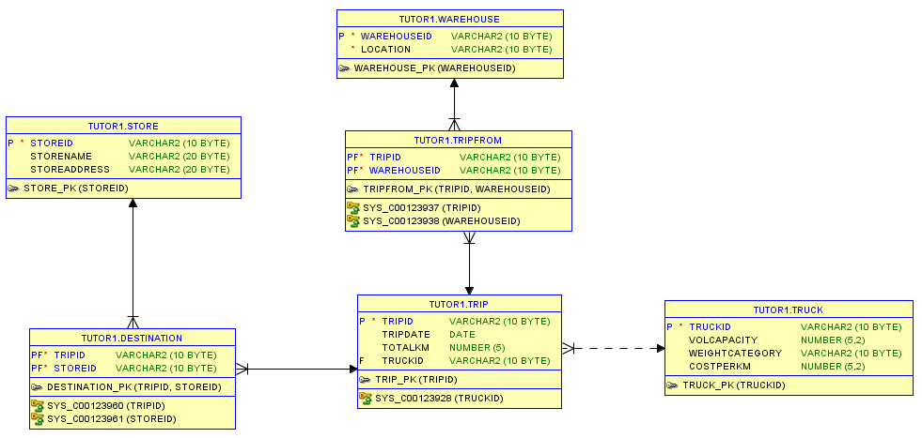

The tables from the operational database are as follows:
Warehouse (WarehouseID, Location)
Trip (TripID, Date, TotalKm, TruckID)
TripFrom (TripID, WarehouseID)
Truck (TruckID, VolCapacity, WeightCategory, CostPerKm)
Store (StoreID, StoreName, Address)
Destination (TripID, StoreID)

First you need to create the operational database using the following SQL:

Create Table Warehouse
(WarehouseID Varchar2(10) Not Null,
Location Varchar2(10) Not Null,
Primary Key (WarehouseID)
);

Create Table Truck
(TruckID Varchar2(10) Not Null,
VolCapacity Number(5,2),
WeightCategory Varchar2(10),
CostPerKm Number(5,2),
Primary Key (TruckID)
);

Create Table Trip
(TripID Varchar2(10) Not Null,
TripDate Date,
TotalKm Number(5),
TruckID Varchar2(10),
Primary Key (TripID),
Foreign Key (TruckID) References Truck(TruckID)
);

Create Table TripFrom
(TripID Varchar2(10) Not Null,
WarehouseID Varchar2(10) Not Null,
Primary Key (TripID, WarehouseID),
Foreign Key (TripID) References Trip(TripID),
Foreign Key (WarehouseID) References Warehouse(WarehouseID)
);

Create Table Store
(StoreID Varchar2(10) Not Null,
StoreName Varchar2(20),
StoreAddress Varchar2(20),
Primary Key (StoreID)
);

Create Table Destination
(TripID Varchar2(10) Not Null,
StoreID Varchar2(10) Not Null,
Primary Key (TripID, StoreID),
Foreign Key (TripID) References Trip(TripID),
Foreign Key (StoreID) References Store(StoreID)
);

--Insert Records to Operational Database
Insert Into Warehouse Values ('W1','Warehouse1');
Insert Into Warehouse Values ('W2','Warehouse2');
Insert Into Warehouse Values ('W3','Warehouse3');
Insert Into Warehouse Values ('W4','Warehouse4');
Insert Into Warehouse Values ('W5','Warehouse5');

Insert Into Truck Values ('Truck1', 250, 'Medium', 1.2);
Insert Into Truck Values ('Truck2', 300, 'Medium', 1.5);
Insert Into Truck Values ('Truck3', 100, 'Small', 0.8);
Insert Into Truck Values ('Truck4', 550, 'Large', 2.3);
Insert Into Truck Values ('Truck5', 650, 'Large', 2.5);

Insert Into Trip Values ('Trip1', to_date('14-Apr-2013', 'DD-MON-YYYY'), 370, 'Truck1');
Insert Into Trip Values ('Trip2', to_date('14-Apr-2013', 'DD-MON-YYYY'), 570, 'Truck2');
Insert Into Trip Values ('Trip3', to_date('14-Apr-2013', 'DD-MON-YYYY'), 250, 'Truck3');
Insert Into Trip Values ('Trip4', to_date('15-Jul-2013', 'DD-MON-YYYY'), 450, 'Truck1');
Insert Into Trip Values ('Trip5', to_date('15-Jul-2013', 'DD-MON-YYYY'), 175, 'Truck2');

Insert Into TripFrom Values ('Trip1', 'W1');
Insert Into TripFrom Values ('Trip1', 'W4');
Insert Into TripFrom Values ('Trip1', 'W5');
Insert Into TripFrom Values ('Trip2', 'W1');
Insert Into TripFrom Values ('Trip2', 'W2');
Insert Into TripFrom Values ('Trip3', 'W1');
Insert Into TripFrom Values ('Trip3', 'W5');
Insert Into TripFrom Values ('Trip4', 'W1');
Insert Into TripFrom Values ('Trip5', 'W4');
Insert Into TripFrom Values ('Trip5', 'W5');

Insert Into Store Values ('M1', 'Myer City', 'Melbourne');
Insert Into Store Values ('M2', 'Myer Chaddy', 'Chadstone');
Insert Into Store Values ('M3', 'Myer HiPoint', 'High Point');
Insert Into Store Values ('M4', 'Myer West', 'Doncaster');
Insert Into Store Values ('M5', 'Myer North', 'Northland');
Insert Into Store Values ('M6', 'Myer South', 'Southland');
Insert Into Store Values ('M7', 'Myer East', 'Eastland');
Insert Into Store Values ('M8', 'Myer Knox', 'Knox');

Insert Into Destination Values ('Trip1', 'M1');
Insert Into Destination Values ('Trip1', 'M2');
Insert Into Destination Values ('Trip1', 'M4');
Insert Into Destination Values ('Trip1', 'M3');
Insert Into Destination Values ('Trip1', 'M8');
Insert Into Destination Values ('Trip2', 'M4');
Insert Into Destination Values ('Trip2', 'M1');
Insert Into Destination Values ('Trip2', 'M2');

2. Solution Model 1 - using a Bridge Table

The measurable fact to be included in the fact table is “Total Delivery Cost”, which is calculated by distance (total kilometres in the Trip table) and cost per kilometre (from the Truck table). The dimensions are Truck, Trip Period and Store.

The snowflake schema for this case study is as follows:

Snowflake Schema-1 (with a Bridge Table)
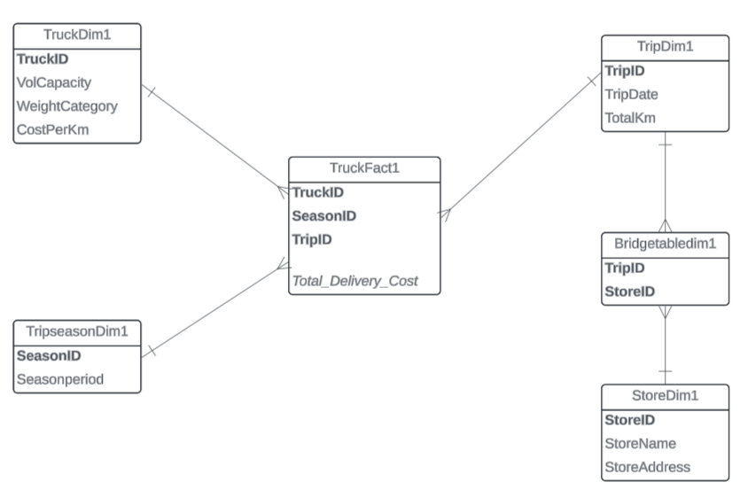

Your tasks:

- Create a dimension table called TruckDim1.

CREATE TABLE TruckDim1 AS
SELECT TruckID, VolCapacity, WeightCategory, CostPerKm
FROM Truck;

- Create a dimension table called TripSeason1. This table will have 4 records (Summer, Autumn, Winter, and Spring).

CREATE TABLE TripSeason1 (SeasonID VARCHAR2(10), SeasonName VARCHAR2(10));
INSERT INTO TripSeason1 VALUES ('S1','Summer'); -- Dec, Jan, Feb
INSERT INTO TripSeason1 VALUES ('S2','Autumn'); -- Mar, Apr, May
INSERT INTO TripSeason1 VALUES ('S3','Winter'); -- Jun, Jul, Aug
INSERT INTO TripSeason1 VALUES ('S4','Spring'); -- Sep, Oct, Nov

- Create a dimension table called TripDim1.

- Ở đây không cần tạo SeasonID vì không có sẵn trong Operational Database nên nó cần tạo một dimension mới để chứa nó => Và vì dimension này không có sẵn trong ob nên ta phải tạo Temp Fact Table để chứa attribute mới thiết lập trong Warehouse sau đó manipulate thành dạng mong muốn => Chứa bản final trong Official TempFact table
=> User-defined dimension
- Do chỉ chọn một số attribute từ bản gốc => Có khả năng duplicates nhưng lại là dimension key trong dimension table
- TempFact: Select all needed attributes from ob + ADD USER-DEFINED ATTRIBUTE ( then manipulate and add data). This will be the input for the Official Fact table to extract directly

CREATE TABLE TripDim1 AS
SELECT TripID,
TripDate,
TotalKm,
CASE
WHEN TO_CHAR(TripDate,'MM') IN ('12','01','02') THEN 'S1'
WHEN TO_CHAR(TripDate,'MM') IN ('03','04','05') THEN 'S2'
WHEN TO_CHAR(TripDate,'MM') IN ('06','07','08') THEN 'S3'
ELSE 'S4'
END AS SeasonID
FROM Trip;

- Create a bridge table called BridgeTableDim1.
- Create a dimension table called StoreDim1.
- Create a tempfact (and perform the necessary alter and update), and then create the final fact table (called it TruckFact1).
- Display (and observe) the contents of the fact table (TruckFact1).

3. Solution Model 2 - add a Weight attribute in the Bridge

The second data warehouse is shown by the following snowflake schema-2. Notice that a weight factor attribute is added to the Trip dimension.

Snowflake Schema-2 (with Weight Factor attribute)
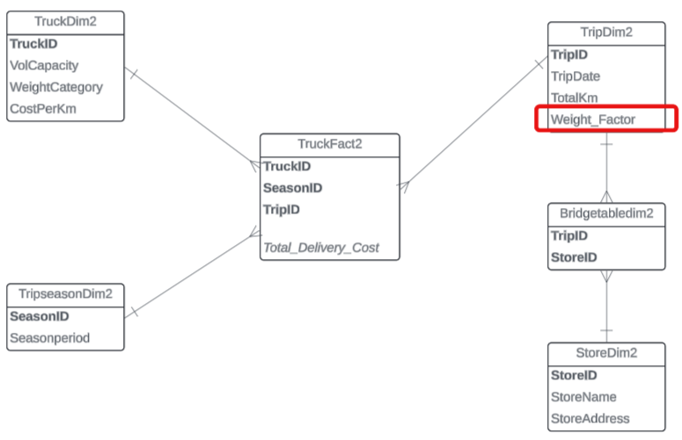

Your tasks:

- Create a dimension table called TruckDim2.
- Create a dimension table called TripSeason2. This table will have 4 records (Summer, Autumn, Winter, and Spring).
- Create a dimension table called StoreDim2.
- Create a bridge table called BridgeTableDim2.

Notes: tasks (a)-(d) to create dimension tables version 2, are identical to the previous tasks (a)-(d) to create dimension tables version 1 in the previous section. However, for the sake of completeness of Schema v2, you need to create the dimension tables v2. You can either copy directly from dimension tables v1, or create the dimension tables v2 the same way you did for v1.

- Create a dimension table called TripDim2 (Notes: this dimension is different from TripDim1 in the previous section).

Hints:
  - Before creating table TripDim2, you need to do a bit of experiments. We don’t want to create a table immediately. Instead we are going to try a few Select statements. Once the correct Select statement is identified, then we can use Create Table as Select to create table TripDim2.
  - Do a select statement to display the contents of the Trip Table. Then do a select statement to display the contents of the Destination Table. Inspect visually, how many stores that each trip has.
  - Now, do another select statement to display the TripID, Date, TotalKm, together with Number of Stores (you need to use an aggregate function to count the number of stores per trip). Can you find a trip that does not have any store in the operational database? Is this trip included in the query result? If not, why not?
  - Revise the above select statement, so that the number of stores is not displayed as an integer number, but as a percentage. For example, if the number of stores is 5, then it should show 0.2 (20%), instead of 5.
  - Now, you are ready to create table TripDim2. Don’t forget that the column that stores the weight must be named

- Create a tempfact (and perform the necessary alter and update), and then create the final fact table (called it TruckFact2).
- Display (and observe) the contents of the fact table (TruckFact2).
- What is the total delivery cost for each store?

4. Solution Model 3 - A ListAGG version

The third version of the data warehouse is having a ListAgg attribute, which holds the information of the group of each record in the parent dimension table. In this case, the Trip dimension is added with an attribute called StoreGroupList which lists a group of stores for each trip.

Snowflake Schema-3 (with ListAGG)
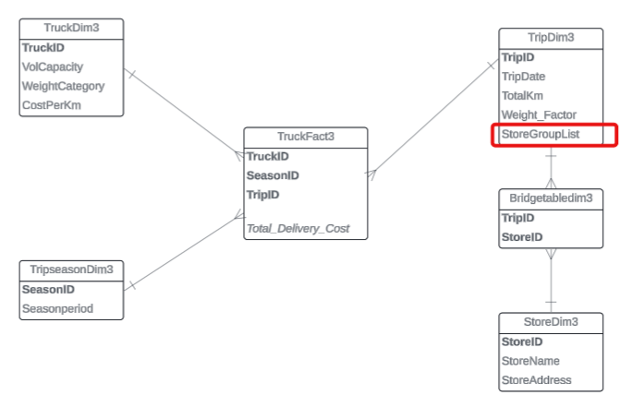

Your tasks:

- Create a dimension table called TruckDim3.
- Create a dimension table called TripSeason3. This table will have 4 records (Summer, Autumn, Winter, and Spring).
- Create a dimension table called StoreDim3.
- Create a bridge table called BridgeTableDim3.

Notes: tasks (a)-(d) to create dimension tables version 3, are identical to those for v1 and v2 in the previous section. However, for the sake of completeness of Schema v3, it would be better if you could create the dimension tables for v3 separately.

- Create a dimension table called TripDim3 (Note that TripDim3 is different from TripDim1 and TripDim2).

Hints:
- Like with TripDim2, before creating table TripDim3, we would like to experiment with a few Select statements to find out what is the best way to create table TripDim3.
- Do a select statement to display TripID, TripDate, TotalKm, and WeightFactor.
- Now do a select statement to display TripID, TripDate, TotalKm, WeightFactor, and StoreGroupList. The StoreGroupList column is implemented by the ListAGG function.

The ListAGG function has the following format:
LISTAGG (attr1, '_') Within Group (Order By attr1) As columnname

Attr1 is the store id, and the '_' is to indicate that the store ids are concatenated with the '_' symbol (e.g. M1_M2_M3_M4_M8). If we want to have the stores listed in a descending order (e.g. M8_M4_M3_M2_M1), then we use Within Group (Order By attr1 Desc).

- You can now create table TripDim3 by using the above select statement.

- Create a tempfact (and perform the necessary alter and update), and then create the final fact table (called it TruckFact3).

- Display (and observe) the contents of the fact table (TruckFact3).

FIT5137 Advanced Database Technology
Lab 5 Multi Fact Table [SOLUTION]
Case Study # (BOOK SALES)

- A Book Sales Case Study - Description

The following is an E/R diagram of an operational database. The system stores information about books, including the authors, publishers, book categories, as well as the reviews that each book has received. The ‘stars’ attribute in the Review entity records the star rating for each review (e.g. 5 stars for excellent to 1 star for poor, etc). One book may receive many reviews. For simplicity, it is assumed, as also shown in the E/R diagram, that a book will only have one category.

The E/R diagram also includes entities related to sales of books, and the stores which sale the books. Each store has many sales transactions (i.e. the Sales entity), and each sales transaction may include several books (i.e. the SalesDetails entity). The TotalPrice attribute in the SalesDetails entity is basically quantity multiplied by unitprice, whereas the TotalPrice attribute in the Sales entity is the total price for each sales transaction.

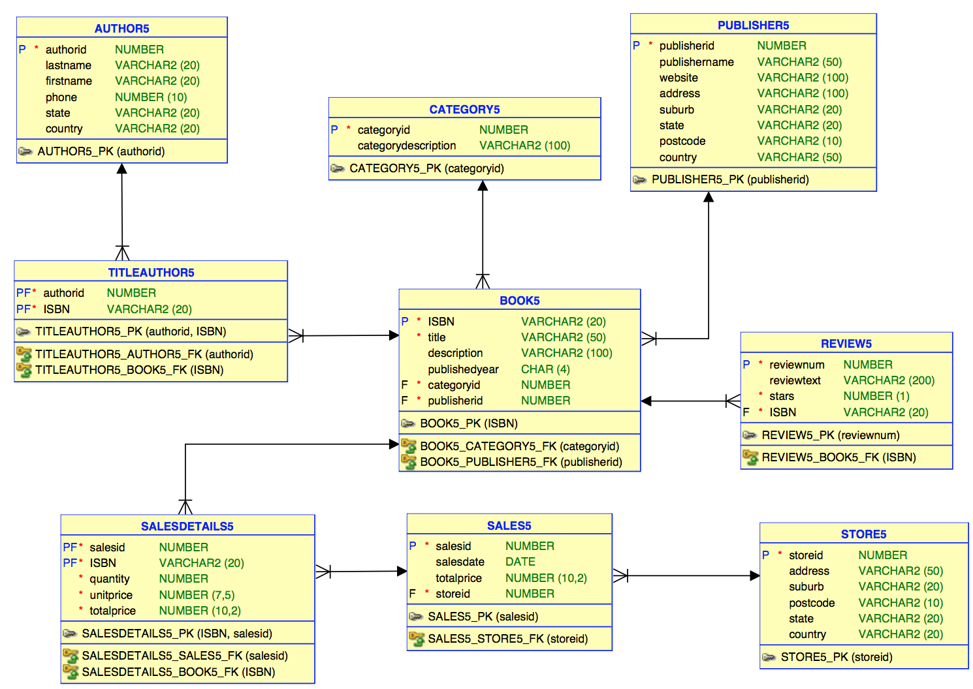

The tables form the operational database are as follows and they are in DTANIAR account:

DTANIAR.AUTHOR5 (authorid, lastname, firstname, phone, state, country)
DTANIAR.BOOK5(ISBN, title, description, publishedyear, categoryid, publisherid)
DTANIAR.TITLEAUTHOR5(authorid, ISBN)
DTANIAR.CATEGORY5(categoryid, categorydescription)
DTANIAR.PUBLISHER5(publisherid, publishername, website, address, suburb, state, postcode, country)
DTANIAR.REVIEW5(reviewnum, reviewtext, stars, ISBN)
DTANIAR.STORE5(storeid, address, suburb, postcode, state, country)
DTANIAR.SALES5(salesid, salesdate, totalprice, storied)
DTANIAR.SALESDETAILS5(salesid, ISBN, quantity, unitprice, totalprice)

You are required to design a small data warehouse for analysis purposes. The analysis is needed for identifying at least the following questions:

- What are the total sales for each bookstore in a month?
- What is the number of books sold for each category?
- What is the book category that has the highest total sales?
- What is the number of reviews for each category?
- How many 5-star reviews for each category?

2. Solution Model - using multi-fact

Based on the above requirements, it is clear that there are three fact measures:
- Total sales,
- Number of books sold, and
- Number of reviews

Total sales and number of books sold would be useful for the management to understand how the book sales perform. Number of reviews would be useful for the marketing department to understand people’s perception on certain books and would be able to use this information to launch any marketing campaign.

Potentially, there can be many dimensions. However, based on the above requirements, we limit the dimensions to the following four dimensions:
- Store dimension,
- Time dimension,
- Book category dimension, and
- Star rating dimension.

In summary, the first subject: “book sales” will be the first fact, with all the four dimensions (e.g. Store, Time, Category, and Star Rating dimensions). The fact measures are total sales, and number of books sold.

The second subject is “reviews”, with only two dimensions: Category, and Star Rating dimensions. There is only one fact measure, which is number of reviews.

The star schema will then have two fact entities: Book sales fact, and Review fact. Note that the category and star rating dimensions are shared by the two facts.

The multi-fact star schema for this case study is as follows:

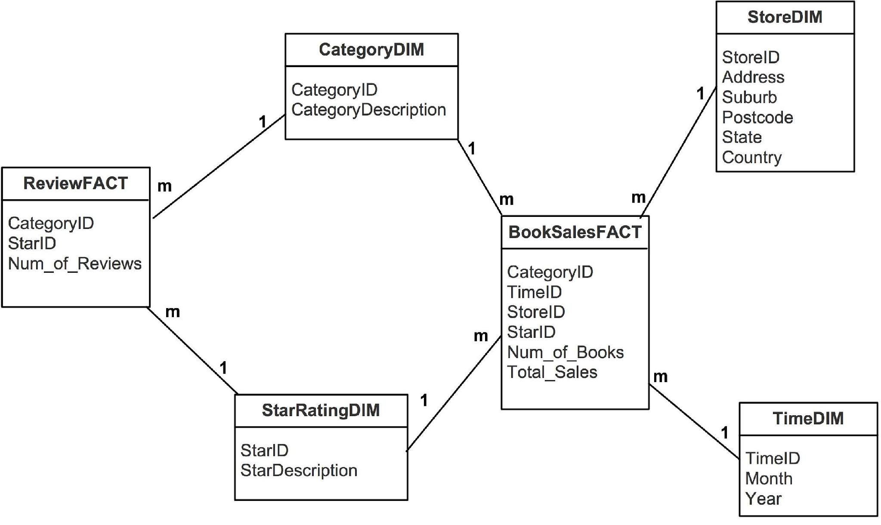

Your tasks:
- Create a dimension table called TimeDim.

create table timedim
as select distinct
to_char(salesdate, 'yyyymm') as timeid,
to_char(salesdate,'mm') as month,
to_char(salesdate,'yyyy') as year
from dtaniar.sales5;

- Create a dimension table called StoreDim.

create table storedim
as select * from dtaniar.store5;

- Create a dimension table called CategoryDim.

create table categorydim
as select *
from dtaniar.category5;

- Create a dimension table called StarRatingDim. This table will have 6 records (0 for 'Unknown', 1 for 'Poor', 2 for 'Not Good', 3 for 'Average', 4 for 'Good', 5 for 'Excellent')

Create Table StarRatingDim
( StarID Number(1),
StarDescription Varchar2(15));

Insert Into StarRatingDim Values (0, 'Unknown');
Insert Into StarRatingDim Values (1, 'Poor');
Insert Into StarRatingDim Values (2, 'Not Good');
Insert Into StarRatingDim Values (3, 'Average');
Insert Into StarRatingDim Values (4, 'Good');
Insert Into StarRatingDim Values (5, 'Excellent');

- Create a fact table called ReviewFact.

create table reviewfact as
select
b.CATEGORYID,
r.STARS as starid,
count(*) as num_of_review
from dtaniar.book5 b, dtaniar.review5 r
where b.isbn=r.isbn
group by b.CATEGORYID, r.STARS;

- Create a tempfact table called TempBookWithStar. (NOTE: Books without review should be included in the result, and it should get a ZERO in the Star).

Create table TempBookWithStar as
Select
B.ISBN,
B.CategoryID,
NVL(R.Stars, 0) As Star
From dtaniar.book5 B, dtaniar.review5 R
Where B.ISBN = R.ISBN(+);

--select *
--from TempBookWithStar
--where ISBN='0316465186';
Book 0316465186 is the one that does not have any reviews, and the star is 0

- Create a tempfact table called TempBookWithAvgStar. (NOTE: Calculate the average of stars by each book and each category using TempBookWithStar. The average of stars should be an integer either 0 or 1,2,3,4,5).

Create table TempBookWithAvgStar
As Select
ISBN,
CategoryID,
Round(Avg(Star)) As Avg_Star
From TempBookWithStar
Group By ISBN, CategoryID;

- Create the final fact table called BookSalesFact. (NOTE: starid in the fact table is the average of stars).

Create Table BookSalesFact as
Select
T.CategoryID,
To_Char(S.SalesDate, 'YYYYMM') As TimeID,
S.StoreID,
T.Avg_star as StarID,
sum(sd.quantity) as Num_of_Books,
Sum(SD.TotalPrice) As Total_Sales
From
TempBookWithAvgStar T,
dtaniar.Sales5 S,
dtaniar.SalesDetails5 SD
Where T.ISBN=sd.ISBN and sd.SALESID= s.SALESID
Group by
T.CategoryID,
To_Char(S.SalesDate, 'YYYYMM'),
S.StoreID,
T.Avg_star;

Hints:
- Please make sure there are 6 required records in StarRatingDim. Think about that can you create it by coping REVIEW table or create it manually.

- Be careful to create the table TempBookWithStar. The tempfact table should include the books without reviews. Thus, we have to use OUTER JOIN to create the tempfact table.

SELECT *
FROM dtaniar.book5 b, dtaniar.review5 r
WHERE b.ISBN=r.ISBN(+);

OR

SELECT *
FROM dtaniar.book5 b
LEFT OUTER JOIN dtaniar.review5 r
ON b.ISBN=r.ISBN;

- When creating the table TempBookWithStar, the star of the books without review should be ZERO. Thus, we need to use function NVL.

This is the syntax to set the null value to 0:
NVL (attribute_name, 0)

- After creating the TempBookWithStar, display the table and observe the contents of the table. Try to find the books without reviews.

- When creating the TempBookWithAvgStar, the average of stars for each book and category should be either 0, or 1,2,3,4,5. Thus, we need to use ROUND to make sure the average value is an integer.

This is the syntax to set a number into an integer:
ROUND(attribute_name)

- After creating the TempBookWithAvgStar, display the table and observe the contents of the table. So far, we have the average of stars by each book.

- Now, you are ready to create table BookSalesFact using the average of stars created by the table TempBookWithAvgStar, and other attributes in the operation database.

Now, answer the questions using the dimension tables and fact tables you have created.

- What are the total sales for each bookstore in a month?

select
s.STOREID, s.Address,
t.MONTH,
sum(f.total_sales) as total_sales
from storedim s, timedim t, booksalesfact f
where s.STOREID=f.STOREID and f.timeid = t.timeid
group by s.STOREID,s.Address, t.MONTH
order by s.STOREID,s.Address, t.MONTH;

Note: s.Address is used to provide additional information about the store, as storeID alone is insufficient for the reader to gather store information.

- What is the number of books sold for each category?

select
c.CATEGORYID,
c.CATEGORYDESCRIPTION,
sum(f.num_of_books) as total_num_books
from booksalesfact f, categorydim c
where f.categoryid = c.categoryid
group by c.CATEGORYID, c.CATEGORYDESCRIPTION
order by c.CATEGORYID, c.CATEGORYDESCRIPTION;

- What is the book category that has the highest total sales?

select * from (
select
c.CATEGORYID,
c.CATEGORYDESCRIPTION,
sum(f.Total_Sales) as total_Sales
from booksalesfact f, categorydim c
where f.categoryid = c.categoryid
group by c.CATEGORYID, c.CATEGORYDESCRIPTION
order by total_Sales desc)
where rownum =1;

- What is the number of reviews for each category?

select
c.CATEGORYID,
c.CATEGORYDESCRIPTION,
sum(f.num_of_review) as number_of_reviews
from reviewfact f, categorydim c
where f.categoryid = c.categoryid
group by c.CATEGORYID, c.CATEGORYDESCRIPTION
order by c.CATEGORYID, c.CATEGORYDESCRIPTION;

- How many 5-star reviews for each category?

Select
c.CATEGORYID,
c.CATEGORYDESCRIPTION,
sum(f.NUM_OF_REVIEW) as number_of_5star_reviews
from
reviewfact f,
categorydim c,
starratingdim s
where f.categoryid = c.categoryid
and s.starid = f.starid
and s.STARID=5
group by c.CATEGORYID, c.CATEGORYDESCRIPTION
order by c.CATEGORYID, c.CATEGORYDESCRIPTION;

FIT5137 Advanced Database Technology
Lab 6 Granularity
Solution

Case Study 1 - Clothing Company
Let’s consider a Clothing case study. The operational database consists of the following tables:
CUSTOMER1
CUSTID | LNAME | FNAME | ADDRESS | PHONE | CITY
107 | Smith | John | 731 Plenty Road | 9231455 | Clayton
232 | Wong | Franklin | 638 Voss Street | 9756945 | Preston
133 | Zelaya | Alicia | 3321 Castle Ave | 9867055 | Balwyn
154 | Wallace | Jennifer | 291 Berry Street | 9234536 | Preston
179 | Narayan | Ramesh | 975 Fire Road | 9456738 | Carlton
181 | Jane | Adam | 229 Clayton Road | 9543877 | Clayton
183 | Judy | Backhouse | 122 Rose Street | 9235345 | Caulfield

ORDER1
ORDERID | ORDERDATE | PAYMETHOD | ORDERSOURCE | CUSTID
1057 | 20/02/06 | CARD | WEB SITE | 107
1058 | 03/03/06 | CARD | PHONE | 232
1059 | 12/03/06 | CHEQUE | WEB SITE | 133
1060 | 20/03/06 | CHEQUE | WEB SITE | 133
1061 | 10/04/06 | CARD | FAX | 179
1062 | 01/04/06 | CARD | FAX | 179
1063 | 07/09/06 | CARD | WEB SITE | 154
1064 | 14/07/06 | CARD | WEB SITE | 154
1065 | 30/11/06 | CARD | PHONE | 179
1066 | 20/01/06 | CHEQUE | WEB SITE | 179

ORDER_INV1
ORDERID | INVID | ORDERPRICE | QUANTITY
1057 | 11668 | 259.99 | 10
1058 | 11668 | 239.99 | 20
1059 | 11780 | 21.99 | 5
1060 | 11776 | 20.99 | 50
1061 | 11779 | 29.95 | 25
1061 | 11780 | 29.95 | 50
1062 | 11669 | 229.99 | 40
1063 | 11778 | 25.95 | 50
1064 | 11779 | 29.95 | 12
1065 | 11780 | 26.95 | 32
1066 | 11775 | 29.95 | 30

INVENTORY1
INVID | QOH | ITEMID | ITEMSIZE | COLOUR
11668 | 16 | 786 | M | Sienna
11669 | 12 | 786 | L | Forest
11775 | 150 | 894 | S | Khaki
11776 | 147 | 894 | M | Khaki
11777 | 0 | 894 | L | Khaki
11778 | 139 | 894 | S | Olive
11779 | 137 | 894 | M | Olive
11780 | 115 | 894 | L | Olive
QOH = Quantity on Hand

ITEM1
ITEMID | CURRENT PRICE | ITEMDESC | CATEGORY
894 | 29.95 | Women’s Hiking Shorts | Women’s Clothing
897 | 200.95 | Women’s Fleece Pullovers | Women’s Clothing
995 | 50.00 | Children’s Beachcomber Sandals | Children’s Clothing
559 | 35.00 | Men’s Expedition Parka | Men’s Clothing
786 | 259.99 | 3-Season Jacket | Men’s Clothing

A star schema has been created:
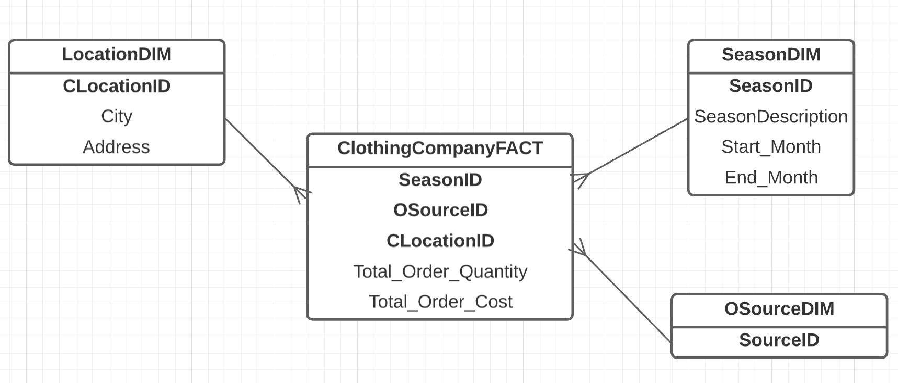
The fact measures included in the above star schema are TotalOrderQuantity, which is taken from the Quantity attribute from table Inventory, and TotalOrderCost, which is the sum of order price x quantity.

The above star schema contains highly aggregated data, and let’s assume that this star schema is at level-2 in the data warehouse architecture.

Questions: Draw level-1 and level-0 star schemas for the above clothing data warehouse case study.
Sample answer:

There are two aggregated dimensions: SeasonDIM and LocationDIM.

In Level-1, one of these dimensions is replaced by a lower level of aggregation. For example, SeasonDIM is changed to OrderDateDIM, or LocationDIM is changed to CustomerDIM.
In Level-1, only one of these dimensions needs to be lowered down.
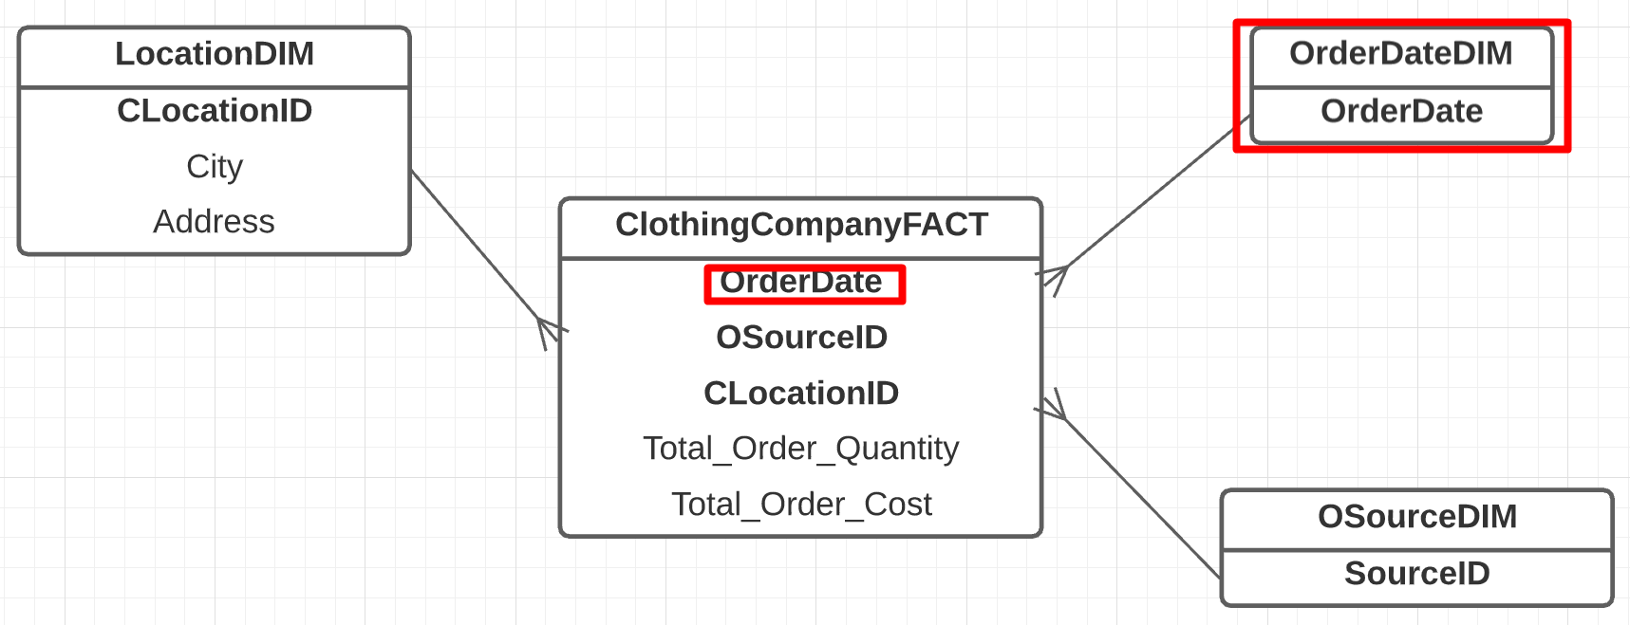

Note: For level 1, you may have many different methods. There is no specific rule for determining the level of aggregation at level 1. Therefore, as long as your level of aggregation is lower than level 2 and higher than level 0, it is acceptable.
****
In Level-0, both dimensions need to be lowered down.
Level-0
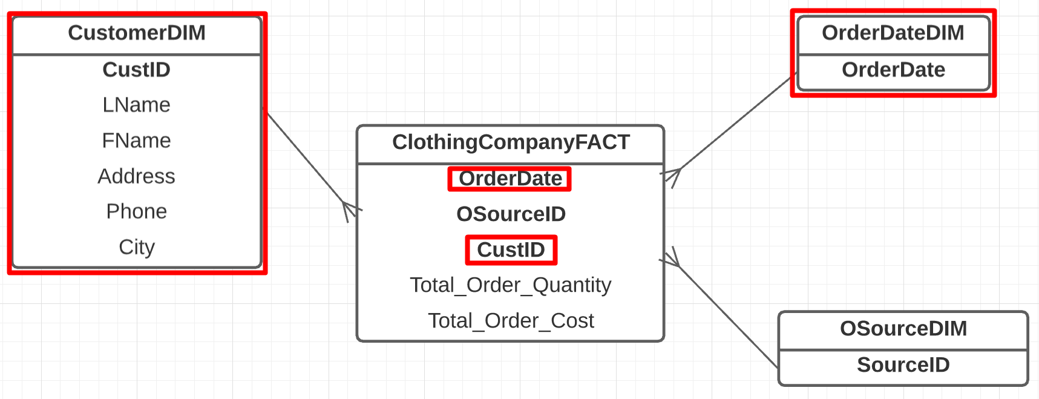

In Oracle, the DATE data type typically displays only the date portion, omitting the hours, minutes and seconds. Assuming that a customer can place multiple orders on the same date, the dateDIM table actually contains records with the full date and time details - hours, minutes and seconds - to accurately distinguish between different orders placed on the same day.
Question：How do I decide if my level 0 design is correct or not?
You can check it by the aggregation level of the fact measure.
Level 0 means the highest level of granularity where there is no aggregation.
Case Study 2 - Toll Way

There is a toll way in a metropolitan city (such as CityLink or EastLink in Melbourne, or any similar toll roads in other major cities in the world). This toll way has a number of gates, where the motorist needs to pay. Every time a motorist passes through this toll gate, the registration number of the vehicle, vehicle type (e.g. car, bus, truck, etc), amount paid, and time, are recorded in the operational database.

A data warehouse needs to be built, for analysing the revenue from the toll payments. The management would like to drill down this revenue based on the tollgate (there is a number of toll gates along the toll way), day of week (e.g. weekdays, weekends), and time period of a day (e.g. peak hours, non-peak hours, late nights).

You are required to draw three levels of star schemas showing three different levels of aggregation for the above data warehouse. Level-0 star schema contains the most detailed data, whereas level-2 star schema is the highly aggregated (e.g. containing highly aggregated data).

Questions:
- Draw a level-2 star schema.
- Draw a level-1 star schema. You may want to add a new dimension, called vehicle (e.g. cars, trucks, busses, etc).
- Draw a level-0 star schema.

Sample answer:

Level 2 - Highly aggregated. This is the most highly aggregated data where we keep “Total Payment” in the Fact table, and the Dimensions are based on Days of Week (not the actual date), and Time Period (not the actual travel time).

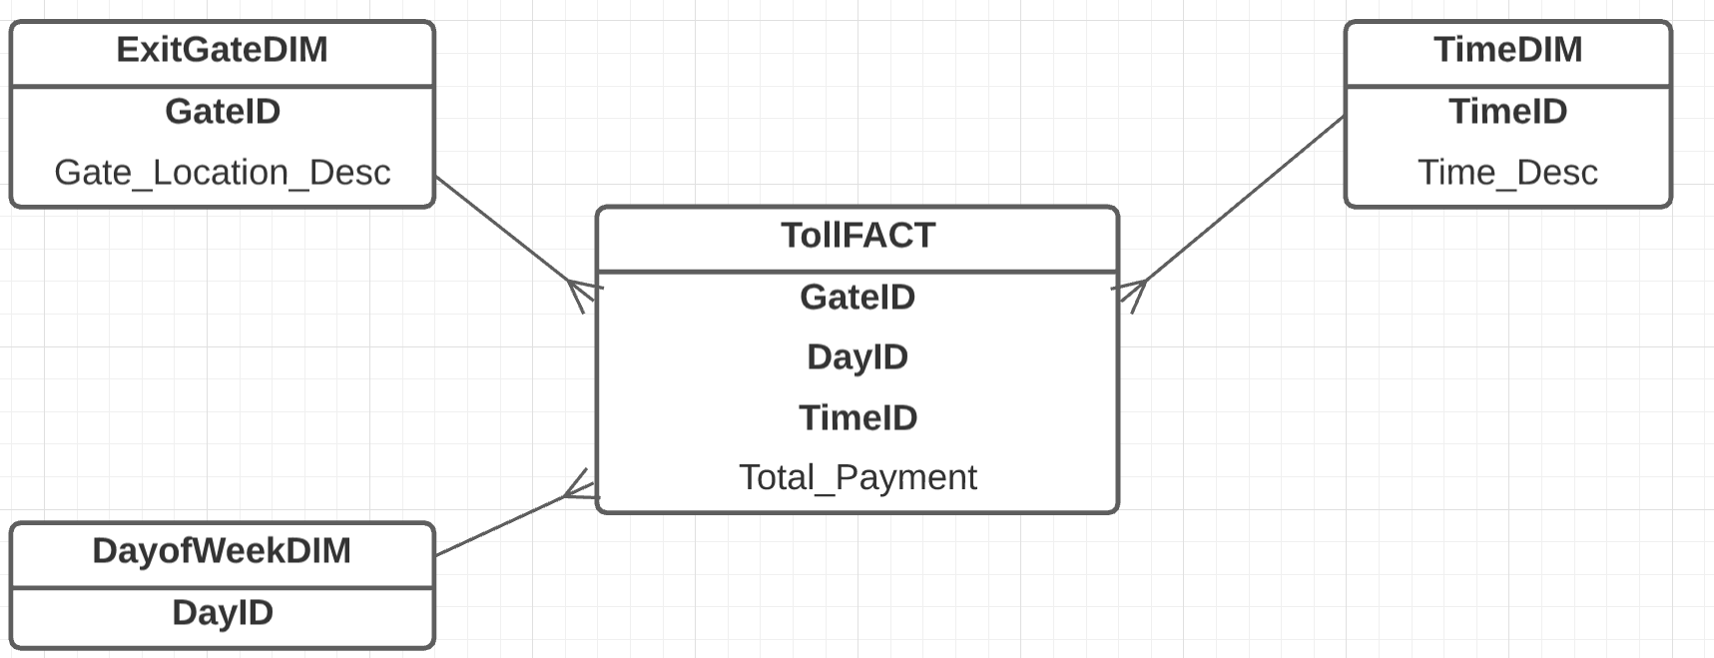

Level 1- We add with an additional dimension, for example the Vehicle Type Dimension. In the Vehicle Type Dimension, we store the vehicle types, such as bus, truck, cars, etc. Note that we do not keep the “Registration Number” of the car. The granularity is at the vehicle type level, not at an individual car level.

So, from level 2 to level 1, the total payment in level 2 is broken down by Vehicle Type. Other dimensions remain unchanged.

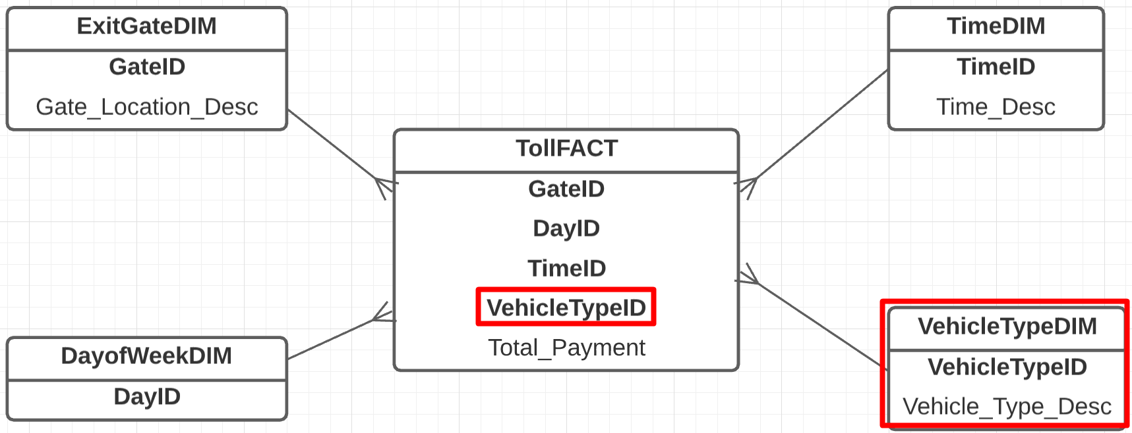
Level 0- Detail Level
This is the most detail level as we have Date_DIM and Time_DIM to indicate the actual travel dates and travel time; as well as Car DIM to indicate the actual car (rather than just the type of vehicle)

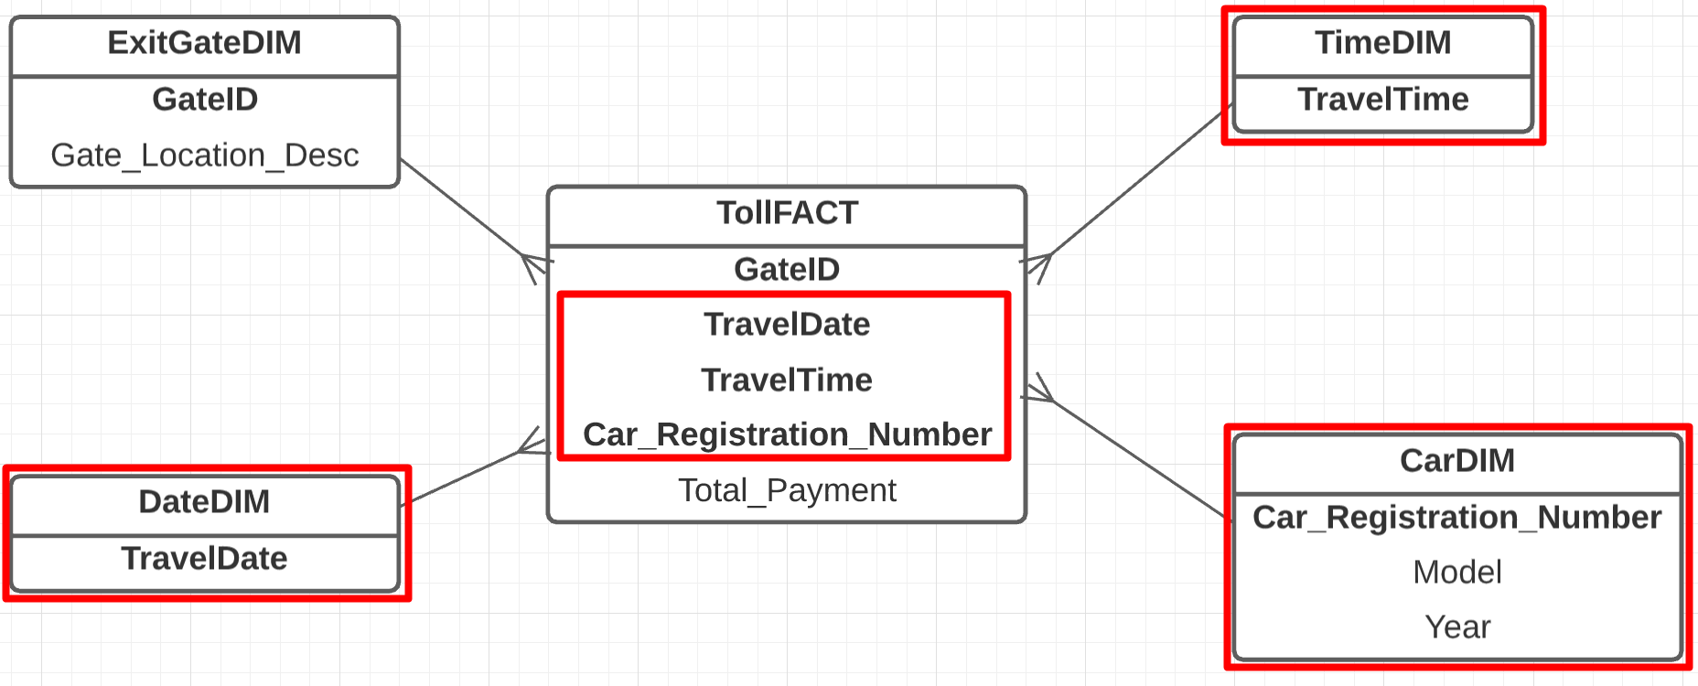

THE END

