FIT5147 Data Exploration Project — Part 2
Spatial–Temporal Alignment of Speed-Camera Enforcement with Pedestrian and Cyclist Activity in the City of Melbourne
Gia Linh (Sally) Vu · Student ID 36071668
Teaching Associates: Michael Niemann & Bruno Luis Mendivez Vasquez · Applied 08
Exploration tool: R / Python (sf · data.table · ggplot2 · classInt · spdep · sfnetworks)
Table of Contents
1 Introduction 2
2 Data Wrangling and Checking 2
2.1 Data sources and provenance 2
2.2 Wrangling — steps that carried the complexity 3
2.3 Data checking, error log, projection 3
3 Data Exploration 5
3.1 RQ1 — Spatial 5
3.2 RQ2 — Temporal 6
3.3 RQ3 — Network 8
3.4 Synthesis 9
4 Conclusion 10
5 Reflection 10
6 Limitations 10
Bibliography 11
Declaration of AI Assistance 11
Appendix (unmarked) 12

1 Introduction
Speed and red-light cameras are among the most direct instruments a city has for managing road-user risk, yet they are sparse, fixed and location-based, whereas the people most exposed to that risk — pedestrians and cyclists, the vulnerable road users (VRUs) — move through the city in patterns that are dense, continuous and time-varying. The cycling network meant to protect one of those groups is a third geometry again: linear and, in places, discontinuous. This project asks whether these three geometries agree — whether enforcement is placed where VRU activity is greatest, and whether the protective infrastructure holds together as a system. The motivation is a Vision-Zero one: exposure without either enforcement or protection is precisely the combination a safe-system approach tries to eliminate, a tension I experience directly as a daily inner-Melbourne pedestrian and cyclist. The analysis is strictly exploratory and associational: it describes where patterns coincide or diverge and never claims a camera causes a change in behaviour.
The study area is the City of Melbourne (CoM) local-government area (37.7 km²), defined authoritatively by its municipal-boundary polygon rather than by suburb labels. Five open spatial layers are integrated: ~8.2 million five-minute pedestrian/cyclist counts (Transport Activity Counts 2026), fixed and mobile road-safety camera locations, the municipal cycling network including informal routes, and the CoM boundary. Three research questions guide the exploration (stated verbatim from the Part-1 proposal):
RQ1 (Spatial). Across the CoM, how does the spatial distribution of speed-camera enforcement relate to patterns of pedestrian and cyclist activity?
RQ2 (Temporal). Across the CoM, is there a relationship between when pedestrians and cyclists are active and when traffic enforcement occurs?
RQ3 (Network). Across the CoM, how do different segments of the cycling network contribute to its continuity and connectivity?
A data limitation reframes RQ2 up front (and turns it into an analytical decision). Fixed cameras operate 24/7 and automated — their only date field is an annual calibration test — and mobile cameras carry only an audit month, so enforcement timing is unobservable. RQ2 is therefore answered on the activity side, with enforcement entering only through the question: do camera locations coincide with the places that are hottest during the highest-risk activity windows? A fourth, synthesising question runs underneath all three — where do high exposure, low enforcement and weak or discontinuous protection coincide? — and the report builds toward it in its final figure.

2 Data Wrangling and Checking

2.1 Data sources and provenance
Five spatial layers from three open providers were integrated (Table 1); all are CC-BY 4.0 and re-downloadable, so the pipeline is reproducible. Dataset D (the municipal boundary) is not an analysis layer but the authoritative clip mask: every “in the CoM” figure below is defined by spatial intersection with this polygon, because suburb strings mis-scope split suburbs (e.g. South Yarra, Port Melbourne). Adding D lifts the integration to five layers spanning points, lines, a polygon and an 8.2-million-row time series.
# | Layer / grain | Source (provider) & URL | Attributes used | Serves
A | Transport Activity Counts 2026 · 5-min × countline; 8.2M rows | City of Melbourne Open Data — data.melbourne.vic.gov.au (TransportActivityCount_2026.zip) | countLocationId, lat/lon, from/to, class, count | RQ1–2
B1 | Fixed cameras · 333×23 (statewide) | DJCS “Find a road safety camera” — vic.gov.au (Elasticsearch feed) | camera_id, site_type, lat/lon, test/expiry dates | RQ1
B2 | Mobile cameras · 2,252×4 (statewide) | DJCS / DataVic — discover.data.vic.gov.au | location, suburb, reason code, audit month | RQ1
C | Bicycle routes · 274 MultiLineStrings; 198.4 km | City of Melbourne Open Data | Geo Shape, type, name, status, direction | RQ3
D | Municipal boundary · 1 polygon | City of Melbourne Open Data | LGA geometry (clip mask) | frame
Table 1. Data provenance (full URLs in the Bibliography). Tools: R/Python throughout — data.table/pandas for the 8.2M-row I/O, sf/geopandas for spatial work, tidygeocoder/ArcGIS for geocoding, httr2 for the reproducible scrape, lubridate for time.

2.2 Wrangling — the steps that carried the complexity
Fixed cameras (B1) — a reproducible scrape. The “Find a road safety camera” tool renders client-side, so its records never appear in the page HTML. Inspecting the network traffic revealed the underlying Elasticsearch endpoint (POST …/api/tide/elasticsearch/…/_search); a single request with {“size”:1000,“query”:{“match_all”:{}}} returns all 333 records as a tidy CSV, and re-running it reproduced the supplied snapshot exactly (333 rows; identical site-type split Intersection 278 / Freeway 25 / Point-to-point 20 / Highway 10). Three columns (lga, commissioned_date, network) are 100% null and were dropped; four (camera_type, reason, link, status) are constant and were kept but flagged non-discriminating. Points were built in WGS84, projected to EPSG:7855 and clipped to the CoM polygon, dropping the statewide register from 333 to 29 in-CoM cameras (26 intersection, 3 highway).
Mobile cameras (B2) — the headline wrangling task. The real header sits under a title row (read with skip = 1). There are no coordinates, so the 28 sites in CoM suburbs were geocoded from location + suburb via the ArcGIS World Geocoder (100% candidate match) and then accuracy-checked against the boundary: 10 fell outside the CoM and were dropped, leaving 18 — including one clear geocoding error (“Chapel Street, South Yarra” resolved ~15 km north to lat −37.69) that the boundary check caught automatically. 588 of the 2,252 audit dates are the corrupt token “T” (6 within the CoM subset); these were set to NA and reported rather than parsed. The multi-label reason code (A/B/C/D combinations) was one-hot encoded rather than guessing the unpublished legend.
Transport Activity Counts (A) — the big-data step and a timezone discovery. The two quarterly CSVs (1.27 GB, 8,205,370 rows, 1 Jan–12 May 2026) were streamed in chunks and reduced to per-site hour×day-of-week profiles, a daily series and per-site totals. A crucial checking finding emerged here: the timestamps are labelled with a “Z” (UTC) suffix but are in fact Melbourne local wall-clock time. Treating them as UTC and converting displaced every temporal pattern by 10–11 hours — it placed the cyclist “peak” at 3–4 a.m., a physical impossibility that flagged the error. Read as local time, cyclists show the correct 8 a.m. / 5–6 p.m. commuter double-peak. A second data-quality issue was that the coordinate and count columns carry the literal token “null” in 5,604 rows (from coordinate-less sensors); these were read as NA, coerced numeric, and the location-less rows dropped. A third, structural finding: the 159 countlines occupy only 35 distinct physical locations, so activity is measured at 35 sensor sites — the analytical unit for all activity figures. Modes were defined as VRU = pedestrian + cyclist (e-scooter kept separate); a per-site coverage measure preserves the missing ≠ zero distinction.
Bicycle routes (C). The Geo Shape GeoJSON was parsed to line geometry, made valid and projected. An ordinal protection variable was derived — a modelling choice, not a given field — from route type and the treatment sub-types embedded in name (e.g. “Kerbside Separated”, “Capital City Trail”, “Part-Time”), ordered by physical separation from traffic: off-road/trail > separated on-road > painted on-road > part-time > informal > strategic corridor. An existing/proposed flag came from status (235 existing / 39 proposed); segment lengths (metres, requiring the projected CRS) total 198.4 km.

2.3 Data checking, the error log, and the projection decision
Checking ran across six dimensions — completeness, validity, consistency, accuracy, uniqueness and scope/temporal. Table 2 is the error log; it is kept in the body because it is direct evidence of a checking process. Because the source layers are in geographic degrees (EPSG:4326), which are not a length unit, all distances, lengths, densities and areas are computed in GDA2020 / MGA Zone 55 (EPSG:7855, metres) — Melbourne’s official projected CRS, whose area distortion is negligible (<0.1%) at city scale — and reprojected to 4326 only for display.
# | Dataset | Error found (detection) | Correction & justification
1 | A · TAC | Timestamps labelled “Z”/UTC but actually Melbourne local (cyclist peak fell at 3–4 a.m.) | Parsed as local wall-clock — restores correct commuter peaks; avoids a 10–11 h displacement
2 | A · TAC | Coordinate/count columns contain the token “null” (5,604 rows), which types the column as text | Declared as NA on read + coerced numeric; the coordinate-less rows dropped
3 | A · TAC | 159 countlines at only 35 physical coordinates (schema scan) | Aggregated to 35 sensor sites — the honest unit for point measurements
4 | A · TAC | Missing ≠ zero (portal omits absent readings) | Per-site coverage measure; low-coverage sites annotated, never imputed
5 | B1 · fixed | lga / commissioned_date / network 100% null; camera_type/reason/link/status constant | Nulls dropped; constants kept but flagged non-discriminating
6 | B1 · fixed | Statewide extent (lat −38.4…−34.2), not CoM | Spatial clip to boundary polygon → 333 to 29
7 | B2 · mobile | No coordinates (schema) | Geocoded location+suburb (ArcGIS), cached, boundary-checked
8 | B2 · mobile | Geocode error — “Chapel St, South Yarra” ~15 km north (in-boundary test) | Dropped with 9 other out-of-CoM points; match rate reported
9 | B2 · mobile | 588 audit dates = corrupt “T” (value scan); title row above header | Set to NA and reported; read with skip = 1
10 | C · bike | info 100% null; status 85.8% null; protection not a field | Dropped info; derived existing/proposed and the protection ordinal
11 | all | Mixed CRS — degrees vs metres (st_crs audit) | Unified to EPSG:7855 for every metric computation
Table 2. Error log — errors found, how they were detected, and how they were corrected. A before/after row-count audit (raw → cleaned → in-study-area) accompanies it in the code.

3 Data Exploration
The exploration was designed, not fished: each research question was decomposed into sub-questions, each mapped to one figure and (where it helped) one statistical method. Every figure is read in three beats — observation (what is visible), interpretation (what it means for the question), and limitation. Visual encodings are held consistent across all figures — fixed cameras are always vermillion triangles and mobile cameras blue squares (Okabe–Ito, colour-blind-safe); a single sequential ColorBrewer YlGnBu ramp encodes ordered activity magnitude; class breaks and idioms are justified per figure.

3.1 RQ1 — Spatial: does enforcement sit where the activity is?
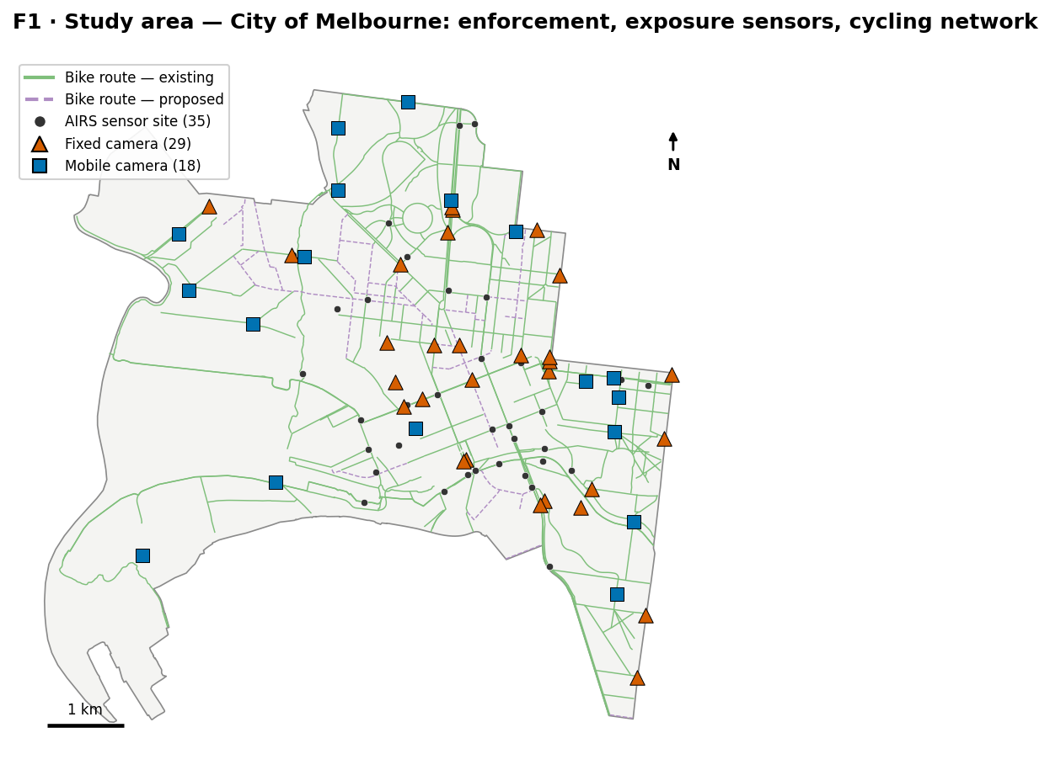
Figure F1. Study-area overview — the CoM boundary, cycling network (green = existing, purple = proposed), 35 AIRS sensor sites and 47 cameras (29 fixed, 18 mobile). Sensors concentrate in the CBD/riverside core; cameras line the arterial edges.
F2 (signature figure) — the histogram–map linkage. Because activity is measured at 35 discrete sensor sites (not a continuous field), it is shown as classed proportional symbols rather than a choropleth that would pretend to fill unmeasured space — an honest idiom choice. Site VRU totals are classified with Jenks natural breaks (5 classes), chosen because the distribution is heavily right-skewed: equal-interval breaks collapse 31 of 35 sites into the lowest class, whereas Jenks (breaks at ~0.66/1.78/3.13/4.55 M) exposes the real tiers. The same breaks are drawn on the histogram (F2a) so “how much” maps onto “where”.
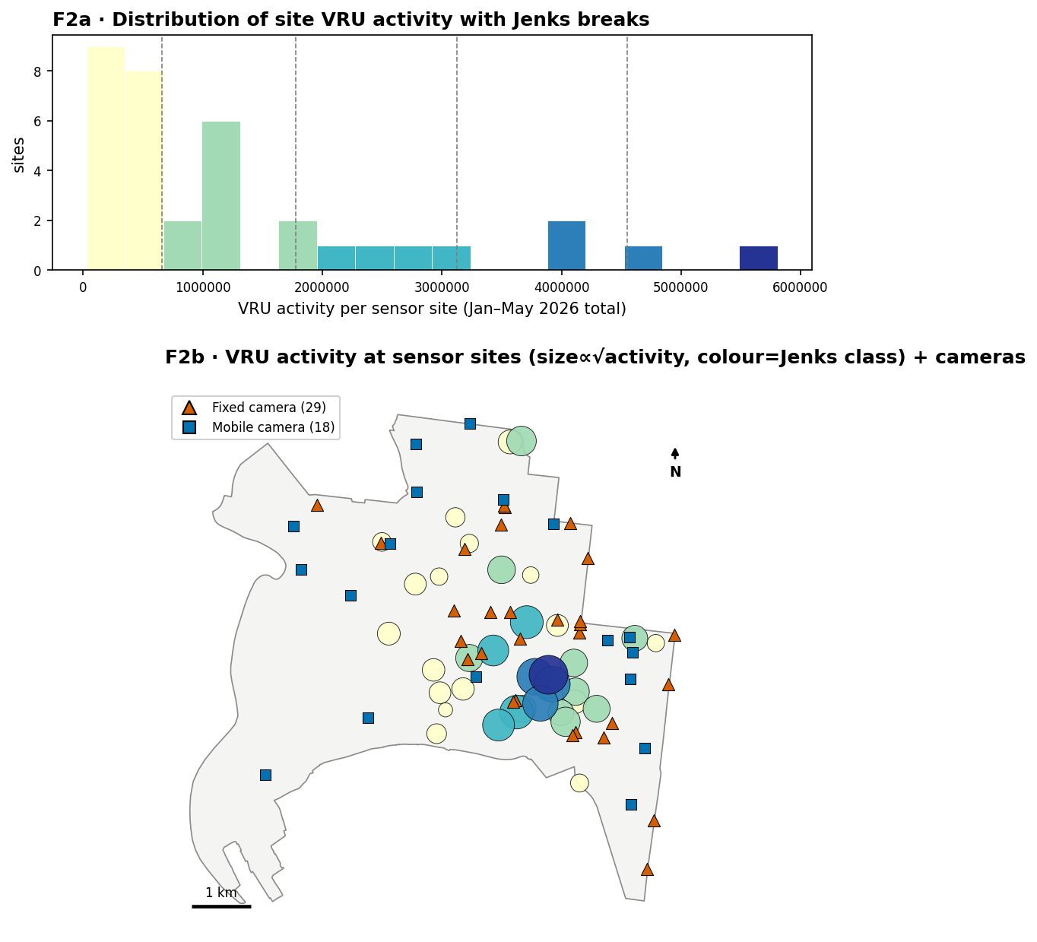
Figure F2. VRU activity at sensor sites (size ∝ √activity, colour = Jenks class) with the shared-break histogram above. The four darkest sites (Swanston St, Elizabeth St, Southbank & Yarra promenades; 3.1–5.8 M each) form a compact CBD/riverside core; cameras sit around, not on, it.
Observation. The top Jenks class holds only four riverside/CBD-spine sites (Swanston St 5.81 M, Elizabeth St 4.55 M, Swanston-road 4.19 M, Southbank Promenade 3.92 M); the camera markers cluster on the arterial ring and intersections, largely outside this core.
Interpretation (RQ1). Enforcement and exposure are spatially decoupled — the busiest pedestrian/cyclist places are pedestrianised streets and off-road promenades that carry little or no fixed-camera enforcement, which is sited for vehicle-offence risk at road intersections.
Limitation. Sensor coverage is densest in the core (Appendix A1), so some contrast reflects where measurement happens; unmeasured ≠ inactive.
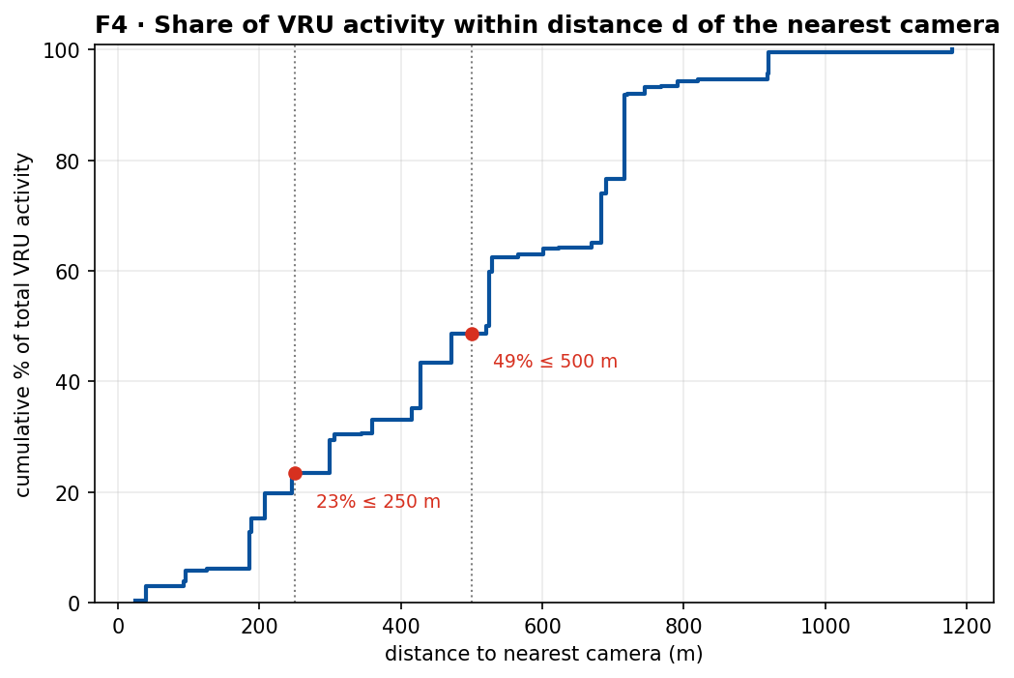
Figure F4. Cumulative share of VRU activity within distance d of the nearest camera. Only 23% of activity lies within 250 m of any camera and 49% within 500 m; the median site-to-camera distance is 526 m (max 1,180 m).
Interpretation (RQ1). Converting the spatial question into one defensible number: barely a quarter of all measured VRU activity is within 250 m of an enforcement point. A Spearman test of site activity against distance-to-camera is weak and non-significant (ρ = −0.15, p = 0.39) — enforcement is neither systematically near nor far from activity, i.e. essentially unrelated to it. (The test is exploratory only: spatial autocorrelation violates independence.)
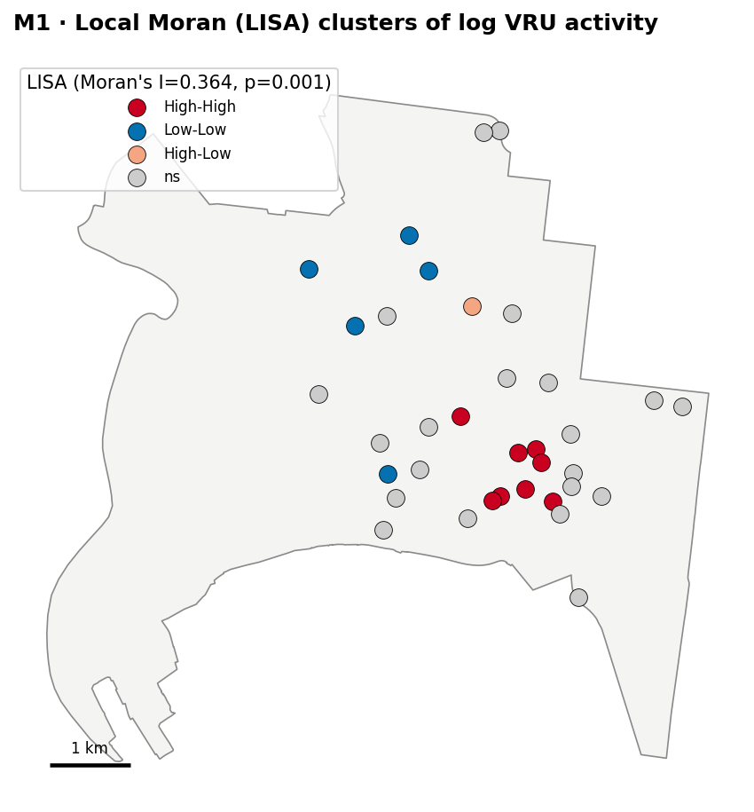
Figure M1. Local Moran (LISA) clusters of log VRU activity (KNN-5 weights). Global Moran’s I = 0.364 (p = 0.001): activity is significantly spatially clustered, so “hotspot” is justified. Eight High-High sites form the CBD/Southbank core; five Low-Low sites sit on the periphery.

3.2 RQ2 — Temporal: when are VRUs active, and does enforcement sit where the peaks are?
Holding the reframing in mind (enforcement timing is unobservable), RQ2 is answered on the activity side. The activity clock (F5) uses a matrix heatmap — the right idiom for doubly-cyclic data (hour × weekday), where line charts let peaks collide — coloured by each mode’s share of its own weekly total (perceptually-uniform, CVD-safe magma).
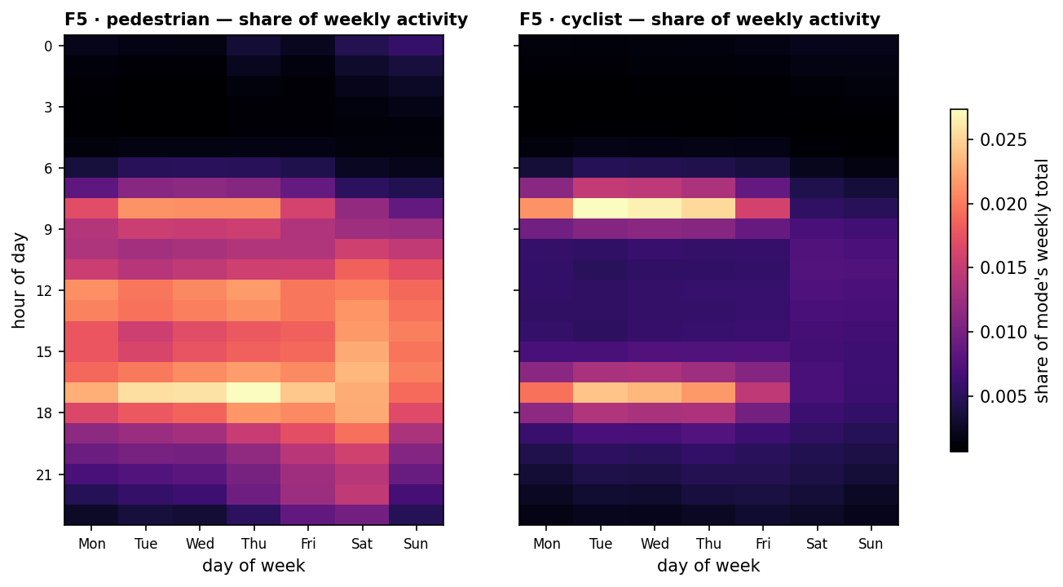
Figure F5. Activity clock — share of weekly activity by hour and weekday. Pedestrians (left) peak broadly midday–afternoon (12–17 h) across all seven days; cyclists (right) show a sharp weekday commuter double-peak at ~8 a.m. and ~5 p.m. that fades at weekends.
Interpretation (RQ2). The two VRU modes have different rhythms: pedestrian exposure is a broad daytime plateau (retail/leisure), cyclist exposure is concentrated in weekday commute windows. The highest-risk window for cyclists is therefore the evening commute — precisely when enforcement placement matters most.
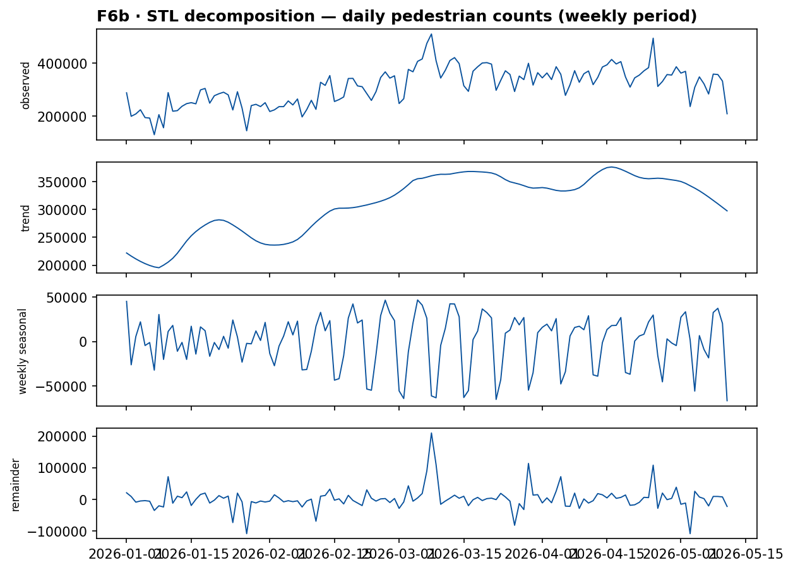
Figure F6b. STL decomposition of daily pedestrian counts (weekly period, robust). The trend rises from ~222 k/day in January to a March peak before easing to ~298 k by May (late-summer→autumn decline); a strong, stable weekly cycle (amplitude ~113 k) separates weekdays from weekends.
F7 — temporal-behaviour clusters. Each site’s 48-value weekday+weekend hourly shape profile was k-means clustered (features standardised; k chosen by average silhouette, which peaks at k = 2). The two groups are substantively clear: a commuter/weekday type (23 sites; stronger 7–9 a.m. peak, weekend share only 25%) and a recreational/weekend type (12 sites; flatter mornings, weekend share 32%). Finer k did not improve separation, itself a finding: the inner-city sensor network is temporally fairly homogeneous.
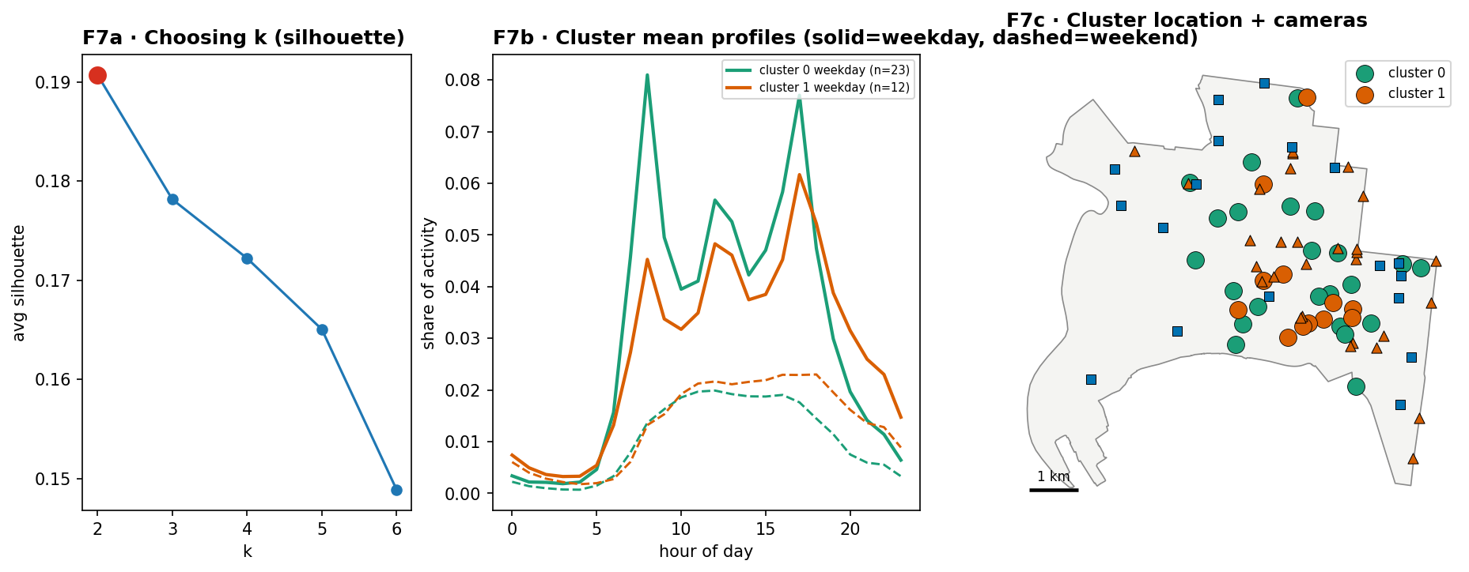
Figure F7. Temporal clustering — silhouette chooser (k = 2), cluster mean profiles (solid = weekday, dashed = weekend), and their spatial distribution with cameras. Recreational/weekend sites concentrate along the river; commuter sites line the CBD grid and approaches.
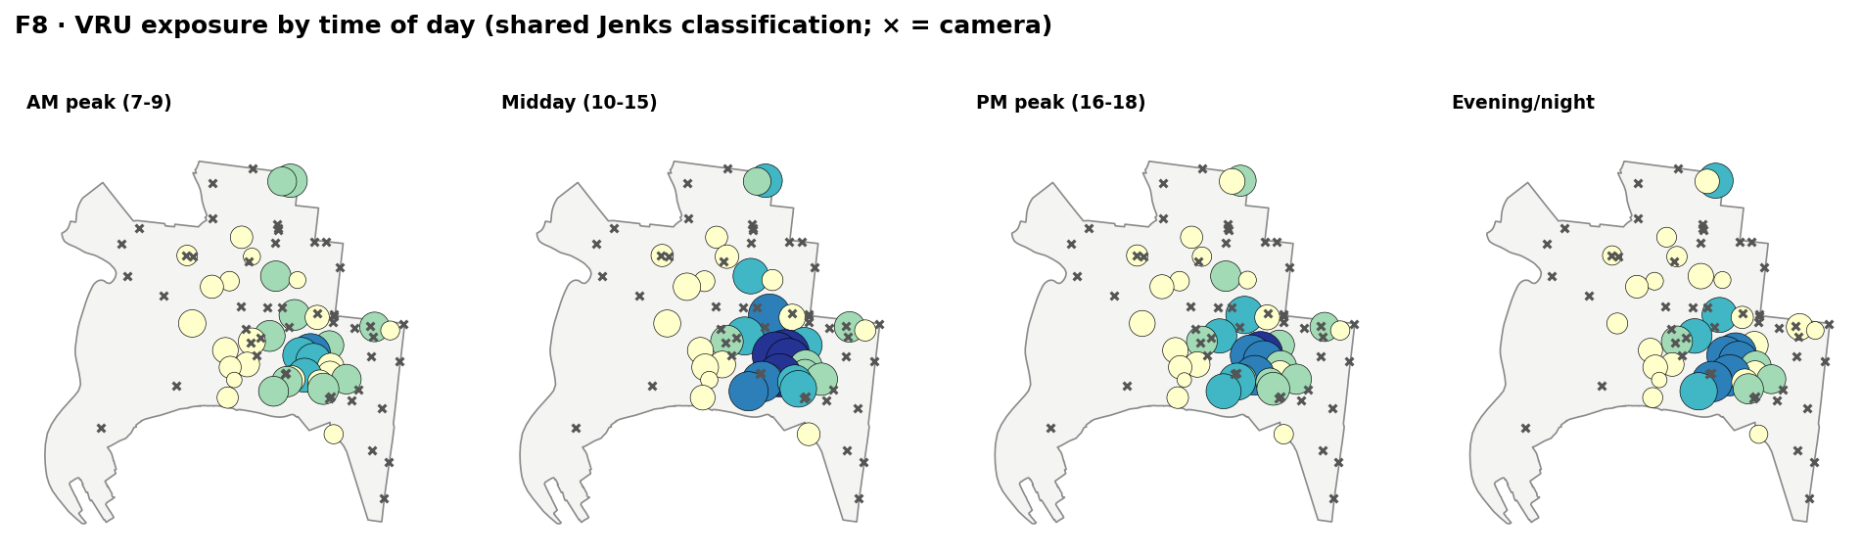
Figure F8. Time-sliced exposure (small multiples, one shared Jenks classification; × = camera). The high-exposure core stays in the CBD/riverside across AM-peak, midday and PM-peak; cameras (fixed ×) remain on the periphery in every window.
Interpretation (RQ2, reframed). Because cameras are time-blind, the honest test is whether their locations coincide with the cells hottest in the high-risk windows — and F8 shows they do not: the exposure core barely moves between time slices, while enforcement stays on the arterial ring throughout. Location, not timing, is the binding constraint on enforcement–exposure alignment.

3.3 RQ3 — Network: is the cycling network one connected system?
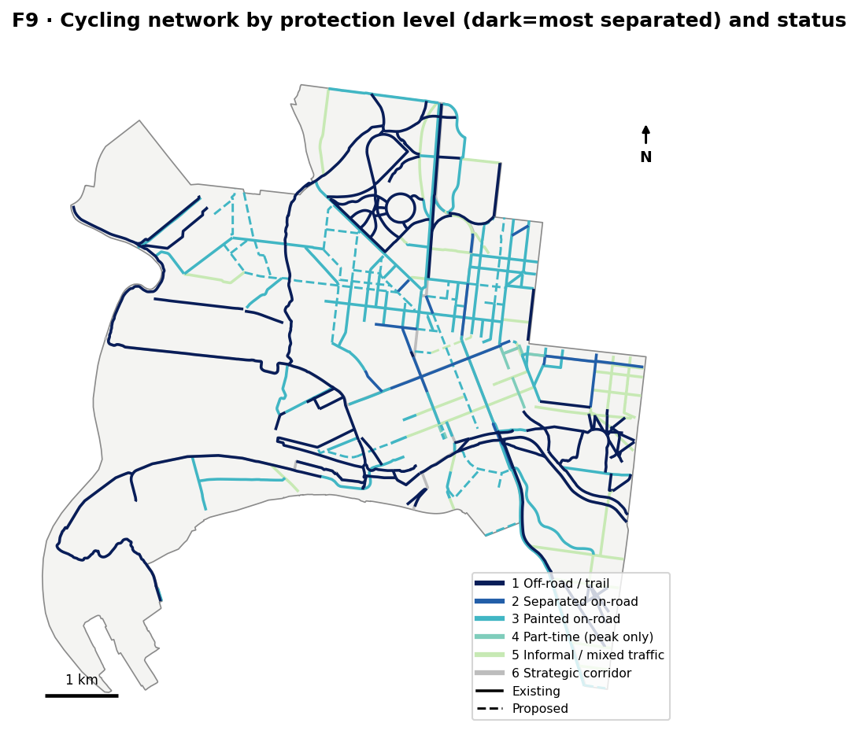
Figure F9. Cycling network by derived protection ordinal (dark = most separated) and status. Off-road trails (dark, 67.4 km) follow the river and parks; the on-street grid is dominated by painted lanes (cyan, 67.6 km). Only 8.2 km (4%) is physically separated on-road; 39 segments are proposed (dashed).
Observation. Of 198.4 km, protection is thin: 67.6 km painted-only, 67.4 km off-road trail, 21.4 km informal/mixed-traffic, and just 8.2 km separated on-road. “Protection” is mostly paint or shared paths, not physical separation.
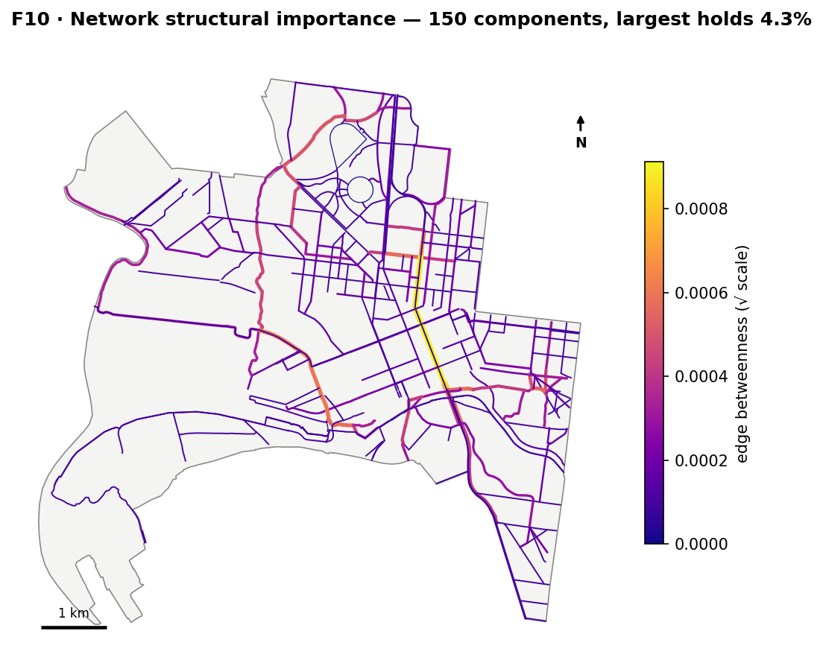
Figure F10. Network structural importance — segments coloured by edge betweenness (√ scale). Built as a graph (10 m noding tolerance), the network resolves into 150 disconnected components; the largest holds only 4.3% of nodes and 76.8% of nodes are dangling (degree-1) ends. A few spine segments (river trail, key corridors) carry disproportionate betweenness.
Interpretation (RQ3). The network is highly fragmented rather than one connected system: even at a generous 30 m noding tolerance it remains 110 components with 68% dangling ends, so the fragmentation is robust, not a digitising artifact. Continuity — not total length — is the network’s weakness, and every dangling end is a point where a rider is handed back into mixed traffic.
Limitation. The network is a 2023 processing vintage compared against 2026 activity; some near-but-unnoded endpoints inflate the raw component count (hence the 10 m tolerance and the sensitivity test).

3.4 Synthesis — where the three geometries disagree
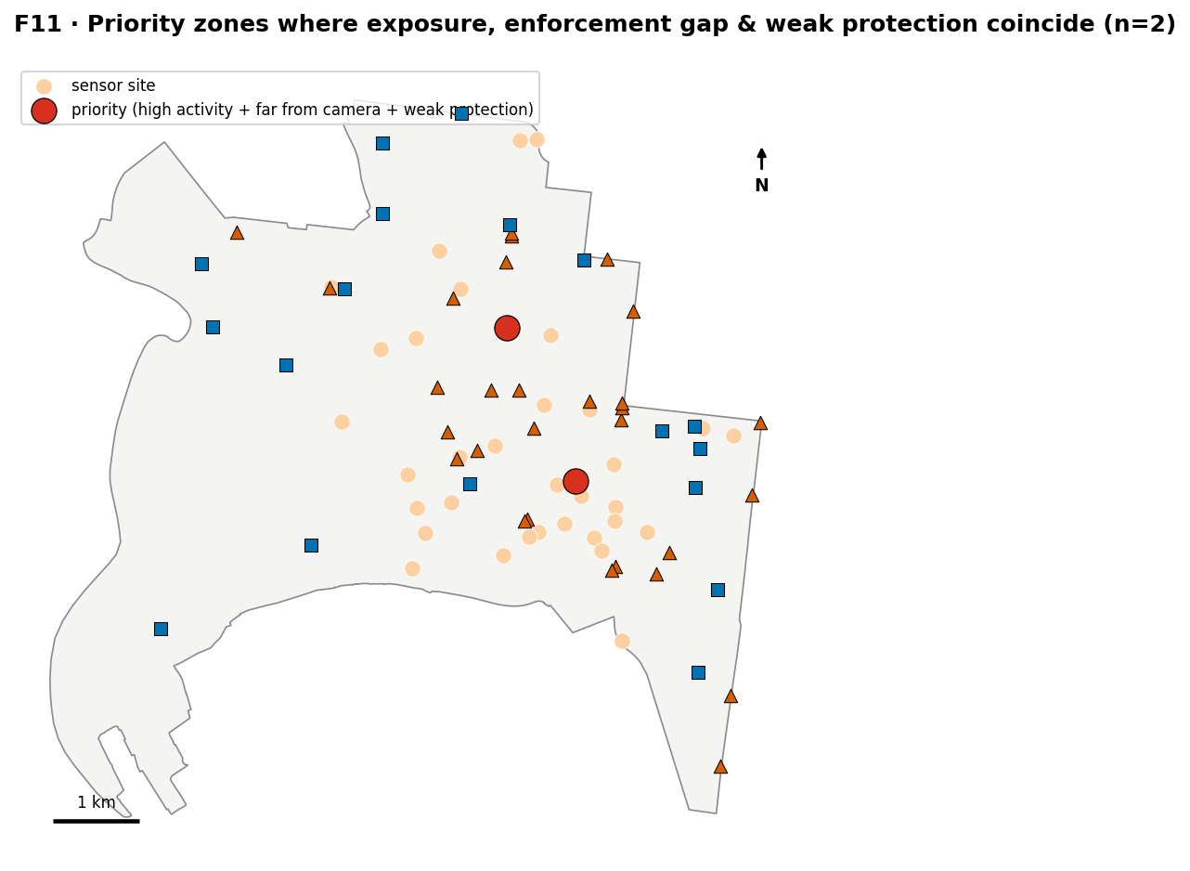
Figure F11. Priority zones where high activity (top tertile), an enforcement gap (top-tertile camera distance) and weak protection coincide. The strict triple-flag identifies 2 sites (Grattan St, Swanston St); the bivariate view (Appendix F3) shows 4 high-activity/low-enforcement sites, of which these 2 also lack nearby separated infrastructure.
Interpretation (synthesis). The clearest disagreement between the three geometries sits on the CBD–Parkville spine: high pedestrian/cyclist exposure, no nearby camera, and painted-only or fragmented bike infrastructure. This is offered as where to look, not a proven risk ranking — it stacks three uncertain layers.

4 Conclusion
RQ1 (spatial). Enforcement and exposure are decoupled. VRU activity is significantly clustered (Moran’s I = 0.364, p = 0.001) in a compact CBD/riverside core, yet only 23% of that activity lies within 250 m of any camera (49% within 500 m; median 526 m), and activity shows no significant association with camera proximity (Spearman ρ = −0.15, p = 0.39). Cameras are sited for vehicle-offence risk at intersections, not for VRU exposure.
RQ2 (temporal). Pedestrians peak across a broad midday–afternoon plateau; cyclists show a sharp weekday 8 a.m./5 p.m. commuter double-peak, and sites separate cleanly into commuter (25% weekend) vs recreational (32% weekend) types. Enforcement timing itself is unobservable, but camera locations do not coincide with the exposure core in any time slice, so the misalignment is spatial and persists through every high-risk window.
RQ3 (network). The cycling network is fragmented, not a connected system: 150 components, largest holding 4.3% of nodes, 76.8% dangling ends, and only 8.2 km of physically separated on-road lane. Continuity is the binding weakness.
Synthesis. Four sites combine high exposure with an enforcement gap; two (Grattan St, Swanston St) also lack nearby protection — the places where the three geometries most clearly disagree and where risk-responsive investment would concentrate. The exploration answered each question, and named where the data could not (enforcement timing).

5 Reflection
The strongest visualisation lesson was that classification is an argument, not a formatting step: the same activity data looks almost uniform under equal-interval breaks and sharply tiered under Jenks, so drawing the breaks onto the histogram beside the map (F2) was the single change that made the spatial contrast honest. A second lesson was to match the idiom to the data’s structure — a matrix heatmap for doubly-cyclic time (F5), small multiples with a shared scale for fair temporal comparison (F8), and proportional symbols rather than a choropleth once I discovered activity was measured at only 35 discrete sites. The third, and most humbling, was that data checking protects analysis: a timestamp labelled “Z” but holding local time would have inverted every temporal finding, and it was caught only because it placed the cyclist peak at 3 a.m. In hindsight I would test a second geocoder as a cross-check and treat the bike-network noding tolerance as an explicit parameter from the outset.

6 Limitations
Five limitations bound every claim above and are disclosed deliberately. Sensor sparsity and placement bias: activity is measured at 35 sites concentrated in the core, so coverage is uneven and absence of a sensor is not absence of activity (missing ≠ zero). Enforcement intent: camera presence is not enforcement intensity or effectiveness, and fixed-camera timing is unobservable — hence the RQ2 reframing. Geocoding uncertainty: the 18 mobile sites are geocoded to street centroids from text, with one error caught and dropped. Temporal and vintage mismatch: the part-year 2026 window supports weekly, not annual, seasonality, the DST change (5 Apr 2026) sits inside it, and the cycling network is a 2023 vintage against 2026 activity. MAUP and independence: tertile cut-points and the network noding tolerance are analytical choices (sensitivity-tested), and spatial autocorrelation violates the independence assumption of the correlation test — so every claim is associational, never causal.

Bibliography
City of Melbourne. (2026). Transport activity counts [Data set]. City of Melbourne Open Data. https://data.melbourne.vic.gov.au/explore/dataset/transport-activity-counts/
City of Melbourne. (2023). Bicycle routes, including informal, on-road and off-road routes [Data set]. City of Melbourne Open Data. https://data.melbourne.vic.gov.au/explore/dataset/bicycle-routes-including-informal-on-road-and-off-road-routes/
City of Melbourne. (2026). Municipal boundary [Data set]. City of Melbourne Open Data. https://data.melbourne.vic.gov.au/explore/dataset/municipal-boundary/
Department of Justice and Community Safety, Victoria. (2026). Find a road safety camera. https://www.vic.gov.au/find-road-safety-camera
Department of Justice and Community Safety, Victoria. (2026). Road safety camera network — Mobile camera locations [Data set]. DataVic. https://discover.data.vic.gov.au/dataset/road-safety-camera-network-mobile-camera-locations
Anselin, L. (1995). Local indicators of spatial association—LISA. Geographical Analysis, 27(2), 93–115.
Cleveland, W. S., & McGill, R. (1984). Graphical perception: Theory, experimentation, and application to the development of graphical methods. Journal of the American Statistical Association, 79(387), 531–554.
Cleveland, R. B., Cleveland, W. S., McRae, J. E., & Terpenning, I. (1990). STL: A seasonal-trend decomposition procedure based on loess. Journal of Official Statistics, 6(1), 3–73.
Harrower, M., & Brewer, C. A. (2003). ColorBrewer.org: An online tool for selecting colour schemes for maps. The Cartographic Journal, 40(1), 27–37.
Jenks, G. F. (1967). The data model concept in statistical mapping. International Yearbook of Cartography, 7, 186–190.
Moran, P. A. P. (1950). Notes on continuous stochastic phenomena. Biometrika, 37(1/2), 17–23.
Munzner, T. (2014). Visualization analysis and design. CRC Press.
Okabe, M., & Ito, K. (2008). Color universal design (CUD). https://jfly.uni-koeln.de/color/
Openshaw, S. (1984). The modifiable areal unit problem (CATMOG 38). Geo Books.
Tobler, W. R. (1970). A computer movie simulating urban growth in the Detroit region. Economic Geography, 46, 234–240.
Software: R Core Team (2026) and Python; sf/geopandas (Pebesma, 2018), data.table, ggplot2, classInt/mapclassify, spdep/esda-libpysal, scikit-learn, statsmodels, sfnetworks/networkx, tidygeocoder / ArcGIS World Geocoder.

Declaration of AI Assistance
Tool. Claude (Anthropic), September 2026. Extent of use. In accordance with the unit’s policy on declared use of generative AI for written and code content, AI was used to help plan the analysis pipeline; to write and run the mechanical code (the reproducible fixed-camera scrape, the 8.2M-row aggregation, cleaning, geocoding, checking, spatial integration, and the figure- and statistic-generating code); and to draft the prose and the first-pass reading of the results in this report. Author responsibility. I have reviewed and verified every figure and statistic against the underlying outputs, confirmed each numerical claim, and take responsibility for the analysis, interpretations and conclusions presented here; the runnable code is submitted alongside this report and every reported number is reproducible from it. Representative prompts and the full method are recorded in the accompanying code file.

Appendix (unmarked)
A2 · Classification-scheme comparison (site VRU, 5 classes). Equal-interval breaks: 1.18/2.34/3.50/4.65 M — collapses 31/35 sites into class 1. Quantiles: 0.21/0.51/1.18/2.20 M. Jenks (used): 0.66/1.78/3.13/4.55 M — the scheme that exposes the skewed tiers. This comparison is the evidence behind the Jenks choice in F2.
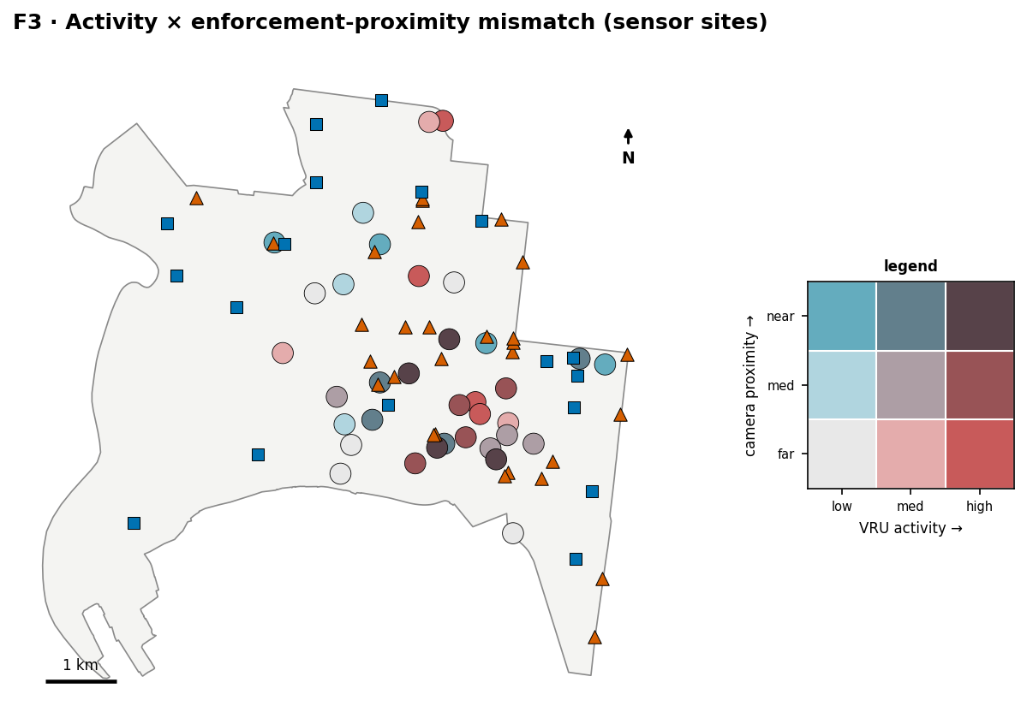
Figure F3. Bivariate map — VRU activity tertiles × camera-proximity tertiles. The dark-red corner (high activity, far from a camera) holds 4 sites; a matching 4 sit near cameras, confirming no systematic alignment.
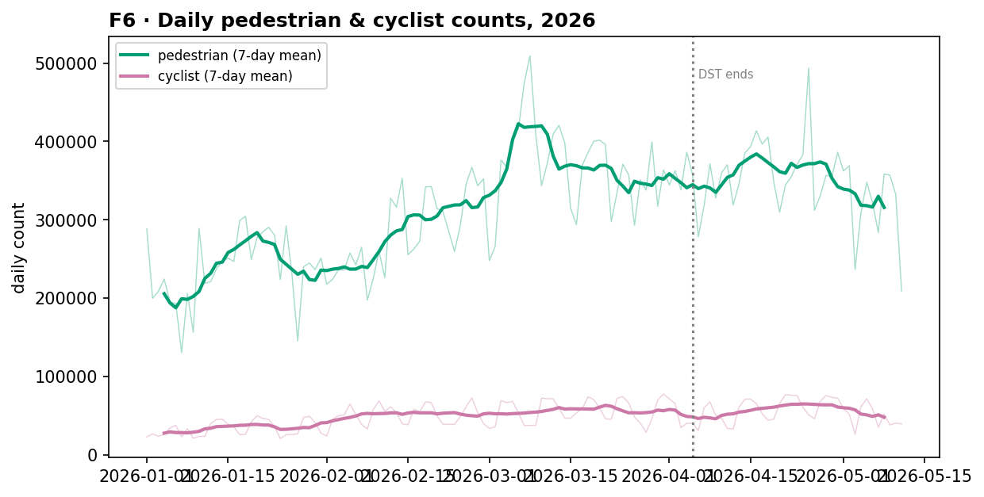
Figure F6. Daily pedestrian and cyclist counts with 7-day means (DST change marked). Pedestrian volumes (~10× cyclist) rise through February–March then ease into autumn.
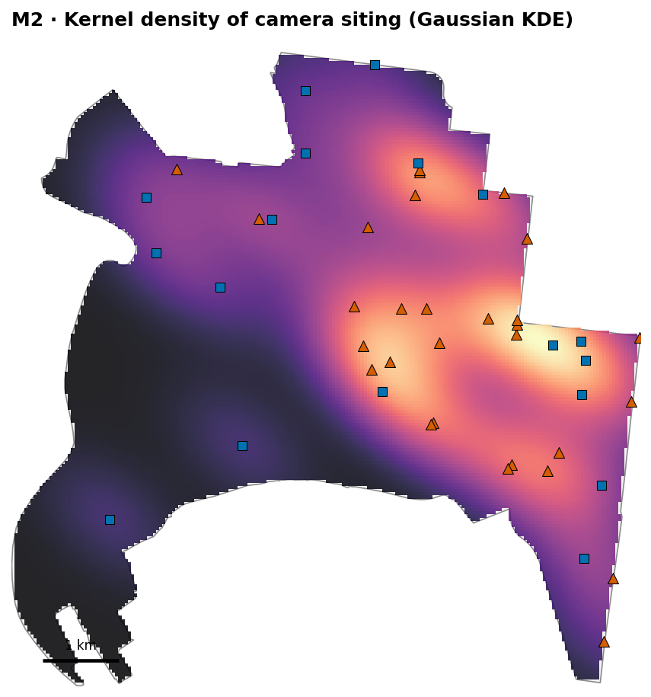
Figure M2. Kernel density of camera siting (Gaussian KDE) — enforcement intensity concentrates on the CBD’s eastern arterials, away from the riverside activity core.
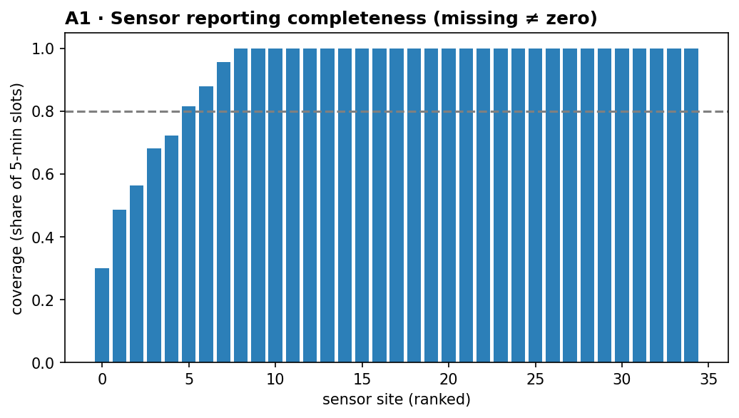
Figure A1. Per-site reporting completeness — most sites report >90% of 5-minute slots; a handful below 0.8 (dashed) are annotated, evidencing the missing ≠ zero check.

