**Looking back; Bengal to Bangladesh**

**Introduction:**

The independent sovereign Bangladesh we see today was not created overnight. We have got this Bangladesh of today through various rebellion struggles and movements since time immemorial.

**Janapadh:**

Ancient Janapads of Bengal The historic term Janapad means human settlement.The sources of ancient Bengal suggest that, in theearliest period Bengal, it was divided among varioustribes or kingdoms which are known as theJanapadas. The ancient Janapadas are as follows:*1.Banga 2.Pundra 3.Gaura 4.Radha 5.Somotate 6.Horkela*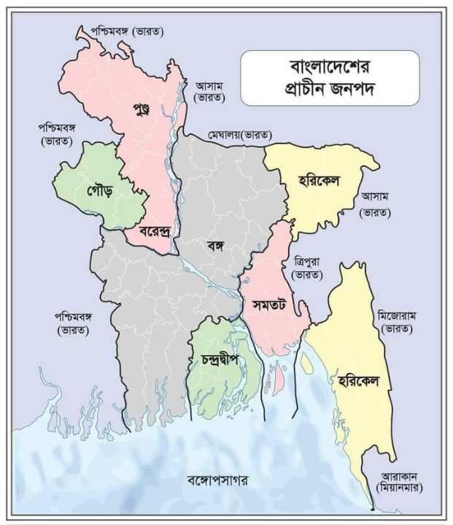

* **Banga**: The regions bordered on the north by the Jamuna River, on the south by the Padma River, and on the east by the Meghna river was the Banga janapada in the ancient times (present Khulna and Barisal regions. Present Mymensingh regions were also sometimes included in the Banga janapad). There was another janapada in Bakla/Bakerganj i.c. present Barishal, known as Chndradip (chandra island).
* **Samatata:** The region on the eastern side of the Meghna i.e. present noakhali-Chittagong, was the Samatata janapada. The Banga and Samatata regions were comparatively low-lying, riverine and wetland.
* **Pundra**: The Pundra was situated on the northern banks of the Ganges-Padma. On the south, it was bordered by the Jamuna. It was indeed the lower part (southern part) of the present northern districts of Bangladesh. The Pundra janpada was the oldest janapada. It is said that before the coming of the Muslims, the oldest Pundra janapada was replaced by the Varendra janapada.
* **Varenda**: The extreme north-western part of present Bangladesh (Rajshahi, Rangpur Dinajpur etc.) was known as Varendra janapada. As a newer janapada it came into existence in the regions of the old Pundra janapada.
* **Gaura**: Roughly the areas of present Rajshahi and Chapai-Nawabganj districts of Bangladesh and Malda and Murshidabad districts Janapad Murshidabad of West Bengal of India were the Gaura
* **Radha:** The western part of the Ganges-Bhagirathi rivers, the ancient Radh janapada including present Medinipur, Burdwan, Purulia, Hoogly etc. of West Bengal. Radha was divided north and south by the Ajay river.
* **Horikel**: The Horikel janapada was located in the present Chittagong regions and Sylhet regions.Political History of Bengal Before and after the Aryans came to India, Bengal was divided into many janapadas. The first Kindom of Bengal was founded by Shashanka around 600 AD in the ancient

**Ancient Dynasities:**

* The Maurya Empire was a vast Iron Age empire in ancient India. Founded by Chandragupta Maurya and later ruled by the Maurya dynasty, this empire lasted from 321 BC to 185 BC. Emperor Ashoka was the best ruler of Maurya dynasty. Ashoka was the third Maurya emperor of the Indian subcontinent, who succeeded his father Bindusara. One of the greatest emperors in Indian history, he ruled most of India except parts of the Deccan. So he can be called an All India Emperor.

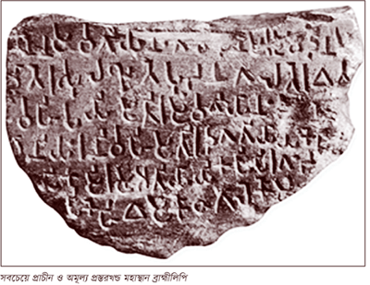

* The Gupta Empire was an ancient Indian empire on the Indian subcontinent which existed from the mid 3rd century CE to mid 6th century CE. It was the seventh ruling dynasty of Magadha. At its zenith, from approximately 319 to 467 CE, it covered much of the Indian subcontinent.[8] This period has been considered as the Golden Age of India by historians. The ruling dynasty of the empire was founded by Gupta and the most notable rulers of the dynasty were Chandragupta I, Samudragupta, Chandragupta II, Kumaragupta I and Skandagupta.
* The founder of the Pala Empire was Gopala, who established it in the 8th century. The best known and greatest of his later rulers is Dharmapala. Dharmapala expanded the empire and played an important role in the development of education and culture. It was during his time that the Pala Empire became known as a powerful state.
* King Ballal Sen was the founder of the Sen era. Among the other important rulers of the Sena era is the name of King Lakshmana Sena, who was the last ruler of the Sena dynasty.

**Muslim** **Dynasities:**

* In 1204 AD, the Turkish hero Ikhtiyar Uddin Mohammad bin Bakhtiyar defeated Laxman Sen, the last ruler of the Khalji Sen dynasty, and established the Muslim Empire in Bengal, which continued for nearly 500 years.
* The Nawab period of Bengal began in 1717, during the rule of Murshid Quli Khan, who came to power as the first independent Nawab. Nawab Sirajuddaula was defeated by the British East India Company at the Battle of Palashi in 1757, marking the fall of Nawabi rule.
* The defeat of Nawab Siraj at the Battle of Palashi in 1757 laid the foundations of English rule in the Indian subcontinent. Later, the British ruled India for about 200 years. The first 100 years were under the rule of the East India Company and after the Sepoy Mutiny of 1857, the English Governor Queen Victoria took over the administration of the Indian subcontinent.

**Partition of 1947:**

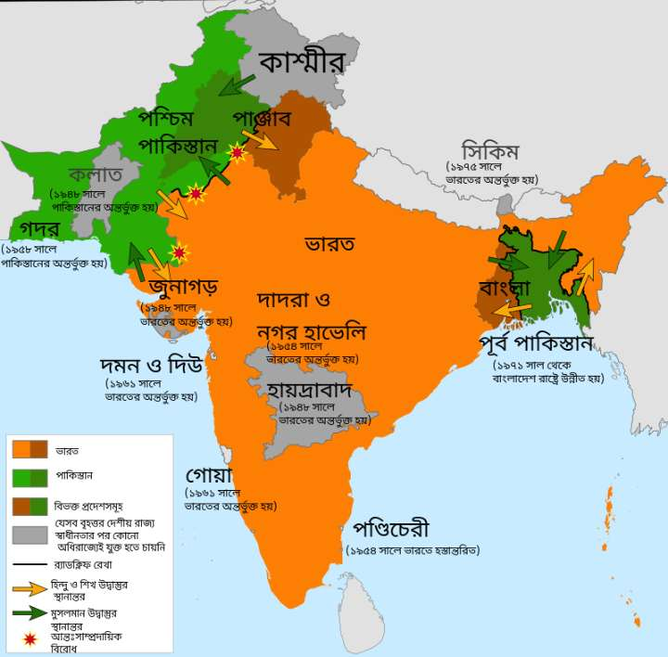

On August 14 and 15, 1947, the Indian subcontinent was divided and a new state called Pakistan was born and Pakistan was divided by two part west Pakistan and east pakistan. After about 23 years, the rulers of Pakistan ruled the people of east Pakistan.

**Language Movement:**

The language movement is one of the most important cultural and political movements in Bengali history. On March 21, 1948, Muhammad Ali Jinnah announced at the Race Course Maidan that Urdu would be the national language of Pakistan. In this protest, when the students came out in small groups of five to seven with the slogan 'I want the national language Bangla', the police beat them with batons and fired shots. 21 February,1952 Rafiq Uddin Ahmad, Abdul Jabbar, Abul Barkat, Abdus Salam died in the shooting for their language movement . Since 1999, the United Nations has declared February 21 as International Mother Language Day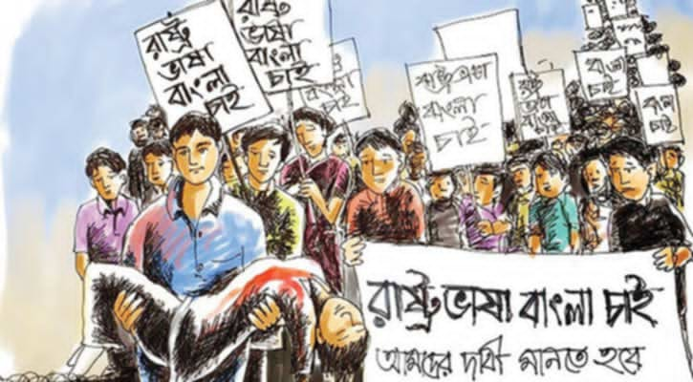

The United Front is a political alliance formed in 1954 against Pakistani rule in East Bengal (present-day Bangladesh). Its purpose was to protect the interests of the people of Bengal and to fight against communal political forces. The United Front was led by some prominent politicians, such as Suhrawardy, Dr. Kamal Hossain, and Nurul Amin. The political activities of the United Front later played an important role during the Liberation War of East Bengal.

**Six points movement:**

The Constitution should provide for a Federation of Pakistan in its true sense based on the Lahore Resolution, and the parliamentary form of government with supremacy of a Legislature directly elected on the basis of universal adult franchise.[1] The federal government should deal with only two subjects: Defence and Foreign Affairs, and all other residual subjects should be vested in the federating states.[1] Two separate, but freely convertible currencies for the two 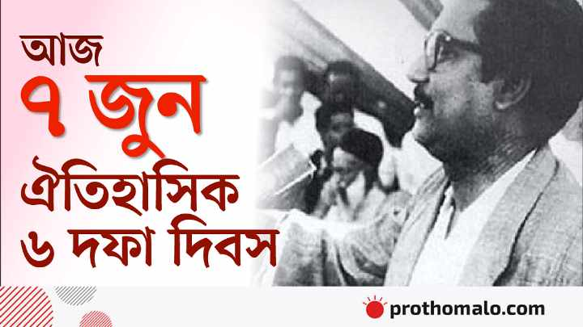wings should be introduced; or if this is not feasible, there should be one currency for the whole country, but effective constitutional provisions should be introduced to stop the flight of capital from East to West Pakistan. Furthermore, a separate reserve bank should be established and separate fiscal and monetary policy be adopted for East Pakistan.The power of taxation and revenue collection should be vested in the federating units and the federal centre would have no such power. The federation would be entitled to a share in the state taxes to meet its expenditures. There should be two separate accounts for the foreign exchange earnings of the two wings; the foreign exchange requirements of the federal government should be met by the two wings equally or in a ratio to be fixed; indigenous products should move free of duty between the two wings, and the constitution should empower the units to establish trade links with foreign countries.East Pakistan should have a separate military or paramilitary force, and Navy headquarters should be in East Pakistan.

**Mass Uprising:**

The 1969 mass uprising The upheaval of the political and liberation struggle of the then East Pakistan and the current Bangladesh the language Keep an eye out editing The most important movement took place in 1969 with the spontaneous participation of the people of East Pakistan against the state of Pakistan. In history it is known as Mass Uprising It takes a revolutionary form All democratic parties, professional organizations and people from every position joined this movement 4 January – The All-Party Students' Struggle Parishad presented its historic 11-point programme.[1] January 7 and 8 – Democratic Action Committee (DAC), a political unity to promote democracy, is formed. January 20 - Asaduzzaman, student leader of Dhaka University, was killed in a firing incident at a student procession. January 24 - Matiyur Rahman, a teenage student of Navkumar Institute, and many others were killed in police firing. February 15 - Killing of Sergeant Zahurul Haque, one of the accused in the Agartala conspiracy case, detained in Kurmitola Cantonment. [2] February 18 - Rajshahi University teachers were shot dead in a silent procession. Shamsujjoha. 22 February - Agartala Conspiracy case withdrawn and prisoners unconditionally released 26 February - Ayub Khan convenes a round table meeting to discuss with opposition leaders. Later, when the round table meeting failed, Ayub Khan resigned.

**Election of 1970:**

The 1970 general election was the first multi-party election in the history of Pakistan. The election was contested by the Awami League in East Pakistan and various political parties in West Pakistan. In East Pakistan, the Awami League, under the leadership of Bangabandhu Sheikh Mujibur Rahman, won 160 of the 162 seats and won a single majority. It took shape in the liberation war B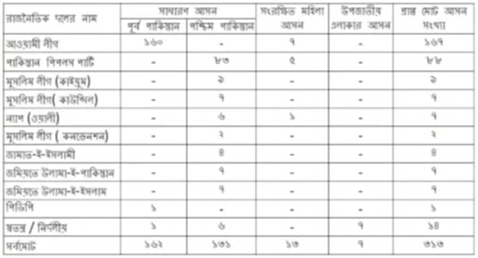

**Born of Bangladesh**:

The Liberation War of 1971 is a very important chapter in the history of Bangladesh. It started on the night of March 25 with Operation Searchlight by the Pakistani Army, which was a brutal brutality against the common people. After

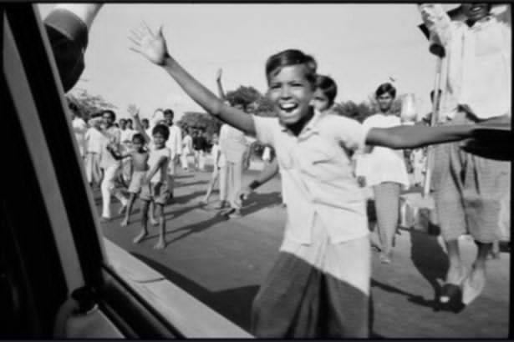

this freedom fighters were organized for the freedom struggle of Bangladesh. During the Liberation War, Bengalis fought against the Pakistani invaders. After 9 months of fighting, Bangladesh gained independence on 16 December 1971. Millions of people were killed in this war and there was widespread devastation across the country. The Liberation War was an important event in the establishment of Bangladesh's independence and national identity, and it continues to have a profound impact on the history and culture of the country. A