smart lock

Needed hardware items:

* ATMEGA 16
* 2*16 LCD
* 4*3 KEYPAD
* BUTTON
* MOTOR
* 2 LED
* SPEAKER
* BC547
* MINRES10K

Priorities of use interrupt:

The "interrupt" has been used to activate the supervisor mode and halt the execution of any other operation. This allows the supervisor to modify any stored data, and once finished, the program resumes executing what it was doing before the interrupt occurred. In this case, a button has been used, connected to PORTD.3. When this button is pressed, it triggers "interrupt 1" with a priority level of 3 in the vector handle interrupt.

Simulation:

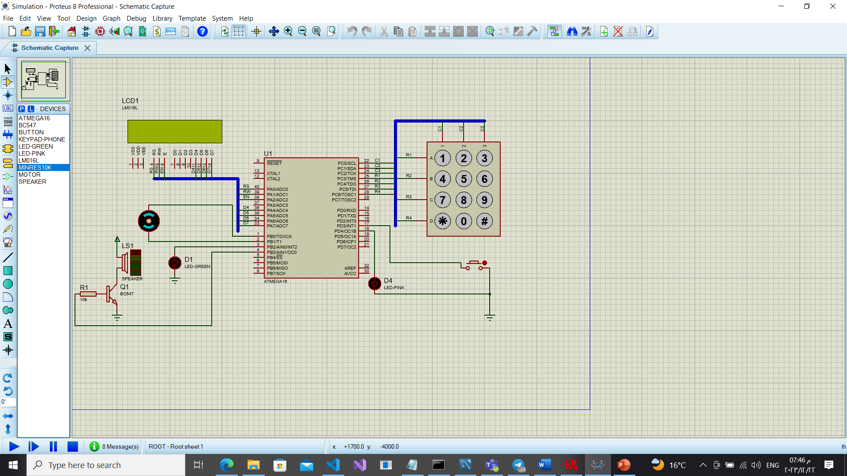

Table connection:

|  |  |
| --- | --- |
| **Input/output** | **Port name** |
| output | C0 ,C1 ,C2 |
| input | C3 ,C4, C5, C6 ,C7 |
| output | B0 ,B1,B2,B3 |
| input | D3 |
| output | D4 |

FlowChart

