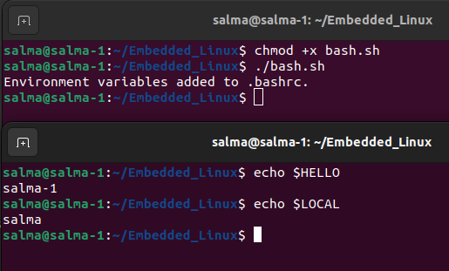
Q1: When the new terminal is opened, it will have the updated environment variables from .bashrc applied. In this case, HELLO will contain the value of the hostname, and LOCAL will contain the username of the current user.

