Submission Links

==================

S3 Bucket: http://salmazbucket.s3-website-us-east-1.amazonaws.com

RDS: database-1.cxbgcudgdvye.us-east-1.rds.amazonaws.com

EB: Udagramapi-env.eba-xb3v7pdb.us-east-1.elasticbeanstalk.com

Deployments

==============

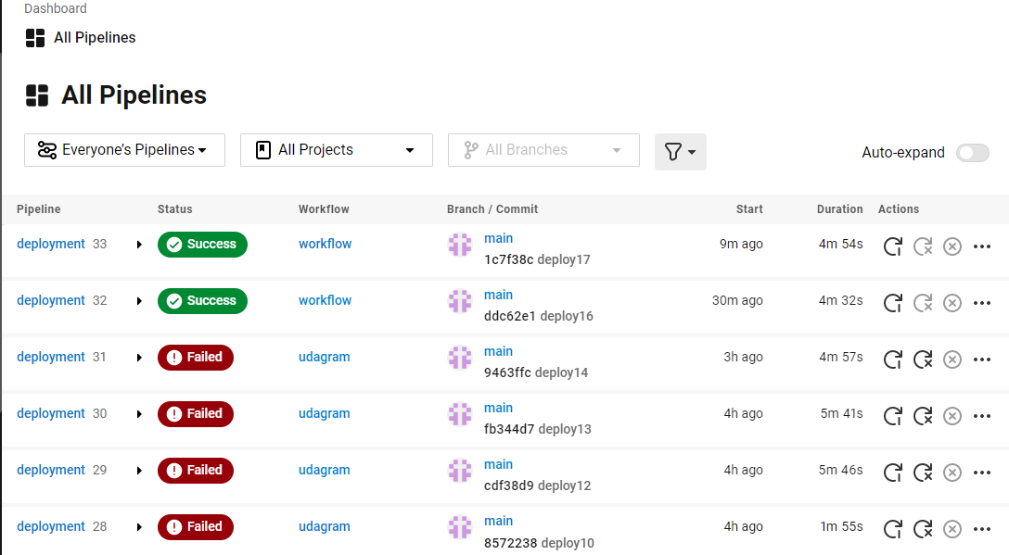

Last deployment

===============

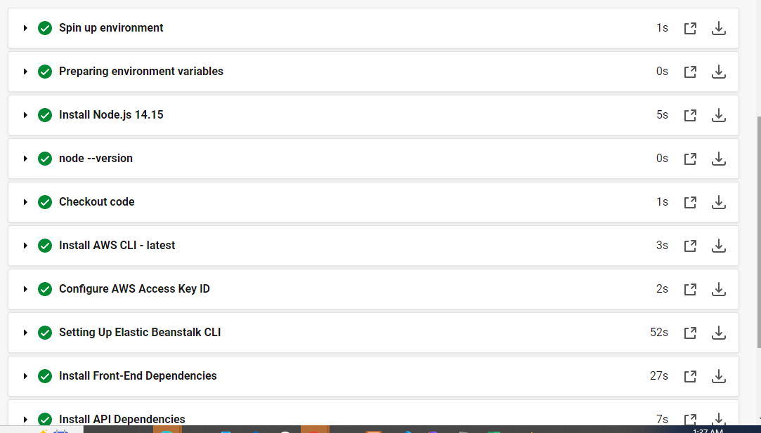

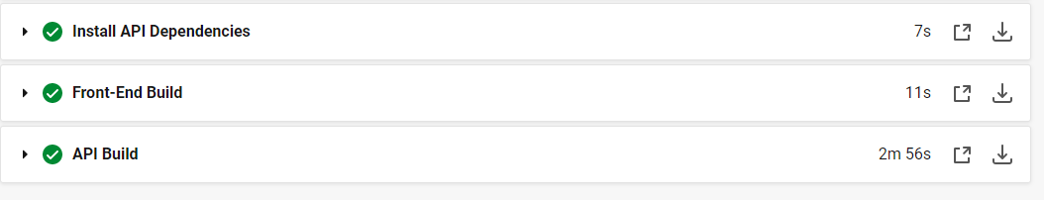

Env Variables set in CIrcleci

===========================

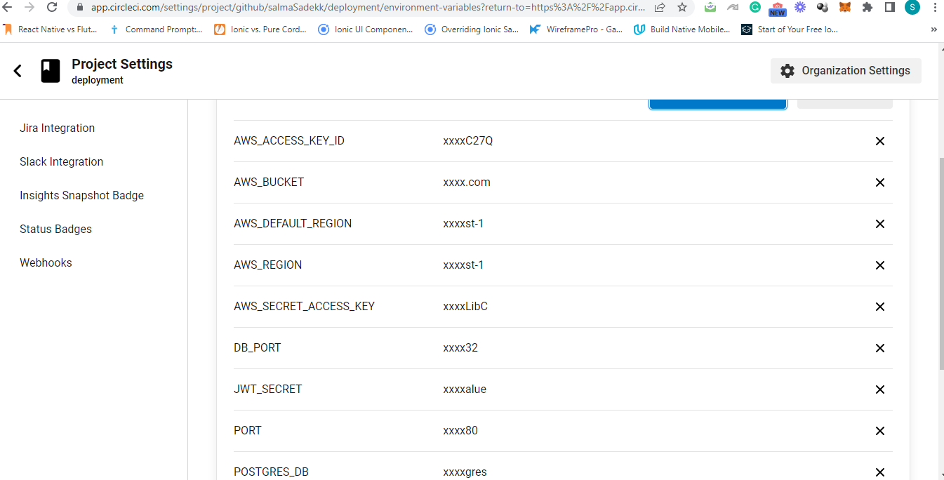

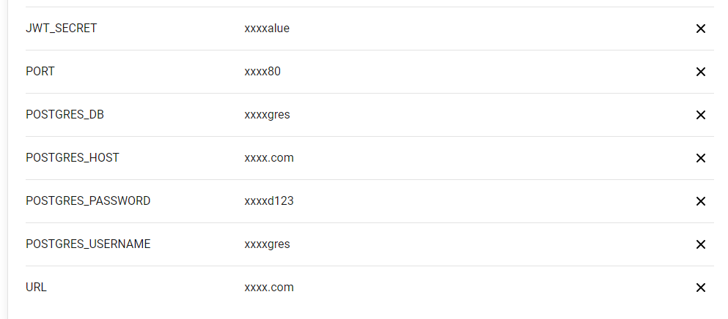

RDS

==========



EB

==========

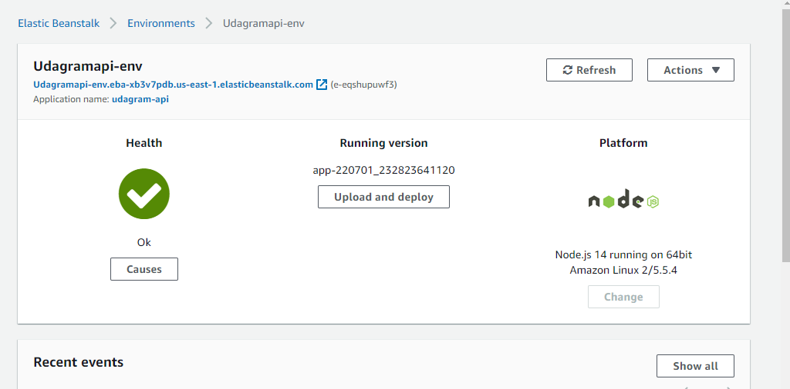

S3

========

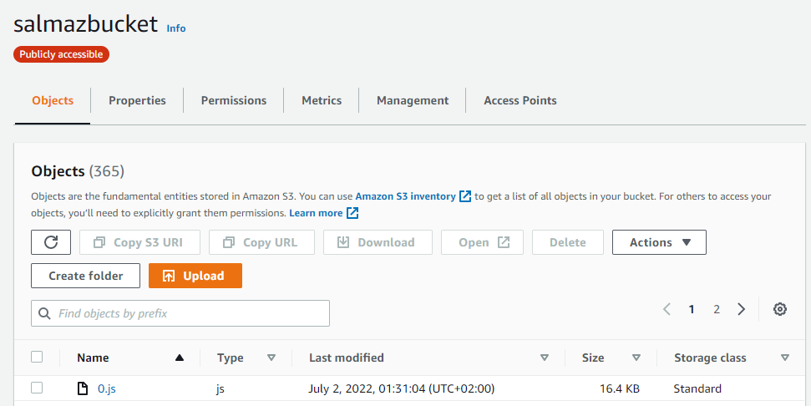

Diagram high-level overview of the infrastructure

=============================================

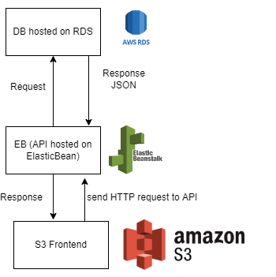

Diagram overview of the pipeline

=====================

