HOTEL RESERVATION SYSTEM

Project Documentation



1.INTRODUCTION
Submitted To:
DR. Mahmoud Khalil
ENG. Mazen Tarek
Developed By:
Reem Ahmed Mohamed 25P0028
Mohamed Nasser Mohamed 25P0088
Salma Tamer AbdelAzim 25P0064
Sara Mohamed Mohamed 25P0089
Hana Sameh Nour ElDeen 25P0079

This project focuses on building a Hotel Reservation System using Java, with an emphasis on applying Object-Oriented Programming (OOP) concepts. The goal is to design a system that manages hotel operations such as guest registration, room booking, and payment handling in a structured and organized way.
In this milestone, the main focus is on developing the backend logic only, without a graphical user interface. The system is built using well-designed classes that represent real-world entities like guests, rooms, reservations, and staff members.

2.PROBLEM DESCRIPTION
Managing hotel reservations manually or with unstructured systems can lead to issues such as booking conflicts and difficulty tracking guests and rooms. This system was designed to organize data efficiently and allow both guests and staff to perform their tasks easily and correctly.

3.SYSTEM & DESIGN IMPLEMENTATION
The system is built using multiple classes representing key entities. The Guest class allows users to register, log in, view available rooms, and manage their reservations (create, cancel, and checkout).
An abstract Staff class is used, with Admin and Receptionist inheriting from it. The Admin handles managing rooms, room types, and amenities (CRUD operations), as well as registering new staff members, while the Receptionist is responsible for reservation-related tasks such as check-in and check-out.
Rooms are represented by a Room class, which is associated with a RoomType and a list of Amenity objects. The Reservation class stores booking details including guest, room, dates, and status. The Invoice class handles payment information during checkout.
All data is stored using an in-memory database implemented with ArrayLists for guests, rooms, reservations, staff members, amenities and invoices.

4.OOP CONCEPTS
Encapsulation: Attributes are private and accessed through getters and setters.
Inheritance: Admin and Receptionist extend the Staff class
Enums: Used for gender, roles, reservation status, and payment methods.
Validation & Exceptions: Ensures correct input and handles errors like unavailable rooms.

5.DESIGN DECISIONS
Several design decisions were made to keep the system organized, clear, and easy to extend.
5.1Separation of responsibilities
Each class was designed to represent a single real-world entity (Guest, Room, Reservation, etc.), and each class handles its own logic. This makes the system easier to understand, test, and modify without affecting other parts.

5.2 Use of inheritance for staff roles
A base Staff class was created to store common attributes such as username and password, while Admin and Receptionist extend it. This avoids code duplication and allows shared behavior to be reused while still supporting role-specific functionality.

5.3 Use of enums instead of strings
Enums were used for values like gender, roles, reservation status, and payment methods. This prevents invalid inputs and makes the code more readable and safer compared to using plain strings.

5.4 In-memory database for simplicity
Instead of connecting to an external database, ArrayLists were used to store system data. This simplifies development and allows easy testing of functionality without dealing with database setup.

5.5 Encapsulation and data protection:
All attributes are private and accessed through getters and setters. This ensures that data is not modified directly and allows validation to be applied when values are updated.

5.6 Clear relationships between classes
Objects are connected logically (e.g., a Reservation links a Guest and a Room). This reflects real-world relationships and makes the system more intuitive.

5.7 Basic validation and exception handling
Input validation and custom exceptions were added to handle cases like invalid data or unavailable rooms. This improves system reliability and prevents unexpected behavior.

6.GRAPHICAL USER INTERFACE (GUI)
The Hotel Reservation System's graphical interface was developed using JavaFX, following the Model-View-Controller (MVC) architectural pattern. The UI is structured around FXML layout files paired with dedicated Java controller classes, with a shared CSS stylesheet providing a consistent visual theme across all screens. The application entry point is LoginMain.java, which initializes the hotel database, loads the login screen, and launches the JavaFX stage in a maximized fullscreen state.
The system supports three distinct user roles — Guest, Receptionist, and Admin — each with a dedicated dashboard and set of functionalities. Authentication is handled by LoginController, which validates credentials against the hotel database and routes users to their respective dashboards. A SessionManager class maintains the currently logged-in user across screen transitions.
The Guest interface allows registered users to browse available rooms with real-time filtering by room type, amenity, and price range. Guests can make reservations, view and cancel existing bookings, proceed to checkout and payment, and manage their profile. New users can register through a dedicated registration screen. The Receptionist dashboard provides tools for processing guest check-ins and check-outs, generating invoices, viewing guest and reservation databases, and managing personal profile settings including password changes. The Admin dashboard offers full system control, including creating, updating, and deleting rooms, room types, and amenities, as well as registering new staff members, viewing all system databases, and managing the admin's own profile.
Screen navigation is implemented programmatically by loading FXML files via FXMLLoader and replacing the current scene on the existing stage. To maintain consistent fullscreen behavior across all transitions, each navigation method retrieves the current scene's dimensions and passes them to the new scene instance before calling stage.setMaximized(true). The interface applies a unified dark navy and light grey color scheme, with scrollable forms used throughout to accommodate content-heavy screens on any display resolution.

7.SOME SCREENS & TEST CASES
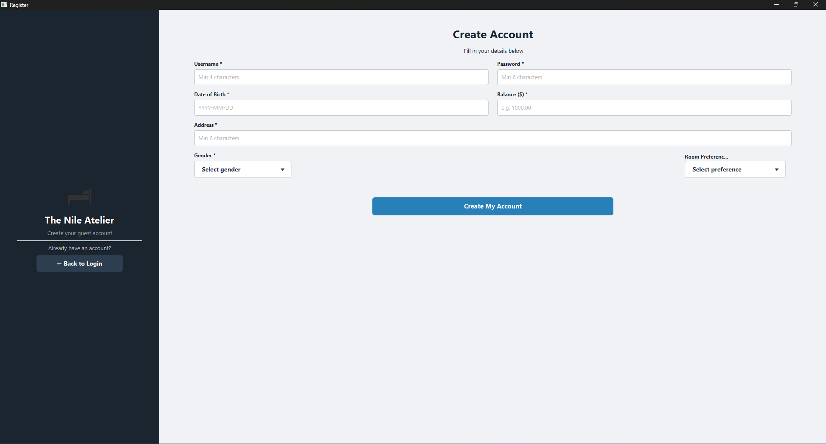
Guest Registeration
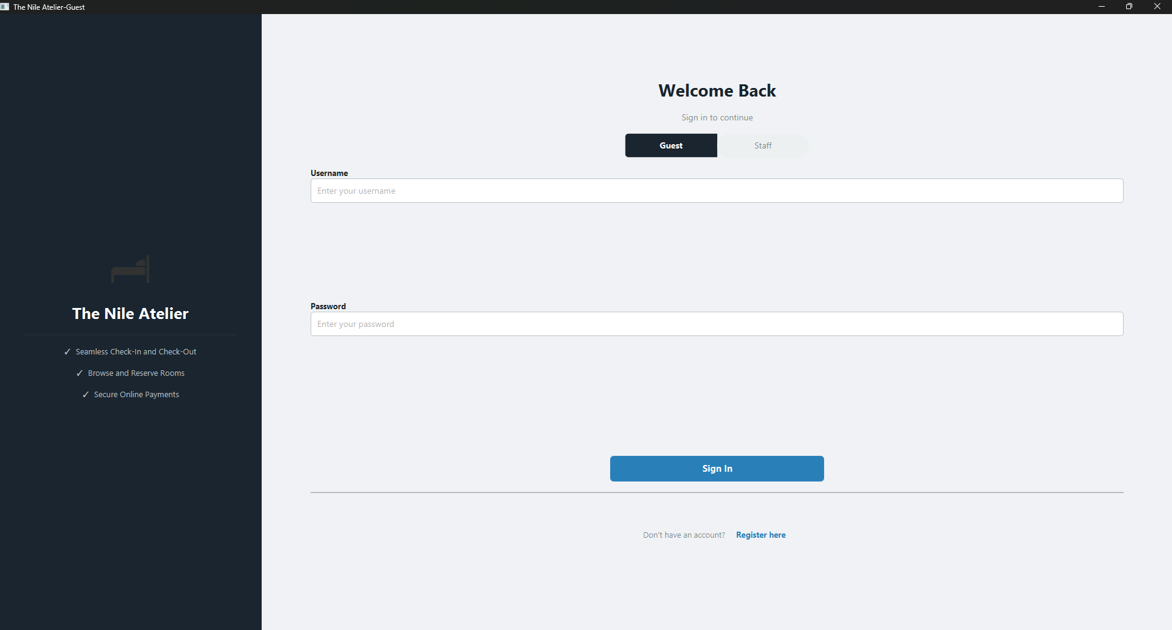
Login Dashboard

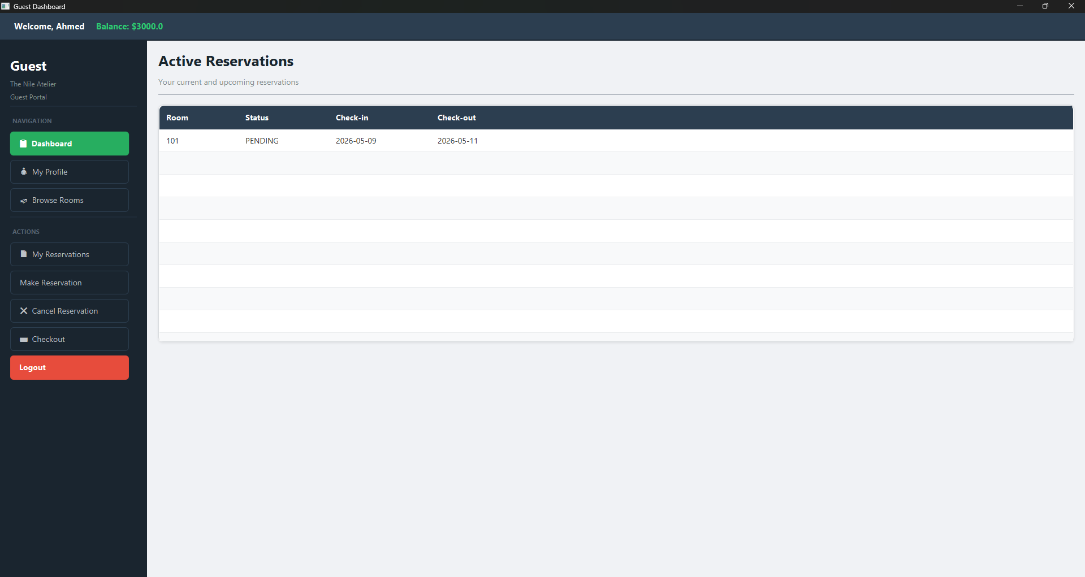
Guest Dashboard
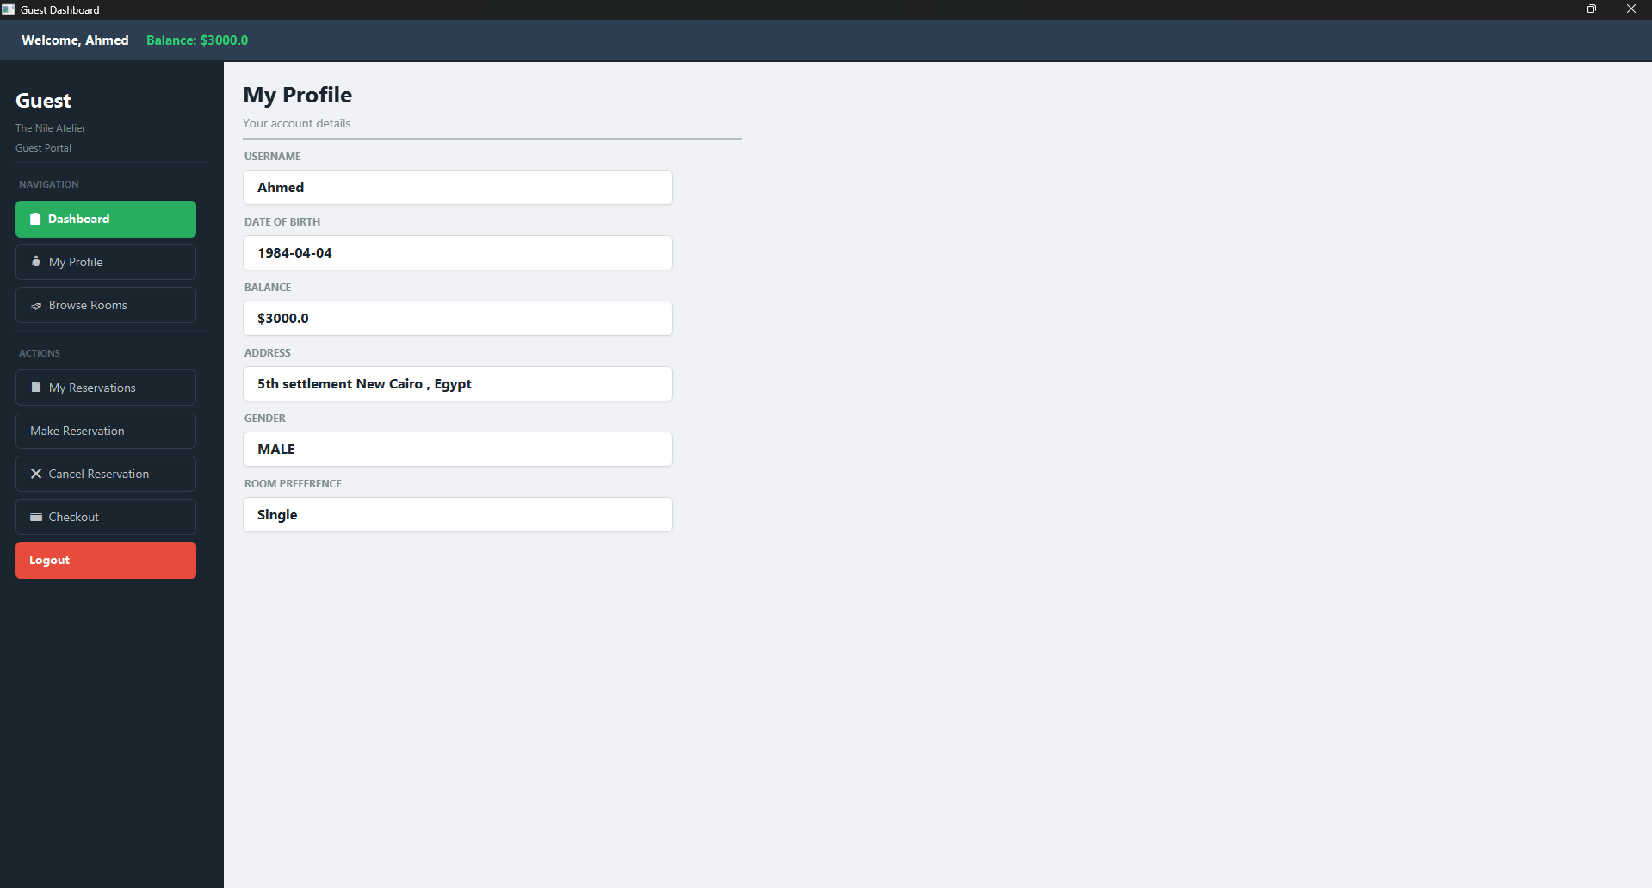
Guest Viewing Profile

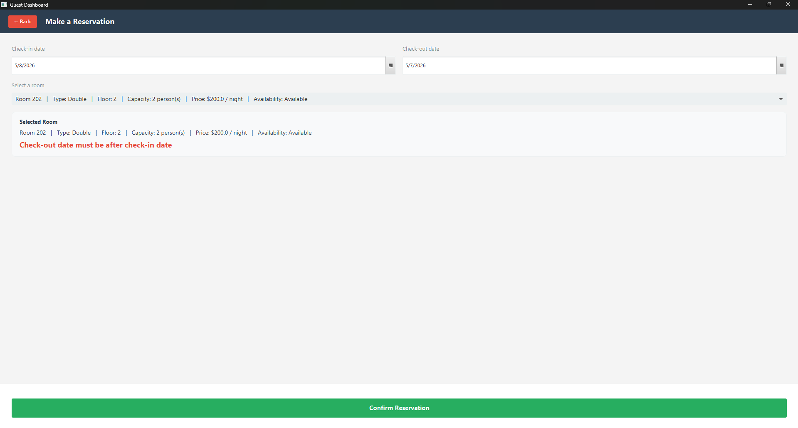
Unsuccessful Reservation
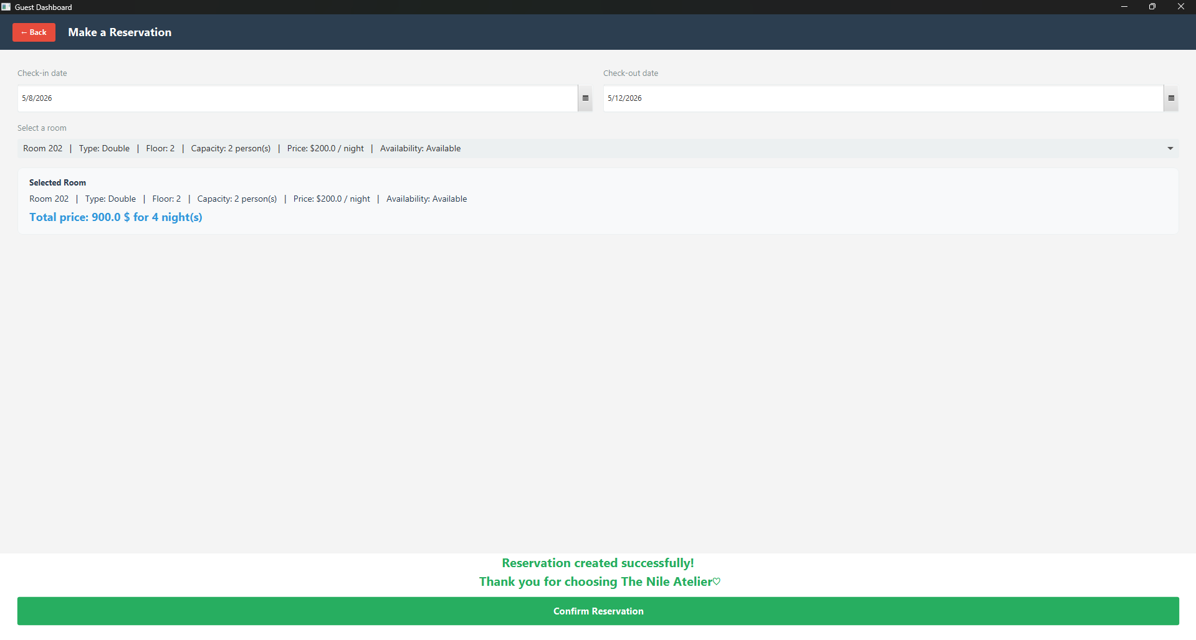Successful Reservation

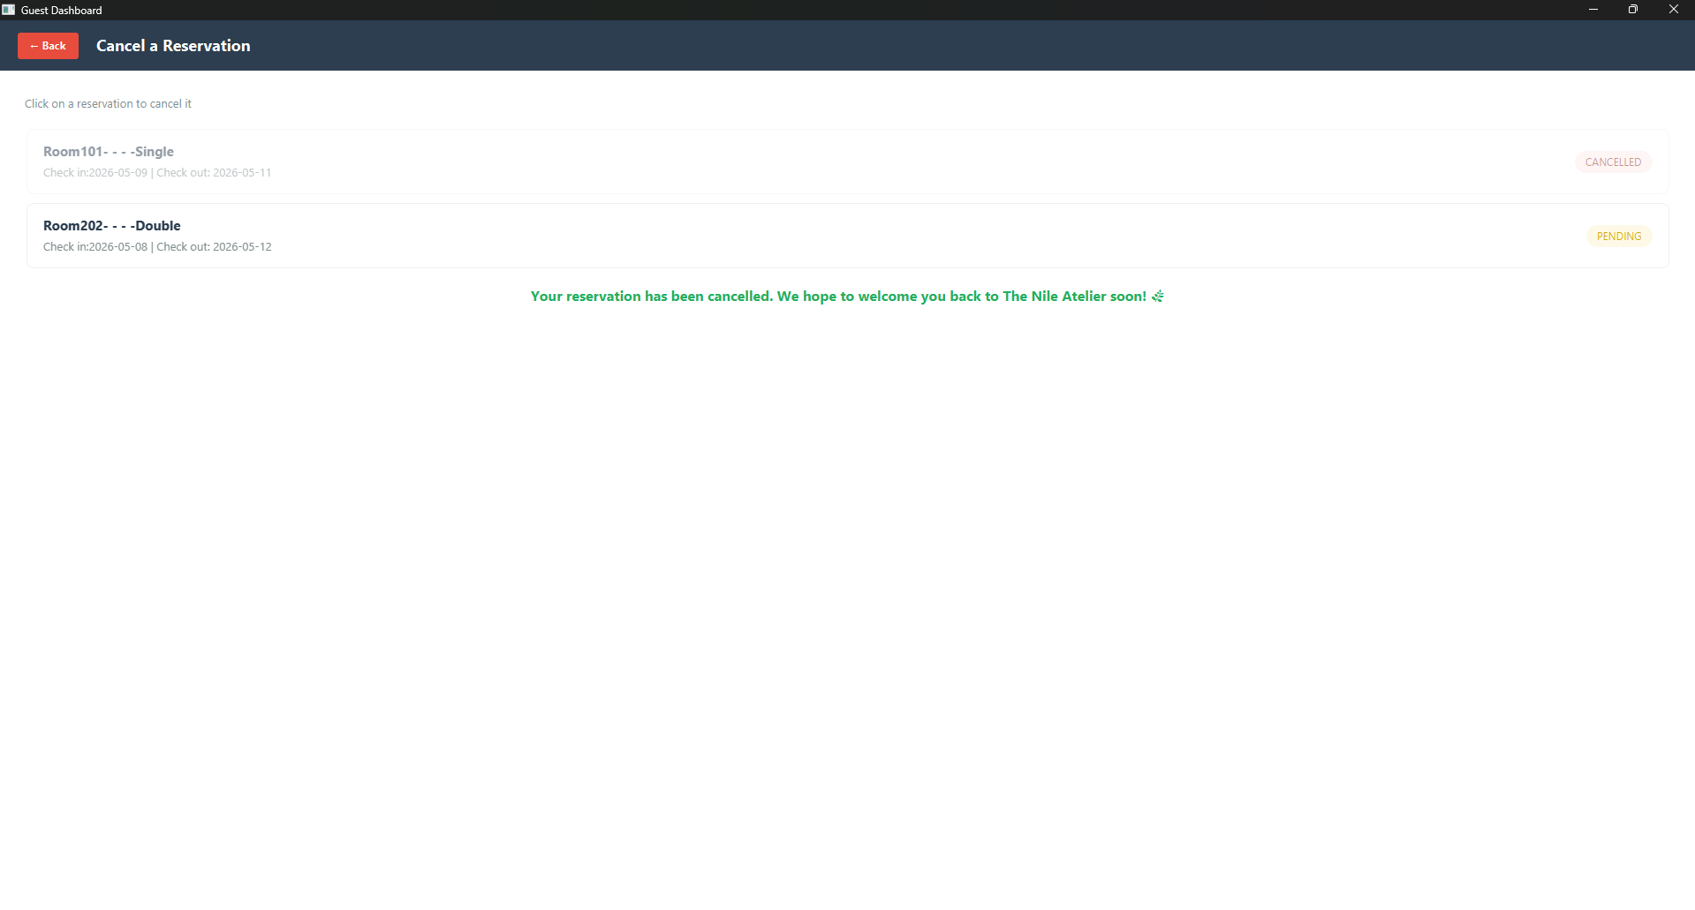
Cancelling a Reservation

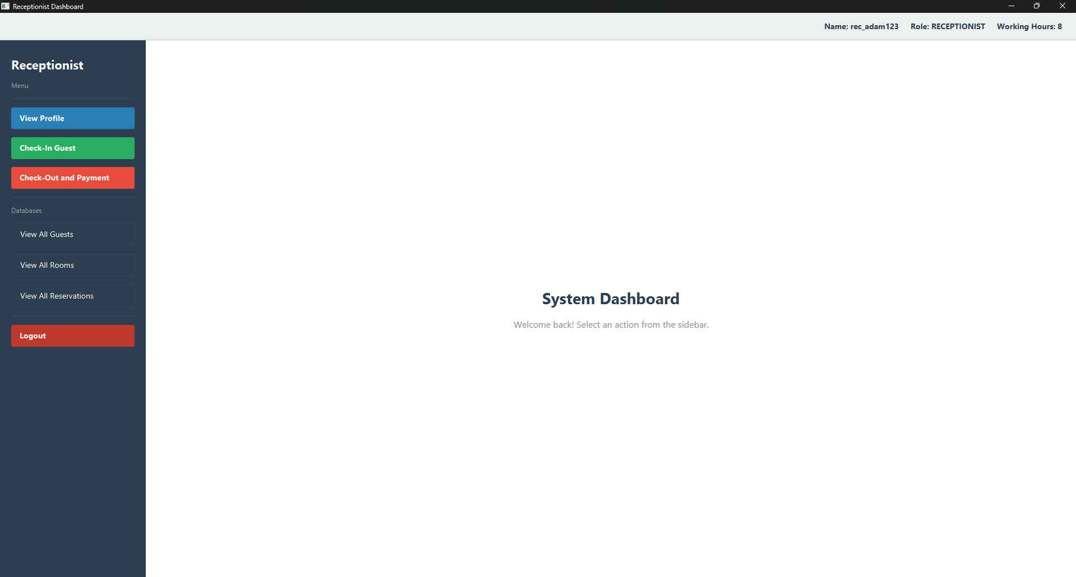
Receptionist Dashboard

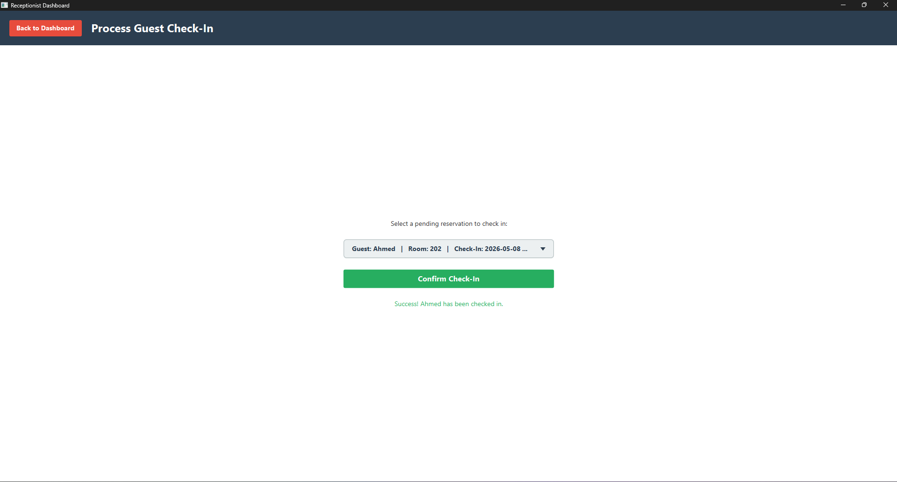
Check-In

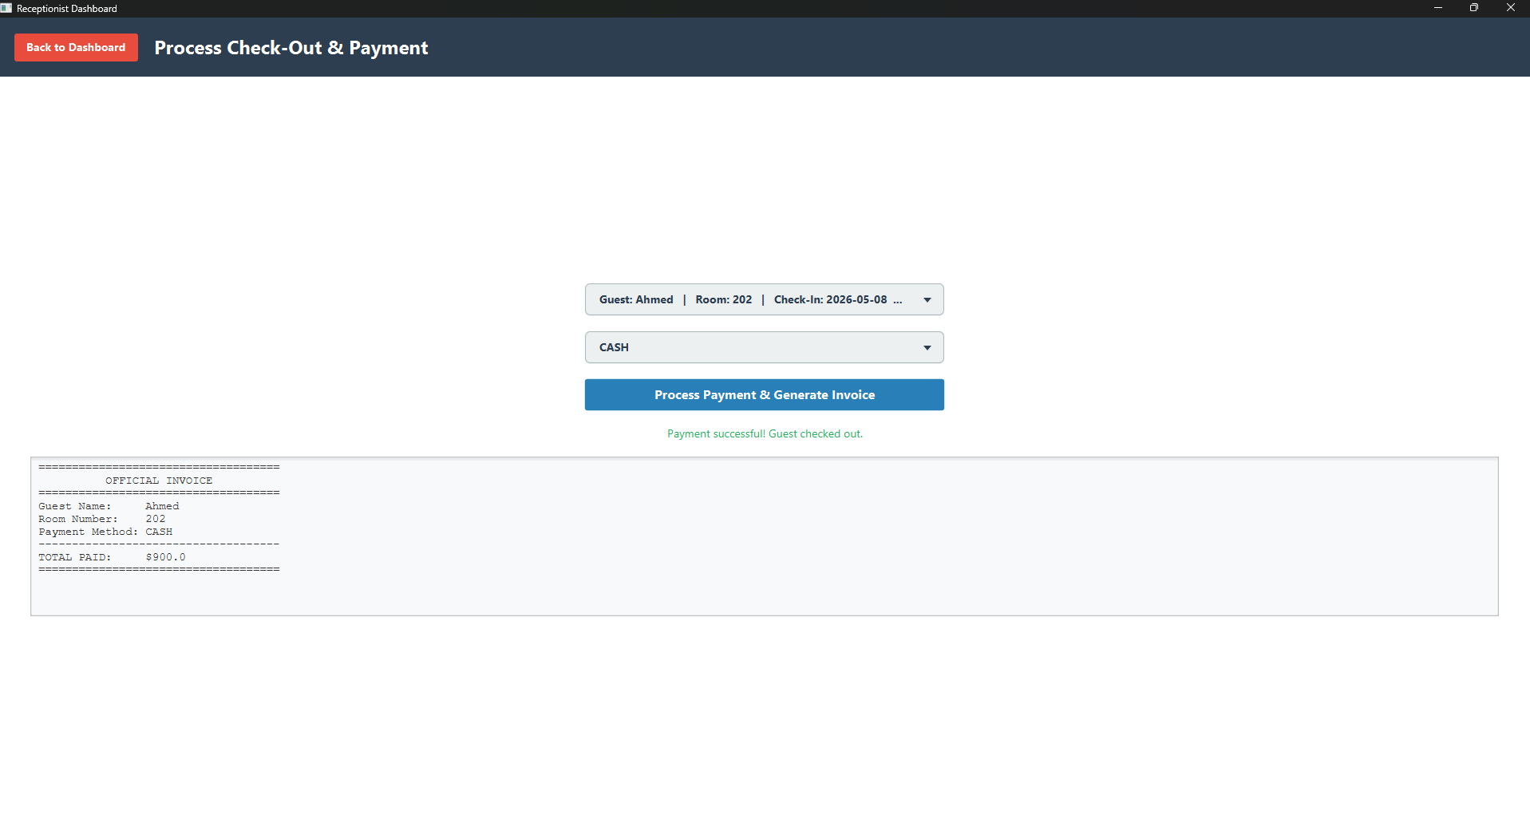
In-Person Check Out

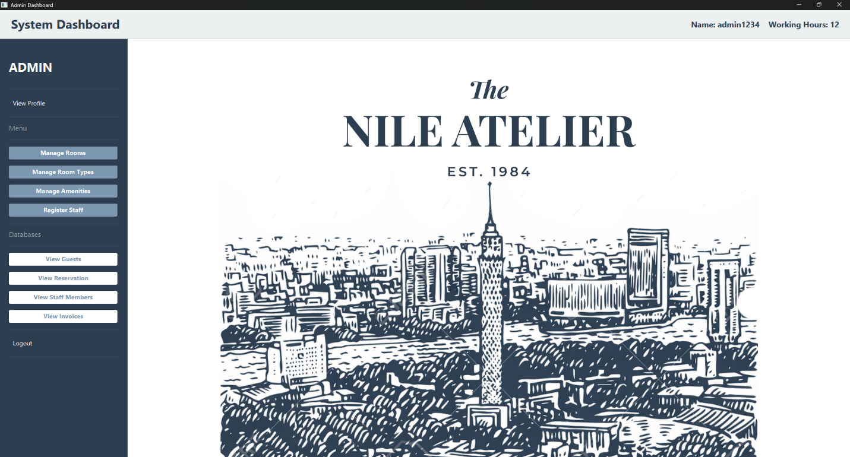
Admin Dashboard

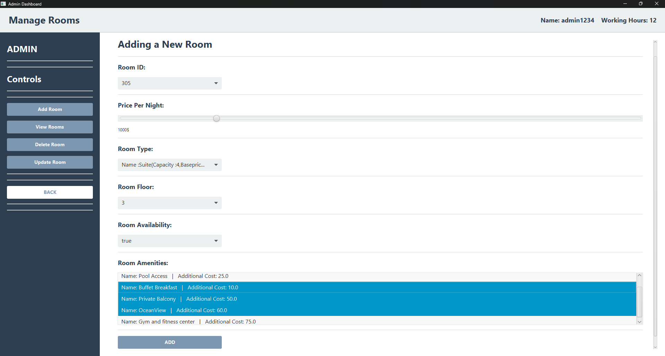
Add Room

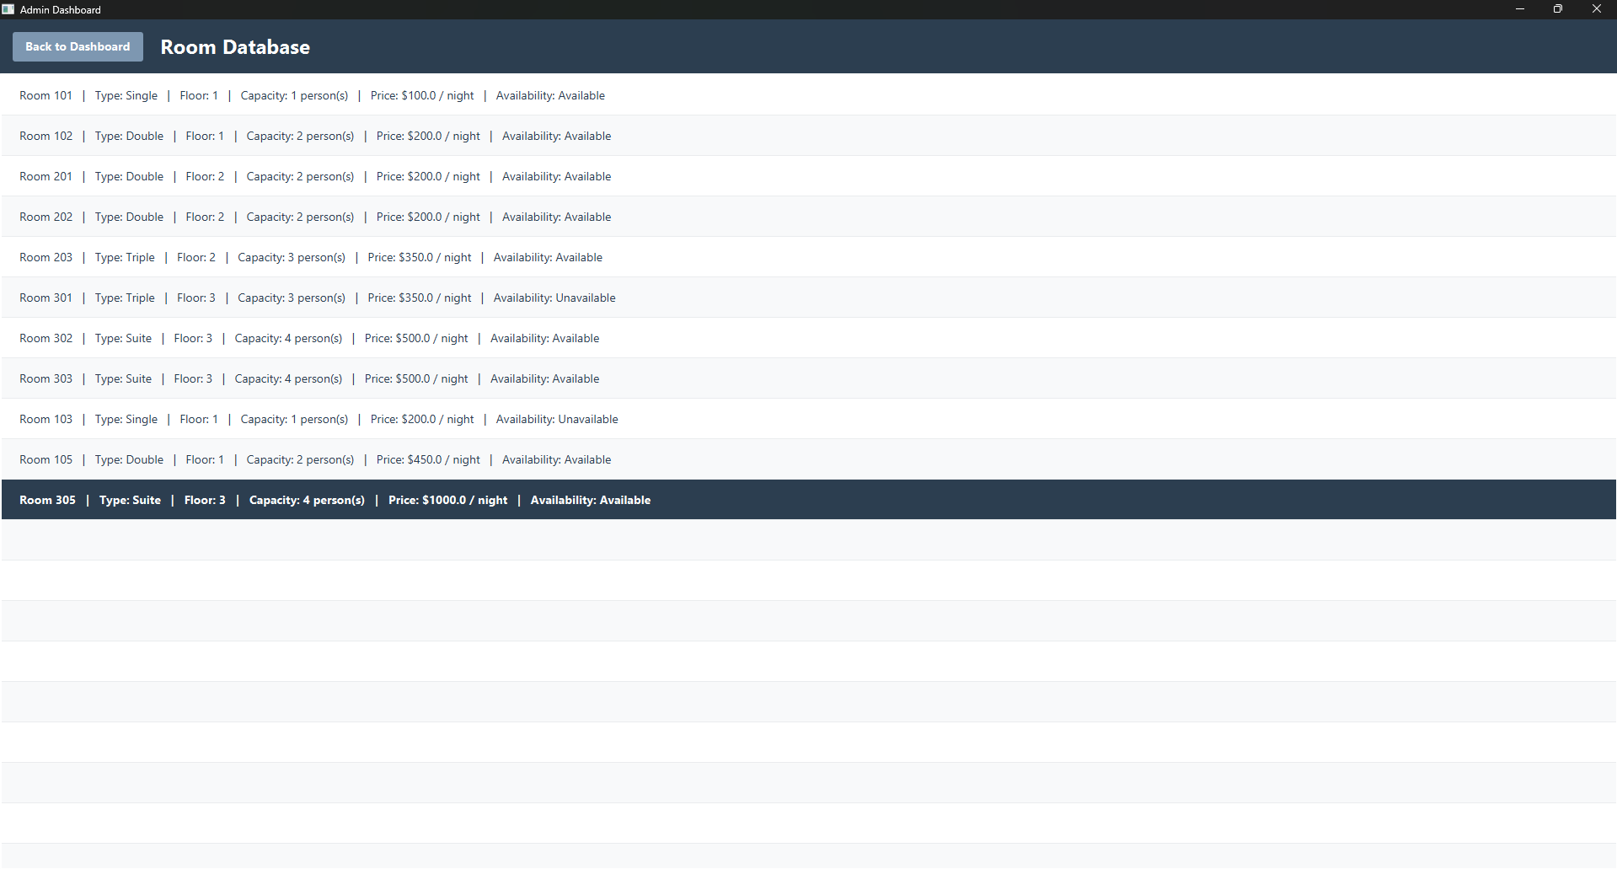
View Rooms

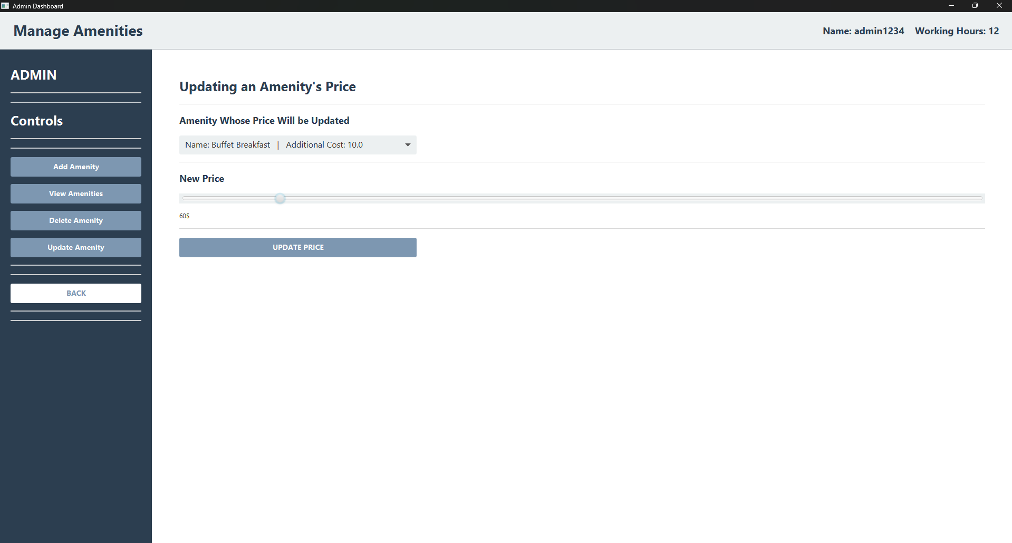
Update Amenity

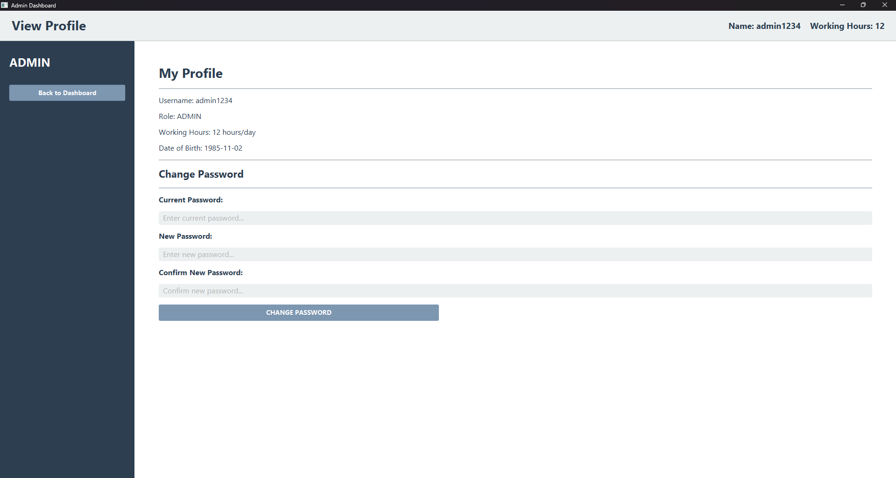
Staff View Profile

8.CONCLUSION
The Nile Atelier Reservation System was successfully developed as a fully functional desktop application using Java and JavaFX. The system delivers a complete hotel management experience across three user roles — Guest, Receptionist, and Admin — each with a tailored interface and role-specific capabilities. The application follows a clean MVC architecture, separating business logic from the user interface and ensuring maintainability and scalability.
Throughout the development process, the team overcame several technical challenges including JavaFX configuration across multiple development environments, Git version control conflicts, and cross-screen navigation consistency. These were resolved through proper dependency management, environment-specific VM configuration, and a unified scene-switching approach that ensures fullscreen display on all screens regardless of the host machine's resolution.
The result is a stable, user-friendly application that covers the core operations of a hotel management system, from guest registration and room browsing to reservations, check-in, check-out, invoicing, and administrative control — laying a solid foundation for future enhancements such as database integration, online booking, and reporting features.

