Name : Salma Mohamed Fouad
Supervised BY: dr. Ayman Alhelbawy

Balancing Approach
To balance the‘OTHER’category itself also make the class as all almost balanced with other classes
• Determine the target sample size by taking the minimum sample count across all categories inside ‘OTHER’ (n = 811).
• Downsample each subcategory within ‘Other’to match this target, preserving smaller subcategories that already have fewer samples.
• Combine the balanced ‘Other’ subcategories with the remaining non-Other categories, keeping their original distribution.

This approach results in a more balanced dataset, reducing the risk of bias toward the "Other" category and improving model generalization across all classes.

With countVectorizer With TF-IDFVectorizer
SVC (with classwight) | Accuracy | Recall | Precision | F1-score
BOW | 0.63 | 0.71 | 0.59 | 0.63
POS | 0.15 | 0.19 | 0.15 | 0.13
NER | 0.18 | 0.20 | 0.17 | 0.12
POS+NER | 0.20 | 0.23 | 0.19 | 0.17
SVC (with classwight) | Accuracy | Recall | Precision | F1-score
BOW | 0.66 | 0.72 | 0.61 | 0.65
POS | 0.13 | 0.17 | 0.14 | 0.12
NER | 0.18 | 0.20 | 0.17 | 0.12
POS+NER | 0.20 | 0.22 | 0.19 | 0.16

SVC () | Accuracy | Recall | Precision | F1-score
BOW | 0.67 | 0.66 | 0.65 | 0.65
POS | 0.34 | 0.13 | 0.15 | 0.11
NER | 0.41 | 0.14 | 0.15 | 0.11
POS+NER | 0.40 | 0.17 | 0.20 | 0.15
SVC () | Accuracy | Recall | Precision | F1-score
BOW | 0.684 | 0.67 | 0.66 | 0.66
POS | 0.32 | 0.12 | 0.20 | .10
NER | 0.41 | 0.14 | 0.15 | 0.11
POS+NER | 0.394 | 0.17 | 0.30 | 0.16
Multinomial Naive Bayes | Accuracy | Recall | Precision | F1-score
BOW | 0.613 | 0.42 | 0.75 | 0.46
POS | 0.27 | 0.11 | 0.11 | 0.07
NER | 0.22 | 0.10 | 0.13 | 0.06
POS+NER | 0.42 | 0.14 | 0.19 | 0.12

Multinomial Naive Bayes | Accuracy | Recall | Precision | F1-score
BOW | 0.64 | 0.67 | 0.60 | 0.62
POS | 0.271 | 0.11 | 0.15 | 0.09
NER | 0.21 | 0.10 | 0.13 | 0.07
POS+NER | 0.39 | 0.15 | 0.19 | 0.14

MLP | Accuracy | Recall | Precision | F1-score
BOW | 0.64 | 0.70 | 0.60 | 0.64
POS | 0.32 | 0.15 | 0.18 | 0.13
NER | 0.410 | 0.14 | 0.15 | 0.11
POS+NER | 0.36 | 0.18 | 0.25 | 0.16
MLP | Accuracy | Recall | Precision | F1-score
BOW | 0.550 | 0.48 | 0.49 | 0.48
POS | 0.30 | 0.15 | 0.20 | 0.12
NER | 0.41 | 0.14 | 0.18 | 0.11
POS+NER | 0.36 | 0.18 | 0.25 | 0.16

HMM | Accuracy | Recall | Precision | F1-score
BOW | 0.182 | 0.11 | 0.11 | 0.09
POS | 0.044 | 0.09 | 0.09 | 0.03
NER | 0.041 | 0.11 | 0.10 | 0.03
POS+NER | 0.07 | 0.09 | 0.10 | 0.06
HMM | Accuracy | Recall | Precision | F1-score
BOW | 0.13 | 0.10 | 0.11 | 0.08
POS | 0.0445 | 0.09 | 0.09 | 0.03
NER | 0.38 | 0.10 | 0.13 | 0.07
POS+NER | 0.07 | 0.9 | 0.10 | 0.6
Confusion Matrix :
1) SVC(with class weights) X BOW_tfidf
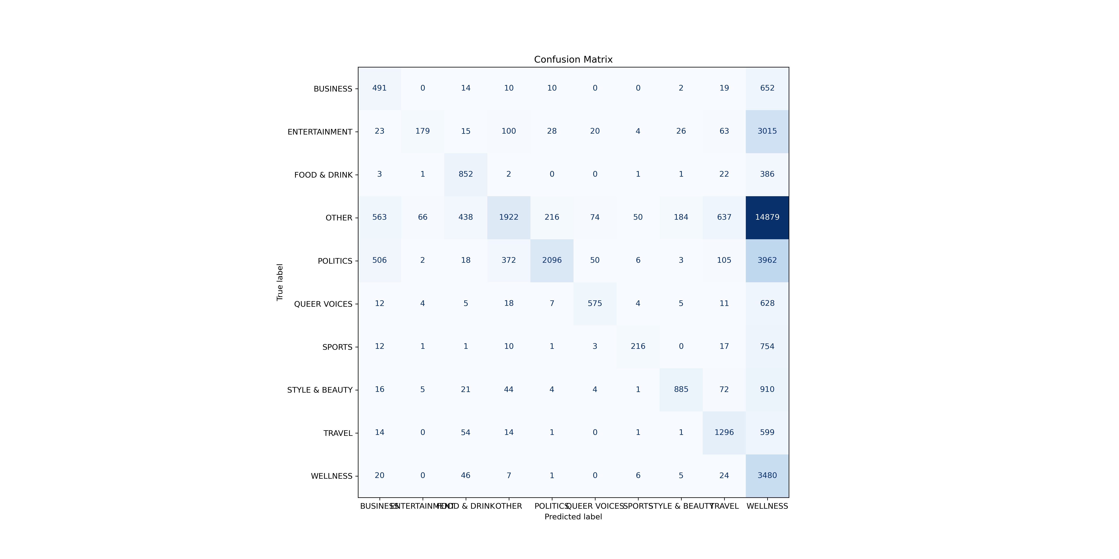
2) SVC() X BOW_tfidf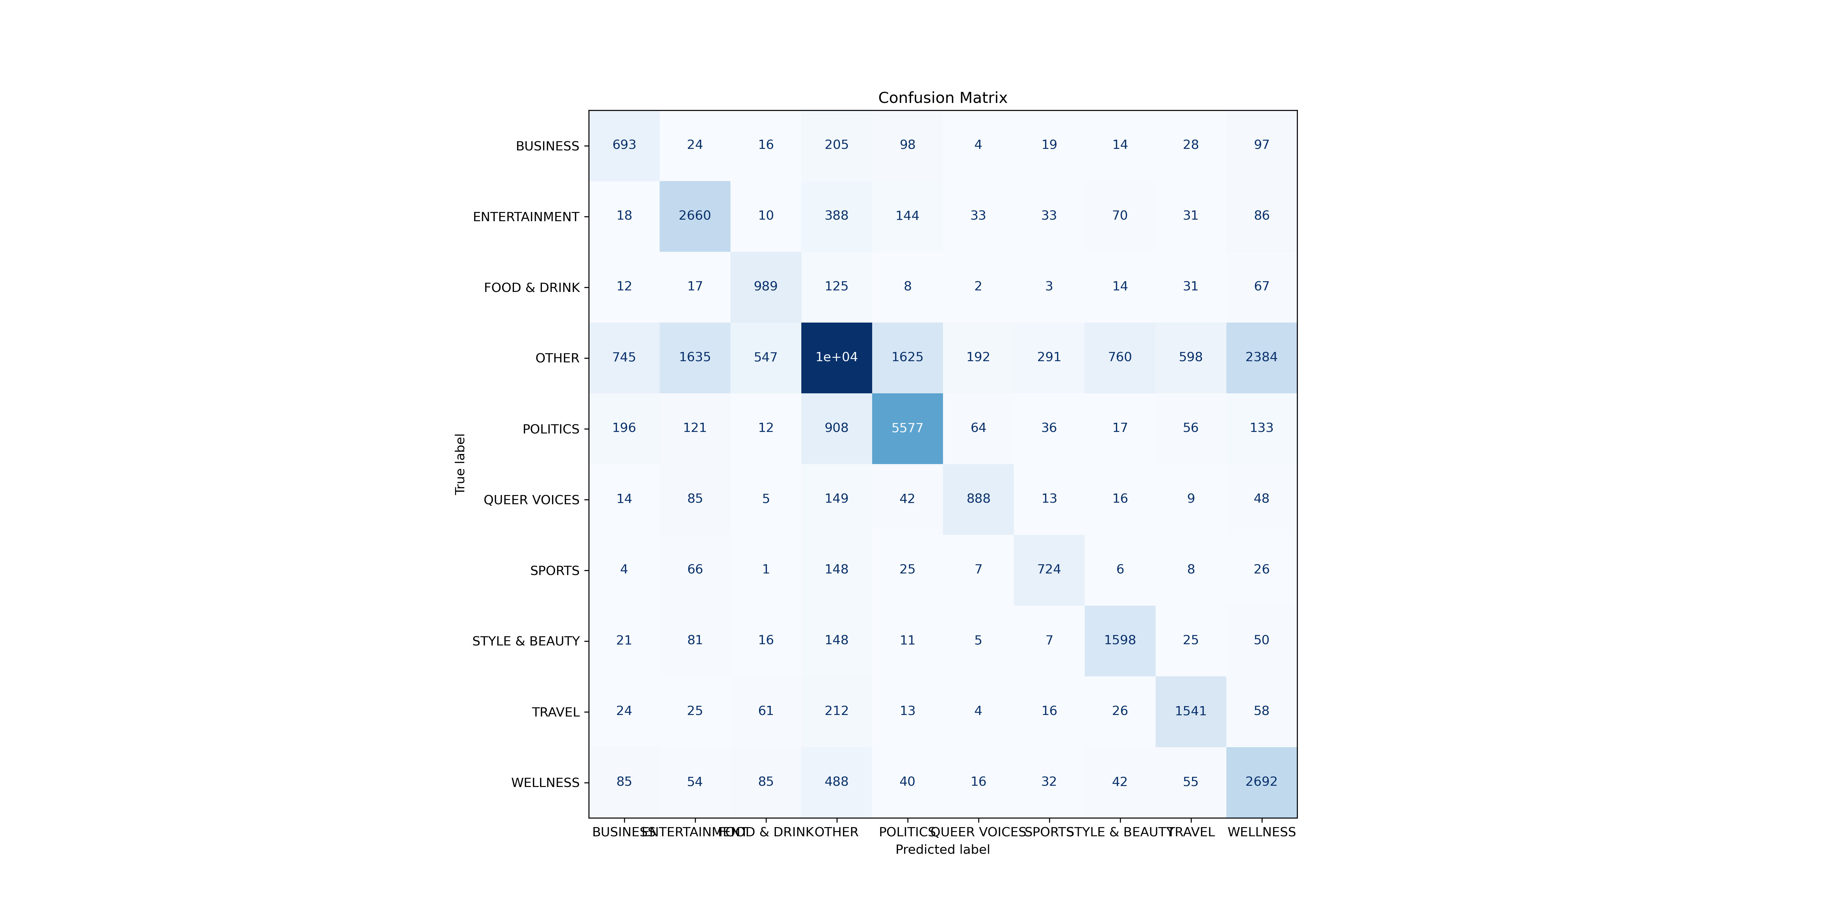

3) NB X BOW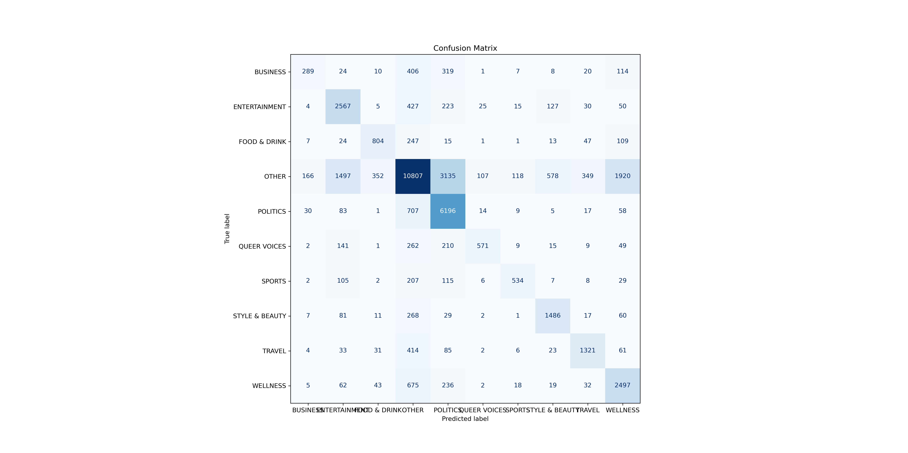

4) MLP X BOW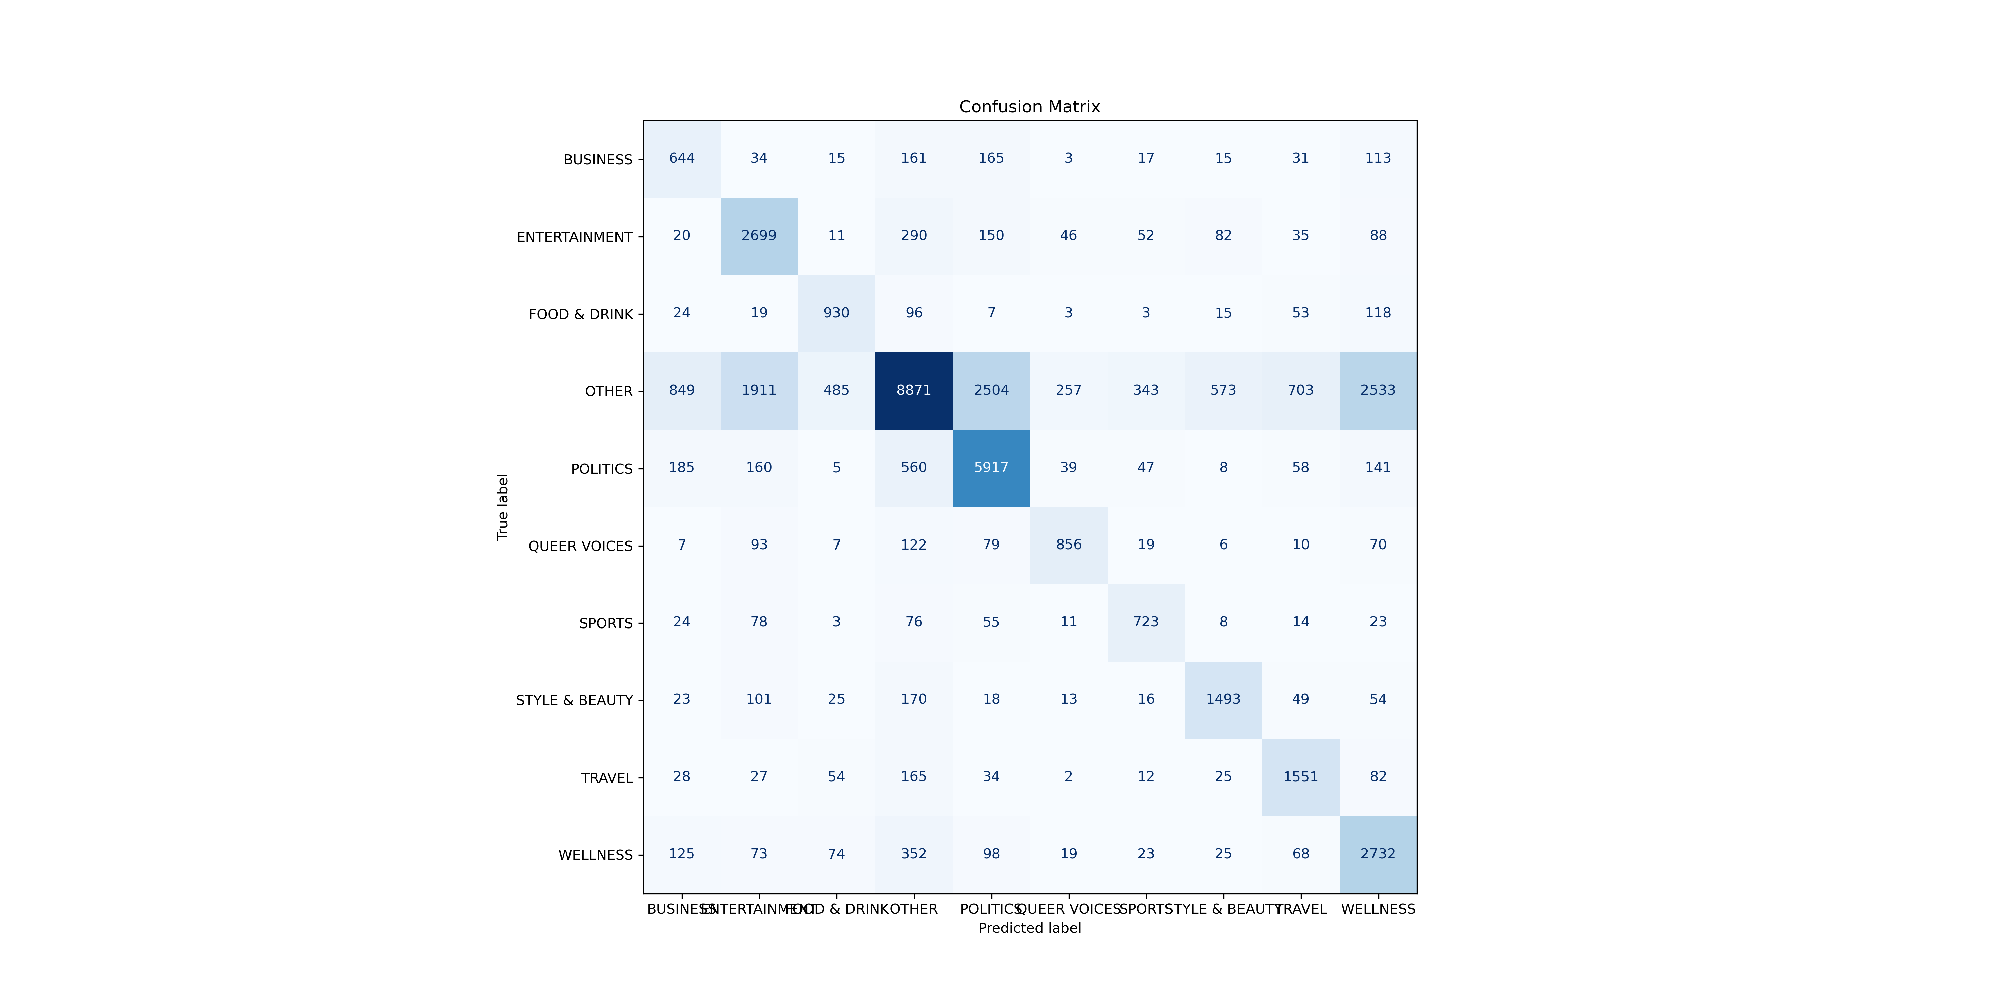
5)HMM X NER_tfidf
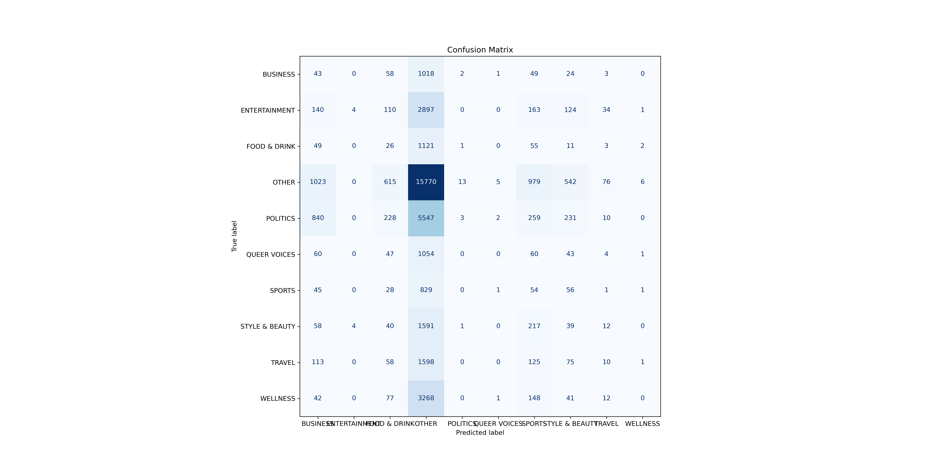
6) HMM X BOW
