Name : Salma Mohamed Fouad
Supervised BY: dr. Ayman Alhelbawy
- Part 2
- Preprocessing :
Replace any digit with <num>
Removed any non-word char

- Build N gram Models:
Using “def build_word_model_with_padding()” :from lab
That create each model with every word with the (n-1)-words frequencies
- Build models per category:
For each category use “def build_word_model_with_padding()”
Saves:
ngram_counts: A frequency dictionary containing all observed n-grams and their occurrence counts within the category.
total_ngrams: The total number of n-grams extracted from the category corpus, used for probability normalization.
vocab: The vocabulary set containing all unique tokens observed in the training data for the category.
vocab_size: The size of the vocabulary ,used for smoothing techniques such as Laplace smoothing.
n: The order of the language model (e.g., unigram, bigram, trigram).

- Probability | Perplexity :
- Two classification criteria are supported:
- Maximum log-likelihood, which selects the class that assigns the highest probability to the input sequence.
- Minimum perplexity, which selects the class for which the sequence is least surprising.

Perplexity provides a normalized measure of model fit, while log-likelihood reflects the raw sequence probability.

The vocabulary size |V| is added in the denominator as part of Laplace smoothing. This adjustment is used to:
- Avoid Zero Probabilities: It prevents the model from assigning zero probability to unseen n-grams, which would otherwise make them impossible during inference.
- Improve Generalization: By allocating probability mass to unseen or rare events, the model can better handle out-of-vocabulary words in new data.

Tried 2 data (original vs OTHERresampled)
 | Original | OTHERresampled
Unigram | 0.4894 | 0.4635
Bigram | 0.3164 | 0.3498
Trigram | 0.1649 | 0.1458

Confusion matrices :
Original UNIgram:
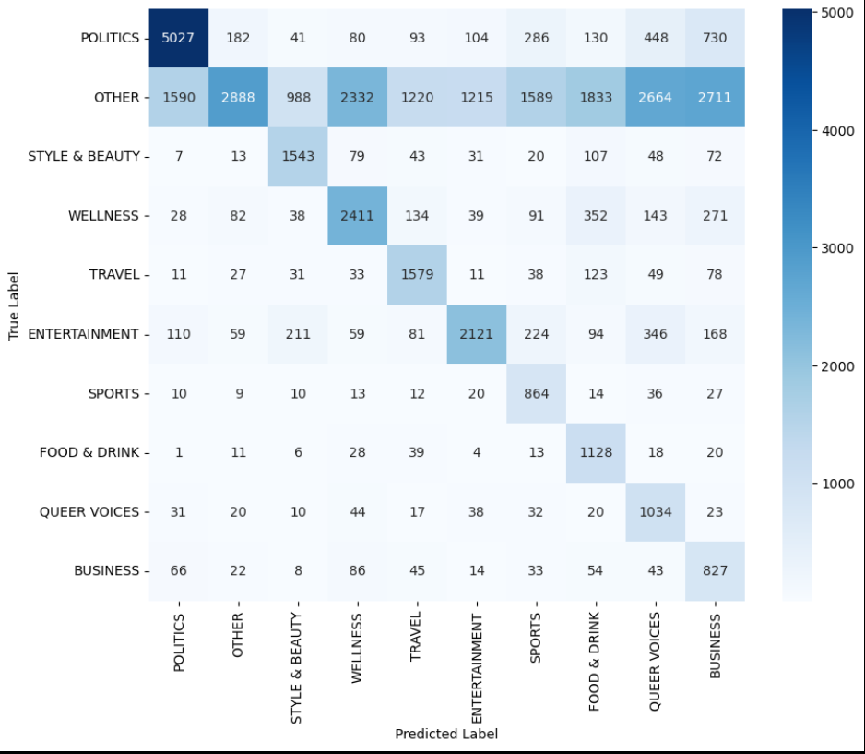

OTHERresampled UNIgram:
