Business case for investors

GROUP MEMBERS:

Marc Kishinkwa 24246603

Salmaan Vally 26049597

Adrian Van Kraayenburg 24165220

Mathapelo Ngoasheng 25955527

Dinah Lee Booysen 26186365

Group 19 WeSellCC

# 1. Executive Summary

WeSellCC is an online clothing store that aims on penetrating the market instantly due to its unbeatable prices, ease of use of its website and mobile application, the business sells clothing consisting of very well-known brands (eg. LEVIS etc…) for male and female. With warehouses in Johannesburg, Cape Town and Durban, the decision from which warehouse a product must be shipped depends on the customers location, the closest warehouse is chosen, to keep shipping costs at a minimal and focus mainly on speedy delivery. The company buys clothing in bulk to get it at a lower price , this will be discussed more in detail below. As well as the target market, various costs and profits associated with the business, the organizational structure, benefits, and how funds were acquired

WeSellCC mission is to present customers with a energizing and wide range of products to choose from, regardless whether it be clothing for running along the beach up until coats that one would wear if the outside temperature is below freezing

The company’s objectives are:

* An accessible website and mobile app that is easy to surf
* Speedy delivery of products
* Customer satisfaction
* Social popularity

A summary of the financial metrics is shown below:

|  |  |  |  |  |  |
| --- | --- | --- | --- | --- | --- |
|  | **Year 1** | **Year 2** | **Year 3** | **Year 10** | **Total Cash Outlay** |
| **Investment Value (£) – Capital and Revenue** | **R308 500** | **R350 000** | **R408 000** | **R1 094 000** | **£x** |
| **Available / Committed Funding** | **R250 000** | **R291 500** | **R349 500** | **R1 035 500** | **£x** |
| **Return on Investment (ROI)** | **R100 000** | **R116 500** | **R139 800** | **R496400** | **£x** |

From the above table it is concluded with an initial investment of R308 500 and a profit mark up of 40% and a fixed amount of salary expenses, dividends of R58 500 a year

It is evident that the company can grow its investment value by 15% each year by re investing the ROI

The ROI grows by 16% each year, if the company carries on running the company in this manner for 10 years, the return on investment will be R496 400 a year, this is after the salaries and dividends have been payed to employees and current shareholders.

# 2. Introduction and Overview

## **2.1) Company Description**

WeSellCC will offer creative, branded male and female clothing, online, that is both functional and beautiful. Salmaan Vally and Marc Kishinkwa, co-owners of WeSellCC, will create a cost-effective operation that will eliminate the cost of inventory by having 3 warehouses within a 300 kilometre radius of each other, WeSellCC inventory control department, handle all buying and shipping of clothing to the customer. WeSellCC will process the order and collect the payment online using PayPal to ensure the customers trust to carry out the payment. The order will then be sent to the WeSellCC inventory control department, either Johannesburg, Durban or Cape Town is chosen depending on the client’s location, after the location is figured the order is filled and shipped. WeSellCC will focus on maintaining good relations with suppliers to ensure the best prices, and marketing of its products.

## **2.2) Types of Consumers/ Target market**

* People that are too busy with their daily lives to be able to make it to a retail store
* Bargain hunters, people that search various online stores and physical stores to obtain the best price before purchasing.
* Consumers with a unique taste for fashion
* Consumers that prefer a large variety of products and ease of use of website and mobile application

## **2.3) Investors and capital**

The two co-founders invested R50 000 each which amount to R100 000 and a long term loan of R208 500 was obtained from a financial provider that amounts to R308 500 of funding that is required in order to start the business, WeSellCC is open to any interested investors

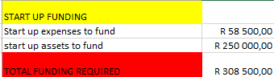

Figure : amount of start-up funding required

Start-up assets to fund includes purchasing of property and merchandise for the warehouses. Such a big amount is required since buying in bulk reduces the cost price which maximises the profit.

The businesses financial information will be discussed more in detail further on in this document under Cost/benefits assessment

## **2.4) Competitive advantages of E-commerce store (WeSellCC)**

* Fewer employees needed , which means less expenses
* Automating inventory management
* Lower order processing costs
* Open 24/7
* Easier to understand customer preferences
* Wider range of customers from all over the country

These five advantages already elaborate that an E-commerce store is more profitable, the main advantage is that it is open 24/7 in comparison to a retail clothing store that is only open during certain hours, and that your product is for sale all over the country instead of it being only for sale in one specific location.

# 3. Market analysis summary:

In the past 15 years, branded fashion wear has grown into a billion dollar niche in the clothing market. The fame of the Internet has launched a number of online stores for branded fashion wear but no company is exclusively selling a wide range of diverse branded products online.  There are a number of reasons for this but the strongest is that the concept is new and untested.  Will clients purchase something that they wear that can only be viewed online?  We trust they will, if the procedure is fun and the products are great and offered at an unbeatable price.

The key is publicising our target customers in the traditional advertising medium for fashion, i.e. google ads, fashion magazine’s

The ads will focused on the eliminating the middle man in your clothing budget and stepping up to the individual style of WeSellCC. The company emblem will also be an important advertising tool in bringing customers to our website.

## **3.1) Market segmentation**

WeSellCC will focus on two separate group ages of male and females:

* Male and female 17-25 years of age

Youth help drive the market so this is a must attract group to the website, since majority of the youth have less money than the older class which will be discussed next, the solution is to have inexpensive products in each category and range , the company’s logo will be seen and remembered, and the small purchases will grow overtime as this age category start earning more money.

* Male and female 26-40 years of age

This age category is the main group which will drive WeSellCC , this group is responsible for the growth of the company. Since they older it will be slightly harder to attract them in comparison to the youth, but once they attracted WeSell will deliver quality, savings and a hassle free and speedy return policy, these are key factors of the companies success. The key factors will bring them back to the website to purchase more products.

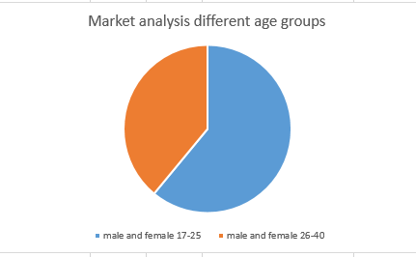

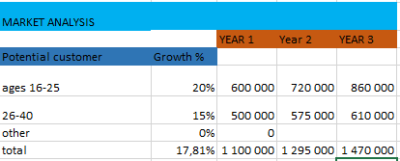

# 4. Strategies and assessment of benefits:

## **4.1) Sales Strategy**

WeSellCC will offer various types of discounts at random selected days initially during the first 3 months, to create awareness of the website. The discounts will include:

* 15% off , on a total bill of R300 or more
* Certain products will be on sale to even out seasonality, a reduced sale of 25% on the selected items

## **4.2) Sales forecast**

WeSellCC expects sales to increase steadily during the first year, it will start slow but once our sales strategy is implemented it is expected to increase at a much quicker rate, the forecast indicates that we will achieve a 38% percent increase during the first and second year, we only expect this amount to increase. The company is certain that this goal can be achieved, A graph showing a sales forecast is shown below:

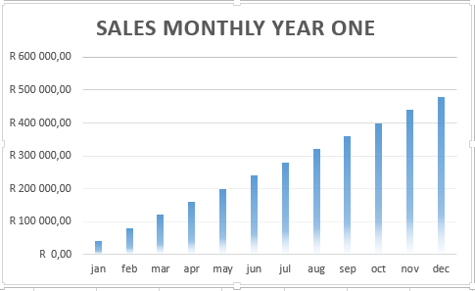

## **4.3) Benefits of investing in WeSellCC ( E-commerce store)**

The benefits of investing in WeSell is summarised below

* Overcome geographical limitations

If you have a physical store you are restricted to a certain location , whereas with an online store products can be bought from any location in South Africa

* Gain new customers with search engine visibility

If a internet user is searching the web for clothing products for sale , WeSell will be listed in the searches.

* Lower costs

No personnel will be required except for 4 employees in each warehouse, this reduces personnel costs.

* Finding the product quicker
* Provide detailed information about products
* Open for business 24/7

All of the above mentioned benefits creates a lot of room to reduce costs and target customers using various strategies such as being listed on price check and making use of pop up adds to inform internet users when sales are taking place.

If the investor chooses to do nothing he will lose out on a R140 000 return of investment of R100 000 a year, which is a 40% ROI , the return on investment is calculated based on the projected sales forecast without taking the strategies into consideration, there is a high possibility that the forecast can increase in bigger increments.

# 5. Cost/benefits assessment

## **5.1) Break-even analysis**

The break-even analysis is based on running costs and fixed costs which include rent, payroll, utilities and marketing costs

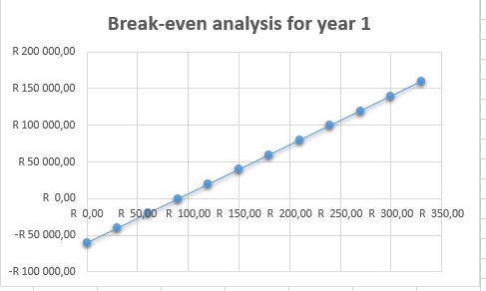

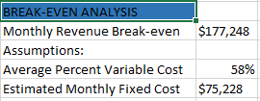

## **7.2) Projected Profit and Loss**

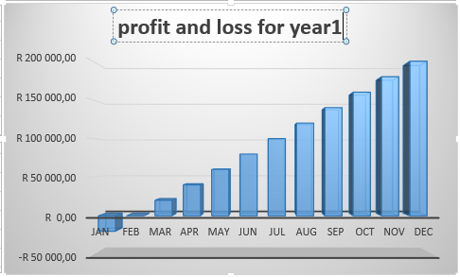

Projected Profit for 3 years:

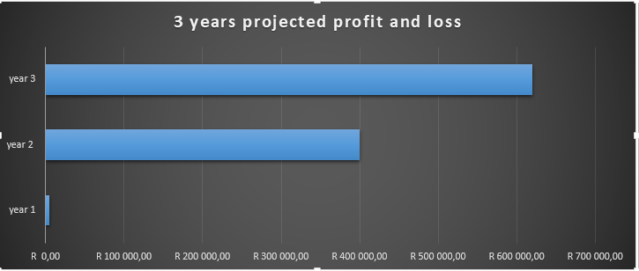

## **5.3) Start-up funding/total assets, liabilities and capital**

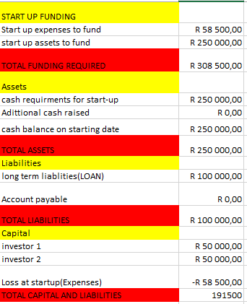

## **5.4) Summary of start-up expenses**

## **5.4) Gross margin**

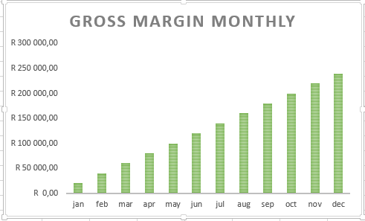

## **5.5) Profit and loss statement**

