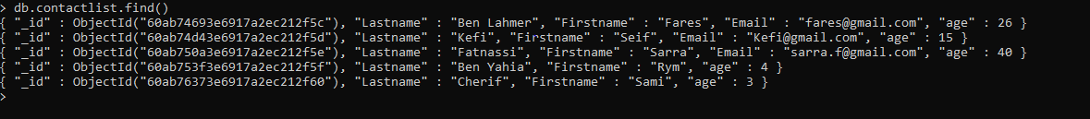

* Display all the information about only one person using his ID.



* Display all the contacts with an age >18



* Display all the contacts with an age>18 and name containing "ah"



* Change the contact's first name from"Kefi Seif" to "Kefi Anis"

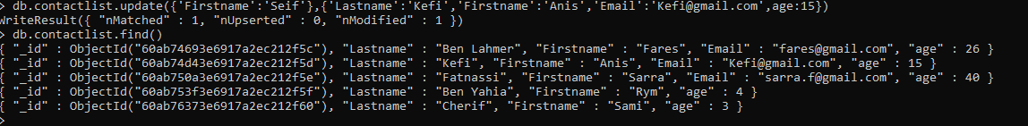

* Delete the contacts that are aged under <5
* Display all of the contacts list

