MLOps Pet Breed Classification
Issue #46 / PR #57 Evidence Report
Sprint 5 – E1: Airflow Drift-Triggered Retraining DAG

1. Scope
- This report documents the work completed for Sprint 5 Issue #46 and PR #57, including implementation, validation, Docker/Airflow execution, the real execution attempt, resource limitation encountered, cleanup, and current PR status.

2. PR #57 Status
- PR #57 – [S5][E1] Implement Airflow drift-triggered retraining DAG.
- Base branch: dev.
- Feature branch: feature/s5-issue-46-airflow-retraining-dag.
- PR remains open and has not been merged.
- The work is kept separate from dev/main until explicitly approved.

3. Work Completed
- Added an isolated Airflow 3.3.2 runtime using Docker Compose.
- Added the pet_breed_drift_retraining DAG.
- Implemented: drift check → candidate retraining → candidate evaluation → quality gate.
- Connected the DAG to the existing Sprint 4 drift scorecard through a drift decision step.
- Added candidate retraining and candidate evaluation scripts.
- Added DAG validation and retraining-artifact tests.
- Added a resource-conscious Airflow training configuration using CPU-friendly settings, num_workers=0 and batch_size=8.
- Disabled pin_memory and persistent_workers for the Airflow data loaders.
- Added atomic candidate artifact handling so an incomplete training run does not replace a valid candidate.
- Kept the data policy explicit: train for fitting, validation for model selection, and test protected from fitting.
- Added Airflow retraining documentation/runbook.
- Removed generated/debug runtime artifacts from the PR and restored unrelated Sprint 4 evidence changes.

4. Airflow Environment Validation
- The Airflow environment was successfully built and started after resolving the local Docker/WSL runtime issue.
- Airflow 3.3.2 was confirmed and the DAG was discovered successfully.
- The discovered DAG was pet_breed_drift_retraining and was loaded by a real Airflow runtime.

5. Real DAG Execution Attempt
- A real manual DAG run was triggered. The drift-check task completed successfully and detected drift, so the workflow proceeded to candidate retraining.
- Run ID: manual__2026-10-06T11:37:23.234757+00:00.
- The retraining task started and produced training output, but the process was terminated by the Docker environment because of memory exhaustion.
- Docker inspection showed OOMKilled=true and the process ended with SIGKILL (signal 9).
- A partial checkpoint was produced, but it is intentionally NOT treated as successful candidate evidence. Evaluation and quality-gate completion were not reached.

6. Screenshot Evidence
- The original screenshots from the previous work sessions need to be inserted here: Airflow runtime, DAG discovery/graph, drift detection, retraining logs, resource/OOM evidence, PR #57, and CI/CD validation.

7. Validation and Cleanup
- Generated runtime/debug artifacts were removed from the branch.
- Sprint 4 monitoring scorecard files were restored to the dev versions so Issue #46 does not introduce unrelated evidence changes.
- The generated drift decision is treated as runtime output rather than committed static evidence.
- The cleanup was committed and pushed to the existing Issue #46 feature branch.
- No merge into dev or main was performed.

8. Acceptance Status
- Airflow DAG importable/validated: COMPLETED – DAG discovered successfully.
- Drift condition can trigger retraining: COMPLETED – real run passed drift check and entered retraining.
- Candidate artifacts produced by a real run: PARTIAL – partial checkpoint produced, but retraining was OOM-killed.
- Protected test split: IMPLEMENTED – test split remains protected from fitting.
- Full end-to-end DAG execution with real evidence: NOT COMPLETED – blocked by local Docker memory exhaustion.

9. Conclusion
- Issue #46 has a working Airflow/DAG implementation and was exercised in a real runtime. The important limitation is the local resource constraint during retraining. We will not claim a successful end-to-end retraining run without real evidence. This report records the actual result without overengineering or fabricating evidence.

Appendix A — Airflow Execution Screenshots
The following screenshots provide visual evidence from the real Airflow execution described in this report.
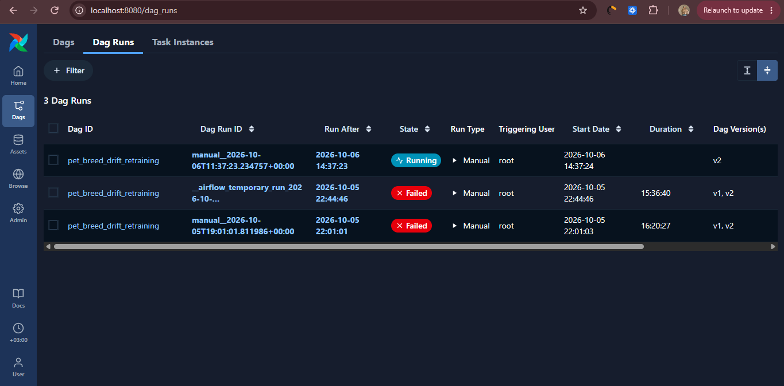
Screenshot 1 — Airflow DAG Runs
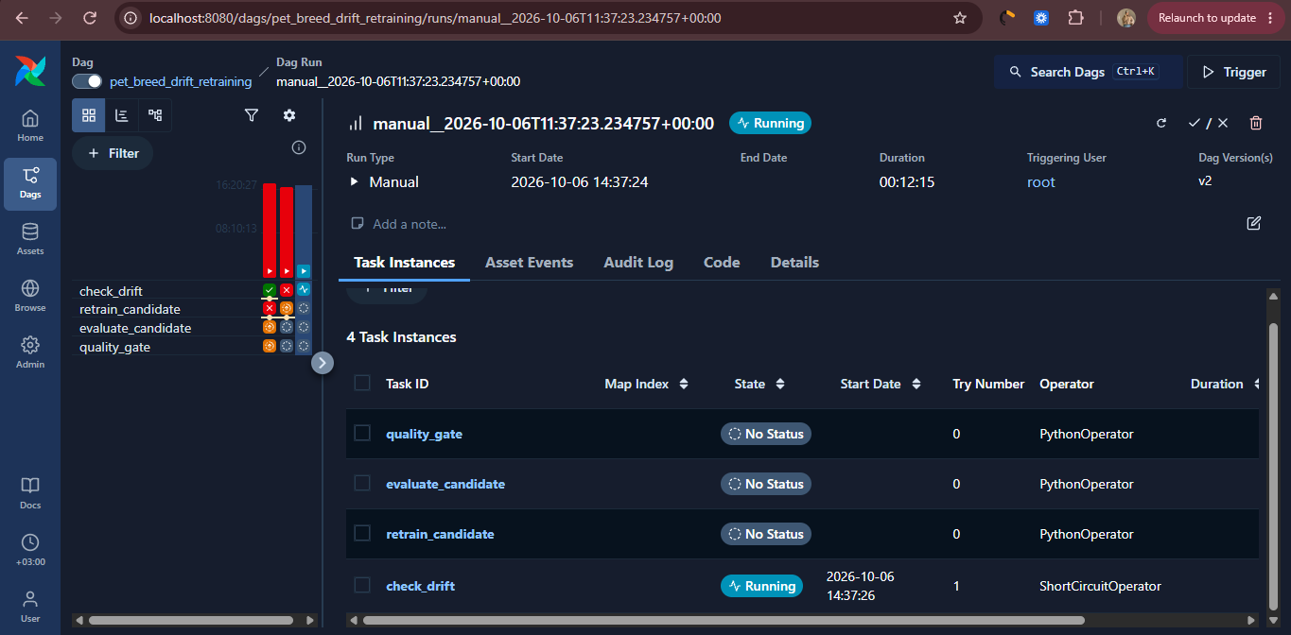
Screenshot 2 — Drift Check Running
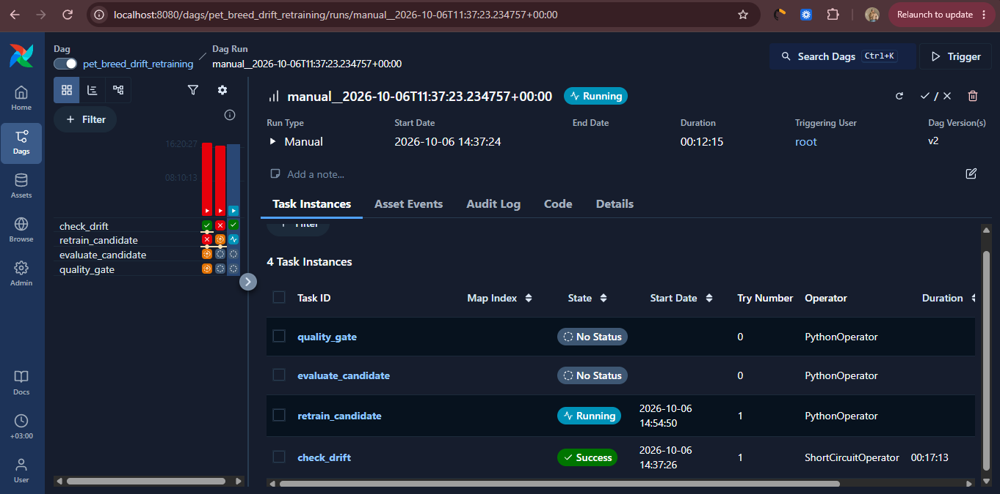
Screenshot 3 — Drift Check Succeeded / Retraining Running
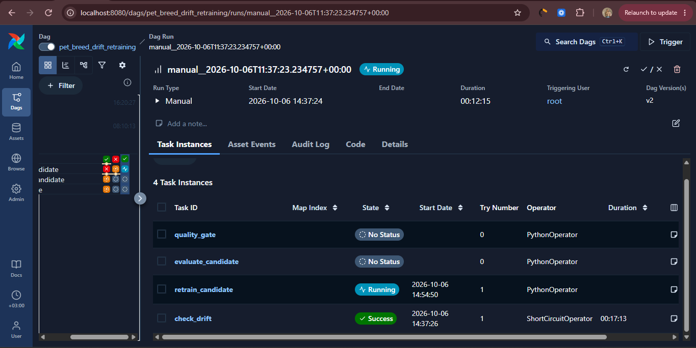
Screenshot 4 — Retraining Still Running
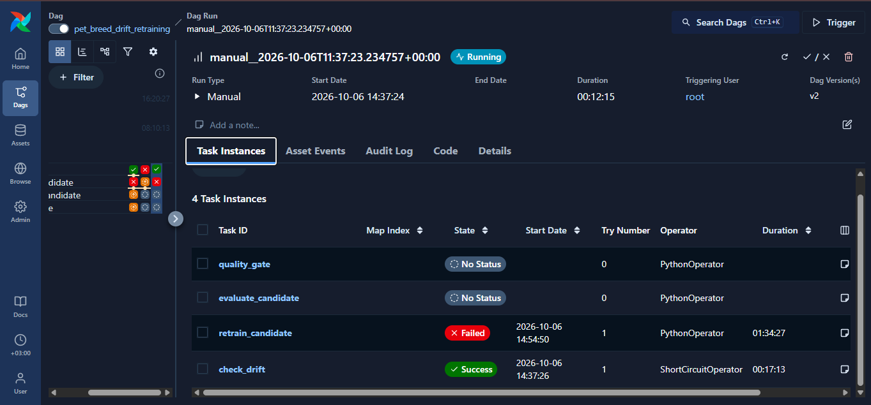
Screenshot 5 — Retraining Failed; Evaluation and Quality Gate Not Executed

