Online Mobile Store UML

Entity-Relationship Diagram (ERD)

is a visual representation used to model the structure of a **database**. It illustrates the relationships between **entities** (such as tables) and their **attributes**. ERDs help database designers and developers understand the data schema and plan how data will be stored and retrieved.

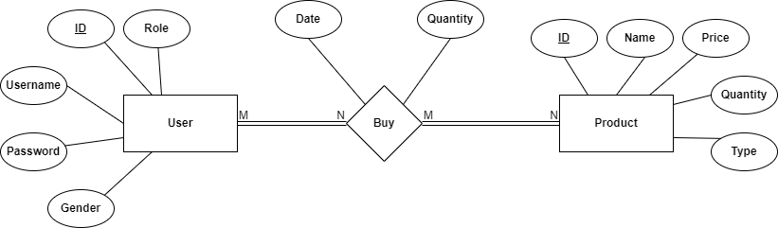

# Use Case Diagram

The diagram showcases relationships between **actors**, **use cases** (system functionalities), and the **system** itself. It summarizes how users (actors) interact with a system or software application.

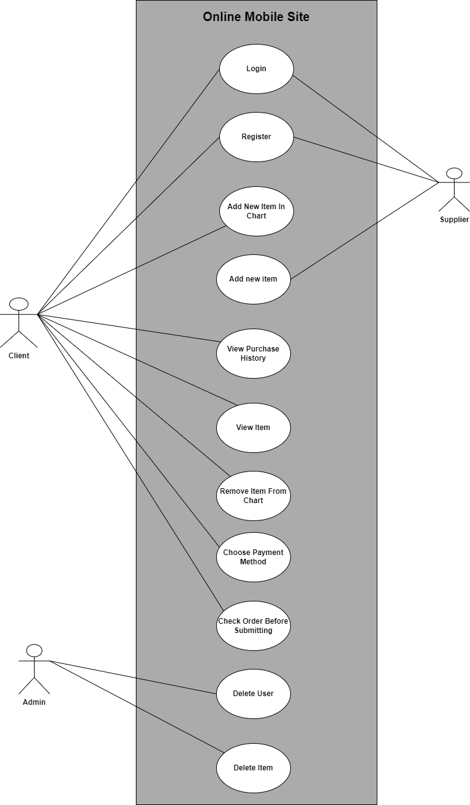

# High Level Decomposition

This decomposition diagram outlines the main modules of the system and their relationships.

Each module represents a distinct aspect of the Online Mobile Store project.

