# Log-In Model:

A Client or Supplier or Admin can login using username “unique email” and password as main required input values.

## First class Diagram for Log-in:

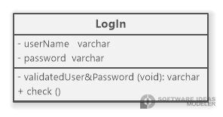

Second Flow Chart for function inside the model: 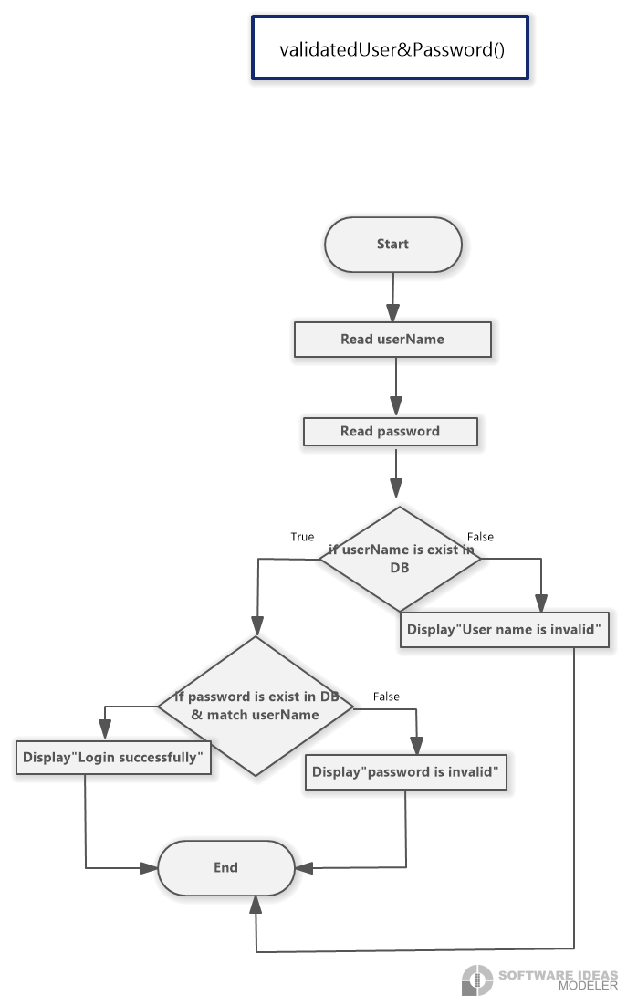 **id=**OMS-DESIGN-VALOG****

Third Sequence Diagram for model: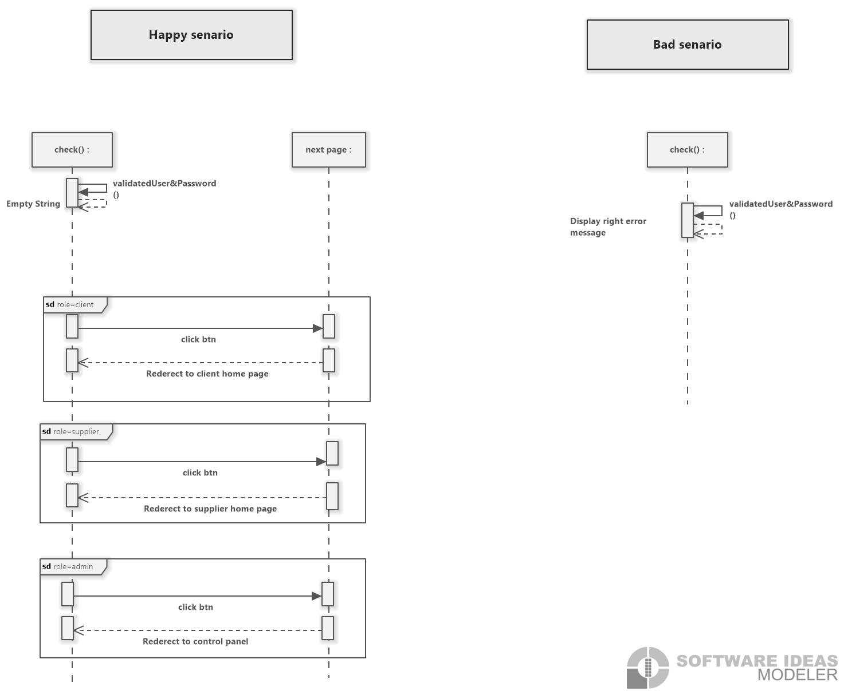**ID=**OMS-DESIGN-CHKLOG****

# Sign Up Model:

A Client or Supplier can create a new account using full name, email, gender and the role (Client or Supplier) as main required input values.

## First class Diagram for Sign UP:

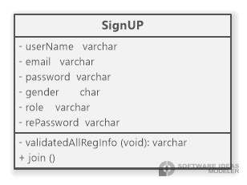

Second Flow Chart for function for this model:

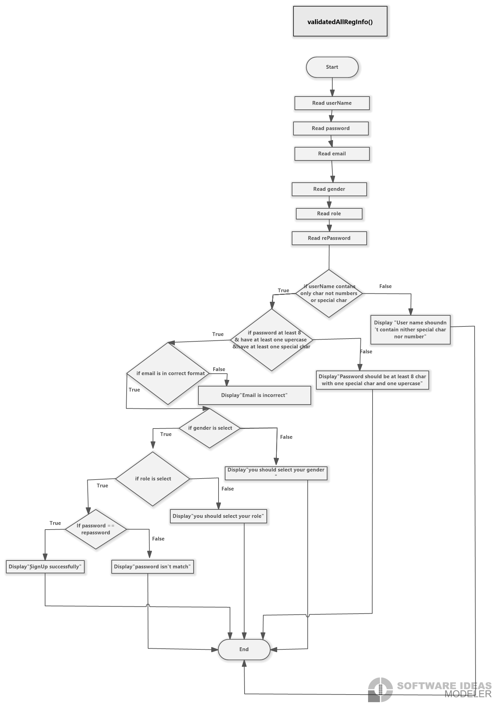

**ID=**OMS-DESIGN-VALREG****

Third Sequence Diagram for model 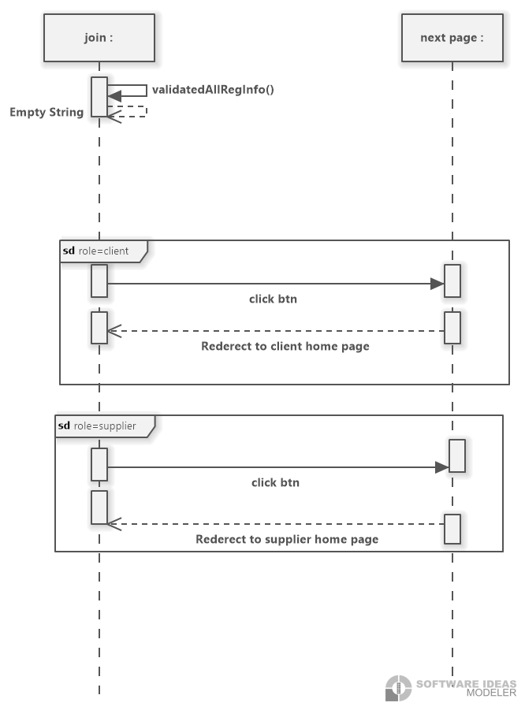**ID=**OMS-DESIGN-JOIN****

**The Supplier Module** makes it easy for suppliers to manage their inventory by adding new items effortlessly. Suppliers can provide item information like name, category, description, price, and photo, making the online store's product selection more varied. This module helps suppliers interact smoothly, ensuring that the store's inventory stays up-to-date for customers to browse and purchase.

1. **Class diagram:** which shows the Supplier module including its attributes and functions.

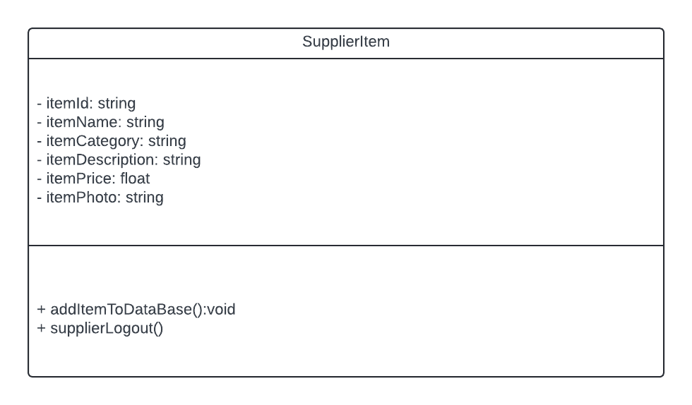

1. **Flow Charts:** which shows the flow of functions.

This is the flow chart for addItemToDataBase() function:

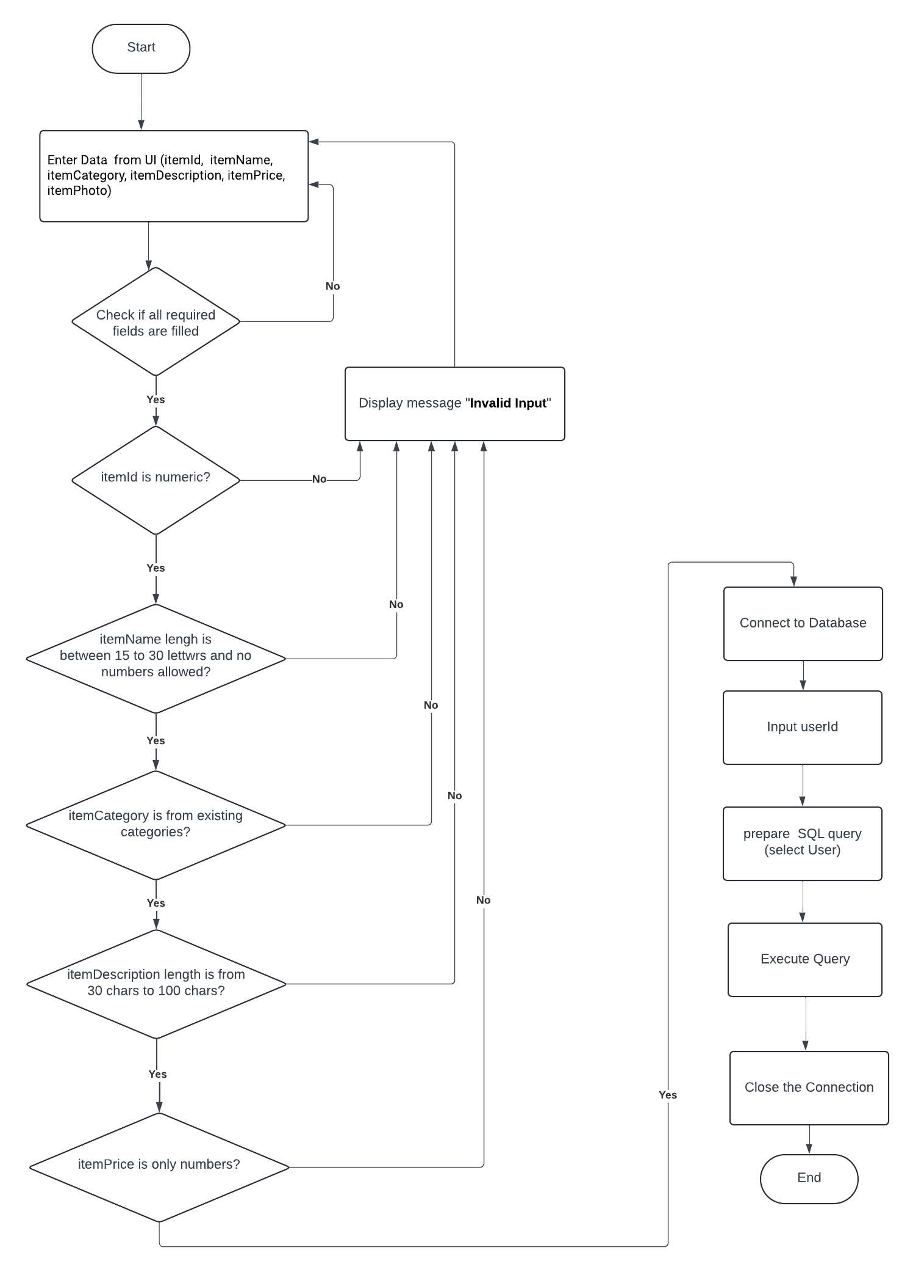

**ID=**OMS-DESIGN-ADDB****

This is the flow chart for supplierLogout() function:

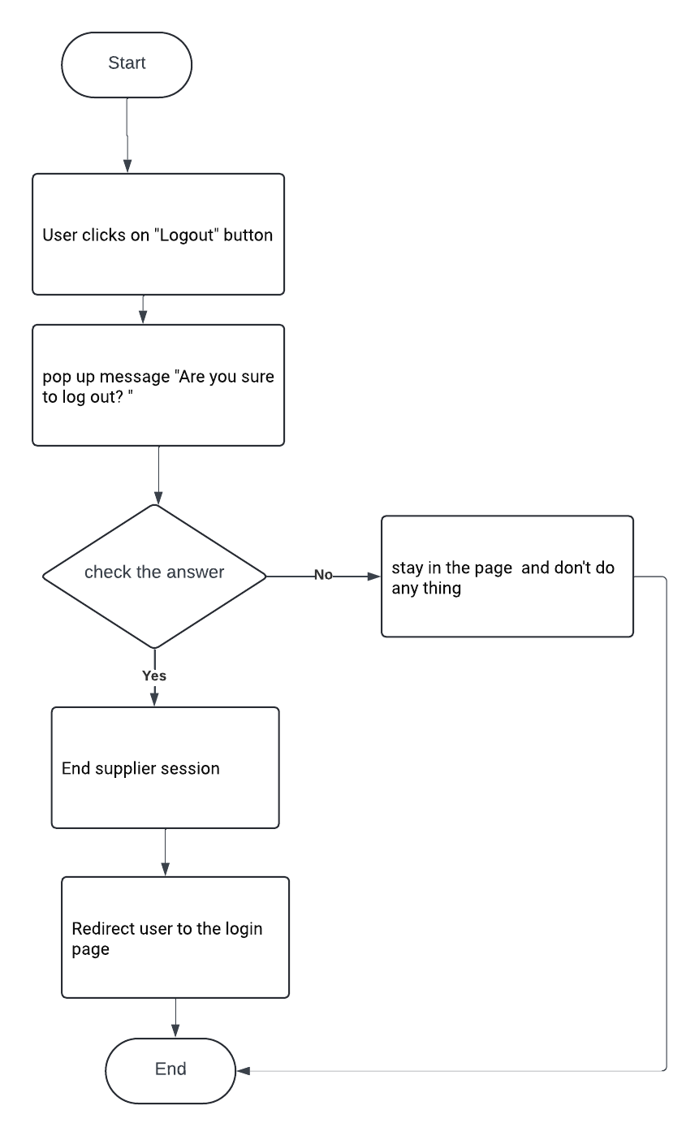

**ID=**OMS-DESIGN-OUT****

1. **Sequence diagram:** which shows the interfaces .

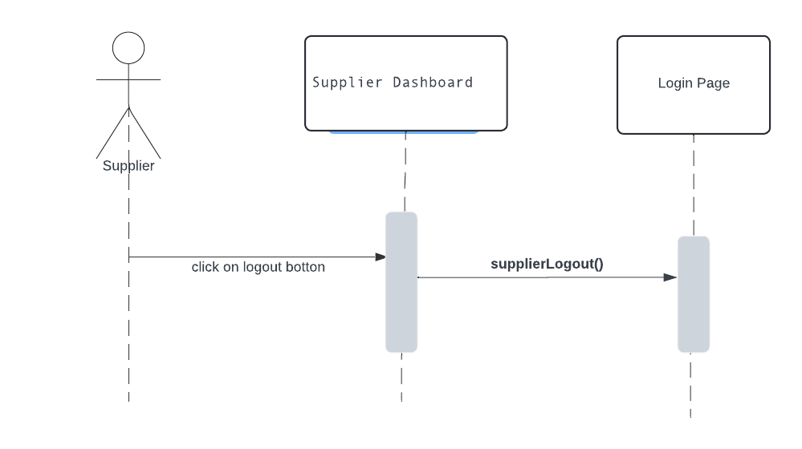

**Admin Module** is responsible for managing user accounts and items within the system. It provides functionalities such as deleting users and items from the database. The module ensures proper system administration and data management.

1. **Class diagram:** which shows the admin module including its attributes and functions.

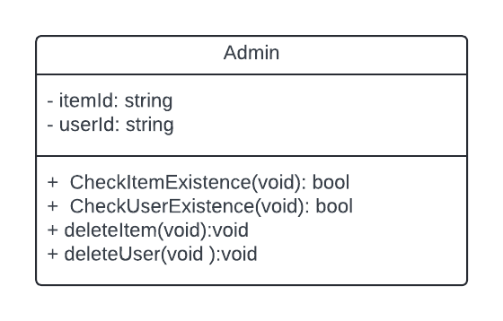

1. **Flow Charts:** which shows the flow of functions.

This is the flow chart to CheckUserExistence() function :

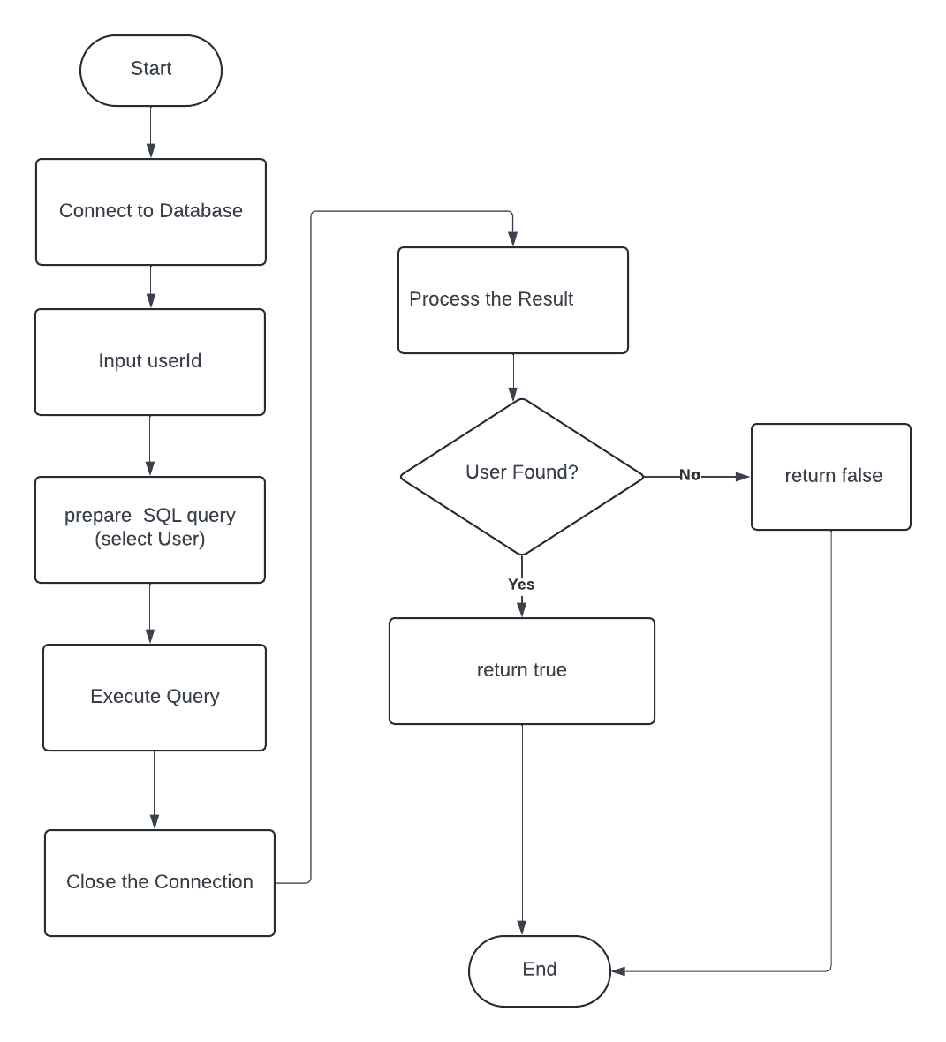

**ID=**OMS-DESIGN-EXUSR****

This is the flow chart to CheckItemExistence() function :

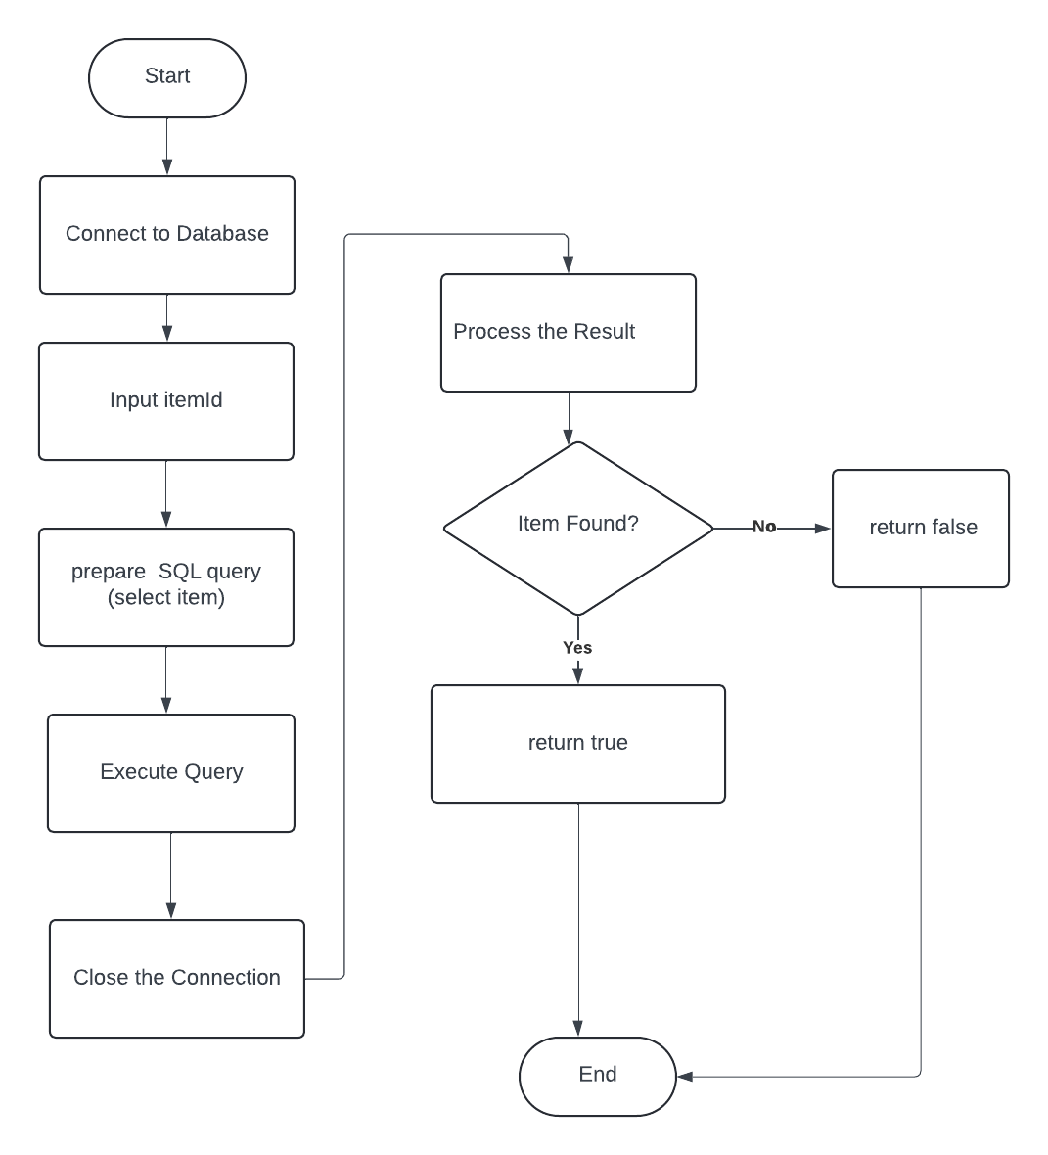

**ID=**OMS-DESIGN-EXITM****

This is the flow chart to deleteUser() function :  
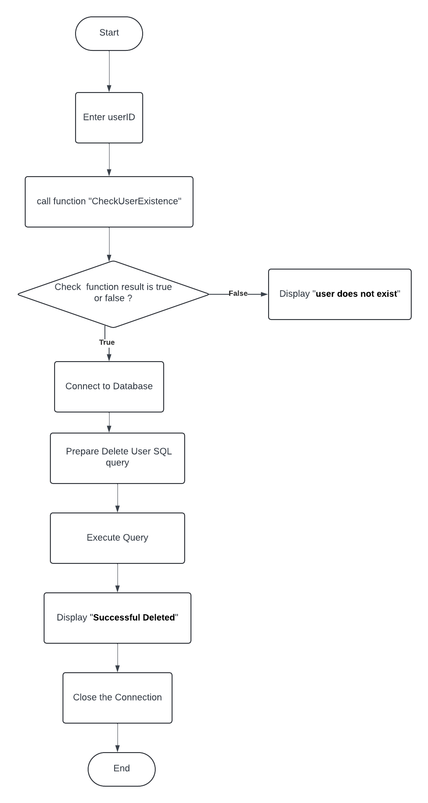

**ID=**OMS-DESIGN-DLUSR****

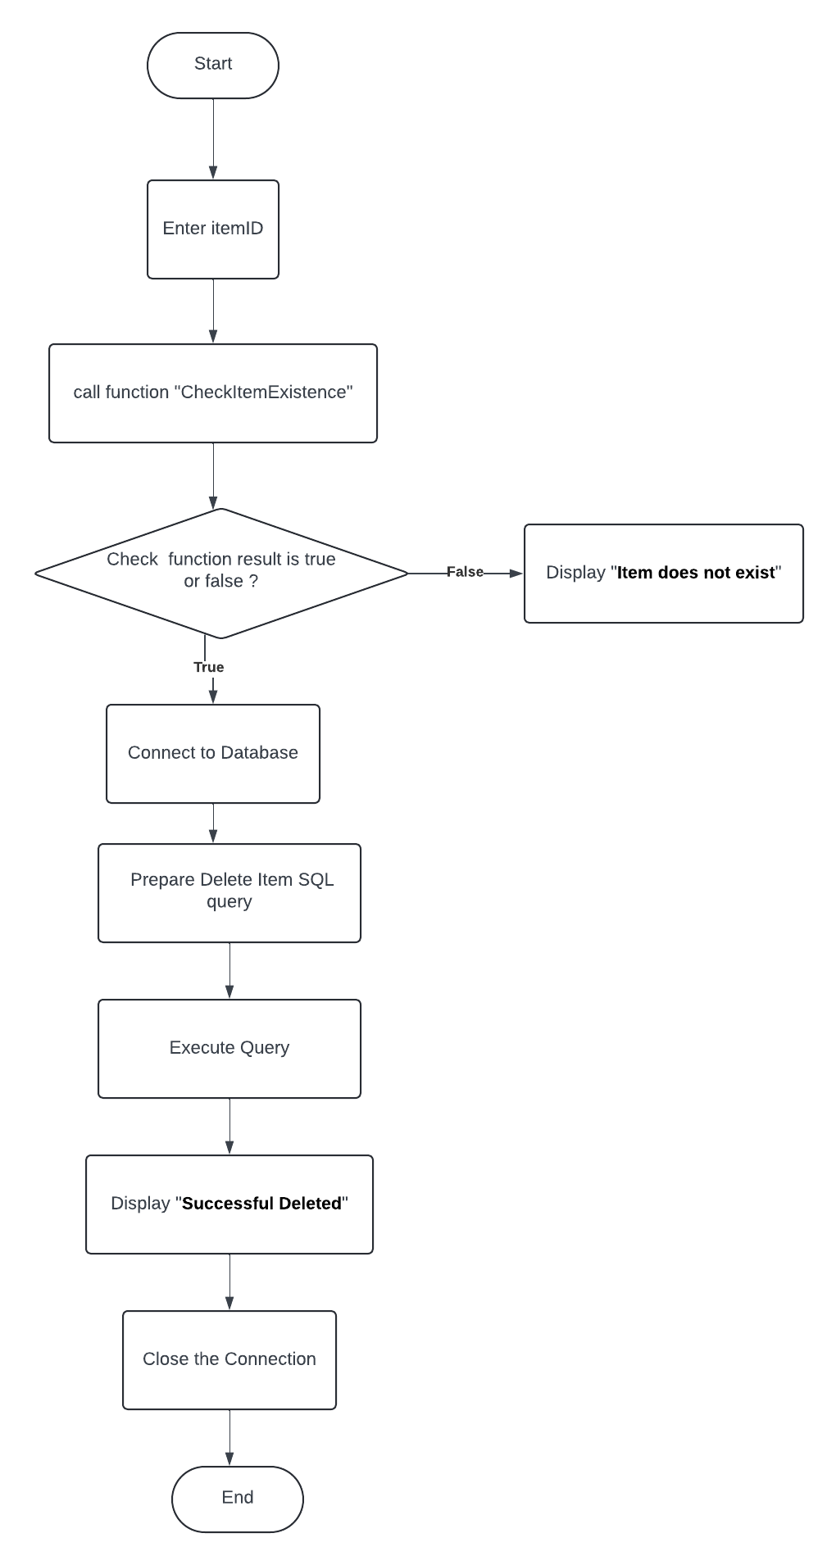This is the flow chart to deleteItem() function :

**ID=**OMS-DESIGN-DLITM****

**Client dashboard low-level design:**

1. Class Diagram:

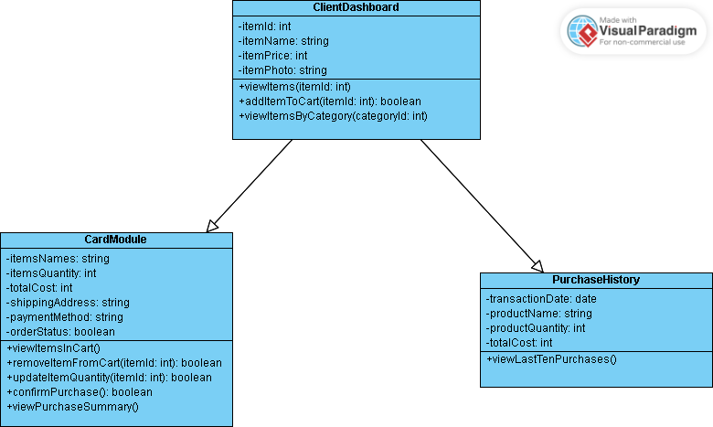

1. Sequence diagram:

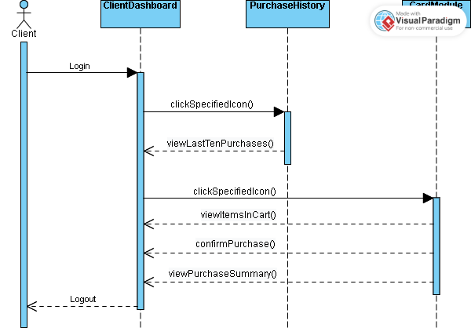

**ID=**OMS-DESIGN-SEQ****

1. Functions flowcharts:

* addItemToCart() function:

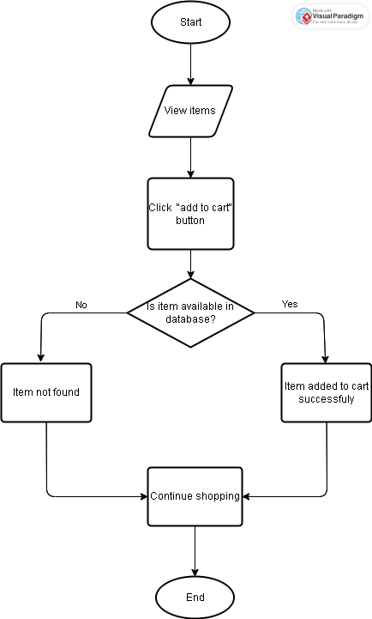 **ID=**OMS-DESIGN-ADCRD****

* removeItemFromCart() function:

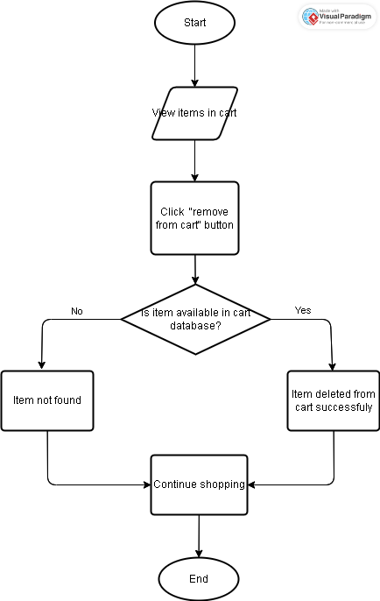

**ID=**OMS-DESIGN-RMCRD****

* updateItemQuantity() function: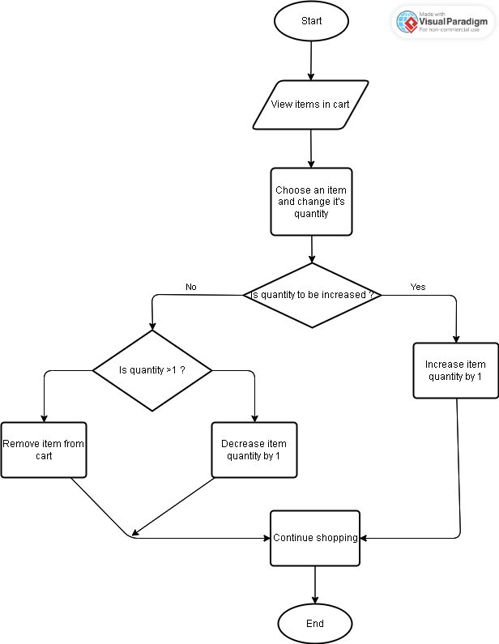

**D=**OMS-DESIGN-UPQTY****

* confirmPurchase() function:

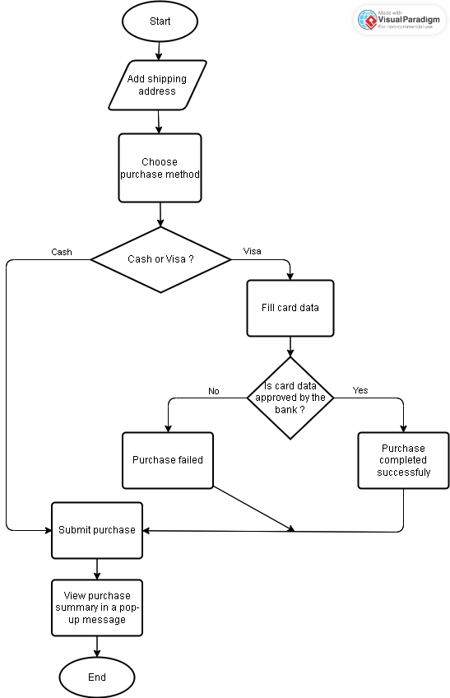

**D=**OMS-DESIGN-CNFRM****

* viewLastTenPurchases() function:

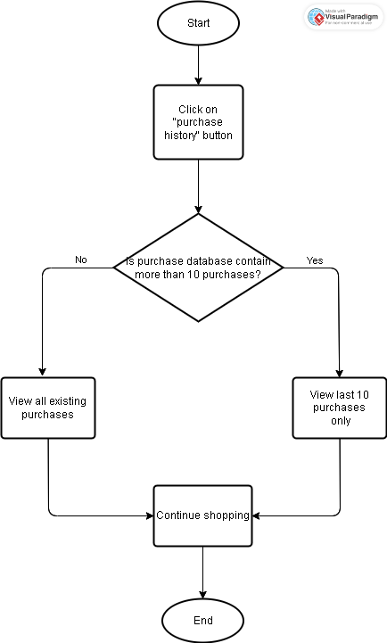

**ID=**OMS-DESIGN-VWPUR****

**Online mobile store Wire Frames:**

