**Evolution 1**

**1)FOSSIL RECORD**

The **fossil record** provides evidence of species that have either **become extinct** or **evolved into other species** over time. It reveals several important facts:

• **99%** of all organisms that ever lived on Earth are now **extinct**  
• **Radioactive dating** and **half-life studies** show that Earth is about **4.6 billion years old**  
• The **oldest fossils** are of **prokaryotic cells**, the first organisms to develop on Earth  
• **Transitional fossils** link extinct species to modern ones  
 – Example: **Archaeopteryx** shows traits of both **reptiles and birds**  
 – Example: **Hyracotherium (Eohippus)**, an ancient horse, is a **transitional form** leading to the modern **horse (Equus)**

**2) COMPARATIVE ANATOMY**

• Organisms with similar anatomical structures are likely related and share a common ancestor  
• Example: The dental structure of chimpanzees and humans is very similar  
 → This shows that both species descended from a common ancestor less than 10 million years ago

**DR SALMA KHALED BIOLOGY EDUCATOR**

**Homologous Structures**

• **Same internal structure**, but **different functions**  
• Examples:  
 – **Bat wing**  
 – **Whale fin**  
 – **Human arm**  
• Indicate a **common ancestry**  
• Example of **divergent evolution**

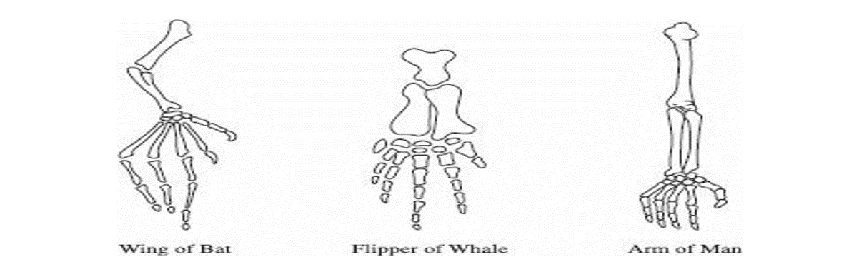

**Analogous Structures**

• **Same function**, different internal structure  
• Examples:  
 – **Bat wing** (mammal)  
 – **Fly wing** (insect)  
• Similarity is due to **adaptation**, not shared ancestry  
• Evidence of **convergent evolution**

**Vestigial Structures**

• Structures that are **reduced in size** and **no longer serve a function**  
• Examples:  
 – **Human appendix**

**DR SALMA KHALED BIOLOGY EDUCATOR**

**3)COMPARATIVE BIOCHEMISTRY**

• Organisms with a **common ancestor** share **similar biochemical pathways**  
• The **closer the relationship**, the **more similar** their **biochemistry**  
• Example: **Humans and mice** are both **mammals**, so they share many biochemical similarities  
→ This is why scientists can **test medicines on mice** and **apply results to humans**

### **4)COMPARATIVE EMBRYOLOGY**

• **Closely related organisms** go through **similar stages** in **embryonic development**  
• This is because they **evolved from a common ancestor**  
• Example:  
 – All **vertebrate embryos** develop **gill pouches** on the sides of their throats  
 – In **fish**, these become **gills**  
 – In **humans**, they form the **eustachian tubes** (connect the middle ear to the throat)

**5) MOLECULAR BIOLOGY**

• All **aerobic organisms** use **cellular respiration**, which involves **electron transport chains**  
• These chains require a common **polypeptide** called **cytochrome c**  
• Comparing the **amino acid sequence** of cytochrome c in different organisms shows how **closely related** they are  
• Example:  
 – The **cytochrome c in humans** is **identical** to that in **chimpanzees**

**6) BIOGEOGRAPHY**

• The **theory of continental drift** states that about **250 million years ago**, all continents were joined in a supercontinent called **Pangaea.**

**DR SALMA KHALED BIOLOGY EDUCATOR**

**Lamarck’s Theory:**  
Lamarck believed organisms change in response to their environment. For example, giraffes stretched their necks to reach tall trees, and he thought this acquired trait was passed to offspring. His ideas were based on **use and disuse** and **inheritance of acquired traits**.

**Darwin’s Theory of Natural Selection:**

• Populations tend to grow exponentially, overpopulate, and exceed resources.  
• Overpopulation leads to competition and struggle for existence.  
• In any population, there's variation and unequal ability to survive and reproduce.  
• Only the best-fit individuals survive and pass traits to offspring. This is called survival of the fittest.

**How the Giraffe Got Its Long Neck**  
According to Darwin, Taller Giraffe had a better chance of surviving and getting food. Over time, more long-necked giraffes survived and reproduced. Eventually, only long-necked giraffes remained. No giraffe’s neck grew longer during its life, the population's average neck length changed.

**How the Peppered Moth Changed from Light to Dark**  
Most peppered moths were light-colored and well-camouflaged. After industrial pollution darkened the environment, dark moths had the advantage and survived more. Dark moths became more common — a shift called **industrial melanism**. No moth changed its color; instead, the allele frequency in the population changed.

**Evolution and Drug Resistance**  
Evolution can happen quickly. Antibiotics don’t cause mutations — they kill non-resistant bacteria. The resistant ones survive, reproduce, and create a drug-resistant population. The same happens with the AIDS virus: drug-sensitive viruses die, while resistant ones survive and multiply. This rapid evolution is why diseases like AIDS remain hard to cure.

**DR SALMA KHALED BIOLOGY EDUCATOR**

**Types of Natural Selection**  
Natural selection can change how common traits are in a population in three ways:

* **Stabilizing selection** favors intermediate traits.
* **Disruptive (diversifying) selection** favors extreme traits at both ends.
* **Directional selection** favors one extreme trait over others.

**Stabilizing Selection**  
This type of natural selection removes extreme traits and favors the average or most common forms in a population.

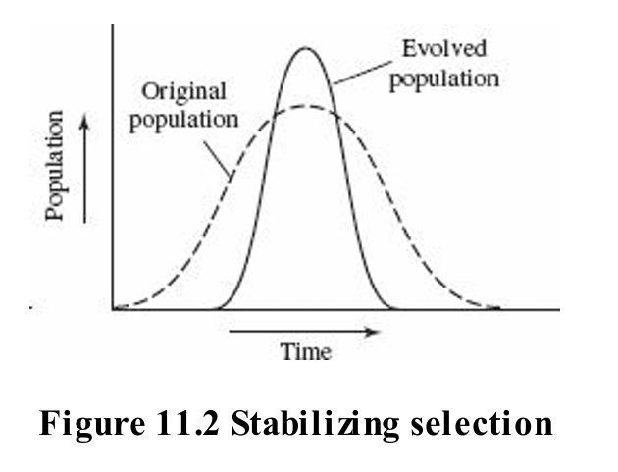

**Disruptive or Diversifying Selection**  
This type of selection favors individuals at both extremes of a trait and reduces the number of individuals with intermediate traits.

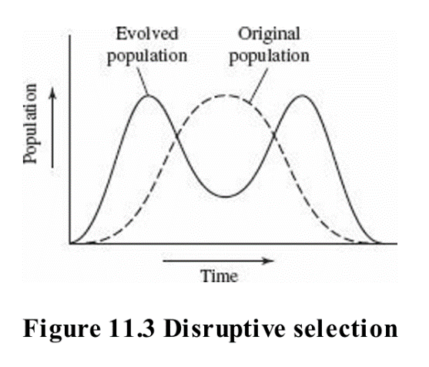

**DR SALMA KHALED BIOLOGY EDUCATOR**

**Directional Selection**  
When the environment changes, one phenotype may replace another in the population. This happened with the peppered moths in England—dark moths replaced light ones due to industrial pollution.

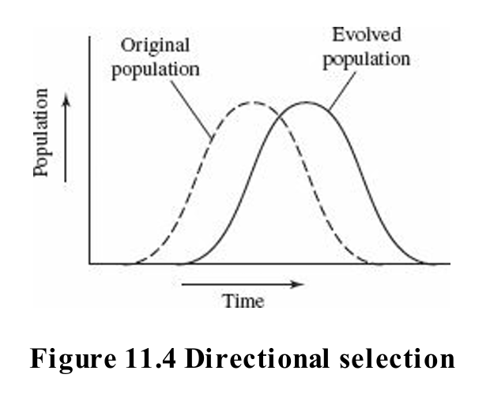

**Variation Within a Population**

* **Mutation**: A change in genetic material that introduces new alleles.
* **Genetic Drift**: A random change in allele frequency.
  + **Bottleneck Effect**: Natural disasters reduce population size and genetic diversity.
  + **Founder Effect**: A small group splits off to form a new population, often carrying rare alleles. Example: polydactyly in the Amish.
* **Gene Flow**: Movement of alleles between populations, like pollen traveling between valleys.

**DR SALMA KHALED BIOLOGY EDUCATOR**

**POPULATION STABILITY— HARDY-WEINBERG EQUILIBRIUM**

1. **Very Large Population** – Small changes won’t affect overall allele frequencies.
2. **Isolation** – No gene flow in or out; migration would alter allele frequencies.
3. **No Mutations** – Mutations introduce new alleles or change frequencies.
4. **Random Mating** – If individuals choose mates, certain traits may be favored.
5. **No Natural Selection** – All individuals must have an equal chance to survive and reproduce.

**Hardy-Weinberg Equation (Simplified Explanation)**

This equation helps calculate allele frequencies in a population. For a gene with two alleles:

* Let **p** = frequency of the dominant allele
* Let **q** = frequency of the recessive allele

The two key equations are:

1. **p + q = 1** → total allele frequency
2. **p² + 2pq + q² = 1** → genotype frequency
   * **p²** = homozygous dominant
   * **2pq** = heterozygous
   * **q²** = homozygous recessive

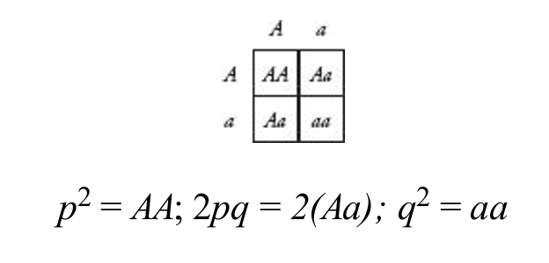

**DR SALMA KHALED BIOLOGY EDUCATOR**