**Photosynthesis**

**Photosynthesis**

* **Definition**: The process by which light energy is used to make glucose.
* **Energy Conversion**: Solar energy → Chemical energy (stored in chemical bonds).
* **Organisms**:
  + All **plants** (Kingdom Plantae).
  + **Algae** (Kingdom Protista).

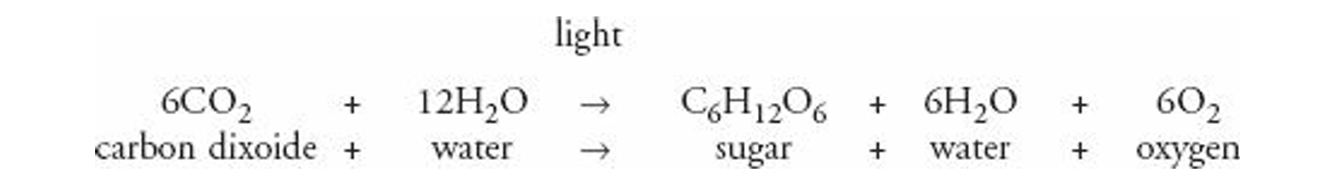

**Type of Reaction**

* **Overall reaction**: **Reduction**
  + Why? → Carbon in CO₂ **gains electrons/protons** from hydrogen in H₂O.
  + **Remember**:
    - **Reduction = gain** of electrons (or protons).
    - **Oxidation = loss** of electrons.

**Autotrophs**

* **Definition**: Organisms that make their own food.
* Examples: Plants, algae, some bacteria.

**DR SALMA KHALED BIOLOGY EDUCATOR**

**Chloroplast Structure**

* **Enclosed by**: A **double membrane**.
* **Inside the chloroplast**:
  1. **Grana** → stacks of thylakoids
     + Site of **light-dependent reactions** (needs sunlight).
  2. **Stroma** → fluid-filled space around grana
     + Site of **Calvin cycle** (light-independent reactions).

⚡ Quick tip to remember:

* **Grana = Light reactions (energy capture)**
* **Stroma = Calvin cycle (sugar making)**

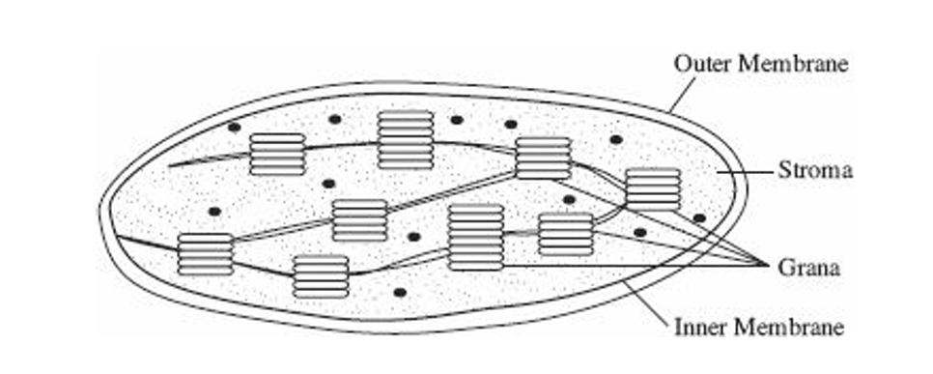

**Light and Photosynthetic Pigments**

1. **Light behavior**
   * When light hits an object → it can be **reflected, transmitted, or absorbed**.
   * Example:
     + A **red object** reflects red light, absorbs all others.
     + A **green plant** reflects green → can’t use green light for photosynthesis → that’s why shining only green light makes the plant die.

**DR SALMA KHALED BIOLOGY EDUCATOR**

1. **Pigments** = Substances that absorb visible light.
   * Only **absorbed light** can power photosynthesis.
   * Different pigments absorb different **wavelengths** of light.
2. **Types of Pigments**
   * **Chlorophyll a**
     + Green pigment.
     + **Main pigment** → directly used in **light reactions**.
   * **Accessory (antenna) pigments** → expand usable light range:
     + **Chlorophyll b** → absorbs everything except green.
     + **Carotenoids** → yellow, orange, red (color of carrots).
     + **Phycobilins** → red, found in **red algae** (deep ocean, low light).
3. **Absorption spectrum**
   * **Red & Blue light = absorbed (most effective for photosynthesis)**.
   * **Yellow & Orange = reflected**.
   * **Green = reflected** (why plants look green).

✨ Quick Memory Tip:

* **Best light for photosynthesis** = **Red & Blue**.
* **Worst light** = **Green**.

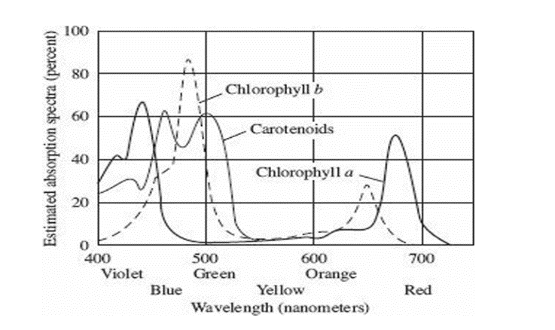

**DR SALMA KHALED BIOLOGY EDUCATOR**

**Photosynthesis: Two Stages**

1. **Light-dependent reactions** → Make **ATP + NADPH (energy & protons)**.
2. **Light-independent reactions (Calvin cycle)** → Use that energy to make **sugar (PGAL)**.

🔑 Both happen **only in the light**.

**Light-Dependent Reactions**

* **Location**: **Grana**, in the **thylakoid membranes**.
* **Main structures**: **Photosystems (I & II)** made of chlorophyll a, chlorophyll b, and carotenoids.
* **Main result**: Produce **lots of ATP** (and NADPH).

**How ATP is made**

1. **Light hits chlorophyll** → electrons get **excited**.
2. Electrons go through **ETC (Electron Transport Chain)**.
3. ETC pumps **protons (H⁺)** across thylakoid → creates a **proton gradient**.
4. Protons flow back through **ATP synthase** → **ATP is produced**.

**Energy flow equation**:  
☀️ light → chlorophyll → excited e⁻ → ETC → proton gradient → ATP synthase → **ATP**

**DR SALMA KHALED BIOLOGY EDUCATOR**

**Role of Water (Photolysis)**

💧 Water splits into **electrons, protons, and oxygen**.

* **Electrons** → replace those lost by chlorophyll.
* **Protons (H⁺)** → used in ATP synthase & carried by **NADP → NADPH** (for Calvin cycle).
* **Oxygen (O₂)** → released into the atmosphere (our breathable oxygen source).

⚡ **End products of Light-Dependent Reactions**:

* **ATP** (energy)
* **NADPH** (protons & electrons carrier)
* **O₂** (waste, but essential for life!)

✨ Quick Memory Trick:  
Think of **“Water split = Electrons, Protons, Oxygen” (EPO)**.

**Light-Independent Reactions (Calvin Cycle)**

* Take place in the **stroma** of chloroplasts.
* Use **ATP** and **NADPH** from light reactions + **CO₂** from the air.
* Through a cycle (Calvin cycle), **CO₂ is fixed** into a 3-carbon sugar called **PGAL**.
* PGAL can be used to build **glucose** and other organic molecules.
* Key enzyme: **Rubisco**.

**Simplified equation:**  
CO₂ + ATP + NADPH → PGAL (→ glucose)

**DR SALMA KHALED BIOLOGY EDUCATOR**

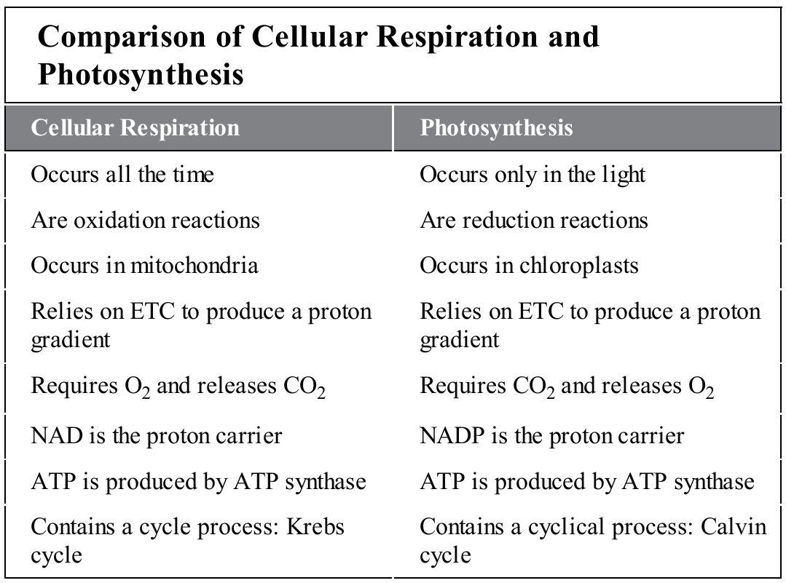

**Structure of the Leaf**

* **Palisade layer** → tightly packed cells with chloroplasts → main site of photosynthesis.
* **Spongy mesophyll** → also has chloroplasts but cells are loosely packed → surrounded by air spaces for gas exchange (O₂, CO₂, water vapor).
* **Epidermis** → clear, protective layer, lets light through, no photosynthesis.
* **Cutin** → waxy, waterproof layer on top → prevents excess water loss.
* **Guard cells + stomates** → open/close to control gas exchange while reducing water loss.

**DR SALMA KHALED BIOLOGY EDUCATOR**

**C-4 Photosynthesis**

* Adaptation for **hot, dry environments**.
* Special anatomy + biochemistry → **less water loss, more sugar production**.
* Examples: **corn, sugarcane, crabgrass**.

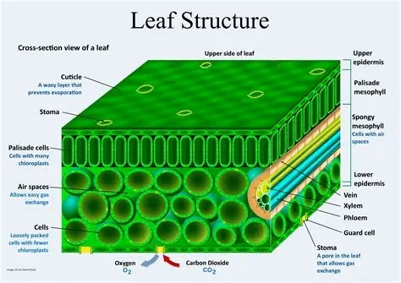

**DR SALMA KHALED BIOLOGY EDUCATOR**

