Name: Salma Khaled Mohamed

Track : Data Management

Analytical Sql case study

My assumptions to solve cases

Case 1:

In this case: first I need get daily revenue: calculate that by recharge date of day minus recharge date of next day divided by amount recharge

But when do that: show last value of each customer is equal to zero because no value minus of it no lead date so, must calculate last value

Then get avg and stddev of revenue

Then show graph and need to compare lastvalue to avg and stddvv

To equation : y= avg+2*stddev

Then calculate: Y=lastvalue-avg / stddev

But problem faced in this cases: stddev has zero value and cannot divide by it so do case when if greater than zero calculate y

Then calculate cases of graph

Results show repeated so, use choose first value of results graph then do ranking to get first row only .

Code formatted :

SELECT calendar_dt,  
       cust_id,  
       value  
FROM   (SELECT calendar_dt,  
               cust_id,  
               value,  
               **Row_number**()  
                 over(  
                   PARTITION BY calendar_dt, cust_id, mvm_status  
                   ORDER BY cust_id) AS row1  
        FROM   (SELECT calendar_dt,  
                       cust_id,  
                       mvm_status,  
                       **First_value**(mvm_status ignore nulls)  
                         over(  
                           PARTITION BY calendar_dt, cust_id, mvm_status  
                           ORDER BY cust_id) AS value  
                FROM   (SELECT calendar_dt,  
                               cust_id,  
                               y,  
                               CASE  
                                 WHEN y = 0THEN 'N'  
                                 WHEN y > 0  
                                      AND y < 1 THEN 'U'  
                                 WHEN y > 1 THEN 'HU'  
                                 WHEN y < 0  
                                      AND y >- 1 THEN 'R'  
                                 WHEN y >- 2  
                                      AND y <- 1 THEN 'HR'  
                               END AS MVM_STATUS  
                        FROM   (SELECT calendar_dt,  
                                       cust_id,  
                                       CASE  
                                         WHEN stdd > 0 THEN ( lastvalue - avg )  
                                                            / stdd  
                                       END AS y  
                                FROM   (SELECT calendar_dt,  
                                               cust_id,  
                                               recharge_dt,  
                                               recharge_amt_num,  
                                               lastvalue,  
                                               **Round**(**Avg**(daily_revenue)  
                                                       over(  
                                                         PARTITION BY cust_id),  
                                               2) AS  
                                               avg,  
                                               **Round**(**STDDEV**(daily_revenue)  
                                                       over(  
                                                         PARTITION BY cust_id),  
                                               2) AS  
                                               STDD  
                                        FROM   (SELECT calendar_dt,  
                                                       cust_id,  
                                                       recharge_dt,  
                                                       recharge_amt_num,  
                                                       recharge_amt_num / (  
                                                       **Lead**(recharge_dt, 1)  
                                                       over(  
                                                         PARTITION BY cust_id  
                                                         ORDER BY cust_id,  
                                                       recharge_dt  
                                                       )  - recharge_dt ) AS  
       daily_revenue,  
       recharge_amt_num / ( calendar_dt -  
       **Last_value**(recharge_dt  
       ignore  
       nulls)  
       over(  
       PARTITION BY cust_id  
       ORDER BY cust_id ) )  
       AS lastvalue  
       FROM   case1))))))  
WHERE  row1 = 1

Results :

Case 2:

SELECT cust_id,  
       month_start_dt,  
       month_base_flag,  
       CASE  
         WHEN **SUM**(countno)  
                over(  
                  PARTITION BY cust_id  
                  ORDER BY cust_id ROWS BETWEEN 1 preceding AND CURRENT ROW) = 2  
       THEN  
         'b'  
         WHEN **SUM**(countno)  
                over(  
                  PARTITION BY cust_id  
                  ORDER BY cust_id ROWS BETWEEN unbounded preceding AND 1  
                preceding ) =  
              1  
              AND **SUM**(countno)  
                    over(  
                      PARTITION BY cust_id  
                      ORDER BY cust_id ROWS BETWEEN CURRENT ROW AND CURRENT ROW  
                    ) = 1  
       THEN 'r'  
         WHEN **SUM**(countno)  
                over(  
                  PARTITION BY cust_id  
                  ORDER BY cust_id ROWS BETWEEN 1 preceding AND 1 preceding ) =  
              1 THEN  
         'o'  
         WHEN firstval IS NOT NULL THEN 'I'  
       END AS IBRO_SEGMENT  
FROM   (SELECT cust_id,  
               month_start_dt,  
               month_base_flag,  
               **First_value**(month_base_flag ignore nulls)  
                 over (  
                   PARTITION BY cust_id  
                   ORDER BY cust_id ROWS BETWEEN CURRENT ROW AND CURRENT ROW )  
               AS  
                      firstval,  
               **Count**(month_base_flag)  
                 over (  
                   PARTITION BY cust_id, month_start_dt  
                   ORDER BY cust_id, month_start_dt ROWS BETWEEN CURRENT ROW AND  
                 1  
                 following )  
               AS  
                      countno  
        FROM   case2  
        ORDER  BY cust_id,  
                  month_start_dt)

Results :

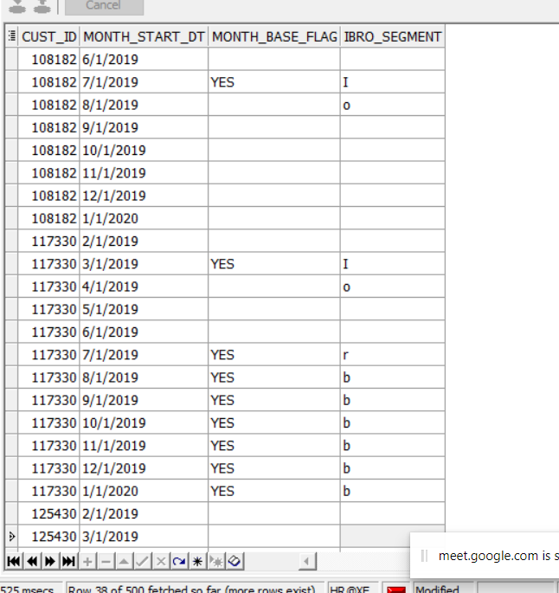

Case 3 (a):

Sol:1

1)My assumptions

First : when solve problem get date difference between currentdate and before date then filter where diff equal 0ne that indicate each day then count difference and get max

Results :

But , I know problem case sum all consecutive days not only diff 1

2) code formatted

SELECT cust_id,  
       max_consecutive_days  
FROM   (SELECT cust_id,  
               max_consecutive_days,  
               **Row_number**()  
                 OVER(  
                   partition BY cust_id, max_consecutive_days  
                   ORDER BY cust_id) AS SELECT_ONE_ROW  
        FROM  (SELECT cust_id,  
                      *Max*(c)  
                        OVER (  
                          partition BY cust_id  
                          ORDER BY cust_id ) AS Max_Consecutive_Days  
               FROM  (SELECT cust_id,  
                             calendar_dt,  
                             *Count*(diff)  
                               OVER (  
                                 partition BY cust_id  
                                 ORDER BY calendar_dt, cust_id ) AS c  
                      FROM  (SELECT cust_id,  
                                    calendar_dt,  
                                    diff  
                             FROM   (SELECT cust_id,  
                                            calendar_dt,  
                                            calendar_dt - **Lag** (calendar_dt)  
                                            OVER (  
                                              partition BY cust_id  
                                              ORDER BY calendar_dt ) AS  
                                            diff  
                                     FROM   case3))  
                      WHERE  diff = 1)))  
WHERE  select_one_row = 1

Sol2: but it fit in first case but wrong in other cases , use flag to indicate not 1 day diff but not fit when data is null

SELECT cust_id,  
       calendar_dt,  
       NEW  
FROM  (SELECT cust_id,  
              calendar_dt,  
              **Max**(pp)  
                over (  
                  PARTITION BY cust_id  
                  ORDER BY calendar_dt, cust_id )AS NEW  
       FROM  (SELECT cust_id,  
                     calendar_dt,  
                     a,  
                     pp,  
                     CASE  
                       WHEN **Lead**(a)  
                              over (  
                                PARTITION BY cust_id  
                                ORDER BY calendar_dt, cust_id ) IS NULL THEN  
                       'yes'  
                     END AS firstlead  
              FROM  (SELECT cust_id,  
                            calendar_dt,  
                            a,  
                            **Count**(e)  
                              over (  
                                PARTITION BY cust_id  
                                ORDER BY calendar_dt, cust_id ROWS BETWEEN  
                              CURRENT ROW  
                              AND  
                              unbounded  
                              following ) AS pp  
                     FROM  (SELECT cust_id,  
                                   calendar_dt,  
                                   a,  
                                   **Lead**(w, 1)  
                                     over (  
                                       PARTITION BY cust_id  
                                       ORDER BY calendar_dt, cust_id ) AS e  
                            FROM  (SELECT cust_id,  
                                          calendar_dt,  
                                          a,  
                                          **Max**(a)  
                                            over (  
                                              PARTITION BY cust_id  
                                              ORDER BY calendar_dt, cust_id ) AS  
                                          w  
                                   FROM   (SELECT cust_id,  
                                                  calendar_dt,  
                                                  CASE  
                                                    WHEN diff = 1 THEN **Count**(  
                                                    diff)  
                                                    over (  
                                                      PARTITION BY cust_id  
                                                      ORDER BY calendar_dt,  
                                                    cust_id )  
                                                  END AS a  
                                           FROM   (SELECT cust_id,  
                                                          calendar_dt,  
                                                          calendar_dt - **Lag** (  
                                                          calendar_dt)  
                                                          over (  
                                                            PARTITION BY cust_id  
                                                            ORDER BY calendar_dt  
                                                          )  
                                                          AS diff  
                                                   FROM   case3))))))  
       WHERE  firstlead IS NOT NULL)  
GROUP  BY cust_id,  
          calendar_dt,  
          NEW  
ORDER  BY cust_id

Sol 3 : to solve my problem in first sol and second sol , think about ranking to rank value then get diff between current value and no in row number such as : my current row no 5 and date 5/10/2019 then diff equal 1/10/2019 , I do that in all days , results all days have 1 difference = 1/1/2019 is first value but diff greater than 1 results not equal first date then count and get max , results is correct now(right sol)

SELECT cust_id,  
       max_consecutive_days  
FROM   (SELECT cust_id,  
               max_consecutive_days,  
               **Row_number**()  
                 OVER(  
                   partition BY cust_id, max_consecutive_days  
                   ORDER BY cust_id) AS row1  
        FROM   (SELECT cust_id,  
                       *Max*(max1)  
                         OVER (  
                           partition BY cust_id  
                           ORDER BY cust_id ) AS Max_Consecutive_Days  
                FROM   (SELECT cust_id,  
                               calendar_dt,  
                               *Count*(val)  
                                 OVER (  
                                   partition BY cust_id, val  
                                   ORDER BY cust_id, calendar_dt ) AS max1  
                        FROM   (SELECT cust_id,  
                                       calendar_dt,  
                                       ( calendar_dt - ranking ) AS val  
                                FROM   (SELECT cust_id,  
                                               calendar_dt,  
                                               **Row_number**()  
                                                 OVER (  
                                                   partition BY cust_id  
                                                   ORDER BY cust_id, calendar_dt  
                                                 ) AS  
                                               ranking  
                                        FROM   case3)))))  
WHERE  row1 = 1

Case 3 b:

SELECT cust_id,  
       calendar_dt,  
       amt_le,  
       total,  
       mycase,  
       daydiff,  
       **Avg**(daydiff)  
         over(  
           PARTITION BY cust_id)  
FROM  (SELECT cust_id,  
              calendar_dt,  
              amt_le,  
              total,  
              mycase,  
              **SUM**(CASE  
                    WHEN mycase IS NULL THEN 1  
                    ELSE 0  
                  END)  
                over(  
                  PARTITION BY cust_id) AS daydiff  
       FROM  (SELECT cust_id,  
                     calendar_dt,  
                     amt_le,  
                     total,  
                     CASE  
                       WHEN total > 250 THEN 1  
                     END AS mycase  
              FROM   (SELECT cust_id,  
                             calendar_dt,  
                             amt_le,  
                             **SUM**(amt_le)  
                               over (  
                                 PARTITION BY cust_id  
                                 ORDER BY calendar_dt ROWS BETWEEN unbounded  
                               preceding  
                               AND  
                               CURRENT  
                               ROW) AS  
                             total  
                      FROM   case3)))

My assumptions : get sum of amount then calculate cumulative sum of amount then cases if greater 250 threshold then is number of days I need sum all 0 not 1 to reach to threshold : ,then calc avg but I didn’t reach correct avg value or median value