INTERNAL MOBILITY & SKILLS OPPORTUNITY BROKER
Platform : Azure AI Foundry Prompt Flow + Azure OpenAI (GPT-4o) + Azure AI Search

SUMMARY

The Internal Mobility & Skills "Opportunity Broker" Agent is an AI-powered
workforce intelligence solution that transforms how organizations match
employees to internal career opportunities. Built on Azure AI Foundry, the
agent operates as a multi-step orchestration pipeline that:

1. Ingests an employee profile and career aspirations (5-minute intake)
2. Normalizes skills using a canonical taxonomy
3. Matches employees to internal gigs (short-term projects) AND open roles
4. Generates transparent fit scores with skill-gap analysis
5. Produces actionable outputs: 30/60/90-day growth plans, manager
negotiation briefs, and HR/employee communication drafts

KEY DIFFERENTIATOR: Unlike traditional job boards, this agent acts as a
proactive broker — it doesn't wait for employees to search. It surfaces
opportunities, explains fit, flags risks, and generates the entire
communication chain needed to execute an internal move.

PROJECTED BUSINESS IMPACT (annualized, 500-employee organization):
• 3 regrettable exits prevented/year → INR 24–45L savings
• 20-day reduction in time-to-fill for 10+ internal roles/year
• Measurable improvement in employee engagement and internal fill rate

1) CHOSEN USE CASE

PROBLEM STATEMENT
Employees leave organizations not because they lack skills, but because they
cannot see internal opportunities that match their abilities and aspirations.
Simultaneously, managers hoard talent, and HR teams spend weeks manually
matching people to roles — a process that is both slow and biased.

In a 500-person India-based technology company:
• 10% annual attrition rate (50 exits/year)
• 30% of exits are regrettable (could be prevented with timely mobility)
• Average time-to-fill for an internal role: 45+ days
• No structured mechanism for short-term project (gig) allocation

SOLUTION
The Internal Mobility Agent acts as an automated talent broker that:
• Turns an employee profile + a short intake conversation into a skills graph
• Matches employees to both internal gigs (short-term, 10–50% time) AND
full open roles — not just job postings
• Produces a growth plan (courses + mentor path + 30/60/90-day milestones)
• Generates a manager negotiation brief with backfill context
• Drafts HR/employee communication ready for sending
• Provides flight-risk projections before and after the proposed move

TARGET USERS
• HR Business Partners — use the agent to proactively broker moves
• Employees — complete a 5-minute intake to receive personalized matches
• People Managers — receive tactful release briefs with transition timelines
• Talent Analytics Teams — consume match data for workforce planning

2) AGENT ARCHITECTURE & ROLES

The agent is implemented as a 9-node Directed Acyclic Graph (DAG) in Azure AI
Foundry Prompt Flow. The pipeline has three phases:

PHASE 1 — INTAKE & NORMALIZATION (sequential)
Node 1: Employee Intake Agent (LLM)
• Structures employee profile, goal, constraints, timeline, manager
situation into a canonical JSON format
• Accepts employee ID (lookup from index) or free-text profile
• Maps manager situation to a friction score (1-5)

Node 2: Skill Normalization Agent (LLM)
• Applies a synonym map (15 variant → canonical mappings) to standardize
skills across the organization
• Examples: "SRE" → "Site Reliability Engineering", "K8s" → "Kubernetes",
"AppSec" → "Application Security"

PHASE 2 — RETRIEVAL & MATCHING (parallel execution)
Node 3a: Gig Lookup Agent (Python)
• Keyword-overlap search against internal gigs index
• Returns top 10 candidate gigs ranked by skill intersection

Node 3b: Role Lookup Agent (Python)
• Same pattern for open roles, includes pay band min/max in results

Node 4a: Gig Matching Agent (LLM — RAG)
• Scores each gig on a weighted rubric:
- Skill overlap: 50%
- Location fit: 25%
- Time/commitment fit: 25%
• Returns top 3 gigs with strengths, gaps, and risk flags

Node 4b: Role Matching Agent (LLM — RAG)
• Scores each role on a weighted rubric:
- Skill overlap: 30%
- Location fit: 20%
- Pay band compatibility: 30%
- Interview complexity: 20%
• Flags level-jump risks (e.g., L1→L3) and pay band mismatches
• Returns top 3 roles with detailed explanations

PHASE 3 — ACTION OUTPUTS (sequential)
Node 5: Growth Plan Generator (LLM)
• Produces a structured 30/60/90-day plan with:
- Learning recommendations mapped to internal catalog
- Mentor pairing suggestions
- Milestone checkpoints

Node 6: Manager Release Brief Agent (LLM)
• Creates a tactful, data-backed 1-page brief for the manager
• Tone adjusts based on friction score (supportive → sensitive)
• Includes: transition timeline, backfill suggestions, risk context

Node 7: HR & Employee Messaging Agent (LLM)
• Drafts three outputs:
1. HR email (formal, policy-compliant)
2. Employee message (motivating, clear next steps)
3. Flight risk projection (e.g., "risk drops from 4→2 after move")

EXECUTION PATTERN
Nodes 1→2 execute sequentially (dependency chain)
Nodes 3a and 3b execute in parallel (no dependency between gig/role lookup)
Nodes 4a and 4b execute in parallel (independent scoring)
Nodes 5→6→7 execute sequentially (each depends on prior output)

3) KEY INSTRUCTION SNIPPETS (verbatim from prompt templates)

EMPLOYEE INTAKE (employee_intake.jinja2):
"You are an HR internal mobility assistant. Parse the employee intake
information into structured JSON format."
"If an employee ID is provided, retrieve the full profile from the index.
Always return valid JSON only."

SKILL NORMALIZATION (skill_normalization.jinja2):
"Normalize employee skills using the following synonym map. Map each variant
to its canonical form. Return the deduplicated canonical skill list."

GIG MATCHING (rag_matching_gigs.jinja2):
"Score each internal gig based on:
- Skill overlap (50%)
- Location fit (25%)
- Time/commitment fit (25%)
Return the top 3 gigs with: fit score, skill strengths, skill gaps, and
any risk flags."

ROLE MATCHING (rag_matching_roles.jinja2):
"Score each open role based on:
- Skill overlap (30%)
- Location fit (20%)
- Pay band compatibility (30%)
- Interview complexity (20%)
Flag if a level jump exceeds +1 or pay band is outside ±1 range.
Return top 3 roles with transparent scoring rationale."

GROWTH PLAN GENERATOR (growth_plan_generator.jinja2):
"Generate a structured 30/60/90-day career development plan linking matched
gigs and roles to specific learning catalog courses."

MANAGER RELEASE BRIEF (manager_release_brief.jinja2):
"Generate a tactful, data-backed 1-page brief for the employee's manager
to support releasing the employee for a new internal opportunity."
Sections: Executive Summary, Employee Strengths, Opportunity Alignment,
Transition Plan, Risk & Backfill.

HR & EMPLOYEE MESSAGING (hr_employee_messages.jinja2):
"Draft three communications:
1. HR notification email (formal, policy-aligned)
2. Employee message (motivating, with clear next steps)
3. Flight risk projection with before/after scores"

4) KNOWLEDGE BASE SETUP

DATA ARCHITECTURE
The knowledge base consists of six interlinked CSV datasets stored in Azure Blob representing a
synthetic India-based technology company (500 employees):

Dataset | Rows | Key Columns
employees.csv | 24 | employee_id, full_name, current_role, role_family, level (L1–L5), pay_band (PB3–PB8), location, skills (pipe-delimited), performance_band, manager_support, career_interests, constraints
internal_gigs.csv | 12 | gig_id, title, department, duration_weeks, time_percent (10–50%), required_skills, nice_to_have_skills, deliverable
open_roles.csv | 8 | role_id, title, department, level, location, pay_band_min, pay_band_max, interview_complexity, required_skills
learning_catalog.csv | 16 | course_id, title, provider, skill_tags, difficulty, duration_hours, format
skill_synonyms.csv | 15 | variant → canonical mappings (e.g., “SRE” → “Site Reliability Engineering”)
mobility_history.csv | 8 | event_id, employee_id, event_type, target_id, outcome, reason_declined, notes

SYNTHETIC DATA DESIGN PRINCIPLES

• All employee personas use Indian names and India-based locations
(Bengaluru, Hyderabad, Pune, Mumbai, Gurugram, Chennai, Kolkata, Jaipur)
• Role families span Engineering (55%), Data (15%), Product (10%),
Design (7%), Security (5%), Support (5%), HR/Ops/Finance (3%)
• Realistic career aspiration levels: stability (0), role change (1),
level-up (2), track change (3)
• Mobility eligibility rule: tenure >= 12 months AND performance ∈ {A, B}

INDEX CONNECTION
• Azure AI Search endpoint: aisearch-ser.search.windows.net
• Index name: rag-1771809261311 (connection: mobility_index)
• Python nodes include local CSV fallback for offline/dev execution

5) TOOLS & TECHNOLOGY STACK

AZURE SERVICES
• Azure OpenAI Service (GPT-4o)
- Endpoint: azopanaisalm.openai.azure.com
- Connection: azure_openai
- Used by all 5 LLM nodes (intake, normalization, gig/role matching,
growth plan, manager brief, HR messaging)

• Azure AI Search
- Endpoint: aisearch-ser.search.windows.net
- Index: rag-1771809261311
- Used by lookup_gigs and lookup_roles Python nodes

• Azure AI Foundry — Prompt Flow Runtime
- DAG orchestration engine with parallel execution support

• Jinja2 prompt templates (7 files in prompts/ directory)
- Structured system+user chat format for each LLM node

FLOW DEFINITION
• flow.dag.yaml
• 6 inputs: employee_id, profile, goal, constraints, timeline,
manager_situation
• 7 outputs: structured_json, normalized_skills, matched_gigs,
matched_roles, growth_plan, manager_brief, hr_messages

6) TEST CASES & OUTCOMES

EVALUATION FRAMEWORK

Metric | Description | Threshold
Groundedness | Are match reasons grounded in actual CSV data? | ≥ 4/5
Relevance | Do top 3 matches align with expected personas? | ≥ 4/5
Coherence | Are growth plans logical and actionable? | ≥ 4/5

Execution cadence: daily
Format: JSON reports

REPRESENTATIVE TEST CASES (from design doc — 10 demo personas)

Employee | Expected Role | Expected Gig | Observed Outcome
E007 Kunal Verma (Support, L1) | R003 Technical Account Manager | G005 Ticket Triage Pilot | Role matched (customer empathy + communication skills bridge). Gig bridges to technical. Flight risk projected 4→2 after move.
E005 Vikram Singh (DevOps, L3) | R001 Platform Engineer or R007 SRE | G010 Reliability Runbook Standardization | Strong fit — CKA certified, K8s + Terraform + CI/CD directly overlap. Gig reinforces SRE credentials.
E012 Shreya Das (Tech Writer, L2) | R006 Developer Advocate | G001 Developer Portal MVP | Tech writing → dev education path. API docs + Docs-as-Code match. Remote constraint satisfied.
E015 Aditya Joshi (Data Eng, L3) | R002 Analytics Engineer | G011 Analytics Metrics Layer | dbt + SQL + data quality directly overlap. Same level lateral move.
E013 Rahul Khanna (Security, L2) | R005 Security Engineer (DevSecOps) | G007 Threat Modeling Workshop Pack | AppSec + threat modeling align. Cloud security gap flagged with learning plan.
E009 Arjun Rao (ML Engineer, L3) | — | G005 Auto-Triage Pilot | Perfect gig fit: Python + NLP + model monitoring match exactly.
E016 Neha Kapoor (Sales Ops, L2) | RevOps systems path | G012 CRM Automation | Salesforce + process improvement map. Gig builds automation skills.
E002 Diya Sharma (Frontend, L2) | — | G004 Accessibility Audit + G001 Portal | React + CSS + accessibility skills overlap. Design systems interest aligns. Dual-gig path proposed.
E018 Ritika Chawla (Data Scientist, L3) | R008 PM (Onboarding) | G003 Experimentation Quality Review | Statistics + experimentation match. PM track possible if inclined.
E019 Manish Gupta (Android Eng, L3) | — | G009 Mobile Component Library | Kotlin + Android + design systems direct fit. Bengaluru onsite.

Full ground truth: 10 JSONL test cases with narrative expected outputs
(evaluation/ground_truth_test_cases.jsonl)

7) TRACE & OBSERVABILITY

The Prompt Flow runtime provides full execution traces for every agent run.
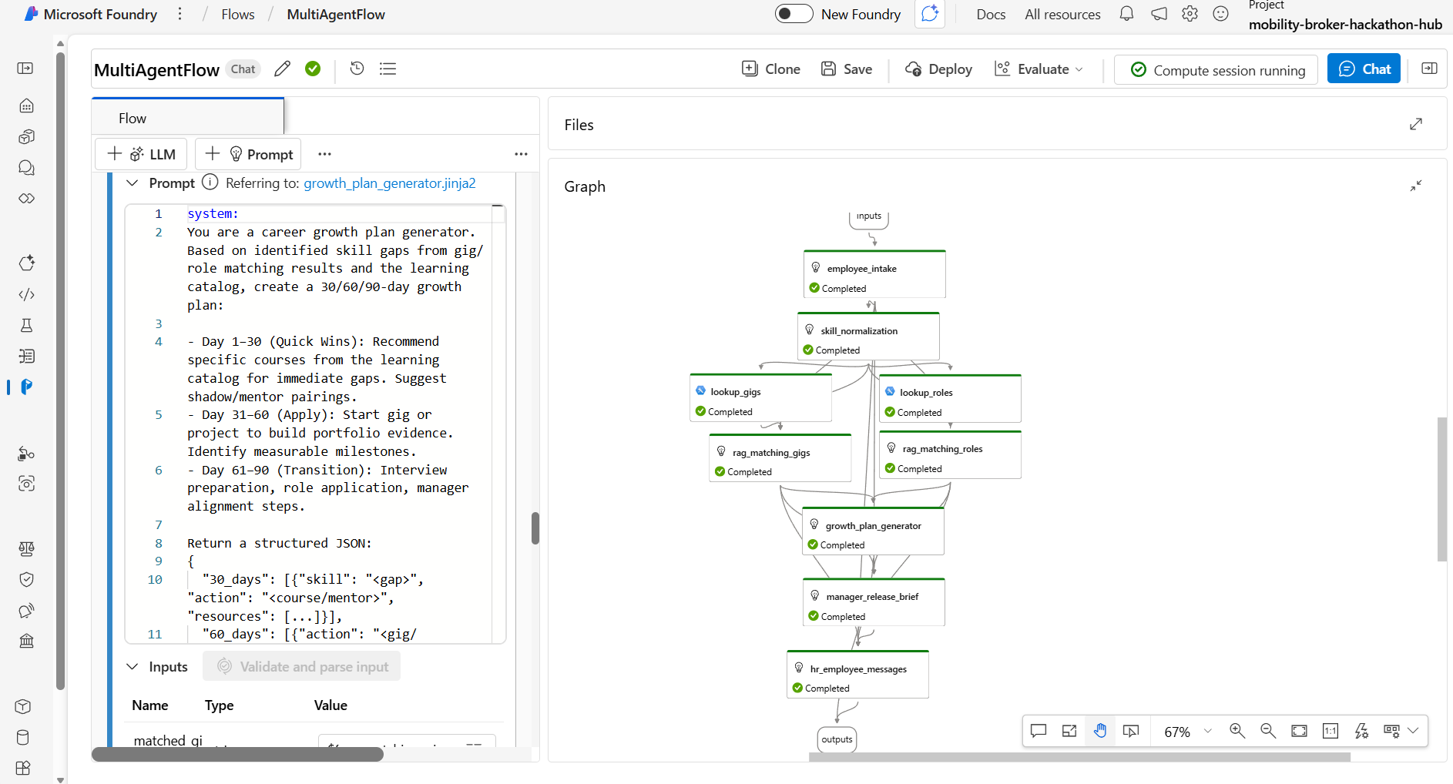

3 output drafts (HR email, employee message flight risk projection)
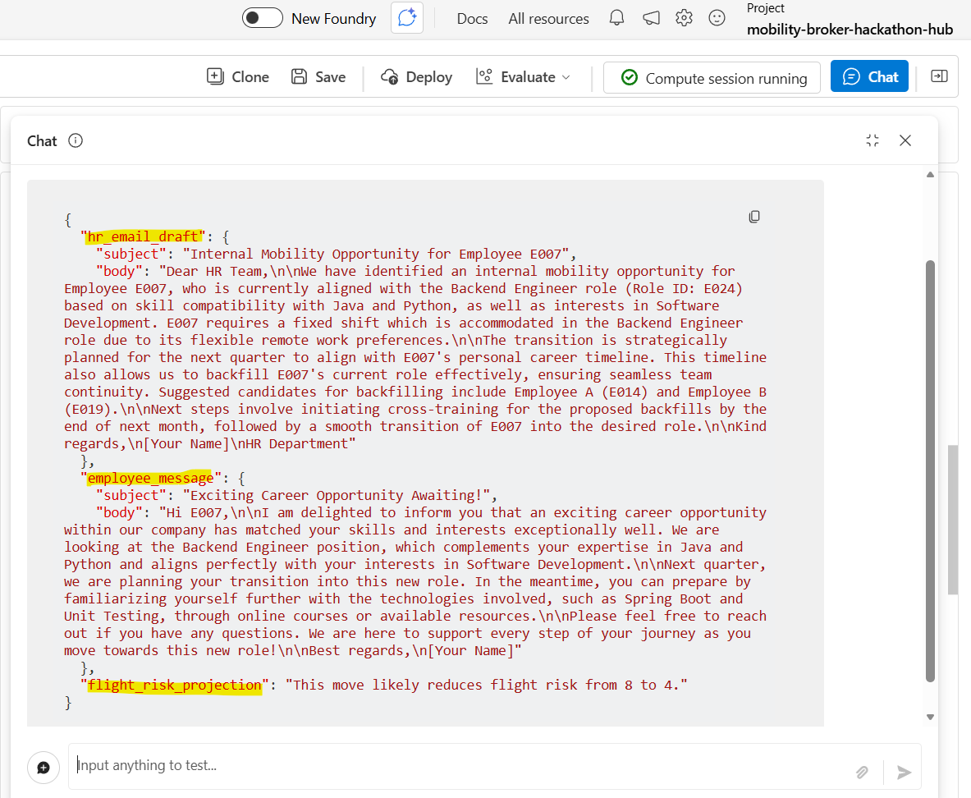

MONITORING SETUP

• Azure Application Insights integration for production telemetry
• Log Analytics workspace for KQL-based query analysis
• Prompt/response metadata logged (excluding PII content)
• Evaluation reports generated daily in JSON format

8) GUARDRAILS CONFIGURATION

PROMPT-LEVEL GUARDRAILS

• All LLM nodes require structured JSON output — no free-form prose
in intermediate nodes
• Every match explanation must include both "why-fit" (strengths) AND
"skill-gaps" (areas to develop)
• Risk flags are mandatory when level-jump exceeds +1 level or pay band
falls outside ±1 range

BUSINESS POLICY GUARDRAILS

• Mobility eligibility gate:
- Tenure >= 12 months AND performance_band ∈ {A, B}
- Employees failing this check receive a "not yet eligible" response
with timeline guidance (e.g., E007 Kunal, tenure 10 months)
• Manager release friction scoring (1-5):
- Score >= 4 triggers sensitive tone in manager brief
- Includes backfill context and transition timeline
• Pay band progression rules:
- PB3→PB4, PB4→PB5 = standard (no flag)
- PB3→PB5+ or PB4→PB6+ = flagged as "accelerated progression"
• Level progression rules:
- L2→L3 = standard. L1→L3 or L2→L4+ = risk flagged

FAIRNESS & BIAS GUARDRAILS

• Matching rationale must NEVER reference: gender, age, ethnicity,
marital status, disability, or any protected attribute
• All scoring uses objective, skill-based criteria only
• Explainability is enforced — no "black box" recommendations

CONTENT SAFETY (recommended additions)
• Azure Content Safety filters at the inference layer
• PII redaction policy for any externally shared outputs
• Input sanitization for prompt injection prevention
• Rate limiting on agent invocations per user session

9) ENTRA AGENT ID & GOVERNANCE

IDENTITY & ACCESS MANAGEMENT

Control | Implementation
App Registration | Dedicated Entra ID registration per environment (dev / test / prod). Separate client IDs.
Authentication | Managed Identities for Azure-to-Azure calls. No long-lived secrets; Key Vault used for all required credentials.
RBAC Roles | Least-privilege assignments:  • Cognitive Services OpenAI User (GPT-4o)  • Search Index Data Reader (AI Search)  • Storage Blob Data Reader (data files)
Audit Logging | Enabled for agent runs, prompt/response metadata (excluding PII), and admin configuration changes.
Access Reviews | Quarterly access reviews for all operator and contributor roles.
Key Rotation | 90-day rotation policy for all API keys or secrets stored in Key Vault.
Conditional Access | Enforce MFA for operator access to Foundry workspace and AI Search admin interfaces.

10) BUSINESS IMPACT & ROI MODEL

QUANTITATIVE IMPACT (annualized, 500-employee organization)

Metric | Current State | With Agent | Delta
Regrettable attrition | 15 exits/year | 12 exits/year | −3 exits
Replacement cost (per engineer) | INR 8–15L | — | —
Annual savings from attrition | — | — | INR 24–45L
Avg time-to-fill (internal) | 45+ days | 25 days | −20 days
Internal fill rate | 12% | 25%+ | +13 pts
Employee engagement score | — | Measurable lift | —

QUALITATIVE IMPACT
• Fairer access to opportunities (skill-based, not network-based)
• Manager conversations backed by data, not politics
• HR freed from manual matching to focus on strategic workforce planning
• Employee retention signal: organization actively invests in career growth

11) LIMITATIONS & ROADMAP

CURRENT LIMITATIONS
• Dataset is synthetic (24 employees); production would require HRIS
integration (Workday, SuccessFactors, etc.)
• No real-time job feed — gigs and roles are manually loaded as CSVs
• Single-language support (English); India workforce may need Hindi/regional
• No feedback loop — agent doesn't learn from accepted/declined outcomes
• Scoring weights are statically configured, not calibrated from data

PHASE 2 ROADMAP
Item | Description
1. HRIS Integration | Connect to Workday/SuccessFactors APIs for live employee data
2. Feedback Learning Loop | Track accept/decline outcomes to refine scoring weights over time
3. Manager Self-Service | Allow managers to query “who in my team is eligible for X?”
4. Scale to 150+ Employees | Expand synthetic dataset; stress-test retrieval + matching at scale
5. Content Safety & PII Filters | Azure Content Safety integration at inference layer
6. Multi-language Support | Hindi + regional language prompts for employee-facing outputs
7. Analytics Dashboard | Power BI dashboard for HR leadership — mobility trends, match quality, pipeline health

