1. PCA Results

a. Without unit type

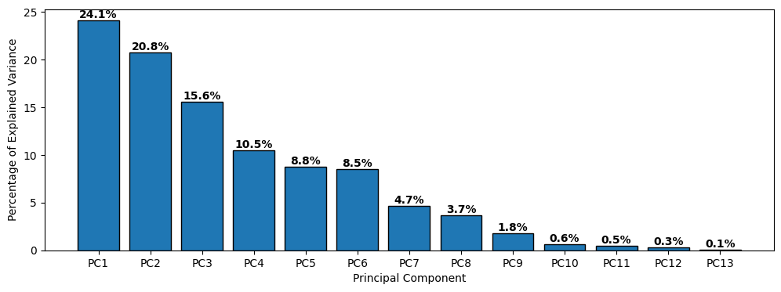

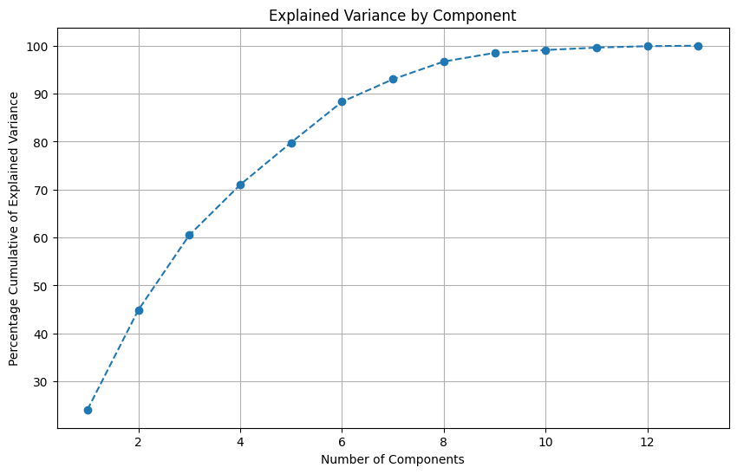

b. With unit type

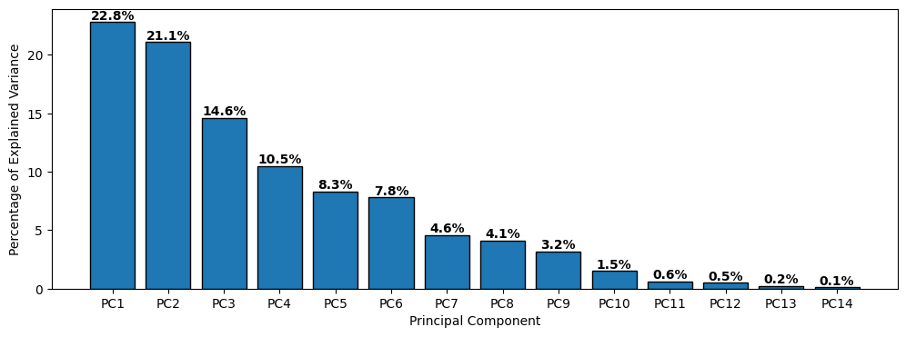

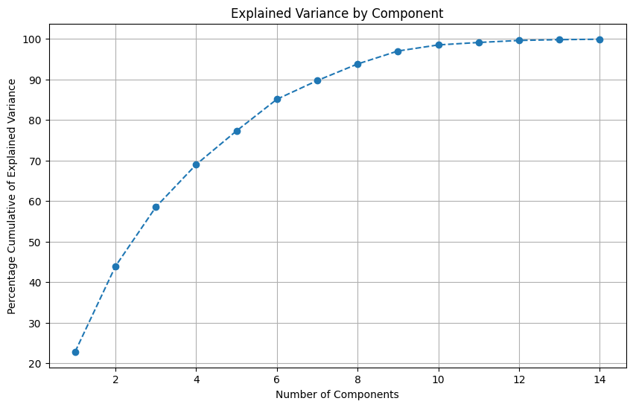

2. CALCULATIONS

A. Without unit_type

I. 7 Components 93% explained variance

eps = 0.36, min_samples = 5

Clusters = 10

Outliers = 19

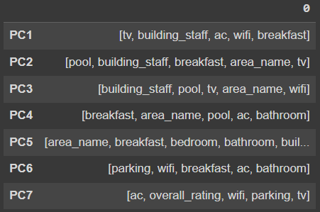

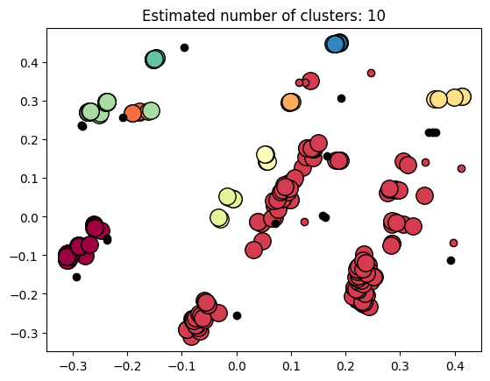

segment

Cluster 2 177

Cluster 1 63

Cluster 8 29

Cluster 10 9

Cluster 7 7

Cluster 9 7

Cluster 3 5

Cluster 4 5

Cluster 5 5

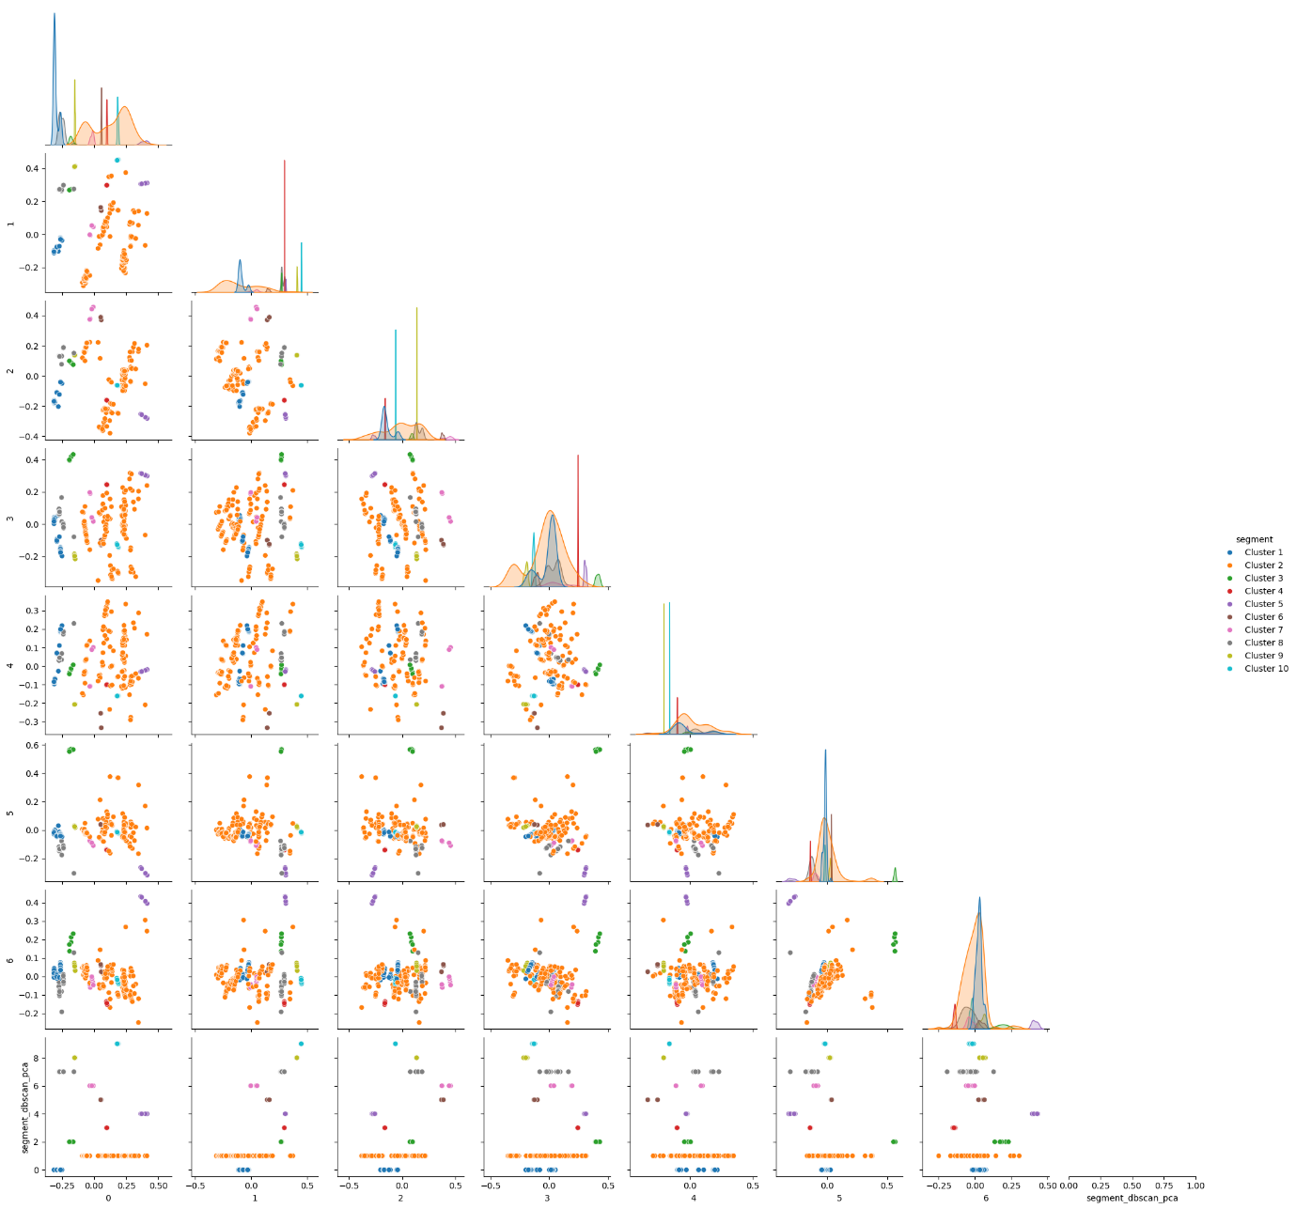

II. 8 Components 96.7% explained variance

eps = 0.38, min_samples = 5

Clusters = 10

Outliers = 16

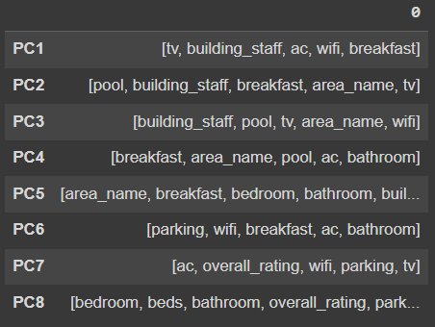

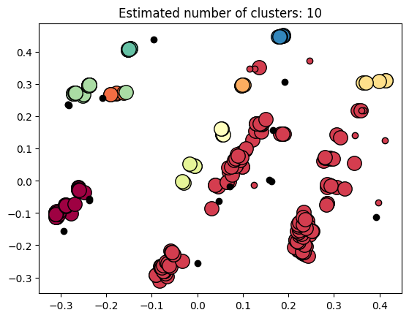

Cluster 2 180

Cluster 1 63

Cluster 8 29

Cluster 10 9

Cluster 7 7

Cluster 9 7

Cluster 3 5

Cluster 4 5

Cluster 5 5

Cluster 6 5

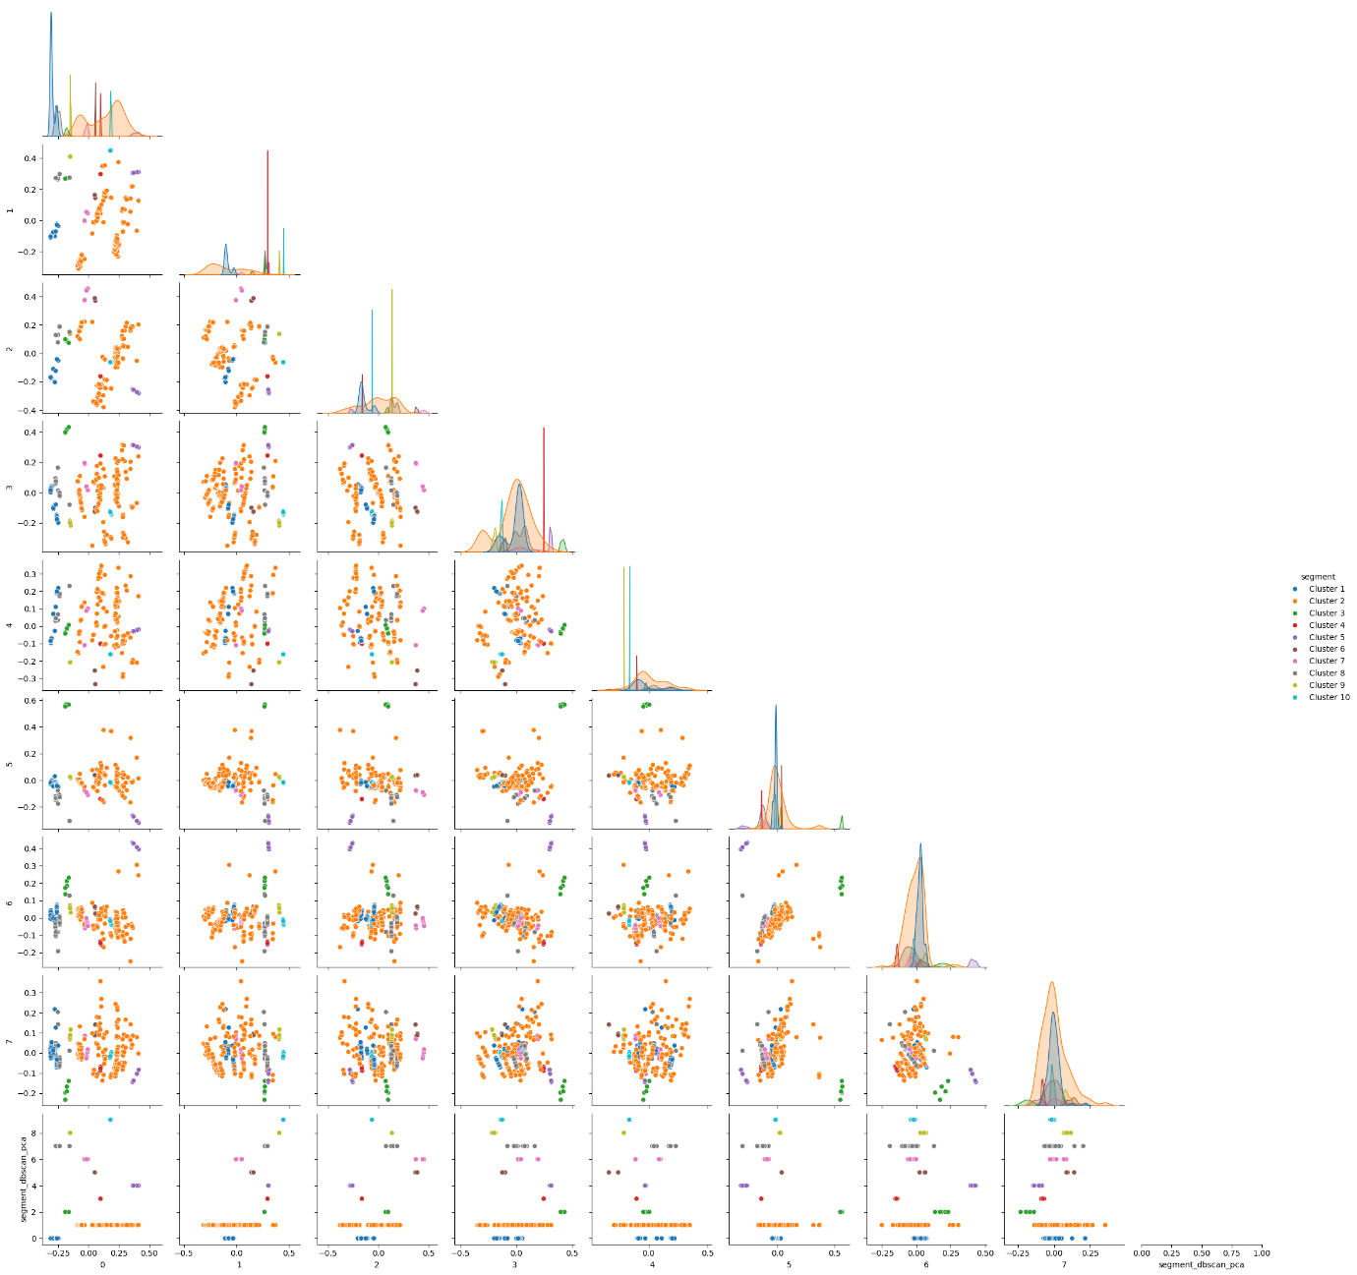

III. 9 Components 98.5% explained variance

eps = 0.38, min_samples = 5

Clusters = 10

Outliers = 22

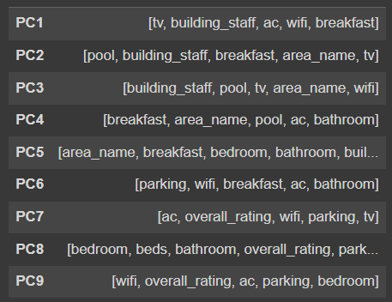

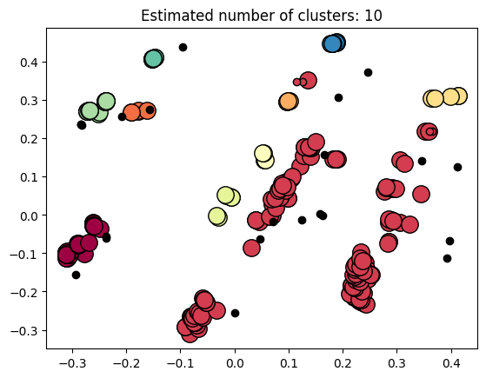

Cluster 2 175

Cluster 1 63

Cluster 8 28

Cluster 10 9

Cluster 7 7

Cluster 9 7

Cluster 3 5

Cluster 4 5

Cluster 5 5

Cluster 6 5

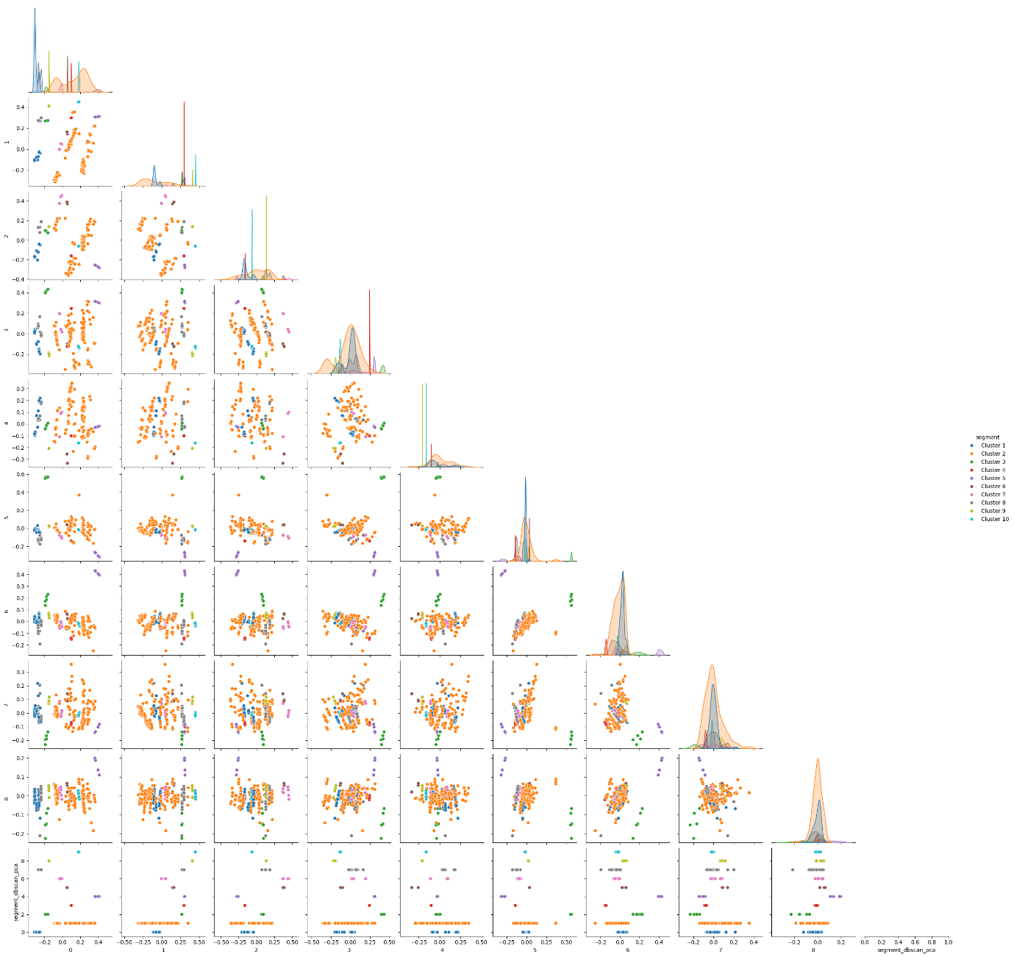

B. With unit_type

I. 7 Components 89.7% explained variance

eps = 0.36, min_samples = 5

Clusters = 10

Outliers = 13



Cluster 2 175

Cluster 1 63

Cluster 8 28

Cluster 10 9

Cluster 7 7

Cluster 9 7

Cluster 3 5

Cluster 4 5

Cluster 5 5

Cluster 6 5



II. 8 Components 93.8% explained variance

eps = 0.37, min_samples = 5

Clusters = 10

Outliers = 17

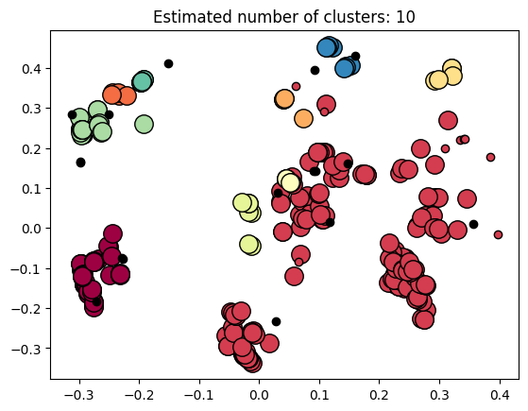

Cluster 2 179

Cluster 1 63

Cluster 8 29

Cluster 10 9

Cluster 7 7

Cluster 9 7

Cluster 3 5

Cluster 4 5

Cluster 5 5

Cluster 6 5

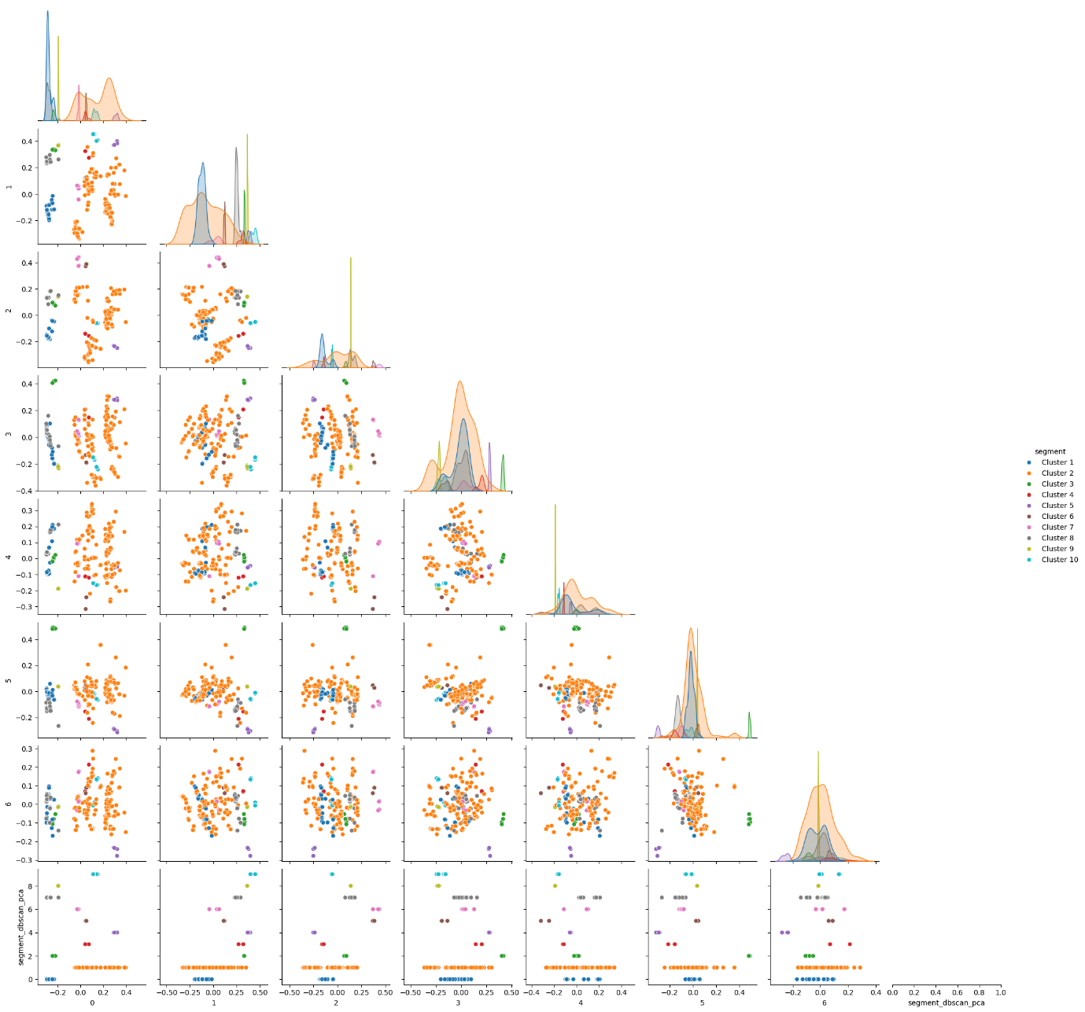

III. 9 Components 97% explained variance

eps = 0.38, min_samples = 5

Clusters = 9

Outliers = 18

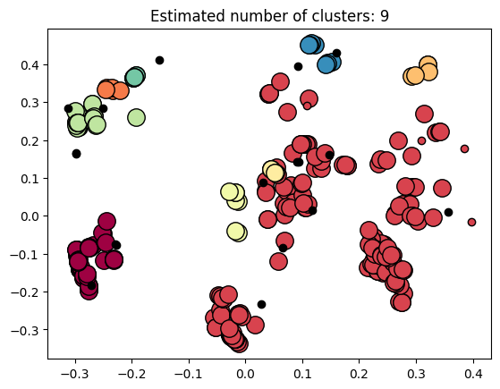

Cluster 2 183

Cluster 1 63

Cluster 7 29

Cluster 9 9

Cluster 6 7

Cluster 8 7

Cluster 3 5

Cluster 4 5

Cluster 5 5

