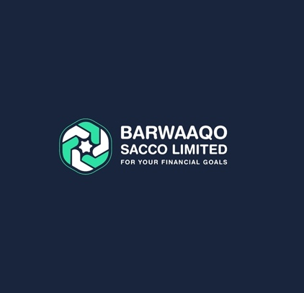

1. **Shaqaale**

Salaried staff are important for the Somaliland economy and contribute to its growth. Employees face extreme difficulties in access their financial needs. Barwaaqo SACCO has tailor made specific products designed to advance access to their financial needs.

All employed staff regardless of their nature of work (Governmental, Corporate or NGOs) will have to save $50 each month of the calendar year, in order to enjoy below benefits.

**Why join Barwaaqo SACCO’s Shaqaale Stream**

* Access to affordable Finance of four times of savings
* Annual dividends on Share Capital
* Group guarantee system
* Emergency, interest-free loan advance of up to 20% of one’s savings

**Who can join Barwaaqo SACCO’s Shaqaale Stream**

* Is a Somaliland citizen, or foreign individual with legal stay permit
* Over 15 years of age
* Declares source of halal income
* Has record of good conduct
* In formal and active employment contract
* Meets and maintains Barwaaqo SACCO’s membership requirements, adheres to its constitution and subsequent procedures.

1. **Hawa (dumar)**

Barwaaqo SACCO’s Hawa Stream is designed specifically to meet the growing finance demand for the Somaliland women who are either self-employed or own and run a small business. Those who subscribe to Barwaaqo SACCO’s Hawa Stream will have to save $30 each month of the calendar year, in order to enjoy below benefits.

**Why join Barwaaqo SACCO’s Hawa Stream**

* Access to affordable Finance of four times of savings
* Annual dividends on Share Capital
* Group guarantee system
* Emergency, interest-free loan advance of up to 20% of one’s savings
* Room for daily saving of $1 a day.

**Who can join Barwaaqo SACCO’s Shaqaale Stream**

* Is a Somaliland citizen, or foreign individual with legal stay permit
* Over 15 years of age
* Declares source of halal income
* Has record of good conduct
* Owns a formal or informal small business
* Meets and maintains Barwaaqo SACCO’s membership requirements, adheres to its constitution and subsequent procedures.

1. **Xoogsato (xirfadleyaasha)**

Skilled laborers and unskilled laborers play an important role in the construction projects and in the economy as a whole. They may include: national technical staff, such as project managers, engineers, and construction foremen. They may also include migrant workers from outside Somaliland, local community members, female workers, IDPs, waste collectors, and people with disabilities.

Barwaaqo SACCO’s Xoogsato Stream is designed to expand access to finance to the underserved market of skilled and unskilled labourers within Somaliland.

Those who subscribe to Barwaaqo SACCO’s Xoogsato Stream will have to save $30 each month of the calendar year, in order to enjoy below benefits.

**Why join Barwaaqo SACCO’s Xoogsato Stream**

* Access to affordable Finance of four times of savings
* Annual dividends on Share Capital
* Group guarantee system
* Emergency, interest-free loan advance of up to 20% of one’s savings
* Room for daily saving of $1 a day.

**Who can join Barwaaqo SACCO’s Shaqaale Stream**

* Is a Somaliland citizen, or foreign individual with legal stay permit
* Over 15 years of age
* Declares source of halal income
* Has record of good conduct
* Engages in a formal or informal labor
* Meets and maintains Barwaaqo SACCO’s membership requirements, adheres to its constitution and subsequent procedures.

1. **Small Business Owners (SBO)**

Small businesses in Somaliland play a critical role in the economy through job creation, economic growth, community support, promote economic resilience and lastly provide unique products and services to the markets.

Barwaaqo SACCO’s SBO Stream is designed to expand access to finance to the underserved small business owners within Somaliland in order to expand their enterprises and create more jobs while deepening the resilience of the national economy.

Those who subscribe to Barwaaqo SACCO’s SBO Stream will have to save $30 each month of the calendar year in order to enjoy below benefits.

**Why join Barwaaqo SACCO’s SBO Stream**

* Access to affordable Finance of **five times** of savings
* Annual dividends on Share Capital
* Group guarantee system
* Emergency, interest-free loan advance of up to 20% of one’s savings
* Room for daily saving of $1 a day.

**Who can join Barwaaqo SACCO’s Shaqaale Stream**

* Is a Somaliland citizen, or foreign individual with legal stay permit
* Own an existing small business
* Business older than one year of existence
* Declares source of halal income
* Has record of good conduct
* Meets and maintains Barwaaqo SACCO’s membership requirements, adheres to its constitution and subsequent procedures.